**Motivation 1: Data compression**

* Start talking about a second type of unsupervised learning problem - **dimensionality reduction**
  + Why should we look at dimensionality reduction?

**Compression**

* Speeds up algorithms
* Reduces space used by data for them
* What is dimensionality reduction?
  + So you've collected many features - maybe more than you need
    - Can you "simply" your data set in a rational and useful way?
  + Example
    - Redundant data set - different units for same attribute
    - Reduce data to 1D (2D->1D)  
      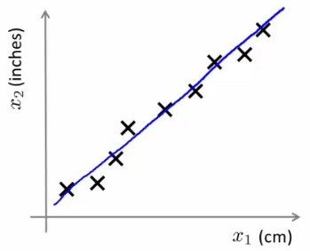
      * Example above isn't a perfect straight line because of round-off error
  + Data redundancy can happen when different teams are working independently
    - Often generates redundant data (especially if you don't control data collection)
  + Another example
    - Helicopter flying - do a survey of pilots (x1 = skill, x2 = pilot enjoyment)
      * These features may be highly correlated
      * This correlation can be combined into a single attribute called aptitude (for example)
* What does dimensionality reduction mean?
  + In our example we plot a line
  + Take exact example and record position on that line  
    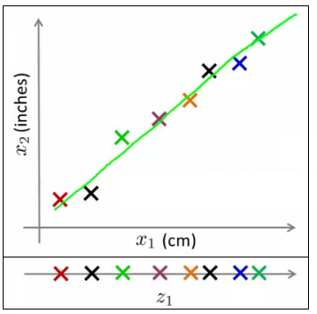
  + So before x1was a 2D feature vector (X and Y dimensions)
  + Now we can represent x1 as a 1D number (Z dimension)
* So we approximate original examples
  + Allows us to half the amount of storage
  + Gives lossy compression, but an acceptable loss (probably)
    - The loss above comes from the rounding error in the measurement, however
* Another example 3D -> 2D
  + So here's our data  
    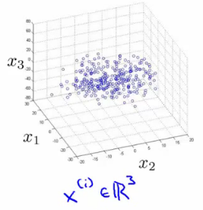
  + Maybe all the data lies in one plane
    - This is sort of hard to explain in 2D graphics, but that plane may be aligned with one of the axis
      * Or or may not...
      * Either way, the plane is a small, a constant 3D space
    - In the diagram below, imagine all our data points are sitting "inside" the blue tray (has a dark blue exterior face and a light blue inside)  
      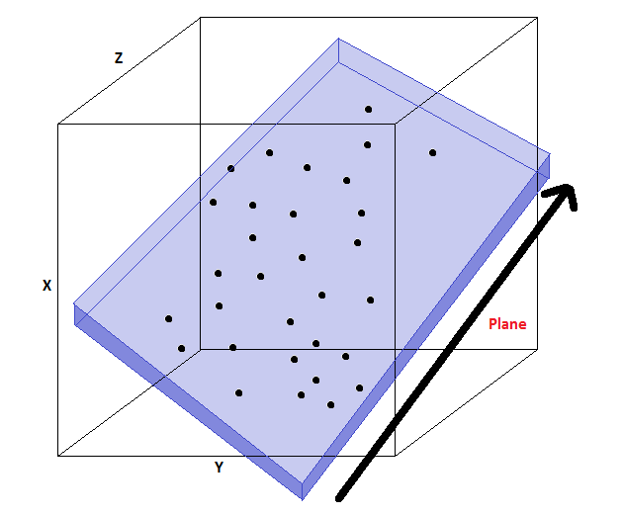
    - Because they're all in this relative shallow area, we can basically ignore one of the dimension, so we draw two new lines (z1 and z2) along the x and y planes of the box, and plot the locations in that box
    - i.e. we loose the data in the z-dimension of our "shallow box" (NB "z-dimensions" here refers to the dimension relative to the box (i.e it's depth) and NOT the z dimension of the axis we've got drawn above) but because the box is shallow it's OK to lose this. Probably....
  + Plot values along those projections  
    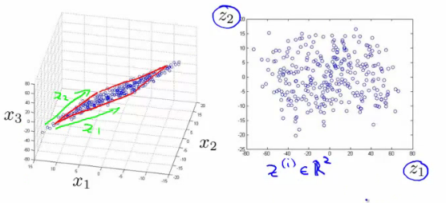
  + So we've now reduced our 3D vector to a 2D vector
* In reality we'd normally try and do 1000D -> 100D

**Motivation 2: Visualization**

* It's hard to visualize highly dimensional data
  + Dimensionality reduction can improve how we display information in a tractable manner for human consumption
  + Why do we care?
    - Often helps to develop algorithms if we can understand our data better
    - Dimensionality reduction helps us do this, see data in a helpful
    - Good for explaining something to someone if you can "show" it in the data
* Example;
  + Collect a large data set about many facts of a country around the world  
    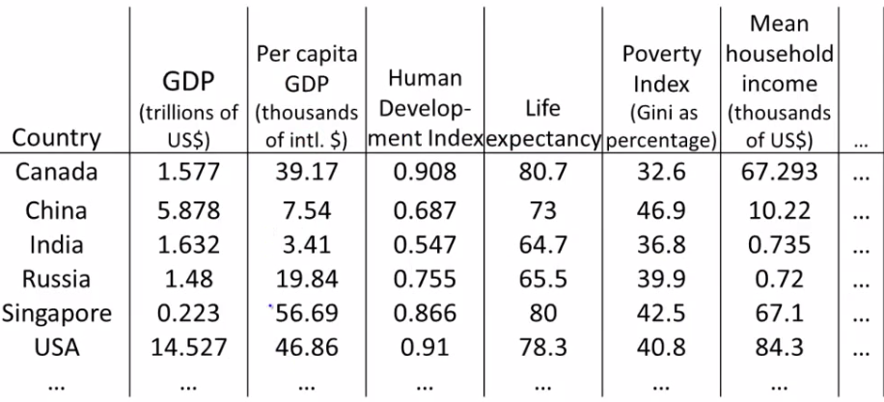
    - So
      * x1 = GDP
      * ...
      * x6 = mean household
    - Say we have 50 features per country
    - How can we understand this data better?
      * Very hard to plot 50 dimensional data
  + Using dimensionality reduction, instead of each country being represented by a 50-dimensional feature vector
    - Come up with a different feature representation (z values) which summarize these features  
      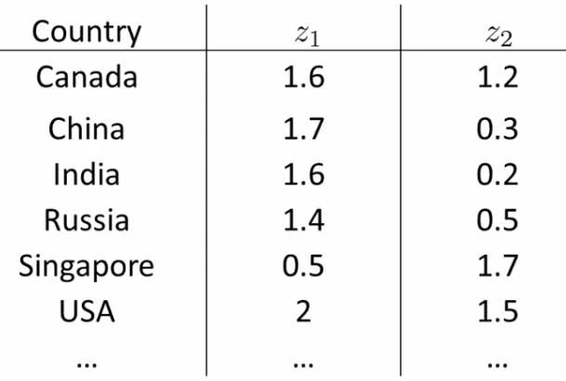
  + This gives us a 2-dimensional vector
    - Reduce 50D -> 2D
    - Plot as a 2D plot
  + Typically you don't generally ascribe meaning to the new features (so we have to determine what these summary values mean)
    - e.g. may find horizontal axis corresponds to overall country size/economic activity
    - and y axis may be the per-person well being/economic activity
  + So despite having 50 features, there may be two "dimensions" of information, with features associated with each of those dimensions
    - It's up to you to asses what of the features can be grouped to form summary features, and how best to do that (feature scaling is probably important)
  + Helps show the two main dimensions of variation in a way that's easy to understand

**Principle Component Analysis (PCA): Problem Formulation**

* For the problem of dimensionality reduction the most commonly used algorithm is **PCA**
  + Here, we'll start talking about how we formulate precisely what we want PCA to do
* So
  + Say we have a 2D data set which we wish to reduce to 1D  
    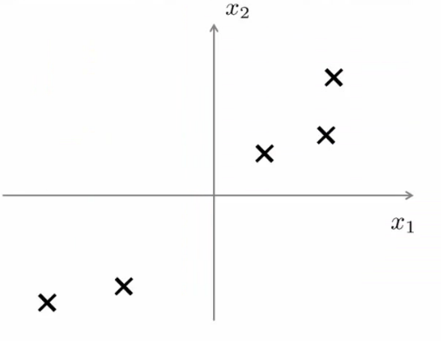
  + In other words, find a single line onto which to project this data
    - How do we determine this line?
      * The distance between each point and the projected version should be small (blue lines below are short)
      * PCA tries to find a lower dimensional surface so the sum of squares onto that surface is minimized
      * The blue lines are sometimes called the **projection error**
        + PCA tries to find the surface (a straight line in this case) which has the minimum projection error  
          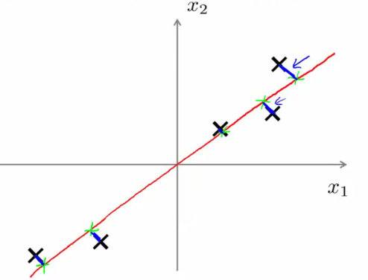
      * As an aside, you should normally do **mean normalization** and **feature scaling** on your data before PCA
* A more formal description is
  + For 2D-1D, we must find a vector u(1), which is of some dimensionality
  + Onto which you can project the data so as to minimize the projection error  
    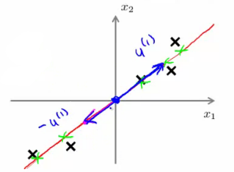
  + u(1) can be positive or negative (-u(1)) which makes no difference
    - Each of the vectors define the same red line
* In the more general case
  + To reduce from nD to kD we
    - Find *k* vectors (u(1), u(2), ... u(k)) onto which to project the data to minimize the projection error
    - So lots of vectors onto which we project the data
    - Find a set of vectors which we project the data onto the linear subspace spanned by that set of vectors
      * We can define a point in a plane with k vectors
  + e.g. 3D->2D
    - Find pair of vectors which define a 2D plane (surface) onto which you're going to project your data
    - Much like the "shallow box" example in compression, we're trying to create the shallowest box possible (by defining two of it's three dimensions, so the box' depth is minimized)  
      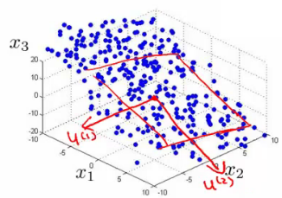
* How does PCA relate to linear regression?
  + PCA is **not** linear regression
    - Despite cosmetic similarities, very different
  + For linear regression, fitting a straight line to minimize the **straight line** between a point and a squared line
    - NB - **VERTICAL distance** between point
  + For PCA minimizing the magnitude of the shortest **orthogonal distance**
    - Gives very different effects
  + More generally
    - With linear regression we're trying to predict "y"
    - With PCA there is no "y" - instead we have a list of features and all features are treated equally
      * If we have 3D dimensional data 3D->2D
        + Have 3 features treated symmetrically

**PCA Algorithm**

* Before applying PCA must do data preprocessing
  + Given a set of m unlabeled examples we must do
    - **Mean normalization**
      * Replace each xji with xj - μj,
        + In other words, determine the mean of each feature set, and then for each feature subtract the mean from the value, so we re-scale the mean to be 0
    - **Feature scaling (depending on data)**
      * If features have very different scales then scale so they all have a comparable range of values
        + e.g. xji is set to (xj - μj) / sj

Where sjis some measure of the range, so could be

Biggest - smallest

Standard deviation (more commonly)

* With preprocessing done, PCA finds the lower dimensional sub-space which minimizes the sum of the square
  + In summary, for 2D->1D we'd be doing something like this;  
    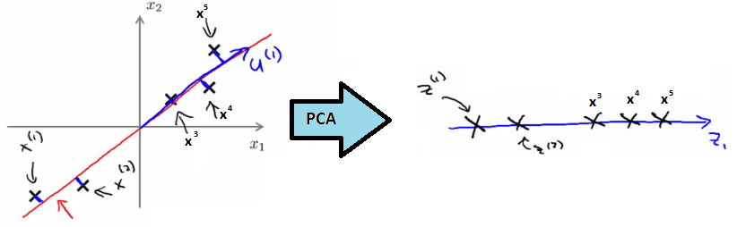
  + Need to compute two things;
    - Compute the **u vectors**
      * The new planes
    - Need to compute the **z vectors**
      * z vectors are the new, lower dimensionality feature vectors
* A mathematical derivation for the u vectors is very complicated
  + But once you've done it, the procedure to find each u vector is not that hard

**Algorithm description**

* Reducing data from *n*-dimensional to k-dimensional
  + Compute the covariance matrix  
    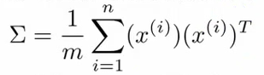
    - This is commonly denoted as Σ (greek upper case sigma) - NOT summation symbol
    - Σ = sigma
      * This is an [n x n] matrix
        + Remember than xiis a [n x 1] matrix
    - In MATLAB or octave we can implement this as follows;  
      http://www.holehouse.org/mlclass/14_Dimensionality_Reduction_files/Image%20%5b13%5d.png
  + Compute eigenvectors of matrix Σ
    - **[U,S,V] = svd(sigma)**
      * svd = singular value decomposition
        + More numerically stable than **eig**
      * **eig**= also gives eigenvector
  + U,S and V are matrices
    - U matrix is also an [n x n] matrix
    - Turns out the columns of U are the u vectors we want!
    - So to reduce a system from n-dimensions to k-dimensions
      * Just take the first *k-vectors* from U (first k columns)  
        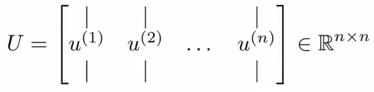
* Next we need to find some way to change x (which is n dimensional) to z (which is k dimensional)
  + (reduce the dimensionality)
  + Take first k columns of the u matrix and stack in columns
    - n x k matrix - call this Ureduce
  + We calculate z as follows
    - z = (Ureduce)*T* * x
      * So [k x n] * [n x 1]
      * Generates a matrix which is
        + k * 1
      * If that's not witchcraft I don't know what is!
* Exactly the same as with supervised learning except we're now doing it with unlabeled data
* So in summary
  + Preprocessing
  + Calculate sigma (covariance matrix)
  + Calculate eigenvectors with **svd**
  + Take k vectors from U (Ureduce= U(:,1:k);)
  + Calculate z (z =Ureduce' * x;)
* No mathematical derivation
  + Very complicated
  + But it works

**Reconstruction from Compressed Representation**

* Earlier spoke about PCA as a compression algorithm
  + If this is the case, is there a way to **decompress** the data from low dimensionality back to a higher dimensionality format?
* Reconstruction
  + Say we have an example as follows  
    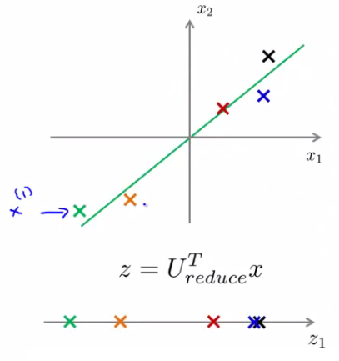
  + We have our examples (x1, x2 etc.)
  + Project onto z-surface
  + Given a point z1, how can we go back to the 2D space?
* Considering
  + z (vector) = (Ureduce)*T* * x
* To go in the opposite direction we must do
  + xapprox = Ureduce* z
    - To consider dimensions (and prove this really works)
      * Ureduce= [n x k]
      * z [k * 1]
    - So
      * xapprox = [n x 1]
* So this creates the following representation  
  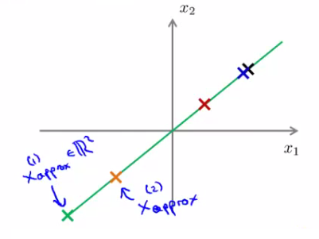
* We lose some of the information (i.e. everything is now perfectly on that line) but it is now projected into 2D space

**Choosing the number of Principle Components**

* How do we chose *k*?
  + k = number of **principle components**
  + Guidelines about how to chose k for PCA
* To chose k think about how PCA works
  + PCA tries to minimize averaged squared projection error  
    http://www.holehouse.org/mlclass/14_Dimensionality_Reduction_files/Image%20%5b17%5d.png
  + Total variation in data can be defined as the average over data saying how far are the training examples from the origin  
    http://www.holehouse.org/mlclass/14_Dimensionality_Reduction_files/Image%20%5b18%5d.png
* When we're choosing k typical to use something like this  
  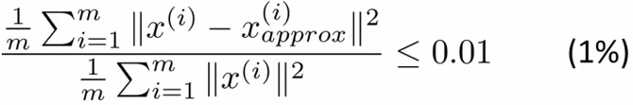
  + Ratio between averaged squared projection error with total variation in data
    - Want ratio to be small - means we retain 99% of the variance
  + If it's small (0) then this is because the numerator is small
    - The numerator is small when xi = xapproxi
      * i.e. we lose very little information in the dimensionality reduction, so when we decompress we regenerate the same data
* So we chose k in terms of this ratio
* Often can significantly reduce data dimensionality while retaining the variance
* How do you do this  
  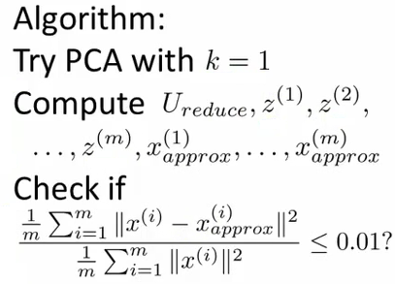

**Advice for Applying PCA**

* Can use PCA to speed up algorithm running time
  + Explain how
  + And give general advice

**Speeding up supervised learning algorithms**

* Say you have a supervised learning problem
  + Input x and y
    - x is a 10 000 dimensional feature vector
    - e.g. 100 x 100 images = 10 000 pixels
    - Such a huge feature vector will make the algorithm slow
  + With PCA we can reduce the dimensionality and make it tractable
  + How
    - 1) Extract xs
      * So we now have an unlabeled training set
    - 2) Apply PCA to x vectors
      * So we now have a reduced dimensional feature vector z
    - 3) This gives you a new training set
      * Each vector can be re-associated with the label
    - 4) Take the reduced dimensionality data set and feed to a learning algorithm
      * Use y as labels and z as feature vector
    - 5) If you have a new example map from higher dimensionality vector to lower dimensionality vector, then feed into learning algorithm
* PCA maps one vector to a lower dimensionality vector
  + x -> z
  + Defined by PCA **only** on the training set
  + The mapping computes a set of parameters
    - Feature scaling values
    - Ureduce
      * Parameter learned by PCA
      * Should be obtained only by determining PCA on your training set
  + So we use those learned parameters for our
    - Cross validation data
    - Test set
* Typically you can reduce data dimensionality by 5-10x without a major hit to algorithm

**Applications of PCA**

* **Compression**
  + Why
    - Reduce memory/disk needed to store data
    - Speed up learning algorithm
  + How do we chose k?
    - % of variance retained
* **Visualization**
  + Typically chose k =2 or k = 3
  + Because we can plot these values!
* One thing often done wrong regarding PCA
  + A bad use of PCA: Use it to prevent over-fitting
    - Reasoning
      * If we have xi we have n features, zi has k features which can be lower
      * If we *only* have k features then maybe we're less likely to over fit...
    - This doesn't work
      * BAD APPLICATION
      * Might work OK, but not a good way to address over fitting
      * Better to use regularization
    - PCA throws away some data without knowing what the values it's losing
      * Probably OK if you're keeping most of the data
      * But if you're throwing away some crucial data bad
      * So you have to go to like 95-99% variance retained
        + So here regularization will give you AT LEAST as good a way to solve over fitting
* A second PCA myth
  + Used for compression or visualization - good
  + Sometimes used
    - Design ML system with PCA from the outset
      * But, what if you did the whole thing without PCA
    - See how a system performs without PCA
      * ONLY if you have a reason to believe PCA will help should you then add PCA
    - PCA is easy enough to add on as a processing step
      * Try without first!