**Anomaly detection - problem motivation**

* Anomaly detection is a reasonably commonly used type of machine learning application
  + Can be thought of as a solution to an unsupervised learning problem
  + But, has aspects of supervised learning
* What is anomaly detection?
  + Imagine you're an aircraft engine manufacturer
  + As engines roll off your assembly line you're doing QA
    - Measure some features from engines (e.g. heat generated and vibration)
  + You now have a dataset of x1 to xm (i.e. *m*engines were tested)
  + Say we plot that dataset   
    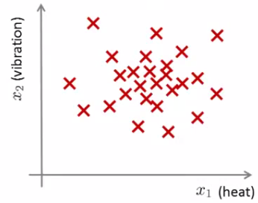0
  + Next day you have a new engine
    - An anomaly detection method is used to see if the new engine is anomalous (when compared to the previous engines)
  + If the new engine looks like this;  
    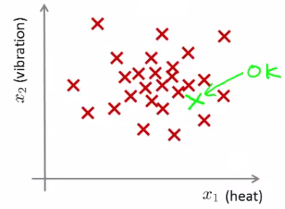  
    - Probably OK - looks like the ones we've seen before
  + But if the engine looks like this  
    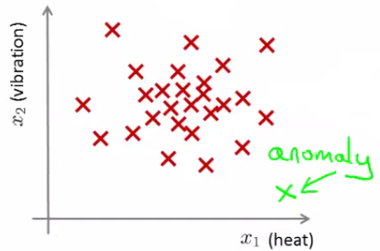  
    - Uh oh! - this looks like an **anomalous data-point**
* More formally
  + We have a dataset which contains **normal** (data)
    - How we ensure they're normal is up to us
    - In reality it's OK if there are a few which aren't actually normal
  + Using that dataset as a reference point we can see if other examples are **anomalous**
* How do we do this?
  + First, using our training dataset we build a model
    - We can access this model using **p(x)**
      * This asks, "What is the probability that example x is normal"
  + Having built a model
    - if p(xtest) < ε --> flag this as an anomaly
    - if p(xtest) >= ε --> this is OK
    - ε is some threshold probability value which we define, depending on how sure we need/want to be
  + We expect our model to (graphically) look something like this;  
    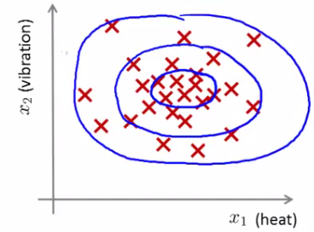
    - i.e. this would be our model if we had 2D data

**Applications**

* Fraud detection
  + Users have activity associated with them, such as
    - Length on time on-line
    - Location of login
    - Spending frequency
  + Using this data we can build a model of what normal users' activity is like
  + What is the probability of "normal" behavior?
  + Identify unusual users by sending their data through the model
    - Flag up anything that looks a bit weird
    - Automatically block cards/transactions
* Manufacturing
  + Already spoke about aircraft engine example
* Monitoring computers in data center
  + If you have many machines in a cluster
  + Computer features of machine
    - x1 = memory use
    - x2 = number of disk accesses/sec
    - x3 = CPU load
  + In addition to the measurable features you can also define your own complex features
    - x4 = CPU load/network traffic
  + If you see an anomalous machine
    - Maybe about to fail
    - Look at replacing bits from it

**The Gaussian distribution (optional)**

* Also called the **normal distribution**
* Example
  + Say x (data set) is made up of real numbers
    - Mean is μ
    - Variance is σ2
      * σ is also called the **standard deviation** - specifies the width of the Gaussian probability
    - The data has a Gaussian distribution
  + Then we can write this ~ *N(*μ,σ2 )
    - ~ means = is distributed as
    - *N* (should really be "script" N (even curlier!) -> means normal distribution
    - μ, σ2 represent the mean and variance, respectively
      * These are the two parameters a Gaussian means
  + Looks like this;  
    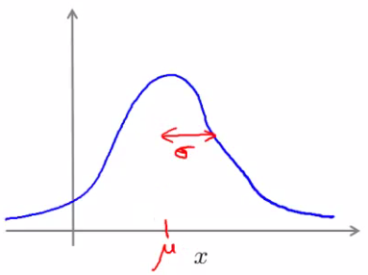
  + This specifies the probability of x taking a value
    - As you move away from μ
* Gaussian equation is
  + P(x : μ , σ2) (probability of x, parameterized by the mean and squared variance)  
    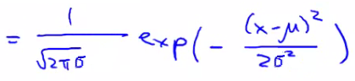
* Some examples of Gaussians below
  + Area is always the same (must = 1)
  + But width changes as standard deviation changes

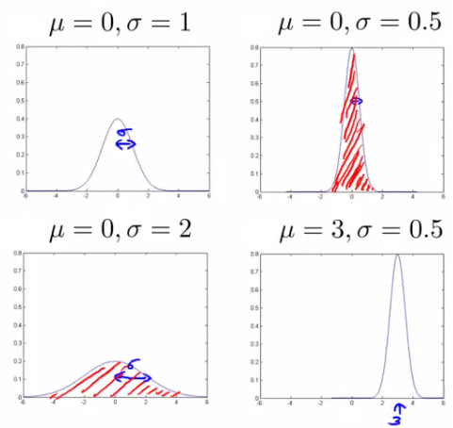

**Parameter estimation problem**

* What is it?
  + Say we have a data set of m examples
  + Give each example is a real number - we can plot the data on the x axis as shown below   
    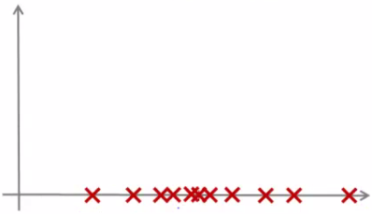
  + Problem is - say you suspect these examples come from a Gaussian
    - Given the dataset can you estimate the distribution?
  + Could be something like this  
    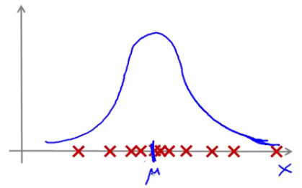
  + Seems like a reasonable fit - data seems like a higher probability of being in the central region, lower probability of being further away
* Estimating μ and σ2
  + μ = average of examples
  + σ2 = standard deviation squared   
    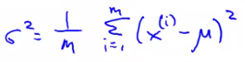
  + As a side comment
    - These parameters are the maximum likelihood estimation values for μ and σ2
    - You can also do 1/(m) or 1/(m-1) doesn't make too much difference
      * Slightly different mathematical problems, but in practice it makes little difference

**Anomaly detection algorithm**

* Unlabeled training set of m examples
  + Data = {x1, x2, ..., xm}
    - Each example is an n-dimensional vector (i.e. a feature vector)
    - We have n features!
  + Model P(x) from the data set
    - What are high probability features and low probability features
    - x is a vector
    - So model p(x) as
      * = p(x1; μ1 , σ12) * p(x2; μ2 , σ22) * ... p(xn; μn , σn2)
    - Multiply the probability of each features by each feature
      * We model each of the features by assuming each feature is distributed according to a Gaussian distribution
      * p(xi; μi , σi2)
        + The probability of feature xi given μi and σi2, using a Gaussian distribution
  + As a side comment
    - Turns out this equation makes an **independence assumption** for the features, although algorithm works if features are independent or not
      * Don't worry too much about this, although if you're features are tightly linked you should be able to do some dimensionality reduction anyway!
  + We can write this chain of multiplication more compactly as follows;  
    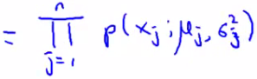
    - Capital PI (Π) is the product of a set of values
  + The problem of estimation this distribution is sometimes call the problem of **density estimation**

**Algorithm**

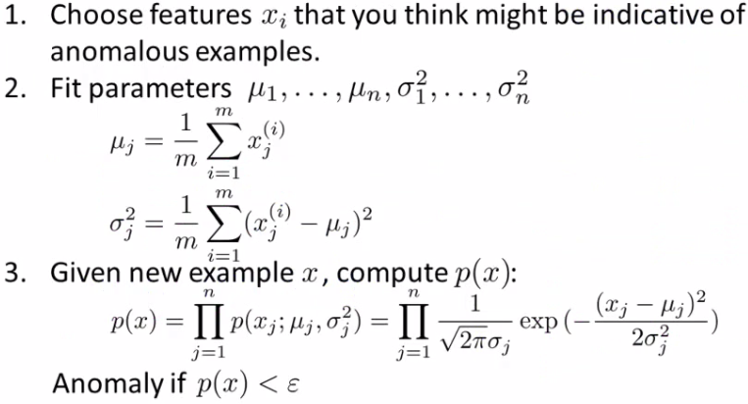

* **1 - Chose features**
  + Try to come up with features which might help identify something anomalous - may be unusually large or small values
  + More generally, chose features which describe the general properties
  + This is nothing unique to anomaly detection - it's just the idea of building a sensible feature vector
* **2 - Fit parameters**
  + Determine parameters for each of your examples μi and σi2
    - Fit is a bit misleading, really should just be "Calculate parameters for 1 to n"
  + So you're calculating standard deviation and mean for each feature
  + You should of course used some vectorized implementation rather than a loop probably
* **3 - compute p(x)**
  + You compute the formula shown (i.e. the formula for the Gaussian probability)
  + If the number is very small, very low chance of it being "normal"

**Anomaly detection example**

* x1
  + Mean is about 5
  + Standard deviation looks to be about 2
* x2
  + Mean is about 3
  + Standard deviation about 1
* So we have the following system  
  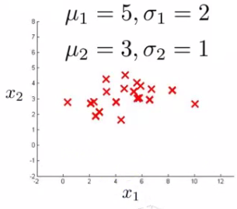
* If we plot the Gaussian for x1 and x2 we get something like this  
  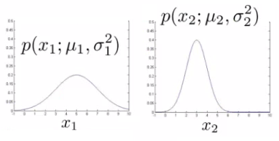
* If you plot the product of these things you get a surface plot like this  
  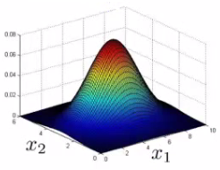
  + With this surface plot, the height of the surface is the probability - p(x)
  + We can't always do surface plots, but for this example it's quite a nice way to show the probability of a 2D feature vector
* Check if a value is anomalous
  + Set epsilon as some value
  + Say we have two new data points new data-point has the values
    - x1test
    - x2test
  + We compute
    - p(x1test) = 0.436 >= epsilon (~40% chance it's normal)
      * Normal
    - p(x2test) = 0.0021 < epsilon (~0.2% chance it's normal)
      * Anomalous
  + What this is saying is if you look at the surface plot, all values above a certain height are normal, all the values below that threshold are probably anomalous

**Developing and evaluating and anomaly detection system**

* Here talk about developing a system for anomaly detection
  + How to evaluate an algorithm
* Previously we spoke about the importance of real-number evaluation
  + Often need to make a lot of choices (e.g. features to use)
    - Easier to evaluate your algorithm if it returns a **single number** to show if changes you made improved or worsened an algorithm's performance
  + To develop an anomaly detection system quickly, would be helpful to have a way to evaluate your algorithm
* Assume we have some labeled data
  + So far we've been treating anomalous detection with unlabeled data
  + If you have labeled data allows evaluation
    - i.e. if you think something iss anomalous you can be sure if it is or not
* So, taking our engine example
  + You have some labeled data
    - Data for engines which were non-anomalous -> y = 0
    - Data for engines which were anomalous -> y = 1
  + Training set is the collection of normal examples
    - OK even if we have a few anomalous data examples
  + Next define
    - Cross validation set
    - Test set
    - For both assume you can include a few examples which have anomalous examples
  + Specific example
    - Engines
      * Have 10 000 good engines
        + OK even if a few bad ones are here...
        + LOTS of y = 0
      * 20 flawed engines
        + Typically when y = 1 have 2-50
    - Split into
      * Training set: 6000 good engines (y = 0)
      * CV set: 2000 good engines, 10 anomalous
      * Test set: 2000 good engines, 10 anomalous
      * Ratio is 3:1:1
    - Sometimes we see a different way of splitting
      * Take 6000 good in training
      * Same CV and test set (4000 good in each) different 10 anomalous,
      * Or even 20 anomalous (same ones)
      * This is bad practice - should use different data in CV and test set
  + Algorithm evaluation
    - Take trainings set { x1, x2, ..., xm}
      * Fit model p(x)
    - On cross validation and test set, test the example x
      * y = 1 if p(x) < epsilon (anomalous)
      * y = 0 if p(x) >= epsilon (normal)
    - Think of algorithm a trying to predict if something is anomalous
      * But you have a label so can check!
      * Makes it look like a supervised learning algorithm
* What's a good metric to use for evaluation
  + y = 0 is very common
    - So classification would be bad
  + Compute fraction of true positives/false positive/false negative/true negative
  + Compute precision/recall
  + Compute F1-score
* Earlier, also had **epsilon** (the threshold value)
  + Threshold to show when something is anomalous
  + If you have CV set you can see how varying epsilon effects various evaluation metrics
    - Then pick the value of epsilon which maximizes the score on your CV set
  + Evaluate algorithm using cross validation
  + Do final algorithm evaluation on the test set

**Anomaly detection vs. supervised learning**

* If we have labeled data, we not use a supervised learning algorithm?
  + Here we'll try and understand when you should use supervised learning and when anomaly detection would be better

**Anomaly detection**

* **Very small number of positive examples**
  + Save positive examples just for CV and test set
  + Consider using an anomaly detection algorithm
  + Not enough data to "learn" positive examples
* **Have a very large number of negative examples**
  + Use these negative examples for p(x) fitting
  + Only need negative examples for this
* **Many "types" of anomalies**
  + Hard for an algorithm to learn from positive examples when anomalies may look nothing like one another
    - So anomaly detection doesn't know what they look like, but knows what they *don't* look like
  + When we looked at SPAM email,
    - Many types of SPAM
    - For the spam problem, usually enough positive examples
    - So this is why we usually think of SPAM as supervised learning
* Application and why they're anomaly detection
  + **Fraud detection**
    - Many ways you may do fraud
    - If you're a major on line retailer/very subject to attacks, sometimes might shift to supervised learning
  + **Manufacturing**
    - If you make HUGE volumes maybe have enough positive data -> make supervised
      * Means you make an assumption about the kinds of errors you're going to see
      * It's the unknown unknowns we don't like!
  + **Monitoring machines in data**

**Supervised learning**

* **Reasonably large number of positive and negative examples**
* Have enough positive examples to give your algorithm the opportunity to see what they look like
  + If you expect anomalies to look anomalous in the same way
* Application
  + Email/SPAM classification
  + Weather prediction
  + Cancer classification

**Choosing features to use**

* One of the things which has a huge effect is which features are used
* **Non-Gaussian features**
  + Plot a histogram of data to check it has a Gaussian description - nice sanity check
    - Often still works if data is non-Gaussian
    - Use **hist**command to plot histogram
  + Non-Gaussian data might look like this  
    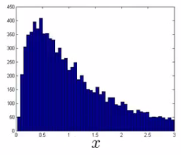
  + Can play with different transformations of the data to make it look more Gaussian
  + Might take a log transformation of the data
    - i.e. if you have some feature x1, replace it with log(x1)  
      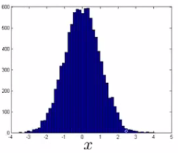
      * This looks much more Gaussian
    - Or do log(x1+c)
      * Play with c to make it look as Gaussian as possible
    - Or do x1/2
    - Or do x1/3

**Error analysis for anomaly detection**

* Good way of coming up with features
* Like supervised learning error analysis procedure
  + Run algorithm on CV set
  + See which one it got wrong
  + Develop new features based on trying to understand *why* the algorithm got those examples wrong
* Example
  + p(x) large for normal, p(x) small for abnormal
  + e.g.  
    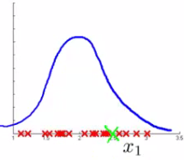
  + Here we have one dimension, and our anomalous value is sort of buried in it (in green - Gaussian superimposed in blue)
    - Look at data - see what went wrong
    - Can looking at that example help develop a new feature (x2) which can help distinguish further anomalous
* Example - data center monitoring
  + Features
    - x1 = memory use
    - x2 = number of disk access/sec
    - x3 = CPU load
    - x4 = network traffic
  + We suspect CPU load and network traffic grow linearly with one another
    - If server is serving many users, CPU is high and network is high
    - Fail case is infinite loop, so CPU load grows but network traffic is low
      * New feature - CPU load/network traffic
      * May need to do feature scaling

**Multivariate Gaussian distribution**

* Is a slightly different technique which can sometimes catch some anomalies which non-multivariate Gaussian distribution anomaly detection fails to
  + Unlabeled data looks like this   
    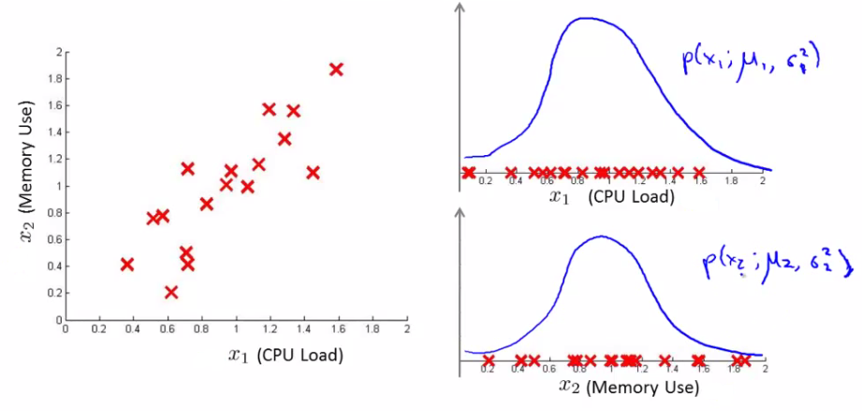
  + Say you can fit a Gaussian distribution to CPU load and memory use
  + Lets say in the test set we have an example which looks like an anomaly (e.g. x1 = 0.4, x2 = 1.5)
    - Looks like most of data lies in a region far away from this example
      * Here memory use is high and CPU load is low (if we plot x1vs. x2 our green example looks miles away from the others)
  + Problem is, if we look at each feature individually they may fall within acceptable limits - the issue is we know we shouldn't don't get those kinds of values **together**
    - But individually, they're both acceptable  
      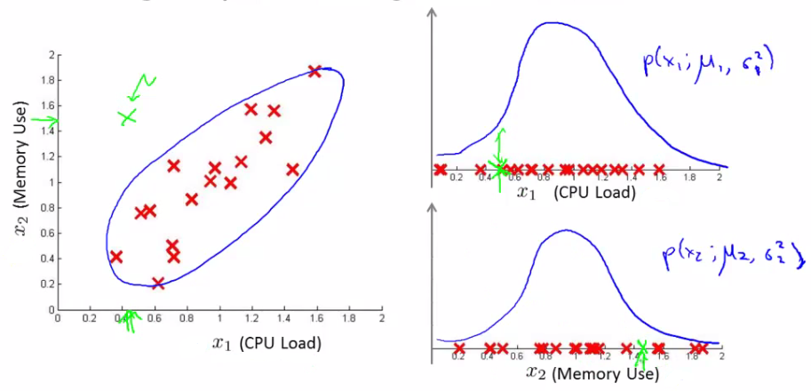
  + This is because our function makes probability prediction in concentric circles around the the means of both  
    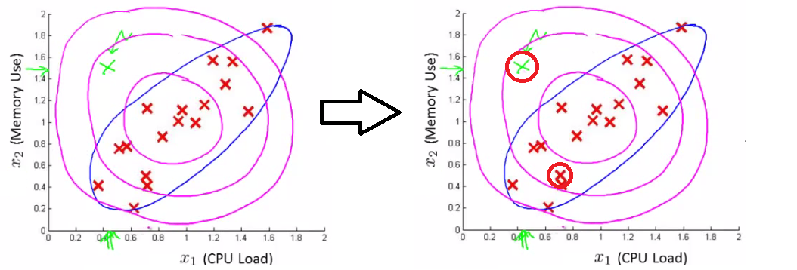
    - Probability of the two red circled examples is basically the same, even though we can clearly see the green one as an outlier
      * Doesn't understand the meaning

**Multivariate Gaussian distribution model**

* To get around this we develop the **multivariate Gaussian distribution**
  + Model p(x) all in one go, instead of each feature separately
    - What are the parameters for this new model?
      * μ - which is an *n* dimensional vector (where n is number of features)
      * Σ - which is an [n x n] matrix - the **covariance matrix**
* For the sake of completeness, the formula for the multivariate Gaussian distribution is as follows  
  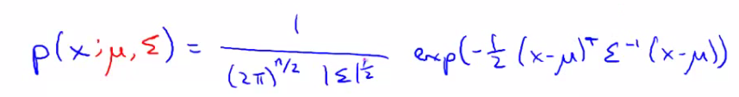
  + NB don't memorize this - you can always look it up
  + What does this mean?
    - http://www.holehouse.org/mlclass/15_Anomaly_Detection_files/Image%20%5b22%5d.png = absolute value of Σ (determinant of sigma)
      * This is a mathematic function of a matrix
      * You can compute it in MATLAB using **det(sigma)**
* More importantly, what does this p(x) look like?
  + 2D example  
    http://www.holehouse.org/mlclass/15_Anomaly_Detection_files/Image%20%5b23%5d.png
    - Sigma is sometimes call the identity matrix  
      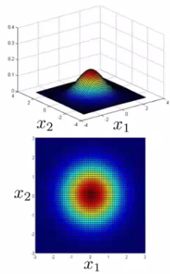
      * p(x) looks like this
        + For inputs of x1 and x2 the height of the surface gives the value of p(x)
  + What happens if we change Sigma?  
    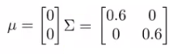
  + So now we change the plot to  
    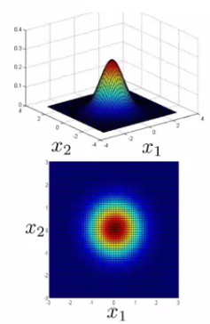
    - Now the width of the bump decreases and the height increases
  + If we set sigma to be different values this changes the identity matrix and we change the shape of our graph  
    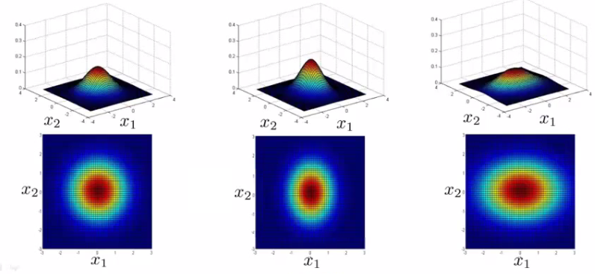
  + Using these values we can, therefore, define the shape of this to better fit the data, rather than assuming symmetry in every dimension
* One of the cool things is you can use it to model correlation between data
  + If you start to change the off-diagonal values in the covariance matrix you can control how well the various dimensions correlation  
    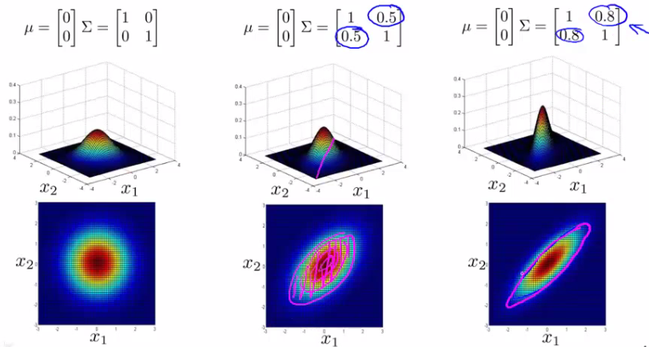
    - So we see here the final example gives a very tall thin distribution, shows a strong positive correlation
    - We can also make the off-diagonal values negative to show a negative correlation
* Hopefully this shows an example of the kinds of distribution you can get by varying sigma
  + We can, of course, also move the mean (μ) which varies the peak of the distribution

**Applying multivariate Gaussian distribution to anomaly detection**

* Saw some examples of the kinds of distributions you can model
  + Now let's take those ideas and look at applying them to different anomaly detection algorithms
* As mentioned, multivariate Gaussian modeling uses the following equation;  
  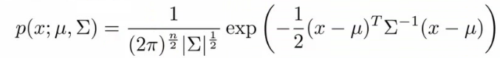
* Which comes with the parameters μ and Σ
  + Where
    - μ - the mean (n-dimenisonal vector)
    - Σ - covariance matrix ([nxn] matrix)
* Parameter fitting/estimation problem
  + If you have a set of examples
    - {x1, x2, ..., xm}
  + The formula for estimating the parameters is  
    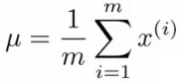  
    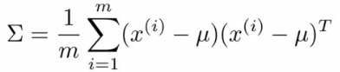
  + Using these two formulas you get the parameters

**Anomaly detection algorithm with multivariate Gaussian distribution**

* **1)** Fit model - take data set and calculate μ and Σ using the formula above
* **2)** We're next given a new example (xtest) - see below  
  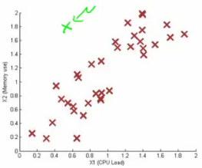
  + For it compute p(x) using the following formula for multivariate distribution  
    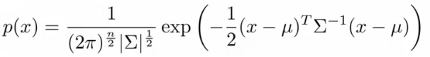
* **3)** Compare the value with ε (threshold probability value)
  + if p(xtest) < ε --> flag this as an anomaly
  + if p(xtest) >= ε --> this is OK
* If you fit a multivariate Gaussian model to our data we build something like this  
  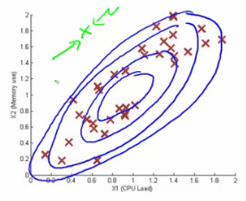
* Which means it's likely to identify the green value as anomalous
* Finally, we should mention how multivariate Gaussian relates to our original simple Gaussian model (where each feature is looked at individually)
  + Original model corresponds to multivariate Gaussian where the Gaussians' contours are axis aligned
  + i.e. the normal Gaussian model is a special case of multivariate Gaussian distribution
    - This can be shown mathematically
    - Has this constraint that the covariance matrix sigma as ZEROs on the non-diagonal values  
      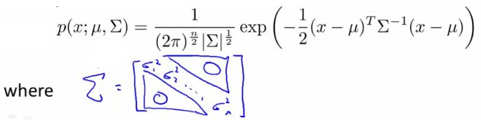
    - If you plug your variance values into the covariance matrix the models are actually identical

**Original model vs. Multivariate Gaussian**

Original Gaussian model

* Probably used more often
* There is a need to manually create features to capture anomalies where x1 and x2take unusual combinations of values
  + So **need to make extra features**
  + Might not be obvious what they should be
    - This is always a risk - where you're using your own expectation of a problem to "predict" future anomalies
    - Typically, the things that catch you out aren't going to be the things you though of
      * If you thought of them they'd probably be avoided in the first place
    - Obviously this is a bigger issue, and one which may or may not be relevant depending on your problem space
* Much **cheaper computationally**
* **Scales much better** to very large feature vectors
  + Even if n = 100 000 the original model works fine
* **Works well even with a small training set**
  + e.g. 50, 100
* Because of these factors it's used more often because it really represents a optimized but axis-symmetric specialization of the general model

**Multivariate Gaussian model**

* Used less frequently
* **Can capture feature correlation**
  + So no need to create extra values
* **Less computationally efficient**
  + Must compute inverse of matrix which is [n x n]
  + So lots of features is bad - makes this calculation very expensive
  + So if n = 100 000 not very good
* **Needs for m > n**
  + i.e. number of examples must be greater than number of features
  + If this is not true then we have a singular matrix (non-invertible)
  + So should be used only in m >> n
* If you find the matrix is non-invertible, could be for one of two main reasons
  + m < n
    - So use original simple model
  + Redundant features (i.e. linearly dependent)
    - i.e. two features that are the same
    - If this is the case you could use PCA or sanity check your data