**Problem description and pipeline**

* Case study focused around photo OCR
* Three reasons to do this
  + 1) Look at how a **complex system** can be put together
  + 2) The idea of a machine learning **pipeline**
    - What to do next
    - How to do it
  + 3) Some more interesting ideas
    - Applying machine learning to tangible problems
    - **Artificial data synthesis**

**What is the photo OCR problem?**

* Photo OCR = photo optical character recognition
  + With growth of digital photography, lots of digital pictures
  + One idea which has interested many people is getting computers to understand those photos
  + The photo OCR problem is getting computers to read text in an image
    - Possible applications for this would include
      * Make searching easier (e.g. searching for photos based on words in them)
      * Car navigation
* OCR of documents is a comparatively easy problem
  + From photos it's really hard

**OCR pipeline**

* 1) Look through image and find text
* 2) Do character segmentation
* 3) Do character classification
* 4) *Optional* some may do spell check after this too
  + We're not focussing on such systems though



* **Pipelines** are common in machine learning
  + Separate modules which may each be a machine learning component or data processing component
* If you're designing a machine learning system, pipeline design is one of the most important questions
  + Performance of pipeline and each module often has a big impact on the overall performance a problem
  + You would often have different engineers working on each module
    - Offers a natural way to divide up the workload

**Sliding window image analysis**

* How do the individual models work?
* Here focus on a sliding windows classifier
* As mentioned, stage 1 is **text detection**
  + Unusual problem in computer vision - different rectangles (which surround text) may have different aspect ratios (aspect ratio being height : width)
    - Text may be short (few words) or long (many words)
    - Tall or short font
    - Text might be straight on
    - Slanted  
      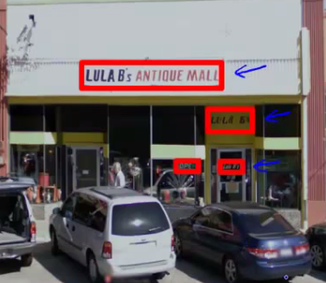
  + Let's start with a simpler example

**Pedestrian detection**

* Want to take an image and find pedestrians in the image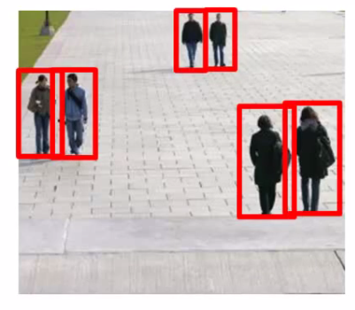
* This is a slightly simpler problem because the aspect ration remains pretty constant
* Building our detection system
  + Have 82 x 36 aspect ratio
    - This is a typical aspect ratio for a standing human
  + Collect training set of positive and negative examples  
    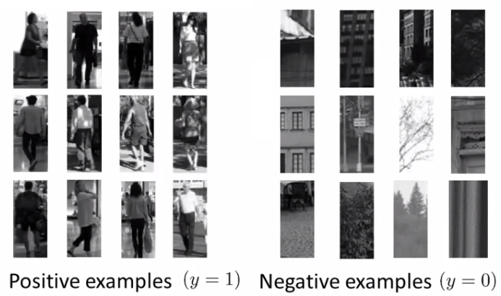
  + Could have 1000 - 10 000 training examples
  + Train a neural network to take an image and classify that image as pedestrian or not
    - Gives you a way to train your system
* Now we have a new image - how do we find pedestrians in it?
  + Start by taking a rectangular 82 x 36 patch in the image  
    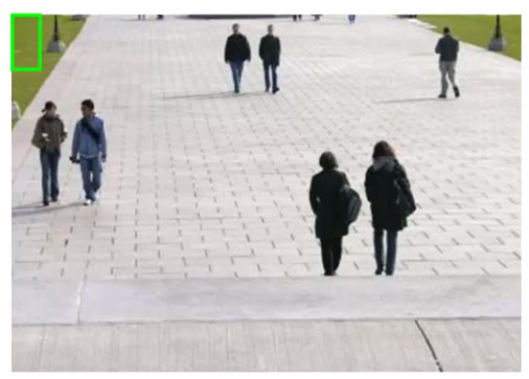
    - Run patch through classifier - hopefully in this example it will return y = 0
  + Next slide the rectangle over to the right a little bit and re-run
    - Then slide again
    - The amount you slide each rectangle over is a parameter called the step-size or stride
      * Could use 1 pixel
        + Best, but computationally expensive
      * More commonly 5-8 pixels used
    - So, keep stepping rectangle along all the way to the right
      * Eventually get to the end
    - Then move back to the left hand side but step down a bit too
    - Repeat until you've covered the whole image
  + Now, we initially started with quite a small rectangle
    - So now we can take a larger image patch (of the same aspect ratio)
    - Each time we process the image patch, we're resizing the larger patch to a smaller image, then running that smaller image through the classifier
  + Hopefully, by changing the patch size and rastering repeatedly across the image, you eventually recognize all the pedestrians in the picture  
    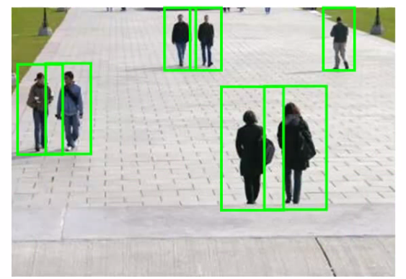

**Text detection example**

* Like pedestrian detection, we generate a labeled training set with
  + Positive examples (some kind of text)
  + Negative examples (not text)  
    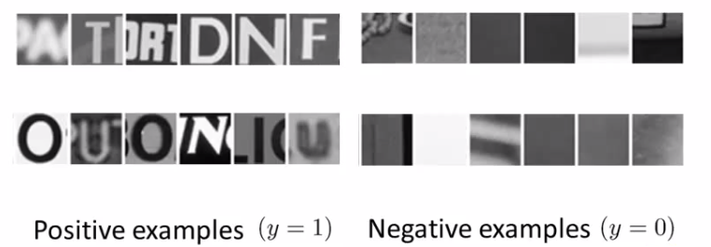
* Having trained the classifier we apply it to an image
  + So, run a sliding window classifier at a fixed rectangle size
  + If you do that end up with something like this  
    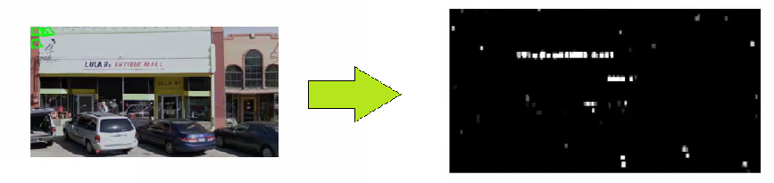
  + White region show where text detection system thinks text is
    - Different shades of gray correspond to probability associated with how sure the classifier is the section contains text
      * Black - no text
      * White - text
    - For text detection, we want to draw rectangles around all the regions where there is text in the image
  + Take classifier output and apply an **expansion algorithm**
    - Takes each of white regions and expands it
    - How do we implement this
      * Say, for every pixel, is it within some distance of a white pixel?
      * If yes then colour it white  
        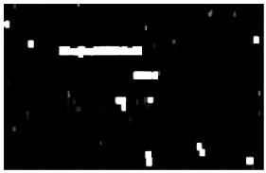
  + Look at connected white regions in the image above
    - Draw rectangles around those which make sense as text (i.e. tall thin boxes don't make sense)  
      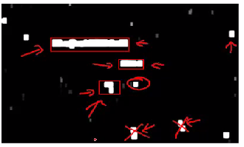
  + This example misses a piece of text on the door because the aspect ratio is wrong
    - Very hard to read

**Stage two is character segmentation**

* Use supervised learning algorithm
* Look in a defined image patch and decide, is there a split between two characters?
  + So, for example, our first training data item below looks like there is such a split
  + Similarly, the negative examples are either empty or hold a full characters  
    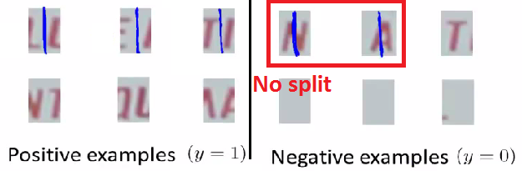
* We train a classifier to try and classify between positive and negative examples
  + Run that classifier on the regions detected as containing text in the previous section
* Use a 1-dimensional sliding window to move along text regions
  + Does each window snapshot look like the split between two characters?
    - If yes insert a split
    - If not move on
  + So we have something that looks like this  
    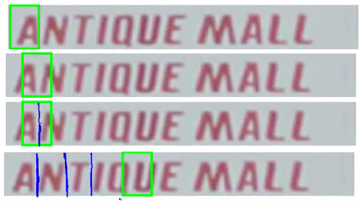

**Character classification**

* Standard OCR, where you apply standard supervised learning which takes an input and identify which character we decide it is
  + Multi-class characterization problem

**Getting lots of data: Artificial data synthesis**

* We've seen over and over that one of the most reliable ways to get a high performance machine learning system is to take a low bias algorithm and train on a massive data set
  + Where do we get so much data from
  + In ML artifice data synthesis
    - Doesn't apply to every problem
    - If it applies to your problem can be a great way to generate loads of data
* Two main principles
  + 1) Creating data from scratch
  + 2) If we already have a small labeled training set can we amplify it into a larger training set

**Character recognition as an example of data synthesis**

* If we go and collect a large labeled data set will look like this   
  + Goal is to take an image patch and have the system recognize the character
  + Treat the images as gray-scale (makes it a bit easer)  
    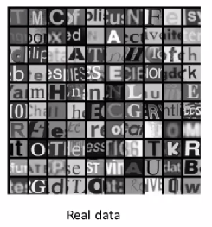
* How can we amplify this
  + Modern computers often have a big font library
  + If you go to websites, huge free font libraries
  + For more training data, take characters from different fonts, paste these characters again random backgrounds
* After some work, can build a synthetic training set   
  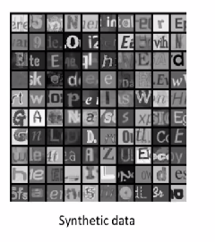
  + Random background
  + Maybe some blurring/distortion filters
  + Takes thought and work to make it look realistic
    - If you do a sloppy job this won't help!
    - So unlimited supply of training examples
  + This is an example of creating new data from scratch
* Other way is to introduce distortion into existing data
  + e.g. take a character and warp it  
    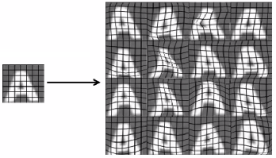
    - 16 new examples
    - Allows you amplify existing training set
  + This, again, takes though and insight in terms of deciding how to amplify

**Another example: speech recognition**

* Learn from audio clip - what were the words
  + Have a labeled training example
  + Introduce audio distortions into the examples
* So only took one example
  + Created lots of new ones!
* When introducing distortion, they should be reasonable relative to the issues your classifier may encounter

**Getting more data**

* Before creating new data, make sure you have a low bias classifier
  + Plot learning curve
* If not a low bias classifier increase number of features
  + Then create large artificial training set
* Very important question: How much work would it be to get 10x data as we currently have?
  + Often the answer is, "Not that hard"
  + This is often a huge way to improve an algorithm
  + Good question to ask yourself or ask the team
* How many minutes/hours does it take to get a certain number of examples
  + Say we have 1000 examples
  + 10 seconds to label an example
  + So we need another 9000 - 90000 seconds
  + Comes to a few days (25 hours!)
* Crowd sourcing is also a good way to get data
  + Risk or reliability issues
  + Cost
  + Example
    - E.g. Amazon mechanical turks

**Ceiling analysis: What part of the pipeline to work on next**

* Through the course repeatedly said one of the most valuable resources is developer time
  + Pick the right thing for you and your team to work on
  + Avoid spending a lot of time to realize the work was pointless in terms of enhancing performance

**Photo OCR pipeline**

* Three modules
  + Each one could have a small team on it
  + Where should you allocate resources?
* Good to have a single real number as an evaluation metric
  + So, character accuracy for this example
  + Find that our test set has 72% accuracy

**Ceiling analysis on our pipeline**

* We go to the first module
  + Mess around with the test set - manually tell the algorithm where the text is
  + Simulate if your text detection system was 100% accurate
    - So we're feeding the character segmentation module with 100% accurate data now
  + How does this change the accuracy of the overall system  
    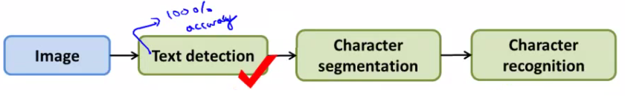
  + Accuracy goes up to 89%
* Next do the same for the character segmentation
  + Accuracy goes up to 90% now
* Finally doe the same for character recognition
  + Goes up to 100%
* Having done this we can qualitatively show what the upside to improving each module would be
  + Perfect text detection improves accuracy by 17%!
    - Would bring the biggest gain if we could improve
  + Perfect character segmentation would improve it by 1%
    - Not worth working on
  + Perfect character recognition would improve it by 10%
    - Might be worth working on, depends if it looks easy or not
* The "ceiling" is that each module has a ceiling by which making it perfect would improve the system overall

**Other example - face recognition**

* NB this is not how it's done in practice  
  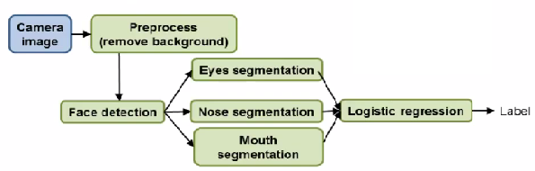
  + Probably more complicated than is used in practice
* How would you do ceiling analysis for this
  + Overall system is 85%
  + Perfect background -> 85.1%
    - Not a crucial step
  + + Perfect face detection -> 91%
    - Most important module to focus on
  + + Perfect eyes ->95%
  + + Perfect Nose -> 96%
  + + Perfect Mouth -> 97%
  + + Perfect logistic regression -> 100%
* Cautionary tale
  + Two engineers spent 18 months improving background pre-processing
    - Turns out had no impact on overall performance
    - Could have saved three years of man power if they'd done ceiling analysis