Name: John Stephen Gutam
Email: jgutam@gmu.edu

Robust Estimation and panorama stitching
Part-1: Homography estimation
- The solution follows a typical pipeline for image stitching:
- Feature Extraction: The code uses the SIFT algorithm for feature extraction and descriptor calculation. It detects key points in images and computes descriptors that represent the appearance of these key points.
- Putative Matching: Then the code calculates pairwise distances between descriptors to find putative matches. The cdist function from ‘scipy.spatial.distance’ is used to compute the Euclidean distance between pairs of descriptors.
- RANSAC for Homography estimation: RANSAC estimates the homography matrix that aligns one image with the other. In each iteration of RANSAC, four random matches are sampled to estimate a candidate homography. Then the no. of inliers is counted by applying the estimated homography to all putative matches and checking if the transformed points lie within a certain threshold distance from their corresponding points in the other image. The homography with the largest number of inliers is chosen as the best estimate.

- For the given image the number of inliers and average residual are

Number of inliers: 107
Average residual: 1.4440694
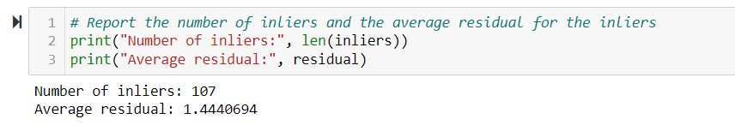
The location of Inlier matches in both images:

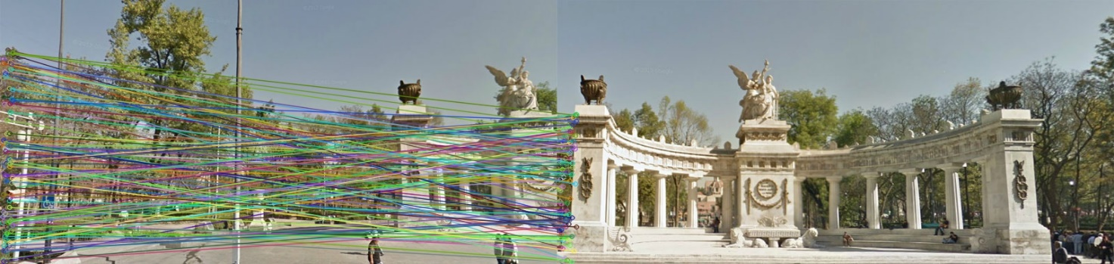

- Final result of my stitching image.
