Name: John Stephen Gutam
Email: jgutam@gmu.edu

Fundamental Matrix Estimation and Camera Calibration
Part 1: Fundamental matrix estimation

- Normalized algorithm
Points and epi-polar lines for the fundamental matrix for normalized algorithms.
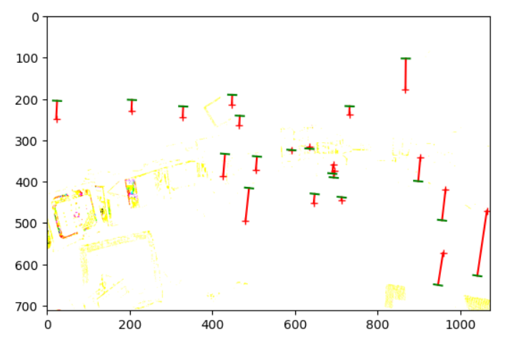
Residual for normalized: 3125.5062959537036

- Unnormalized algorithm:
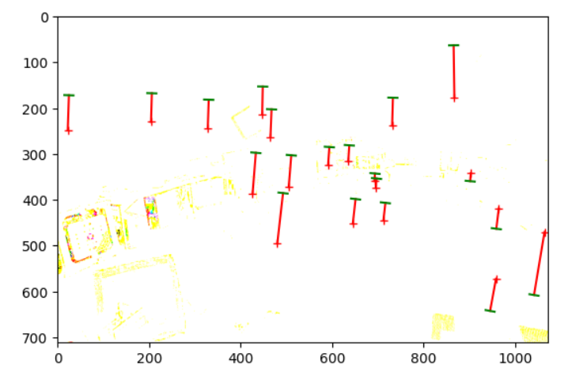
Residual for unnormalized: 4866.075470062337

Part 2: Camera calibration

The projection matrix residual using the residuals:
Projection Matrix 1 Residual: 13.54583289329173
Projection Matrix 2 Residual: 15.544953452595896

