BARBER SHOP
BOOKING SYSTEM
Project Proposal and System Documentation
Proposal • Database ERD • Text-Based Wireframes

Prepared for academic project planning

1. Project Overview
Project Title: Barber Shop Booking System
Client: A local barber shop (the specific shop name should be confirmed with the owner before final submission).
Technology: React for the frontend, Laravel REST API for the backend, MySQL for the database, and Laravel Sanctum for API authentication.
Main Purpose: To provide a central online place where customers can view barber shop services, choose a barber and available appointment time, submit a booking request, and check booking status. Staff can manage services, barber profiles, availability, and appointment schedules.
Problem Statement: Appointment details can be difficult to manage when bookings are handled through walk-ins, phone calls, or chat messages. Customers may also arrive late or fail to attend at the date and time they booked. This can leave gaps in the barber’s schedule, waste available time slots, and inconvenience other customers. The selected barber shop must confirm which of these issues it actually experiences before final submission.
User Roles: Admin/Staff: manage barber profiles and services, maintain availability, review and update appointments, and view the schedule. Customer: create an account, browse services and barbers, request an appointment, view booking status, and cancel a booking according to shop policy.
Main Database Entities: Users, Barbers, Services, and Appointments.
Basic Relationships: One customer can have many appointments. One barber can be assigned many appointments. One service can be selected for many appointments. Each appointment is linked to one customer, one barber, and one service.
Planned Features: Registration and login; role-based access; service and barber listings; appointment booking; appointment status tracking; staff appointment management; search and filtering; schedule conflict validation; No-show tracking; cancellation and rescheduling according to shop policy; dashboard summaries; and input validation. Appointment reminders may be added if time and available services allow.

2. System Scope
Customer functions: Register and sign in; browse available services and barbers; select a service, barber, date, and available time; submit an appointment request; view upcoming and past appointments; and cancel when allowed.
Admin/Staff functions: View the appointment dashboard; search and filter appointments; add, edit, or disable services; manage barber profiles and availability; confirm or reject requests; mark appointments as completed, cancelled, or No-show; and manage the schedule.
Booking status workflow: A customer submits a request. The request is saved as Pending or Confirmed depending on the shop's agreed process. Staff can confirm or reject it. Completed appointments are marked after the service. Cancellation rules should be agreed with the client.

3. Main Database Entities
Users: Stores account information and role (Admin/Staff or Customer).
Barbers: Stores barber profile information and availability details.
Services: Stores service name, description, duration, price, and active/inactive status.
Appointments: Stores customer, barber, service, appointment date/time, notes if needed, booking status, and relevant timestamps for tracking appointment changes.

4. Entity Relationship Diagram (ERD)
The ERD image below is included as the database design reference. Review entity names, fields, and relationship cardinalities against the final Laravel migrations before implementation or submission.
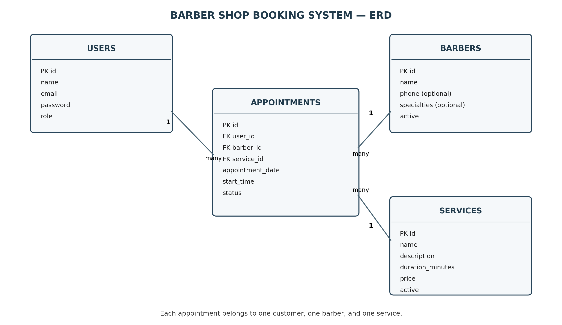
Figure 1. Entity Relationship Diagram for the Barber Shop Booking System.

5. Text-Based Wireframes
These are text-only layout sketches, not screenshots or image mockups. Counts and sample rows are placeholders to demonstrate layout, not real shop data.

Relationship Summary
- Users (Customer) 1 ─── many Appointments
- Barbers 1 ─────────── many Appointments
- Services 1 ────────── many Appointments
- Each Appointment references one User, one Barber, and one Service.

5.1 Login / Register
[ BARBER SHOP BOOKING SYSTEM ]
Email: [________________________________]
Password: [________________________________]
[ Log In ] [ Create Account ]
[ Forgot password? ]

5.2 Customer Dashboard
[ Barber Shop ] Dashboard | Services | Barbers | My Appointments | Logout
[ Upcoming appointments: 2 ] [ Pending: 1 ] [ Completed: 5 ]
[ + Book an Appointment ]
Upcoming appointments
Date | Time | Barber | Service | Status | Action
-----------|-------|--------------|----------|-----------|---------
2026-10-15 | 10:00 | Sample barber| Haircut | Confirmed | [ View ]
2026-10-18 | 14:30 | Sample barber| Beard trim| Pending | [ View ]

5.3 Browse Services
[ Services ] Dashboard | Services | Barbers | My Appointments | Logout
Search services: [___________________________] [ Search ]
Service | Duration | Price | Description | Action
--------------|----------|-------|-------------------|---------
Haircut | 30 min | ₱--- | Standard haircut | [ Book ]
Beard trim | 20 min | ₱--- | Beard grooming | [ Book ]
[ Previous ] [ 1 ] [ 2 ] [ Next ]

5.4 Book an Appointment
[ BOOK AN APPOINTMENT ]
Service: [ Select service v ]
Barber: [ Select barber v ]
Date: [ Choose date ]
Available time: [ 10:00 ] [ 10:30 ] [ 11:00 ] [ 11:30 ]
Notes (optional): [_____________________________________]
[ Confirm Booking ] [ Cancel ]

5.5 My Appointments
[ MY APPOINTMENTS ]
Search: [________________] Status: [ All v ] Date: [________] [ Filter ]
Date | Time | Service | Barber | Status | Action
-----------|-------|-----------|--------|-----------|----------------
2026-10-15 | 10:00 | Haircut | Alex | Confirmed | [ View ] [ Cancel ]
2026-10-18 | 14:30 | Beard trim| Sam | Pending | [ View ] [ Cancel ]
[ Previous ] [ 1 ] [ 2 ] [ Next ]

5.6 Admin / Staff Dashboard
[ BARBER SHOP ADMIN ] Dashboard | Appointments | Services | Barbers | Logout
[ Today's bookings: 8 ] [ Pending requests: 3 ] [ Completed: 12 ]
Appointment schedule (staff can mark missed bookings as No-show after the agreed grace period)
[ Search __________ ] [ Date filter v ] [ Status filter v ] [ Apply ]
Date | Time | Customer | Barber | Service | Status | Action
------|------|----------|--------|---------|---------|----------------
... | ... | ... | ... | ... | Pending | [ Confirm ] [ Reject ]

5.7 Manage Services
[ MANAGE SERVICES ] [ + Add Service ]
Search: [______________________________________________]
Service | Duration | Price | Status | Actions
-----------|----------|-------|--------|----------------
Haircut | 30 min | ₱--- | Active | [ Edit ] [ Disable ]
Beard trim | 20 min | ₱--- | Active | [ Edit ] [ Disable ]
[ Previous ] [ 1 ] [ 2 ] [ Next ]

5.8 Manage Barbers
[ MANAGE BARBERS ] [ + Add Barber ]
Search: [______________________________________________]
Barber | Specialties | Working days | Availability | Actions
-------|-------------|--------------|--------------|----------------
... | ... | ... | Available | [ Edit ] [ Disable ]
[ Previous ] [ 1 ] [ 2 ] [ Next ]

6. Main Booking Workflow
- Customer signs in and chooses a service.
- Customer chooses a barber, date, and available time slot.
- The system validates the request and checks for overlapping confirmed appointments for the same barber.
- The appointment is saved with the agreed initial status (for example, Pending).
- Admin/Staff reviews the request, confirms or rejects it, and updates the status after the service.
- Customer checks the latest status in My Appointments. If the customer does not arrive, staff follows the shop’s agreed grace-period policy and records the appointment as No-show when appropriate.
Missed-appointment handling: The system records a No-show status only after the barber shop’s agreed waiting period. The system should not automatically penalize customers unless the shop defines and approves a clear policy.

7. Validation and Testing Considerations
- Required fields and invalid dates/times are rejected with clear feedback.
- Customers can only view or change their own appointments.
- Admin/Staff-only operations are protected by backend authorization.
- Overlapping confirmed bookings for the same barber are rejected.
- Search, filters, pagination, and dashboard totals use saved database records.
- Appointment status changes follow the workflow agreed with the client, including the waiting period for No-show decisions.

8. Assumptions and Items to Confirm
- Confirm the actual barber shop/client name and obtain feedback from the owner or staff.
- Confirm shop opening hours, barber working schedules, service prices and durations.
- Agree on booking rules, cancellation deadlines, whether requests start as Pending or Confirmed, and the grace period before staff can mark a booking as No-show.
- Verify the ERD matches the final database migrations and model relationships.
- Dashboard figures and sample appointment rows in the wireframes are illustrative placeholders, not real data.

9. Technology Summary
- Frontend: React
- Backend: Laravel REST API
- Database: MySQL
- Authentication: Laravel Sanctum
- Development tools: Visual Studio Code and local PHP/MySQL environment

