The Certificate

Introduction:
How do you know that you are dealing with the right person or rather the trusted web site?
By the Secure Certificates, this provides security for your website by encrypting communications between the server and the person visiting the website. A certificate contains the information about Certificate ID, owner of the Certificate, email address, duration of validity and other information.
Applications which are used in your system are approved CA (Certificate authorities) to provide secure certificate. Each application has its own Certificates. For example, secure transactions between web servers and browsers.
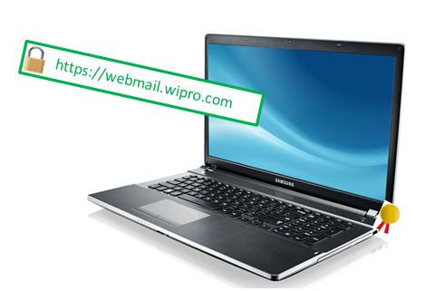Certificates can be used for:
- Authentication, which verifies the identity of someone or something.
- Privacy, which ensures that information, is only available to the intended audience.
- Encryption, which disguises information so that unauthorized readers are unable to decipher it.
- Digital signatures, which provide nonrepudiation and message integrity.
These services can be important to the security of your communications. In addition, many applications use certificates, such as e-mail applications and Web browsers.
Why Standards?
The purpose of this standard is to define how certificates are to be used to confirm identity, secure communications between devices, and ensure the integrity of transmissions. Different types of standards used.
Standards | Purpose
X.500 | It is a series of computer networking standards covering electronic directory services.
X.509 | Public key Certification -Standard provided for an authentication framework, widely used.
X.520 and X.521 | X.520 and X.521 together provide a definition of a set of attributes and object classes to be used for representing people and organizations as entries in the Directory Information Tree.
Certificate X.509:
X.509 is an ITU-T standard for a public key infrastructure and Privilege Management Infrastructure. X.509 specifies, amongst other things, standard formats for public key certificates, certificate revocation lists, attribute certificates, and a certification path validation algorithm. It is almost used in cryptography for encryption.
Structure of the Certificate
A certificate contains information about the owner of the certificate, like e-mail address, owner's name, certificate usage, duration of validity, resource location or Distinguished Name (DN) which includes the Common Name (CN) and the certificate ID of the person who certifies (signs) this information. It contains also the public key and finally a hash to ensure that the certificate has not been tampered with. This is a certificate trust tree or certificate path. Usually your browser or application has already loaded the root certificate of well-known Certification Authorities (CA) or root CA Certificates. The CA maintains a list of all signed certificates as well as a list of revoked certificates. A certificate is insecure until it is signed, as only a signed certificate cannot be modified. You can sign a certificate using itself.

Syntax
Certificate
Version
Serial Number
Algorithm ID
Issuer
Validity
Not Before
Not After
Subject
Subject Public Key Info
Public Key Algorithm
Subject Public Key
Issuer Unique Identifier (optional)
Subject Unique Identifier (optional)
Extensions (optional)
Certificate Signature Algorithm
Certificate Signature

Structure of the Certificate

Certificate:
Data:
Version: 3 (0x2)
Serial Number: 16 2f 63 e6 00 00 00 00 2f 49
Signature Algorithm: sha1RSA
Issuer: C=FJ, ST=Fiji, L=Suva, O=SOPAC, OU=ICT, CN= webmail.wipro.com Root CA/Email=Wipro Class 1 Enterprise CA
Validity
Not Before: ‎Wednesday, ‎March ‎12, ‎2014 9:21:23 PM
Not After : ‎Tuesday, ‎May ‎31, ‎2016 6:12:21 PM
Subject: C=FJ, ST=Fiji, L=Suva, O=SOPAC, OU=ICT, CN=webmail.wipro.com
Subject Public Key Info:
Public Key Algorithm: rsaEncryption
RSA Public Key: (1024 bit)
Modulus (1024 bit):
30 82 01 0a 02 82 01 01 00 b0 30 2e e5 6a 01 ee 58 62 d3 47 d0 1e 6a 1f 76 97 a5 e4 38 9e 67 0f 10 eb 7d 77 da 9e da a1 26 75 96 aa 52 9e d0 8a fd 3e aa c5 99 01 46 21 38 9f cc 8a c7 d0 55 17 de 2c 19 61 3b d6 98 49 fb a1 41 c0 71 28 0a 8d 17 aa 2c 55 af 61 15 6a ……
Exponent: 65537 (0x10001)
X509v3 extensions:
X509v3 Basic Constraints:
CA:FALSE
Netscape Comment:
OpenSSL Generated Certificate
X509v3 Subject Key Identifier:
FE:04:46:ED:A0:15:BE:C1:4B:59:03:F8:2D:0D:ED:2A:E0:ED:F9:2F
X509v3 Authority Key Identifier:
keyid:E6:12:7C:3D:A1:02:E5:BA:1F:DA:9E:37:BE:E3:45:3E:9B:AE:E5:A6
DirName:/C=FJ/ST=Fiji/L=Suva/O=SOPAC/OU=ICT/CN= webmail.wipro.com Root CA/Email= Wipro Class 1 Enterprise CA
serial:00
Signature Algorithm: sha1RSA
34:8d:fb:65:0b:85:5b:e2:44:09:f0:55:31:3b:29:2b:f4:fd:
aa:5f:db:b8:11:1a:c6:ab:33:67:59:c1:04:de:34:df:08:57:
2e:c6:60:dc:f7:d4:e2:f1:73:97:57:23:50:02:63:fc:78:96:
34:b3:ca:c4:1b:c5:4c:c8:16:69:bb:9c:4a:7e:00:19:48:62:
e2:51:ab:3a:fa:fd:88:cd:e0:9d:ef:67:50:da:fe:4b:13:c5:
0c:8c:fc:ad:6e:b5:ee:40:e3:fd:34:10:9f:ad:34:bd:db:06:
ed:09:3d:f2:a6:81:22:63:16:dc:ae:33:0c:70:fd:0a:6c:af:
bc:5a
-----BEGIN CERTIFICATE-----
MIIDoTCCAwqgAwIBAgIBATANBgkqhkiG9w0BAQQFADCBiTELMAkGA1UEBhMCRkox
DTALBgNVBAgTBEZpamkxDTALBgNVBAcTBFN1dmExDjAMBgNVBAoTBVNPUEFDMQww
2HXEb1qYSvn49zgk/L2UJDer8RzYke77G5+IuiXa9iF/BDI1Fz02HPu3Mp5Cr3e2
Bu0JPfKmgSJjFtyuMwxw/Qpsr7xa
-----END CERTIFICATE-----

The certificate contains the reference to the issuer, the public key of the owner of this certificate, the dates of validity of this certificate and the signature of the certificate to ensure this certificate hasn’t been tampered with. The certificate does not contain the private key as it should never be transmitted in any form whatsoever. This certificate has all the elements to send an encrypted message to the owner (using the public key) or to verify a message signed by the author of this certificate.
Relationship between ISO model and Certificates:
OSI is a conceptual model that characterizes and standardizes the internal functions of a communication system by defining 7 layers physical layer , data link layer, network layer, transport layer, session layer, presentation layer and application layer.
Among these layers security provided in transport layer with the help of SSL while transferring the information. SSL is the basis for the Internet standard protocol.
SSL Hand Shake Protocol
SSL Record protocol

TCP
IP
SSL Change Cipher Spec protocol
SSL Alert protocol

HTTP
SSL Architecture - Provides a basis for secure communication Confidentiality + Message authenticity

SSL certificate, for implementing SSL security over the transport layer, can be obtained from a Certificate Authority. CA is an entity that issues digital certificates. The digital certificate certifies the ownership of a public key by the named subject of the certificate. Examples of CA Providers Symantec, Comodo Group , Go Daddy and GlobalSign .

What is an SSL Certificate?
SSL Certificates are small data files that digitally bind a cryptographic key to an organization’s details. When installed on a web server, it activates the padlock and the https protocol and allows secure connections from a web server to a browser. Typically, SSL is used to secure credit card transactions, data transfer and logins, and more recently is becoming the norm when securing browsing of social media sites. SSL Certificates bind together:
- A domain name, server name or hostname
- An organizational identity (i.e. company name) and location
An organization needs to install the SSL Certificate onto its web server to initiate secure sessions with browsers.
SSL V3.0 and TLS are widely used in the transport layer. SSL1.0/2.0 was used early which considered as unsecured. SSLv3 and TLSv1.0 are very similar, but have a few differences.
The main difference is that, while SSL connections begin with security and proceed directly to secured communications, TLS connections first begin with an insecure “hello” to the server and only switch to secured communications after the handshake between the client and the server is successful. If the TLS handshake fails for any reason, the connection is never created. Ad-hoc MAC’s were changed to HMAC’s
Where to see Certificate loaded in browser:
The padlock is activated, showing you that the browser connection to the server is now secure.
To view the details of an SSL Certificate, go to a secure site, click on the padlock and select “View Certificate”.
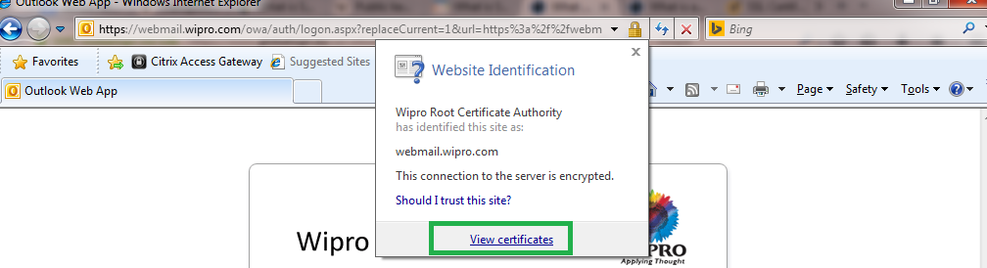

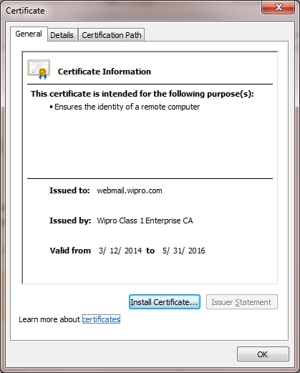
To view the actual contents of the certificate click the "Details" tab:
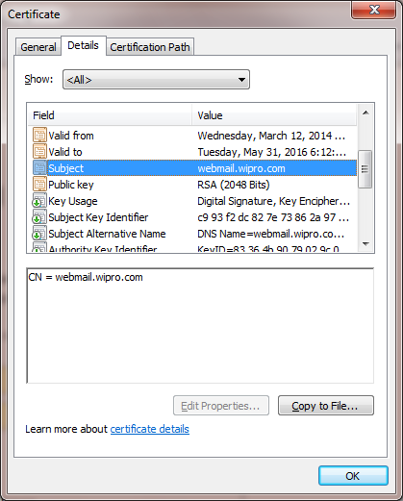

Why is the Root Certificate important?
SSL Certificates need to be issued from a trusted Certificate Authority's Root Certificate, and preferably by a 2048 bit Certificate that's widely distributed. The Root Certificate must be present on the end user's machine in order for the Certificate to be trusted. If it is not trusted the browser will present untrusted error messages to the end user. E.g., in e-commerce, such error messages result in immediate lack of confidence in the website and organizations risk losing confidence and business from the majority of consumers.
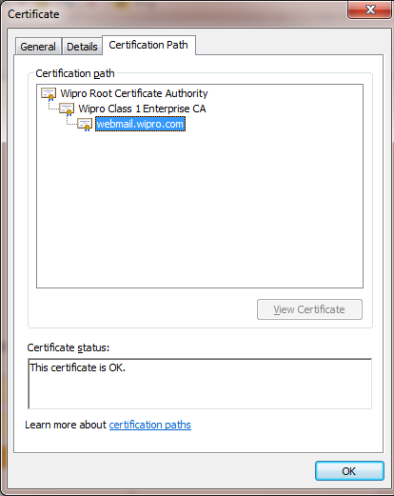
How transactions happen between web servers and browsers using SSL?
The Secure Socket Layer protocol was created by Netscape to ensure secure transactions between web servers and browsers. The protocol uses a third party, a Certificate Authority (CA), to identify one end or both end of the transactions.
- A browser requests a secure page (usually https://).
- The web server sends its public key with its certificate.
- The browser checks that the certificate was issued by a trusted party (usually a trusted root CA), that the certificate is still valid and that the certificate is related to the site contacted.
- The browser then uses the public key, to encrypt a random symmetric encryption key and sends it to the server with the encrypted URL required as well as other encrypted http data.
- The web server decrypts the symmetric encryption key using its private key and uses the symmetric key to decrypt the URL and http data.
- The web server sends back the requested html document and http data encrypted with the symmetric key.
- The browser decrypts the http data and html document using the symmetric key and displays the information.
View/Manage certificates available in Windows7 OS:
- You must be logged on as an administrator to perform these steps.
- Open the certificate manager to view the certificate.
- Step1: Click on the search button
- Step2: Type “certmgr.msc” in the search box and Press the enter key.
- You can use Certificate Manager to view details about your certificates, modify, delete.
- You can also import or export the certificates.

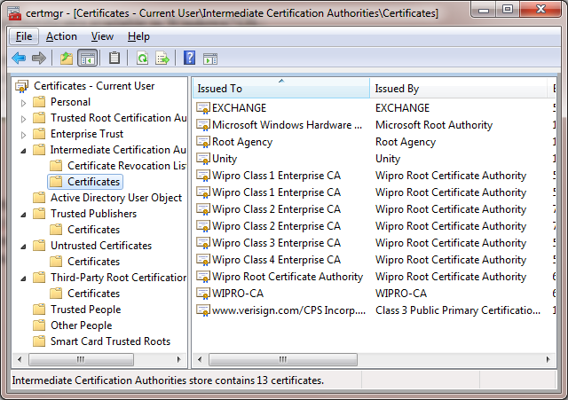
Certificate Manager

Appendix:
Certificates are approved by the Certificate Authority. Which is a digital signature provides Authentication, Privacy and Encryption. Different types of algorithms used for encryption and decryption. Encryption disguises information so that unauthorized readers are unable to tamper the information.
Algorithms used:
- Encryption – AES, Triple-DES and CAST5.
- Key Establishment – RSA
- Digital Signature – RSA and Digital Signature Algorithm
- Hash – SHA-224, SHA-256, SHA-384 and SHA-512
Public Key and Private Key:
In public key encryption, two different keys are used to encrypt and decrypt information. The private key is a key that is known only to its owner, while the public key can be made known and available to other entities on the network.
The two keys are different but complementary in function. For example, a user's public key can be published within a certificate in a folder so that it is accessible to other people in the organization. The sender of a message can retrieve the user's certificate from Active Directory Domain Services, obtain the public key from the certificate, and then encrypt the message by using the recipient's public key. Information that is encrypted with the public key can be decrypted only by using the corresponding private key of the set, which remains with its owner, the recipient of the message.
Message-->[Public Key]-->Encrypted Message-->[Private Key]-->Message

Symmetric Encryption
Symmetric encryption is the oldest and best-known technique. A secret key, which can be a number, a word, or just a string of random letters, is applied to the text of a message to change the content in a particular way. This might be as simple as shifting each letter by a number of places in the alphabet. As long as both sender and recipient know the secret key, they can encrypt and decrypt all messages that use this key.

Asymmetric Encryption
The problem with secret keys is exchanging them over the Internet or a large network while preventing them from falling into the wrong hands. Anyone who knows the secret key can decrypt the message. One answer is asymmetric encryption, in which there are two related keys-a key pair. A public key is made freely available to anyone who might want to send you a message. A second, private key is kept secret, so that only you know it.
Any message that is encrypted by using the public key can only be decrypted by applying the same algorithm, but by using the matching private key. Any message that is encrypted by using the private key can only be decrypted by using the matching public key.

