Last Name: __________________________ First Name: _____________________________
Lab 1: Looking at Data: Distributions
Write your name, class section, lab title, and date. Print out commands and outputs. Make sure to answer all parts of each question. Print outs may be in black and white even if some figures are in color.

For questions 1-3, Import the data set “grades” into R-Studios from the following URL: http://mathfaculty.fullerton.edu/sbehseta/grades.txt
Don’t forget to attach it!!

This will generate a data frame of size 100 x 3 called “grades” in R-Studios for you. Rows are students, and columns represent the Verbal SAT score, the Math SAT score, and the GPA for each student.

1. Create histograms for the three variables of interest. Color each histogram with a different color. You may add a title to the histograms if you like.

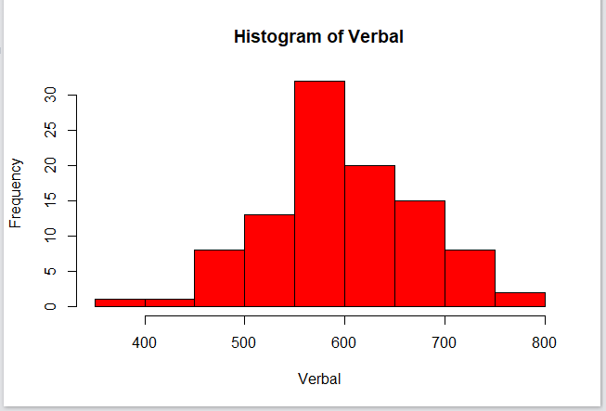
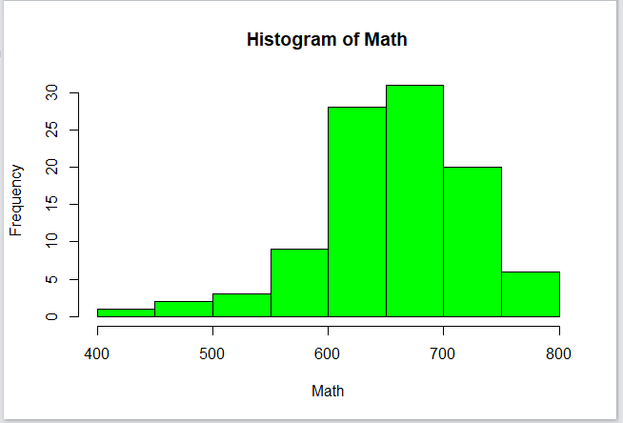
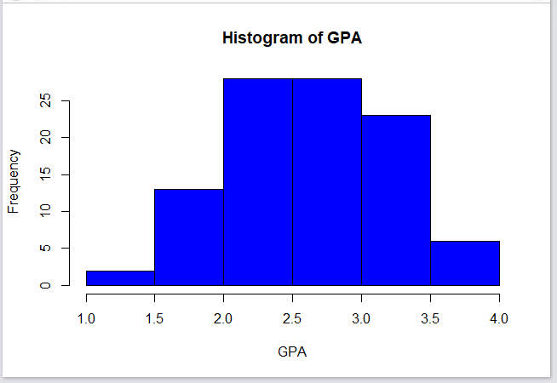
2. Calculate the min, the max, the mean, the median, first quartile, third quartile, and the standard deviation of each variable.

Verbal:
Min. 1st Qu. Median Mean 3rd Qu. Max. Standard Deviation
361.0 552.0 592.5 598.5 649.8 752.0 76.02917
Math:
Min. 1st Qu. Median Mean 3rd Qu. Max. Standard Deviation
441.0 611.0 662.5 654.1 701.0 800.0 65.63103
GPA:
Min. 1st Qu. Median Mean 3rd Qu. Max. Standard Deviation
1.200 2.300 2.750 2.706 3.125 3.900 0.56797
3. Report your findings in detail. Compare the verbal scores with the math scores by creating side-by-side boxplots. Comment on the symmetry (shape), measures of centrality, measures of spread, and any suspected outliers (giving values if any).
There are 2 outliers in the Math section with values between 400 and 500, and 1 outlier in the Verbal section with value below 400. The symmetry for Verbal is skewed to left and Math is symmetrical. The centrality for Verbal is close to 600 and above 650 for Math. For the spread, excluding the outliers, Math has a range of about 300 whereas Verbal is approximately 350.
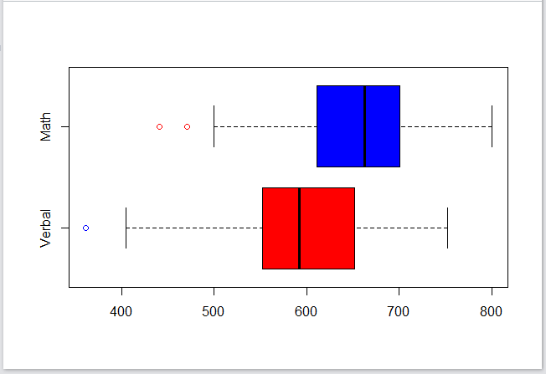
*********************** Rstudio Code goes Here *******************************
# reads in RStudios
library(readr)
grades <- read_delim("http://mathfaculty.fullerton.edu/sbehseta/grades.txt",
"\t", escape_double = FALSE, trim_ws = TRUE)
view(grades)
attach(grades)

hist(Verbal, col='red')
hist(Math, col='green')
hist(GPA, col='blue')

summary(Verbal)
sd(Verbal)
summary(Math)
sd(Math)
summary(GPA)
sd(GPA)

boxplot(Verbal, Math, col = c("Red", "Blue"), outcol = c("Blue", "Red"),
names = c("Verbal", "Math"), horizontal = TRUE)

