**Last Name: __________________________ First Name: ____________________**_____________________

# Tossing a coin

The probability of getting a Heads or a Tails on a coin toss is both 0.5. We can use **R** to simulate an experiment of flipping a coin several times and compare our results with the theoretical probability. First let fix the convention:

**0 = Tails and 1 = Heads**

We can use the following command to tell **R** to flip a coin 15 times:

> sample(0:1,15,rep=T)

[1] 1 1 0 1 0 1 1 1 0 0 0 1 1 1 0

This gives 6 Tails and 9 heads. In fact we can write a function to flip a coin *n* times:

> FlipCoin = function(n) sample(0:1,n,rep=T)

> e1=FlipCoin(30)

> e1

[1] 0 1 1 0 1 1 0 1 0 1 1 1 0 0 1 0 1 0 1 1 1 1 0 1 0 0 0 0 0 1

Now we can use the sum command to compare the results from this experiment to the theoretical probabilities. For example in the above experiment of flipping a coin 30 times, we can count the heads and tails as:

> sum(e1==0)

[1] 14

> sum(e1==0)/30

[1] 0.4666667

> sum(e1==1)

[1] 16

> sum(e1==1)/30

[1] 0.5333333

This gives us 14 Tails and 16 Heads. The “probability” or relative frequency of a Tail in this experiment is 0.467 and a Head is 0.533. **Note that you may get different answers**. We can plot a **relative** histogram using the command:

> hist(e1,breaks=c(-0.5,0.5,1.5), prob=T)

# Questions

1. Use **R** to simulate an experiment of tossing a coin 100 times. Print the histogram as above.

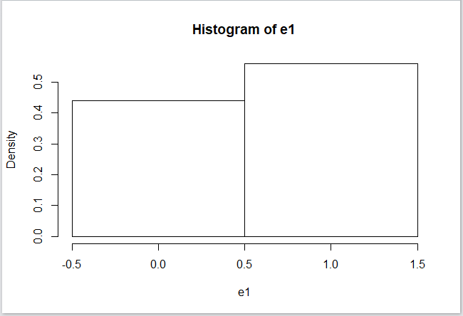

1. Find the relative frequency of a Tail and Head in your experiment and fill in the table on the next page.
2. Repeat 2 for tossing a coin 500 times (do not print histogram).

# Rolling dice

The probability of getting a number between 1 to 6 on a roll of a die is 1*/*6 = 0*.*1666667. As above we can use **R** to simulate an experiment of rolling a die a number of times and compare our results with the theoretical probability. We can use the following command to tell **R** to roll a die 20 times:

> sample(1:6,20,rep=T)

[1] 3 3 4 1 1 2 2 5 1 2 4 4 3 2 1 5 2 6 5 2

As before we can write a function to roll a die *n* times:

> RollDie = function(n) sample(1:6,n,rep=T)

> d1=RollDie(50)

> d1

[1] 3 4 5 5 6 5 1 6 3 3 1 3 5 4 4 3 2 1 5 2 1 1 2 2 3 1 6 2 6 1 5 1 4 1 4 4 4 6

[39] 2 1 5 5 2 6 1 3 6 3 1 6

Now we can use the sum command to compare the results from this experiment to the theoretical probabilities. For example, in the above experiment the number of 3’s and its relative frequency is:

> sum(d1==3)

[1] 8

> sum(d1==3)/50

[1] 0.16

The number 3 occurs 8 times and its relative frequency is 0*.*16 which is quite close to 1*/*6. **Note that you may get different answers**. We can plot a **relative** histogram using the command:

> hist(d1,breaks=c(0.5,1.5,2.5,3.5,4.5,5.5,6.5), prob=T)

# Questions

1. Use **R** to simulate an experiment of rolling a die 200 times. Print the relative histogram and write your name on it.

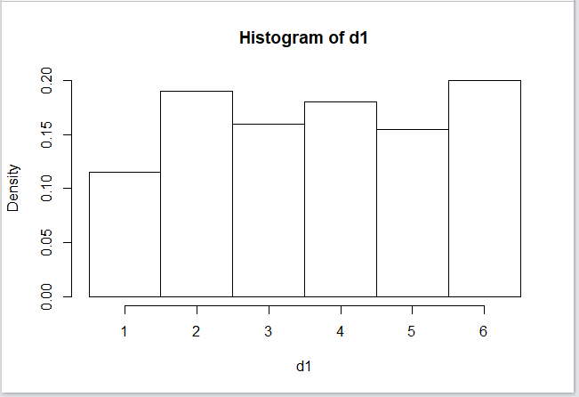

1. Find the relative frequency of the numbers 1 to 6 in your experiment and fill in the table on the next page.
2. Repeat 2 for rolling a die 1000 times (do not print histogram).

# To Hand in

Fill in the next sheet with answers to above questions and hand it in along with one histograms each for “coin toss” and “rolling a die” with your name on it.

# Lab Project 4

# Coin Toss

|  |  |  |
| --- | --- | --- |
|  | 100 tosses | 500 tosses |
| Relative Frequency of Heads | 0.56 | 0.47 |
| Relative Frequency of Tails | 0.44 | 0.53 |

# Rolling Dice

|  |  |  |
| --- | --- | --- |
|  | 200 rolls | 1000 rolls |
| Relative Frequency of 1 | 0.115 | 0.158 |
| Relative Frequency of 2 | 0.19 | 0.186 |
| Relative Frequency of 3 | 0.16 | 0.164 |
| Relative Frequency of 4 | 0.18 | 0.152 |
| Relative Frequency of 5 | 0.155 | 0.161 |
| Relative Frequency of 6 | 0.2 | 0.179 |