**Name: John Terry Mbomeh**

**Senegambia**

**Banjul**

**Gambia**

**Contact: +220-200 4699/271 4750/3854903**

**Email:** [jterrymbomeh@gmail.com](mailto:jterrymbomeh@gmail.com)

**What Sapp: +220-200 4699**

**Employment History:**

|  |  |
| --- | --- |
| **Duration of my employment**  **(2018-2019)** | Position: Head of Photocopy departmentName of organization: Glory to Glory **Key roles and responsibilities:**   * Ensures that all machines are working correctly in order * Weekly maintenance of machines |
| **Duration of my employment (2018 to 2019)** | **Position: Logistics and Procurement Officer**  **Name of organization: God’s Choice Technologies Computer Training Institute**  **Key roles and responsibilities**   * + Procuring machines every two (2) weeks per month   + Ensures that all machine are working correctly in order   + Always maintaining the computer lab in order   + Procuring stationary materials/items in whole sales |
| **Duration of my employment (2018 to 2019)** | **Position: Registrar**  **Name of organization: God’s Choice Technologies Computer Training Institute**  **Key roles and responsibilities:**   * Taking data base information for each students * Storing payment records of each student * Taking information of staff payment * Establish and maintain a comfortable and inclusive materials for students * Provide facilitators with regular, scheduled meetings with a designated person, such as a lecture, religious educator, and student president, to evaluate how the institution is going and to continue developing facilitation skills. |
| **Duration of my employment (2018 to 2019)** | **Position: Finical Secretary Officer**  **Name of organization: Rogbangba Progressive Youth Organization**  **Key roles and responsibilities**   * Taking care of monetary issue * Ensures that to put things in place for any monetary programs |
| **Duration of my employment (2018 to 2019)** | **Position: Marketing Officer**  **Name of organization: God’s Choice Technologies Computer Training Institute**  **Key roles and responsibilities:**   * Going out and talk to customers how they can reach to the institute * Having house to house campaign telling every good aspect about the institution |
| **Duration of my employment (2019 to 2020** | **Position: ADMIN**  **Name of organization: God`s Choice Technologies Computer Training Institute**  **Key roles and responsibilities:**   * To ensures that all student`s fees are to be collected before or during the examination progress. * To put all student’s affairs in place * Working as the assistance principal in the organization/school etc. |
| **Duration of my employment (2020 to 2021** | **Position: Desktop Publisher**  **Name of organization: Modern Technology Computer Training Institute**  **Key roles and responsibilities:**   * To give/delivery the best satisfaction to customers * To design, prepared and print documents |
| **Duration of my employment (2020 to 2021** | **Position: ICT Lecturer**  **Name of organization: Modern Technology Computer Training Institute**  **Key roles and responsibilities:**   * To give/delivery the best satisfaction to student * To ensure that student will go out with the best quality in term of ICT |
| **Duration of my employment (2022 to 2023)** | **Position: Class Room Teacher**  **Name of organization: Leaders Academy School**  **Key roles and responsibilities:**   * To give/delivery the best satisfaction to pupils * To ensure that pupils should understand 85-95% of what the teacher has though before leaving the classroom * Passing information to pupils during classes most be skillful and should be well understood by the pupils |

**Educational Background:**

* **2014-2015**
* Natural Keyboard Entertainment School

# Certificate in piano (key-board)

* **2018-2019**
* **Certificate of best student of the year**

# 2018-2019

* **God`s Choice Technology Computer Training School**

# Certificate in Microsoft package

* Statement of Result
* **2019-2020**
* **Certificate in Graphics Design**
* **2019-2020**
* **Certificate in Microsoft Package Teaching Course**
* **2019-2020**
* **Certificate in Computer Hardware Course**
* **2020-2021**
* **Diploma in Microsoft package**

Other Professional Experiences

Photography

Video editor

Piano playing

Social media marketing etc.

**Referees:**

**Name**: Mr. Ishmael Turay

**Organization**: God’s Choice Technologies Computer Institute

**Position**: Lecturer

**Contact**: +23288-570-924

**Name**: Abdulai Tunkara

**Organization**: Modern Technology Computer Training Institute

**Position**: Chief Executive Officer C.E.O

**Contac**t: +232-874-524

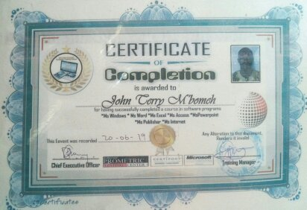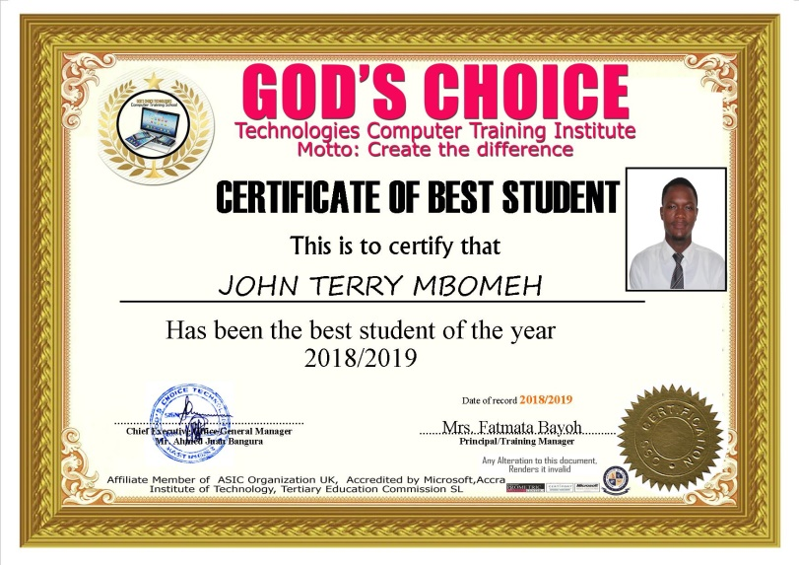**Below Are Some of My Relevant Documents**

