Module author
mPAY24 GmbH

License
http://ec.europa.eu/idabc/eupl.html EUPL, Version 1.1

Module Installationguide

0. Requirements:
* Prestashop >= 1.4.4.0
* PHP >= 5
* cURL (http://www.php.net/curl)
* DOM (http://www.php.net/dom)

1. Extract the archiv and copy the folder 'modules/mpay24' into the folder 'modules' or directly import the module on the module site in the backend .
2. Log into the backend of the shop and navigate to Modules->Payments & Gateways.
3. Here you should be able to see the mPAY24 module.
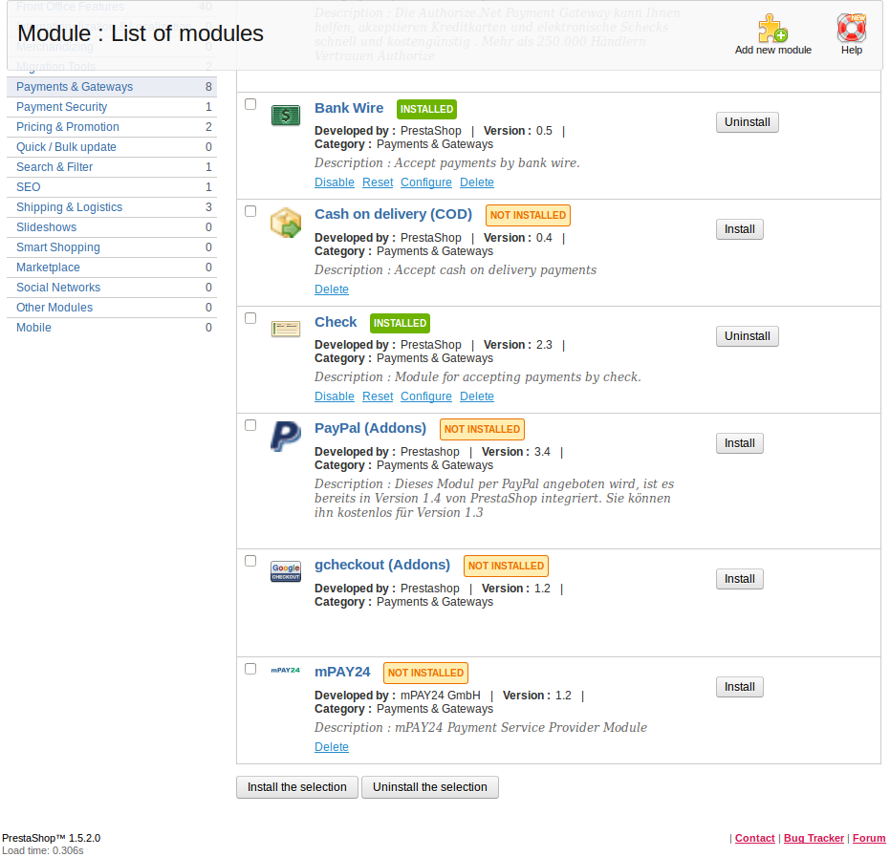
- When you click on the 'Install' button you should see a message 'Module installed successfully' and you should be able to configure the module by pressing the link 'Configure'.

- As a begining, after you have installed the module, you must set a few values – the mode of the system (it's strongly recommended to use the test mode first), your merchant id (a 5 digit number begining with 9 for the test system and 7 for the live system) and your SOAP password (provided from mPAY24). In case your server is behind a proxy you must set these settings too. Save your settings!

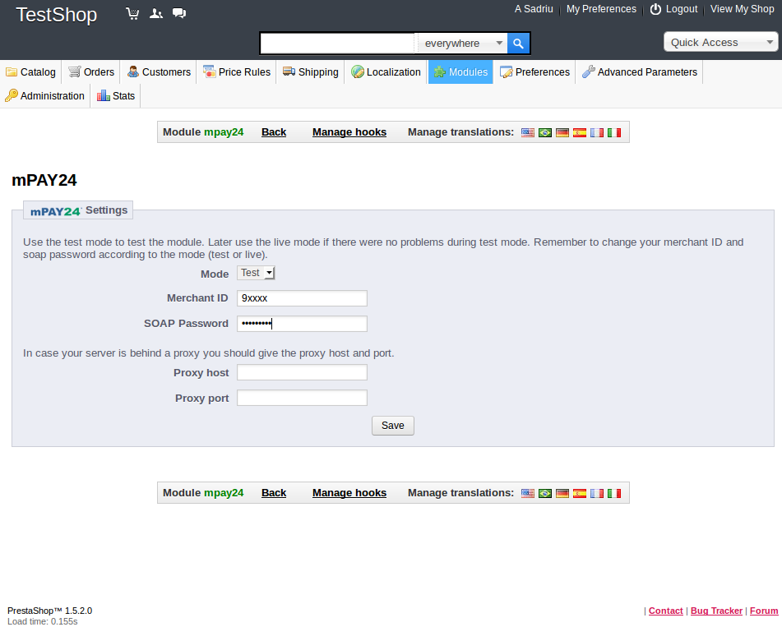

- With the 'Save' button will be create a connection with mPAY24, so in case all the settings are right you should see a list of the payment systems that are active for your merchant id by mPAY24. You can activate or deactivate some of the payment systems, set wether the end customer should be able to type the billing address on the pay page from mPAY24 or not (this feature is working only after accord with mPAY24). You are also able to set a lot of design settings for the mPAY24 pay page. After you are done with the settings click the button 'Save settings'.

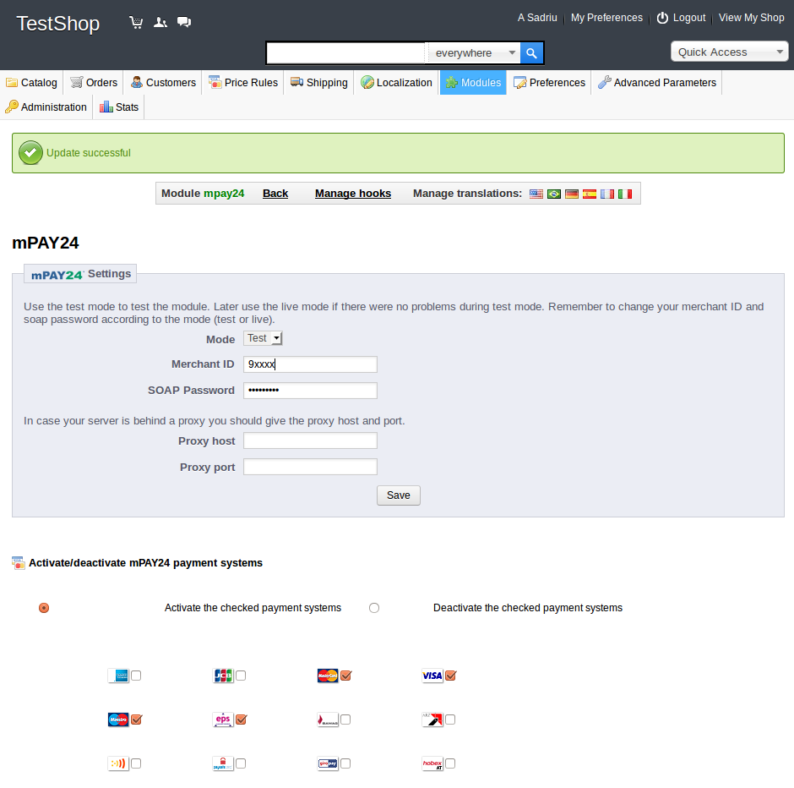

- Now you are able to check out:
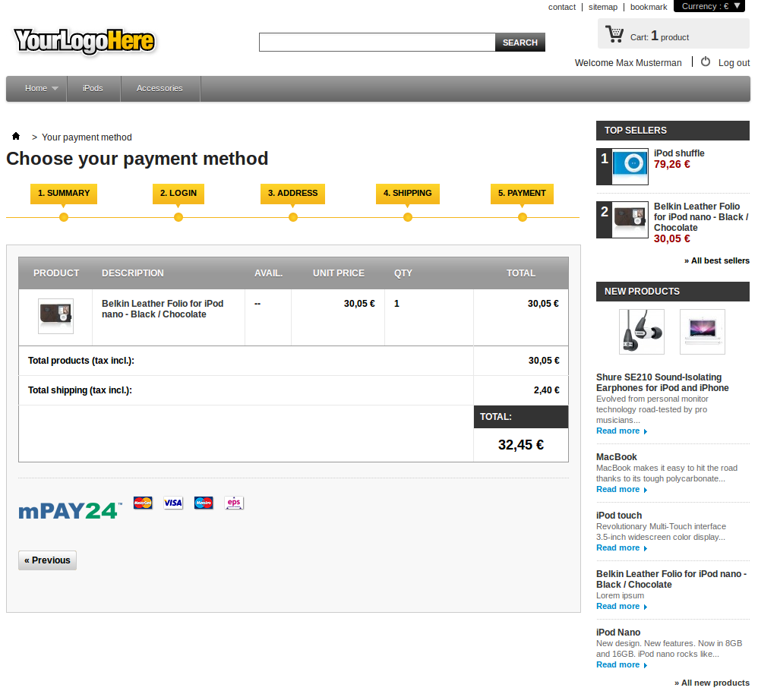

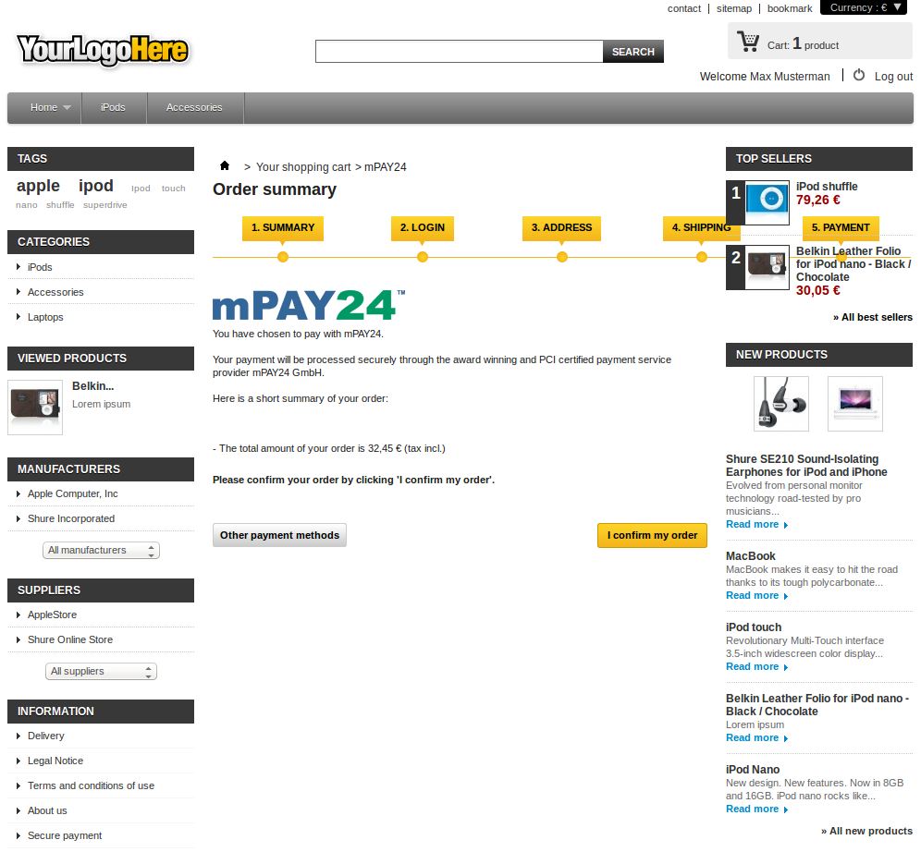

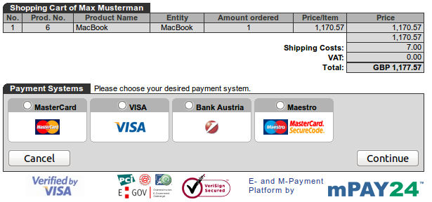

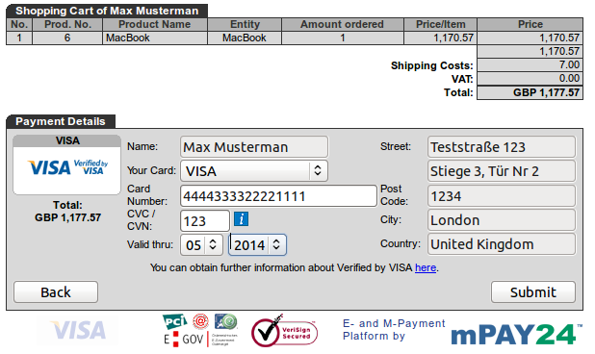

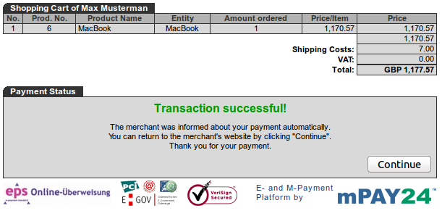

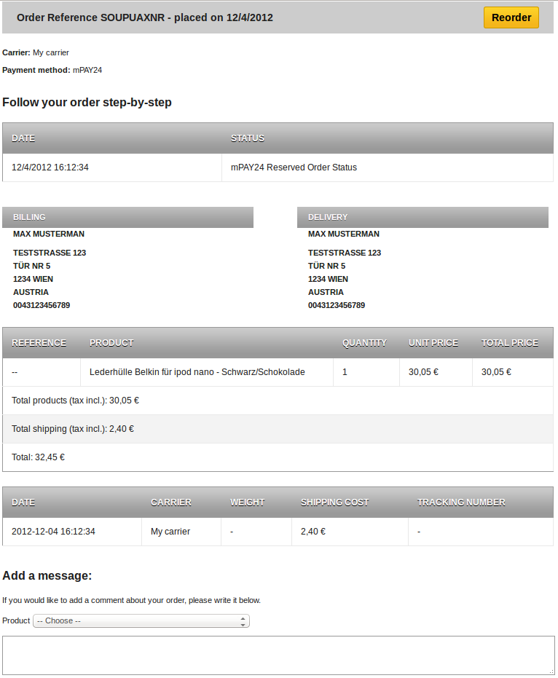

8. The module gives you the possibility to clear, credit and cancel a transaction. You are able to request the status of a transaction whenever you want.

