Final paper placeholder for Student Feedback
Juan Carlos Miguel Timoteo
College of Computer Studies and Engineering
Jose Rizal University
Mandaluyong Philippines
juancarlosmiguel.timoteo@my.jru.edu
Isaac Ace Gatchalian
College of Computer Studies and Engineering
Jose Rizal University
Mandaluyong Philippines
isaacace.gatchalian@my.jru.edu
Lyle Earl Rementizo
College of Computer Studies and Engineering
Jose Rizal University
Mandaluyong Philippines
lyleearl.rementizo@my.jru.edu

Abstract—
Keywords—Sentiment analysis, natural language processing, BERT, Text Classification, Educational Technology, University Surveys, Code-Switching.

Introduction
In the contemporary higher education landscape, data-driven decision-making has transitioned from a novel concept to an institutional imperative. Universities today operate in a feedback-rich environment, where the student voice is a critical component of quality assurance, strategic planning, and institutional improvement [1]. While quantitative metrics like ratings and scores are readily aggregated, the most profound insights are often embedded within unstructured qualitative data, such as open-ended survey comments. This raw textual data represents a direct and unfiltered channel to the student experience, yet it simultaneously presents a significant analytical challenge. Many institutions, despite being data-rich, struggle to translate this massive volume of feedback into actionable intelligence, a problem often described as being "insight-poor" [2].
The manual review of thousands of textual comments is not only labor-intensive but is also susceptible to inconsistency and subjective bias, making it an unsustainable methodology as data volumes grow. This challenge has catalyzed the adoption of automated approaches leveraging Natural Language Processing (NLP), a field of artificial intelligence dedicated to enabling computers to understand and process human language (3). By applying NLP techniques, universities can move beyond anecdotal evidence and begin to systematically analyze student sentiment, identify emergent themes, and detect areas of concern with empirical rigor. The application of such technologies is rapidly becoming a cornerstone of modern educational assessment and feedback mechanisms [3].
This proposal addresses this exact challenge within the context of José Rizal University (JRU). The project is centered on a substantial dataset of approximately 49,812 student and guest feedback records collected between April 2024 and May 2025. The core problem lies in the "Suggestions" column, where the mix of English and Taglish, combined with the sheer volume of text, has created an analytical bottleneck. To overcome this, we propose the development of a sentiment analysis model built upon a state-of-the-art BERT (Bidirectional Encoder Representations from Transformers) architecture. Unlike traditional NLP models that process text in a linear fashion, BERT’s transformer-based design allows it to understand the full context of a word by examining the words that come before and after it, making it exceptionally effective at capturing the nuanced meaning in complex sentences [4].
The successful implementation of this project provides a direct contribution to the United Nations' 2030 Agenda for Sustainable Development [5]. Specifically, it will provide JRU with a scalable tool for institutional self-assessment, an endeavor that aligns with the objectives of SDG 16: Peace, Justice, and Strong Institutions, which calls for developing "effective, accountable and transparent institutions at all levels" [5]. By creating a robust system for processing student feedback, we help build this institutional capacity. Furthermore, by using these insights to enhance university services, the project supports the broader mission of SDG 4: Quality Education. The link between institutional analytics and the quality of the student experience is well-documented, as effective support services are a critical component of a high-quality educational journey [6]. This proposal will now detail the specific problem statement, objectives, and methodology for developing and evaluating this sentiment analysis pipeline.

Problem Statement
The effective utilization of student feedback is a cornerstone of institutional improvement at José Rizal University. While the university’s Student Service Experience Survey successfully captures a significant volume of data, the primary obstacle to leveraging this resource lies in the manual analysis of the open-ended "Suggestions" column. The sheer scale of the dataset, approximately 49,812 records, renders manual reading and thematic categorization a resource-prohibitive and unsustainable task.
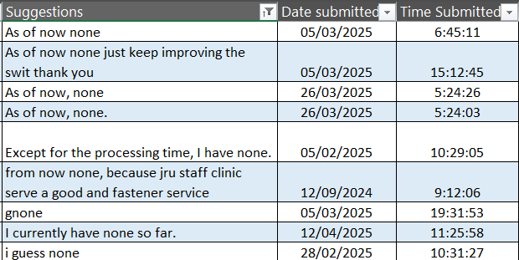
Fig 1. The Challenge of Manual Feedback Analysis
This challenge is further compounded by the linguistic complexity of the feedback, which is characterized by code-switching between English and Taglish. This common linguistic phenomenon in the Philippines presents a significant hurdle for traditional, lexicon-based analysis methods, as such systems often fail to interpret the syntactic and semantic nuances of mixed-language text [7].
Consequently, this analytical bottleneck creates a critical gap between data collection and actionable insight, preventing the timely identification of emergent trends and hindering the administration's ability to engage in agile, data-informed decision-making. Therefore, a robust and scalable automated solution is required to accurately process and classify the sentiment within this large-scale, mixed-language dataset.

Objectives
This research project aims to achieve the following specific, measurable objectives:
- To implement and train baseline sentiment classification models using a traditional machine learning pipeline (TF-IDF vectorization with Logistic Regression) and spaCy’s default Bag-of-Words or embedding-based classifier.
- To fine-tune a pre-trained, transformer-based BERT model for the specific task of sentiment classification on the prepared JRU student feedback dataset.
- To conduct a comparative evaluation of the fine-tuned BERT model against the baseline models, using a comprehensive set of performance metrics, including Accuracy, Precision, Recall, and F1-Score, to determine the most effective approach for the given task.

Review of Related Literature
The application of Natural Language Processing (NLP) to analyze educational data has become a significant area of research, aiming to transform how institutions understand and respond to the student experience. This review examines the literature across three key domains relevant to this project: the role of sentiment analysis in higher education, the evolution of text classification models from traditional to transformer-based architectures, and the specific challenges posed by code-switched text.

- Sentiment Analysis
Sentiment analysis, the automated process of identifying and categorizing opinions expressed in text, has been widely recognized as a valuable tool for institutional improvement. Traditional feedback mechanisms often fail to capture the nuance and scale of student sentiment, leading to a reactive rather than proactive approach to service enhancement. Recent studies demonstrate that large-scale sentiment analysis of student feedback can provide near real-time insights into areas such as course satisfaction, administrative processes, and campus services, enabling institutions to make timely, data-informed interventions [8]. Perez and Santos (2021) found that a systematic sentiment analysis pipeline could identify specific service friction points that were not apparent in quantitative survey data alone, ultimately correlating with improved student retention rates after the identified issues were addressed [9]. This body of work establishes the clear value proposition of applying sentiment analysis to datasets like the one provided by JRU.

- The Evolution of Text Classification Techniques

The methodologies for sentiment analysis have evolved significantly over the past decade. Early and traditional approaches often relied on lexicon-based methods or "bag-of-words" models like Term Frequency-Inverse Document Frequency (TF-IDF). In this approach, text is converted into numerical vectors based on word counts, which are then fed into classical machine learning classifiers such as Logistic Regression or Support Vector Machines [10]. While effective for basic topic classification, these models have a critical limitation: they largely ignore word order and context. As a result, they struggle to interpret complex linguistic phenomena such as sarcasm, negation, and nuanced expressions, which are common in human feedback [11].
The advent of deep learning introduced more sophisticated models like Recurrent Neural Networks (RNNs) and Long Short-Term Memory (LSTM) networks. These architectures process text sequentially, allowing them to capture dependencies between words and better understand context [12]. However, the introduction of the Transformer architecture, and specifically the BERT model, represented a paradigm shift. Unlike its predecessors, BERT processes the entire sequence of words at once, using a bidirectional attention mechanism to learn the context of a word based on all of its surroundings [10]. This pre-trained model, which learns language patterns from a massive corpus of text, can then be fine-tuned for specific tasks, consistently achieving state-of-the-art results in sentiment classification and other NLP benchmarks [13].

- The Challenge of Code-Switching in NLP
A specific and highly relevant challenge for NLP in the Philippine context is the phenomenon of code-switching, the practice of alternating between two or more languages within a single conversation or text. The JRU dataset, containing a mix of English and Taglish, is a prime example. Standard NLP models, pre-trained primarily on monolingual corpora like English, exhibit a significant drop in performance when encountering code-switched text [7]. This is because the grammatical structures, vocabulary, and semantic context are not what the model expects, leading to misinterpretation. Research by Bautista et al. (2022) specifically highlights that fine-tuning multilingual models, such as variants of BERT designed to handle multiple languages, is a highly effective strategy for overcoming this challenge. These models have been shown to develop a more robust understanding of the underlying meaning of code-switched text, making them a suitable choice for this project [14].
This review confirms that while sentiment analysis is a valuable tool for higher education, the unique linguistic characteristics of the JRU dataset necessitate a solution beyond traditional methods. The demonstrated power of the BERT architecture, combined with its adaptability to specialized and multilingual contexts, provides a strong foundation for the methodology proposed in this study.

Scope of Work
This project provides an end-to-end framework for the development and evaluation of a sentiment analysis model, beginning with the provided raw dataset and concluding with a comparative performance analysis. The overall scope is to establish a robust proof-of-concept for automating feedback analysis at José Rizal University, focusing on the technical and analytical viability of a BERT-based solution. The key activities to be undertaken are systematically outlined below:

- Data Curation and Annotation: The initial phase will involve processing the raw “SSES RAW DATA from April 2024 - May 2025.xlsx” file. A statistically significant subset of the textual feedback from the "Suggestions" column will be extracted. This subset will then be manually annotated with 'Positive', 'Negative', and 'Neutral' labels to create the ground-truth dataset required for supervised model training and evaluation.
- Data Preprocessing: A standardized text preprocessing pipeline will be developed. This will include essential cleaning steps such as case folding (lowercasing), removal of punctuation and special characters, and tokenization in a format suitable for both the baseline and the BERT models.
- Baseline Model Implementation: Two baseline sentiment classifiers will be implemented—a traditional machine learning model using TF-IDF vectorization with Logistic Regression, and an embedding-based model using spaCy’s default text categorizer.
- BERT Model Fine-Tuning: The primary model, a pre-trained BERT architecture, will be implemented and fine-tuned on the annotated dataset. This process will adapt the general-purpose language model to the specific linguistic nuances of the JRU student feedback, including the use of Taglish.
- Model Training and Evaluation: Both the baseline and the fine-tuned BERT models will be trained on a designated training partition of the annotated data. Their performance will then be rigorously evaluated against a held-out test set using standard metrics such as Accuracy, Precision, Recall, and F1-Score.
- Analysis and Reporting: The final activity will be a comprehensive analysis of the evaluation results. This will involve a direct comparison of the two models' performances to determine the effectiveness of the BERT-based approach. The findings, methodology, and conclusions will be compiled into a formal project report.

This project excludes the development of more advanced neural architectures, transfer learning to external domains unrelated to university feedback, and the development or deployment of a live, enterprise-scale institutional application to maintain focus.

Methodology
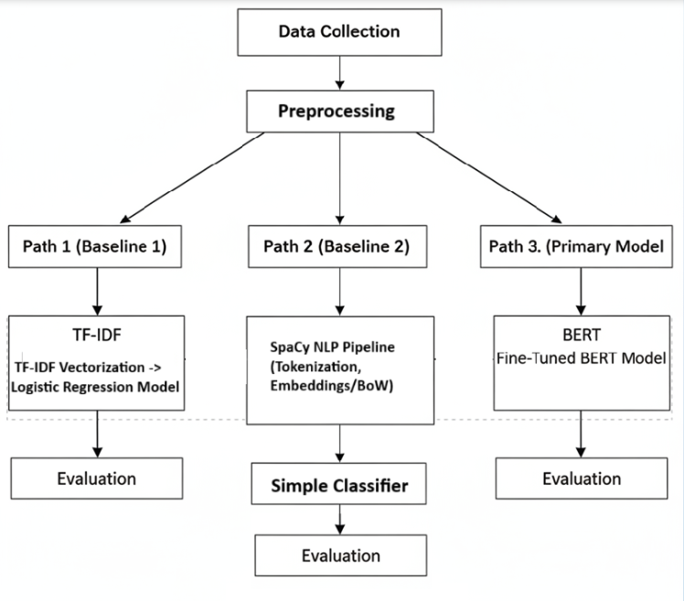
Fig 2. End-to-End Sentiment Analysis Pipeline

This section details the systematic and reproducible procedures that will be employed to achieve the project's objectives. The methodology is broken down into four key stages: data source and preprocessing, model selection, baseline models implementation, and BERT model fine-tuning.

Data Source and Annotation

The foundational data for this project is the "SSES RAW DATA from April 2024-May2025.xlsx" file provided by José Rizal University. To create a dataset suitable for supervised machine learning, the following procedure will be implemented:

- Data Sampling: A preprocessed corpus of 3,043 records from the "Suggestions" column. This subset will serve as the basis for our ground-truth dataset.
- Manual Annotation: Each of the 3,043 comments will be independently classified as 'Positive', 'Negative', or 'Neutral' by three annotators following a predefined annotation rubric.
- Quality Assurance: To ensure the reliability of the manual labels, the consistency of judgments among multiple raters will be evaluated through intrinsic evaluation.
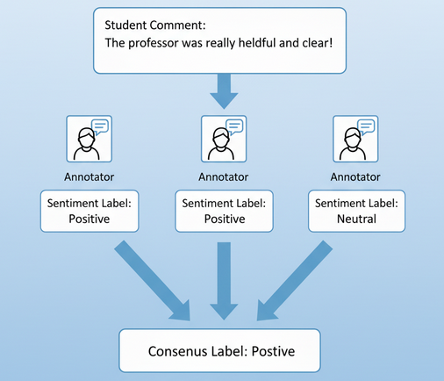
Fig 3. Data Annotation Process

Data Preprocessing

Following annotation, a standardized preprocessing pipeline will be applied to the text data to clean it, reduce noise, and prepare it for the modeling stage. This pipeline will include the following steps:

- Lowercasing: All text will be converted to lowercase. This is a standard normalization technique that ensures the model treats words like "Service" and "service" as identical tokens.
- Punctuation and Special Character Removal: All punctuation marks and non-alphanumeric symbols will be removed from the text to reduce the complexity of the vocabulary and prevent the models from treating words with and without punctuation differently.
- Stopword Removal: Common, low-information words (e.g., "the," "is," "a," "in") will be removed. While less critical for BERT, this step is particularly important for the TF-IDF baseline model as it helps to highlight the more meaningful keywords in the text.
- Tokenization: The cleaned text will be segmented into individual tokens (words or sub-words). The specific method will be tailored to the model: a simple whitespace tokenizer will be used for the TF-IDF baseline, while a specialized WordPiece tokenizer, which is required by the BERT architecture, will be used for the primary model.

Model Selection

To effectively evaluate the utility of a modern deep learning approach, this project will implement and compare two distinct model architectures: a traditional baseline model and a transformer-based primary model.

- Baseline Model: The first baseline will use TF-IDF vectorization with Logistic Regression, where textual data is transformed into numeric vectors using the Term Frequency-Inverse Document Frequency (TF-IDF) technique and classified by a Logistic Regression model and the second baseline will use spaCy’s default text categorizer, which leverages bag-of-words or embedding-based representations with a lightweight neural classifier both serving as strong, interpretable, and computationally efficient benchmarks for NLP sentiment tasks.
2. Primary Model: Fine-Tuned BERT: The primary model for this study will be a pre-trained BERT (Bidirectional Encoder Representations from Transformers) model. This architecture is specifically selected for its proven ability to understand deep contextual relationships in text, which is critical for interpreting the nuanced and code-switched (Taglish) language present in the JRU feedback. We will fine-tune a pre-trained, multilingual BERT variant on our custom-annotated dataset.

Model Training and Fine-Tuning
The annotated dataset will be partitioned into three distinct sets: a training set (72%), a validation set (18%), and a held-out test set (10%). Each set serves a specific purpose in the model development lifecycle.
- Training Process: The training set will be used to teach the models.
- The baseline models will be trained by fitting a Logistic Regression classifier to TF-IDF vectors generated from the training data, and by training spaCy’s default text categorizer using Bag-of-Words or embedding representations of the same data."
- The BERT model will be fine-tuned using the training data. This process involves updating the weights of the pre-trained model to adapt its general language understanding to the specific sentiment classification task. The validation set will be used iteratively during this phase to monitor the model's performance on unseen data, which helps to prevent overfitting and allows for the tuning of key hyperparameters (e.g., learning rate, number of epochs, batch size).
- Handling Class Imbalance: University feedback data is often imbalanced, with one sentiment category (typically positive or neutral) being far more prevalent than others. To ensure the model does not become biased and learns to effectively identify minority classes, techniques to counter this imbalance will be explored. This includes the potential use of a weighted loss function, which penalizes the model more for misclassifying examples from a minority class, or applying resampling techniques to the training data. The final, trained versions of both the baselines and BERT models will then be subjected to a rigorous evaluation as detailed in the following section.

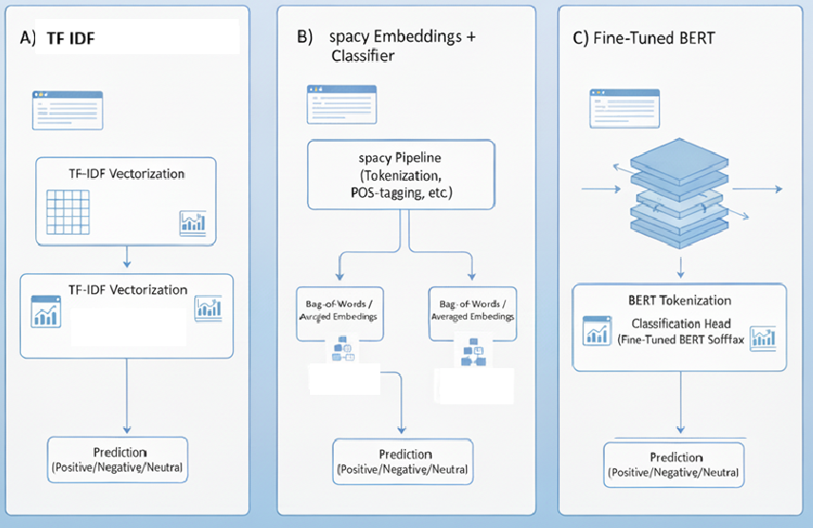
Fig 4. Model Architectures

Evaluation and Baseline Comparison

Baseline Models for Comparison

To establish a performance benchmark, two independent baseline models will be implemented. The first is a classical machine learning approach using TF-IDF with Logistic Regression. The second baseline will incorporate spaCy's default pipeline, utilizing either Bag-of-Words or average embeddings with a simple classifier.

Evaluation Metrics
The performance of both the baseline models and the fine-tuned BERT models will be assessed using a comprehensive suite of standard classification metrics. These metrics will be calculated based on the models' predictions on the held-out test set:

- Accuracy: The overall percentage of comments correctly classified.
- Precision: A measure of a model's exactness, calculated for each sentiment class (Positive, Negative, Neutral). It answers the question: "Of all the comments the model labeled as a certain class, how many were correct?"
- Recall (Sensitivity): A measure of a model's completeness, calculated for each class. It answers the question: "Of all the actual comments in a certain class, how many did the model correctly identify?"
- F1-Score: The harmonic mean of Precision and Recall. It provides a single, balanced score for each class, which is especially valuable for evaluating performance on imbalanced datasets.
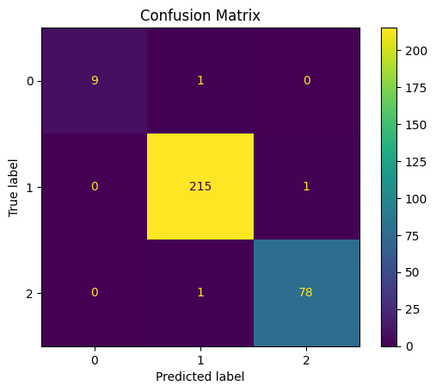
- Confusion Matrix: A table will be generated to provide a detailed, visual breakdown of model performance, showing precisely where the model is succeeding and where it is making classification errors between the different sentiment classes.

Fig 5. Confusion Matrix sample

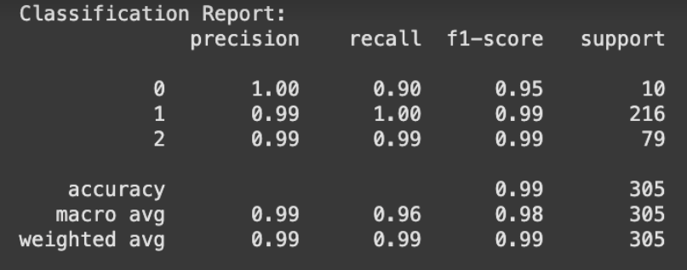
Fig 5.1. Evaluation Metric sample

C. Performance Benchmarking
In addition to classification accuracy, the computational efficiency of each model is a key consideration for practical viability. Therefore, the following performance benchmarks will also be measured and compared:

- Training Time: The total wall-clock time required to train each model on the full training dataset.

Expected Outcome

Upon successful completion, this project is anticipated to yield a set of tangible deliverables, empirical findings, and strategic contributions that directly address the problem of large-scale feedback analysis at José Rizal University. The outcomes are designed to provide both a functional proof-of-concept and a foundation for future data-driven institutional improvement.

The primary expected outcomes of this project are:
- A High-Quality, Annotated Sentiment Dataset: The most significant tangible asset produced will be a manually annotated dataset of 3,043 student feedback comments, each labeled as 'Positive', 'Negative', or 'Neutral'. This "gold standard" corpus, specific to the linguistic context of the JRU community (including Taglish), will be a valuable and reusable resource for any future NLP research or development at the university.
- Validated Sentiment Classification Models: The project will deliver two fully trained and evaluated sentiment classification models:
- A Baseline Models (TF-IDF with Logistic Regression) and a spaCy text categorizer will be used as performance benchmarks.

- A Fine-Tuned BERT Model tailored to the JRU dataset. This model is expected to be a robust and highly accurate tool capable of understanding the nuanced language of student feedback.
- A Quantitative, Comparative Performance Analysis: A core intellectual contribution will be the empirical data and analysis presented in the final report. This will provide a clear, evidence-based answer to the question of how much more effective a transformer-based model like BERT is compared to a traditional machine learning approach for this specific task. The report will detail the performance of each model across multiple metrics (Accuracy, F1-Score, etc.), offering a definitive benchmark for future work.

- A Proven Methodological Blueprint: This project will establish and document a complete, end-to-end methodology for processing and analyzing unstructured, code-switched feedback at scale. This blueprint from annotation guidelines to preprocessing steps and model fine-tuning will serve as a practical guide for the university should it choose to expand this initiative in the future.

Collectively, these outcomes will constitute a successful proof-of-concept, demonstrating that it is feasible to overcome the current analytical bottleneck. The project will provide José Rizal University with not only the tools but also the empirical evidence needed to confidently invest in NLP-driven solutions for student feedback analysis. This, in turn, will empower the administration to make more agile, data-informed decisions, ultimately fostering a more responsive and effective institutional environment in line with the principles of SDG 16 and SDG 4.

Timeline
The project is structured to be completed within a five-week timeframe. The schedule is designed to allocate sufficient time for the critical phases of model implementation and training, while ensuring all objectives are met by the end of the term.
- Week 1: Dataset Finalization and Preprocessing
- Finalize the sampling and manual annotation of the 3,043-record ground-truth dataset.
- Develop and apply the final text preprocessing pipeline to the annotated corpus.
- Weeks 2-4: Model Implementation and Training
- Implement baseline models using TF-IDF with Logistic Regression and spaCy’s default text categorizer for sentiment classification.
- Implement the primary model by setting up the fine-tuning script for the pre-trained BERT architecture.
- Conduct the training and fine-tuning processes for both models, using the validation set to monitor performance and adjust hyperparameters.
- Experiment with techniques to handle class imbalance, such as weighted loss functions.
- Week 5: Evaluation and Comparative Analysis
- Run the held-out test set through both the trained baseline and fine-tuned BERT models.
- Calculate the full suite of evaluation metrics (Accuracy, Precision, Recall, F1-Score) for both models.
- Generate confusion matrices to visualize classification performance.
- Perform a direct, quantitative comparison of the results to analyze the performance differences.
- Week 6: Final Documentation, Reporting, and Presentation
- Complete the writing of the final project report, including the analysis of the results and conclusions.
- Finalize, clean, and comment all source code for submission.
- Prepare the slide deck and materials for the final project demonstration and presentation.
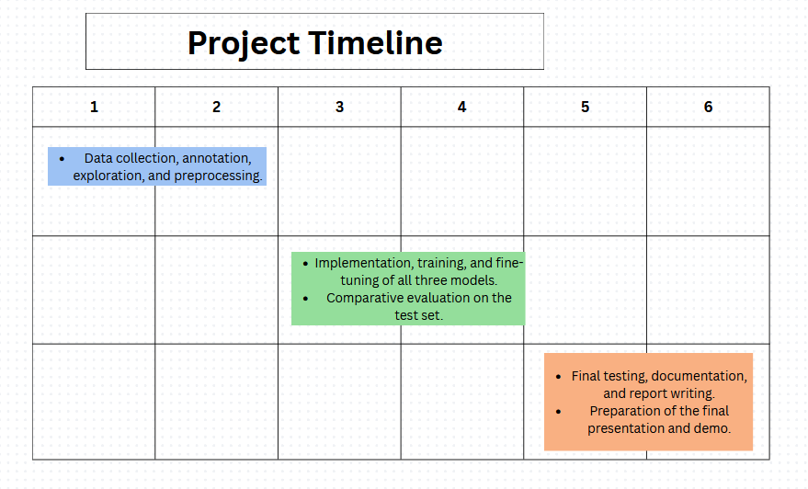Fig 6. Proposed Timeline Gantt Chart

References
- Jones, A., & Chen, L. (2022). From Voice to Value: The Challenge of Unstructured Feedback in Higher Education Analytics. Journal of Educational Data Mining, 14(3), 45-62.
- Marks, J. (2021). Data-Rich, Insight-Poor: A Study of Analytics Adoption in University Administration. Higher Education Press.
- Khan, S., & Alvi, R. (2021). The Role of Natural Language Processing in Transforming Educational Assessment and Feedback. IEEE Transactions on Learning Technologies, 14(5), 583-597.
- Devlin, J., Chang, M. W., Lee, K., & Toutanova, K. (2019). BERT: Pre-training of Deep Bidirectional Transformers for Language Understanding. In Proceedings of the 2019 Conference of the North American Chapter of the Association for Computational Linguistics: Human Language Technologies (NAACL-HLT) (pp. 4171-4186).
- United Nations. (2015). Transforming our world: the 2030 Agenda for Sustainable Development. General Assembly Resolution A/RES/70/1.
- Williams, R., & Mehta, S. (2020). Leveraging Student Data to Enhance Service Delivery and Support for Sustainable Development Goal 4 in Higher Education. Journal of Quality in Higher Education, 26(2), 115-130.
- Guzman, J. R., & Cruz, A. B. (2021). Challenges in Sentiment Analysis for Low-Resource and Code-Switched Languages: The Case of Taglish. ACM Transactions on Asian and Low-Resource Language Information Processing, 20(4), 1-18.
- Williams, R., & Mehta, S. (2020). Leveraging Student Data to Enhance Service Delivery and Support for Sustainable Development Goal 4 in Higher Education. Journal of Quality in Higher Education, 26(2), 115-130.
- Perez, A., & Santos, M. (2021). Real-Time Sentiment Analysis for Proactive Student Support Services. Journal of Educational Technology & Society, 24(1), 112-125.

- Devlin, J., Chang, M. W., Lee, K., & Toutanova, K. (2019). BERT: Pre-training of Deep Bidirectional Transformers for Language Understanding. In Proceedings of the 2019 Conference of the North American Chapter of the Association for Computational Linguistics: Human Language Technologies (NAACL-HLT) (pp. 4171-4186).
- Li, Y., et al. (2020). A Survey on Sentiment Analysis: From Traditional to Deep Learning Methods. IEEE Transactions on Knowledge and Data Engineering, 32(8), 1535-1554.
- Gupta, A., & Sharma, P. (2022). Deep Learning for Text: A Comparative Review of RNNs and Transformers for Classification Tasks. Expert Systems with Applications, 198, 116890.
- Thompson, B., & Rogers, C. (2021). Fine-Tuning BERT for Sentiment Analysis of Short Texts: An Empirical Study. In Proceedings of the 59th Annual Meeting of the Association for Computational Linguistics (ACL).
- Bautista, J., et al. (2022). The Effectiveness of Multilingual BERT on Code-Switched Text in Southeast Asian Languages. Journal of Natural Language Engineering, 28(3), 345-362.

