Instructions for joining a contest

You have been sent file <player-name>.tar. Below you see this file for me in directory demo on my laptop.

If Openvpn is to be used to establish the contest network, the file franco.tar will contain contest vpn credentials in directory keys, the openvpn configuration file client.conf, a contest configuration file Parms, and scripts to join the vpn. If OpenVPN is not used only the Parms file is archived. Untar franco.tar and list its contents (below assumes OpenVPN is used):


The file client.conf is the openvpn configuration file for joining the vpn. The file run.client runs openvpn on client.conf. You need to be administrator to use this. The keys directory contains your openvpn credentials.

If you are joining from outside your organization’s perimeter and the OpenVPN server is inside the perimeter you likely need to start and use a socks proxy. To connect to the socks proxy do this:

assuming ssh is used as the proxy and the restricted account for the proxy is visitor on machine example.edu. This is followed by a password prompt - the password will be provided by the OpenVPN administrator. To make sure the proxy is running do this:

If it is not running you will see this:

You must have the socks proxy running if joining from outside your organization’s perimeter if the OpenVPN server is operating from within the perimeter. If using a socks proxy you must also make a change to client.conf. First edit the file, for example like this

Then make the change where circled in red – remove the semi-colon:

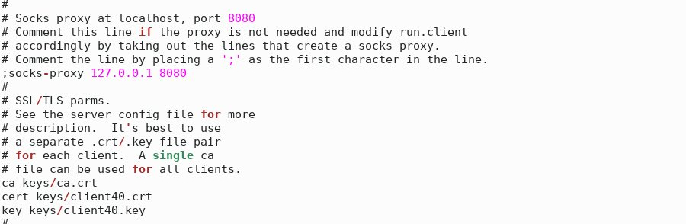
O
Save the edited file, change directory, and start openvpn (you have to have admin privileges):

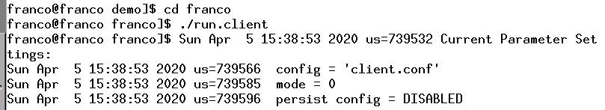
…

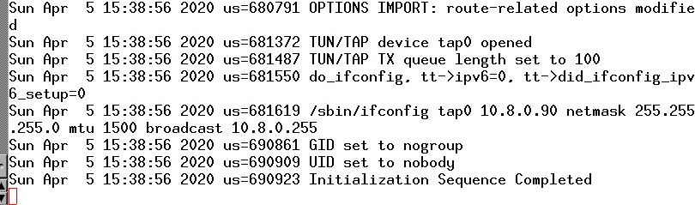
If you see ‘Initialization Sequence Completed’ you likely will have joined the vpn. To make sure use ifconfig (if ifconfig is not found you can get it using ‘sudo apt install net-tools’). You will see a tap interface with a 10.8.0 ip address. Here it is 10.8.0.90 but your rightmost octet will be a number between 100 and 149.

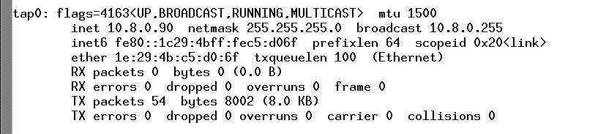
…
Summary
Your VM
Connecting to the contest using OpenVPN
The following assumes a directory called keys with files ca.crt, clientX.key, clientX.crt
an OpenVPN configuration file client.conf with a section like this:
ca keys/ca.crt
cert keys/clientX.crt
key keys/clientX.key
where X is a number from 0 to 150, and a line indicating the internal address of the
OpenVPN server like this:
remote 10.52.10.254 1194
plus scripts run.client and run.player for starting the OpenVPN connection and Client

Using OpenVPN with a socks proxy
1. edit client.conf → remove semi-colon from ;socks-proxy 127.0.0.1 8080
2. check whether there is a connection to socks proxy → pstree -paul | grep ssh
example result:
-ssh,6687,user -N -f -T -D 8080 visitor@example.edu
3. if there is no result as above (no connection) then do this:
a. connect to socks proxy → ssh -N -f -T -D 8080 visitor@example.com
(password may be required)
4. check whether openvpn is running → pstree -paul | grep openvpn
example result:
-openvpn,6984,nobody client.conf
5. if there is a result as above (openvpn is running) then do this:
a. kill the running process → killall openvpn
6. start the openvpn client → ./run.client

Using OpenVPN without a socks proxy
1. complete steps 1, 4, 5, 6 above

Connecting to the contest without using OpenVPN
1. Set your ip address statically according to the number in file Parms

