Instructions for joining the final contest

You have been sent file <your-team-name-X>.tar where X is A, B, or C. Below you see a tar file for me (without the X) in directory CDX on my laptop. I recommend the tar file you were sent should be placed in a clean directory because when it is untarred a lot of files will show up. Change directory to where you put the tar file and run the ls command like this:

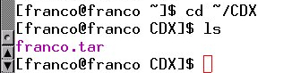

The tar file contains contest vpn credentials in directory keys, the configuration file client.conf used to join the vpn, a contest configuration file Parms, and scripts to join the vpn and to start and stop the Client. Untar the file and run ls to get a new directory, in this case named franco:

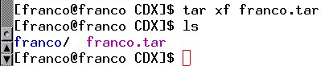

Now change directory to the new directory and look at its contents with ls:

Use command ‘ls keys‘ to see the contents of directory keys which contains OpenVPN credentials:

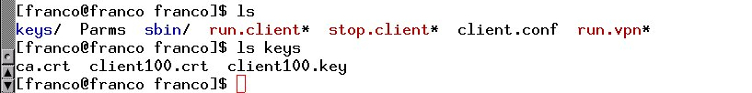
File ca.crt is the OpenVPN server’s certificate. File client100.crt is my OpenVPN certificate and file client100.key is my OpenVPN key. Now take a look at the last lines of the configuration file client.conf with tail:
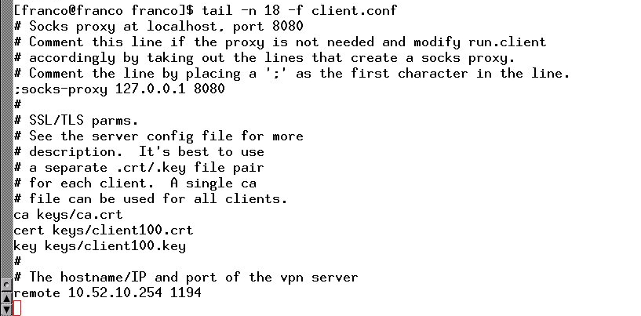

Note the following:
- The line at the bottom of the file is remote 10.52.10.254 1194. The 10.52.10.254 IP address is the address of the machine that hosts the OpenVPN server. The 1194 is the port on which the server is listening. If you are joining from inside UC’s perimeter there is no problem because UCIT allows that port to be used from inside the perimeter. From outside the perimeter, say from India or Turkey, or even Mason, Ohio, you will need to tunnel into UC’s network to get to the OpenVPN server. You do this with a socks proxy. See below about how to do this.
- The server certificate, your certificate, and your key are stated in this file with the same names as in directory keys. The location of those files is also given as keys.
- There is no specification in the configuration file for the IP address that your VM will get when it joins. The IP address is determined by the OpenVPN server that maps your certificate and key to one.
- There is a socks-proxy line that begins with a semi-colon – that means this line is commented out. If you need to use a socks proxy because you are joining the contest from outside of UC then this line must be uncommented by removing the semi-colon and you must start a socks proxy like this:
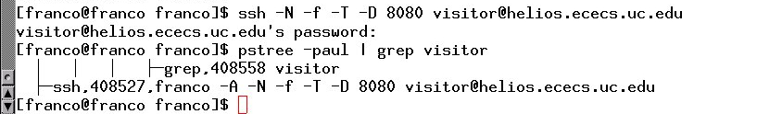
The password is iwarsdemo. Use pstree to make sure the socks proxy is running. The above shows it is running with process number 408527.

To connect to the competition network run run.client like this:
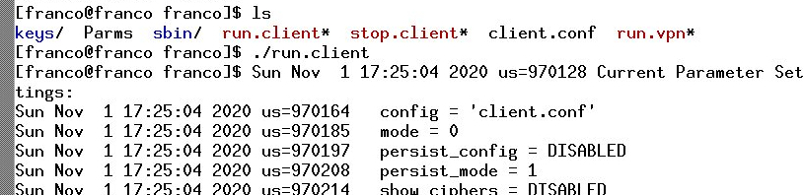

What you see above is the beginning of a long output that ends like this if your actually connected:

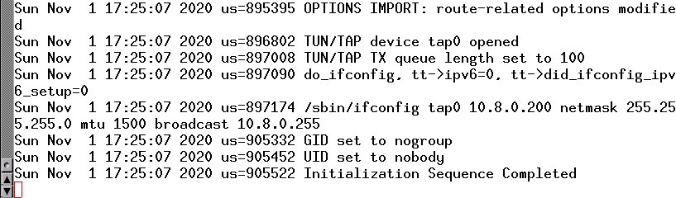

If you do not see “Initialization Sequence Completed” then something is wrong. There are two things to try to correct the problem. First, make sure there are no openvpn processes running before running run.client. Use pstree | grep openvpn for this check. To kill openvpn processes use sudo killall openvpn. Another possibility is you are trying to use a socks proxy but you forget to uncomment the socks-proxy line in client.conf.

To make sure you are connected use /sbin/ifconfig or something similar like this:

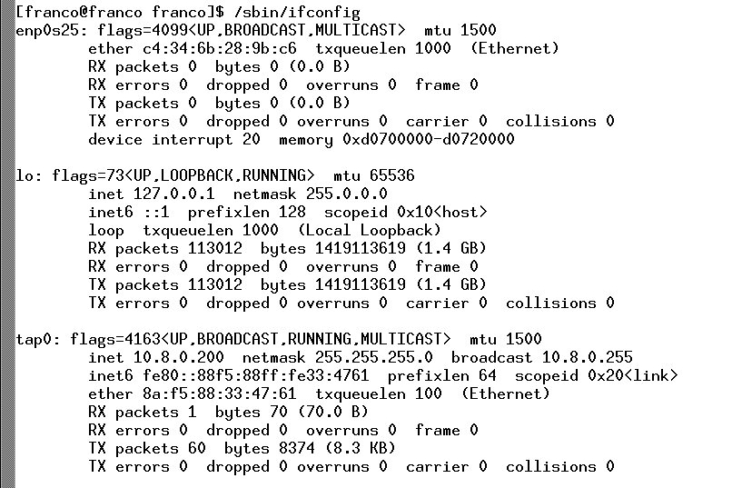
The interface tap0 has been created by the OpenVPN server. The IP address given by the server is 10.8.0.200. If tap0 or tap1 is missing from the output of /sbin/ifconfig then something is wrong but this is unlikely if run.client produced a successful output.

To quit the competition network use stop.client.

The main purpose of the file Parms is to supply the start and end dates and times of the competition.

Summary
Your VM
Connecting to the contest using OpenVPN
The following assumes a directory called keys with files ca.crt, clientX.key, clientX.crt
an OpenVPN configuration file client.conf with a section like this:
ca keys/ca.crt
cert keys/clientX.crt
key keys/clientX.key
where X is a number from 0 to 150, and a line indicating the internal address of the
OpenVPN server like this:
remote 10.52.10.254 1194
plus scripts run.client and run.player for starting the OpenVPN connection and Client

Using OpenVPN with a socks proxy
1. edit client.conf → remove semi-colon from ;socks-proxy 127.0.0.1 8080
2. check whether there is a connection to socks proxy → pstree -paul | grep ssh
example result:
-ssh,6687,user -N -f -T -D 8080 visitor@helios.ececs.uc.edu
3. if there is no result as above (no connection) then do this:
a. connect to socks proxy → ./run.proxy (password may be required)
4. check whether openvpn is running → pstree -paul | grep openvpn
example result:
-openvpn,6984,nobody client.conf
5. if there is a result as above (openvpn is running) then do this:
a. kill the runnung process → killall openvpn
6. start the openvpn client → ./run.client

Using OpenVPN without a socks proxy
1. complete steps 1, 4, 5, 6 above

Connecting to the contest without using OpenVPN
1. complete step 6 above

