VirtualBox and Pcap Tools – a solution

Problem:
Run two VMs in a VirtualBox hypervisor run from a host: one is a Kali VM and the other an Ubuntu VM. Put the two VMs and the host on the same network. From the Kali VM run nmap on the host and display the result. Send messages from the host to the Ubuntu VM. Have the Kali VM intercept those messages. Display one message in particular, called a flag. Use tcpdump for capture and wireshark for analysis.

There are a couple of ways to put all three OSes on the same network. We will do this by using a host only adapter for each of the VMs. From the host, launch VirtualBox, open the ‘File’ menu, and select ‘Host Network Manager’. You should see a desktop with VirtualBox main page and Host Network Adapter as shown in Figure 1 (the display manager in the figure is KDE – the VirtualBox main page and the Host Network Adapter window will be the same on Windows or Linux or anything else).

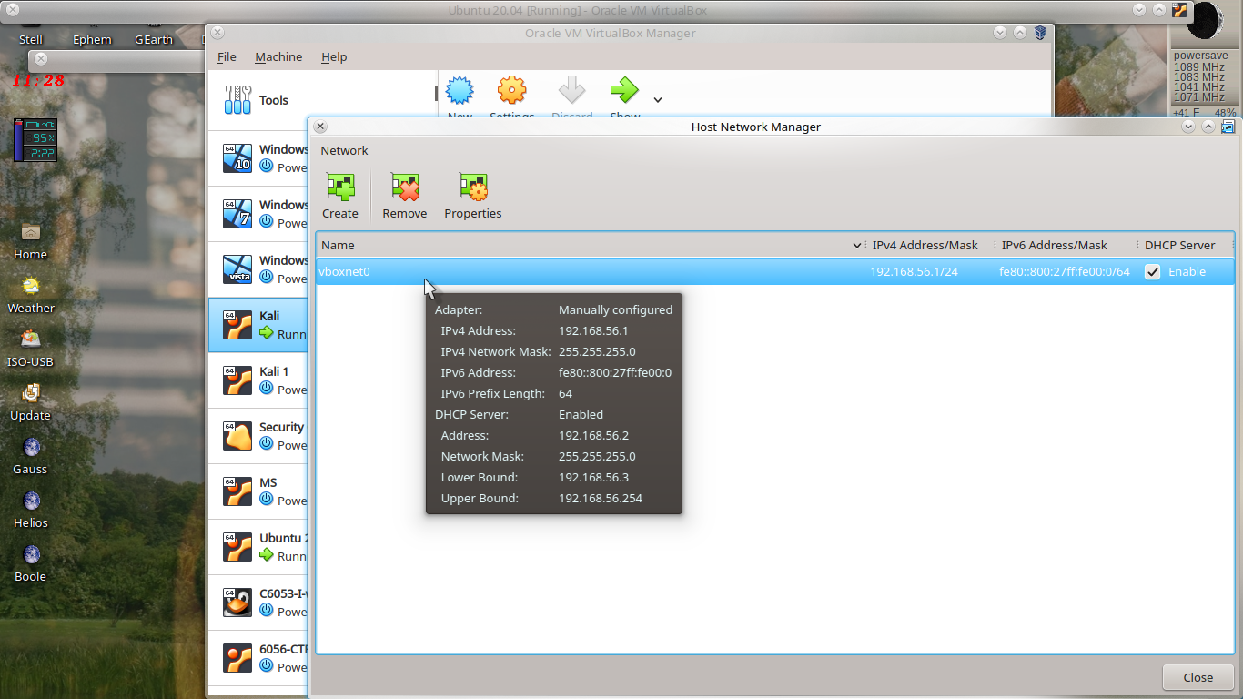Figure 1: The ‘Host Network Manager’ window of VirtualBox showing one network named vboxnet0
Notice the line named vboxnet0. If no such line exists, click ‘Create’ and check the box labeled ‘DHCP Server’. Make sure the ‘DHCP Server’ box is checked no matter what. Take note of the network IP address: in this case it is 192.168.56.1/24 which means that machines on the network will have addresses ranging from 192.168.56.1 to 192.168.56.255. Notice that the DHCP server will be at address 192.168.56.2.

Now for each of the VMs you will use, select the VM label in the left margin of the VirtualBox main page then click ‘Settings’, then ‘Network’, then select ‘Host-only Adapter’ in the menu next to ‘Attached to:’. Make sure to use the same name network for both VMs. Click ‘Advanced’ and, from the menu labeled ‘Promiscuous Mode:’, choose ‘Allow All’. Refer to Figure 2 to see what this looks like.

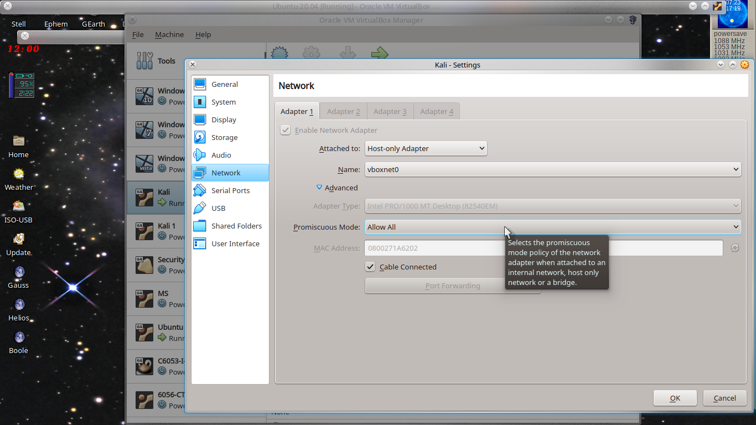Figure 2: Choose the same host-only adapter network for both VMs. Here it is shown for the Kali VM.
Start the VMs. After they are both running, open a terminal on the host and run the command /sbin/ifconfig (on windows, open a terminal using ‘cmd’ and run ipconfig). The host has been given an additional network interface named the same as the network prescribed for the VMs. An example is shown in Figure 4. Do the same for the VMs. An example is shown for the Ubuntu VM in Figure 5. Observe that the address of the host on the vboxnet0 network is 192.168.56.1 and the address of the Ubuntu VM is 192.168.56.7 so both machines are on the same network, although the network interfaces are different in both cases.

Verify that the machines can communicate with each other. From the terminal on the host run the command ping 192.168.56.7. The output is similar to this:

PING 192.168.56.7 (192.168.56.7) 56 (84) bytes of data.
64 bytes from 192.168.56.7: icmp_seq=1 ttl=64 time=0.838 ms
64 bytes from 192.168.56.7: icmp_seq=2 ttl=64 time=0.388 ms
64 bytes from 192.168.56.7: icmp_seq=3 ttl=64 time=0.257 ms
64 bytes from 192.168.56.7: icmp_seq=4 ttl=64 time=0.455 ms
...

which confirms that the host can communicate with the Ubuntu VM. Try this in all directions between VMs and host to see that all machines are communicating on the same network.

nmap:
Run nmap from the Kali VM on the host. From above the host has IP address 192.168.56.1. This is shown in Figure 3. Switches used are -Pn which skips host discovery and p 1-20000 for checking ports 1 to 20000.

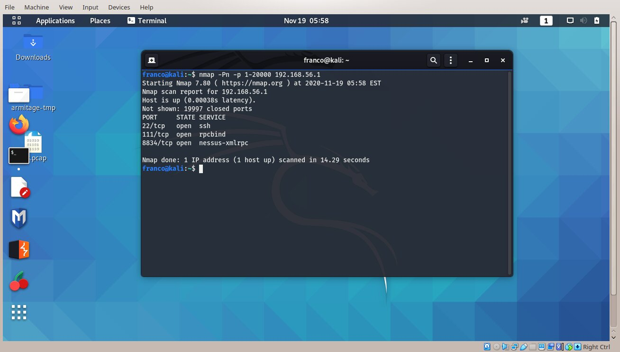Figure 3: Run nmap against the host

Communication Channel:
Next establish a channel between the host and the Ubuntu VM. On the host, in a terminal window, run
netcat -l -p 8000 -u -v > results.txt &

The -u switch means receive using the UDP protocol, -l means listen, -v means verbose. You know this is working if you see ‘Bound on 0.0.0.0 8000’. If you see

‘netcat: getnameinfo: Temporary failure in name resolution’

it could be due to the host not being on a reachable outside network or the nameserver in /etc/resolv.conf is not effective. You might edit /etc/resolv.conf as root and replace the nameserver entry there with this:

nameserver 8.8.8.8

then try again. On the Ubuntu VM send UDP packets to the host, port 8000 by running this:

netcat 192.168.56.1 8000 -u

then type anything and hit return. On the host, the file results.txt will contain that text.

At this point you can run tcpdump on Kali Linux to capture traffic between the Ubuntu VM and the host. Open a terminal in Kali. For tcpdump to work, permissions on /usr/bin/dumpcap need to be changed. Run this command:

sudo chmod u+s /usr/bin/dumpcap
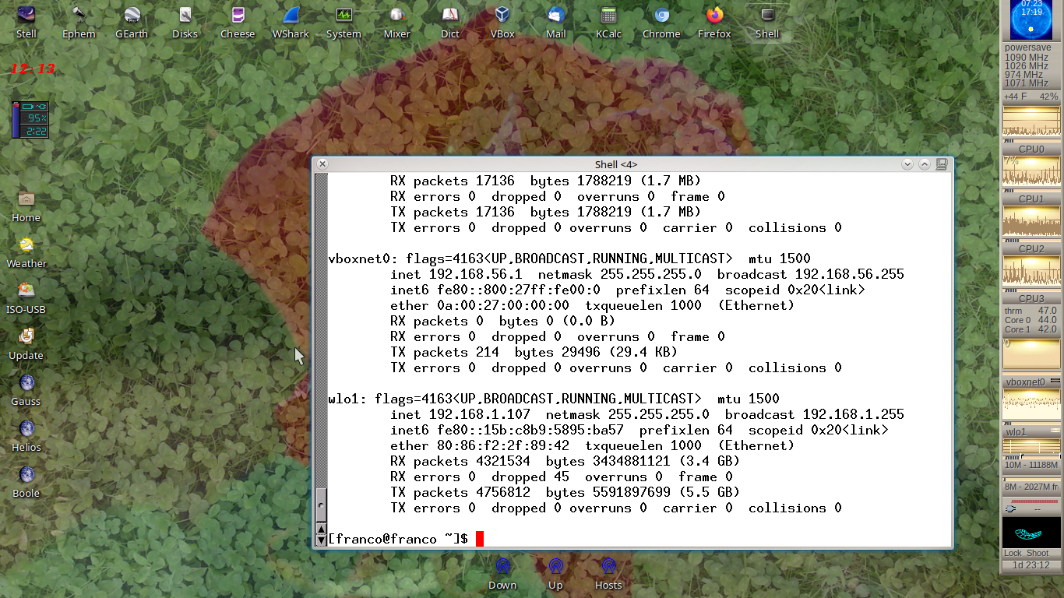Figure 4: Running /sbin/ifconfig on the host shows that the host is on the vboxnet0 network with IP address 192.168.56.1
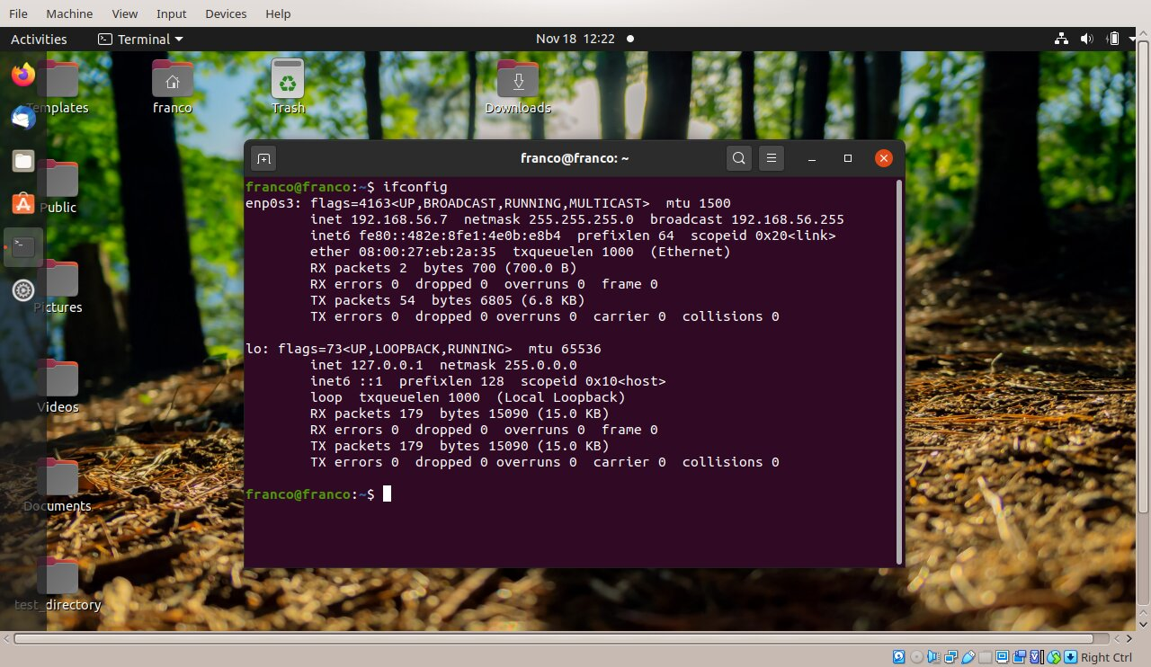Figure 5: Use /sbin/ifconfig to see that the VMs are connected to the same network with the host.

tcpdump:
Before starting tcpdump you have to find the network interface that supports the IP address that is on the Host-Only network established earlier. Use /sbin/ifconfig for this. Suppose it is eth0. Now you can start tcpdump like this:

sudo tcpdump -i eth0 -c 10 -w out.pcap

Packet information on the network will then be captured in file out.pcap. The -c 10 switch calls for tcpdump to quit after 10 packets are captured.

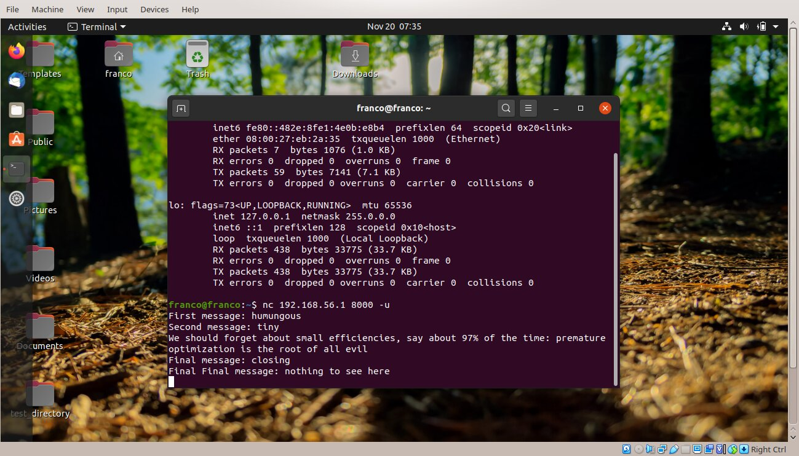Figure 6: Sending text messages from the Ubuntu VM
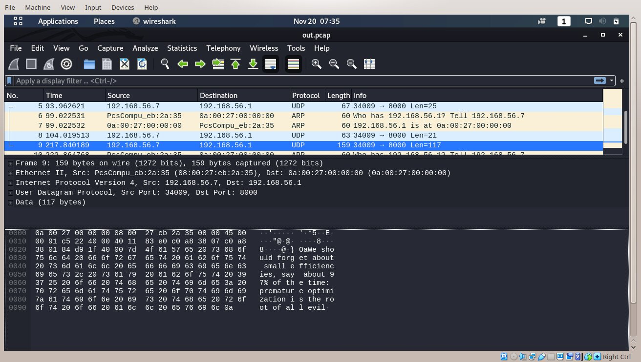Figure 7: Packets captured by tcpdump in out.pcap on the Kali VM are analyzed in wireshark - the packet with the flag is shown

wireshark:
Next open wireshark on out.pcap and look for the packet containing the flag. Figure 6 shows the text messages that are sent from the Ubuntu VM (nc is just an alias for netcat) to the host. Figure 7 shows wireshark applied to out.pcap on the Kali VM, in particular the packet containing the flag is shown – the flag can be seen on the right. The file results.txt contains exactly the text messages that were sent from the Ubuntu VM.

