Running Spring boot application for TODOList app:

1. Copy or clone from git repository.
2. Goto todo directory
3. Run mvn clean build/ mvn package

This will clean build and create the jar files todo-0.0.1.SNAPSHOT.jar

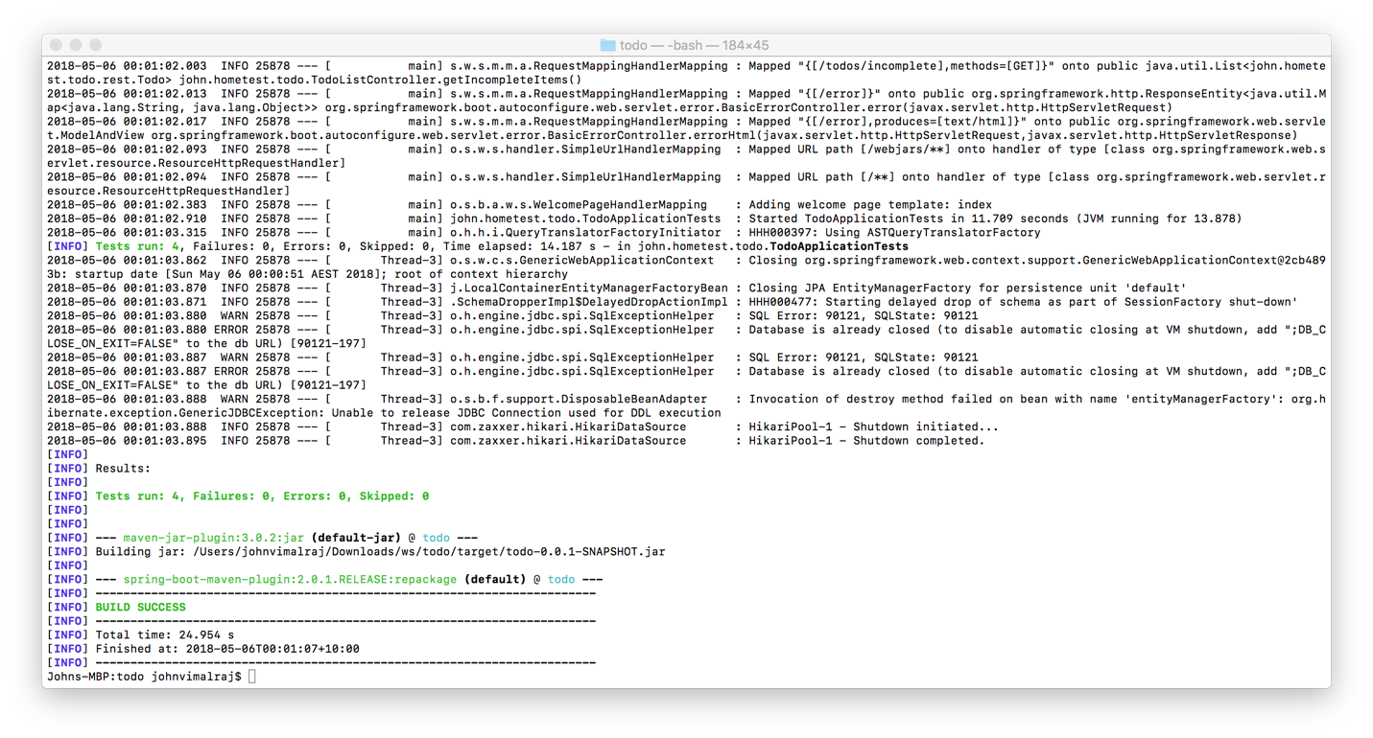

And also run the test case and

[**INFO**] **Tests run: 4**, Failures: 0, Errors: 0, Skipped: 0, Time elapsed: 14.187 s - in john.hometest.todo.**TodoApplicationTests**

2018-05-06 00:01:03.862 INFO 25878 --- [ Thread-3] o.s.w.c.s.GenericWebApplicationContext : Closing org.springframework.web.context.support.GenericWebApplicationContext@2cb4893b: startup date [Sun May 06 00:00:51 AEST 2018]; root of context hierarchy

1. Change directory to target

Run the command java -jar todo-0.0.1.SNAPSHOT.jar

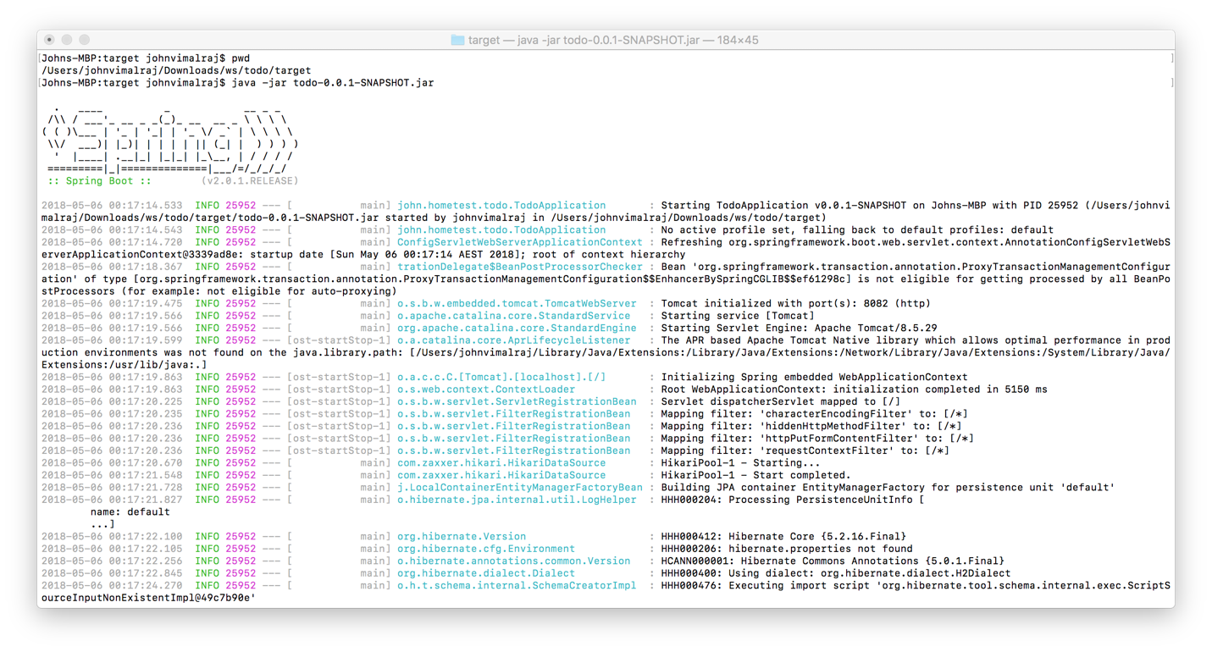

1. Once Started the TodoApplication, Check the webpage in the browser

Host: localhost Port:8082.

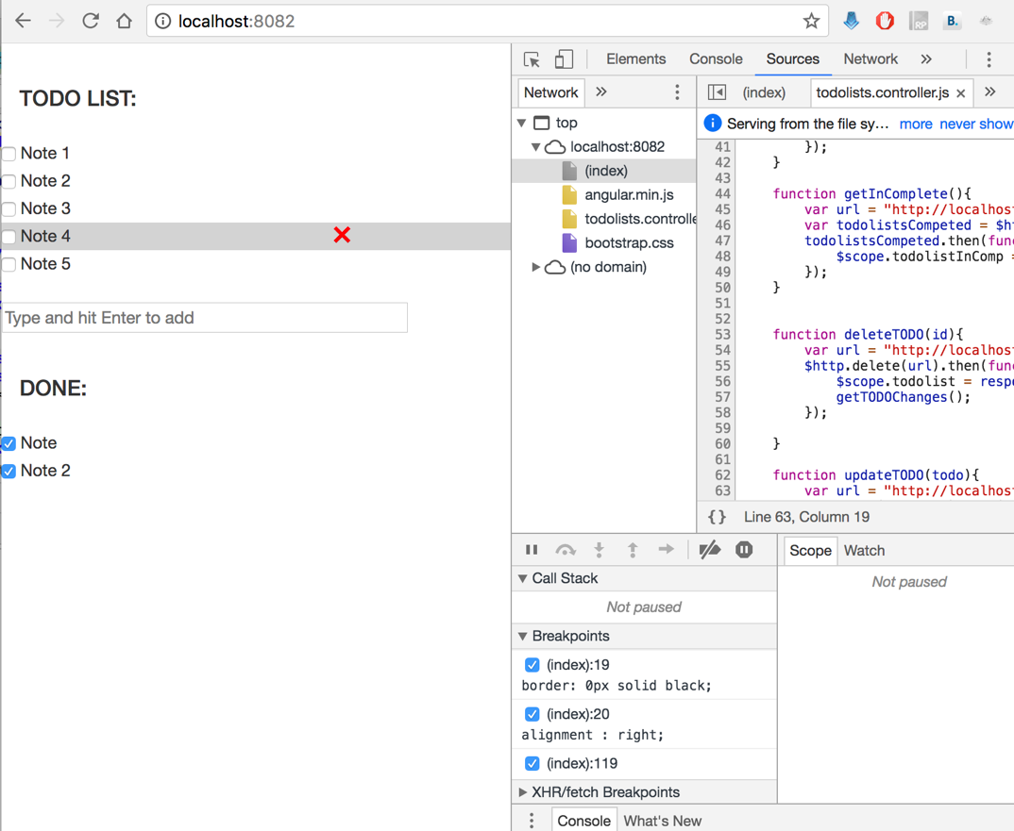

1. REST API test

