Algonquin College Logo

# SCHOOL OF ADVANCED TECHNOLOGY

### ICT - Applications & Programming

### Computer Engineering Technology – Computing Science



A11

Game Interface

Team:

John Vinh - Id: 041-004-759

Game Proposal - NumPuz

***This template is suggested (not mandatory) to answer A11 Specification.***

|  |  |
| --- | --- |
| **Part**  **1** | **GUI Definition** |

**EXPLANATION**

*The purpose of this assignment is to define the elements of the GUI application to be used in your game implementation.*

* ***Example****:*

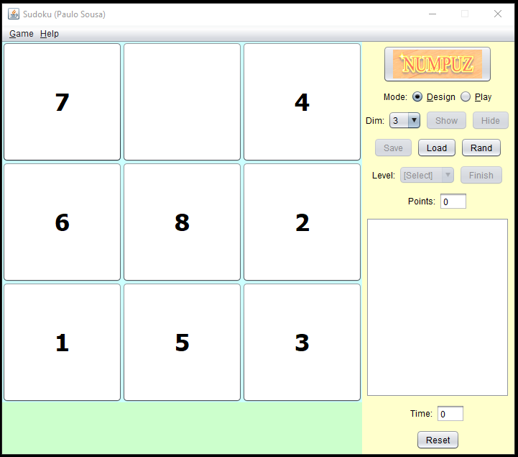

* ***Note****: The professor interface is also a proposal. It means that your own implementation can be different. What does matter is that the game functionality will be respected.*
  1. **Defining the Components**

**List of components**

*Include the list of components that you will use (they can be from Swing or JavaFX).*

Swing components:

* JButton
* JRadioButton
* JComboBox
* JMenu
* JLabel

**Functionalities and Behaviors**

*What are the behaviors and functionalities that you will provide? How these elements are related with functionalities.*

***Example****: The game mode can be selected by RadioButtons, etc.*

* The game mode can be selected by JRadioButtons
* The dimensions can be selected with a JComboBox
* Configurations can be loaded from JMenu
* Game can be reset with a JButton
* Score and elapsed time are shown with JLabel

**Details**

*Drawn your interface (ex: in an image from Paint / Powerpoint slide, or any sketch tool), describing:*

* *The components;*
* *The properties (ex: size, dimension, color, position, etc)*
* *Additional GUI components (ex: the layout to be used).*
  1. **User Manual**

**Basic cycle**

*Create a brief description about how your game can be used.*

***Example****: If you have to design the solution to be saved and played later, how are the stems. Most importantly, how someone can play the* ***NumPuz****.*

* *Note: your process do not need to be followed exactly when you are going to the implementation. For while, it is only a script about how to play.;*
* The game mode should be chosen with a radio button.
* If the game mode is not chosen explicitly, a default one will be selected when the user starts to play.
* Numbers which are adjacent to the empty space can be moved by clicking on them

**FINAL SUGGESTIONS**

*Here some ideas to think about your language....*

* *Try to create a game whose execution can be very intuitive (easy to be played).*
* *Remember that this game will be in fact implemented only in the next assignment.*

**References**

*[Include eventual references used here]*

Algonquin College

Fall, 2022