Unit Converter

DevOps Project Simulation

**Prepared by:**

ralf.jared.q.deuna

john.arvee.r.flores

giomhel.g.c.motos

christine.m.v.olalo

julius.c.l.salando

# Table of Contents

Table of Contents 2

List of Figures 4

Version History 6

Workplan 7

Abstract 8

Description of Roles 9

Introduction 9

Review of Related Literature 9

Amazon Web Services 9

Jenkins 9

SonarQube 9

Ansible 9

GitLab 10

Selenium 10

Tomcat 10

Putty 10

Process Flow 11

Environment Setup 11

Cloud Formation 11

Jenkins 14

SonarQube 14

Ansible 15

GitLab 15

Selenium 16

Tomcat 16

Code Development 19

Continuous Integration/Continuous Deployment 22

Maven 22

SonarQube 26

Ansible 27

Selenium 30

Works Cited 32

# List of Figures

Figure 1 - Methodology 11

Figure 2 - AWS Log In Page 11

Figure 3 - AWS Dashboard 12

Figure 4 - AWS - CloudFormation Dashboard 12

Figure 5 - AWS - Create stack - Select Template 13

Figure 6 - AWS - Create Stack - Specify Details 13

Figure 7 - AWS - Create Stack - Review 14

Figure 8 - Jenkins Dashboard 14

Figure 9 - SonarQube Dashboard 15

Figure 10 - Environment setup - Ansible - Install 15

Figure 11 - Environment setup - Ansible Version 15

Figure 12 - Environment setup - Ansible - Install Ansible Lint 15

Figure 13 - Environment setup - Ansible Lint Version 15

Figure 14 - GitLab Dashboard 16

Figure 15 - Selenium Dashboard 16

Figure 16 - Tomcat Dashboard 17

Figure 17 - Tomcat Application Manager Dashboard 17

Figure 18 - Environment Setup - Docker Machine Installation 17

Figure 19 - Environment Setup - Docker Compose installation 18

Figure 20 - Environment Setup - Docker Compose Change Mode 18

Figure 21 - Environment Setup - Tomcat - Docker Compose Link 18

Figure 22 - Environment Setup - Tomcat - Run Tomcat 18

Figure 23 - Environment Setup - Tomcat Edit Users 18

Figure 24 - Environment Setup - Tomcat - Adding of roles 18

Figure 25 - Environment Setup - Tomcat - Return tomcat-users.xml to original folder 18

Figure 26 - Environment Setup - Tomcat - Restart Tomcat 19

Figure 27 - Unit Converter Page 19

Figure 28 - Code Development - Source Code 21

Figure 29 - Maven - Create a freestyle project 22

Figure 30 - Maven - Project Options 22

Figure 31 - Maven - Source Code Management Configuration 23

Figure 32 - Maven - Build Triggers Configuration 23

Figure 33 - Maven - Build Environment Configuration 24

Figure 34 - Maven - Build Step Configuration 24

Figure 35 - Maven - Post-build Action Configuration 25

Figure 36 - SonarQube - Create a freestyle project 26

Figure 37 - SonarQube - Project Options Configuration 26

Figure 38 - Ansible - Create a freestyle Project 27

Figure 39 - Ansible - Configure Project Options 28

Figure 40 - Ansible - Source Code Management 28

Figure 41 - Ansible - Build Environment 29

Figure 42 - Ansible - Build Configuration 29

Figure 43 - Ansible Post-build Actions 30

Figure 44 - Selenium Project Options 30

Figure 45 - Selenium Build Configuration 31

Figure 46 - Selenium Output 31

# Version History

|  |  |  |  |
| --- | --- | --- | --- |
| **Name** | **Version** | **Date** | **Comment** |
| ralf.jared.q.deuna | 1.0 | 07/14/2016 | Created document template |
| ralf.jared.q.deuna | 1.1 | 07/14/2016 | Added CloudFormation setup, and ADOP dashboard and configuration |
| ralf.jared.q.deuna | 1.1 | 07/14/2016 | Added version 1 of Unit Converter |
| ralf.jared.q.deuna | 1.2 | 07/15/2016 | Added figure captions |
| ralf.jared.q.deuna | 1.3 | 07/18/2016 | Added Maven, and SonarQube build configuration |
| julius.c.l.salando | 1.3 | 07/18/2016 | Added Review of Related Literature |
| christine.m.v.olalo | 1.4 | 07/19/2016 | Added Introduction |
| giomhel.g.c.motos | 1.4 | 07/19/2016 | Added methodology |
| john.arvee.r.flores | 1.4 | 07/19/2016 | Added abstract |
| ralf.jared.q.deuna | 1.5 | 07/21/2016 | Added Ansible and Selenium build configuration |

# Workplan

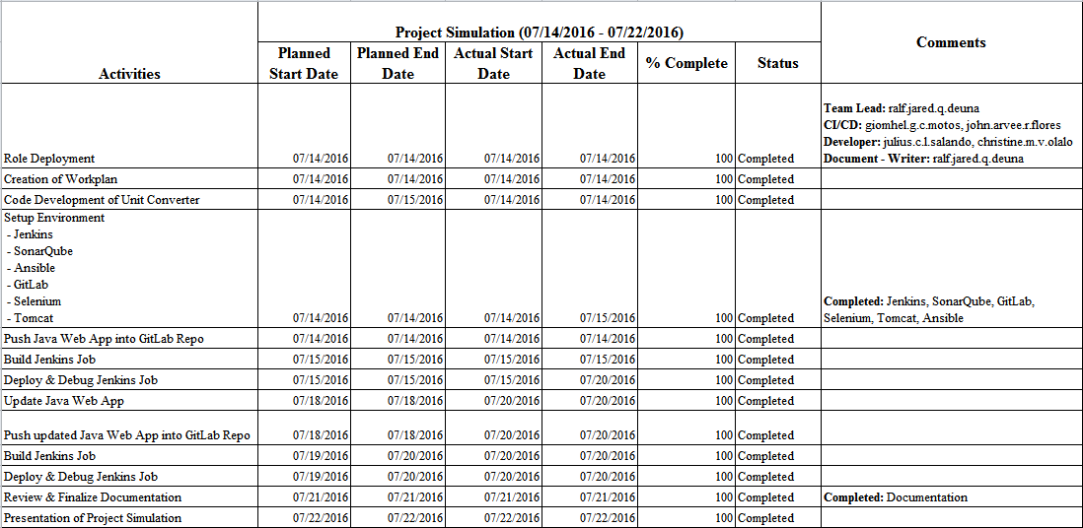

# Abstract

This project involves a simulation of a real life project as Development Operations (DevOps). DevOps is the overall practice of automating the process of software development and infrastructure changes. As DevOps, the goal is to create an end to end process starting from code development, SCM, application building, testing, environment provisioning up to project deployment with the use of automation tools that vary from build automation to continuous integration and continuous development. The team decided on creating a web-based unit converter app. Development started with constructing an Amazon Web Services (AWS) instance which functions as the server of the project. The needed configuration for each tool was then set up in the created server which would act as the main environment in the entire lifecycle of the project. Using the automation tools provided, the team was able to completely and correctly build and test the web app from design through the development process to deployment.

# Description of Roles

|  |  |  |
| --- | --- | --- |
| **Role** | **Responsibility** | **Name** |
| Team Lead | Overall in-charge of the project | ralf.jared.q.deuna |
| CI/CD | In-charge of Configuration of Tools | giomhel.g.c.motos, john.arvee.r.flores |
| Developer | In-charge of the Development of Application that will be used | julius.c.l.salando, christine.m.v.olalo |
| Document – Writer | In-charge of Documenting the whole project | ralf.jared.q.deuna |

# Introduction

Development Operations (DevOps) can be described as the overall practice of automating the process of software delivery and infrastructure changes. Different tools are integrated to ensure that projects are completely and correctly done in the entire service lifecycle, from design through the development process to production support. These automation tools that vary from build automation to continuous integration can leverage increasingly programmable and dynamic infrastructures from a lifecycle perspective.

DevOps also promotes cross functionality and shared responsibilities. It essentially extends continuous development goals to continuous integration and release. (What is DevOps?, 2016) (What Is This Devops Thing, Anyway, n.d.)

# Review of Related Literature

## Amazon Web Services

Amazon Web Services (AWS) is a cloud services platform. It provides a broad set of infrastructure services, such as computing power, storage options, networking and databases, delivered as a utility: on-demand, available in seconds, with pay-as-you-go pricing. It is available in 190 countries, through 12 geographic Regions, 32 Availability Zones, and over 50 local Points of Presence. It was launched in 2006. (What is AWS? – Amazon Web Services, n.d.)

## Jenkins

Jenkins is an open source continuous integration tool written in Java. It is a server-based system running in a servlet container such as Apache Tomcat. Jenkins provides hundreds of plugins to support building, deploying and automating any project. (Jenkins, n.d.)

## SonarQube

SonarQube (formerly known as Sonar) is an open source tool used to measure and analyze code quality. It is written in Java but is able to analyze code in many languages. It covers seven axes of code quality: Architecture and Design, Duplications, Unit tests, Complexity, Potential bugs, Coding rules and Comments. (SonarQube, n.d.) (Geiger, 2014)

## Ansible

Ansible is a software platform for managing and combining multi node software deployment, as well as ad-hoc changes in the execution and configuration management of a system. It is designed for multi-tier deployments. Ansible models IT infrastructure by describing how systems inter-relate, rather than just managing one system at a time. It works by connecting to your nodes and pushing out small programs, called "Ansible Modules" to them. These programs are written to be resource models of the desired state of the system. Ansible then executes these modules (over SSH by default), and removes them when finished. (Millares, 2016) (OVERVIEW: How Ansible Works, n.d.)

## GitLab

GitLab is an application to code, test, and deploy code together. It provides Git repository management with fine grained access controls, code reviews, issue tracking, activity feeds, wikis, and continuous integration. It is a remote repository where you can create projects of different sizes with speed and efficiency. It helps you manage code, communicate and collaborate on different software projects. (Carias, 2015) (About Us, n.d.)

## Selenium

Selenium is a free (open source) automated testing suite for web applications across different browsers and platforms. It is quite similar to HP Quick Test Pro (QTP) only that Selenium focuses on automating web-based applications.

Selenium is not just a single tool but a suite of software's, each catering to different testing needs of an organization. It has four components.

· Selenium Integrated Development Environment (IDE)

· Selenium Remote Control (RC)

· WebDriver

· Selenium Grid

(Introduction to Selenium, n.d.)

## Tomcat

Apache Tomcat, often referred to as Tomcat, is an open-source web server developed by the Apache Software Foundation (ASF). Tomcat implements several Java EE specifications including Java Servlet, JavaServer Pages (JSP), Java EL, and WebSocket, and provides a "pure Java" HTTP web server environment in which Java code can run. (Apache Tomcat, 2016)

## Putty

PuTTY is an SSH and telnet client, developed originally by Simon Tatham for the Windows platform. (PuTTY, n.d.)

# Process Flow

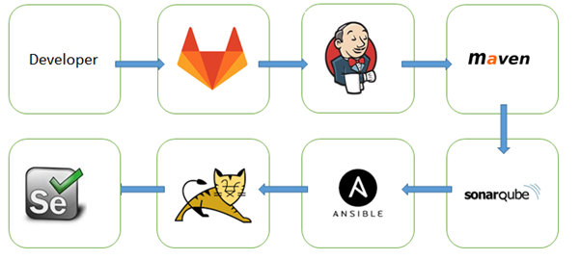

Figure 1 - Methodology

The developer of the application pushes the codes of the web application to the GitLab repository which triggers Jenkins to automatically start the build via webhooks. Jenkins then builds specific jobs that are needed by the project. Maven is the first Jenkins job which is used to package the code and generates the WAR file. SonarQube then provides specific tests to assure that the codes of the web application passes the quality gates specified. After the tests, the project then is deployed by Ansible to Tomcat which will then contain the web application. Selenium will test if the web application link is up or not, or other test cases.

# Environment Setup

## Cloud Formation

Step 1: Login using your credentials in AWS

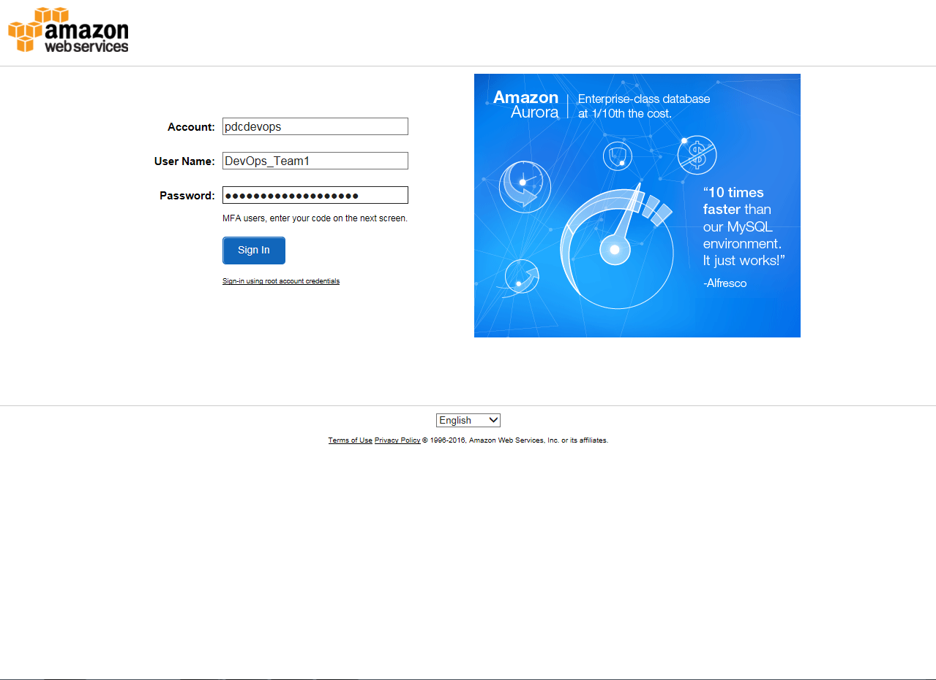

Figure 2 - AWS Log In Page

Step 2: Select “CloudFormation” on the Dashboard

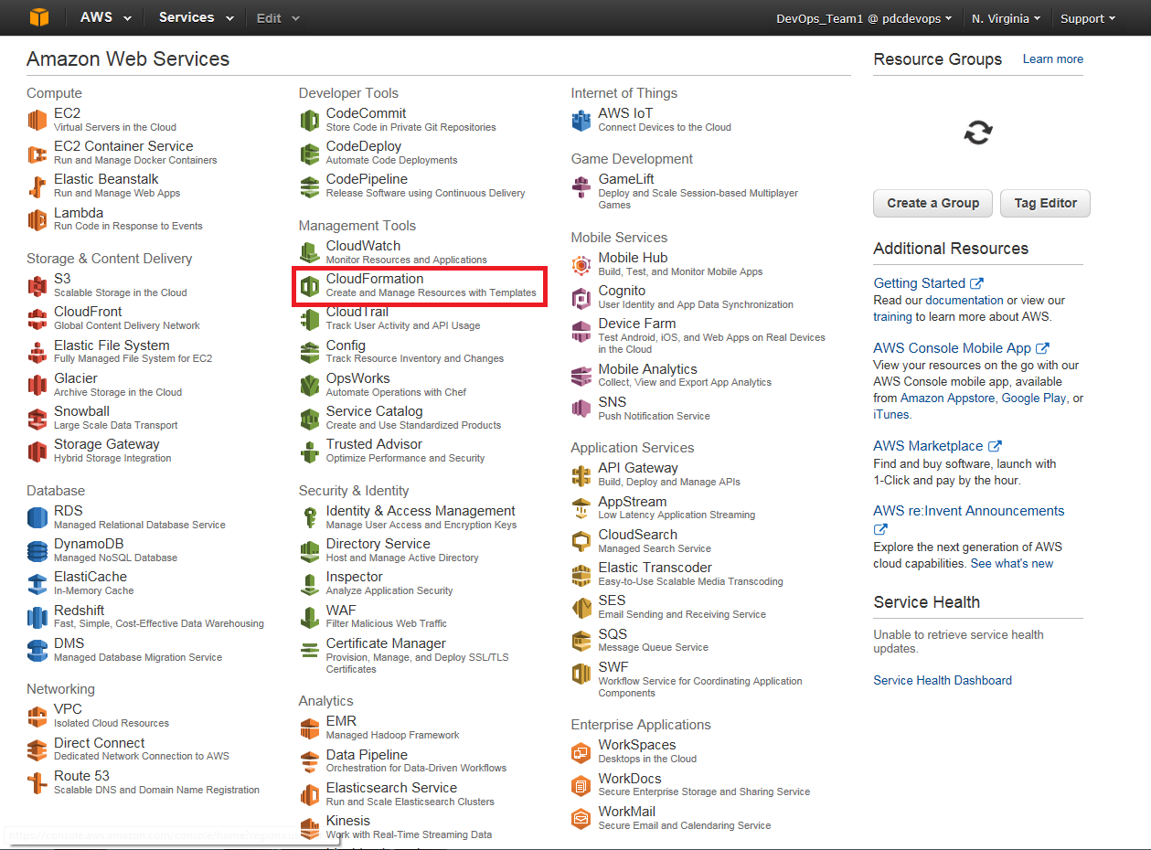

Figure 3 - AWS Dashboard

Step 3: Select “Create a Stack” in the CloudFormation Dashboard

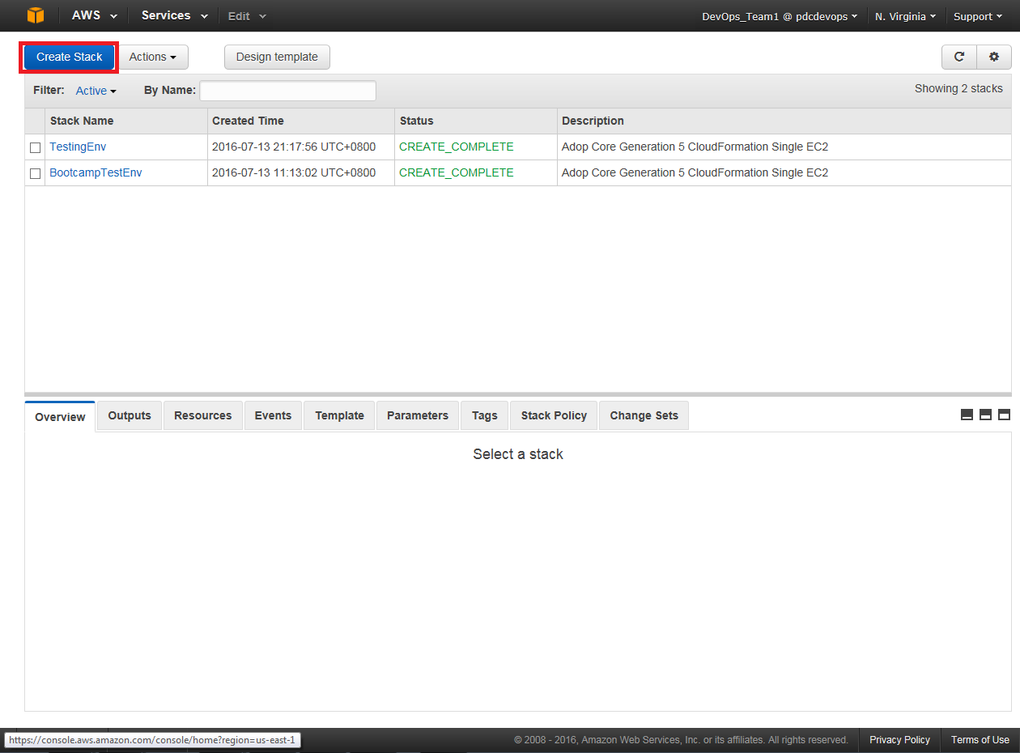

Figure 4 - AWS - CloudFormation Dashboard

Step 4: Select “Upload a template to Amazon S3” and upload your JSON file

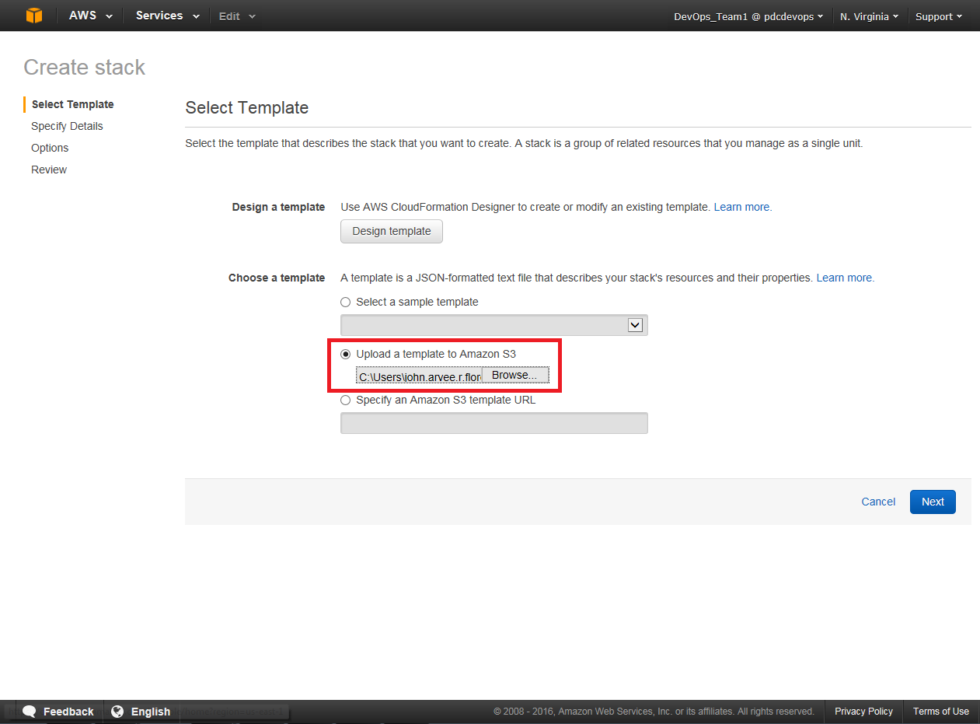

Figure 5 - AWS - Create stack - Select Template

Step 5: Specify your Stack name and enter the Parameters required

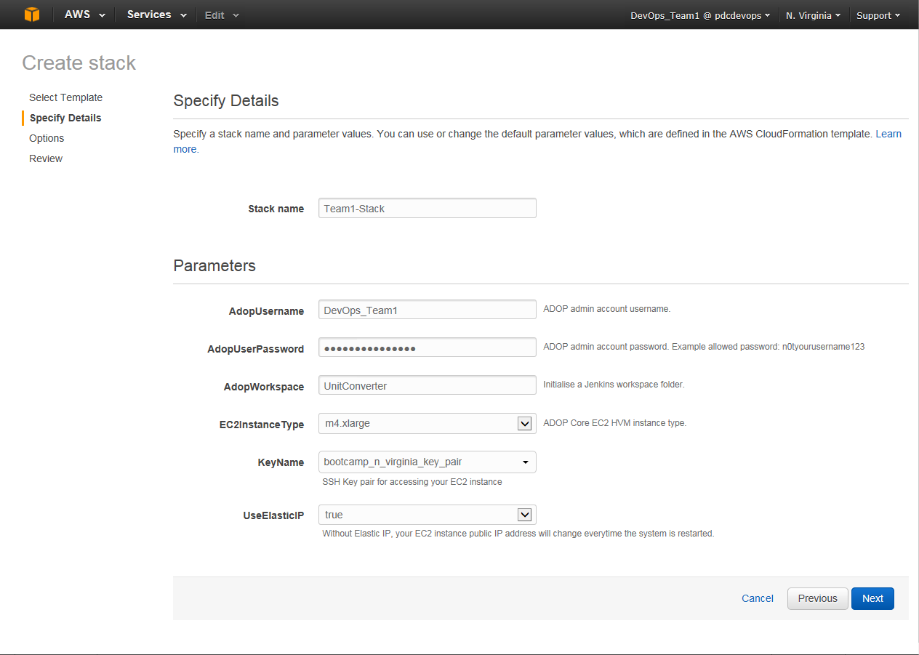

Figure 6 - AWS - Create Stack - Specify Details

Step 6: Review the details and the click Create

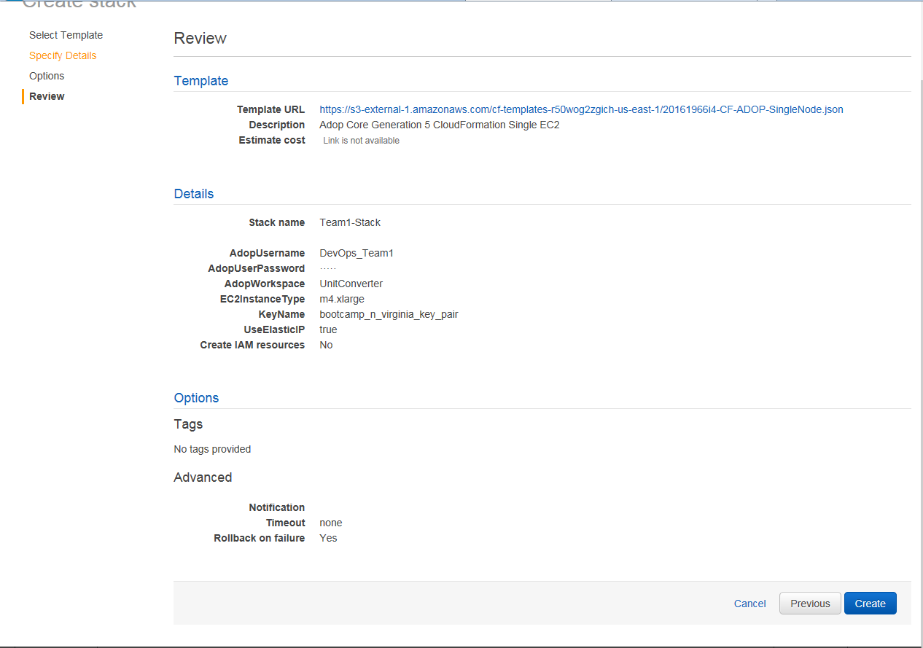

Figure 7 - AWS - Create Stack - Review

Through the setup of CloudFormation, Jenkins, SonarQube, GitLab, Selenium, and other tools were also created.

## Jenkins

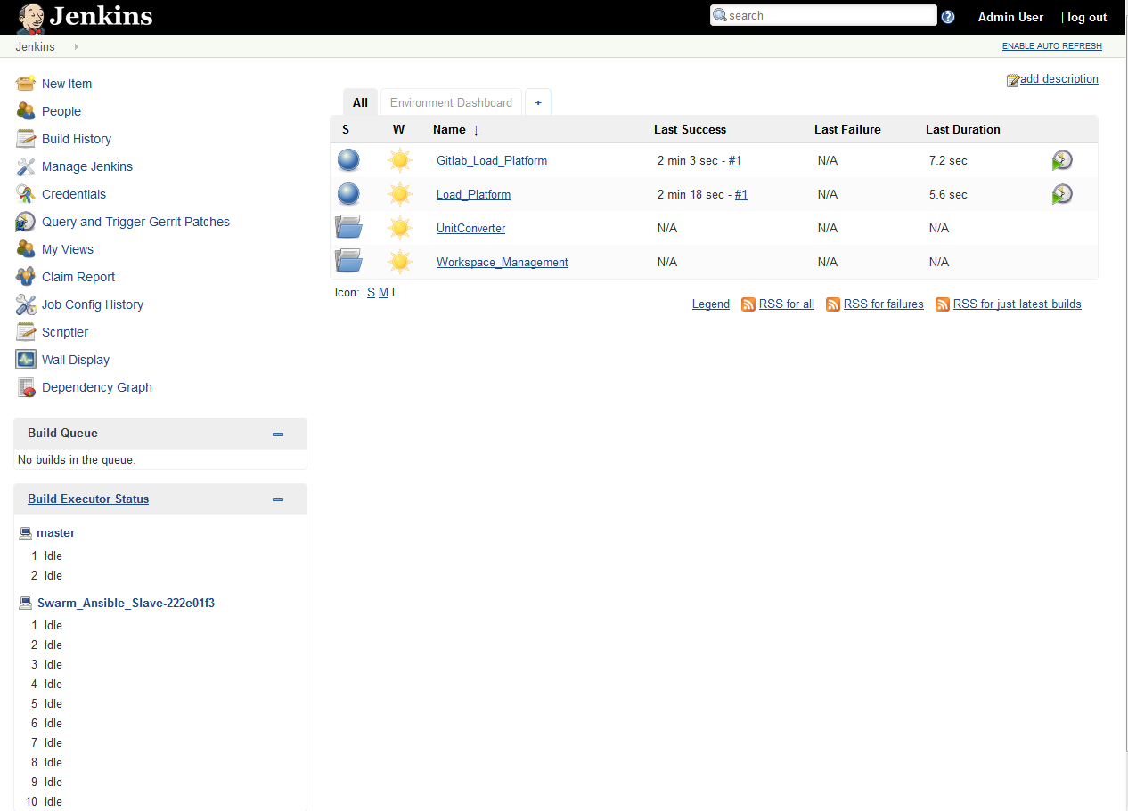

Figure 8 - Jenkins Dashboard

## SonarQube

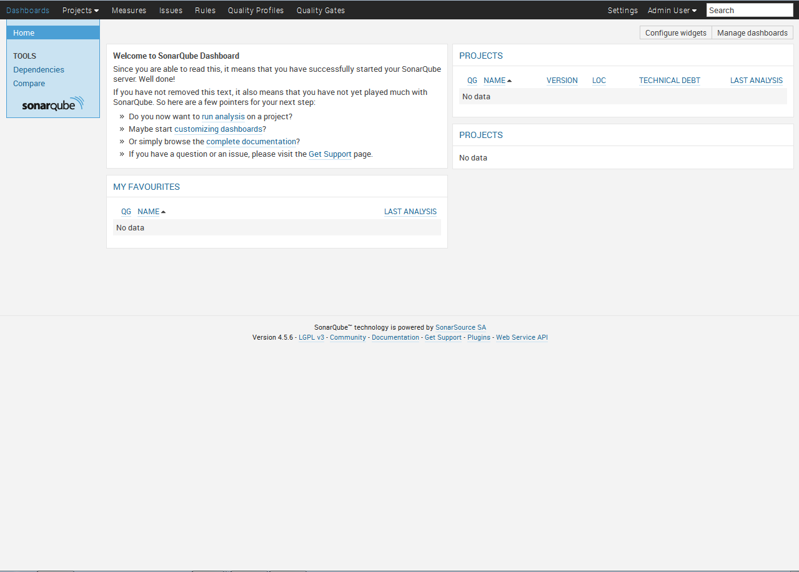

Figure 9 - SonarQube Dashboard

## Ansible

Step 1: Enter the command “sudo pip install ansible” to install ansible.

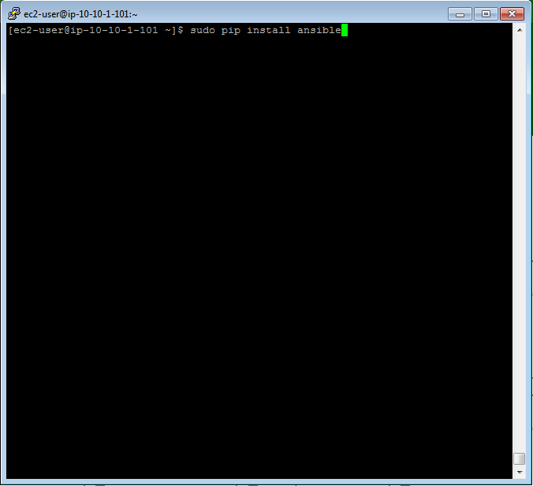

Figure 10 - Environment setup - Ansible - Install

Step 2: Verify the version of ansible with the command “ansible –version”

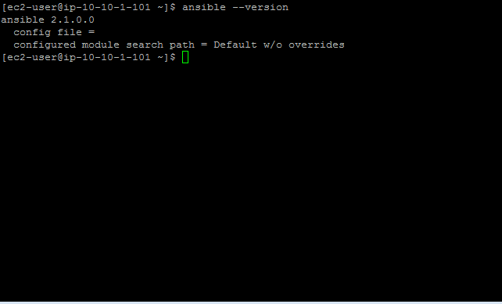

Figure 11 - Environment setup - Ansible Version

Step 3: Enter the command “sudo pip install ansible-lint” to install ansible-lint.

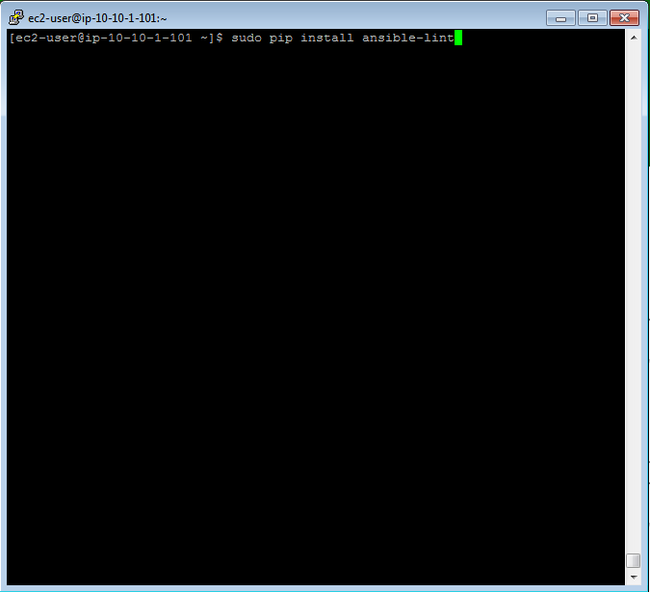

Figure 12 - Environment setup - Ansible - Install Ansible Lint

Step 4: Verify ansible-lint version with the command “ansible-lint –version”

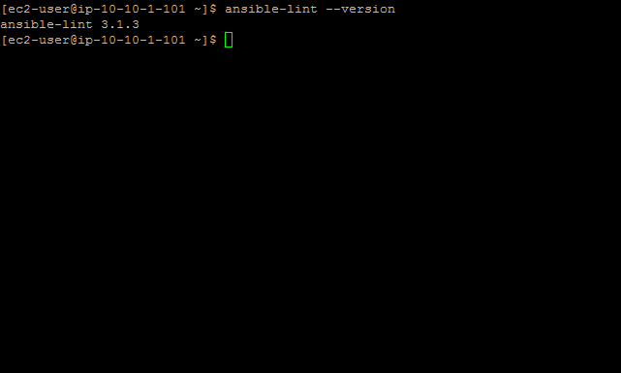

Figure 13 - Environment setup - Ansible Lint Version

## GitLab

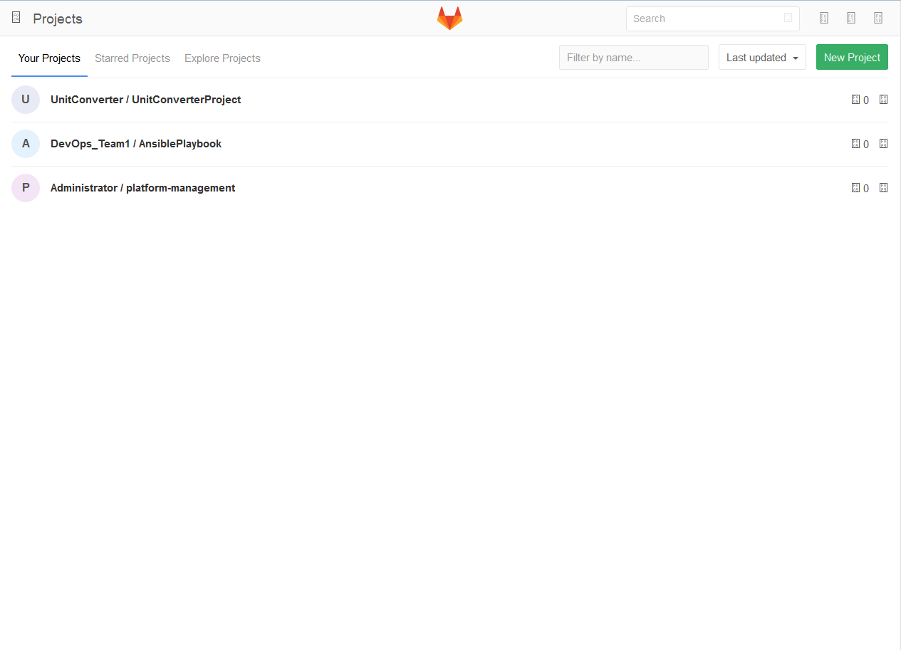

Figure 14 - GitLab Dashboard

## Selenium

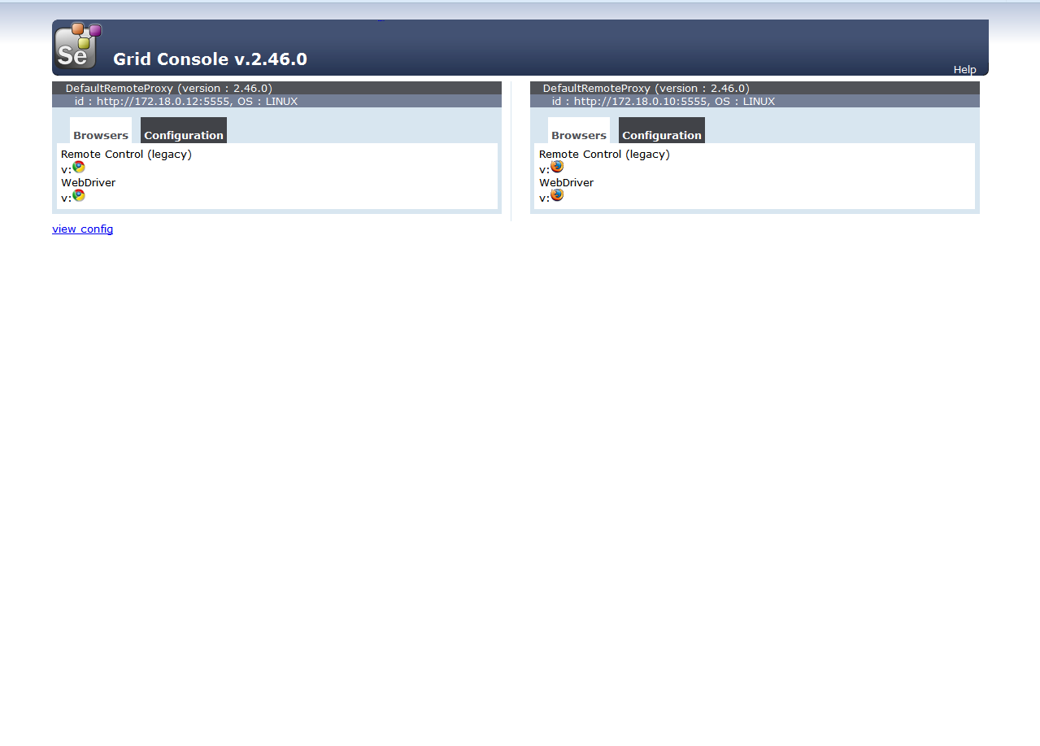

Figure 15 - Selenium Dashboard

## Tomcat

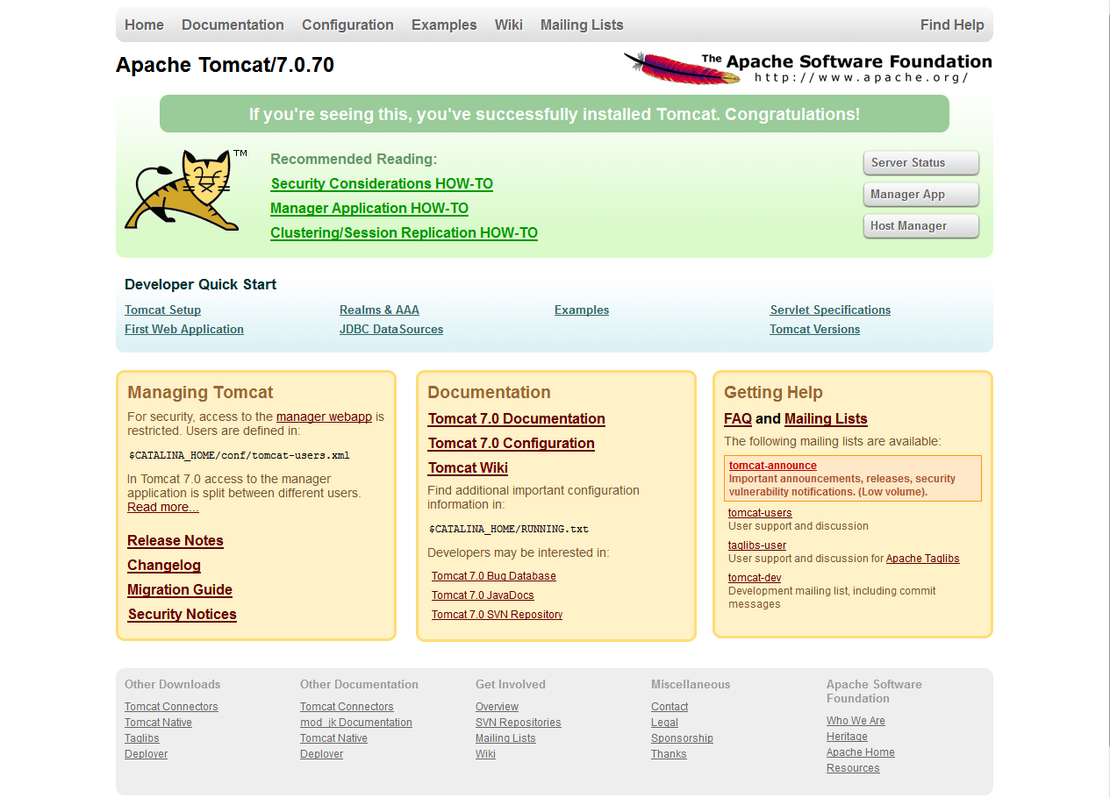

Figure 16 - Tomcat Dashboard

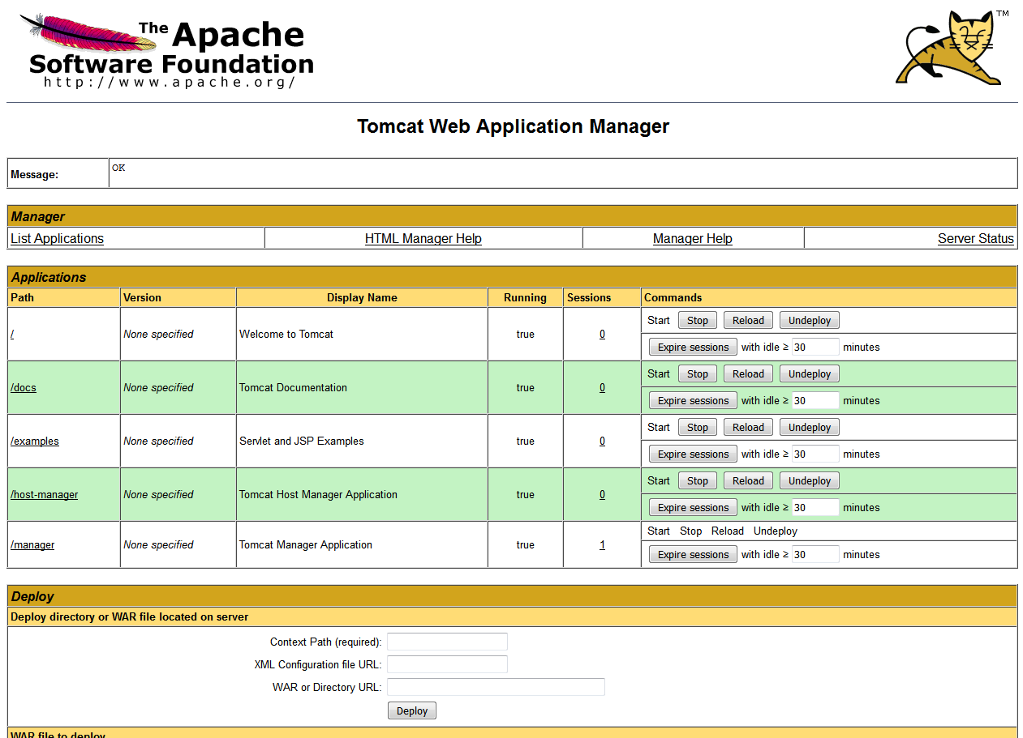

Figure 17 - Tomcat Application Manager Dashboard

Step 1: Install Docker Machine

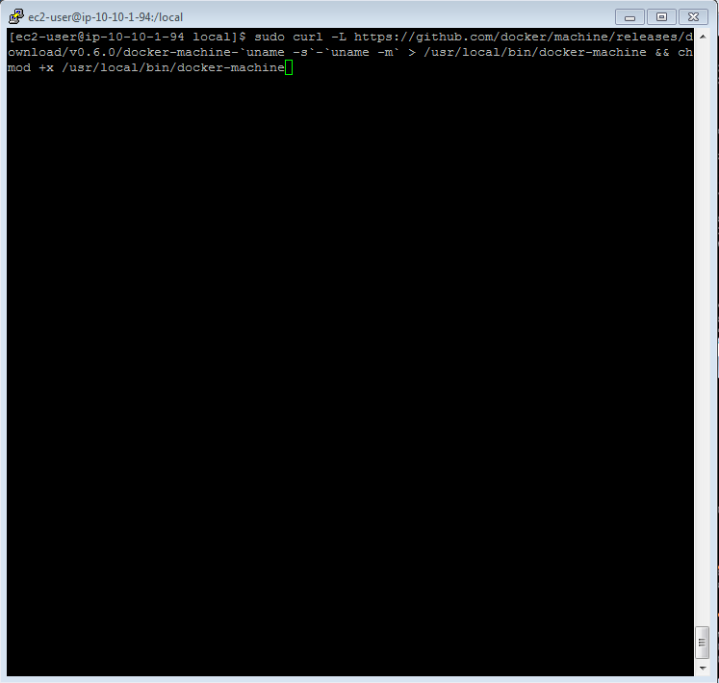

Figure 18 - Environment Setup - Docker Machine Installation

Step 2: Install Docker Compose

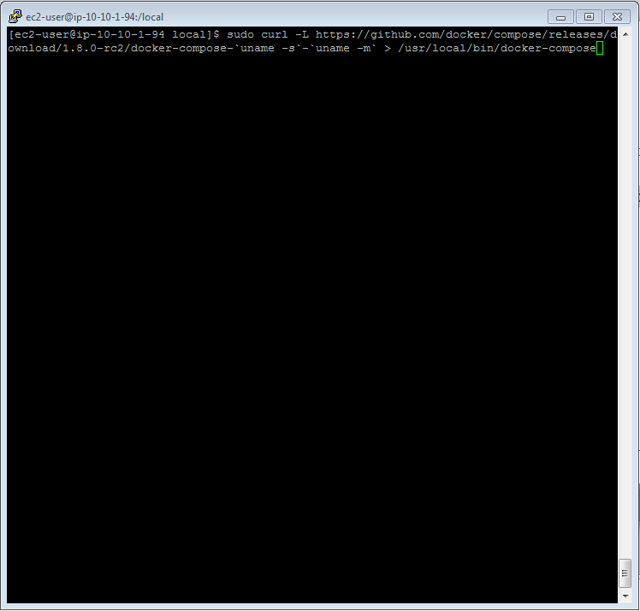

Figure 19 - Environment Setup - Docker Compose installation

Step 3: Change permission

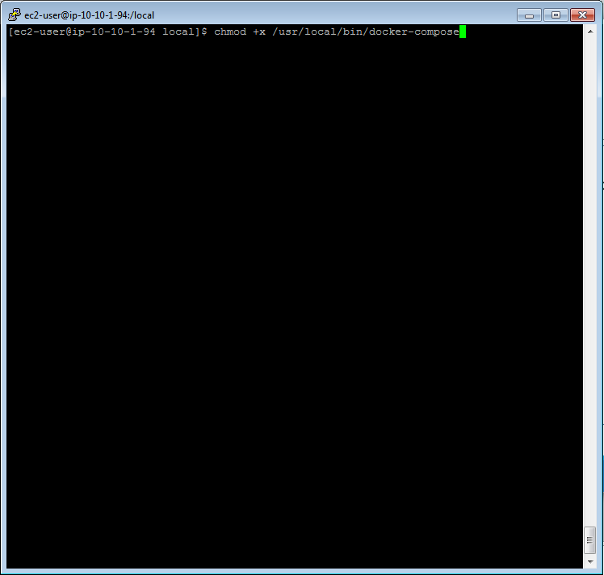

Figure 20 - Environment Setup - Docker Compose Change Mode

Step 4: Docker Compose is linked in the folder /usr/bin

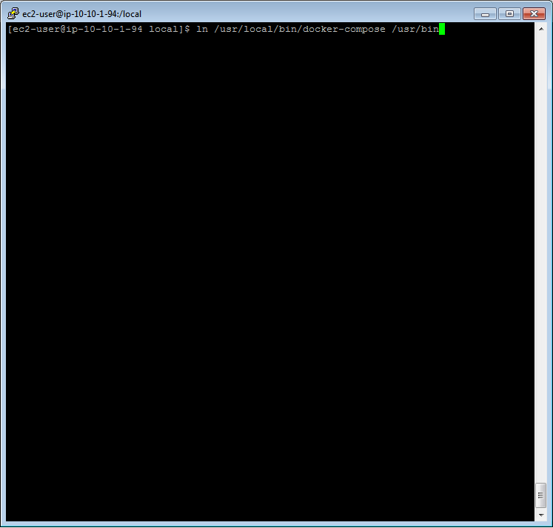

Figure 21 - Environment Setup - Tomcat - Docker Compose Link

Step 5: Run Tomcat

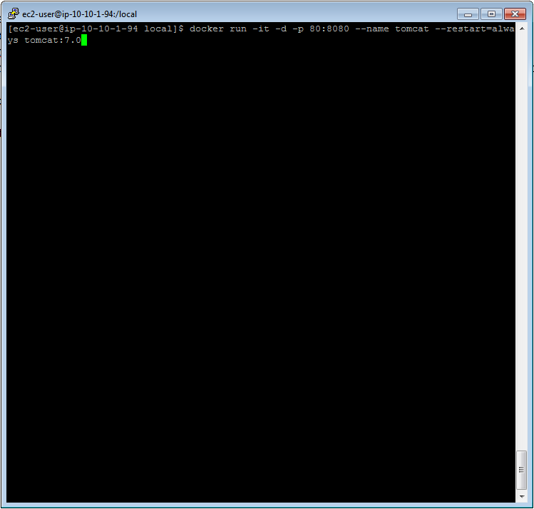

Figure 22 - Environment Setup - Tomcat - Run Tomcat

Step 6: Edit tomcat-user.xml

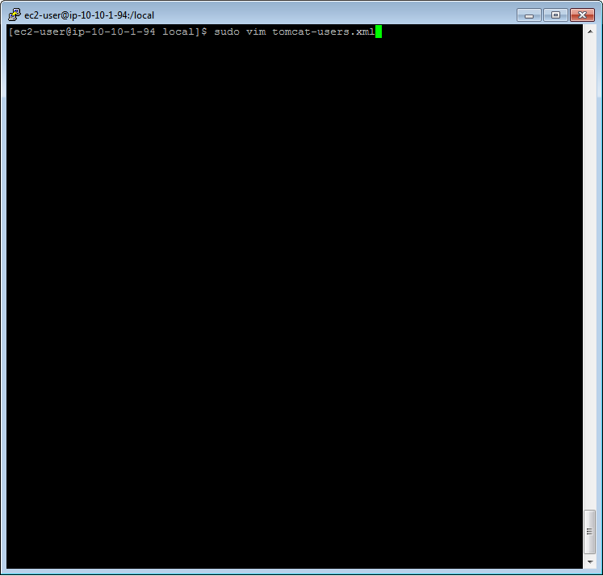

Figure 23 - Environment Setup - Tomcat Edit Users

Step 7: Add username and password

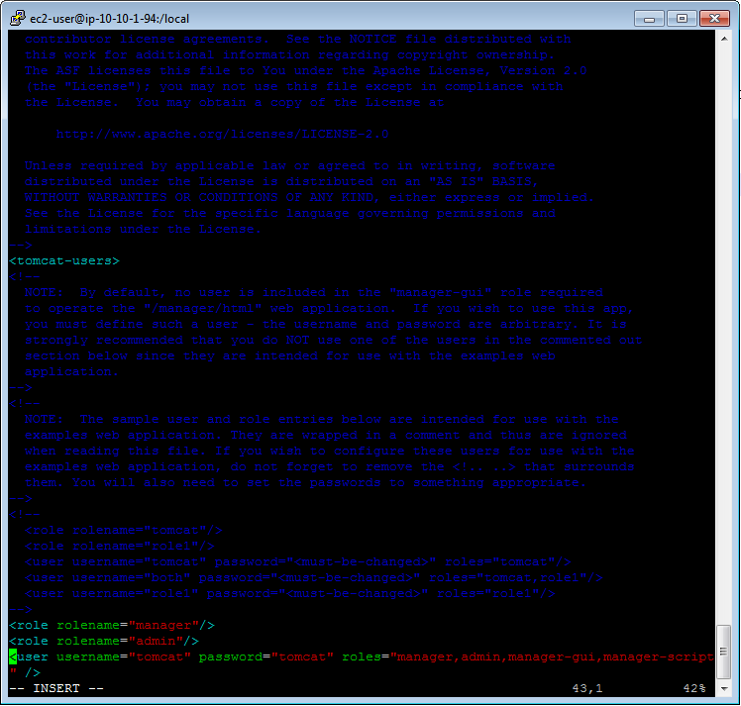

Figure 24 - Environment Setup - Tomcat - Adding of roles

Step 8: Return tomcat-users.xml to original folder

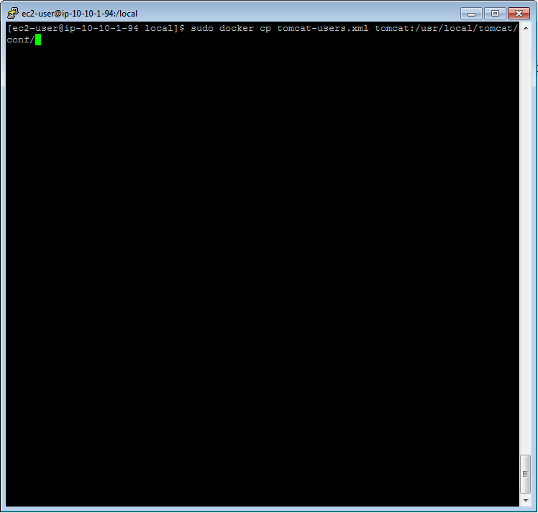

Figure 25 - Environment Setup - Tomcat - Return tomcat-users.xml to original folder

Step 9: Restart Tomcat

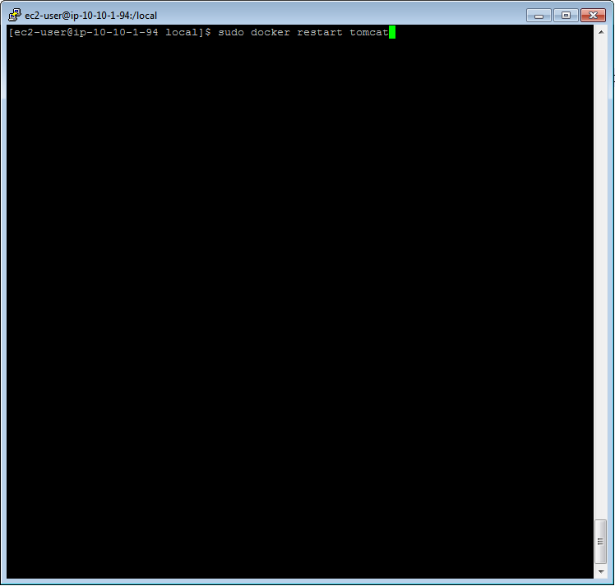

Figure 26 - Environment Setup - Tomcat - Restart Tomcat

# Code Development

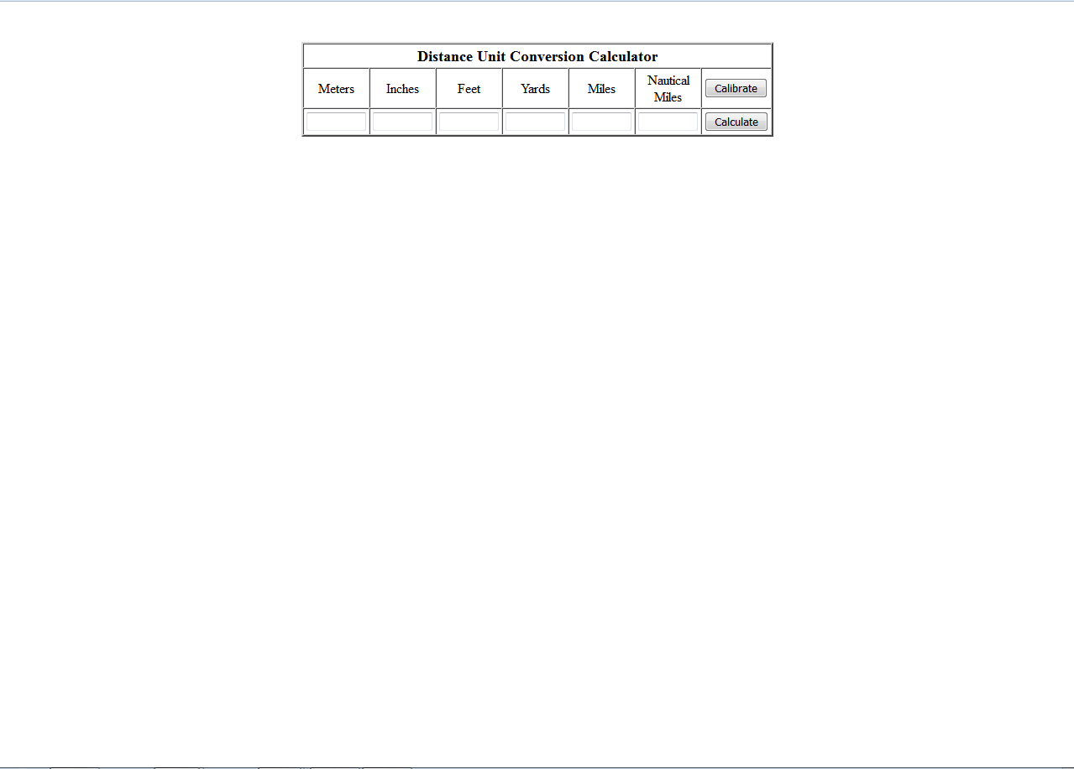

Figure 27 - Unit Converter Page

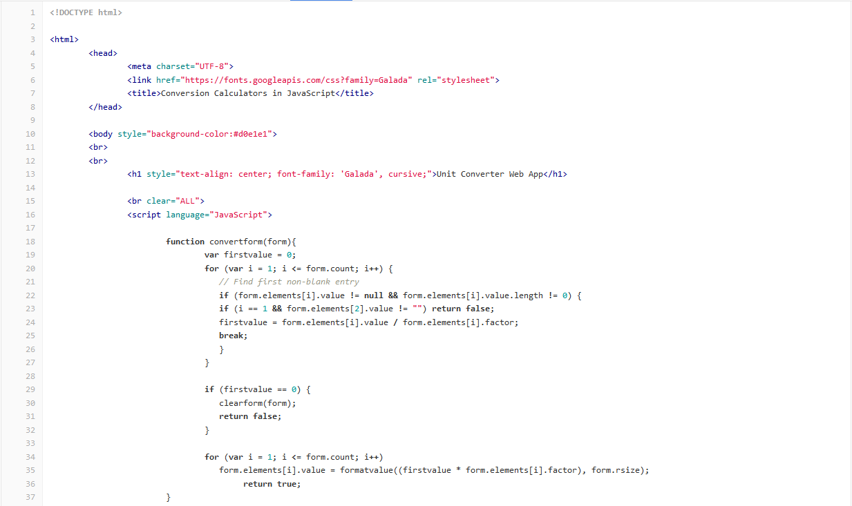

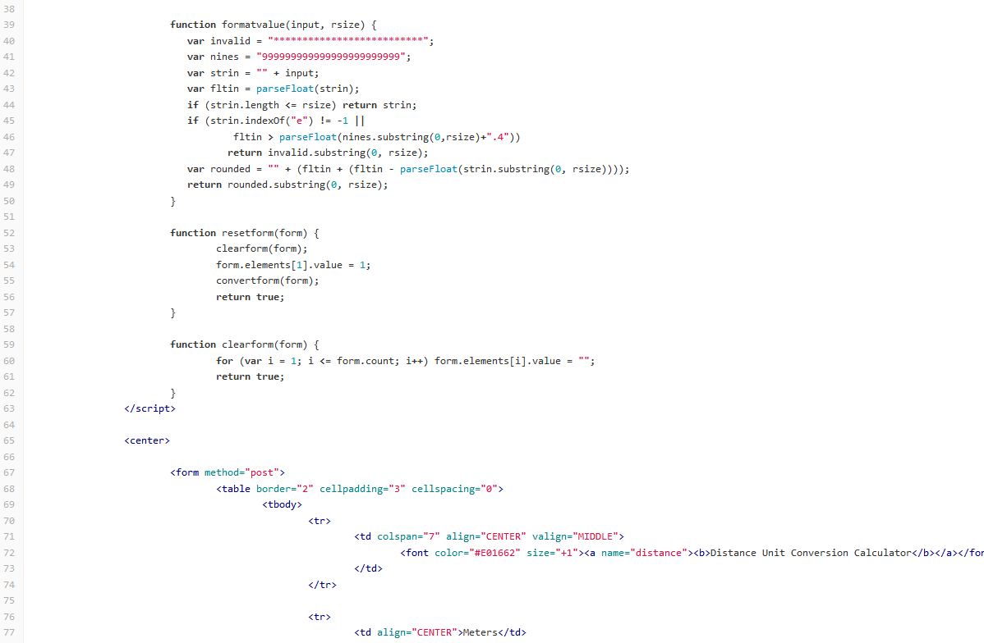

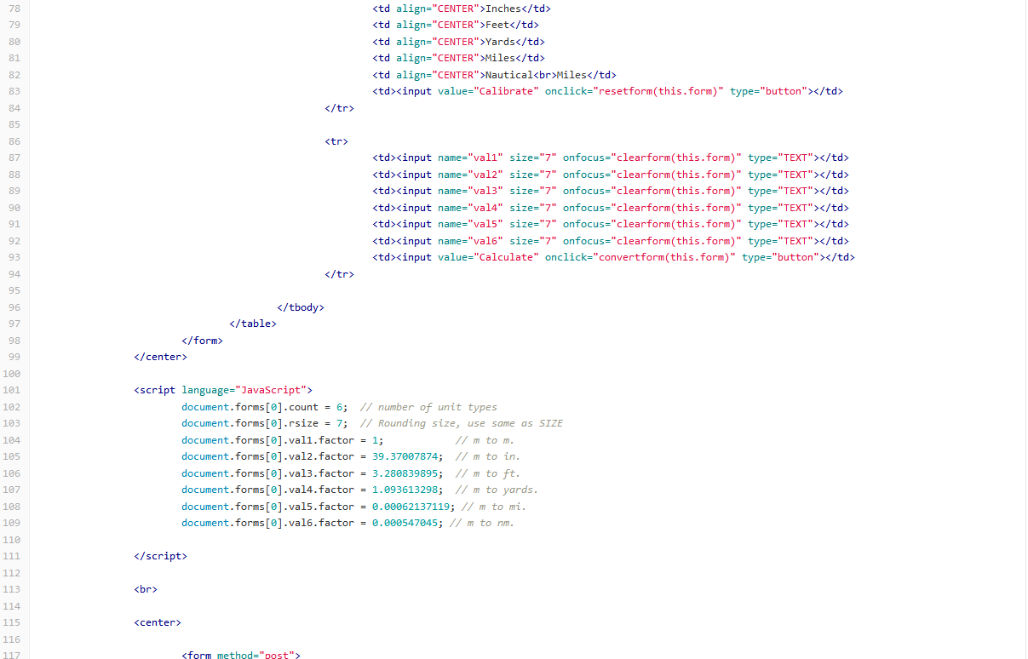

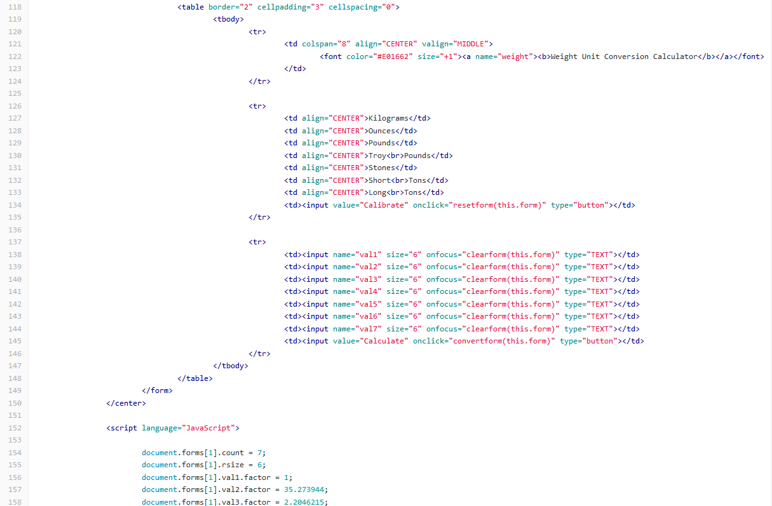

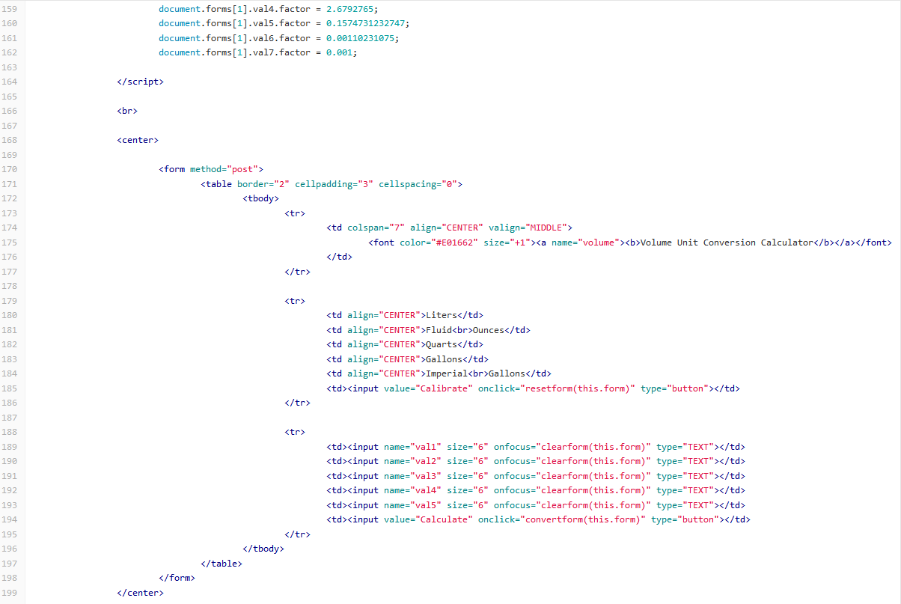

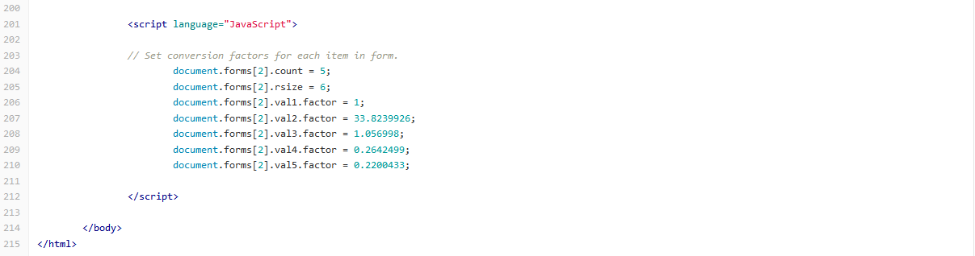

Figure 28 - Code Development - Source Code

# Continuous Integration/Continuous Deployment

## Maven

Step 1: Create a freestyle project

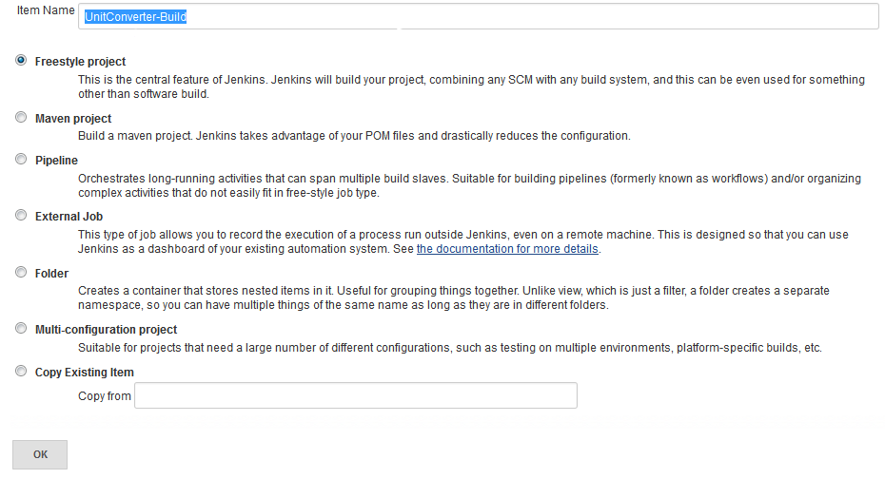

Figure 29 - Maven - Create a freestyle project

Step 2: Configure Project Options

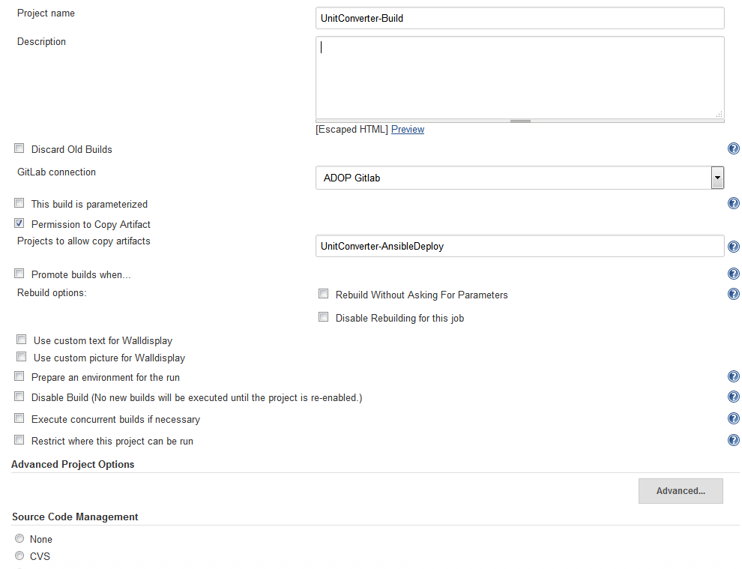

Figure 30 - Maven - Project Options

Step 3: Configure Maven Source Code Management

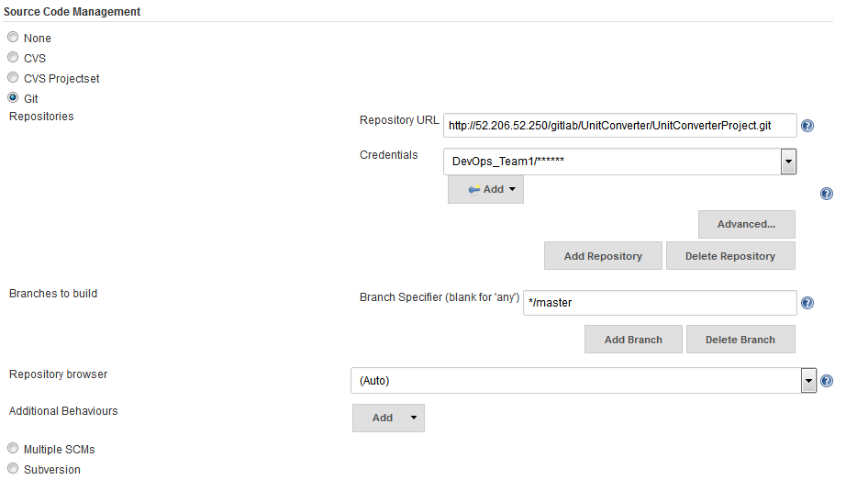

Figure 31 - Maven - Source Code Management Configuration

Step 4: Configure Build Triggers

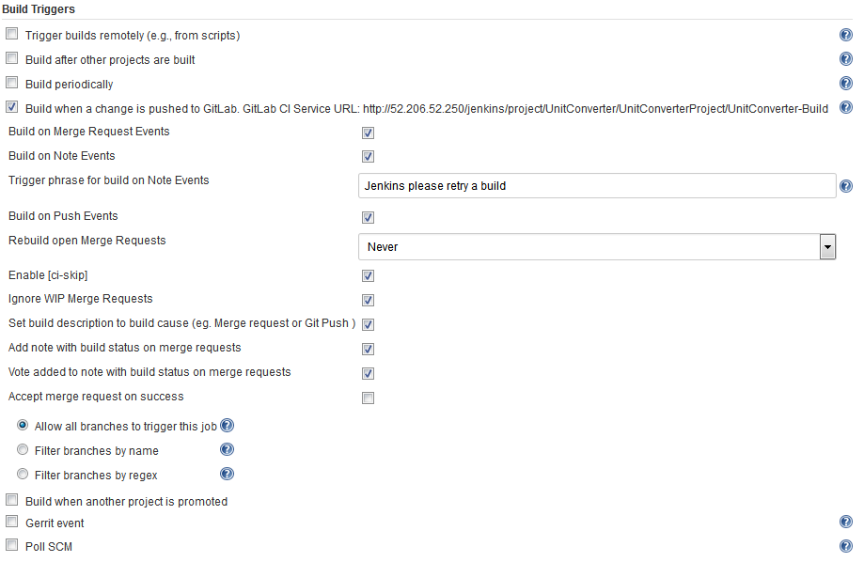

Figure 32 - Maven - Build Triggers Configuration

Step 5: Configure Build Environment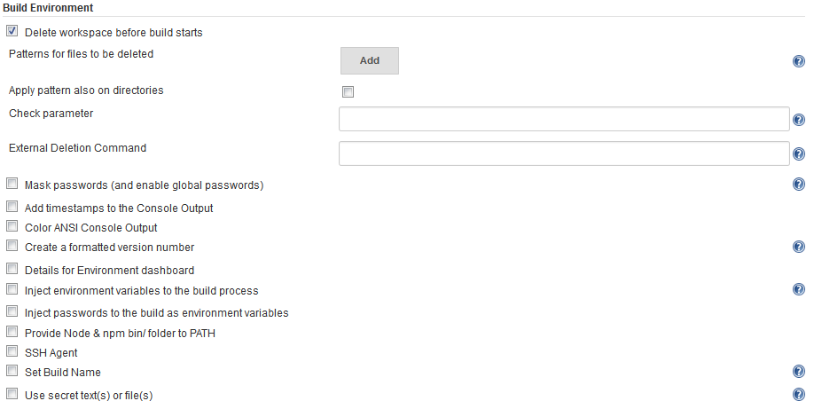

Figure 33 - Maven - Build Environment Configuration

Step 6: Configure Build Step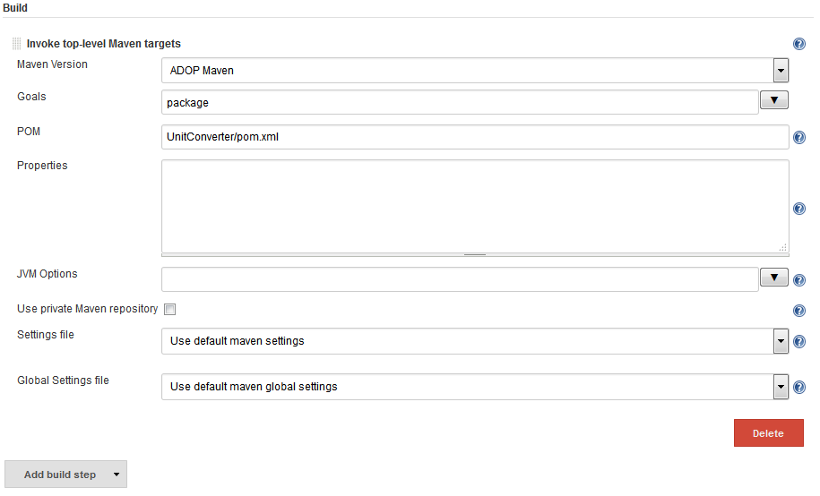

Figure 34 - Maven - Build Step Configuration

Step 7: Configure Post-build Action

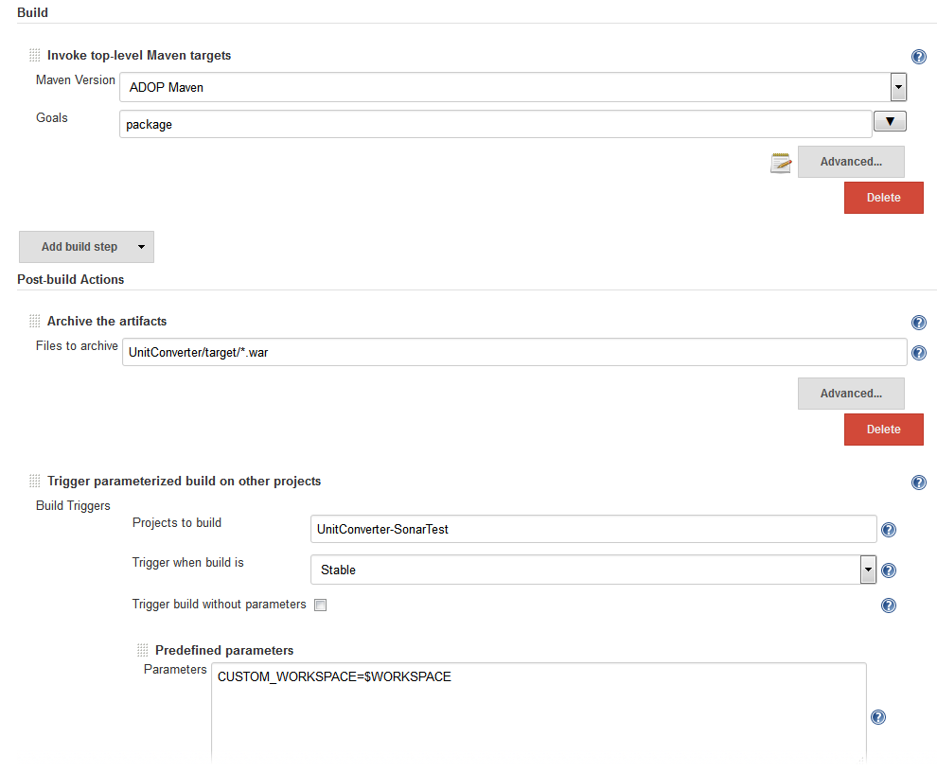

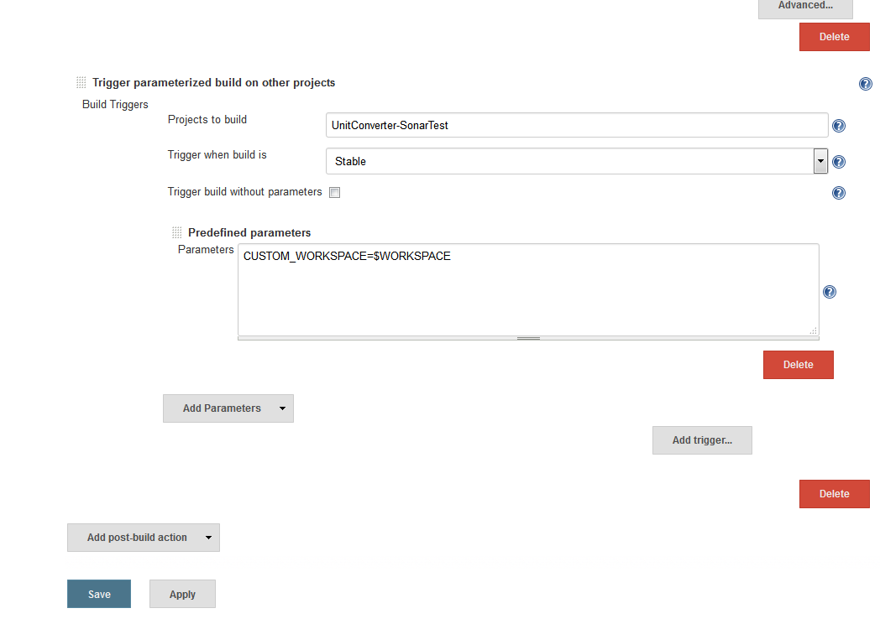

Figure 35 - Maven - Post-build Action Configuration

## SonarQube

Step 1: Create Freestyle project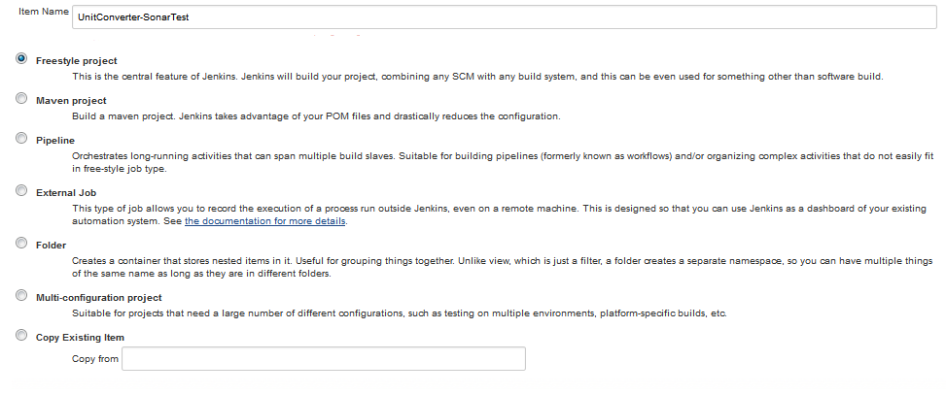

Figure 36 - SonarQube - Create a freestyle project

Step 2: Configure Advance Project Options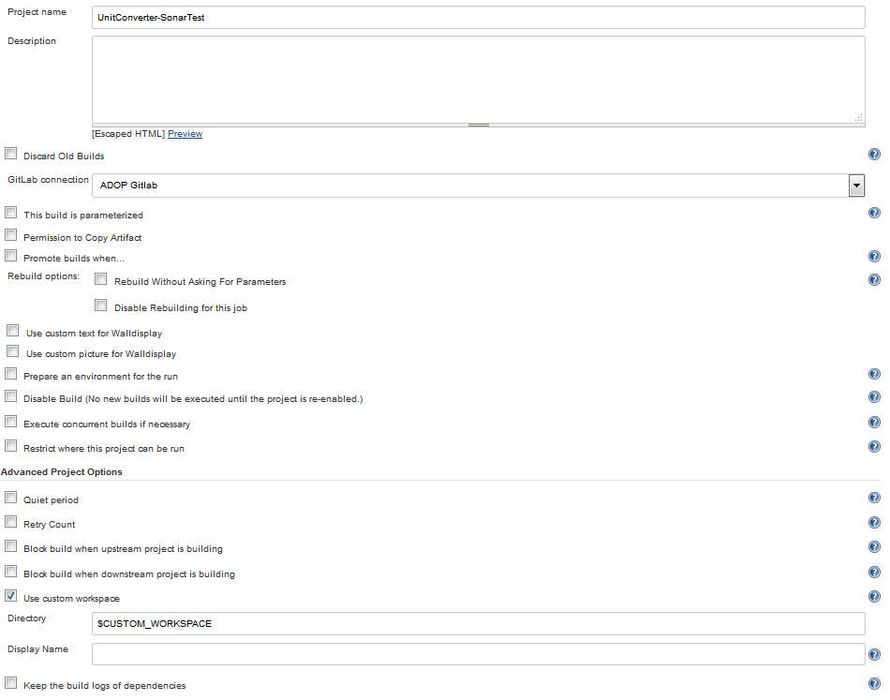

Figure 37 - SonarQube - Project Options Configuration

Step 3: Configure Post-build Actions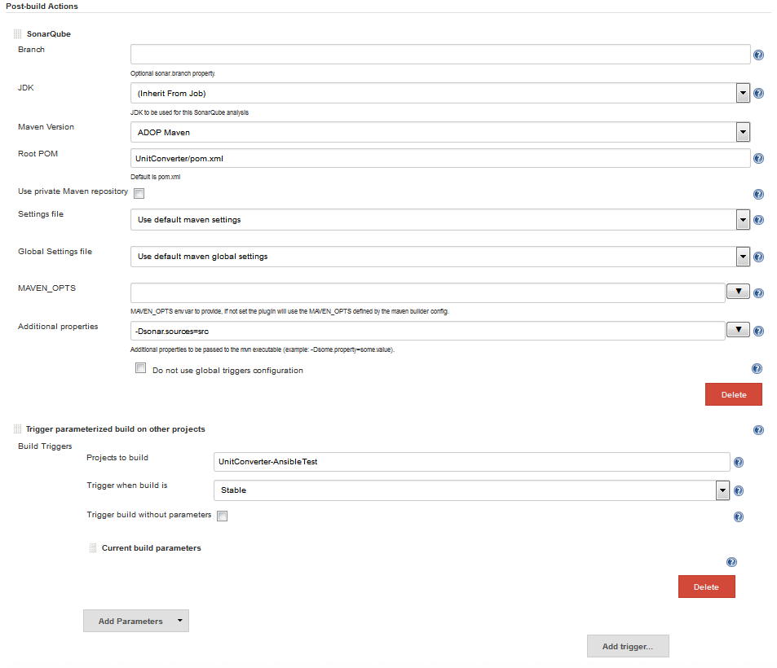

Figure 35 - SonarQube - Post-build Actions Configuration

## Ansible

Step 1: Create a freestyle project for Ansible

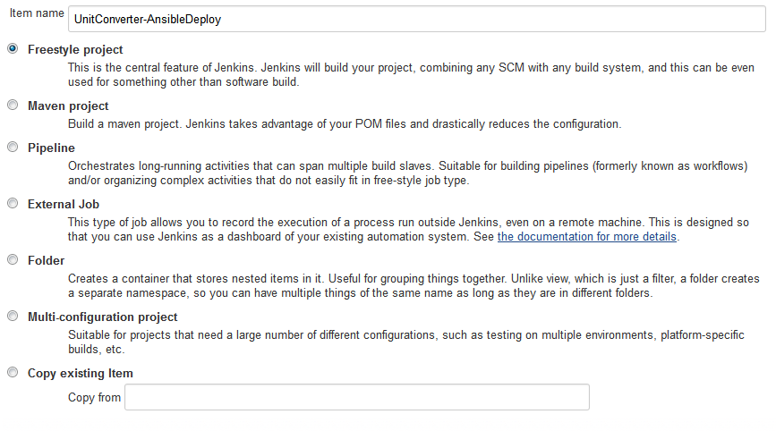

Figure 38 - Ansible - Create a freestyle Project

Step 2: Configure Ansible Project Options

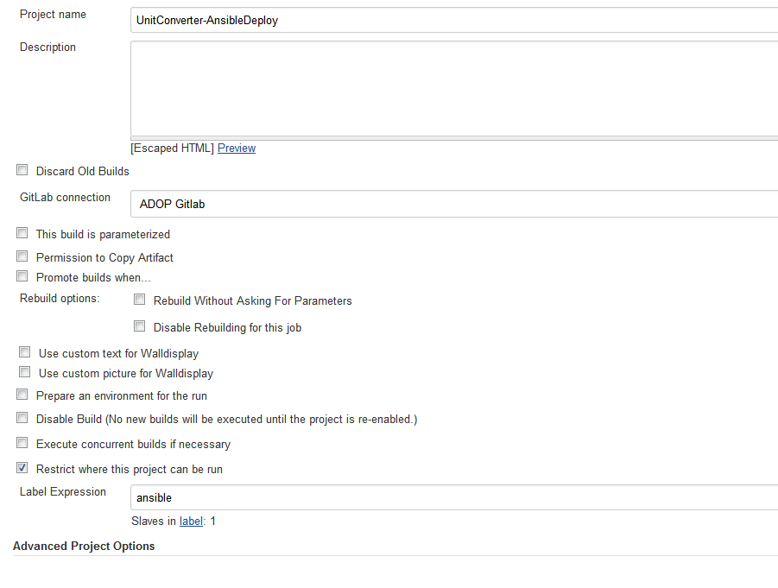

Figure 39 - Ansible - Configure Project Options

Step 3: Configure Source Code Management

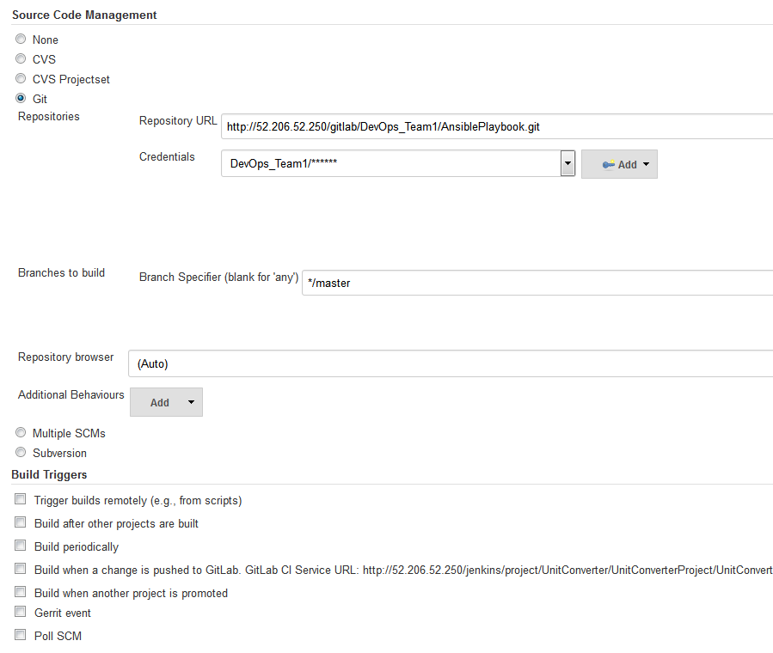

Figure 40 - Ansible - Source Code Management

Step 4: Configure Build Environment

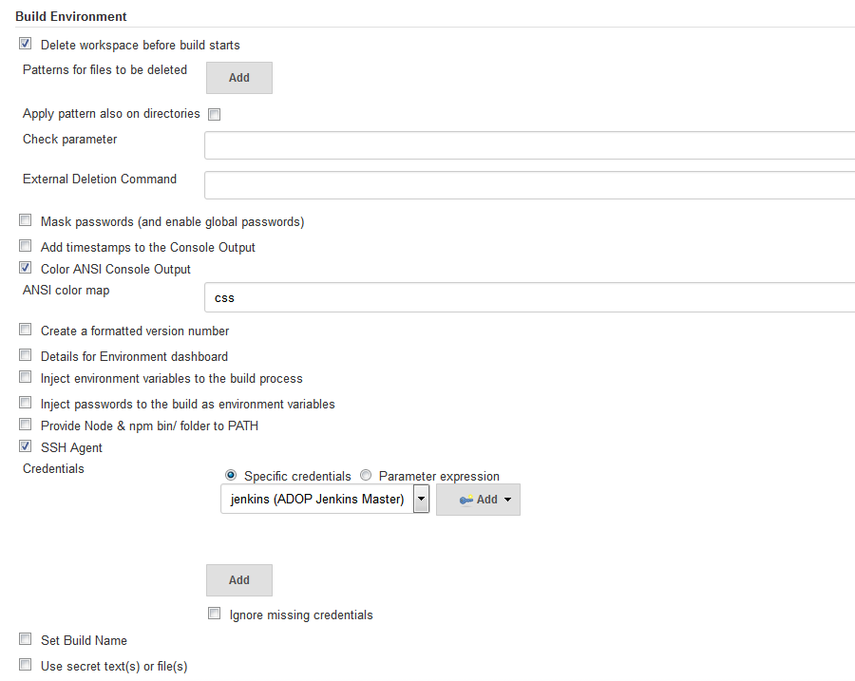

Figure 41 - Ansible - Build Environment

Step 5: Configure Build Configuration

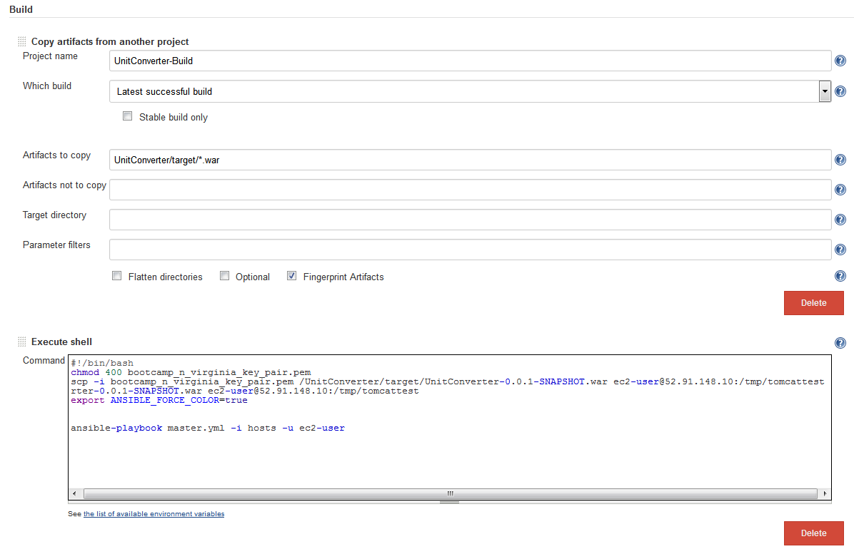

Figure 42 - Ansible - Build Configuration

Step 6: Configure Post-build Actions

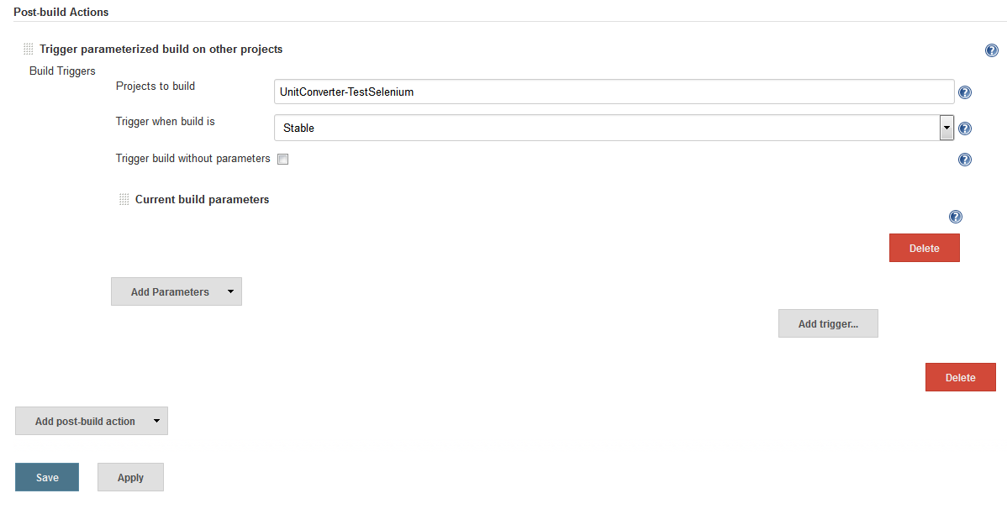

Figure 43 - Ansible Post-build Actions

## Selenium

Step 1: Create a freestyle job for Selenium test

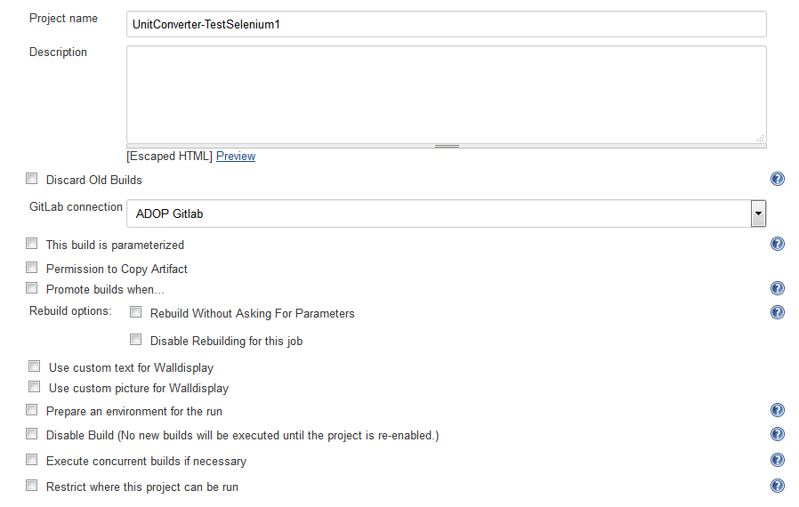

Figure 44 - Selenium Project Options

Step 2: Configure the build for the Selenium Test

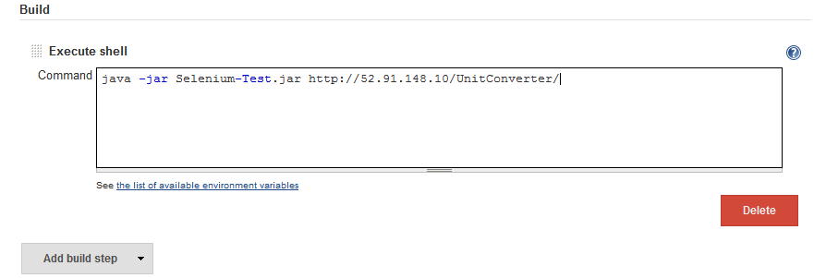

Figure 45 - Selenium Build Configuration

Output

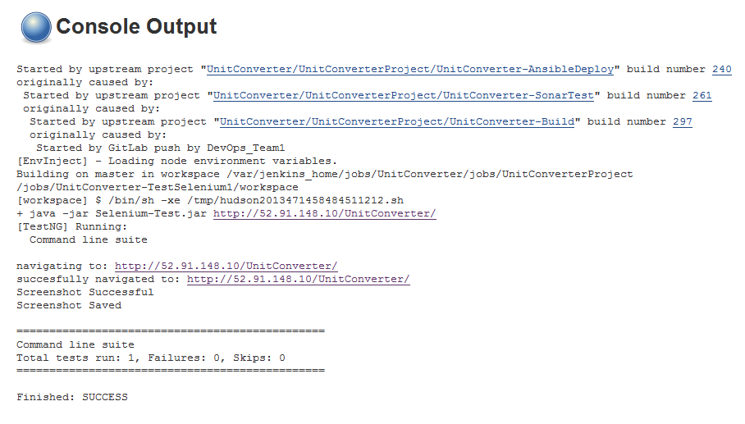

Figure 46 - Selenium Output

# Works Cited

*About Us*. (n.d.). Retrieved July 18, 2016, from GitLab: https://about.gitlab.com/about/

*Apache Tomcat*. (2016, July 5). Retrieved July 18, 2016, from Wikipedia: https://en.wikipedia.org/wiki/Apache_Tomcat

Carias, K. (2015, May 18). *Simple words for a GitLab Newbie* . Retrieved July 18, 2016, from GitLab: https://about.gitlab.com/2015/05/18/simple-words-for-a-gitlab-newbie/

Geiger, M. (2014, February 19). *SonarQube – What is it? How to get started? Why do I use it?* Retrieved July 18, 2016, from Matthias Geiger's Blog: https://matthiasgeiger.wordpress.com/2014/02/19/sonarqube-what-is-it-how-to-get-started-why-do-i-use-it/

*Introduction to Selenium* . (n.d.). Retrieved July 18, 2016, from Guru99: http://www.guru99.com/introduction-to-selenium.html

*Jenkins*. (n.d.). Retrieved July 18, 2016, from Jenkins: https://aws.amazon.com/what-is-aws/

Millares, G. (2016, March 4). *What Is Ansible and How Does It Work?* . Retrieved July 18, 2016, from Stone River eLearning: http://blog.stoneriverelearning.com/what-is-ansible-and-how-does-it-work/

*OVERVIEW:How Ansible Works*. (n.d.). Retrieved July 18, 2016, from Ansible: https://www.ansible.com/how-ansible-works

*PuTTY*. (n.d.). Retrieved July 18, 2016, from PuTTY: http://www.putty.org/

*SonarQube*. (n.d.). Retrieved July 18, 2016, from SonarQube: http://www.sonarqube.org/

*What is AWS? - Amazon Web Services*. (n.d.). Retrieved July 18, 2016, from Amazon Web Services: https://aws.amazon.com/what-is-aws/

*What Is DevOps? (2016, January 16). Retrieved July 19, 2016, from The Agile*

*Admin: https://theagileadmin.com/what-is-devops/*

*What Is This Devops Thing, Anyway? (n.d.). Retrieved July 19, 2016, from Jong En*

*Dynamische Informatica: http://www.jedi.be/blog/2010/02/12/what-is-this-devops-thing-*

*anyway/*