Republic of the Philippines
TECHNICAL EDUCATION AND SKILLS DEVELOPMENT AUTHORITY

NATIONAL CERTIFICATE II

in
COMPUTER SYSTEMS SERVICING
is hereby awarded to

JOHN VITERBS A. GALICIA

for having completed the competency requirements under the Philippine TVET Competency Assessment and Certification System in the following units of competency:

Unit Code Unit Title

BASIC COMPETENCIES
500311105 Participate in workplace communication 500311106 Work in a team environment
500311107 Practice career professionalism 500311108 Practice occupational health and safety
procedures

Unit Code Unit Title

COMMON COMPETENCIES
ELC315202 Apply quality standards ELC311203 Perform computer operations
ELC311201 Perform mensuration and calculation ELC311202 Prepare and interpret technical drawing ELC724201 Use hand tools
ELC724202 Terminate and connect electrical wiring and electronic circuits
ELC724205 Test electronic components
Unit Code Unit Title

CORE COMPETENCIES
ELC724331 Install and configure computer systems ELC724332 Set­up Computer Networks ELC724333 Set­up Computer Servers
ELC724334 Maintain and Repair Computer Systems and Networks

Issued on: June 20, 2023
Valid until: June 19, 2028

SEC. SUHARTO T. MANGUDADATU, Ph. D.
TESDA DIRECTOR GENERAL


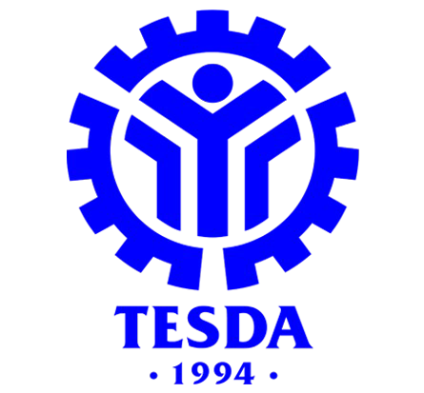

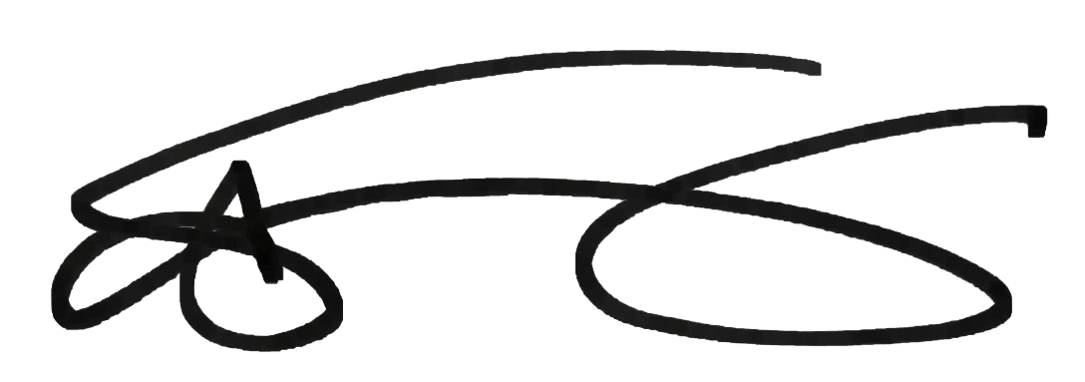

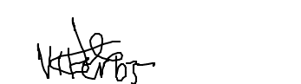
Certificate No: 23131402008591 ULI­GJA­04­309­13088­001

This certificate is system generated through T2MIS

