Product Information
1. Available colors: Black/Gold/Blue
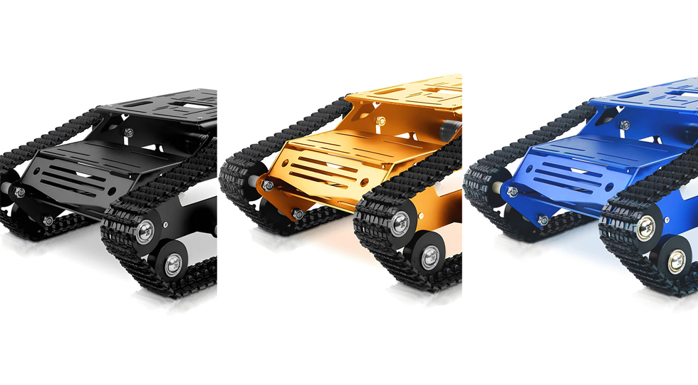
2. Track Chassis Size
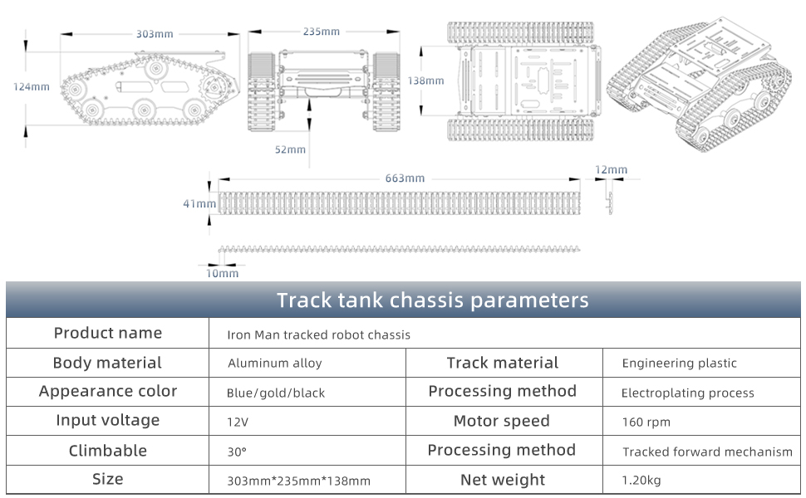
3. Product List3.1 With DC Motor
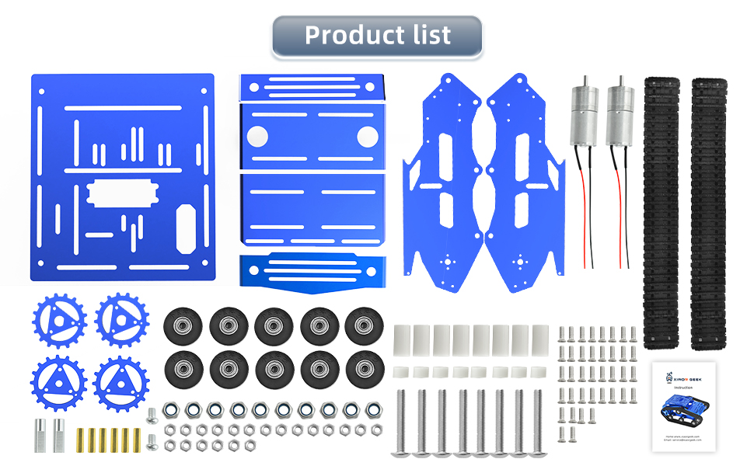
3.2 With Encoder Motor
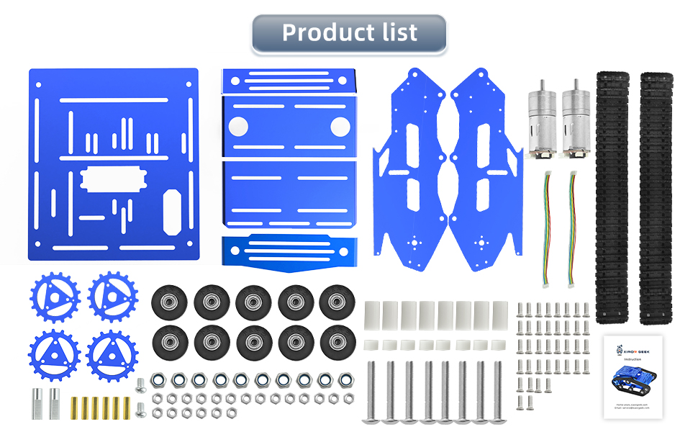
4. Optional motor type: DC reduction motor/Hall-encoder motor
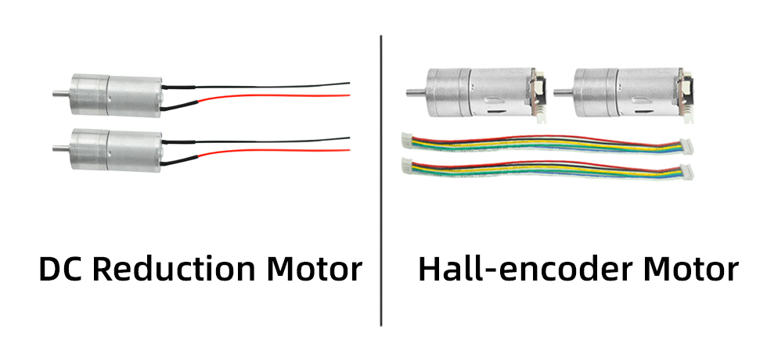
4.1 DC reduction motor
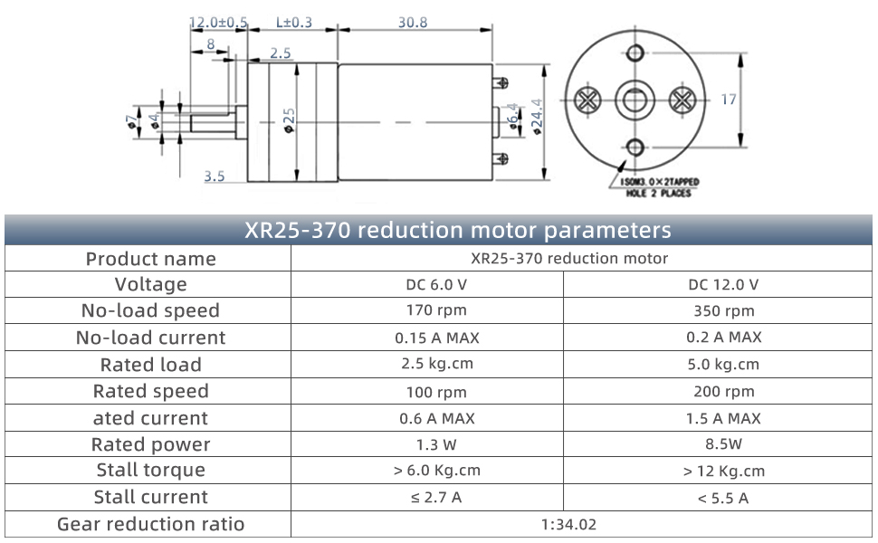
4.2 Hall-encoder motor
