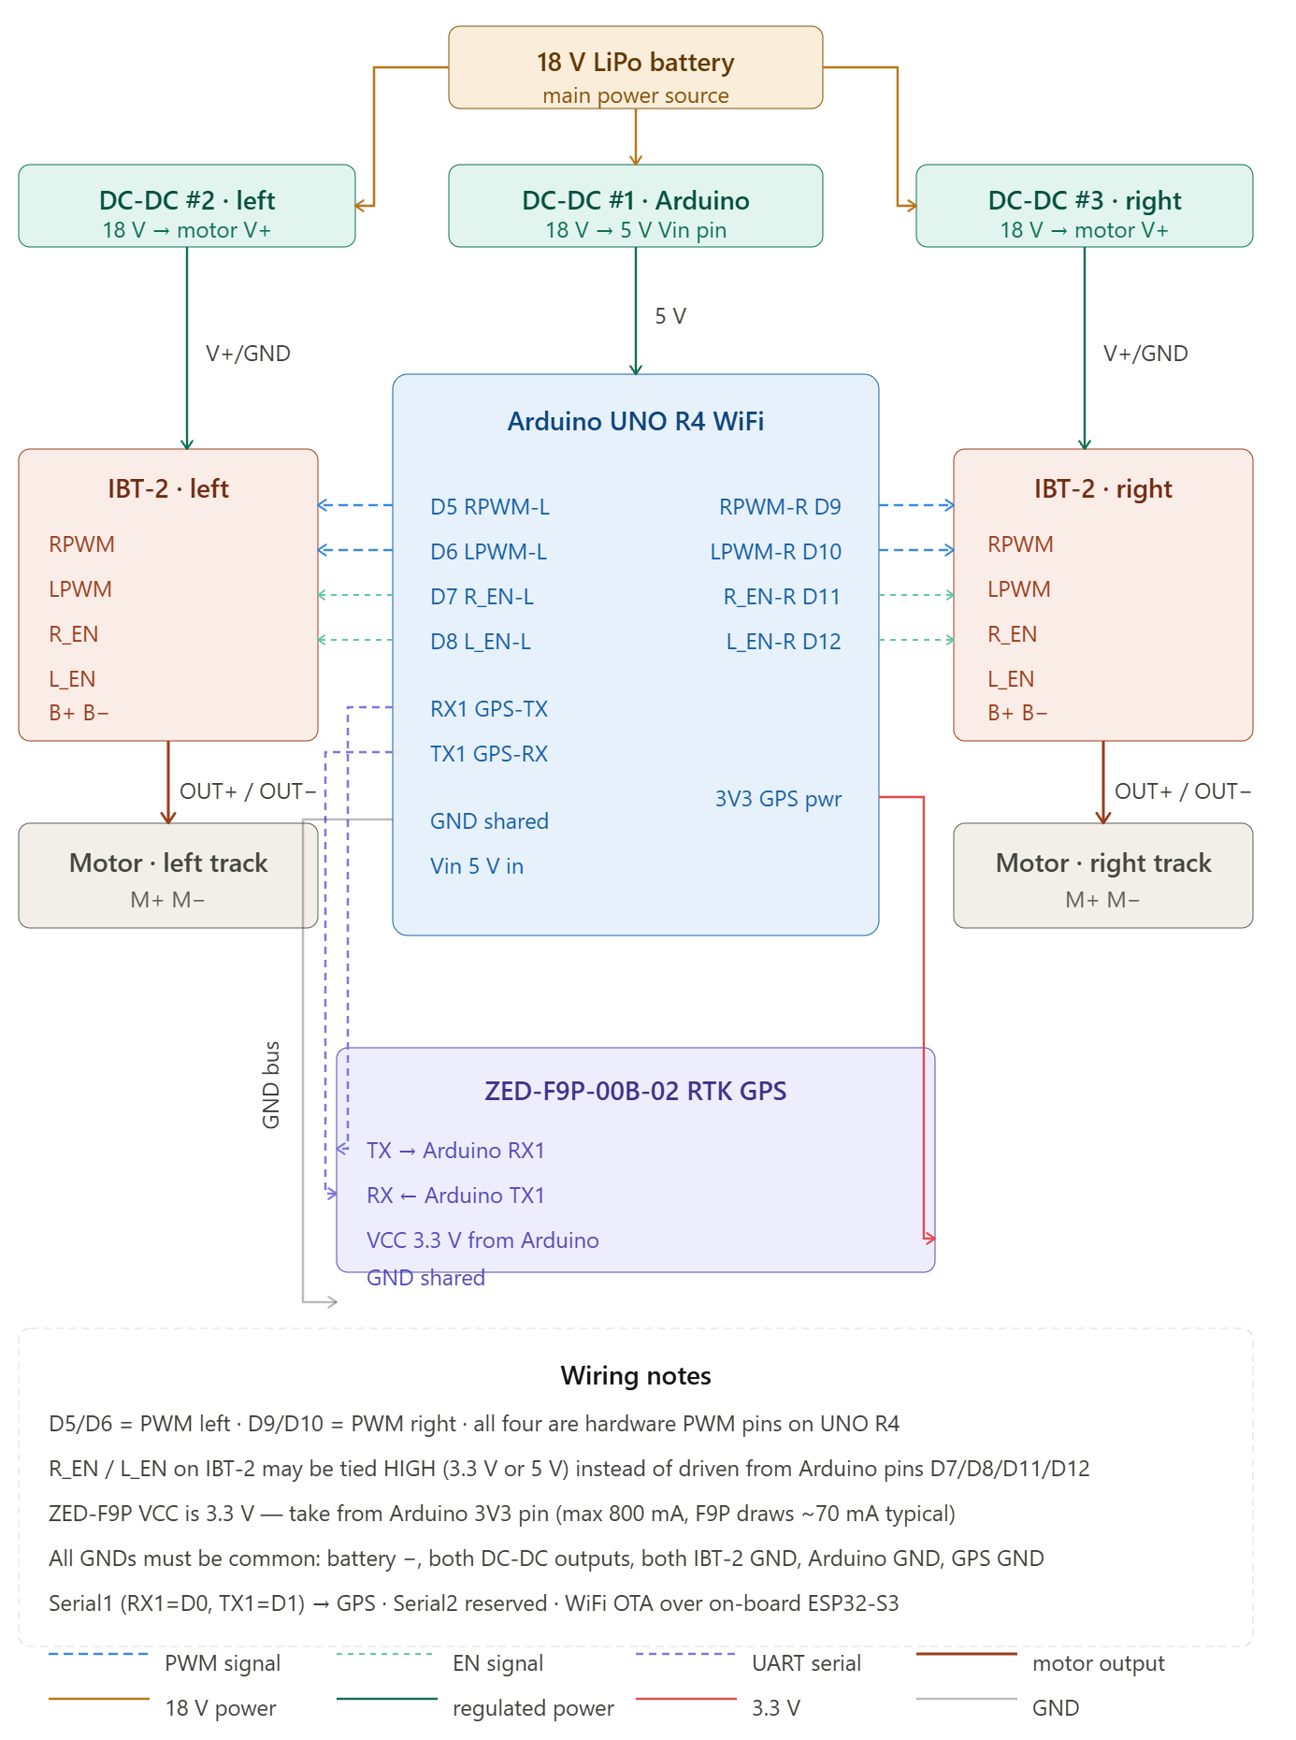
Power topology — the 18V battery splits into three branches: one Mazmoral DC-DC per track motor (stepped to your motor's operating voltage), and a third DC-DC for the Arduino rail (5V to Vin). This isolates motor switching noise from the MCU.
IBT-2 wiring — RPWM and LPWM take the two Arduino PWM pins per driver (e.g. D5/D6 for left, D9/D10 for right). R_EN and L_EN are tied HIGH as we discussed before — no need to drive them from the Arduino.
GPS — ZED-F9P TX connects to Arduino Serial1 (RX1). The module runs on 3.3V which you can pull straight from the UNO R4's 3.3V pin. NMEA sentences (GGA, RMC etc.) get parsed on the Arduino and forwarded over WiFi UDP.
PWM for tank steering — with two independent motors you get differential drive: both forward = straight, one reversed = spin, speed difference = gentle turn. No steering servo needed.
Want me to add a GND plane diagram, or generate the matching Arduino sketch structure for dual-motor PWM + GPS parsing?
ey design decisions that mirror your CoPilot car project:
Motor control — applyIBT2() drives RPWM/LPWM directly. Positive speed → RPWM pulses, LPWM at 0. Negative → reversed. R_EN/L_EN are wired HIGH on the board so no pin needed. A PWM_DEADBAND of 10 prevents creep at near-zero commands.
Differential drive — setDrive(throttle, steering) mixes the two axes: left = throttle + steering, right = throttle − steering. Your Android app just sends those two values and the sketch handles the tank math.
GPS parsing — character-by-character buffering on Serial1, XOR checksum verified on every sentence before parsing. Handles both $GNGGA (position, fix quality 4=RTK-fixed) and $GNRMC (speed, course). The fix quality byte in telemetry lets your Android app distinguish RTK-fixed from float or plain GPS.
JSON protocol — identical to your existing CoPilot UDP protocol (port 5005/5006, type field). Swap "CMD" for throttle/steering instead of the car's single-axis commands. The HELLO/ACK handshake and watchdog timeout are preserved.
Things to configure before flashing:
- Set SSID / PASSWORD
- Confirm GPS baud — ZED-F9P defaults to 38400 but can be changed in u-center; update GPS_BAUD to match
- Tune PWM_MIN / CMD_TIMEOUT_MS for your tank's feel

(SparkFun_u-blox_GNSS_Arduino_Library) is genuinely better for the ZED-F9P. It gives you:
- RTK status — direct access to getCarrierSolutionType() returning 0/1/2 (none/float/fixed) rather than inferring it from the GGA fix quality byte
- High-rate position — getLatitude(), getLongitude() etc. return pre-parsed int32_t in degrees×10⁷, no floating point string conversion
- UBX protocol — talks native binary UBX instead of NMEA, which is faster and more reliable at high update rates (up to 20 Hz on the F9P)
- RTCM injection — if you ever pipe RTCM correction data from a base station, the library handles it cleanly
- Auto-configuration — you can call setNavigationFrequency(10) etc. directly rather than crafting UBX config packets by hand
The hand-rolled parser works fine for basic NMEA at 1–5 Hz, but for a tank doing path following with RTK GPS you probably want the real thing.
Want me to rewrite the GPS section of TankCoPilot.ino to use the SparkFun library? It would replace the entire NMEA parser block with about 20 cleaner lines, and the GpsState struct would get populated via UBX instead.
Here's a summary of what changed:
Removed — the entire hand-rolled NMEA parser (~80 lines): readGps(), parseNmeaSentence(), parseGGA(), parseRMC(), nmeaLatLon(), nmeaChecksum(), splitNmea(), and the nmeaBuf/nmeaIdx buffers.
Added — SFE_UBLOX_GNSS gnss object and a 10-line updateGps() that calls gnss.getPVT() and reads pre-parsed fields directly.
GpsState changes — fixQuality and utcTime replaced by rtkType (0/1/2 = none/float/fixed). The telemetry JSON field is now "rtk" instead of "fix" — you'll want to update the Android app to match.
Setup changes — gnss.begin(Serial1) replaces the bare Serial1.begin(), with three config calls:
- setUART1Output(COM_TYPE_UBX) — silences NMEA output so the library only sees clean UBX frames
- setNavigationFrequency(5) — 5 Hz; bump to 10 if you want faster path following (F9P supports up to 20 Hz)
- saveConfigSelective() — persists to F9P flash so it survives power cycles
Install the library first — Arduino IDE → Library Manager → search SparkFun u-blox GNSS v3 (the v3 version, not the older v2).

WIFI Uploading Sketch
Done. Three changes made to the sketch:
- #include <ArduinoOTA.h> added at the top
- OTA_HOSTNAME and OTA_PASSWORD constants added near the WiFi credentials — change "tank1234" to something private before deploying
- ArduinoOTA.begin() + callbacks in setup(), with motorsStop() called in onStart() so the motors always halt before a flash
- ArduinoOTA.handle() as the first call in loop()
To use it from the IDE:
- Upload once via USB to get the OTA code onto the board
- After that, with the tank powered on and on the same WiFi network, go to Tools → Port and you'll see TankCoPilot at 192.168.x.x appear as a network port
- Select it and hit Upload as normal — the IDE will prompt for OTA_PASSWORD
One thing to be aware of: ArduinoOTA.handle() is blocking while a transfer is in progress, so the watchdog will fire and stop the motors during a flash — which is exactly what you want.

