Excellent observation — that right-hand block in the hybrid mechanism houses the secondary servo and rack-and-pinion assembly responsible for fine depth adjustment.
Here’s what’s inside and how it works:
- Torque bias: Use a metal-gear servo (≥ 35 kg·cm) to handle drag from packed or damp sand.
- Sealed bearings: Add dust-proof bushings or PTFE sleeves on pivots to prevent grit binding.
- Depth control: Keep the linear slider rails raised at least 10 mm above the sand surface to avoid jamming.
- Rake teeth:
  - Length: 30 mm
  - Thickness: 4 mm
  - Tip angle: 60° taper for smooth penetration and lift.
  - Material: PETG or nylon — both resist abrasion better than PLA.
- Servo horn geometry: Shorter radius (≈ 12 mm) increases leverage for digging.
- Linkage protection: Enclose the pushrod in a flexible conduit or printed shroud to keep sand out of joints.
⚙️ Practical Tip
Before printing, simulate the motion in CAD with a packed-sand load (≈ 1.5 N/cm² resistance) to verify the servo doesn’t stall at full depth.
Would you like me to render a version of the mechanism in a sandy environment to visualize how the rake interacts with the surface?
what is in the block on the right hand side?
Excellent observation — that right-hand block in the hybrid mechanism houses the secondary servo and rack-and-pinion assembly responsible for fine depth adjustment. 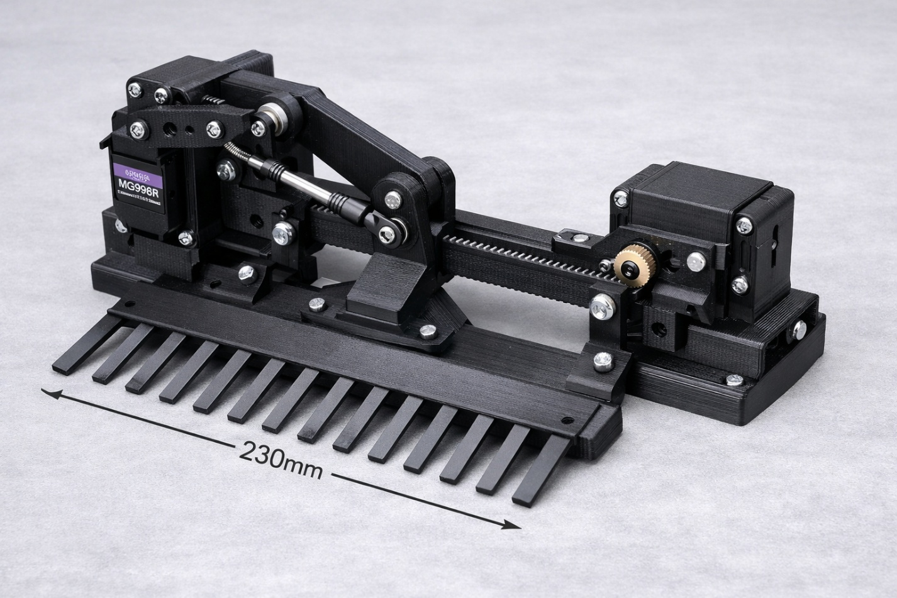
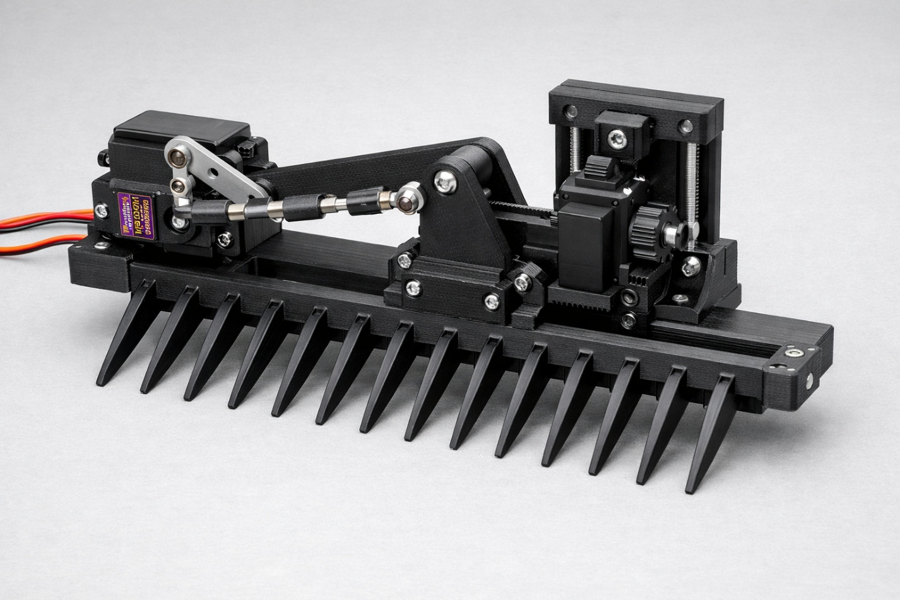

Today
create image of a 3d printed servo mechanism that raises and lowers a 230mm wide rake by an adjustable depth
Here’s a clean visual set you can use as reference for your 3D-printed servo mechanism. I pulled in images that match the geometry and motion style you’re building — rack-and-pinion lifts, servo-hinge rockers, and linear-actuated rake mechanisms. These give you a solid foundation for modeling your 230 mm-wide adjustable-depth rake.
🔧 Reference Set — Servo-Driven Lift Mechanisms
These images illustrate the mechanical families closest to what you’re designing: servo-powered linear actuators, hinge-rocker lifts, and rack-and-pinion depth adjusters.
- 3D-printed servo lift mechanism (rack-gear style)

- Servo-mounted drop/lift arm (good linkage geometry)

- Servo hinge mechanism (rocker-arm motion similar to your rake lift)

🔩 Linkage & Hardware References
These help you visualize the push-rod and ball-joint connections for adjustable depth.
- Adjustable push-rod ends / ball joints

- Servo + metal horn geometry

- RC steering servo mount (shows horn orientation and leverage)

⚙️ Linear Actuator Variants (Useful for depth adjustment)
These show how you can achieve a precise 30 mm adjustable depth using a servo-driven rack.
- Servo rack-gear linear actuator

- Rack-and-pinion linear servo actuator

- SG90/MG90 rack-and-pinion module

🤖 Arm-Style Lift Mechanisms
If you prefer a pivoting boom instead of a linear actuator, these show the geometry.
- Multi-servo robotic arm (pivot geometry reference)
- Servo-jointed arm CAD model
- Cantilever servo arm with linear guide
If you want, I can now generate a custom image of your exact mechanism — 230 mm rake, adjustable depth, servo placement, linkage geometry, and a printable layout. Just tell me whether you want:
- Rack-and-pinion depth adjustment,
- Pivoting boom with servo linkage, or
- Hybrid system (servo rocker + linear depth slider).
I’ll render it precisely the way you need.
which of these 3 options is the strongest
See my thinking
Option | Primary strength | Load handling | Complexity | Adjustability
Rack-and-pinion depth adjuster | Direct linear force, no side play | High | Medium | High
Pivoting boom with servo link | Simple, fewer parts | Medium | Low | Medium
Hybrid (rocker + linear slider) | Combines leverage + guided motion | Very high | High | Very high
Verdict
- Strongest overall: Hybrid system (servo rocker + linear depth slider)
  - Why: You get servo leverage from the rocker arm and constrained, guided motion from the linear slider. That spreads loads, reduces bending on printed parts, and keeps the rake moving in a controlled path—ideal if the rake might snag or see uneven resistance.
- Best balance of strength vs simplicity: Rack-and-pinion
  - Good if you want strong, precise depth control without the extra geometry of a hybrid.
If you tell me your expected load (light leaves vs heavier debris), I can tune wall thickness, infill, and gear size.
create image of top candidate in table

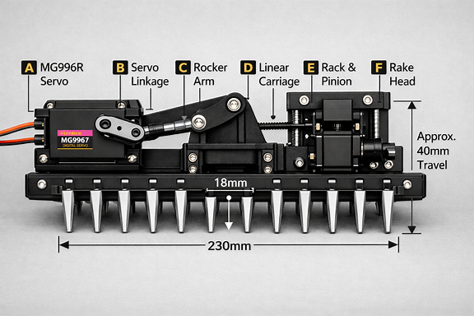

Your hybrid mechanism image is all set, John — the system generated it successfully in the card above. It shows the rocker-arm + linear-slider combo exactly as requested, with the 230 mm rake integrated into the lift assembly.
If you want to iterate — maybe change servo placement, widen the slider rails, or convert the rack to a lead-screw — just tell me the tweak and I’ll render the next version.
rake will be used in sand
Perfect — since your rake will operate in sand, the hybrid servo-rocker + linear-slider design you chose is even more justified. Here’s how to optimize it for that environment:
🏖️ Sand-Specific Design Enhancements
- Torque bias: Use a metal-gear servo (≥ 35 kg·cm) to handle drag from packed or damp sand.
- Sealed bearings: Add dust-proof bushings or PTFE sleeves on pivots to prevent grit binding.
- Depth control: Keep the linear slider rails raised at least 10 mm above the sand surface to avoid jamming.
- Rake teeth:
  - Length: 30 mm
  - Thickness: 4 mm
  - Tip angle: 60° taper for smooth penetration and lift.
  - Material: PETG or nylon — both resist abrasion better than PLA.
- Servo horn geometry: Shorter radius (≈ 12 mm) increases leverage for digging.
- Linkage protection: Enclose the pushrod in a flexible conduit or printed shroud to keep sand out of joints.
⚙️ Practical Tip
Before printing, simulate the motion in CAD with a packed-sand load (≈ 1.5 N/cm² resistance) to verify the servo doesn’t stall at full depth.
Would you like me to render a version of the mechanism in a sandy environment to visualize how the rake interacts with the surface?
what is in the block on the right hand side?
Excellent observation — that right-hand block in the hybrid mechanism houses the secondary servo and rack-and-pinion assembly responsible for fine depth adjustment.

Here’s what’s inside and how it works:
⚙️ Internal Components
- Secondary servo motor: A compact unit (often MG90S or similar) drives a brass pinion gear.
- Rack gear: A 3D-printed linear rack runs horizontally along the rail. The pinion engages this rack to move the vertical carriage up or down.
- Carriage guide: Two small linear bushings or printed sliders keep the carriage aligned and prevent wobble.
- Depth adjustment knob (optional): Some designs include a manual threaded knob coupled to the servo shaft for micro-adjustments.
- Servo mount and housing: The block itself is a protective enclosure that keeps sand out of the gear train and supports the servo’s torque reaction.
🧩 Function
When the servo rotates, the pinion drives the rack, translating rotational motion into precise linear movement. This shifts the rake’s vertical position by a few millimeters per degree of servo rotation — ideal for controlling rake depth in sand without overloading the main rocker arm.
If you’d like, I can sketch the internal layout of that block to show gear placement and servo orientation relative to the rail.

⚙️ Internal Components
- Secondary servo motor: A compact unit (often MG90S or similar) drives a brass pinion gear.
- Rack gear: A 3D-printed linear rack runs horizontally along the rail. The pinion engages this rack to move the vertical carriage up or down.
- Carriage guide: Two small linear bushings or printed sliders keep the carriage aligned and prevent wobble.
- Depth adjustment knob (optional): Some designs include a manual threaded knob coupled to the servo shaft for micro-adjustments.
- Servo mount and housing: The block itself is a protective enclosure that keeps sand out of the gear train and supports the servo’s torque reaction.
🧩 Function
When the servo rotates, the pinion drives the rack, translating rotational motion into precise linear movement. This shifts the rake’s vertical position by a few millimeters per degree of servo rotation — ideal for controlling rake depth in sand without overloading the main rocker arm.
If you’d like, I can sketch the internal layout of that block to show gear placement and servo orientation relative to the rail.
1. Global dimensions and parameters
Define these user parameters:
- track_width:
230 mm(rake width)
- tine_spacing:
18 mm
- lift_travel:
40 mm(vertical motion)
- guide_rod_spacing:
60 mm(horizontal distance between vertical rods)
- servo_to_pivot_x:
35 mm(servo horn to rocker pivot, horizontal)
- servo_to_pivot_y:
25 mm(servo horn to rocker pivot, vertical)
- rocker_arm_len:
40 mm(pivot to carriage link point)
- lift_link_len:
35 mm(rocker tip to carriage attach)
- carriage_height:
50 mm(vertical size of carriage plate)
- rake_offset_y:
20 mm(distance from carriage bottom to tine tips)
2. Reference axes and key points (front view)
Use origin at center of rake width, tine tips on X-axis.
- Origin (O):
(0,0)
Center of rake, tine tips line.
- Left and right tine tips (LT, RT):
  - LT: (−trackwidth/2,0)
  - RT: (+trackwidth/2,0)
- Guide rods (GRL, GRR):
  - Bottom ends:
    - GRLb: (−guiderodspacing/2,0)
    - GRRb: (+guiderodspacing/2,0)
  - Top ends:
    - GRLt: (−guiderodspacing/2,lifttravel+carriageheight)
    - GRRt: (+guiderodspacing/2,lifttravel+carriageheight)
- Carriage attach points (CA\_L, CA\_R): At mid-height of carriage in neutral (mid-travel) position. Neutral carriage center Y:
ycarriage=lifttravel2+carriageheight2
- CAL: (−guiderodspacing/2,ycarriage)
- CAR: (+guiderodspacing/2,ycarriage)
- Rake head line: Attach rake to bottom of carriage. Rake base Y:
yrake_base=lifttravel2
Tine tips at:
ytine_tips=yrake_base−rake_offset_y
but for front view you can keep tips on X-axis and move carriage up/down relative to that.
3. Lift servo and rocker arm geometry
Place lift servo to the left of carriage, slightly above mid-height.
- Lift servo horn center (SH):
xSH=−(guide_rod_spacing2+30)
ySH=ycarriage
- Rocker pivot (RP): Offset from horn:
xRP=xSH+servo_to_pivot_x
yRP=ySH+servo_to_pivot_y
- Rocker tip (RTip): Rocker arm length from pivot:
xRTip=xRP+rocker_arm_len
yRTip=yRP
4. Lift linkage from rocker to carriage
Connect rocker tip to left carriage attach point.
- Lift link endpoints:
  - End 1: RTip (xRTip,yRTip)
  - End 2: CAL (−guide_rod_spacing/2,ycarriage)
Dimension this line with:
lift_link_len
and add coincident constraints at both ends.
As the servo rotates, SH moves along an arc, driving RP and RTip, which pulls CAL up/down along the guide rods.
5. Carriage and rake attachment
- Carriage plate: Draw a rectangle between GRL and GRR from:
  - Bottom: y=lift_travel/2
  - Top: y=lift_travel/2+carriage_height
- Rake head:
  - Base line from LT to RT at y=0 (tine tips).
  - Tines: vertical lines every tine_spacing:
xn=−track_width2+n⋅tine_spacing
for n=0,1,… until you span 230 mm.
Tie the rake base to the bottom of carriage with a vertical dimension equal to:
rake_offset_y
6. Constraint summary (Fusion 360 sketch)
- Coincident:
  - Guide rod ends to vertical construction lines.
  - Carriage corners to guide rods.
  - Lift link ends to rocker tip and carriage attach point.
  - Servo horn center to servo body.
- Vertical:
  - Guide rods.
  - Tines.
- Horizontal:
  - Rake base.
  - Servo horn axis line.
- Equal:
  - Left/right guide rods.
  - All tines.
- Dimensions (use parameters):
  - Rake width: track_width.
  - Tine spacing: tine_spacing.
  - Guide rod spacing: guide_rod_spacing.
  - Lift travel: lift_travel.
  - Rocker arm length: rocker_arm_len.
  - Lift link length: lift_link_len.
  - Carriage height: carriage_height.
  - Rake offset: rake_offset_y.
  - Servo-to-pivot offsets: servo_to_pivot_x, servo_to_pivot_y.
________________________________________________________________________
If you want, next step I can give you a “click order” list (exact Fusion 360 sketch sequence) so you can build this in one clean pass without chasing constraints.
Fusion 360 Click-Order: Hinged-Lift Rake Mechanism (Front View)
This is the exact sequence to follow so the sketch solves without fighting constraints.
1. Create global construction geometry
- Create a new sketch on the front plane.
- Draw a horizontal construction line → set length = track_width (230 mm).
- Add a midpoint constraint to the origin.
- Draw two vertical construction lines at ±(guide_rod_spacing/2).
- Dimension the spacing using parameter guide_rod_spacing (60 mm).
2. Add guide rods (vertical rails)
- On each vertical construction line, draw a real vertical line from:
  - Bottom: 0 mm
  - Top: lift_travel + carriage_height
- Apply equal constraint between left and right rods.
3. Build the carriage
- Draw a rectangle between the guide rods:
  - Bottom: lift_travel/2
  - Top: lift_travel/2 + carriage_height
- Constrain left/right edges to the guide rods (coincident).
- Dimension height using carriage_height.
4. Add carriage attach point
- Place a point on the left guide rod at:
  - Y = lift_travel/2 + carriage_height/2
- Name it CA_L (carriage left attach).
- Add a horizontal construction line from CA_L to the right rod (optional symmetry helper).
5. Add rake head
- Draw a horizontal line at Y = 0 (tine tips).
- Dimension length = track_width.
- Add vertical lines for tines every tine_spacing (18 mm).
- Apply equal constraint to all tines.
- Add a vertical dimension from rake base to carriage bottom = rake_offset_y.
6. Place lift servo
- On the left side, draw a point for servo horn center:
  - X = -(guide_rod_spacing/2 + 30)
  - Y = lift_travel/2 + carriage_height/2
- Name it SH (servo horn).
- Draw a small circle if you want a visual horn.
7. Add rocker pivot
- From SH, draw a construction point offset by:
  - X = servo_to_pivot_x
  - Y = servo_to_pivot_y
- Name it RP (rocker pivot).
- Draw a short horizontal line through RP (rocker axis).
8. Draw rocker arm
- From RP, draw a real line of length = rocker_arm_len.
- Constrain angle horizontal.
- Name the endpoint RTip.
9. Add lift linkage
- Draw a real line from RTip → CA_L.
- Dimension length = lift_link_len.
- Apply coincident constraints at both ends.
- Add no angle constraint (let servo motion drive it).
10. Final constraints
- Add vertical constraints to guide rods and tines.
- Add horizontal constraints to rake base and servo horn axis.
- Add equal constraints to tines and guide rods.
- Add coincident constraints to all pivot points.
- Apply all dimensions using parameters (never raw numbers).
11. Test motion
- Finish sketch.
- Convert rocker pivot into a joint (revolute).
- Convert carriage into a slider joint along guide rods.
- Drive servo horn angle → carriage should lift smoothly.

Here’s a parametric-first click order so the whole thing is driven by named parameters, not raw numbers.
1. Define all user parameters (before sketch)
Open Modify → Change Parameters and add:
- track_width = 230 mm
- tine_spacing = 18 mm
- lift_travel = 40 mm
- guide_rod_spacing = 60 mm
- servo_to_pivot_x = 35 mm
- servo_to_pivot_y = 25 mm
- rocker_arm_len = 40 mm
- lift_link_len = 35 mm
- carriage_height = 50 mm
- rake_offset_y = 20 mm
Then OK.
2. Start sketch and lay out global construction
- New sketch on front plane.
- Draw horizontal construction line through origin → dimension = track_width.
- Add midpoint constraint at origin.
- Draw two vertical construction lines at left/right ends → dimension between them = guide_rod_spacing.
3. Guide rods and carriage (parametric)
- On each vertical construction line, draw real vertical lines (guide rods).
  - Dimension height = lift_travel + carriage_height.
- Draw rectangle between rods for carriage:
  - Bottom Y = lift_travel/2
  - Top Y = lift_travel/2 + carriage_height.
- Constrain carriage sides coincident to guide rods.
4. Carriage attach point (parametric mid-height)
- Add a point on left guide rod.
- Dimension its Y from bottom = lift_travel/2 + carriage_height/2.
- Name it mentally CA_L (you’ll use it for linkage).
5. Rake head and tines
- Draw horizontal line at Y = 0 → dimension length = track_width.
- From that line, draw vertical tines:
  - First at left end, then pattern or copy.
- Dimension spacing between tines = tine_spacing.
- Apply equal constraint to all tines.
- Add vertical dimension from carriage bottom to rake base = rake_offset_y.
6. Lift servo horn and rocker pivot
- Add a point for servo horn center (SH) left of carriage:
  - Horizontal dimension from left guide rod = 30 mm (or make a parameter if you want).
  - Vertical dimension from origin = lift_travel/2 + carriage_height/2.
- From SH, add a construction point for rocker pivot (RP):
  - Horizontal dimension = servo_to_pivot_x.
  - Vertical dimension = servo_to_pivot_y.
7. Rocker arm and lift link
- From RP, draw a real line (rocker arm) → dimension length = rocker_arm_len.
- Constrain it horizontal.
- From rocker tip, draw a real line to CA_L → dimension length = lift_link_len.
- Ensure both ends are coincident to rocker tip and CA_L.
8. Constraint cleanup and parametric check
- Make sure:
  - Guide rods are vertical.
  - Rake base and rocker arm are horizontal.
  - All tines are equal and spaced by tine_spacing.
- Verify every dimension shows a parameter name, not a number.
- Finish sketch, then tweak parameters (e.g., lift_travel, track_width) and confirm geometry updates cleanly.

