**Software Development Simulation**

**D10126532 John Warde DT230B**

# 1. General Information

The SimSE ***Incremental Model*** was chosen for this part of the assessment.

The Incremental Model divides a project into small logical small parts; each module will go through requirements, design implementation and integration phases – a sort of mini-waterfall model. Each module version is delivered to the customer for feedback; this feedback is then used for refining further versions of the same module and possible insight into other modules within the project. Extra analysis tasks (such as risk & difficulty analysis) are employed to prioritise modules based on value to the customer, difficulty and changeability. The product is demonstrated earlier to the customer to give customer confidence; the feedback received from a customer review allows the project team to increase accuracy (of requirements) and customer satisfaction. Customers are involved throughout the project and sometimes sitting alongside the project team members.

The Incremental model is popular today, especially in web related projects. There are many incremental/iterative software development methods including Agile Unified Process (AUP), Dynamic Systems Development Method (DSDM), Extreme Programming (XP) and SCRUM.

I have been involved in many projects where the Waterfall Model was used. I have researched incremental models for possible usage in a project I was due to manage; however circumstances beyond my control prevented this.

I want to get involved in projects using agile/iterative methods and choosing this model is an opportunity to further my knowledge in this area. I can see the benefits of this type software development and I can see how other sections of this Masters course can be used in unison (in particular design patterns and refactoring, from Programming Paradigms: Principles & Practices) to build better quality and more robust software for the customer.

# 2. Simulation Output

Below is a point form summary of my attempts using the SimSE Incremental Model.

## Attempt 1

* For each module, I concentrated on getting the Requirements and then Design completed before starting implementation phases.
* Towards the end of the attempt, I felt that I needed to concentrate on a few more of the simulation variables.
* I had set team members’ one task at a time whereas they might be able to do some tasks in parallel, more of the time.
* The simulation aim was to complete project in/around 200 ticks. Probably needed to keep an eye on the score in real time towards the end.
* Noted that score was directly related to (customer) satisfaction.
* Noted that I should have been doing Risk Analysis after Requirements to reveal the value to customer.

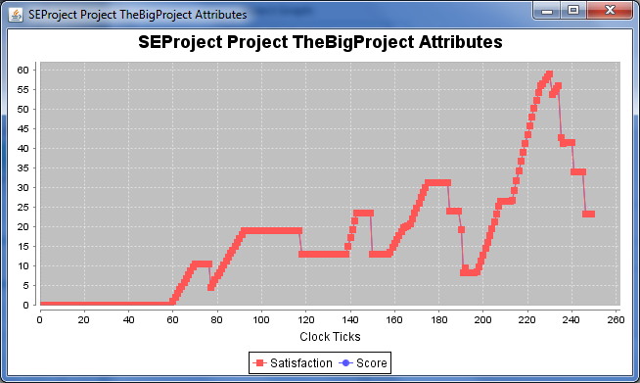

## Attempt 2

* I planned a more structured approach in this attempt, instructed team to execute requirements **and** risk analysis on all modules (before attempting any design work) and deciding which modules to focus on first, i.e. modules with the highest value to customer.
* Kept a continuous eye on the “Artefacts at a Glance” table (below), it offered the most/concise feedback.
* At clock tick 202, I had 100 for all of Requirements, Design, Implementation, Accuracy, Total Satisfaction, Risk Analysis, Difficulty Analysis and Integration for Module 1, 3 & 4 and a score of 75 approx.
* Then kept advancing one tick at a time (while concentrating the team on design of the last module), deciding as soon as the score started to go down I would submit the final product to the customer.
* However, I did not envisage that the satisfaction/score would drop as much as it did when another user requirement came in at clock tick 214. Lesson learned.

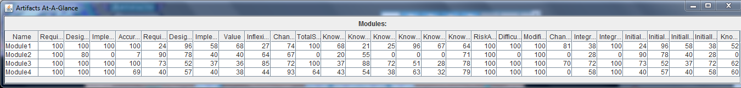

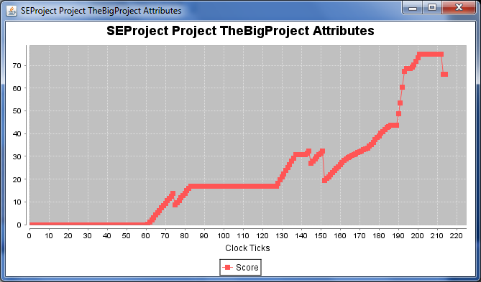

## Attempt 3

* For this attempt, I took the same approach; also I took better notes of who was doing what – I do not know why I didn’t score as well in this attempt.
* In this model, you cannot view any of the rules/triggers; you cannot view any action graph or composite graphs (see screenshots below). Should I be able to see these graphs in this model? – To analyse what caused value changes in the attributes of the project.
* The Known Value of the modules (after risk analysis) was low for all modules – this may have been a factor in the low scoring throughout the project.

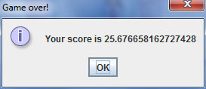

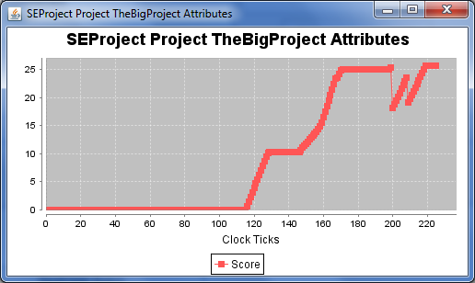

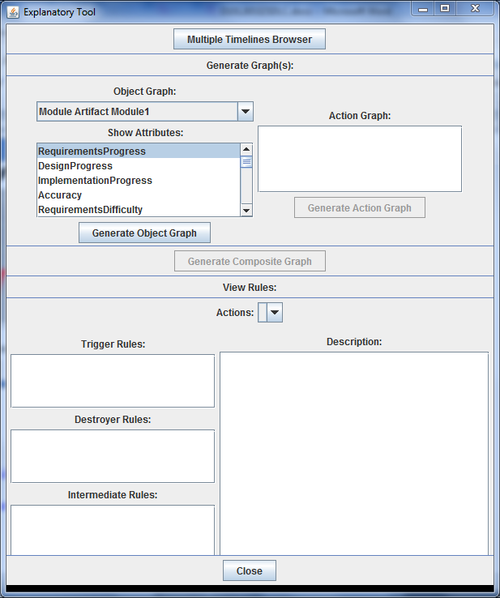

## Attempt 4

* In this attempt, a sharper focus was put on accuracy which is linked to satisfaction (and score).
* However, in this attempt/project accuracy fluctuated greatly and I assigned “evolve code” tasks to the team to improve the accuracy (value) which has a positive effect on satisfaction.
* After reviewing the graphs for all 4 modules (below), the evolve code task could perhaps have been employed even earlier in the timeline.
* I found it frustrating when Implementation Integration for a module was less than 100% and the Integrate task could not be assigned to anyone on the team – is this correct?
* However, I achieved a targeted score of plus seventy in this attempt – **71.26**.

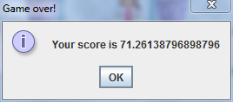

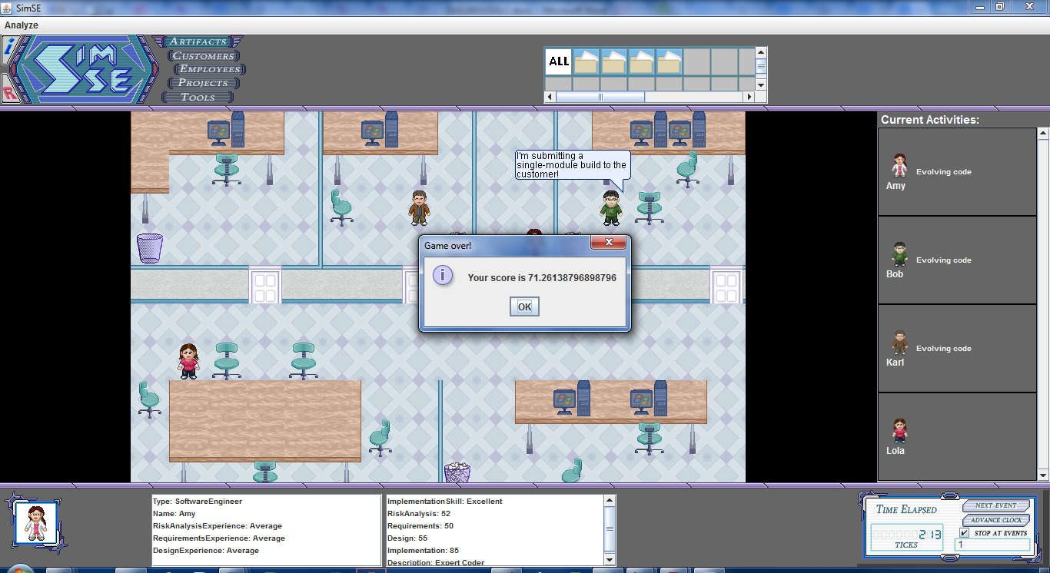

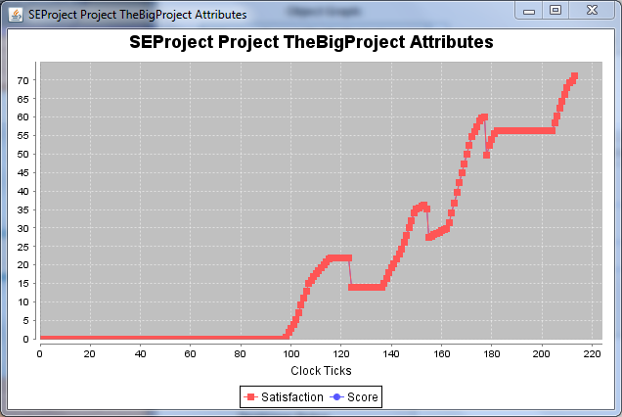

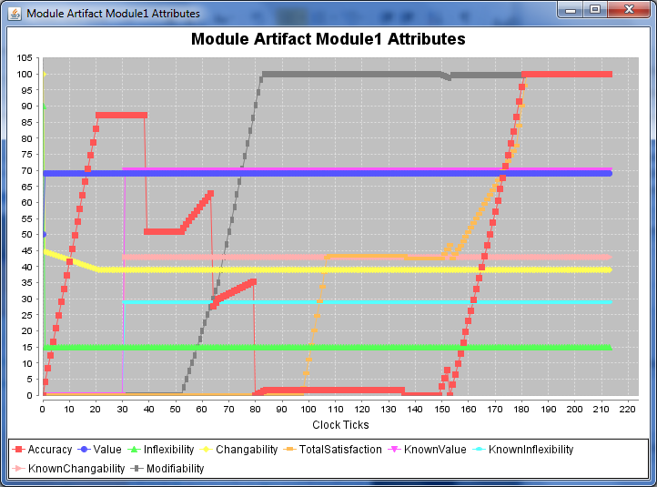

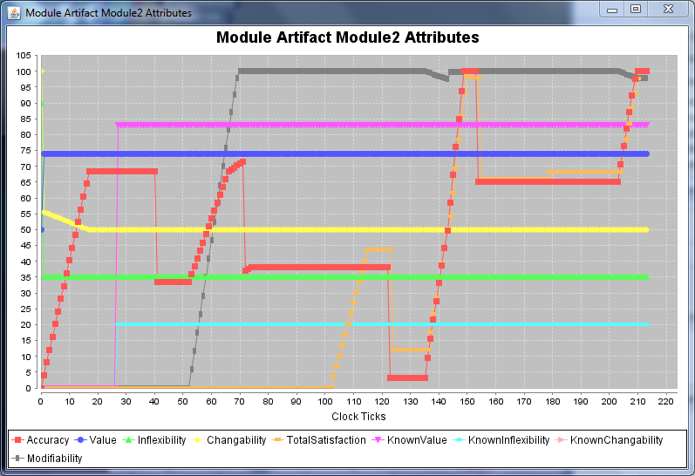

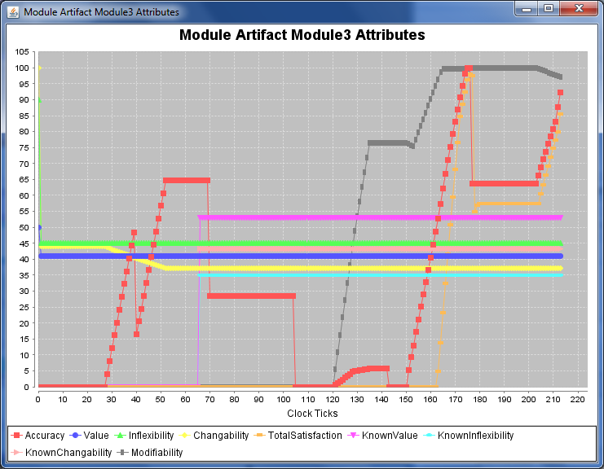

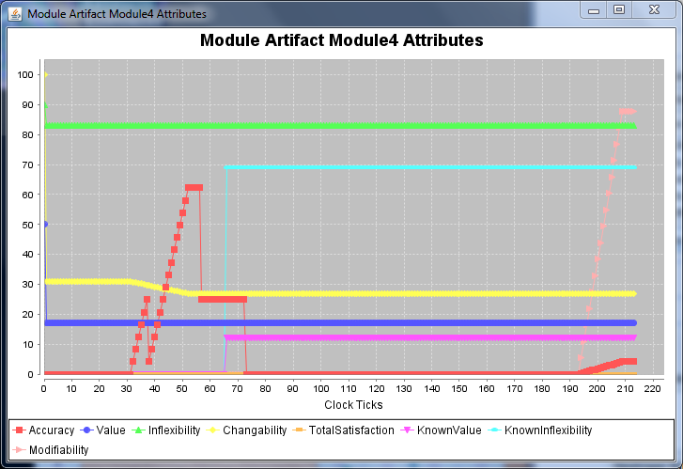

# 3. Reflections

The simulator focuses the student on the key aspects of incremental project management success, such as accuracy to customer requirements and adjustment through customer feedback.

The approach I took was to complete requirements and risk analysis on all modules first, risk analysis reveals the value the customer puts on each module plus the inflexibility (adherence to customer requirements) and changeability (the likelihood of changes by customer) values of all the modules.

Implementation was done in order of customer value, with the acceptance that very little of the last module would be completed within the timeframe of 200 clock ticks. Where modules were rated of a similar value, inflexibility and changeability values shaped the final decision.

For the majority of the task assignments, I assigned two people, one with strong experience in that task and the other with less experience, having 2 people assigned at a time should lead to better quality output of the task.

The methods learned/applied here will not only help in the execution of a project but would also help focus the quality control aspect – monitoring and responding to key performance indicators will help produce a better quality product for the customer.

The model I chose does not have attributes such as budget, tools, interaction with the customer and impact of workload on resources. Iterative methods have the noble aim of not overworking team members and to keep to a regular hours work week.

I had not attempted any of the other simulation models where there may have been an increased number of risk types; however Risk Management was still important in this model along with a cohesive action plan to take when the risks occurred i.e. customer changes, inaccurate requirements or inaccurate implementation of requirements.

Finally, the simulator enforced all the objectives for a successful project – criterion should always be **S**pecific, **M**easurable, **A**ccurate, **R**ealistic, **T**ime bound.