

CBG - IT Strategy & Governance
WSO2 API Management and Integration Platform
Infrastructure Design Document
Version 1.0



Document Control
Project: | WSO2 API Management and Integration Platform
BRS reference: | <BRS Related>
Document title: | WSO2 API Management and Integration Platform Infrastructure Design Document
Author: | <User>
Status: | <Status>

Creation, Update and Review History
No. | Version | Purpose | Name | Entity | Designation | Date
1 | 1.0 | Creation | Nandini Govindaraju | KULANA | IT Strategy & Governance | 12/02/2025
2 | 1.1 | Added | Nandini Govindaraju | KULANA | IT Strategy & Governance | 17/02/2025

Approval History
No. | Version | Name | Job Description | Signature | Date
1

Distribution List
Version | Entity | Name | Date
1.0

Table of Contents

1 Introduction 4
2 Architecture Overview 4
2.1 High-Level Architecture 5
2.1.1. Design Principles 6
2.1.2. API Management and Integration Platform - Distributed Architecture – Key Components 8
3 Infrastructure Topology 10
3.1 VM Requirements 12
3.2 Software and Libraries Requirements 14
3.3 Database Requirements 14
3.4 Product-Level VM Ports 15
3.5 Firewall Port-Opening 16
3.6 Security Considerations 17
4 Signature & Approvals 20

- Introduction
This document presents the infrastructure and technical design for the deployment of the WSO2 API Management and Integration Platform, enabling seamless integration between core banking services and internal/external applications. The solution is built on WSO2 API Manager 4.4 and WSO2 Micro-Integrator 4.3, designed to provide secure, scalable, and high-availability API management and integration capabilities.
The architecture incorporates NGINX for load balancing and clustering, ensuring efficient traffic distribution and failover mechanisms. ELK (Elasticsearch, Logstash, Kibana) is integrated for centralized log aggregation, monitoring, and API analytics, enabling better observability and troubleshooting. A relational database is used for persistent storage, maintaining API metadata, configurations, and transaction logs.

By implementing this platform, CBG aims to:
- Enhance API lifecycle management with security, governance, and monitoring.
- Enable seamless integration between core banking systems and third-party applications.
- Ensure high availability and scalability through clustering and load balancing.
- Improve operational insights with logging and analytics.

This document details the infrastructure components, deployment topology, and security considerations to establish a robust API management and integration platform.
- Architecture Overview
The high-level architecture of the WSO2 API Management and Integration Platform is designed to provide a scalable, secure, and resilient environment for API lifecycle management and backend integrations. This architecture separates concerns across different components, enabling efficient workload distribution, fault tolerance, and high availability. The key components include WSO2 API Manager, WSO2 Micro Integrator, NGINX, ELK Stack, a Database, and NFS. Each of these components has a specific role in enabling API lifecycle management, backend integrations, security enforcement, monitoring, and logging.

High-Level Architecture
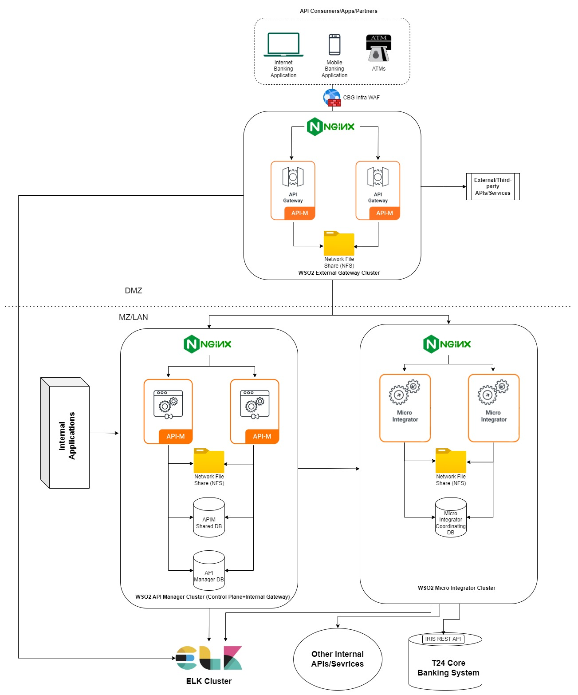

Design Principles
The platform is designed with scalability, high availability, and resilience in mind, ensuring uninterrupted API and integration services. The architecture follows key principles to eliminate single points of failure, optimize performance, and maintain business continuity through redundancy, load balancing, and failover mechanisms.
        - Clustering for Redundancy:
- API Manager: WSO2 API Manager 4.4 is deployed in an active-active cluster with multiple nodes for the Control Plane, Internal Gateway, and External Gateway.
- Micro Integrator: WSO2 Micro Integrator 4.3 is set up in a stateless active-active cluster, ensuring no single point of failure.
- Database Redundancy: The underlying database (PostgreSQL/MySQL/Oracle) is clustered using master-slave replication or a high-availability solution.
        - Load Balancing:
- API Gateway Traffic Handling: External and Internal API Gateways are fronted by an NGINX load balancer to evenly distribute requests.
- Micro Integrator Load Distribution: Requests are distributed across multiple Micro Integrator nodes using a round-robin or least-connection algorithm.
        - Auto-Scaling Mechanism:
- Manual VM Scaling: Since this is a pure VM-based deployment, additional VMs can be provisioned manually based on resource utilization.
- Horizontal Scaling: Additional API Manager or Micro Integrator nodes can be added to scale the platform horizontally.
- Vertical Scaling: Resource allocation (CPU, RAM) can be increased dynamically based on demand.

        - Failover and Disaster Recovery:
- Multi-Datacentre Deployment: Option to deploy API Manager and Micro Integrator across two or more geographically separated data centres.
- Database Failover Mechanism: The database uses clustering or a read-replica setup with automatic failover.
- Session Persistence: Stateless authentication mechanisms (e.g., OAuth tokens, JWT) ensure seamless failover without session loss.
        - High Availability for Analytics:
- WSO2 Choreo Analytics / ELK Stack: API analytics is managed using either WSO2 Choreo Analytics or an existing ELK stack.
- Log Collection Redundancy: Logs from API Manager and Micro Integrator nodes are collected and centralized in ELK using Filebeat and Logstash.
- High Availability ELK: Elasticsearch is configured with multiple data nodes, and Kibana is deployed redundantly to prevent data loss.
        - Performance Optimization:
- Caching Mechanisms:
  - API Manager caching policies reduce load on the database.
  - Micro Integrator supports distributed caching for frequently accessed integration responses.
- Thread Pool Optimization: Fine-tuned API Manager and Micro Integrator thread pools for concurrent request handling.
- Database Connection Pooling: Optimized database connection pools ensure minimal latency and high throughput.
By implementing these principles, the WSO2 API Management and Integration platform ensures high availability, fault tolerance, and scalability while maintaining optimal performance.

API Management and Integration Platform - Distributed Architecture – Key Components

The WSO2 API Management and Integration Platform is designed using a distributed architecture, ensuring scalability, security, and resilience. This architecture separates concerns across different components, enabling efficient workload distribution, fault tolerance, and high availability. The key components include WSO2 API Manager, WSO2 Micro-Integrator, NGINX, ELK Stack, a Database, and NFS. Each of these components has a specific role in enabling API lifecycle management, backend integrations, security enforcement, monitoring, and logging.
        - WSO2 API Manager 4.4 – API Exposure, Security, and Governance:
WSO2 API Manager is responsible for exposing, managing, securing, and monitoring APIs. It provides authentication and authorization using OAuth2, JWT, and Mutual TLS (mTLS), ensuring secure access to APIs. The platform includes throttling and rate-limiting policies to control API traffic and avoid system overload. A self-service API Developer Portal is available for API discovery and subscription, enhancing developer experience. The deployment supports multi-tenancy, enabling multiple API consumers and providers to coexist efficiently.
- Security Features: OAuth2, JWT, mTLS, and API access control
- Scalability: Clustered deployment with multi-region support
- Storage: Uses NFS for syncing API artifacts, configurations, and shared data across nodes

        - WSO2 Micro-Integrator 4.3 – Backend Service Integration:
WSO2 Micro-Integrator acts as the mediation layer, handling protocol transformation, message routing, and service orchestration. It facilitates seamless connectivity between Core Banking Systems, CRMs, ERPs, and external services. Supporting multiple protocols (REST, SOAP, JMS, Kafka, SAP, etc.), it ensures flexible integration with diverse systems. Micro-Integrator also enables service chaining and workflow orchestration, reducing dependency on monolithic architectures.
- Mediation Capabilities: Message transformation, service orchestration, and backend integrations
- Scalability: Horizontally scalable and containerized using Docker and Kubernetes
- Storage: Uses NFS for sharing configuration files, logs, and integration artifacts
        - NGINX – Load Balancer and Reverse Proxy:
NGINX functions as a load balancer and reverse proxy, efficiently distributing incoming API traffic across multiple WSO2 API Gateway nodes. It enhances fault tolerance and high availability, ensuring seamless API delivery. By offloading SSL termination, it improves security while reducing the load on backend services. Additionally, caching and sticky sessions optimize performance for high-traffic APIs.
- Traffic Management: Efficient API request routing across multiple WSO2 nodes
- Security & Performance: SSL termination, caching
        - ELK Stack – Centralized Logging and API Analytics:
The ELK Stack (Elasticsearch, Logstash, and Kibana) provides a centralized logging and monitoring solution for API traffic and backend integrations. It aggregates logs from API Manager, Micro-Integrator, and NGINX, offering deep insights into system performance, API consumption trends, and security anomalies. Kibana dashboards enable real-time log visualization and troubleshooting, helping teams detect and resolve issues proactively.
- Logging & Monitoring: Aggregates logs from API Manager, Micro-Integrator, and NGINX
- Analytics & Visualization: Kibana dashboards for monitoring API usage and performance

        - Database – Persistent Storage for API Metadata and Logs:
A database is required to store API metadata, configurations, transaction logs, and authentication details. It plays a key role in user authentication, access management, and audit logging, ensuring secure API interactions. The platform supports databases Oracle, depending on enterprise requirements. To prevent data loss, the database setup includes replication, backup strategies, and failover mechanisms.
- Data Storage: API definitions, subscription details
- Security & Compliance: Stores authentication and authorization data for secure API access
- Deployment Mode: Clustered database setup with failover mechanisms for high availability
        - NFS – Shared Storage for Configuration and Artifacts:
NFS (Network File Share) ensures a centralized and synchronized file system across all API Manager and Micro-Integrator nodes. It helps maintain consistency in API artifacts and deployment configurations, reducing redundancy. By providing a common storage layer, NFS enhances reliability in multi-node and clustered deployments.
- Configuration Synchronization: API Gateway artifacts, integration flows, and shared data
- Infrastructure Topology
The infrastructure topology for the WSO2 API Management and Integration Platform is designed to ensure scalability, high availability, and efficient resource utilization across different environments: Development (Dev), Quality Assurance (QA), and Production. Each environment is configured with specific virtual machine (VM) requirements tailored to its role in the development lifecycle.
The Disaster Recovery (DR) environment will mirror the production and post-production setups. The CBG infrastructure team will clone the environment while updating IPs, DNS configurations, and other necessary settings. Meanwhile, the database team will ensure real-time data replication of the WSO2 database for DR. Additionally, the Network File Share will be configured with rsync to synchronize files and artifacts from production to the DR environment.
Environment Details:
Development: 3 VMs
Testing: 9 VMs
Production: 9 VMs
Disaster Recovery (DR): 9 VMs
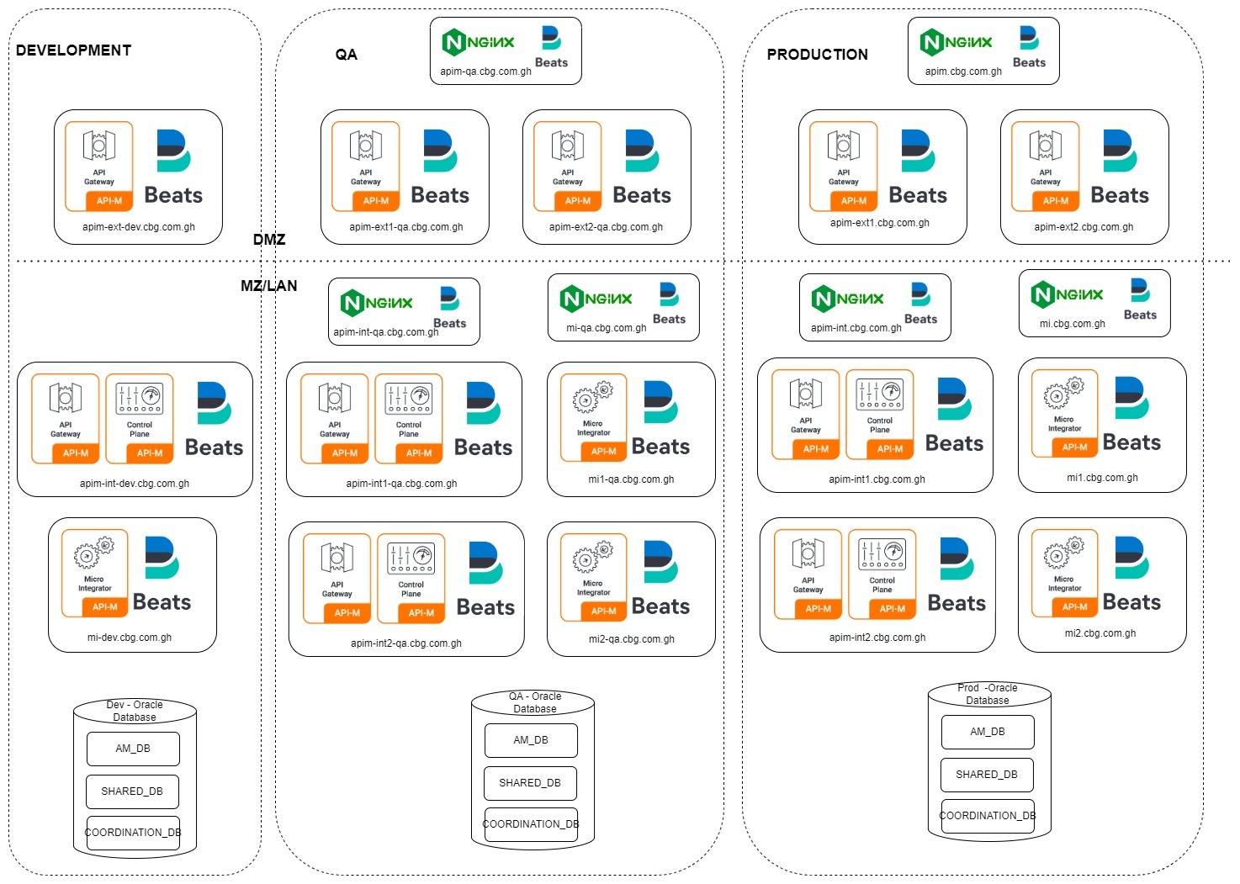

VM Requirements
The following table outlines the VM specifications for each environment, detailing the components, hostnames, and resource allocations:
Sr.No | Environment | Component | Hostname | vCPU | Memory (GB) | Disk(GB) | NIC | Remarks
1 | Dev | WSO2 Micro Integrator | mi-dev.cbg.com.gh | 4 | 32 | 150 | 2
2 | Dev | WSO2 API Manager (Control Plane+Internal Gateway) | apim-int-dev.cbg.com.gh | 2 | 16 | 150 | 2
3 | Dev | WSO2 API Manager (External Gateway) | apim-ext-dev.cbg.com.gh | 2 | 16 | 150 | 2
4 | QA | WSO2 Micro Integrator | mi1-qa.cbg.com.gh | 2 | 32 | 150 | 2
5 | QA |  | mi2-qa.cbg.com.gh | 2 | 32 | 150 | 2
6 | QA | Loadbalancer - WSO2 Micro Integrator | mi-qa.cbg.com.gh | 2 | 16 | 150 | 2
7 | QA | WSO2 API Manager(Control Plane+Internal Gateway) | apim-int1-qa.cbg.com.gh | 2 | 16 | 150 | 2
8 | QA |  | apim-int2-qa.cbg.com.gh | 2 | 16 | 150 | 2
9 | QA | Loadbalancer - WSO2 API Manager(Control Plane+Internal Gateway) | apim-int-qa.cbg.com.gh | 2 | 16 | 150 | 2
10 | QA | WSO2 API Manager(External Gateway) | apim-ext1-qa.cbg.com.gh | 2 | 16 | 150 | 2
11 | QA |  | apim-ext2-qa.cbg.com.gh | 2 | 16 | 150 | 2
12 | QA | Loadbalancer - WSO2 API Manager(Control Plane+External Gateway) | apim-qa.cbg.com.gh | 2 | 16 | 150 | 2
13 | Production | WSO2 Micro Integrator | mi1.cbg.com.gh | 2 | 32 | 150 | 2
14 | Production |  | mi2.cbg.com.gh | 2 | 32 | 150 | 2
15 | Production | Loadbalancer - WSO2 Micro Integrator | mi.cbg.com.gh | 2 | 16 | 150 | 2
16 | Production | WSO2 API Manager(Control Plane+Internal Gateway) | apim-int1.cbg.com.gh | 2 | 16 | 150 | 2
17 | Production |  | apim-int2.cbg.com.gh | 2 | 16 | 150 | 2
18 | Production | Loadbalancer - WSO2 API Manager(Control Plane+Internal Gateway) | apim-int.cbg.com.gh | 2 | 16 | 150 | 2
19 | Production | WSO2 API Manager(External Gateway) | apim-ext1.cbg.com.gh | 2 | 16 | 150 | 2
20 | Production |  | apim-ext2.cbg.com.gh | 2 | 16 | 150 | 2
21 | Production | Loadbalancer - WSO2 API Manager(Control Plane+External Gateway) | apim.cbg.com.gh | 2 | 16 | 150 | 2

Software and Libraries Requirements
The following table lists the required software and libraries for the WSO2 API Management and Integration Platform deployment, along with their versions and remarks,
S.No | Component | DB Name | Remarks
1 | WSO2 API Manager | 4.4 | API Manager (Internal and Externa Gateway)
2 | WSO2 Micro Integrator | 4.3 | Integration and Backend Processing
3 | Oracle JDK | 11 | Required for WSO2 Products
4 | Oracle Database | 19c | Centralized DB for WSO2
5 | Oracle Linux | 8.3 | OS for all VMs except for jump server
6 | NGINX | 1.26.3 | Load Balancer
7 | ELK Stack | Existing Versions | Centralized Logging & Monitoring
8 | Filebeat | 8.17 | Log Forwarder to ELK
9 | Network File Share (NFS) | Latest | For shared file artifact storage across clustered nodes
10 | Common Utilities | Latest | unzip, curl, vim, jq,  net-tools, dnsutils, telnet, lsof, sysstat
11 | Security Tools (Optional) | Latest | ufw (firewall), fail2ban (SSH protection)
12 | Jump Servers | Windows | WSO2 Integration Studio V8.0.0 or Later, WinSCP, PuTTY, MobaXterm, Postman, Notepad++, SOAP UI, Oracle DB client, Google Chrome, Oracle JDK 11, VSCode latest version

Database Requirements

The platform utilizes dedicated databases for various components to handle configurations, metadata, and coordination data. Each environment can have a separate database with multiple schemas. The table below outlines the database requirements for each environment:
Note: All the environment’s related DB has to be clustered and high-available except Dev environment

S.No | Environment | Component | DB Name | UserName | Password | Connection String
1 | Dev | WSO2 API Manager (Internal+external) | WSO2AM_DB
2 | Dev |  | WSO2SHARED_DB
3 | Dev | WSO2 Micro Integrator | WSO2_COORDINATION_DB
4 | QA | WSO2 API Manager (Internal+external) | WSO2AM_DB
5 | QA |  | WSO2SHARED_DB
6 | QA | WSO2 Micro Integrator | WSO2_COORDINATION_DB
7 | Production | WSO2 API Manager (Internal+external) | WSO2AM_DB
8 | Production |  | WSO2SHARED_DB
9 | Production | WSO2 Micro Integrator | WSO2_COORDINATION_DB

Product-Level VM Ports
The platform utilizes dedicated databases for different components to manage configurations, metadata, and coordination information. The following table specifies the database requirements for each environment:
S.No | Component | Purpose | Port | Description
1 | WSO2 API Manager | HTTPS Management Console | 9443 | HTTPS servlet transport (https://localhost:9443/carbon)
2 | WSO2 API Manager | HTTP Management Console | 9763 | HTTP servlet transport (http://localhost:9763/carbon)
3 | WSO2 API Manager | Embedded LDAP Server | 10389 | Port for LDAP authentication
4 | WSO2 API Manager | Internal Message Broker | 5672 | Handles internal messaging in API Manager
5 | WSO2 API Manager | Gateway HTTP Transport | 8280 | Passthrough/NIO HTTP transport
6 | WSO2 API Manager | Gateway HTTPS Transport | 8243 | Passthrough/NIO HTTPS transport
7 | WSO2 API Manager | Throttling TCP Events | 9611 | Receives throttling events over TCP (binary data publisher)
8 | WSO2 API Manager | Throttling SSL Events | 9711 | Secure transport for throttling events (binary data publisher)
9 | WSO2 API Manager | WebSocket Transport | 9099 | WebSocket connection handling
10 | WSO2 API Manager | Kerberos Authentication | 8000 | Exposes the Kerberos key distribution center server
11 | WSO2 API Manager | Multicast Membership | 45564 | Opened if the membership scheme is multicast
12 | WSO2 API Manager | WKA Membership Scheme | 4000 | Opened if the membership scheme is WKA
13 | WSO2 API Manager | RMI Registry | 11111 | Used for remote monitoring of Carbon
14 | WSO2 API Manager | JMX Monitoring Port | 9999 | MIServer port for JMX monitoring behind a firewall
15 | WSO2 API Manager | Default HTTP Transport | 80 | HTTP Transport
16 | WSO2 API Manager | Default HTTPS Transport | 443 | HTTPS Transport
17 | WSO2 API Manager | SSH Port to access VM | 22 | SSH Port to access VM
18 | WSO2 Micro Integrator | HTTP Transport | 8290 | Passthrough HTTP transport
19 | WSO2 Micro Integrator | HTTPS Transport | 8253 | Passthrough HTTPS transport
20 | WSO2 Micro Integrator | HTTP Management API | 9201 | HTTP port for Micro Integrator Management API
21 | WSO2 Micro Integrator | HTTPS Management API | 9164 | HTTPS port for Micro Integrator Management API
22 | WSO2 Micro Integrator | Micro Integrator Dashboard | 9743 | Dashboard interface for Micro Integrator
23 | WSO2 Micro Integrator | Default HTTP Transport | 80 | HTTP Transport
24 | WSO2 Micro Integrator | Default HTTPS Transport | 443 | HTTPS Transport
25 | WSO2 Micro Integrator | SSH Port to access VM | 22 | SSH Port to access VM
26 | NGINX Load Balancer | Default HTTP Transport | 80 | HTTP Transport
27 | NGINX Load Balancer | Default HTTPS Transport | 443 | HTTPS Transport
28 | NGINX Load Balancer | SSH Port to access VM | 22 | SSH Port to access VM

Firewall Port-Opening
<Table to be updated>

Security Considerations

The platform is designed with a multi-layered security approach to safeguard APIs, backend systems, and data. It integrates industry-standard security mechanisms to ensure authentication, authorization, and data protection. The key security features include:

TLS (Transport Layer Security) Encryption:
The platform enforces TLS 1.2+ for secure communication and data encryption between all components:
- API Gateway & Clients: Ensures all API communications are encrypted, protecting against eavesdropping and MITM attacks.
- Service-to-Service Communication: TLS encrypts internal traffic between microservices, databases, and backend components.
- Certificate Management: Uses trusted CA-signed certificates or an internal PKI for TLS certificate issuance, renewal, and revocation.
- Strict Cipher Suites: Implements strong encryption standards (e.g., AES-256, RSA-2048) to prevent cryptographic vulnerabilities.
TLS ensures confidentiality, data integrity, and authentication in all API interactions.

API Key Management:
To prevent unauthorized access and ensure secure communication between clients and APIs, the platform utilizes OAuth2, JWT, and mTLS:
- OAuth2 (Open Authorization 2.0): Provides secure access delegation, enabling users to grant applications access to resources without sharing credentials.
- JWT (JSON Web Token): Used for secure authentication, where tokens carry user identity and access privileges, reducing the need for repeated authentication.
- mTLS (Mutual TLS): Ensures both client and server authentication using certificates, protecting against man-in-the-middle (MITM) attacks.
These mechanisms enforce strong authentication and authorization while ensuring token integrity and expiration handling.

IP Whitelisting:
To restrict access to critical services, the platform enforces IP-based access control:
- Only trusted IP addresses (internal or external) are allowed to interact with APIs.
- Any request originating from an unlisted IP is automatically blocked.
- Helps mitigate unauthorized access attempts and geofencing-based security controls.
This ensures that APIs and backend services remain protected from unauthorized external threats.

Intrusion Detection:
The platform includes real-time monitoring and anomaly detection to identify and mitigate threats:
- Threat monitoring: Scans API traffic for anomalies such as unusual request patterns, rapid access attempts, or malformed requests.
- SQL Injection Prevention: Filters and sanitizes inputs to prevent database manipulation.
- DDoS Attack Mitigation: Implements rate limiting and behavioral analysis to detect and block abnormally high API requests.
These proactive security measures help detect and prevent intrusions before they cause harm.

Role-Based Access Control (RBAC):
To enforce fine-grained access control, the platform follows RBAC principles:
- Users and applications are assigned specific roles with defined privileges.
- Access is restricted based on roles, ensuring users can only interact with authorized resources.
- RBAC policies are enforced at both API Gateway and backend service layers.
By implementing least privilege access, RBAC minimizes security risks associated with unauthorized access.

Internal and External Gateways:
To enhance security, the platform segregates internal and external APIs:
- External API Gateway: Handles requests from public users, partners, and third-party integrations.
- Internal API Gateway: Manages requests within the organization, ensuring secure service-to-service communication.
This segregation ensures that:
- Public-facing APIs are exposed with additional security layers like WAF (Web Application Firewall) and DDoS protection.
- Internal APIs remain protected from external threats, reducing the risk of data leaks and unauthorized access.
By combining these security layers—API Key Management, IP Whitelisting, Intrusion Detection, RBAC and API Gateway Segmentation—the platform ensures robust protection against unauthorized access, data breaches, and cyber threats. These mechanisms help maintain data integrity, confidentiality, and availability while ensuring a seamless yet secure user experience.

- Signature & Approvals
ACCEPTED BY KULANA:  Name:  Designation:  Signature:  Date: | ACCEPTED BY CBG:  Name: Designation:  Signature:  Date:
ACCEPTED BY KULANA:  Name  Designation:  Signature:  Date: | ACCEPTED BY CBG:  Name: Designation:  Signature: Date:

