

CBG - IT Strategy & Governance
Governance Blueprint - Templates
HLD – High Level Design
Version 1.0

Solution Architecture Document (SAD)



Document Control
Project: | <Project Related>
BRS reference: | <BRS Related>
Document title: | <HLD name & ID>
Author: | <User>
Status: | <Status>

Creation, Update and Review History
No. | Version | Purpose | Name | Entity | Designation | Date
1 | 1.0 | Creation | John Wati | Kulana | Enterprise Architect | 27-Feb-2025

Approval History
No. | Version | Name | Job Description | Signature | Date
1

Distribution List
Version | Entity | Name | Date
1.0

Table of Contents
1. Introduction 5
1.1 Purpose: 5
1.2 Scope: 5
1.3 Audience: 5
1.4 References: 6
1.5 Definitions 6
2. Business Context 7
2.1 Business Problem/Opportunity 7
2.2 Business Objectives 7
2.3 Business Capabilities 7
2.4 Key Business Requirements 8
2.5 Key Business Processes 8
2.5.1 ATM Transactions 8
2.5.2 Transaction Logging & Monitoring 8
2.6 Business Users & Key Stakeholders 8
2.7 Functional Requirements 9
3. Solution Overview 14
3.1 Solution Description 14
3.2 Key Features 14
3.3 High Level Architecture—Need to update the recent one 15
3.4 Solution Objectives 15
3.5 Solution Scope 16
3.5.1 In Scope 16
3.5.2 Out of Scope 16
3.6 Assumptions 16
3.7 Constraints 16
3.8 Dependencies 16
3.9 Architecture Decisions 17
3.10 Decision Rationale: 17
4. Architectural Design | Solution Architecture 18
4.1 Logical Architecture 18
4.1.1 sequence diagrams 18
4.1.2 Components diagrams 18
4.2 Infrastructure Architecture 19
4.2.1 Infrastructure Repository 20
4.3 Data Architecture—Is this really required? 22
4.3.1 Data Model: 22
4.3.2 Data Storage: 23
4.3.3 Data Migration:--This is not required 23
4.3.4 Interface Inventory 23
4.4 Security Architecture 25
4.4.1 Security Requirements: 25
4.4.2 Threat Model: ---This component is not included in the HLD document shared BY CBG 25
4.5 Deployment Architecture: CI/CD to be included? 27
4.5.1 Deployment Strategy: Rolling Updates—Manual deployments to be included 27
4.5.2 Environment Configuration 27
4.5.3 Deployment Architecture (CI/CD) 28
5. Non-Functional Requirements (NFRs) 29
5.1 3.6.1 Availability & Reliability 29
6. Solution and System Operational Management 31
6.1 System Support 31
6.2 Backup / Restore / Data Retention Methodology—Did we check with CBG Team?? 31
7. Solution Delivery Considerations 32
7.1 Development Considerations 32
7.2 Deployment Considerations 32
7.3 32
7.4 Technology Stack 32
7.5 33
7.6 Integration with Enterprise Architecture 33
7.7 Risks and Mitigations 33
7.8 Standards and Guidelines 33
7.9 Assumptions and Constraints 33
8. Dependencies 34
8.1 Internal Dependencies 34
8.2 External Dependencies 34
9. appendix 35
9.1 Glossary 35
9.2 Acronyms 35
9.3 References 35
9.4 Additional: Diagrams scripts 36

Introduction

This section provides an overview of the document and its purpose.

Purpose:

The purpose of this Solution Architecture Document (SAD) is to define the architectural approach and design decisions for WSO2 API Management and Integration Platform. It provides a structured framework to guide the implementation of the solution, ensuring alignment with business objectives, technical requirements, and enterprise architecture principles.

Scope:

This document covers the architecture of WSO2 API Management and Integration Platform including:
- The systems and components involved
- The integration of different technologies and services
- The key business processes supported by the solution
- The stakeholders impacted by the solution
- The high-level design principles and non-functional requirements

Audience:

Role | Responsibility
Solution Architects | Define architectural decisions and ensure alignment with enterprise strategy.
Developers | Implement the solution based on the defined architecture.
DevOps & Infra Teams | Manage infrastructure, deployment, and automation.
Project Managers | Ensure project delivery and stakeholder communication.
Business Analysts | Translate business needs into functional and technical requirements.
Security Team | Assess security risks and ensure compliance.

References:
Document | Description
Business Requirements Document (BRD) | Defines business needs and objectives.
Industry Standards (ISO, TOGAF, OWASP, etc.) | Relevant industry standards for architecture and security.

Definitions
Term | Definition
API (Application Programming Interface) | A set of rules for communication between software components.
WSO2 API CTL | tool but will not develop full DevOps pipelines.

Business Context
This section outlines the business drivers and context for implementing the WSO2 API Management and Integration Platform.

Business Objectives
The solution aims to:
- Improve Efficiency – Streamline transactions and minimize system downtime.
- Enhance Customer Experience – Enable real-time banking services and faster transactions.
- Ensure Security & Compliance – Strengthen authentication, access controls, and regulatory adherence.
- Support Scalability & Agility – Facilitate future growth and third-party integrations.
- Optimize Costs – Reduce operational overhead through automation and system modernization.

Business Capabilities
The proposed solution will provide:
- Secure API-Driven Banking – API-based authentication, account services, and transaction processing.
- Real-Time Transaction Processing – Instant balance inquiries, withdrawals, and payments.
- Advanced Security & Compliance – Role-based access, encryption, and fraud prevention.
- Seamless System Interoperability – Integrated workflow between Postilion, WSO2, IRIS, and T24.
- Transaction Monitoring & Analytics – Real-time logging, auditing, and anomaly detection.

Key Business Requirements
The solution must ensure:
- Secure API Gateway – Manage internal and external API traffic securely.
- Seamless ATM-Postilion Integration – Enable real-time transaction routing.
- Real-Time Data Exchange – Between WSO2, IRIS, and T24 Core Banking.
- Scalable & High-Performance Infrastructure – Handle high transaction loads efficiently.
- Regulatory Compliance – Adherence to PCI DSS, GDPR, and financial security standards.
- Comprehensive Logging & Monitoring – Transaction visibility for auditing and security.

Key Business Processes

ATM Transactions
Actors: ATM User, ATM Terminal, Postilion , WSO2 , Core Banking
- User initiates a transaction (balance inquiry, withdrawal, transfer).
- Postilion validates and routes the request via WSO2 API Gateway.
- WSO2 forwards the request to IRIS Middleware and T24 Core Banking.
- Core Banking processes and returns the response using the same path.

Transaction Logging & Monitoring
Actors: IT Admins, Security Teams, Fraud Analysts
- Transactions are logged via WSO2 and IRIS for auditing.

Business Users & Key Stakeholders
Role | Responsibility
Banking Customers | Perform transactions via ATMs & digital channels.
IT & Security Teams | Manage API security, monitoring, and compliance.
Business Analysts | Define business needs and ensure alignment.
Developers & Architects | Design, implement, and optimize integrations.
Operations Team | Monitor infrastructure and resolve transaction issues.
Compliance Officers | Ensure regulatory and security compliance.
Executives & Decision Makers | Oversee digital transformation and adoption.

Functional Requirements

Use Case ID | Use Case Name | Actors | Preconditions | Steps | Success Criteria | Failure Conditions | Dependencies & Gaps
UC-001 | Balance Inquiry | Customer, System | Customer must have a valid account. | - Customer requests balance inquiry at the ATM.  - Postilion calls getAccountBalanceSummary API in ISO 8583 format.  - WSO2 API Manager receives and forwards the request to WSO2 Micro Integrator.  - WSO2 Micro Integrator converts ISO 8583 → REST JSON and calls IRIS (T24 Web Services).  - IRIS forwards the request to T24 Core Banking, which fetches the balance from the database.  - The response follows the reverse path, transforming REST JSON → ISO 8583, and finally, Postilion displays the balance to the customer. | Correct balance displayed. | Invalid account, network failure. | Dependency: T24 API availability  Gap: No offline balance retrieval
UC-002 | Account-to-Account Transfer | Customer, System | Customer must have sufficient funds. | 1. Customer initiates transfer.  2. Postilion calls createUnipayment.  3. T24 processes debit & credit.  4. Postilion confirms transaction. | Funds successfully transferred. | Insufficient funds, incorrect account. | Dependency: Instant settlement via T24  Gap: No real-time tracking for failed transfers
UC-003 | Mini-Statement | Customer, System | Account must have transaction history. | 1. Customer requests statement.  2. Postilion calls getAccountStatement.  3. T24 retrieves last transactions.  4. Postilion displays transactions. | Mini-statement displayed. | No transactions, invalid account. | Dependency: T24 data availability  Gap: Limited transaction history (e.g., last 5 only)
UC-004 | Cash Withdrawal (CBG Card) | Customer, ATM, System | Customer must have valid ATM card & funds. | 1. Customer inserts card & enters PIN.  2. Postilion calls createUnipayment.  3. T24 validates & debits account.  4. ATM dispenses cash. | Cash successfully withdrawn. | Insufficient funds, incorrect PIN. | Dependency: ATM network connectivity  Gap: No retry mechanism for failed withdrawals
UC-005 | Funds Transfer (Internal) | Customer, System | Sender must have sufficient funds. | 1. Customer initiates transfer.  2. Postilion calls createUnipayment.  3. T24 validates & processes transaction.  4. Postilion confirms. | Funds successfully transferred. | Insufficient funds, incorrect account. | Dependency: T24 instant processing  Gap: No automated notifications for failed transfers
UC-006 | Network Messages (Logon & Echo) | System Admin, System | Postilion & T24 must be online. | 1. Postilion sends logon message.  2. Echo messages sent periodically.  3. T24 responds with heartbeat. | Connection remains active. | Network failure, timeout. | Dependency: Stable network connectivity  Gap: No failover mechanism in case of persistent failure
UC-007 | Cheque Book Request | Customer, System | Account must support cheque books. | 1. Customer requests cheque book.  2. Postilion calls createChequeIssue.  3. T24 processes request & confirms. | Cheque book request processed. | Account restrictions, system downtime. | Dependency: Manual processing in T24  Gap: No tracking for pending requests
UC-008 | Money Voucher (Cardless Withdrawal) | Customer, System | Customer must generate valid voucher. | 1. Customer requests cardless withdrawal.  2. Postilion calls createUnipayment.  3. T24 validates voucher & debits account.  4. ATM dispenses cash. | Cash successfully withdrawn. | Expired/invalid voucher, insufficient funds. | Dependency: Secure voucher generation & validation  Gap: No mechanism for lost/stolen vouchers
UC-009 | Reversal | Customer, System | Failed transaction must be eligible for reversal. | 1. Transaction fails after debit.  2. Postilion calls reverseTransaction.  3. T24 processes reversal & credits account. | Transaction successfully reversed. | Reversal eligibility expired, system error. | Dependency: T24 automated reversal processing  Gap: No automated customer notification after reversal
UC-010 | GIP Name Inquiry | Customer, System | Recipient’s bank must support GIP lookup. | 1. Customer enters recipient's account.  2. Postilion calls nameEnquiry.  3. T24 fetches & returns recipient's name. | Recipient’s name displayed. | Non-existent account, system error. | Dependency: T24 integration with GIP  Gap: No caching for frequently searched accounts
UC-011 | GIP Credit Transfer | Customer, System | Sender must have sufficient funds. | 1. Customer initiates interbank transfer.  2. Postilion calls interbankFundsTransfer.  3. T24 validates & transfers funds.  4. Customer is notified. | Funds successfully transferred. | Insufficient funds, incorrect recipient details. | Dependency: T24 & GIP instant settlement  Gap: No refund mechanism for failed transfers

Solution Overview
This section provides a high-level overview of the proposed solution.

Solution Description

The proposed solution facilitates seamless integration between ATMs, the Postilion Switch, and the T24 Core Banking System. Using WSO2 Enterprise Integrator (WSO2 EI) as the middleware, the solution ensures secure and reliable transaction processing. The integration will enable real-time transaction routing, reconciliation, and error handling.

Key Features
- Seamless Integration: Enables communication between ATMs, Postilion, and T24 via WSO2.
- Transaction Processing: Supports real-time financial transactions (withdrawals, deposits, balance inquiries, and fund transfers).
- Security & Compliance: Implements encryption, authentication, and logging mechanisms.
- Error Handling & Retry Mechanism: Ensures transaction consistency with automated retries.-To be Explained
- Scalability: Designed to handle high transaction volumes.
- Monitoring & Logging: Provides real-time transaction tracking and audit logging.

High Level Architecture

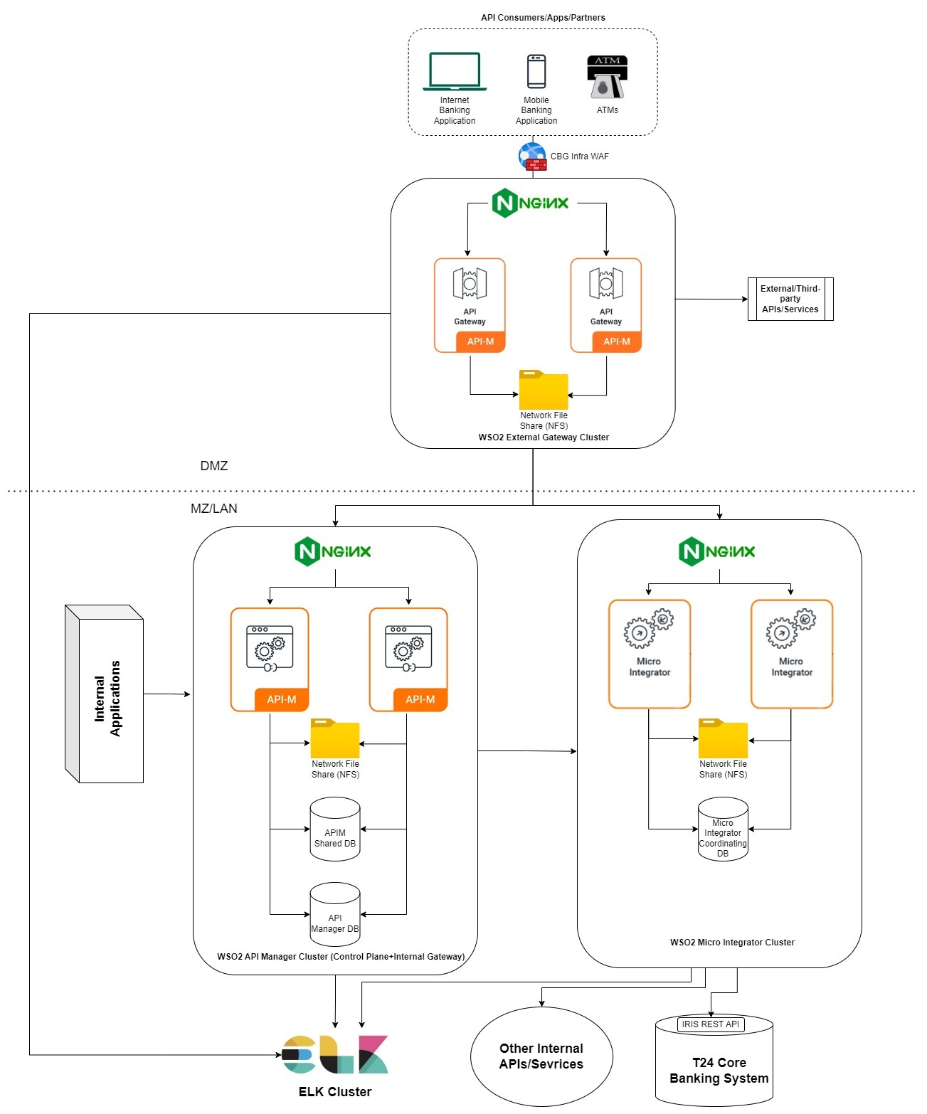

Solution Objectives
- Ensure real-time transaction processing.
- Provide secure and seamless communication between ATMs, Postilion, and T24.
- Enhance fault tolerance through robust error handling.
- Ensure compliance with banking security standards.
- Provide scalable architecture to support future expansion.

Solution Scope

In Scope
- Integration of ATMs via Postilion to T24 and back.
- Message transformation and protocol mediation using WSO2 EI.
- Security measures (encryption, authentication, and authorization).
- Transaction monitoring and logging.
- Error handling with automatic retry mechanisms.

Out of Scope
- Direct modification of Postilion or T24 core functionalities.
- Non-ATM channels (e.g., mobile banking, internet banking).
- Third-party fraud detection systems beyond logging and reporting.

Assumptions
- ATMs, Postilion, and T24 support standard messaging formats.
- Network connectivity between components is stable and secure.
- Transactions comply with banking security regulations.
- Postilion and T24 provide standard APIs or message interfaces.

Constraints
- Transaction latency must remain within defined SLAs.
- High availability of the WSO2 EI component is required.
- Regulatory compliance must be maintained at all times.

Dependencies
- Availability of Postilion and T24 APIs and message formats.

Architecture Decisions

# | Title | Decision
AD1 | Use of Oracle Linux OS | WSO2 has not been tested yet in Oracle Linux OS. This OS was chosen following CBG’s policy.
AD2 | Message Format Standardization | OFS is adopted for transaction messaging to ensure compatibility with existing financial systems setup and minimize integration complexity.

Decision Rationale:

Use of Oracle Linux OS
- The decision to use Oracle Linux OS aligns with CBG’s internal IT policies and infrastructure standards, ensuring consistency and streamlined support.
- Although WSO2 has not been officially tested on Oracle Linux, the OS is highly compatible with Red Hat Enterprise Linux (RHEL), a supported platform for WSO2.
- Oracle Linux offers enterprise-grade security, stability, and performance, making it a reliable choice for middleware hosting.

Message Format Standardization (OFS Adoption vs. ISO 8583 Strategy)

- OFS (Open Financial Services) format was chosen primarily due to the current setup in Postilion, allowing for easier integration with the existing transaction processing flow.
- However, OFS is not a long-term strategic option; the preferred approach is to standardize on ISO 8583 messaging, which is the global standard for financial transactions.
- Moving to ISO 8583 in the future will enhance interoperability, scalability, and compliance with modern banking infrastructure and payment networks.

Architectural Design | Solution Architecture
This section provides detailed architectural design information.

Logical Architecture

sequence diagrams

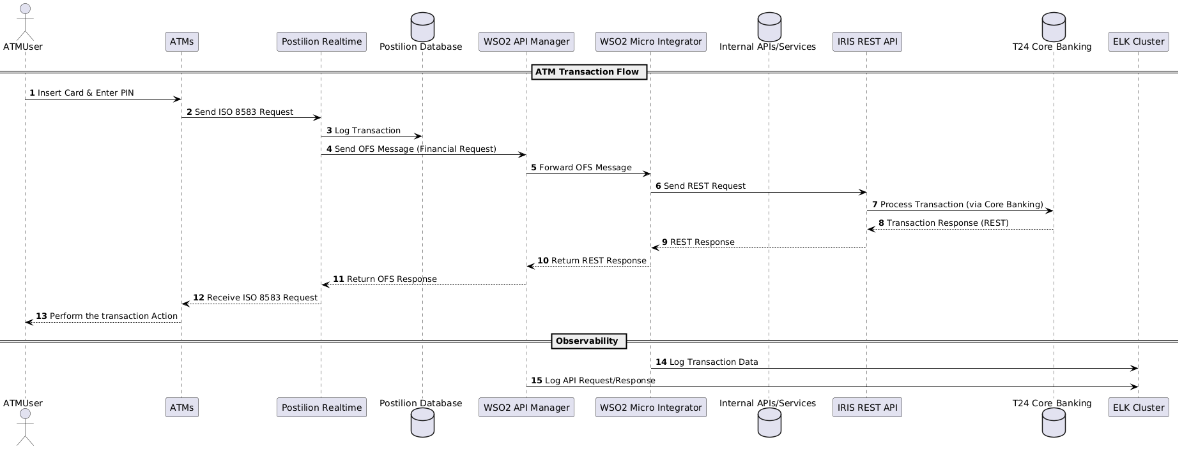

Components diagrams
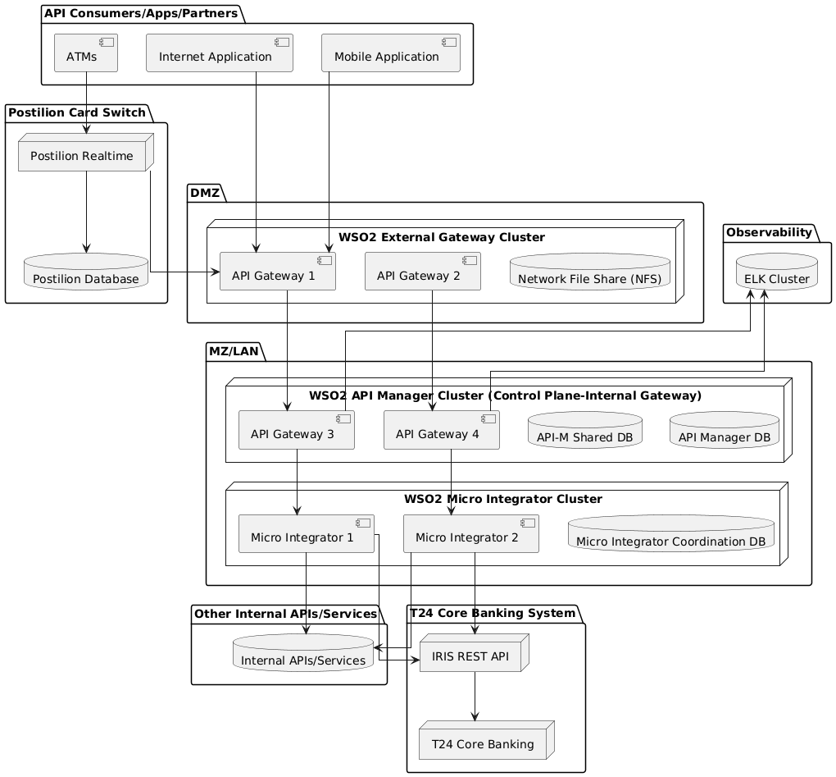

Infrastructure Architecture
The infrastructure topology for the WSO2 API Management and Integration Platform is designed to ensure scalability, high availability, and efficient resource utilization across different environments: Development (Dev), Quality Assurance (QA), and Production. Each environment is configured with specific virtual machine (VM) requirements tailored to its role in the development lifecycle.

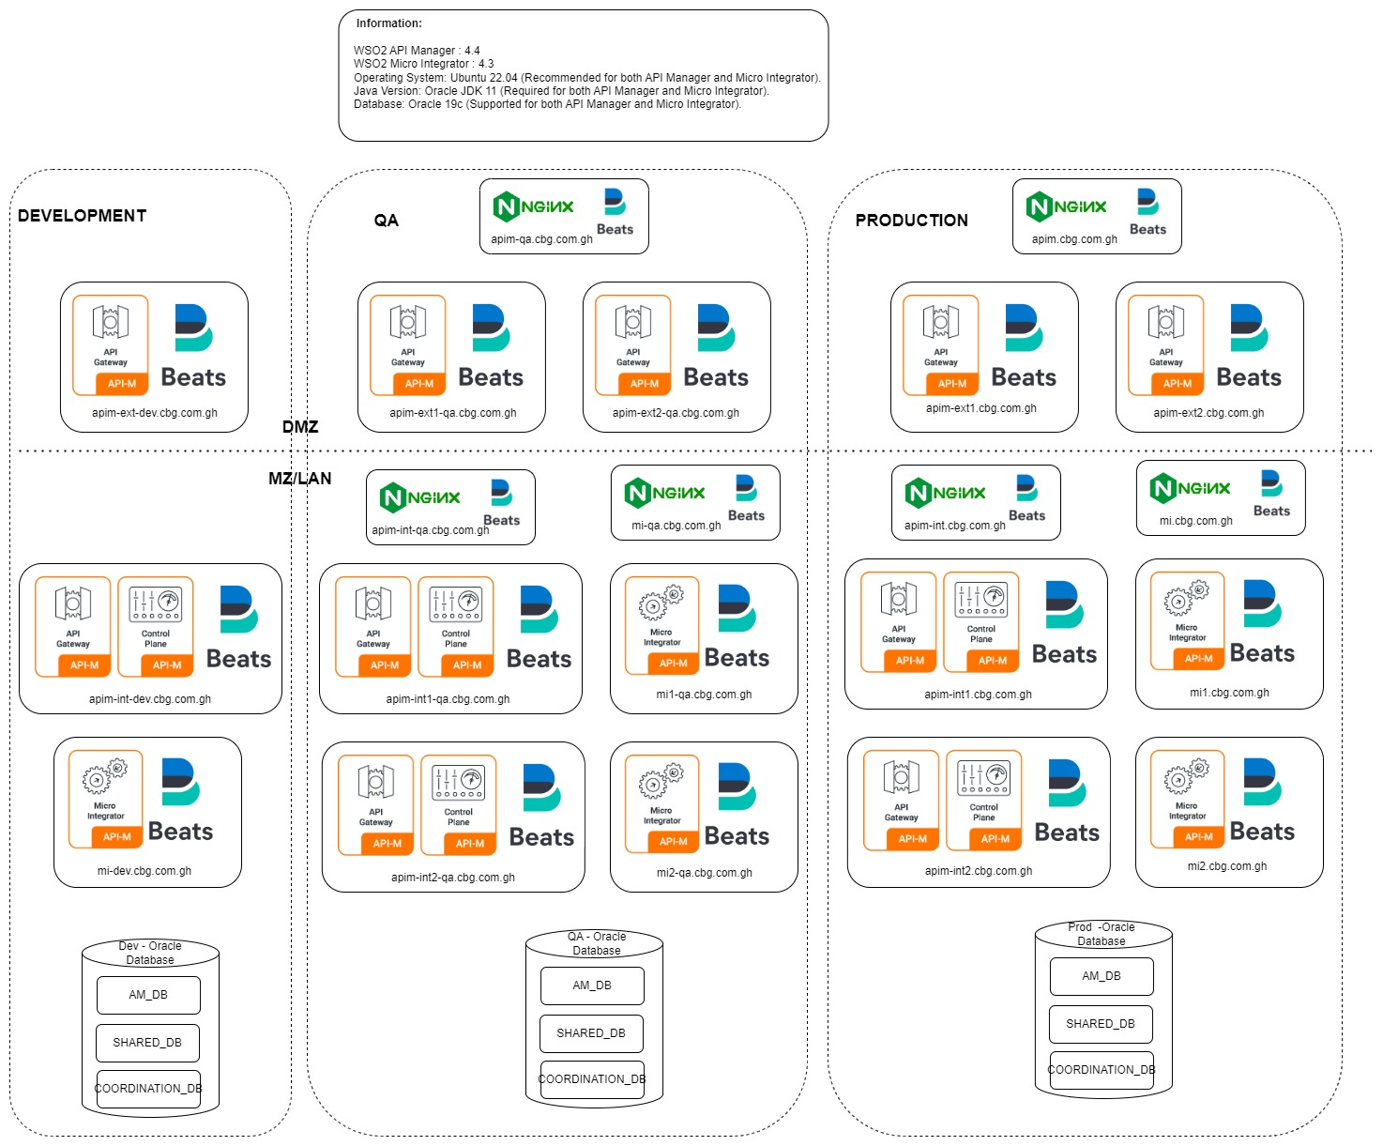

Infrastructure Repository
Ref. | Hardware | Specification | Location | Access
Production Environment
IF.PRD.01 | Production WSO2 API Manager (Control Plane + Internal Gateway) | 2 vCPU, 16GB RAM, 150GB Disk, Ubuntu 22.04 | Data Center | Admin, DevOps, API Team
IF.PRD.02 | Production WSO2 API Manager (External Gateway) | 2 vCPU, 16GB RAM, 150GB Disk, Ubuntu 22.04 | Data Center | Admin, API Consumers
IF.PRD.03 | Production WSO2 Micro Integrator (MI-1) | 2 vCPU, 32GB RAM, 150GB Disk, Ubuntu 22.04 | Data Center | Admin, Integration Team
IF.PRD.04 | Production WSO2 Micro Integrator (MI-2) | 2 vCPU, 32GB RAM, 150GB Disk, Ubuntu 22.04 | Data Center | Admin, Integration Team
IF.PRD.05 | Production Load Balancer (API Manager Internal Gateway) | 2 vCPU, 16GB RAM, 150GB Disk, HAProxy/Nginx | Data Center | Admin, DevOps
IF.PRD.06 | Production Load Balancer (API Manager External Gateway) | 2 vCPU, 16GB RAM, 150GB Disk, HAProxy/Nginx | Data Center | Admin, DevOps
IF.PRD.07 | Production Load Balancer (Micro Integrator) | 2 vCPU, 16GB RAM, 150GB Disk, HAProxy/Nginx | Data Center | Admin, DevOps
IF.PRD.08 | Production Database Server | Oracle 19c, 4 vCPU, 64GB RAM, 500GB Disk, RHEL 8 | Data Center | Admin, DBA Team
Quality Assurance (QA) Environment
IF.QA.01 | QA WSO2 API Manager (Control Plane + Internal Gateway) | 2 vCPU, 16GB RAM, 150GB Disk, Ubuntu 22.04 | QA Environment | QA Engineers, API Team
IF.QA.02 | QA WSO2 API Manager (External Gateway) | 2 vCPU, 16GB RAM, 150GB Disk, Ubuntu 22.04 | QA Environment | QA Engineers, API Consumers
IF.QA.03 | QA WSO2 Micro Integrator (MI-1) | 2 vCPU, 32GB RAM, 150GB Disk, Ubuntu 22.04 | QA Environment | QA Engineers, Integration Team
IF.QA.04 | QA WSO2 Micro Integrator (MI-2) | 2 vCPU, 32GB RAM, 150GB Disk, Ubuntu 22.04 | QA Environment | QA Engineers, Integration Team
IF.QA.05 | QA Load Balancer (API Manager Internal Gateway) | 2 vCPU, 16GB RAM, 150GB Disk, HAProxy/Nginx | QA Environment | Admin, DevOps
IF.QA.06 | QA Load Balancer (API Manager External Gateway) | 2 vCPU, 16GB RAM, 150GB Disk, HAProxy/Nginx | QA Environment | Admin, DevOps
IF.QA.07 | QA Load Balancer (Micro Integrator) | 2 vCPU, 16GB RAM, 150GB Disk, HAProxy/Nginx | QA Environment | Admin, DevOps
IF.QA.08 | QA Database Server | Oracle 19c, 4 vCPU, 64GB RAM, 500GB Disk, RHEL 8 | QA Environment | Admin, DBA Team
Development (Dev) Environment
IF.DEV.01 | Dev WSO2 API Manager (Control Plane + Internal Gateway) | 2 vCPU, 16GB RAM, 150GB Disk, Ubuntu 22.04 | Dev Environment | Developers, API Team
IF.DEV.02 | Dev WSO2 API Manager (External Gateway) | 2 vCPU, 16GB RAM, 150GB Disk, Ubuntu 22.04 | Dev Environment | Developers, API Consumers
IF.DEV.03 | Dev WSO2 Micro Integrator | 4 vCPU, 32GB RAM, 150GB Disk, Ubuntu 22.04 | Dev Environment | Developers, Integration Team
IF.DEV.04 | Dev Load Balancer (API Manager Internal Gateway) | 2 vCPU, 16GB RAM, 150GB Disk, HAProxy/Nginx | Dev Environment | Admin, DevOps
IF.DEV.05 | Dev Load Balancer (API Manager External Gateway) | 2 vCPU, 16GB RAM, 150GB Disk, HAProxy/Nginx | Dev Environment | Admin, DevOps
IF.DEV.06 | Dev Load Balancer (Micro Integrator) | 2 vCPU, 16GB RAM, 150GB Disk, HAProxy/Nginx | Dev Environment | Admin, DevOps
IF.DEV.07 | Dev Database Server | Oracle 19c, 4 vCPU, 64GB RAM, 500GB Disk, RHEL 8 | Dev Environment | Admin, DBA Team

Access Definitions:
- Admin: Full access to all infrastructure, responsible for configurations and security.
- API Team: Developers and engineers working on API configurations and integrations.
- Integration Team: Engineers handling middleware, data transformations, and message routing.
- DBA Team: Database administrators responsible for managing Oracle databases.
- API Consumers: Users who interact with API services via external gateways.
- QA Engineers: Team responsible for testing APIs, integration flows, and performance.

Data Architecture—Is this really required?

Data Storage:
Here is a table listing where data is stored in the WSO2 API Management and Integration Platform:
Component | Purpose | Storage Location | Type
WSO2 API Manager | Stores API metadata, configurations, and logs | Oracle 19c (WSO2AM_DB) | Relational Database
WSO2 Micro-Integrator | Stores coordination data and integration configs | Oracle 19c (WSO2_COORDINATION_DB) | Relational Database
WSO2 Shared Database | Shared data storage for multiple components | Oracle 19c (WSO2SHARED_DB) | Relational Database
NGINX | Caching for API Gateway traffic | Server memory (in-memory cache) | In-Memory Storage
ELK Stack (Elasticsearch) | Centralized logging and API analytics | Elasticsearch Cluster | NoSQL Database
File System (NFS) | Stores API artifacts, configuration files, logs | NFS Storage | Network File Storage
WSO2 ELK Stack | Stores API analytics and monitoring data | Elasticsearch / External Analytics | NoSQL / External Storage
OAuth Token Store | Stores authentication tokens (OAuth2, JWT, mTLS) | API Manager DB (Oracle 19c) | Relational Database
Load Balancer (NGINX) | Session persistence, SSL offloading | Server memory (Sticky Sessions) | In-Memory Storage

Interface Inventory

Ref. | Interface Name | Description | Data Objects | Source | Target | Frequency | Batch/Realtime
IN1 | Balance Inquiry | Retrieves account balance | Account Details | ATM | T24 | Realtime | API
IN2 | Account-To-Account Transfer | Internal funds transfer | Payment Details | ATM | T24 | Realtime | API
IN3 | Mini-Statement | Retrieves account transaction history | Account Transactions | ATM | T24 | Realtime | API
IN4 | Cash Withdrawal (CBG Card) | Withdraws cash from ATM | Payment Details | ATM | T24 | Realtime | API
IN5 | Cash Withdrawal (Other Bank GH-Link Card) | Withdraws cash using other bank's GH-Link card | Payment Details | ATM | T24 | Realtime | API
IN6 | Internal Funds Transfer | Transfers funds between accounts within the bank | Payment Details | ATM | T24 | Realtime | API
IN7 | Cash Withdrawal (Other Bank MasterCard) | Withdraws cash using MasterCard | Payment Details | ATM | T24 | Realtime | API
IN8 | GIP Name Inquiry | Verifies beneficiary details | Account Details | ATM | T24 | Realtime | API
IN9 | GIP Credit Transfer | Interbank funds transfer | Payment Details | ATM | T24 | Realtime | API
IN10 | Cheque Book Request | Requests a new cheque book | Account Details | ATM | T24 | Realtime | API
IN11 | Money Voucher | Enables cardless withdrawals | Payment Details | ATM | T24 | Realtime | API
IN12 | Reversal | Reverses a previously completed transaction | Transaction Details | ATM | T24 | Realtime | API

Security Architecture
The security architecture ensures that communication between Postilion, WSO2, and T24 remains secure while preventing unauthorized access, data breaches, and denial-of-service attacks.

Security Requirements:
To protect the integration, the following security requirements must be implemented:
- Authentication & Authorization: WSO2 API Manager will enforce OAuth 2.0 with JWT validation for API requests. Request send to IRIS will enforce basic auth for validating the API request.
- Encryption: TLS 1.2/1.3 encryption will be applied to secure data transmission.
- Data Integrity: payload validation will ensure data integrity between Postilion and T24.
- Access Control: Role-based access control (RBAC) will be configured to limit access.
- Logging & Monitoring: Security logs will be collected using a centralized SIEM tool for anomaly detection.

Threat Model: ---This component is not included in the HLD document shared BY CBG
This section identifies potential security threats and corresponding mitigation strategies.
Ref | Threat | Likelihood | Impact | Rating | Mitigation Strategies
TRD-01 | Denial of Service (DoS)  (Disrupts system availability) | Unlikely (2) | High (4) | Medium | - Implement rate limiting & API throttling in WSO2
TRD-02 | Data Breach  (Sensitive customer data exposure) | Unlikely (2) | High (4) | Medium | - Encrypt sensitive data at rest and in transit (AES-256, TLS 1.3)  - Implement API token expiration & refresh policies  - Monitor access logs for unusual patterns
TRD-03 | Man-in-the-Middle Attack  (Intercepting and modifying API communication) | Rare (1) | High (4) | Low | - Use mutual TLS (mTLS) authentication for API calls  - implement IP whitelisting to ensure request come from authorized nodes only.
TRD-04 | SQL Injection  (Injecting malicious queries into database transactions) | Unlikely (2) | Moderate (3) | Medium | - Use parameterized queries and input validation  - Database will be in private subnet  - Enable database firewall rules to block suspicious queries

Deployment Strategy: Rolling Updates—Manual deployments to be included
Rolling updates ensure zero downtime by updating WSO2 components incrementally across multiple nodes. The strategy follows these steps:
- Node Segmentation – WSO2 instances are deployed in a cluster (e.g., API Gateway, Enterprise Integrator).
- Sequential Updates – Updates are applied to one node at a time while others continue serving traffic.
- Health Checks – After updating a node, automated health checks verify stability before moving to the next node.
- Traffic Management – Load balancers direct traffic away from the updating nodes to avoid service disruption.
- Rollback Mechanism – If an update fails, the system reverts to the last stable version.
This approach maintains high availability, avoids full system downtime, and reduces deployment risks.

Environment Configuration
Each deployment follows a structured environment configuration:
Environment | Purpose | Key Features
Development (DEV) | For initial testing and integration | Frequent deployments, unstable
Testing (TEST) | QA testing for WSO2 components | Mock integrations, automated tests
Production (PROD) | Live environment handling real transactions | High availability, strict monitoring
DR
Each environment is configured with:
- WSO2 API Manager (for exposing APIs securely)
- WSO2 Enterprise Integrator (for service orchestration & mediation)

Deployment Architecture (CI/CD)—Please

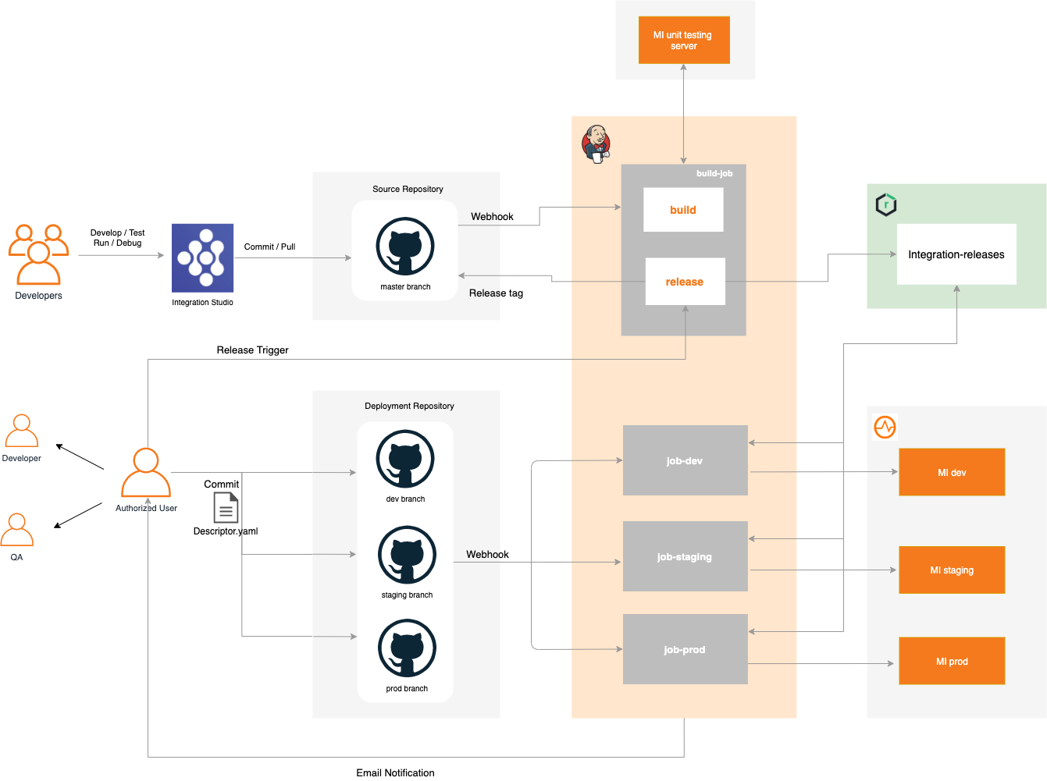

Non-Functional Requirements (NFRs)
The WSO2 API Management and Integration Platform is designed to meet critical non-functional requirements (NFRs) to ensure high availability, security, performance, and scalability. These requirements define the platform's operational and infrastructure constraints, ensuring optimal functionality in production environments.

3.6.1 Availability & Reliability
Requirement | Description | SLA
High Availability (HA) | The platform must support 99.9% uptime through clustering, load balancing, and failover mechanisms. | 99.9% Uptime
Redundancy | API Manager and Micro Integrator nodes are deployed in an active-active configuration to eliminate single points of failure. | No Single Point of Failure
Database Failover | The underlying database must support master-slave replication or active-active clustering to ensure failover continuity. | Failover Time < 1 min
Session Persistence | Stateless authentication mechanisms such as OAuth tokens and JWT ensure seamless user experience even in failover scenarios. | Zero Impact on Session State
Disaster Recovery (DR) | A secondary DR site must be maintained, with data replication to support failover within a defined RTO (Recovery Time Objective) and RPO (Recovery Point Objective). | RTO < 1 Hour, RPO < 15 min

3.6.2 Performance & Scalability
Requirement | Description | SLA
Load Handling | The platform should support at least 100 API requests per second (RPS) with optimized resource allocation. | 10,000 RPS Minimum
Auto-Scaling | The architecture should allow for horizontal scaling by dynamically adding API Manager and Micro Integrator nodes. | Scale Up/Down in < 5 min
Caching Mechanisms | API response caching at the gateway level and backend caching for frequently accessed integration responses. | Cache Hit Ratio > 80%
Thread Optimization | Fine-tuned API Manager and Micro Integrator thread pools for concurrent request processing. | Thread Pool Utilization < 75%
Database Connection Pooling | Optimized database connections to ensure minimal latency and high throughput. | DB Connection Latency < 50ms

3.6.3 Security & Compliance
Requirement | Description | SLA
Authentication & Authorization | OAuth2, JWT, and Mutual TLS (mTLS) are mandatory for API security. | 100% API Authentication Compliance
Role-Based Access Control (RBAC) | Enforce strict access control policies for API consumers and administrators. | Access Policy Updates < 24 Hours
Data Encryption | All sensitive data at rest and in transit must be encrypted using AES-256 for storage and TLS 1.2+ for transmission. | 100% Encrypted Data Compliance
Firewall & Network Security | Secure firewall rules must be configured to allow only necessary ports and IP whitelisting for API consumers. | Zero Unauthorized Access Attempts
Auditing & Logging | All API calls and system activities must be logged centrally for auditing and compliance. | Log Retention > 6 Months
Compliance Standards | The platform must adhere to security and regulatory standards such as GDPR, PCI-DSS, and ISO 27001. | 100% Compliance Certification

Observability & Monitoring
Requirement | Description | SLA
Centralized Logging | Logs from API Manager, Micro Integrator, and NGINX must be aggregated in ELK (Elasticsearch, Logstash, Kibana). | 99.9% Log Availability
Real-Time Monitoring | API usage and performance metrics must be visualized via Kibana dashboards. | Monitoring Latency < 10 sec
Alerting Mechanism | System alerts must be configured for anomalies, failures, or resource exhaustion. | Critical Alerts < 5 sec Delay
Tracing & Debugging | Distributed tracing must be enabled for API requests to diagnose integration issues. | 99.9% Traceability of Transactions

Maintainability & Support---Need to check
Requirement | Description | SLA
Infrastructure as Code (IaC) | Deployment scripts must be automated using Terraform or Ansible for consistent infrastructure provisioning. | 100% Automated Deployment
Configuration Management | Centralized configuration using NFS or Git-based repositories. | Config Change Deployment < 30 min
Version Control | API artifacts and integration flows must be version-controlled to ensure rollback capabilities. | 99.9% Version Control Coverage
Scheduled Maintenance | Defined maintenance windows for patches, upgrades, and security fixes. | Planned Downtime < 2 Hours/Month

Solution and System Operational Management
This section defines the operational management of the system, including support, incident handling, backup strategies, and user management.

System Support
A structured support model ensures efficient issue resolution with clear escalation paths.

Backup / Restore / Data Retention Methodology—Did we check with CBG Team??
- Backup Strategy:
  - Full system backups will be taken daily.
  - Incremental backups will be performed every 4 hours to minimize data loss.
  - Backups will be stored in secure offsite locations (cloud-based and on-premise).
- Data Retention Policy:
  - Application data will be retained for 7 years, in compliance with regulatory and business requirements.
  - Logs and audit trails will be stored for 12 months, after which they will be archived securely.
- Disaster Recovery (DR) Strategy:
  - Recovery Time Objective (RTO): 4 hours
  - Recovery Point Objective (RPO): 15 minutes
  - DR failover testing will be conducted quarterly to ensure readiness.
- Restore Testing:
  - Backup restore validation will be performed monthly to verify data integrity.
  - Restoration logs will be maintained for compliance and auditing.

Solution Delivery Considerations
This section outlines the key considerations for delivering the solution, including development, deployment, data migration, application decommissioning, and the technology stack. It ensures alignment with the overall architecture and provides a roadmap for implementation.

Development Considerations
Category | Details
Development Tools | Eclipse, Postman, JMeter, SonarQube
Code Repository | Git (GitHub/Bitbucket), hosted in CBG’s private repository
Versioning Strategy | Git Flow with feature, release, and hotfix branches
Backup & Recovery | Automated backups using GitHub Actions
Frameworks & Libraries | WSO2 API Manager, WSO2 Integrator, Log4j2
Development Environment | Local (WSO2 API Manager & Integrator), on-premise-based staging & production

Deployment Considerations
Category | Details
Deployment Approach | Rolling Updates using VM
Deployment Components | WSO2 API Manager, WSO2 Integrator
Deployment Checklist | API contract validation, security policies check, performance testing
Deployment Tools | WSO2 Carbon Console
Environment Configuration | Dev, Staging, Production and DR
Rollback Plan | WSO2 version rollback, database snapshots before API policy updates

Category | Details
Migration Approach | Parallel Run with incremental cutover
Scope of Migration | API subscriptions, user roles, security policies
Migration Tools | WSO2 Migration Utility, Custom Java scripts
Source & Target Systems | Legacy API Gateway → WSO2 API Manager
Data Formats | JSON, XML
Data Validation | API response consistency checks, automated API contract validation
Data Cleansing | Removing deprecated API versions, normalizing role-based access policies

Technology Stack
Category | Technology Used
Programming Languages | Java
Frameworks & Libraries | WSO2 API Manager, WSO2 Integrator
Databases | PostgreSQL (for API metadata)
Middleware | WSO2 API Manager, WSO2 Integrator

Integration with Enterprise Architecture
Category | Details
Compliance with Standards | Alignment with CBG’s internal security & compliance policies
Integration with Systems | API integrations with existing microservices and third-party APIs
Scalability & Future-Proofing | WSO2-based microgateway architecture, support for API analytics & monetization

Risks and Mitigations
Risk | Mitigation Strategy
Development Delays | Agile sprints with early API testing
Deployment Failures | Canary deployments, rollback policies
Data Migration Errors | Automated API schema validation
Security Threats | JWT-based authentication, API rate limiting
Business Disruptions | Zero-downtime deployment using WSO2 clustering

Standards and Guidelines
Category | Details
Coding Standards | WSO2 API best practices
Design Patterns | API Gateway
Compliance Requirements | PCI DSS, GDPR, local banking regulations

Assumptions and Constraints
Category | Details
Assumptions | CBG’s IT & Security support, full WSO2 stack licensing is available

Dependencies
This section outlines the dependencies required for the successful implementation of the solution.

Internal Dependencies
Dependency | Description | Owner/Responsible Team
Infrastructure Team | Provisioning and maintenance of servers, databases, and network configurations for WSO2 API Manager and WSO2 Integrator. | CBG IT Infrastructure Team
Security Team | Ensuring compliance with security policies, API authentication mechanisms, and access control. | CBG Security & Compliance Team
Application Development Team | Providing APIS and messages that integrate with WSO2 API Manager. | CBG Software Engineering Team
Database Administrators | Managing database configurations and performance tuning for API metadata storage. | CBG Database Administration Team
CBG Environment Provisioning | Providing the necessary environments for installation, including Development (Dev), Quality Assurance (QA), and Production (Prod). | CBG IT & Infrastructure Team
WSO2 License Management | Procuring and maintaining WSO2 licenses required for API Manager and Integrator. | CBG Procurement & IT Team

External Dependencies
Dependency | Description | Vendor/Provider
WSO2 API Manager | API management platform used for exposing, securing, and monitoring APIs. | WSO2
WSO2 Integrator | Middleware for integrating APIs with enterprise applications. | WSO2
Postilion Team | Providing ISO 8583 message formats and endpoints for transaction processing integration. | Postilion Vendor/Partner
T24 Core Banking Team | Providing API endpoints, request/response payload formats, and authentication details for core banking integration. | T24 Vendor/Partner
Third-Party APIs | External APIs consumed by internal services (e.g., payment gateways, KYC providers). IF ANY | Various API Providers
Monitoring & Logging Tools | Tools like ELK Stack, Prometheus, and Grafana for monitoring API traffic and system health. | Open-source / Licensed Solutions

appendix

Glossary
Term | Definition
API (Application Programming Interface) | A set of rules that allows software applications to communicate with each other.
ISO 8583 | A standard for financial transaction messaging used in banking and payment processing systems.
Middleware | Software that acts as a bridge between different applications or services to enable communication and data exchange.
WSO2 API Manager | A platform for managing, exposing, and securing APIs within an enterprise.
WSO2 Integrator | A tool for integrating various enterprise systems, enabling seamless communication between different applications.
T24 Core Banking | A core banking system used for handling financial transactions and account management.
Postilion | A payment processing solution that supports electronic transactions, including ISO 8583 messages.
CBG (Client’s Business Group) | The organization responsible for providing infrastructure, environments, and licensing for this project.

Acronyms
Acronym | Meaning
API | Application Programming Interface
CBG | Client’s Business Group
ISO 8583 | International Organization for Standardization 8583
QA | Quality Assurance
WSO2 | Web Services Oxygen 2
T24 | Temenos 24 (Core Banking System)

References
Reference | Description
WSO2 API Manager Documentation | Official documentation for WSO2 API Manager.
WSO2 Integrator Documentation | Official documentation for WSO2 Integrator.
ISO 8583 Standard | Official documentation on the ISO 8583 financial transaction message format.
T24 API Guide | Documentation for integrating with T24 Core Banking APIs.
CBG Internal Policies | Internal policies governing IT infrastructure, security, and compliance.

Additional: Diagrams scripts
- Components
@startuml
skinparam linetype ortho

package "API Consumers/Apps/Partners" {
[Internet Application]
[Mobile Application]
[ATMs]
}

package "Postilion Card Switch" {
node "Postilion Realtime" as Postilion_Realtime
database "Postilion Database"
}

package "DMZ" {
node "WSO2 External Gateway Cluster" {
[API Gateway 1] as API_M1
[API Gateway 2] as API_M2
database "Network File Share (NFS)"
}
}

package "MZ/LAN" {
node "WSO2 API Manager Cluster (Control Plane-Internal Gateway)" {
[API Gateway 3] as API_M3
[API Gateway 4] as API_M4
database "API-M Shared DB"
database "API Manager DB"
}

node "WSO2 Micro Integrator Cluster" {
[Micro Integrator 1] as MI1
[Micro Integrator 2] as MI2
database "Micro Integrator Coordination DB"
}
}

package "Observability" {
database "ELK Cluster"
}

package "Other Internal APIs/Services" {
database "Internal APIs/Services"
}

package "T24 Core Banking System" {
node "IRIS REST API"
node "T24 Core Banking" as core_banking
}

[Internet Application] --> API_M1
[Mobile Application] --> API_M1

[ATMs] --> Postilion_Realtime
Postilion_Realtime --> API_M1

API_M1 --> API_M3
API_M2 --> API_M4
API_M3 --> MI1
API_M4 --> MI2

MI1 --> "Internal APIs/Services"
MI2 --> "Internal APIs/Services"

MI1 --> "IRIS REST API"
MI2 --> "IRIS REST API"

"IRIS REST API" --> core_banking

Postilion_Realtime --> "Postilion Database"

"ELK Cluster" <-- API_M3
"ELK Cluster" <-- API_M4
@enduml

- Sequence diagram:

@startuml
autonumber
skinparam sequenceMessageAlign left
skinparam ParticipantPadding 10
skinparam ArrowColor Black
skinparam LifelineBorderColor Black

actor ATMUser

participant "ATMs" as ATMs
participant "Postilion Realtime" as Postilion
database "Postilion Database" as PostilionDB

participant "WSO2 API Manager" as APIM
participant "WSO2 Micro Integrator" as MicroIntegrator

database "Internal APIs/Services" as InternalAPIs
participant "IRIS REST API" as IRISAPI
database "T24 Core Banking" as T24

participant "ELK Cluster" as ELK

== ATM Transaction Flow ==
ATMUser -> ATMs : Insert Card & Enter PIN
ATMs -> Postilion : Send ISO 8583 Request
Postilion -> PostilionDB : Log Transaction
Postilion -> APIM : Send OFS Message (Financial Request)
APIM -> MicroIntegrator : Forward OFS Message
MicroIntegrator -> IRISAPI : Send REST Request
IRISAPI -> T24 : Process Transaction (via Core Banking)
T24 --> IRISAPI : Transaction Response (REST)
IRISAPI --> MicroIntegrator : REST Response
MicroIntegrator --> APIM : Return REST Response
APIM --> Postilion : Return OFS Response
Postilion --> ATMs : Receive ISO 8583 Request
ATMs --> ATMUser : Perform the transaction Action

== Observability ==
MicroIntegrator -> ELK : Log Transaction Data
APIM -> ELK : Log API Request/Response
@enduml

- Data entity:

@startuml
!define primary_key(x) <b>x</b>
!define foreign_key(x) <i>x</i>

entity Customer {
primary_key(CustomerID)
--
FullName : String
Email : String
PhoneNumber : String
Address : String
CreatedAt : DateTime
}

entity CustomerAccounts {
primary_key(AccountNumber)
foreign_key(CustomerID)
--
AccountType : "Savings" | "Current" | "Credit"
Status : String
Currency : String
CreatedAt : DateTime
}

entity CardInformation {
primary_key(CardID)
foreign_key(CustomerID)
foreign_key(AccountNumber)
--
CardNumber : String
ExpiryDate : Date
CVV : String
CardType : String
IssuerBank : String
Status : String
CreatedAt : DateTime
}

entity Balance {
primary_key(BalanceID)
foreign_key(AccountNumber)
--
AvailableBalance : Decimal
Currency : String
LastUpdated : DateTime
}

entity Transactions {
primary_key(TransactionID)
foreign_key(SourceAccountNumber)
foreign_key(DestinationAccountNumber)
--
DebitAmount : Decimal
CreditAmount : Decimal
Currency : String
Status : String
Timestamp : DateTime
Description : Text
}

entity Logs {
primary_key(LogID)
foreign_key(TransactionID)
foreign_key(CustomerID)
--
DebitAmount : Decimal
CreditAmount : Decimal
Status : String
Timestamp : DateTime
Message : Text
}

Customer ||--o{ CustomerAccounts : owns
CustomerAccounts ||--o{ CardInformation : linked_to
CustomerAccounts ||--o{ Balance : maintains
CustomerAccounts ||--o{ Transactions : initiates
Transactions ||--o{ Logs : recorded_as
Transactions ||--o{ Balance : affects
Transactions ||--|{ CustomerAccounts : involves
CardInformation ||--o{ Transactions : used_for
@enduml

