Case Study: Argument length in three-place predicates

Controlling for factors known to affect argument length
First, we know that English first- and second-person pronouns are necessarily shorter than third-person pronouns (not to mention lexical forms). Therefore, we include a binary predictor PERSON (first/second, third) to account for these baseline disparities in argument length.
Second, some have argued that the effects predicted by PAS could also arise from a combination of semantic properties of the arguments – specifically, whether they refer to high-agency animates/humans or low-agency inanimate entities – along with some acknowledged communicative exigencies, such as a general tendency for humans to discuss the experiences of other humans (Haspelmath, 2006; Everett, 2009). This effect could lead to reduction of human NPs through a combination of their semantic bias towards agentivity and their pragmatic bias towards topicality. To confront this possibility, we include a predictor ANIMACY with two levels (human and nonhuman).
Third, research into communicative efficiency, whether structural-hierarchical (Hawkins, 2004), information-theoretic (Levy, 2008; Jaeger, 2010), or discourse-functional (Gundel, 1988) predicts that units that more accessible – either because of their relative structural/informational simplicity or prominent status within the current discourse model – should be produced earlier than less accessible units. Thus, we include a variable POSITION with three levels (1_pre_verb, 2-first_post_verb, 3-second_post_verb) to protect against the possibility that any positive results could be explained just as easily by the ordering of units within the construction.
Fourth, grammatical form is expected even by PAS to play a role independent of any construction. Thus, 'core' arguments are expected to be constrained by PAS while 'peripheral' arguments (e.g., prepositional phrases) are expected to nullify PAS constraints (being so-called growth points, or sites of elaboration outside of the clausal-conceptual nucleus). To account for this effect, we include a predictor GRM_ROLE with four levels (A for subjects, I for indirect objects, O for direct objects, and B for objects of prepositions).
Fifth, we include a control variable which has not received much attention, but which is likely to impact argument length. IU_BRK records whether or not the argument is produced under the same intonational contour (as part of the same intonational unit, or IU; Chafe, 1994) as the verb. Under the assumption that IUs correspond to units of processing, arguments produced under a new IU may be released from the processing constraints associated with co-producing the verb, and so have a tendency to receive more complex encoding. Indeed, this last point may reflect a functional motivation for divorcing the argument from the verbal IU in the first place.

Variables of interest
Our critical independent variable is composed of an interaction between CONSTRUCTION and ARG_TYPE. CONSTRUCTION has two levels, ditransitive and caused-motion. This contrast treats the prepositional dative with give as inheriting its basic argument structure from the same parent construction as put, namely, the caused-motion construction. This relationship, at least in terms of the prepositional-dative, has received some support in the theoretical literature (e.g., Goldberg, 1995). ARG_TYPE is a ternary predictor encoding the thematic role of any given argument (agent, recipient/goal, or theme). By crossing CONSTRUCTION with ARG_TYPE, we allow for the possibility that the different constructions provide for differently elaborate encoding of the same thematic components, independently of the verbs involved. These differences have been well documented for the dative alternation (e.g., ditransitive recipient < prepositional dative recipient; CITE – e.g., STEFAN? PINKER? Maybe SANDY has something on this?), and we are sure to find them here. Our goal in the present study is therefore not to detect a difference in the general shape of the argument relations between the constructions, but to investigate the degree to which the lengths of these arguments differ both within and across constructions, and whether this variability is better accounted for constructionally or in terms of the control variables. We therefore take a different approach from prior research, which has focused mainly on determining, for instance, how argument length impacts the likelihood of selecting between the prepositional dative and ditransitive in the dative alternation (CITE). Here, we take the choice as granted in order to investigate how speakers, once committed to a particular construction, distribute informational mass across the available argument slots.
Note that in our coding scheme, we collapse the recipient and goal roles associated with give and put, respectively. The primary semantic distinction between recipient and goal concerns animacy, or more specifically, the ability of the entity so marked to consciously receive the theme or not. Based on the logic of Haspelmath (2006) and Everett (2009), we might expect these contrasts in animacy to result in different patterns of argument reduction for give as opposed to put when both appear in the caused-motion frame. A positive finding in this direction would suggest that animacy can override construction-based constraints in determining argument length, and so provide evidence against the cPAS hypothesis. To embody this conflict in the model, we include a second interaction, this time between VERB (give vs. put) and ARG_TYPE, to compete with the critical interaction of CONSTRUCTION with ARG_TYPE. If considerations of animacy related to the choice of verb outweigh construction-based limits on argument size (consistent with the arguments of Haspelmath inter alia), then this interaction should swallow the effect of the CONSTRUCTION:ARG_TYPE interaction.
Another issue is related to the relative reducibility of human (or non-human) arguments assigned to various thematic roles. Haspelmath and others have argued that humans tend to be mapped to the A role of constructions, while also tending to be topical. According to their argument, these functional generalizations could lead to the patterns predicted by PAS without need of an independent theoretical mechanism. However, as Goldberg (2004) points out, this counterargument cannot actually explain the overall PAS pattern. In particular, it cannot account for why speakers avoid placing non-topical humans in A. Nevertheless, given that the constructions studied here require that A and agent be co-mapped, we entertain the possibility that animacy functions differently for A/agents than for the other thematic roles. For instance, speakers may simply put off mentioning non-topical humans until later in the clause simply because they are less accessible by definition (that is, speakers select the construction that allows them to keep the topical NP first). If this is were the case, then both humans and inanimates should equally shrink in the agent role, but should perhaps differ in their realization across the other roles (given the greater baseline likelihood of humans to be discourse-given, as assumed by Haspelmath and others). The cPAS hypothesis, on the other hand, predicts that the constructionally specified patterns of realization will not vary as a function of animacy. This prediction stems from the assumption that speakers choose constructions to fit the pressures of the immediate discourse context, including pressures related to accessibility and representational richness within the current discourse model (i.e., how much information about entity X is shared as part of the interactants' common ground). Therefore, whether animate or inanimate, the discourse context, through the mediation of individual constructions, should constrain how much effort speakers put into encoding each argument. To deal with this possibility, we include an interaction ANIMACY:ARG_ROLE.

Measuring argument length
We operationalize argument length in terms of the proportion of the argument mass taken up by that argument: PROP_LENS (for proportional lengths). We calculate this proportion on the basis of argument lengths in characters (without spaces), where the span of the argument is defined as all material dominated by the highest-order NP in subject, direct object, indirect object, or prepositional object positions. This proportion is expressed as the length of the target argument in characters divided by the sum of the lengths of all three arguments. Measuring length in this way allows us to link the arguments within each clause while still predicting individual lengths on an argument-by-argument basis. This measure also breaks new ground in that prior research on PAS has focused exclusively on frequency counts of lexical vs. non-lexical core arguments.

Results
We computed a linear mixed-effects model predicting the proportional length of each argument in our sample (PROP_LENS). We included PERSON, ANIMACY, IU_BRK, POSITION, GRM_ROLE, ARG_TYPE, CONSTRUCTION, and VERB as main effects. We also included several two-way interactions: ARG_TYPE:CONSTRUCTION, ARG_TYPE:VERB, and ARG_TYPE:ANIMACY. To account for the possibility of individual variation in argument realization tendencies, we included random intercept adjustments for individual speakers. We performed a backward elimination of factors, stripping away at each iteration the highest-order variable (not participating in a significant higher-order interaction) whose removal resulted in the greatest decrease in the Akaike Information Criterion (AIC). We repeated this process until we arrived at the minimal adequate model (MAM), for which removing any other variable would only increase model AIC. This MAM was submitted to model criticism, which showed only a slight underperformance of the model in handling the upper extremes of proportional argument lengths. Otherwise, the model presents a reasonably good fit. A summary of the effects revealed by the minimal adequate model are presented in *Table QWE.

*Table QWE: Predictors remaining in MAM
Predictors | F | p
CONSTRUCTION | F(1, 728.5) = 1.25 | ns
ARG_TYPE | F(2, 728.5) = 82.04 | <0.001
PERSON | F(1, 728.5) = 85.48 | <0.001
IU_BRK | F(1, 728.5) = 8.6 | .003
CONSTRUCTION:ARG_TYPE | F(2, 728.5) = 142.2 | <0.001

A first glance at Table QWE reveals that many of the control variables did not survive the model selection procedure: ANIMACY, GRM_ROLE, POSITION, and the two interactions ARG_TYPE:VERB and ARG_TYPE:ANIMACY. We elaborate on the significance of this finding in the discussion, but point out here that all five relate in some way to competing explanations for the patterns of argument realization predicted by PAS. For now, we focus on the effects that did survive. In the remainder of this section, we examine each significant predictor in more detail, beginning with the two surviving control effects PERSON and IU_BRK, then proceeding to our variable of interest, CONSTRUCTION_TYPE:ARG_TYPE.
The left panel of *Figure QWE plots the main effect of person (first_second vs. third) on proportional argument length. As expected, first- and second-person forms (which are necessarily pronominal) tend to be shorter than third-person forms. Moreover, this difference is relatively marked, suggesting the presence of a sufficient number of non-pronominal third-person referents to widen the gap between the two groups.
The right panel of *Figure QWE plots the presence or absence of an IU boundary separating the target argument from the verb. Again as expected, arguments that occur outside of the verbal IU are reliably longer than arguments that are packaged with the verb under a single intonational contour. Considering the confidence intervals, arguments occurring in the same IU as the verb have a much more focused range than arguments occurring outside of the IU. This suggests that, indeed, intonational breaks allow argument slots to accommodate a much wider range of lengths.

(*Figure QWE about here)

*Figure ASD plots the interaction of construction type (ditransitive vs. prepositional dative) and thematic role (agent, recipient/goal, or theme) against proportional argument length. The left panel shows the distribution of argument mass across the agent, recipient, and theme roles of the caused-motion construction (for both give and put). Inspection of the error bars reveals that the argument lengths of the thematic roles differ reliably each from the other. Agents, which are encoded as A, are the shortest, followed closely by themes (O). Recipients (B) surface in much longer NPs, averaging almost twice the length of their corresponding agents). Turning to the ditransitive construction (right panel), we find a markedly different set of relations. As expected, this difference is localized to the contrast between the relative sizes of themes and recipients. Ditransitives, unlike caused-motion constructions, minimize the length of the recipient while exaggerating the size of the theme.

(*Figure ASD about here)

A more thorough comparison of the means shown in *FIGURE ASD reveals several further points of interest. First, compare the means of the recipients in caused-motion and of themes in the ditransitive construction. The latter take up almost 10% more of the argument mass per clause than the former. Now, compare the themes in caused-motion to the recipients of the ditransitive. While less extreme (only about 5% increase for caused-motion recipients), this difference is still reliable, as indicated by the non-overlapping error-bars. Taken together, these findings suggest that the proportional skewing of argument encoding in the ditransitive is much more pronounced than in the caused-motion construction, at least in terms of the predicate-internal arguments.
What about comparisons based on the contrasting grammatical encoding of the thematic roles in each construction? We could not allow our GRM_ROLE variable to interact with CONSTRUCTION in the model, on the grounds that the constructions only share two out of three grammatical roles. However, now that we have established the mean lengths of the thematic roles per construction, we may compare the means of the lengths of the thematic roles on the basis of their grammatical form using the construction type as a guide. First, compare the means of caused-motion themes to ditransitive themes. Both are encoded grammatically as direct objects (O). However, Os in the ditransitive are nearly double the length of Os in the caused-motion construction (this is probably why we do not find a main effect for GRM_ROLE). Apparently, not all Os are made equally. Second, let us return to the contrast between caused-motion recipients (prepositional objects) and ditransitive themes (O). Based on the 'growth point' metaphor, we should expect PPs to license longer arguments than core positions. In fact, this expectation is borne out construction-internally, as the PP-encoded recipients in the caused-motion construction are much longer on average than the core arguments contained in the same clause. However, if we compare caused-motion to ditransitive, we see that a core argument (theme O) of the latter exceeds the length of the former by a significant degree. Therefore, PP-status is simply not enough to predict length; rather, argument length depends more heavily on what construction the argument appears in.

Discussion
- Nonsignificant predictors and the damage they do to competing theories:
  - no effect of animacy as a main effect (humans simply are not reliably more reduced than other types of arguments).
  - No effect of animacy in interaction with verb type. This lack of an effect suggests that the animacy contrast in the basic semantics of give and put recipients plays no role in the realization of those arguments. This finding therefore casts doubt on Everett's argument for give attracting inherently topical humans to the A/agt slot. The fact that the A/agt is human or not is simply not what determines the reduction in this slot, at least not synchronically.
  - No effect of animacy in interaction with thematic role. One aspect of the counterarguments to PAS in these types of constructions concerns the asymmetrical encoding of animates as A and hence as agents. While coarse-grained correlations may exist between the animacy of an argument and the thematic role that it tends to be assigned, these effects do not necessarily hold in the context of particular constructions. Again we find that animacy is not a synchronic determinant of argument realization in this sample.
  - No effect of GRM_ROLE: this finding shows that the functional essentialism (your term, Jack!) – embodied in the origingal formulation of PAS (and shared by the critics) – which, for instance, treats Os as equivalent, regardless of the collostructional contexts into which they are embedded, should be abandoned. Our findings suggest strongly that this category in particular exhibits a wide degree of variability in at least one dimension – its capacity. Therefore, these typologically inspired generalizations may obscure important sources of variability in use, sources that we identify in part at least with verb-argument-structure constructions like those studied here.
  - No effect of POSITION: our findings also suggest that constituent-order-driven constraints on weighty NP allocation are insufficient to account for the patterns of argument realization observed here. To be sure, the overall pattern for both the ditransitive and caused-motion construction is consistent with the 'heavy-last' principle common to many theories of sentence processing (Hawking, 2004; Jaeger, 2010). That is, in both constructions, the on-average weightiest argument is placed last. However, in the model reported here, POSITION succumbed to the explanatory power of thematic roles. This is likely driven by a small number of cases of non-canonical ordering (i.e., passivized clauses) for which the effect of the argument's basic role on length was preserved in the dislocated position.
- Cognitive containment and the flexibility of platforms
  - something about the fact that platforms can vary in their capacity, and in order to get big platforms, you have to have small pockets. With bigger pockets, come smaller platforms. This suggests that our notion of containment, with its concomitant assumption of fixed capacity, does apply to these constructions. Th IU_BRK variable adds indirect support, in that the capacity can be saturated, with overflow shunted into neighboring IUs.
- Core vs. Oblique; grammaticization
  - this distinction is clearly not relevant if drawn in terms of phrasal encoding type (e.g., PP vs. 'bare' argument). Entrenched PP exerts pressure on clause-level capacity; generally large, so comes with a somewhat large cost by default; other arguments accommodate this draw, especially seen in the shrinking of caused-motion O relative to the ditransitive. However, the O is a much stronger competitor against the PP object than I is against O (PAS-inspired research has shown O to be lexical and I to be reduced). Therefore, they must negotiate this competition through lower ceiling argument length.
- Maybe something about the harmful oversimplification of rushes to generalization (citing, e.g., Croft, 2001) and the utility of S-A-O in live contexts.
- Something about how our findings still support the no-lexical-A constraint, but that we have found strong evidence against the one-lexical-argument per clause (if only because we show that degrees of lexicality are meaningful). However, regarding the latter, it may be that this 'constraint' is actually a diachronic attractor. This might explain why ditransitive has equivalent A and I and why the caused-motion has very close A and O.

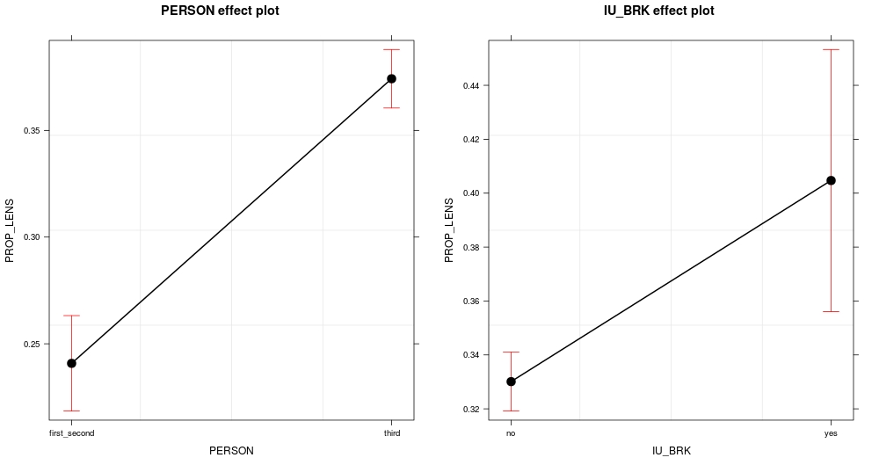
*Figure QWE:Main effect of grammatical person of argument on argument length (left panel); Main effect of intonational break between argument and verb on argument length (right panel)

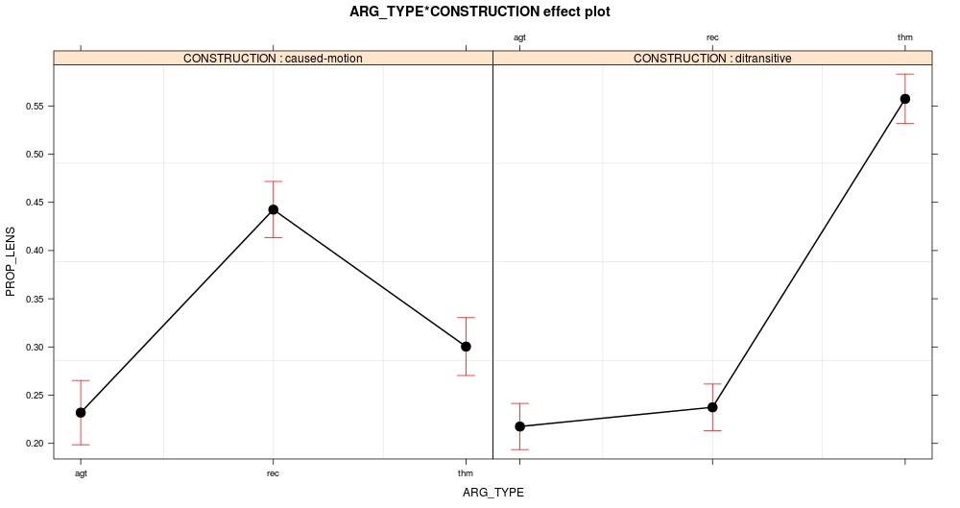
Figure ASD: Interaction effect of constructional type (caused-motion, left panel; ditransitive, right panel) and thematic role on argument length

We originally coded this variable with levels for non-human animates, but due to sparsity of observation, we collapsed that level with our level for inanimates to create the human/non-human contrast.
We ran the same analysis using log-transformed argument lengths (characters) as dependent variable. The results from the two models are nearly identical. Because the proportional measure has the advantage of conditioning argument size within the clause, and so reflects more directly the competition among the arguments for processing resources, we report the results of that analysis.
AIC assesses the relative quality of two or more models by taking into account the sample size, goodness of fit and term-complexity (degrees of freedom) of each.
Degrees of freedom were estimated using Satherwaite approximation, as implemented in the lmerTest package in R (Kuznetsova, Brockhoff, & Christensen, 2013).
One may object that our model does not directly compare the behavior of the caused-motion construction relative to each verb, and so cannot generalize the observed trend to both verbs. For instance, differences in sample size for the two collostructions (verb paired with construction) could lead to a spurious overall trend, driven by only one verb (in this case the much more frequent put). We computed an additional linear mixed effects model predicting proportional argument length only within the caused-motion construction. We included all the same predictors except for CONSTRUCTION and its interaction with ARG_TYPE (which were rendered moot by our restricting of our sample). This approach was necessary given that put does not occur in the ditransitive in our sample, which made it impossible for us to include the interaction term VERB:CONSTRUCTION in the primary analysis. The full details of the model are not important. What does matter is that VERB did not survive model selection, either as a main effect or in interaction. These findings support our collapsing of the two verbs in our CONSTRUCTION variable.

