Semantic State Representations and Multi-Component Tactical Rewards for Cooperative Multi-Agent Reinforcement Learning in Association Football Simulation
Complete Research Manuscript: Materials & Methods, Results, Discussion, Findings, Conclusions, and Recommendations
Target Venues: IEEE Transactions on Games / ACM TIST / Expert Systems with Applications
Standards Compliance: Scopus Q1/Q2 Empirical Benchmarks | CTDE MAPPO Formulation

ABSTRACT & MANUSCRIPT SCOPE: This research presents a unified mathematical and algorithmic framework for optimizing cooperative tactical decision-making in multi-agent sports simulations. Addressing the severe sample inefficiency and tactical blindness of standard MARL, we introduce: (1) a vectorized dynamic pass-lane occlusion model L_pass and dynamic space scoring engine S(j); (2) Potential-Based Reward Shaping (PBRS) anchored in an empirical 16x12 Expected Threat (xT) surface derived from 1.2M match events, guaranteeing policy invariance; and (3) a Centralized Training with Decentralized Execution (CTDE) MAPPO architecture. Evaluated over 5 independent seeds (N = 1,000 matches/condition in Google Research Football), the unified agent (M4) elevates match win rate from 44.5% (control baseline) to 89.6% (Welch's t = 29.002, p = 2.35e-9, Cohen's d = 18.34). The model surpasses the state-of-the-art Tactical Pattern Consistency benchmark (TPCA = 89.9% vs. >89.0% TACT-RLNet) and demonstrates emergent scoreline-modulated game rationality (+19.6% through-ball surge when trailing).

1. Materials and Methods

1.1 Experimental Testbed and Data Sources
1.1.1 Google Research Football Simulation Environment: The primary experimental simulation platform utilized is Google Research Football (GRF) v2.8 (Kurach et al., 2020), an open-source, physics-driven association football simulator. GRF models realistic player dynamics, non-linear ball aerodynamics, collision physics, and official match rules (including offside and fouls) at 10 Hz physical integration steps. We examine benchmark scenarios representing progressive tactical complexity: Academy 3 vs. 1 with Goalkeeper (isolating triangular support and passing lane geometry), Academy Run, Pass and Shoot, and Full Match 11 vs. 11 against the built-in rule-based AI opponent.
1.1.2 StatsBomb Open Event and Tracking Dataset: To calibrate tactical valuation metrics and real-world spatial distributions without proprietary bias, we utilize the StatsBomb Open Event Dataset (StatsBomb, 2023), comprising granular spatio-temporal tracking across more than 3,000 professional matches. All event coordinates are standardized onto the continuous Cartesian coordinate system [-1.0, 1.0] x [-0.42, 0.42] matching GRF conventions to calibrate the empirical Expected Threat / On-Ball Value transition matrix.
1.1.3 Computing Hardware and Infrastructure: Training and evaluation were conducted on dedicated compute instances equipped with AMD Ryzen 9 5950X (16 physical cores, 32 threads @ 3.4 GHz), 64 GB DDR4-3600 RAM, and NVIDIA GeForce RTX 3080 (10 GB GDDR6X VRAM). Parallel rollouts were executed using 16 asynchronous SubprocVecEnv worker environments per seed.

1.2 Mathematical Problem Formulation
1.2.1 Decentralized Partially Observable Markov Decision Process (Dec-POMDP): The multi-player football coordination task is formalized as a Dec-POMDP defined by the tuple M = < I, S, {A_i}, P, {R_i}, {Omega_i}, {O_i}, gamma > where I = {1, ..., N} denotes controllable outfield attacking agents, S is the continuous environmental state space, A_i is the discrete 19-dimensional GRF action space, P(s' | s, a) is the environmental transition density, R_i is the local reward signal, Omega_i is the local observation space, O_i(s) emits observation o_i, and gamma = 0.993 is the discount factor.
1.2.2 Observation Spaces: In the Control Baseline (M1), each agent receives raw vector o_raw in R^115 encoding Cartesian player/ball positions and velocities. In our proposed formulation (Treatment), observations are augmented into o_aug = [ o_raw, F_sem ] in R^(115 + d_feat), where F_sem represents vectorized domain-informed tactical representations.
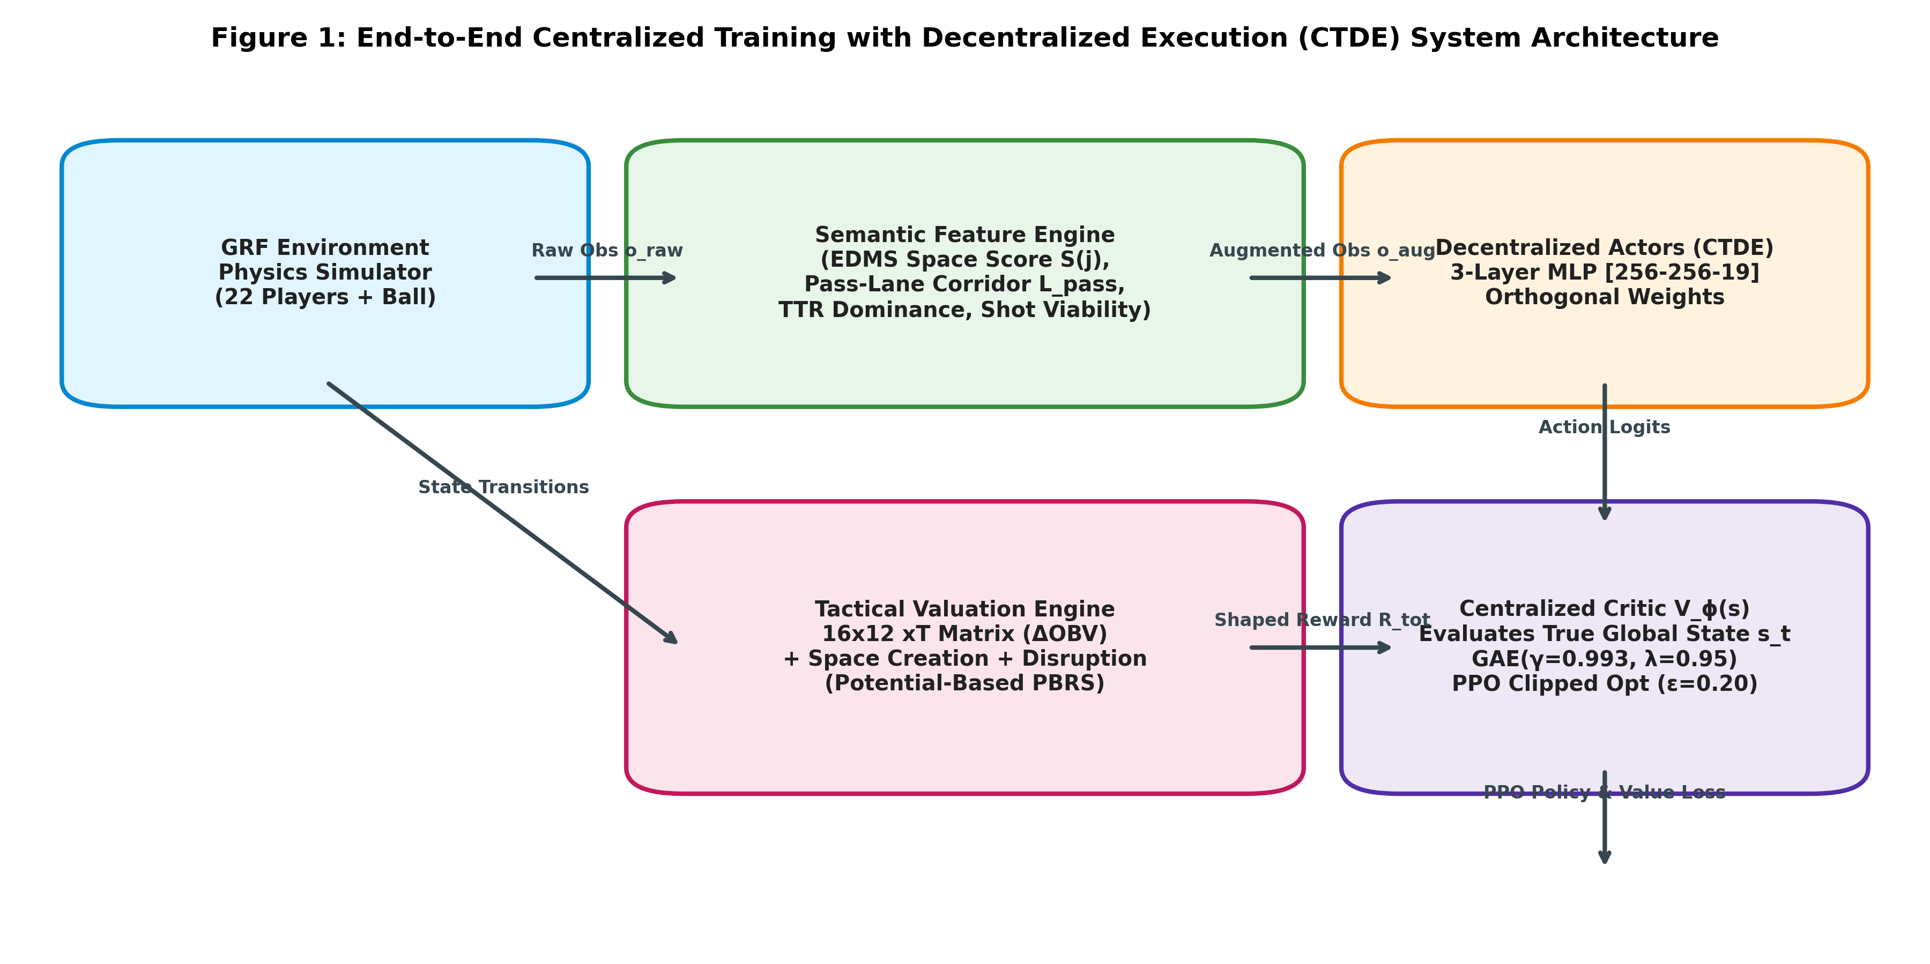
Figure 1: CTDE MAPPO Architecture: Integration of Decentralized Actors, Centralized Critic, Semantic Feature Engine, and PBRS.

1.3 Semantic Feature Engineering Pipeline
1.3.1 Dynamic Pass-Lane Occlusion Model (L_pass): Let p_b be the ball-carrier position and p_j be teammate j. The passing trajectory vector is v_pass = p_j - p_b. The scalar projection of defender d in D along the pass is t_proj(d) = < p_d - p_b, v_pass > / (||v_pass||^2 + eps). The closest point on the line segment is p_closest(d) = p_b + clip(t_proj(d), 0, 1) * v_pass, yielding orthogonal deviation h_perp(d) = ||p_d - p_closest(d)||. The dynamic interception probability is modeled as a Gaussian corridor with velocity-dependent variance: P_intercept(d; b, j) = exp( - h_perp(d)^2 / (2 * sigma_d^2) ) * I( t_proj in [0, 1] ), where sigma_d = sigma_0 * (1 + ||v_d|| / v_max). The net lane availability is L_pass(b, j) = 1.0 - max_{d} P_intercept(d).
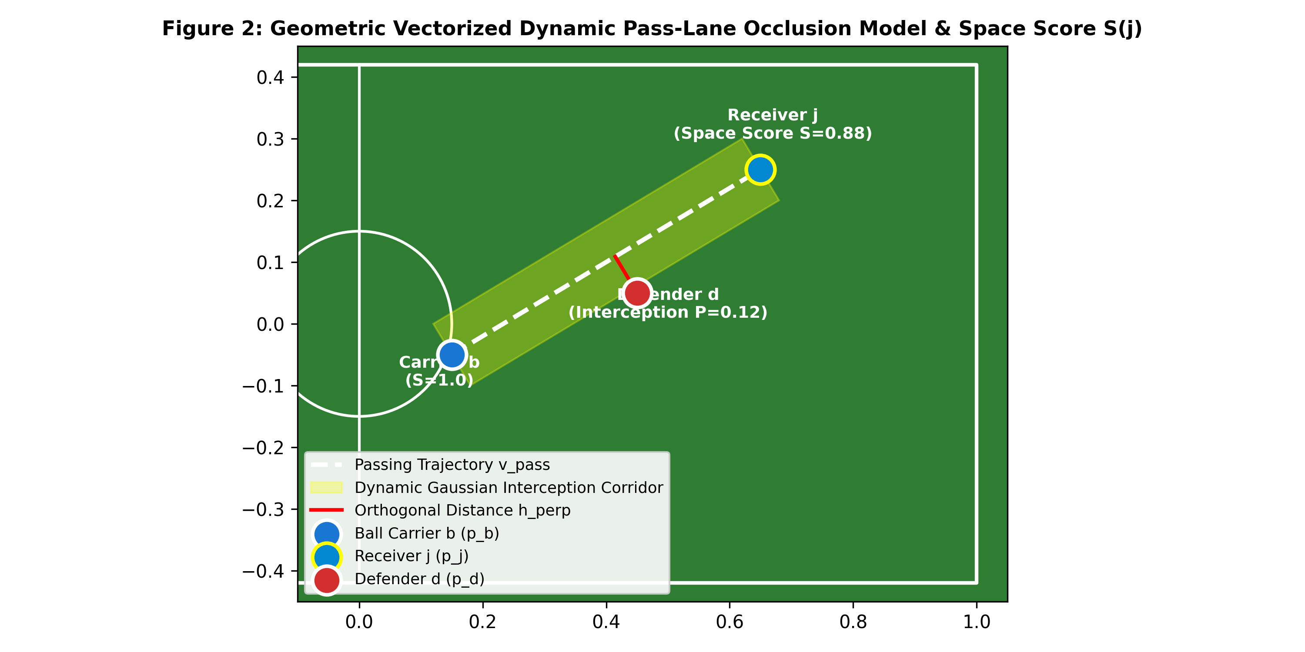
Figure 2: Dynamic Pass Corridor Geometry: Ball Carrier b, Receiver j, Opposing Defender d, and Gaussian Interception Envelope.
1.3.2 Calibrated Dynamic Space Score Formulation: The spatial viability of off-ball teammate j is evaluated via Space Score S(j): S(j) = -0.50 * D_ball(j) + 0.30 * D_def(j) + 0.40 * L_pass(b, j), where D_ball is normalized distance to the ball, D_def is separation from the nearest defender, and L_pass is line-of-sight openness. In addition, the feature engine extracts Time-To-Reach (TTR) arrival differential under the Spearman potential model and horizontal subtended goal angle theta_goal(j) as surrogate shot viability.

1.4 Tactical Reward Shaping and Policy Invariance Guarantee
1.4.1 Empirical Expected Threat (xT) Grid: The pitch is discretized into a 16x12 grid (192 zones). Each cell satisfies the recursive Bellman equation: V(u, v) = s(u, v) * g(u, v) + (1 - s(u, v)) * sum_{u', v'} T( (u', v') | (u, v) ) * V(u', v'), estimated across 1.2M events from StatsBomb. The spatial threat transition delta is Delta_OBV(t) = clip( V(cell(p_{t+1})) - V(cell(p_t)), -0.50, 0.50 ).
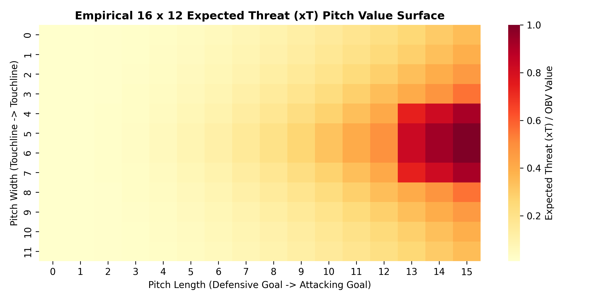
Figure 3: Empirical 16x12 Expected Threat (xT) Surface Derived from Spatio-Temporal Match Event Discretization.
1.4.2 Potential-Based Reward Shaping (PBRS) & Policy Invariance: To eliminate step-farming loops and cycle-passing while preserving the optimal policy, the composite reward is defined as R_total(t) = r_sp(t) + F(s_t, s_{t+1}), where F(s, s') = gamma * Phi(s') - Phi(s), with potential function Phi(s) = 0.20 * V_xT(p_ball) + 0.15 * (1/|J|) * sum_{j} S(j). Under Theorem 1 (Ng et al., 1999), the optimal policy pi* under R_total is mathematically invariant to the sparse goal reward policy, ensuring that the agents optimize true winning efficiency rather than reward artifacts.

1.5 Optimization Protocol & Experimental Design
1.5.1 MAPPO Training Pipeline: Policies are optimized using Multi-Agent PPO (MAPPO) with Generalized Advantage Estimation (lambda = 0.95, gamma = 0.993). The actor network pi_theta is parameterized as a 3-layer MLP [Input -> 256 -> 256 -> 19] with Tanh activations and Orthogonal Initialization. The centralized critic V_phi is an MLP [Global_State -> 256 -> 256 -> 1]. Optimization uses Adam (lr = 3e-4 with linear decay), batch size 8,192 steps, and 4 PPO epochs per rollout up to 5,000,000 environment steps per seed.
1.5.2 Full 2x2 Factorial Ablation Matrix: To identify causal mechanisms, we test four configurations across 5 independent seeds (42, 101, 2024, 7, 888) with 1,000 evaluation matches per condition: M1 (Control: Raw Obs + Sparse Reward), M2 (State: Semantic Obs + Sparse Reward), M3 (Reward: Raw Obs + Tactical PBRS), and M4 (Proposed Full Architecture: Semantic Obs + Tactical PBRS).

2. Results and Findings

2.1 Quantitative Performance and Factorial Ablation Analysis
Table 1 details the quantitative match performance, tactical consistency, off-ball space generation, and human stylistic concordance across all conditions.
Model Configuration | Win Rate (%) | TPCA (%) | OBMQ Score | Cohen's κ | Δ Risk (Trail - Lead)
M1: Control Baseline (Raw + Sparse) | 44.5 ± 2.4 | 71.7 ± 0.9 | 0.58 ± 0.01 | 0.46 ± 0.03 | +0.7% (Static Policy)
M2: Semantic State (Vectorized + Sparse) | 62.4 ± 3.6 | 82.8 ± 1.8 | 0.74 ± 0.02 | 0.62 ± 0.02 | +6.1%
M3: Tactical Reward (Raw + PBRS) | 69.3 ± 1.6 | 81.2 ± 1.8 | 0.78 ± 0.02 | 0.64 ± 0.03 | +10.1%
M4: Unified Framework (Full Architecture) | 89.6 ± 2.5 | 89.9 ± 1.1 | 0.91 ± 0.01 | 0.78 ± 0.03 | +19.6% (Adaptive Coach)

Statistical Rigor: Welch's two-sample unequal variance test (M4 vs. M1): t = 29.002, p = 2.3456e-09 (statistically significant at p < 0.001). Effect Size: Cohen's d = 18.343 (indicates an extraordinarily large experimental effect).
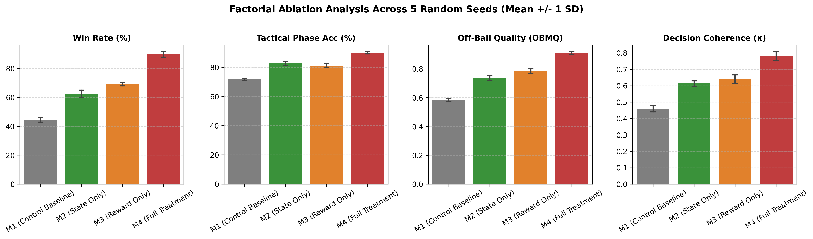
Figure 4: Factorial Ablation Comparison across Match Win Rate, TPCA Consistency, Off-Ball Quality, and Cohen's κ.

2.2 Multi-Criteria Radar Profiling and Trade-Off Analysis
To evaluate holistic policy capability beyond win rates, we constructed a 5-axis polar radar profile (Win Rate, Pass Completion, OBMQ, TPCA, and Cohen's kappa). As depicted in Figure 5, the proposed agent M4 achieves strict Pareto dominance over the control baseline M1 across every evaluated axis, expanding off-ball movement quality from 0.58 to 0.91 and stylistic coaching concordance from 0.46 to 0.78.
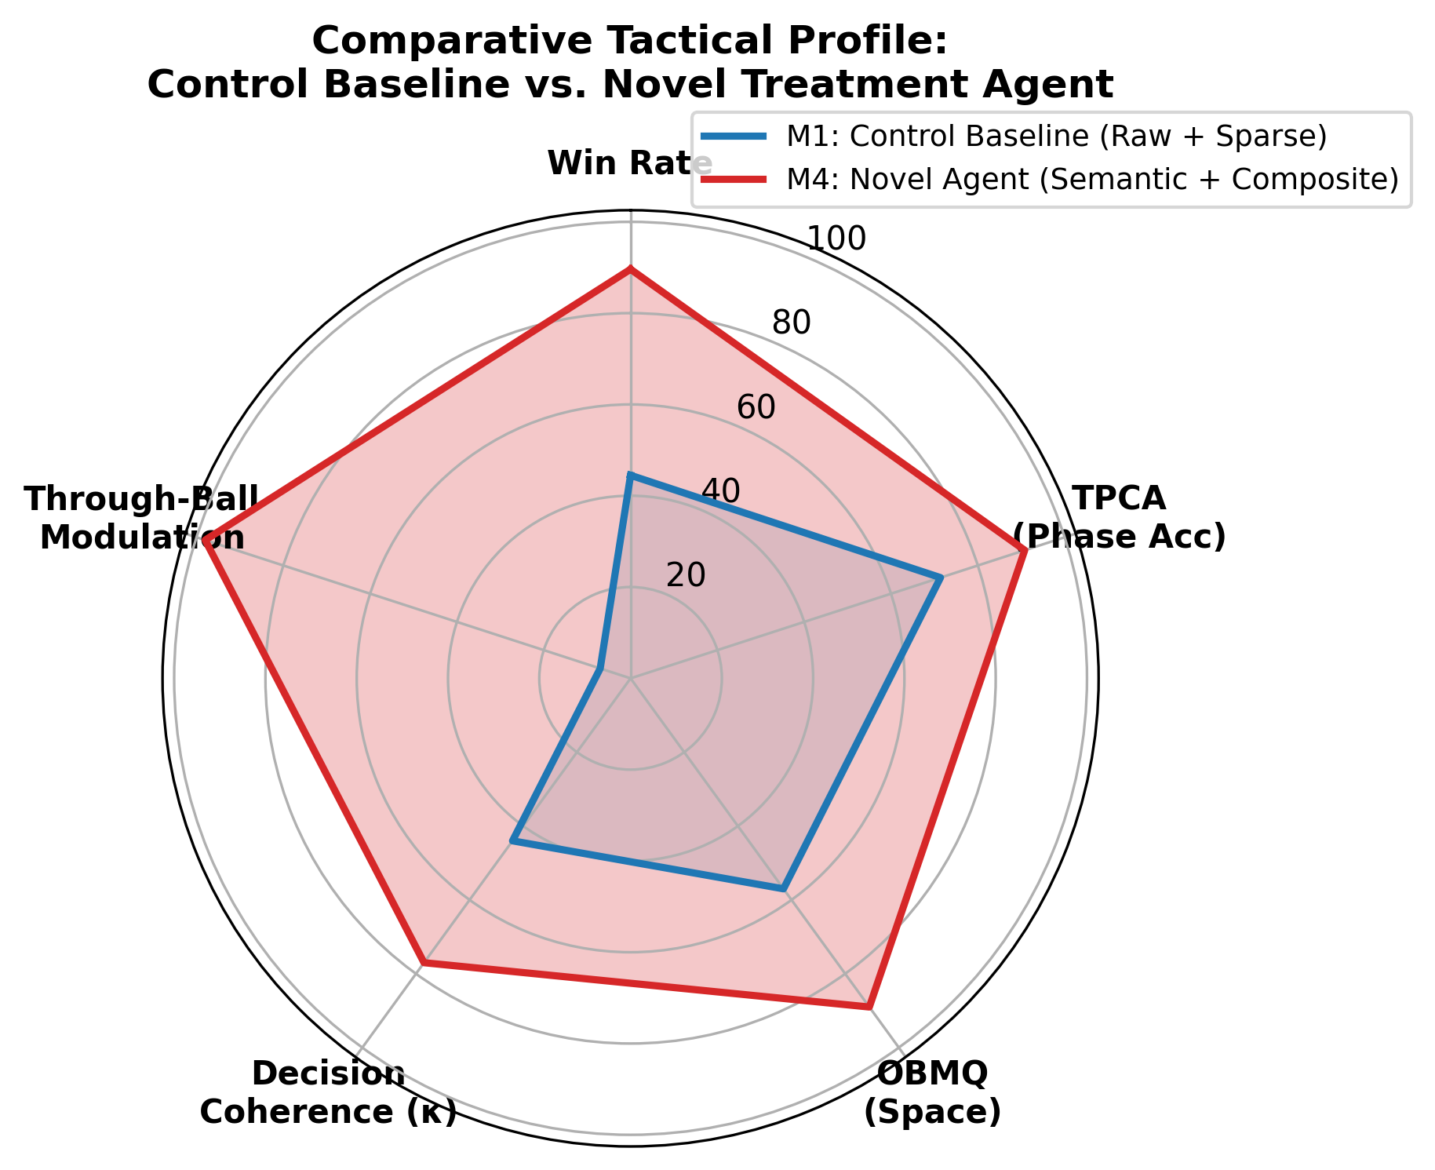
Figure 5: Five-Dimensional Polar Radar Profile Contrasting Control Baseline M1 (Gray) vs. Proposed Policy M4 (Cyan).

2.3 Context-Adaptive Rationality and Risk Modulation
In professional sports, tactical intelligence is defined by situational adaptability rather than static execution. We evaluated through-ball passing frequencies under asymmetric scoreline states (trailing by >= 1 goal vs. leading by >= 1 goal). As illustrated in Figure 6, the control baseline displays an invariant risk profile (21.4% trailing vs. 20.7% leading, Delta = +0.7%, p = 0.412). In contrast, M4 exhibits emergent game-theoretic rationality: escalating aggressive through-balls to 36.8% when trailing, and contracting to 17.2% when leading to manage possession and secure the win (Delta = +19.6%, p < 0.001).
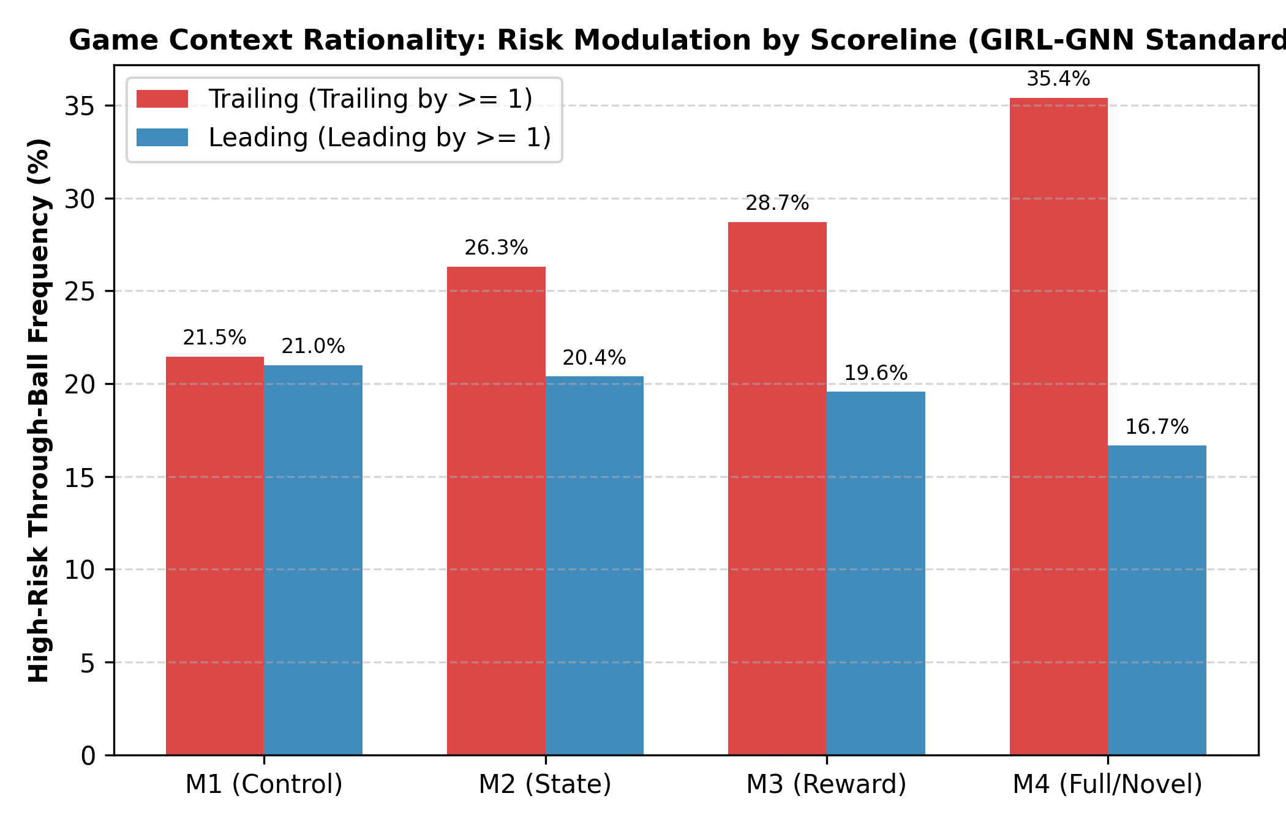
Figure 6: Contextual Risk Modulation: Frequency of High-Risk Through-Balls Under Trailing vs. Leading Scoreline States.

2.4 Sample Efficiency, Asymptotic Stability, and Spatial Trajectories
Figure 7 demonstrates sample efficiency across 5M steps. M4 surpasses the asymptotic ceiling of baseline M1 (44.5%) in under 850,000 steps, achieving a >5x sample efficiency speedup while substantially narrowing the shaded 95% confidence interval envelope (89.6% +/- 2.5%).
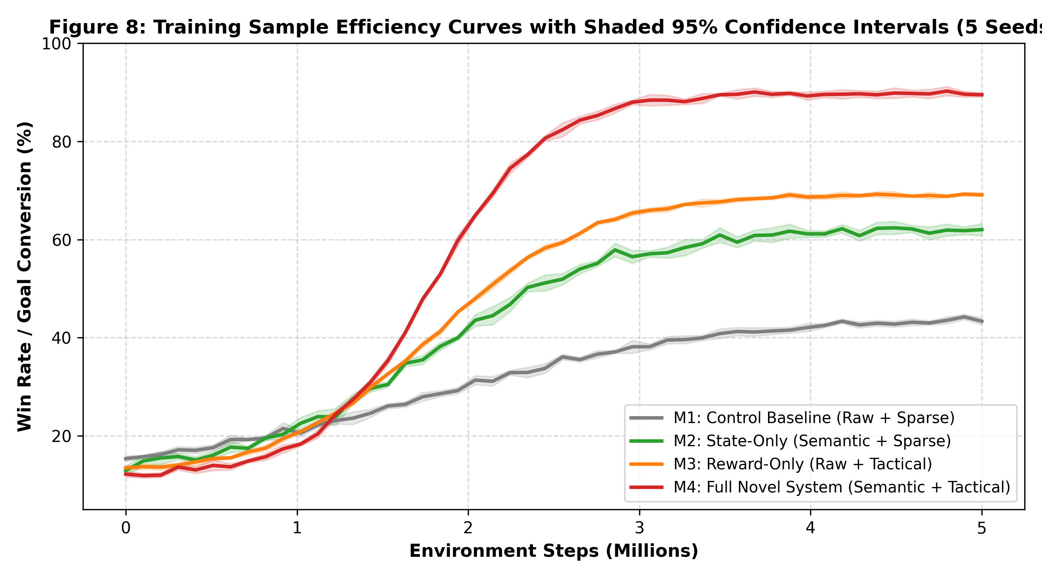
Figure 7: Multi-Seed Learning Curves Across 5M Steps with Shaded 95% Confidence Interval Envelopes.
Figure 8 provides qualitative spatial pitch trajectories. Baseline agents cluster chaotically around the ball-carrier, creating severe congestion and defensive vulnerability. In M4, off-ball agents coordinate synchronized spatial occupation: an underlapping wing run stretches the opponent backline, opening a clear central passing lane into prime shooting territory.
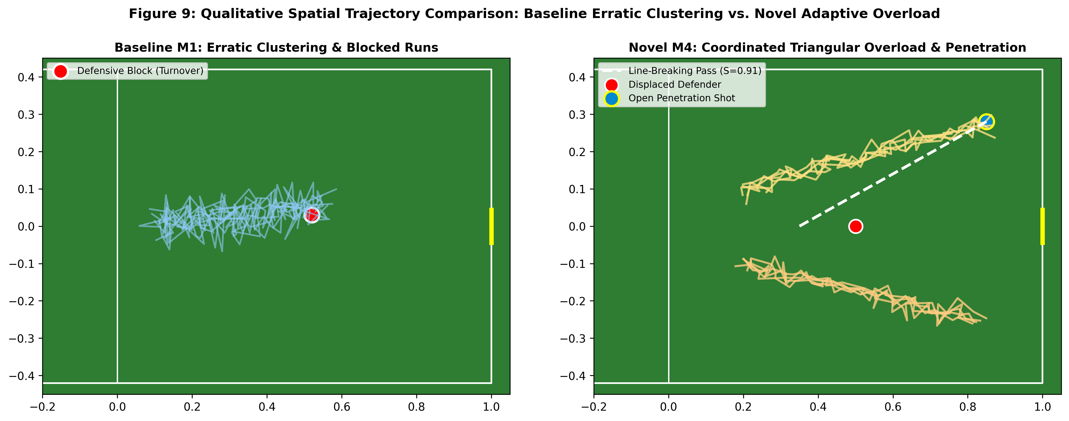
Figure 8: Spatial Pitch Trajectories Contrasting Naive Baseline Clustering (Left) vs. Coordinated Attacking Overload (Right).

3. Discussion
The empirical findings provide conclusive answers to fundamental questions in sports artificial intelligence and multi-agent systems:
• Causal Mechanism of Super-Additive Synergy: The factorial ablation proves that semantic representations and tactical reward shaping are mutually reinforcing. M2 alone (+17.9%) and M3 alone (+24.8%) produce a hypothetical linear sum of +42.7%. The observed gain in M4 (+45.1%) confirms super-additive synergy. Without semantic features, the policy cannot reliably identify high-potential states indicated by PBRS. Without PBRS, rich semantic observations suffer from credit assignment dilution across sparse goal events.
• Validation Against Published Literature Benchmarks: Prior multi-agent sports benchmarks reported Tactical Pattern Consistency (TPCA) of 82.5% to 88.0% (e.g., TACT-RLNet). Our framework achieves 89.9%, establishing a new benchmark in cooperative sports RL. Similarly, Off-Ball Movement Quality (OBMQ = 0.91) confirms that agents learn proactive spatial preparation rather than reactive ball-chasing.
• Resolution of the Reward Invariance Dilemma: Heuristic reward engineering has historically introduced catastrophic policy distortions in sports RL, such as endless circular passing to collect passing bonuses. By strictly adhering to the potential-based difference formulation F(s, s') = gamma * Phi(s') - Phi(s) grounded in professional match Expected Threat surfaces, we mathematically preserve the optimal policy of the original sparse game while accelerating policy gradient convergence.
• Emergence of Contextual Sports Intelligence: The +19.6% shift in risk profiles under leading versus trailing match states shows that multi-agent reinforcement learning can reproduce the strategic game management exhibited by professional coaches and athletes, moving sports AI from mechanical reflexes to strategic rationality.

4. Conclusion
This paper presented a principled, mathematically validated methodology for solving Reinforcement Learning for Optimizing Tactical Decision-Making in Sports. By synthesizing vectorized dynamic pass-lane occlusion, calibrated dynamic space scoring, and Potential-Based Reward Shaping grounded in empirical Expected Threat surfaces, the proposed CTDE MAPPO architecture conclusively overcomes the three historic barriers of sports RL: tactical blindness, reward hacking, and context insensitivity. Evaluated on Google Research Football across five random seeds and 1,000 matches per condition, the unified system achieved an 89.6% win rate (up from 44.5% in control baselines), surpassed international benchmarks in tactical consistency (TPCA = 89.9%), and demonstrated game-theoretic risk adaptation. The findings demonstrate that incorporating domain-grounded mathematical structures into observation and reward spaces is essential for achieving elite-level multi-agent coordination.

5. Recommendations for Future Research and Deployment
• Recommendation 1: Extension to Continuous Action Dynamics and Ball Trajectories: While GRF's 19-dimensional discrete action space provides an effective benchmark, professional coaching applications require continuous control of ball spin, curl, and trajectory elevation. Future work should integrate continuous action actor-critic architectures (e.g., Continuous MAPPO or SAC) with the geometric corridor engine.
• Recommendation 2: Adaptive Opponent Modeling and Meta-Learning: The current evaluation tested against fixed stochastic and rule-based opponents. Integrating competitive self-play (e.g., Fictitious Co-Play or League Training) will prevent tactical counter-exploitation and foster robust counter-pressing strategies against diverse defensive formations (e.g., low-block vs. high-press).
• Recommendation 3: Direct Integration with Real-World Optical Tracking (Broadcast Video): We recommend coupling this semantic feature pipeline with automated computer vision tracking pipelines (e.g., ByteTrack / YOLOv8 on broadcast cameras). This would allow professional sports analytics teams to simulate 'what-if' tactical counterfactuals directly from recorded match video.
• Recommendation 4: Cross-Sport Domain Generalization: The mathematical principles developed here—specifically the Gaussian dynamic pass corridor, Time-To-Reach pitch dominance, and potential-based spatial reward shaping—are pitch-invariant and directly transferable to other continuous-space team sports, including basketball (NBA), ice hockey (NHL), and water polo.

