IT-FP3215 Unit 1 Assessment 5 Attempt 1 John Pool 8.17.21

Browsers used: Chrome, Edge

<https://johnwespool.github.io/IT-FP3215/>

Edge

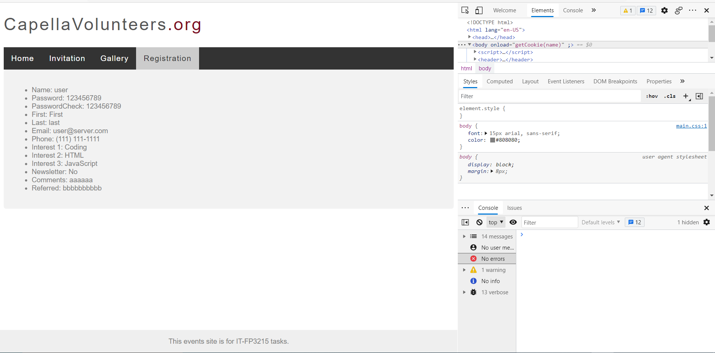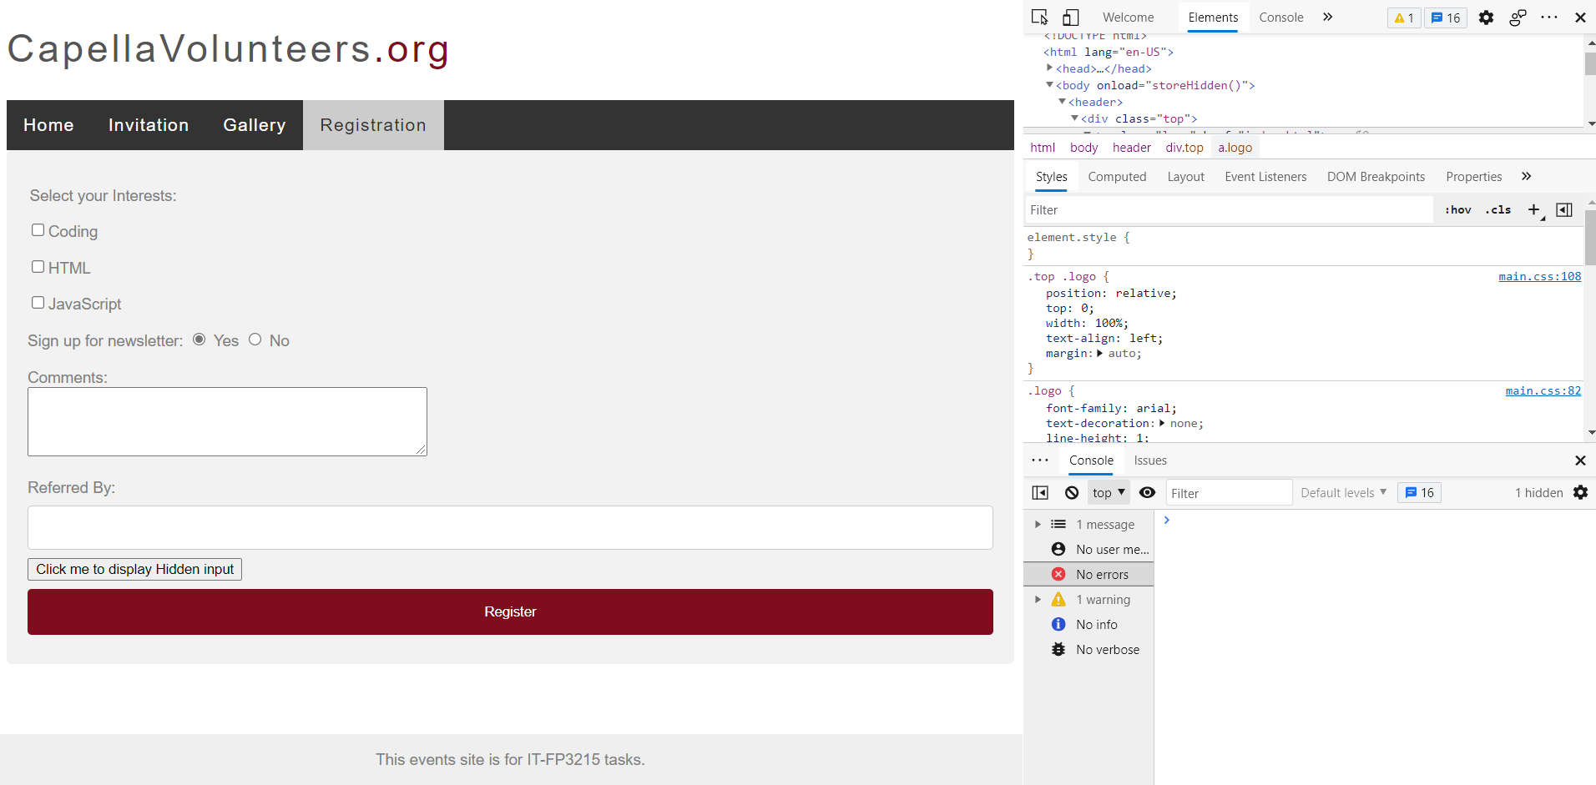

Chrome

