Is the Hawaii Longline Bigeye Tuna Fishery Effectively Managed?

A. John Woodill¹, Ethan T. Addicott² , Nicolás Gómez Andújar¹, Jonathan Sweeney³,
Maria Kavanaugh¹, Michael Harte¹, James R. Watson¹

¹College of Earth, Ocean and Atmospheric Sciences, Oregon State University
² Department of Economics, University of Exeter Business School, Exeter, UK
³ Wherever Jon S. is now

Email: woodilla@oregonstate.edu
Keywords: ecosystem services; fisheries economics; natural capital pricing; sustainability; inclusive wealth; social-ecological system.

Abstract
A key challenge in developing policies for sustainable ocean management is quantifying the value, now and in the future, of impacts on ocean assets such as fisheries. Policies must balance the costs of action with the benefits of preserving future ecosystem services, considering market and non-market services and anticipating changes in the bioeconomic system. An appropriate valuation must consider the present provision of ecosystem services and the effects of environmental changes and human decisions on future service flows. Here, we use a natural capital asset pricing approach to estimate changes in the value (or shadow price) of the US longline bigeye tuna fishery. We link fishing effort data for the period 2010-2018 with ecological and economic data for the United States Hawaii longline fleet to estimate a dynamic welfare function and approximate the role of ecosystem service flows in influencing this welfare over time. We then recover annual natural capital asset price curves to understand how changes in fishery stocks relate to changes in ocean wealth. Our results indicate that from 2010 to 2018, the natural capital asset price ranged from $8,165 to $10,827 per metric tonne. The approximate wealth stored in the fishery grew by $520 million, with minimal year-to-year variance. Our shadow prices, which reflect the opportunity cost of each unit of catch, do not capture ecosystem services beyond food provision captured in market prices for tuna. Therefore, while the total value of the tuna stock is not an appropriate metric, changes in value over time reflect whether there is net investment or depreciation in wealth stored in tuna stocks as governed by market prices, effort costs and ecological growth. Our results demonstrate that effective management practices have led to the maintenance of sustainable bigeye tuna fish stock levels in the Pacific.

INTRODUCTION
Estimating the full economic and ecological costs of fishing is of paramount importance for the long-term sustainable management of the oceans. Traditionally, we have measured the value of fisheries by accounting for immediate costs and benefits, such as operational costs and revenue (Botsford et al. 1997; Edwards et al. 2004; Sanchirico et al. 2008). This approach is market-oriented, where valuation is based on observed prices at the market and fails to account for the loss of future benefits from the harvested fish stock. This undervaluation contributes to financial mismanagement, as short-term economic gains from overextraction are outweighed by the long-term costs of resource degradation and potential ecosystem collapse. By failing to reflect the true value of fisheries in market prices, we incur hidden societal costs from overfishing and degraded ecosystems that surpass the short-term benefits of extraction (Costello et al. 2008; BenDor et al. 2009; Galbraith et al. 2017; Bell et al 2021; CITES). Efforts have been made to create more inclusive measures that encompass these unaccounted-for costs and benefits in economic statistics. In particular, the concept of 'inclusive wealth' aims to aggregate into an index not only the value of manufactured capital (such as machinery and buildings) and human capital (such as skills and knowledge), but also 'natural capital'— the ecosystems, species, and natural resources that provide vital goods and services (Hartwick 1990; Harte 1995; Dasgupta and Maler 2000; Arrow et al. 2003; Doring and Egelkraut 2008; Hartwick 2011; Arrow et al. 2012). This approach has been championed by UNEP/World Bank inclusive wealth accounting efforts, recognizing nature's essential role in supporting human well-being and economic prosperity beyond conventional economic metrics (Managi and Kumar 2018; UNEP 2023; World Bank 2024).
Summing up the value of manufactured capital assets with the value of natural assets requires commensurable units. Because many of the goods and services provided by nature lack a market price, we require an asset price to compare the value of man-made assets, like machines, with natural assets, such as marigolds (Bateman and Mace 2014). To address this measurement challenge, methods have emerged to determine appropriate ‘shadow prices’ for natural assets that describe the opportunity cost of resource use in a way that is comparable with market exchange prices (Dasgupta and Maler 2000; Dasgupta 2001; Arrow et al. 2004; Arrow et al. 2013; Polasky et al. 2015). In the context of fisheries, shadow prices account for the ecological impact of fishing, the cost of depleting fish stocks, the foregone future benefits and the current market value of fish. By capturing otherwise unaccounted-for costs, shadow prices provide a more accurate reflection of the social cost of fishing, thereby guiding more sustainable and responsible resource management practices. However, it is important to note that the shadow price does not account for other non-market values, such as cultural significance or broader ecosystem services beyond food provision. This evolution in economic thinking underscores the need to shift away from a narrow, short-term economic perspective towards a more long-term view that better recognizes the value of nature and the costs of its degradation.
In order to assess the sustainability of a fishery throught the quantification of shadow prices, comprehensive data must be gathered, encompassing fish stock size, growth rate, catch levels, harvest costs, market prices, and any available information regarding the fishery's ecological role and services provided. An increasingly utilized approach combines bioeconomic modeling with an intertemporal welfare function, allowing the integration of biological fish population dynamics and economic behavior into a single index representing net benefits from the resource stock. (Fenichel and Abbott 2014; Fenichel et al. 2016). This function helps square the benefits of harvesting fish today (as reflected in shadow prices) with those that come from leaving fish to reproduce and increase future availability, ultimately influencing the overall natural capital asset price over time. By approximating this function while considering constraints such as fish species' growth and socio-economic factors, we can gain insights into sustainable harvest pathwayschanges in wealth stored in the fishery over time. We can also exploit the relationship between the price of the asset and the intertemporal welfare function to describe the shadow price of fish under current management regimes (rather than idealized or optimized management). This method of natural capital asset pricing (NCAP) helps estimate the shadow price by comparing scenarios with and without an additional catch unit. New methods provide innovative approaches to integrate capital asset theory and ecological models to compute shadow prices, thus offering a way to measure the wealth effects of resource scarcity. This approach has been used for resources like Gulf of Mexico reef fish, woodland caribou in Canada's Alberta Oil Sands, central U.S. groundwater aquifers, and the Baltic Sea fishery (Fenichel and Abbott 2014; Fenichel et al. 2016; Yun et al. 2017; Maher et al. 2020).
The natural capital asset price method is descriptive of the current management practices, capturing how economic and ecological trade-offs are balanced in a heavily managed fishery. By applying this approach, we can better understand how well existing management policies align with sustainability goals by assessing the economic value of maintaining stocks at particular levels. Currently, we lack knowledge about the natural capital asset price for large fish species like Pacific Ocean bigeye tuna.
In this paper, we calculate the natural capital asset price curve and shadow price of bigeye tuna (Thunnus obesus) caught by US longline fisheries in the Western and Central Pacific Oceans, using economic data from NOAA, including revenue and costs, alongside fish stock assessments from the Western and Central Pacific Fisheries Commission. A change in the natural capital asset value represents the change in the wealth stored in the fishery captured by changes in the stock at various levels. In contrast, as we have mentioned, the shadow priceof fish and their shadow price. The shadow price enables calculation of this wealth change and represents the marginal opportunity cost of extracting an additional unit of tuna, accounting for the foregone benefits of future stock availability and ecosystem impacts. Between 2010 and 2018, we estimate a bioeconomic model and approximate the asset price curve for tuna biomass. We find that in 2018, the asset price at current stock levels was was $9,963.28 per metric tonne—exceeding the market price of $9,479.89. This suggests that the market price does not fully capture the long-term value of the resource. Over the period from 2010 to 2018, the change in wealth stored in the fishery covered a $1.44 billion range with minimal year-to-year changes averaging $65 million. This stability in asset price over time points to the effectiveness of current management practices in maintaining sustainable stock levels, underscoring the stability of the fishery under existing regimes. However, potential environmental pressures, such as a projected 25% reduction in fish stock due to climate change, could result in a significant decline in asset value, estimated at $1.52 billion. This research shows how to calculate natural capital asset prices for one of the world's most demanded fish species, providing a template by which to do this for other similar fisheries. It is particularly important to do so now, as many key fisheries face environmental challenges relating to climate change. Understanding the economic impact of these environmental shifts on our marine resources is crucial for future societal planning and the long-term sustainable use of the oceans.

MATERIALS AND METHODS
Our approach builds upon Fenichel and Abbott's (2014) foundational work, which introduced the Natural Capital Asset Price (NCAP) model for estimating shadow prices of natural capital by incorporating resource stock dynamics. Their methods align with inclusive wealth theory, assessing the societal benefits of all capital assets to determine sustainable development, with a focus on the importance of accounting for shadow prices by evaluating capital asset benefits, including those related to natural capital (Dasgupta and Maler 2000; Arrow et al. 2004; Dasgupta 2007; Arrow et al. 2013; Polasky et al. 2015). Grounded in capital asset theory (Jorgenson 1963), Fenichel and Abbott's approach integrates the dynamics of an ecologicalan bioeconomic model to account for changes in resource stock, providing a novel method that combines both theory and empirical data for measuring the value of natural resources as capital assets based on societal benefit. Moreover, considering the complexities introduced by scarcity, the use of a shadow price curve becomes essential for capturing nuanced changes in wealth stemming from variations in natural capital stocks and human behavior, as discussed by Fenichel and Hashida (2019).
The methodology combines an index of the present value of net benefit flows from natural capital stocks, V, with a bioeconomic model describing the dynamics of these stocks, including their growth and harvest rates. This produces a shadow price curve, which represents the opportunity cost of consuming or extracting an additional unit of the resource. Initially applied to calculate the shadow price of reef fish in the Gulf of Mexico (Fenichel & Abbott 2014), the method is now extended to derive a natural capital asset price curve for bigeye tuna in the Pacific Ocean, enabling the assessment of changes in wealth stored in the fishery across different stock levels.
The natural capital asset price equation is described as follows:

$$p\left(s\right)=\frac{D_{s}\left(s,x\left(s\right)\right)+\dot{p}\left(s\right)}{δ-\left(G_{s}(s)-f_{s}(s,x(s)\right)}$$
(2)
In this equation, the unit price of a capital asset , $p\left(s\right)$, of the resource stock, s, is equal to the marginal net benefits from a unit of the asset, $D_{s}\left(s,x\left(s\right)\right)$, which is a function of the resource stock s and the harvest rate x, plus the capital gain return from the stock, $\dot{p}\left(s\right)$, the derivative of $p\left(s\right)$, all divided by the discount rate, δ, less any adjustment to natural capital stocks due to marginal increases in the resource stock growth net of human use and impacts, $G_{s}\left(s\right)-f_{s}(s, x\left(s\right))$. The terms in more detail:
- Marginal Ecosystem Service Flow: $D_{s}\left(s,x\left(s\right)\right)$ represents the marginal net benefits to society derived from the asset, calculated as the net revenue from fishing, where costs are subtracted from the product of landings price and harvest. This reflects the direct economic benefit society gains from utilizing the resource.
- Capital Gain Return: The term $\dot{p}\left(s\right)$ captures the change in the asset price, indicating the potential capital gains from stock changes over time. However, $\dot{p}\left(s\right)$, is challenging to predict due to uncertainty in future stock dynamics, and approximation methods are typically employed to estimate this expected capital gain (see Supplemental for derivation).
- Discount Rate: δ, represents the discount rate, which we set at 3%, based on standard practices in environmental and resource economics to reflect the time preference for benefits from the resource.
- Adjustment to Natural Capital Growth: $G_{s}\left(s\right)-f_{s}(s, x\left(s\right))$, reflects the net growth of the stock, where $G_{s}(s)$ denotes the natural growth of the stock, and $f_{s}(s,x\left(s\right))$ represents the rate of harvest or extraction based on effort, $x\left(s\right)$. This term captures the marginal change in stock growth rates, accounting for both natural growth and the reduction due to human extraction. Ensure that this accurately reflects the marginal changes as specified by the model dynamics.

Together, these components form a comprehensive model of the determinants of an asset price that is consistent with the way financial capital is treated in the literature (Jorgenson 1963). Given the difficulty in predicting future changes in the stock, the standard approach for estimating $\dot{p}\left(s\right)$ is to use approximation methods, such as finite difference approximations or econometric models, to assess capital gain returns from expected changes in the resource stock (CITES).
With an understanding of the shadow price framework, we proceed to estimate the economic implications of resource extraction using the profit function associated with bigeye Tuna in the Pacific. We follow a Homan and Wilen (1997) approach, as was used in the Gulf of Mexico example (Fenichel and Abbott 2014). The marginal net benefit, $D_{s}\left(s,x\left(s\right)\right)$, is derived from the profit function as follows:

$$π= QM - QC$$

where profit, $π$, is calculated as the revenues minus costs. Revenues include the amount caught, Q, times the market price, M. Costs are defined by the amount caught, Q, multiplied by the cost per amount caught, C.
To estimate the amount caught, Q, and thus understand the associated costs, we employ a harvest (catch) function as follows:

$$Q = q⋅(CPU{E)}^{α}$$

where Q is the harvest (catch), q is the catchability coefficient, and CPUE represents catch-per-unit-effort. Fishing effort is implicit in CPUE, which links the catch to the stock size and the effort exerted. The parameter, α, reflects technological change in fishing vessels, capturing improvements in efficiency, advancements in fishing techniques, and the adoption of new technologies. In our analysis of the U.S. Hawaii Longline fishery, the catchability coefficient q is estimated as 0.18, while α is calibrated to 0.84 based on values from the literature (Sharma and Leung 1998).
To allow for the profit function to account for changes in stock level changes, we estimate CPUE as,
$$CPUE = y{ ⋅s}^{γ}$$

where y is the system equivalent parameter that provides the marginal effect of harvest on stock defined in the economic data. Gamma, $γ$, is a measure of the elasticity of harvest as stock levels change within the fishery, provided in the literature. Where y=0.00514 is the system equivalence parameter derived from the average level of biomass harvested over the time series. The stock size s is the given biomass stock and $γ$ =0.74 which is a measure of elasticity based on fishers’ behavior as stock changes (Kompass and Che 2006).
Next, the ecological model in Equation 2, $G_{s}(s)-f_{s}(s,x(s)),$is based on the Gordon-Shafer model (Gordon, 1954; Schaefer, 1957). We first estimate the dynamics of the fish stock as a logistic growth function, $G_{s}(s)$, minus the amount harvested, $f_{s}(s,x(s)$ = Q,
$$\dot{s} = rs(1 - \frac{s}{K}) - Q$$
where r is the intrinsic growth rate, s is the current stock level, K is the upper bound of the stock, both of which have been estimated and are available from the literature(***CITES), and Q is the amount harvested from the fish catch. From our logistic growth function, we can define a function for stock growth across all possible stock levels in each period. Using the equations provided above, and the main Equation 2, we can now approximate a natural capital asset price curve across measured stock levels for bigeye tuna. The main unknown is the dynamic price from capital gain returns, $\dot{p}$. Since this is the time derivative of $p$, we are able to approximate the asset price curve using collocation methods.

Economic and Ecological Data
We obtained economic data for bigeye tuna through NOAA from 2010 to 2018. These data include pounds sold at market, price per pound, and cost per pound sold, which we convert to metric tonnes (See Table 1). The economic data is used to calibrate the economic program described above. We next gathered ecological data from the Western Central Pacific Fisheries Commission (WCPFC) that provides estimates for the bigeye tuna fish stocks and maximum sustainable yields (see Table 1). The WCPFC data covers the entire fishery and is not limited to US estimates. This complicates the analysis, as we assume that fish stock growth is solely due to the harvest by US fleets. We discuss these limitations and possible solutions for additional research in the discussion section below.

RESULTS
The results provide annual asset price curves that describe how the asset price changes across stock levels. Figure 1 provides the price curve for 2018 with the total stock valuation and the natural capital price at the maximum sustainable yield (MSY). The total stock for 2018 was 655,441 metric tonnes, which corresponds to an asset price of $9,463.58 per tonne of fish. The shadow price, by contrast, represents the opportunity cost of harvesting an additional metric tonne of bigeye tuna in the Western Central Pacific. As this value only captures the market value of tuna harvest and future opportunities to capitalize on this value, it does not fully reflect the value of bigeye tuna; however, comparing asset values generated with a consistent methodology through time can provide an important indicator of the stock’s sustainable management. We also report the value of the stock at MSY, which for 2018 was $9963.28 at 159,020 metric tonnes. As this price is higher, it represents a higher opportunity cost to extract a metric tonne of fish when the stock is harvested at MSY, which comports with the concept of maximum sustainable yield. Any change from MSY should move the price higher if MSY is decreased and lower if MSY is decreased. If the total stock size changes, then this suggests there is a change in the total supply of bigeye tuna and thus will shift the price curve. Figure 2 provides the natural capital price for years from 2010-2018 with a range from $8,165 to $10,827.
We approximate the total capitalization of the fishery by multiplying the asset price by the observed stock size. In 2018, this value was $6.2 billion, representing an underapproximation due to the convexity of the price curve. From 2010 to 2018, the fishery's value was stable, fluctuating between $5.43 billion and $6.87 billion, with year-to-year changes averaging $65 million. This range and minimal variance in asset value over time suggests the effectiveness of current management practices in maintaining sustainable fish stock levels, providing insight into the stability of the fishery under existing management regimes (see Figure 3 and Figure 4).
As suggested above, changes in the projected bigeye tuna fish stock will shift the price curve, affecting total valuations proportionally. The decline observed from 2017 to 2018 resulted from reductions in total fish stock estimates. To illustrate the sensitivity of the fishery’s value to stock size under a linear model, we adjust the 2018 baseline stock by ±25% and ±50% and assess the resulting capitalization changes as percentages of the total 2018 value ($6.87 billion). A 25% stock decrease corresponds to a $1.52 billion reduction, representing approximately 22% of the 2018 valuation, while a 50% decrease results in a $3.04 billion reduction, or 44% of the 2018 value. Conversely, increasing the stock by 25% and 50% leads to $1.52 billion and $3.04 billion gains, amounting to 22% and 44% increases relative to the 2018 valuation. These proportional changes indicate that, under the model’s assumptions, valuation is directly sensitive to stock size changes, with each 1% change in stock corresponding to an approximate 0.88% change in total value. Figure 5 illustrates the range of potential values, spanning from $3.15 billion to $9.23 billion.

DISCUSSION
We developed an application of the Natural Capital Asset Pricing methodology to the U.S. Bigeye Tuna Fishery in the Pacific. Our results provide previously unaccounted-for estimates of the natural asset price and change in value – for the U.S. bigeye tuna fishery in the Western Central Pacific Ocean. We utilized recent methods in natural capital asset pricing that account for dynamic changes in the stock using a social-ecological model, and use bioeconomic data provided by NOAA to complete the calculations. We primarily focus on bigeye tuna since it is the most caught species for US longline fishers in Hawaii with the best available data from NOAA. We estimated that the natural capital asset price for years from 2010-2018, with values ranging from $8,165 to $10,827 per metric tonne, and we analyzed the associated shadow prices to capture the opportunity cost of each additional unit of extraction. We utilized 2018 results and varied the amount of stock by plus or minus 25% and 50% to show how the value changes with changes in stock size. For each 25% increase or decrease the total capitalization results in plus or minus $1.52 billion metric tonnes. Change in the value of natural capital is the most important indicator for natural asset sustainability (Fenichel et al. 2020). Our results provide evidence for successful and sustainable fishery management, with a stable asset value through time. These results provide the first estimates of the value of bigeye tuna fisheries as a natural capital asset to (primarily U.S.) society with insights into how much society values fisheries as a natural capital asset and how changes in fisheries management decisions can impact that underlying value now and into the future.
While we provide evidence of a sustainable fishery, this is an outcome of a carefully curated management regime including fisheries catch shares and vessel monitoring systems. The economic impacts of fisheries catch shares, particularly concerning Hawaii's big-eye tuna, hold significant promise in addressing sustainability challenges while fostering economic viability. The Tragedy Of The Commons (CITES: Hardin), marked by a competitive race to fish leading to compressed fishing seasons and ecological damage, underscores the urgency for effective management strategies (CITES). Catch shares, by securing each individual's right to a portion of the total catch, have been shown to mitigate this race to fish. Empirical analysis of natural experiments across 39 US fisheries reveals compelling evidence that catch shares extend fishing seasons, providing a pathway to reduce economic waste and occupational hazards. Moreover, global assessments suggest that catch shares can halt and even reverse the trend toward widespread collapse observed in commercial fisheries worldwide (Costello et al. 2008; Costello et al. 2010; Birkenbach et al 2017). These findings underscore the potential of rights-based catch shares to provide individual incentives for sustainable harvest, offering a hopeful prospect for the future of Hawaii's big-eye tuna fishery amidst growing concerns of global fisheries collapse. By encouraging sustainable practices, catch shares not only improve economic viability but also support the long-term health of marine ecosystems and fishing communities.
Our findings add to the set of previous studies that have estimated the natural capital asset price for other fish species. In a previous study, the natural capital asset price of reef fish in the Gulf of Mexico was estimated using the NCAP modeling approach used here, the calculated approximate shadow price was $3.08 per pound, or $6790.22 per metric tonne (Fenichel and Abbott 2014). They further quantified the total stock capitalization as $265.50 million, which is significantly less than our estimates for bigeye tuna at $1.62 billon. In another study, the price of three species in the Baltic Sea (Cod, Herring, and Sprat) was similarly estimated. Additionally, the authors investigated how sensitive their shadow prices were to the stock size of each species (Yun et al. 2017). While no explicit prices were reported for their simulation exercise, the relationship between the three species provides dynamic price curves based on the catch of the three species in a given year. An increase in one species will ultimately affect the stock biomass of the others, which will change all shadow priced. Their results offered price curves that relate to the dynamics of a natural environment which are important when considering the sustainability of a whole ecosystem and not just one species. While our results only provide estimates for bigeye tuna, additional research might include the relationship between bigeye tuna, yellowfin tuna, and skipjack, which are usually caught together on longline fishing strings. Longline fishers target these three species together so understanding the relationship between these three price curves would be an important next step (Arenas 2006; Matsumoto et al. 2016; Artetxe-Arrate et al. 2021; Campling et al. 2017).
We derived a simple profit model that is aggregated each year to provide annual price estimates. This approach limits our ability to estimate fishers’ behavioral responses temporally and spatially. Failing to assess the availability of resources at the local level and then aggregating, may mistakenly consider scarce resources to be less valuable, and abundant resources to be more valuable, which will bias wealth estimates (Addicott and Fenichel 2019). During our initial analysis, we attempted to estimate a model that includes AIS data from Global Fishing Watch (Kroodsma et al. 2018) and environmental spatial data from NASA OceanColor, such as sea surface temperature and chlorophyll-a (NASA 2017; NASA 2020). Our initial goal for this analysis was to estimate how fishing effort relates to seasonal changes for the US Hawaii Longline fishery and then utilize the economic data to relate the environmental changes to changes in effort. However, our modeling strategy was not able to capture enough variation in the data to accommodate a reasonably accurate model. This was primarily driven by the fact that there was not enough environmental variation in the data for the US Longline fishery since they fish in locations that are similar across the Pacific Ocean. Most bigeye tuna catch is located south of the Hawaiian Islands where there is low temporal variability in water temperature and primary productivity, so the data we analyzed did not include enough variation to allow for accurate predictions of fishing effort. Developing a good predictive model would help to develop an understanding of the behaviors of fishers now and in the future, and would allow for a more detailed NCAP analysis. To make this model, individual fishing log data would be invaluable, so individual trips and spatial behaviors could be better quantified. In addition, the economic data we used was aggregated into individual years, thus is not able to capture individual fishing vessel variable costs (e.g. time at sea and distance traveled). For our analysis, we assumed variable cost as fixed, which restricted the profit function. The number of trips, distances, and time at sea are important costs to consider when deriving a profit function (Chan and Pan 2021). Without these data, we were limited in our analysis, so we utilized the best available data to get a good approximation of the value of the US Longline fishery in Hawaii. Future analysis can expand upon this first attempt to include models of fishers’ behavior with more detailed economic and spatial data related to individual fishing vessels. Further, expanding the analysis to areas outside of the Hawaiian Islands would provide more variation in seasonal changes, and thus might provide a better-specified model. This would improve the accuracy of the capital asset price estimates and provide additional information about the behavior of fishers and responses to environmental changes.
As natural capital asset pricing evaluations extend to other resources throughout the world, it is of utmost importance to have the required data needed to complete the analysis; however, this data is limited in its availability currently. Following Fenichel and Abbott’s methods, one of the main limitations in data gathering is obtaining microeconomic data. This becomes ever more important as the United States begins to implement natural capital accounting onto its balance sheets (White House 2022). The limitations in our analysis (described just above) outline what is needed for a comprehensive application of the NCAP method to fisheries, but this extends to other resources, such as forests, mountain range snowpack, and water supply from streams and rivers, among other important natural assets. It is important to first identify the economic program that will evaluate the natural resource. In the case of fisheries, it is the profit function of the fishers (i.e., how much fish is harvested), but for forests, it might be the value of lumber for construction (Reimer 2020); for snowpack, it might be the value it provides to farmers’ fields, and for water supply, it might be demand for residential water supply or agriculture fields. The coarseness of the data is important to consider in order to capture the microeconomic behaviors that the natural capital asset provides. Obtaining granular sources of data that can be linked to economic programs will become ever more important as the climate continues to disrupt the world’s natural resources. Thus, it is more important now than ever to begin identifying and collecting these data so that the research community and governments can begin assessing the impact of climate change on the value of natural resources; both to the demand for the benefits that they provide and also the value that society holds in the future in the hopes that future generations can benefit as much as current generations.
One of the underlying issues with putting an economic value on nature is that it implies we can put a price on anything even if it is considered invaluable to society. The oceans are an important component of earth's systems and the health and sustainability are of the utmost importance for preserving food security and life. However, applying an economic value to the oceans allows society to evaluate how different decisions will affect the underlying value. This is useful in fisheries to understand how policy or societal responses affect the downstream economic value to society. Simply utilizing stock assessments and market valuations (price times quantity sold) misses the ultimate value that our oceans provide to society; that is, we value not just what is available today, but also what will be available in the future. The price at the market is driven by supply and demand; however, there is also an implicit price that society holds to provide fish to the market but also to the value that society holds collectively. Without quantifying the natural capital asset price of a fishery, it is more difficult to manage fisheries sustainably in the long-run. If it can be measured, it can be managed: that is the fundamental basis for natural capital asset pricing. It is difficult to put a value on nature and how we as a society value it, but as a society, it is important to manage our natural resources efficiently for a sustainable future. The results we provided in this paper are a first estimate of how much the U.S. society values the U.S. bigeye tuna fishery, which will ultimately allow local U.S. fishery managers, governments, and society more broadly, manage this important natural resource sustainably.

CONCLUSION
In conclusion, accurately valuing fisheries is essential for understanding their societal benefits and informing sustainable management practices. Our findings highlight the economic value of bigeye tuna within the framework of sustainable fisheries management, underscoring the importance of maintaining stable fish stocks to support long-term ocean health. While measuring the value of natural resources in vast and complex marine ecosystems presents challenges, integrating natural capital asset pricing provides valuable insights into the total economic worth of the fishery, reflecting its contribution to future service flows. At the same time, shadow prices offer critical guidance by representing the opportunity cost of each additional unit of extraction, allowing managers to assess the immediate impacts of fishing on future stock availability. Effective fisheries management must continue to include precise stock assessments, well-regulated catch quotas, and collaboration with the fishing community to develop sustainable practices. By advancing our capacity to calculate both the natural capital asset price, for long-term valuation, and shadow prices, for sustainable extraction decisions, we can better protect the health of the oceans and ensure that fish populations continue to benefit future generations.

REFERENCES
Addicott, E. T., & Fenichel, E. P. (2019). Spatial aggregation and the value of natural capital. Journal of Environmental Economics and Management, 95, 118-132.
Arenas, P. (2006). Estimated target fleet capacity for the tuna fleet in the eastern Pacific Ocean, based on stock assessments of target species. In Methodological Workshop on the Management of Tuna Fishing Capacity (p. 39).
Arrow, K. J., Dasgupta, P., & Mäler, K. G. (2003). Evaluating projects and assessing sustainable development in imperfect economies. Environmental and Resource Economics, 26, 647-685.
Arrow, K., Dasgupta, P., Goulder, L., Daily, G., Ehrlich, P., Heal, G., ... & Walker, B. (2004). Are we consuming too much?. Journal of Economic Perspectives, 18(3), 147-172.
Arrow, K. J., Dasgupta, P., & Maler, K. G. (2012). Evaluating projects and assessing sustainable development in imperfect economies. Environmental and Resource Economics, 52(4), 511-515. https://doi.org/10.1007/s10640-012-9608-0
Arrow, K. J., Dasgupta, P., Goulder, L. H., Mumford, K. J., & Oleson, K. (2013). Sustainability and the measurement of wealth: further reflections. Environment and Development Economics, 18(4), 504-516.
Artetxe-Arrate, I., Fraile, I., Marsac, F., Farley, J. H., Rodriguez-Ezpeleta, N., Davies, C. R., ... & Murua, H. (2021). A review of the fisheries, life history and stock structure of tropical tuna (skipjack Katsuwonus pelamis, yellowfin Thunnus albacares and bigeye Thunnus obesus) in the Indian Ocean. Advances in Marine Biology, 88, 39-89.
Bateman, I. J., & Mace, G. M. (2020). The natural capital framework for sustainably efficient and equitable decision making. Nature Sustainability, 3(10), 776-783.
Batabyal, A. A., Kahn, J. R., & O'Neill, R. V. (2003). On the scarcity value of ecosystem services. Journal of Environmental Economics and Management, 46(2), 334-352.
Belhabib, D., Le Billon, P., & Wrathall, D. J. (2020). Narco Fish: Global fisheries and drug trafficking. Fish and Fisheries, 21(5), 992-1007.
Belhabib, D., & Le Billon, P. (2022). Fish crimes in the global oceans. Science Advances, 8(12), eabj1927
Bell, J. D., Senina, I., Adams, T., Aumont, O., Calmettes, B., Clark, S., ... & Williams, P. (2021). Pathways to sustaining tuna-dependent Pacific Island economies during climate change. Nature sustainability, 4(10), 900-910.
BenDor, T., Scheffran, J., & Hannon, B. (2009). Ecological and economic sustainability in fishery management: a multi-agent model for understanding competition and cooperation. Ecological economics, 68(4), 1061-1073.
Birkenbach, A. M., Kaczan, D. J., & Smith, M. D. (2017). Catch shares slow the race to fish. Nature, 544(7649), 223-226.
Botsford, L. W., Castilla, J. C., & Peterson, C. H. (1997). The management of fisheries and marine ecosystems. Science, 277(5325), 509-515.
Campling, L., Lewis, A., & McCoy, M. (2017). The tuna longline industry in the Western and Central Pacific Ocean and its market dynamics. In Pacific Islands Forum Fisheries Agency. Last modified.
Chan, H. L., & Pan, M. (2021). Fishing trip cost modeling using generalized linear model and machine learning methods–A case study with longline fisheries in the Pacific and an application in Regulatory Impact Analysis. PloS one, 16(9), e0257027.
Clark, C. W. (2005). Mathematical Bioeconomics: The Mathematics of Conservation. Wiley-Blackwell.
Costello, C., Gaines, S. D., & Lynham, J. (2008). Can catch shares prevent fisheries collapse?. Science, 321(5896), 1678-1681.
Costello, C., Lynham, J., Lester, S. E., & Gaines, S. D. (2010). Economic incentives and global fisheries sustainability. Annu. Rev. Resour. Econ., 2(1), 299-318.
Dasgupta, P., & Maler, K. G. (2000). Net national product, wealth, and social well-being. Environment and Development Economics, 5(1), 69-93. https://doi.org/10.1017/S1355770X00000366
Dasgupta, P. (2001). Human well-being and the natural environment. OUP Oxford.
Devarajan, S., & Fisher, A. C. (1982). Exploration and scarcity. Journal of Political Economy, 90(6), 1279-1290.
Döring, R., & Egelkraut, T. M. (2008). Investing in natural capital as management strategy in fisheries: The case of the Baltic Sea cod fishery. Ecological Economics, 64(3), 634-642.
Edwards, S. F., Link, J. S., & Rountree, B. P. (2004). Portfolio management of wild fish stocks. Ecological Economics, 49(3), 317-329.
Fenichel, E. P., & Abbott, J. K. (2014). Natural capital: from metaphor to measurement. Journal of the Association of Environmental and Resource Economists, 1(1/2), 1-27.
Fenichel, E. P., Abbott, J. K., Bayham, J., Boone, W., Haacker, E. M., & Pfeiffer, L. (2016). Measuring the value of groundwater and other forms of natural capital. Proceedings of the National Academy of Sciences, 113(9), 2382-2387.
Fenichel, E. P., Addicott, E. T., Grimsrud, K. M., Lange, G. M., Porras, I., & Milligan, B. (2020). Modifying national accounts for sustainable ocean development. Nature Sustainability, 3(11), 889-895.
Free, C. M., Mangin, T., Molinos, J. G., Ojea, E., Burden, M., Costello, C., & Gaines, S. D. (2020). Realistic fisheries management reforms could mitigate the impacts of climate change in most countries. PloS one, 15(3), e0224347.
Galbraith, E. D., Carozza, D. A., & Bianchi, D. (2017). A coupled human-Earth model perspective on long-term trends in the global marine fishery. Nature communications, 8(1), 1-7.
Gordon, H. S. (1954). The economic theory of a common-property resource: the fishery. In Classic papers in natural resource economics (pp. 178-203). Palgrave Macmillan, London.
Harley, Shelton & Davies, Nick & Hampton, John & Mckechnie, Sam. (2014). Stock assessment of bigeye tuna in the western and central Pacific Ocean. West Cen Pac Fish Comm 10th Sci Comm Work Pap 7. https://palau-data.sprep.org/system/files/Stock%20assessment%20of%20bigeye%20tuna.pdf
Harte, M. J. (1995). Ecology, sustainability, and environment as capital. Ecological economics, 15(2), 157-164.
Hartwick, J. M. (1990). Natural resources, national accounting and economic depreciation. Journal of Public Economics, 43(3), 291-304. https://doi.org/10.1016/0047-2727(90)90054-V
Hartwick, J. M. (2011). Green national income and green national product. Annu. Rev. Resour. Econ., 3(1), 21-35.
Homans, F. R., & Wilen, J. E. (1997). A model of regulated open access resource use. Journal of Environmental Economics and Management, 32(1), 1-21.
Heal, G. (1998a). Valuing Ecosystem Services. Ecosystems, 1(2), 151-156. https://doi.org/10.1007/s100219900014
Heal, G. M. (1998b). Valuing the future: economic theory and sustainability. Columbia University Press.
Jorgenson, D. W. (1963). Capital theory and investment behavior. The American Economic Review, 53(2), 247-259.
Kompas, T., & Che, T. N. (2006). Economic profit and optimal effort in the Western and Central Pacific tuna fisheries.
Kroodsma, D. A., Mayorga, J., Hochberg, T., Miller, N. A., Boerder, K., Ferretti, F., ... & Worm, B. (2018). Tracking the global footprint of fisheries. Science, 359(6378), 904-908.
Maher, S. M., Fenichel, E. P., Schmitz, O. J., & Adamowicz, W. L. (2020). The economics of conservation debt: a natural capital approach to revealed valuation of ecological dynamics. Ecological Applications, 30(6), e02132.
Managi, S., & Kumar, P. (2018). Inclusive wealth report 2018. Taylor & Francis.
Matsumoto, T., Satoh, K., Semba, Y., & Toyonaga, M. (2016). Comparison of the behavior of skipjack (Katsuwonus pelamis), yellowfin (Thunnus albacares) and bigeye (T. obesus) tuna associated with drifting FAD s in the equatorial central Pacific Ocean. Fisheries Oceanography, 25(6), 565-581.
McClanahan, T., Allison, E. H., & Cinner, J. E. (2015). Managing fisheries for human and food security. Fish and Fisheries, 16(1), 78-103.
Mendenhall, E., Hendrix, C., Nyman, E., Roberts, P. M., Hoopes, J. R., Watson, J. R., ... & Sumaila, U. R. (2020). Climate change increases the risk of fisheries conflict. Marine Policy, 117, 103954.
Mitchell, R. C., & Carson, R. T. (1989). Using surveys to value public goods: The contingent valuation method. Resources for the Future.

NASA Ocean Biology Processing Group (2020). MODIS Aqua Global Level 3 Mapped SST. NASA Ocean Biology Processing Group. https://doi. org/10.5067/MODAM-8D4N9
NASA Ocean Biology Processing Group (2017). Modis-aqua level 3 mapped chlorophyll data version r2018.0. https://oceancolor.gsfc. nasa.gov/data/10.5067/AQUA/MODIS/L3M/CHL/2018
Ojea, E., Pearlman, I., Gaines, S. D., & Lester, S. E. (2017). Fisheries regulatory regimes and resilience to climate change. Ambio, 46(4), 399-412.
Palacios Abrantes, J., Frölicher, T. L., Reygondeau, G., Sumaila, U. R., Tagliabue, A., Wabnitz, C. C., & Cheung, W. W. (2022). Timing and magnitude of climate‐driven range shifts in transboundary fish stocks challenge their management. Global change biology, 28(7), 2312-2326.
Polasky, S., Bryant, B., Hawthorne, P., Johnson, J., Keeler, B., & Pennington, D. (2015). Inclusive wealth as a metric of sustainable development. Annu Rev Environ Resour, 40(1), 445-466.
Pomeroy, R., Parks, J., Mrakovcich, K. L., & LaMonica, C. (2016). Drivers and impacts of fisheries scarcity, competition, and conflict on maritime security. Marine Policy, 67, 94-104.
Reimer, J. J. (2021). An investigation of log prices in the US Pacific Northwest. Forest Policy and Economics, 126, 102437.
Rosas-Munoz, J., & Carrillo-Viramontes, J. A. (2022). Abundance of Resources and Incentives for Collusion in Fisheries. Sustainability, 14(22), 15083.
Salas, S., & Gaertner, D. (2004). The behavioural dynamics of fishers: management implications. Fish and fisheries, 5(2), 153-167.
Sanchirico, J. N., Smith, M. D., & Lipton, D. W. (2008). An empirical approach to ecosystem-based fishery management. Ecological Economics, 64(3), 586-596.
Schaefer, M. B. (1957). Some considerations of population dynamics and economics in relation to the management of the commercial marine fisheries. Journal of the Fisheries Board of Canada, 14(5), 669-681.
Sharma, K. R., & Leung, P. (1998). Technical efficiency of the longline fishery in Hawaii: an application of a stochastic production frontier. Marine Resource Economics, 13(4), 259-274.
Spijkers, J., Singh, G., Blasiak, R., Morrison, T. H., Le Billon, P., & Österblom, H. (2019). Global patterns of fisheries conflict: forty years of data. Global Environmental Change, 57, 101921.
United Nations Environment Programme (2023). Inclusive Wealth Report 2023: Measuring Sustainability and Equity. https://wedocs.unep.org/20.500.11822/43131.
White House (2022). National Strategy to Develop Statistics for Environmental Economic Decisions. Office of Science and Technology Policy Office of Management and Budget Department of Commerce. https://www.whitehouse.gov/wp-content/uploads/2022/08/Natural-Capital-Accounting-Strategy.pdf
World Bank. (2024). The changing wealth of nations: Revisiting the measurement of comprehensive wealth. Washington, DC: World Bank Group. Retrieved from http://documents.worldbank.org/curated/en/099100824155021548/P17844617dfe6e0241ad25120b1320904c2
Yun, S. D., Hutniczak, B., Abbott, J. K., & Fenichel, E. P. (2017). Ecosystem-based management and the wealth of ecosystems. Proceedings of the National Academy of Sciences, 114(25), 6539-6544.

FIGURES

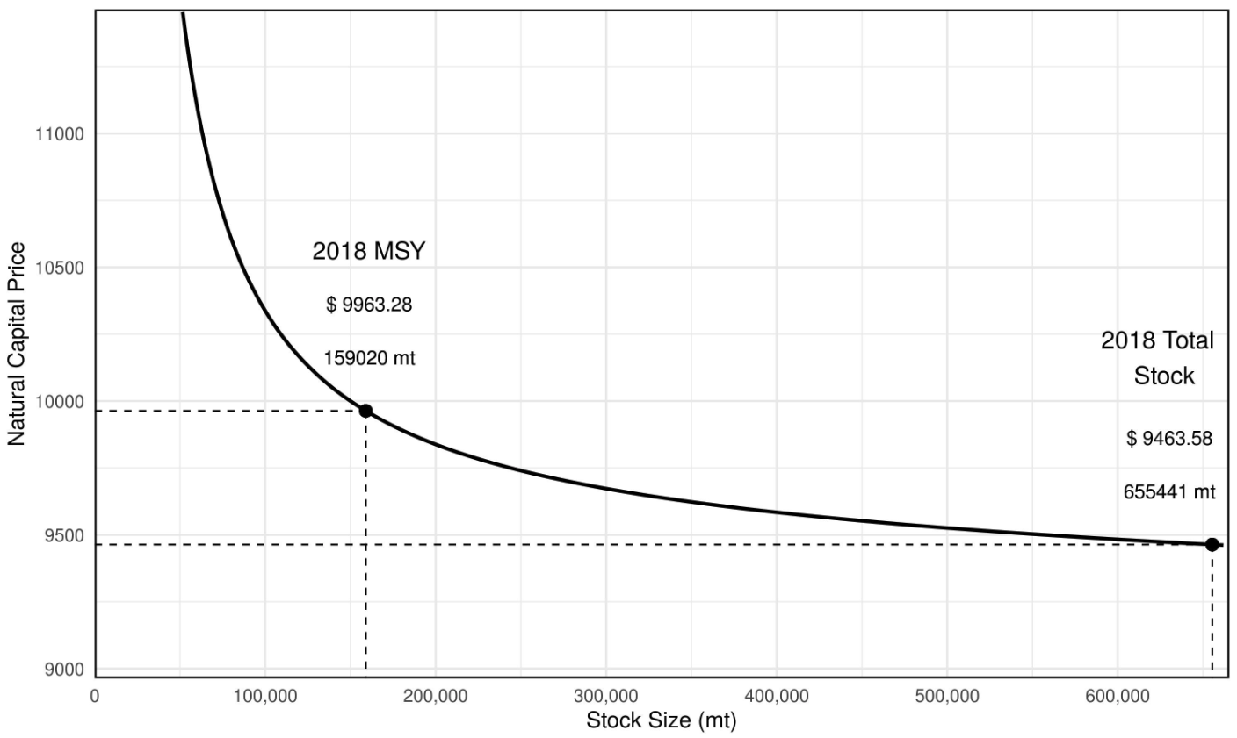
Figure 1 - 2018 Capital Asset Price Curve for Bigeye Tuna.
This figure shows the estimated natural capital asset price curve for bigeye tuna. The x-axis represents the stock size measured in metric tonnes, while the y-axis represents the estimated natural capital price. The point labeled "2018 MSY" indicates the Maximum Sustainable Yield (MSY) for 2018 and the corresponding price at which bigeye tuna is evaluated. The point labeled "2018 Total Stock" represents the estimated total stock capitalization of the fishery for 2018.

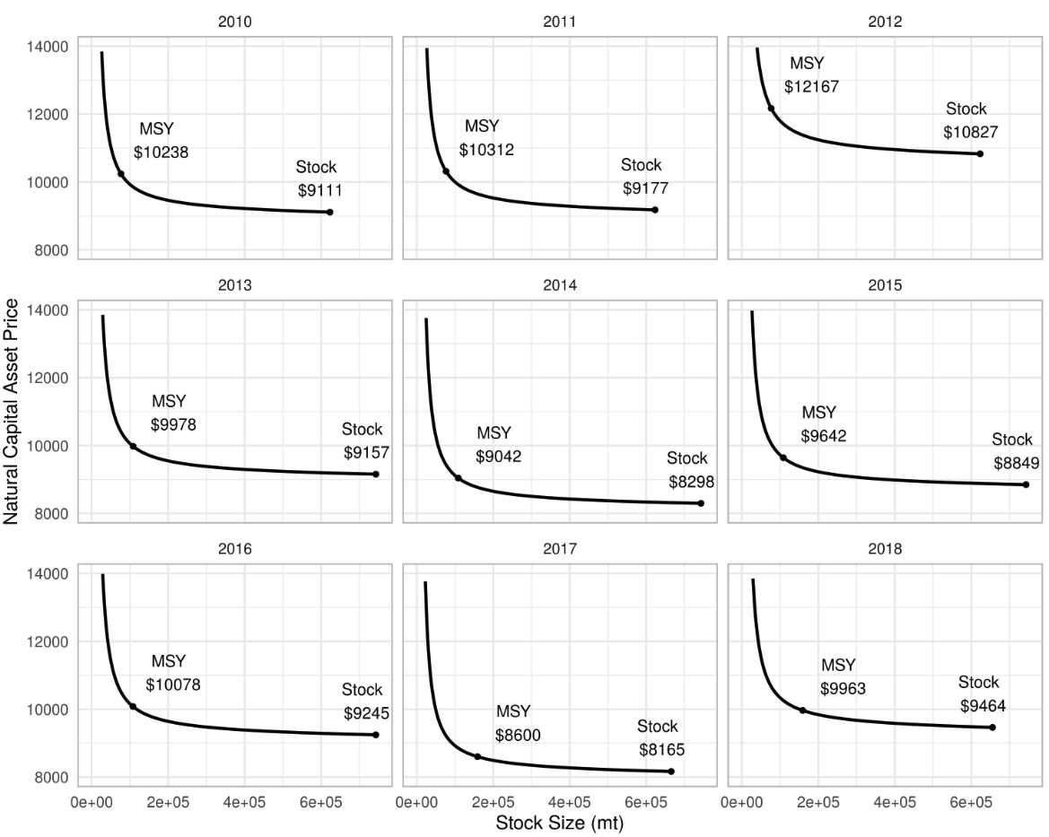
Figure 2. 2010-2018 Capital Asset Price Curve for Bigeye Tuna
This figure displays the individual capital asset price curves for a specific asset over a period of nine years, from 2010 to 2018. The figure captures the price fluctuations of the asset over this period of time. For each year, the figure provides information on the Maximum Sustainable Yield (MSY) and Total Stock, which are key parameters in assessing the sustainability of the asset. The MSY represents the highest level of annual harvest that can be maintained over the long term without compromising the reproductive capacity of the asset, while the Total Stock provides the estimated total stock capitalization of the asset.
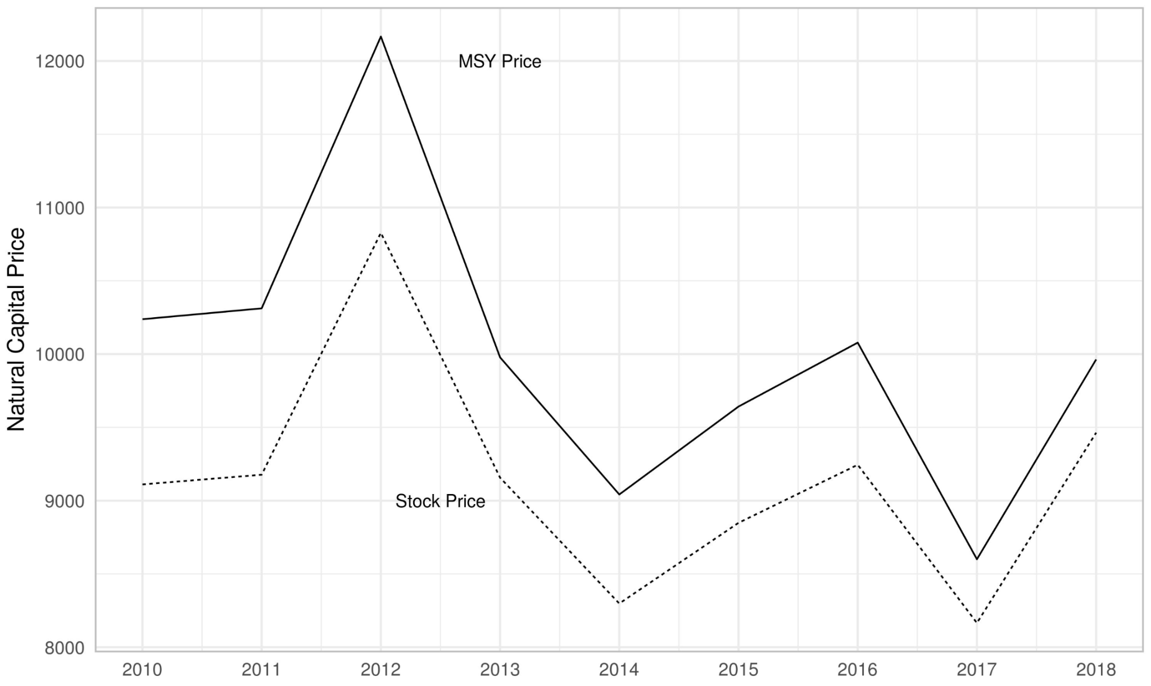
Figure 3. Estimates Prices for Maximum Sustainable Yield and Total Stock from 2010-2018
Figure trend lines for the Maximum Sustainable Yield (MSY) and Total Stock of a specific asset over a period of nine years, from 2010 to 2018. MSY and Total Stock are key parameters in assessing the sustainability of the asset, and the figure provides valuable information on their changes over time.

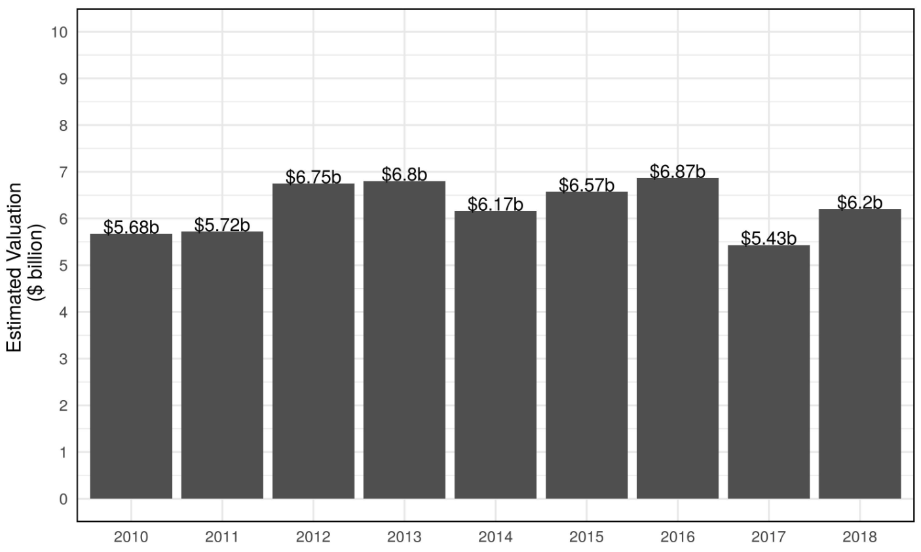
Figure 4 - Estimated Total Stock Capitalization from 2010-2018
This figure provides the total stock capitalization from 2010 to 2018. In the analysis, we estimated each year with individual price curves and evaluated each year's total stock capitalization. The fluctuation in the total capitalization is a result of changes in the biomass stock of bigeye tuna and the related changes in price and cost structures. The biomass stock was increasing until 2017 and 2018 when the biomass of bigeye tuna saw a decline, thus those changes are reflected in the last two years of analysis. From 2013-2016, biomass saw increases thus why those are the largest valuations.

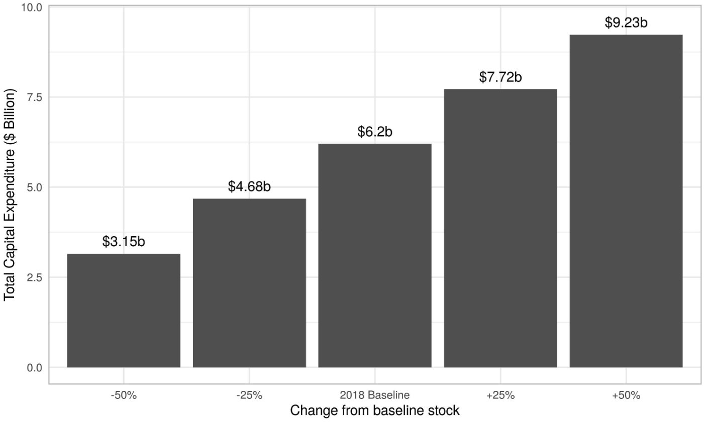

Figure 5. Changes in total capitalization from 2018 baseline biomass stock
The figure provides estimates of the total stock capitalization as the biomass stock changes +/- 25% and 50% using 2018 as a baseline model. As biomass changes by plus or minus 25%, the total stock capitalization changes by 1.5 billion.

TABLES
Summary of Economic and Ecological Data
Year | BET Stock | Maximum  Sustainable Yield | BET Sold  (mt) | Price  (mt) | Cost  per mt
2010 | 623,121 | 76,760 | 4,570.57 | 9,127.15 | 6,062.72
2011 | 623,121 | 76,760 | 4,634.27 | 9,193.28 | 7,583.91
2012 | 623,121 | 76,760 | 4,991.13 | 10,846.75 | 7,892.56
2013 | 742,967 | 108,520 | 5,544.82 | 9,171.24 | 7,032.75
2014 | 742,967 | 108,520 | 5,926.36 | 8,311.43 | 6,547.73
2015 | 742,967 | 108,520 | 7,062.45 | 8,862.59 | 5,092.68
2016 | 742,967 | 108,040 | 6,634.88 | 9,259.42 | 5,202.91
2017 | 665,441 | 159,020 | 6,482.54 | 8,179.16 | 5,401.33
2018 | 655,441 | 159,020 | 6,125.46 | 9,479.89 | 6,591.83
Source: NOAA and WCPFC
Table 1. Annual data for BET (bigeye tuna) stock, Maximum Sustainable Yield (MSY), BET sold in metric tonnes (mt), price per metric tonne, and cost per metric tonne from 2010 to 2018. The data was obtained from the National Oceanic and Atmospheric Administration (NOAA) and the Western and Central Pacific Fisheries Commission (WCPFC).

Parameter | Description | Estimate | Notes | Source
Alpha | tech parameter | 0.84  0.74 |  | Sharma and Leung 1999  Kompas and Che 2012
Gamma | The elasticity of effort with respect to stock size.
y | The system equivalence parameter, representing the scaling factor of effort relative to stock.
r | Growth rate | 0.201
q | Catchability coef | 0.001047 | q = catch / (CPUE * Biomass) | NOAA Hawaii Longline data
CPUE | Catch per unit effort | 5056.64 | CPUE = Pounds sold / # Trips | NOAA Hawaii Longline data

Alpha = comes from the literature

Catchability coef (q)

Q = catch / (CPUE * Biomass)

Catch data comes from NOAA log books and biomass comes from

SUPPLEMENTAL INFORMATION
Appendix 1:

ETHAN’S TEXT BELOW

Derivation of Natural Capital Asset Pricing Equations from Fenichel and Abbott (2014) and Yun et al. (2017)

At time $t$, the present value of net benefits is:
$$V\left(s\left(t\right)\right)= \int_{t}^{∞}{e^{-δ\left(τ-t\right)}D(s\left(τ\right),x\left(s\left(τ\right)\right)dτ}$$
The time-autonomous equation of motion for stock and the economic program allows $V$ to be expressed in terms of only the stock level $s$ and time notation can be suppressed. $D(s,x\left(s\right))$, the flows of net benefits, are then pinned down by just the stock level $s$.
The accounting price for the resource at time $t$is defined as $p\left(s\right)≡\frac{∂V}{∂s}$.
Differentiating the present value of net benefits with respect to $t$gives:
$$\frac{dV}{dt}=δV-D(s,x\left(s\right))$$
Note that $\frac{dV}{dt}=\frac{∂V}{∂s}\frac{ds}{dt}=p\left(s\right)\dot{s}$, which allows the substitution for $\frac{dV}{dt}$ :
$$p\left(s\right)\dot{s}=δV-D(s,x\left(s\right))$$
Rearranging:
$$δV=D\left(s,x\left(s\right)\right)+p\left(s\right)\dot{s}=H(s,x,p)$$
Where $H(s,x,p)$ is the current value Hamiltonian.
Isolating V and differentiating with respect to stock gives:
$$p\left(s\right)=\frac{1}{δ}\left(D_{s}\left(s,x\left(s\right)\right)+p_{s}\dot{s}+p{\dot{s}}_{s}\right)$$
Since, $p_{s}\dot{s}=\frac{∂p}{∂s}\frac{ds}{dt}=\dot{p}$, and ${\dot{s}}_{s}=G_{s}\left(s\right)-f_{S}(s,x\left(s\right))$,
$$p\left(s\right)=\frac{1}{δ}\left(D_{s}+\dot{p}+p\left(G_{s}-f_{S}\right)\right)$$
Solving for $p(s)$, we arrive at the natural capital asset pricing equation.
$$p\left(s\right)=\frac{D_{s}\left(s,x\left(s\right)\right)+\dot{p}}{δ-\left(G_{s}\left(s\right)-f_{s}\left(s,x\left(s\right)\right)\right)}$$

OLD DERIVATION

Following Fenichel and Abbott (2014, 2016), we first establish an intertemporal welfare function, V, that accounts for wealth as a function of stock, s, and an economic program (i.e. describing profit), x, from time-period, t, to infinity. A discount is applied as $e^{-δ }$ to account for discounting into the future from the wealth function. The intertemporal welfare function provides a total accounting of all wealth derived from temporal changes in the stock s and profit x now and into the future as,

$$W(s(t), x(t)) + e^{-δ }W(s(t+1), x(t+1)) + ... + e^{-δ} W(s(t + ∞), x(t+∞))$$

The welfare functional form can be reduced to,
$$V(s(t)) = \int_{t}^{∞}{} e^{-δ(τ-t)}W (s(τ), x(s(τ))) dτ$$
where the value function V(s(t)) is estimated as a function of stock, s, at time period, t, that is integrated over the welfare function between periods $τ$ (hence the intertemporal nature), with a discount rate applied as $e^{-δ(τ-t)}$. Assuming that sustainability is non-declining ($\frac{∂V}{∂t}$ >= 0), we can approximate the shadow price as,

$p\left(s\right)≡\frac{∂V}{∂s}$ (1)

where the approximate shadow price is derived from exchanges through time from the value function. The approximate price in Equation 1 provides the shadow price at different stock levels. Therefore, the natural capital asset shadow price measures the benefit from marginal increases in the stock of capital. Additional derivation steps of the value function with respect to time and stock provide for the unit price of the resource stock in Equation 2. For brevity, we provide the following equation with the derivation provided in Fenichel and Abbott (2014),

Assuming that the value function includes a measure of wealth from all stocks and the value of the resource for all prices at each stock, $s_{i}$, the function is defined as,

$δV = W(S) +p_{1}s_{1} + p_{2}s_{2 }+ . . . +p_{d}s_{d}$ (3)

We know $p_{i}=\frac{∂V}{∂s_{i}}$ as shown above, so the price of the i’th stock level is simply the partial derivative of the value function with respect to the stock. Rewriting Equation 3 as,

$V(S) = μ(S) β$ (4)

provides the value of the stock by approximating the stock as a function, $μ(S)$, which is then scaled by the recovered coefficient. Here we use a Chebychev Polynomial to approximates $μ(S)$ coefficients across nodes, which are distinct points that help capture the behavior of the function over the stock’s range. Thus, to recover the price at each stock level in $μ(S)$, simply find $β_{i}=p_{i}$. Once the price is recovered for each stock i, the natural capital asset pricing Equation 2 can now be evaluated. Substituting Equation 4 into Equation 3 allows for direct estimation of the price across all $s_{i}$ using approximation methods

$$δ μ(S) β= W(S) + \sum_{i=1}^{d}{}diag(\dot{s_{i}})μ_{si}(S) β$$

Thus, solving for unknown coefficients, $β$,

$β= W(S) [δ μ(S) - \sum_{i=1}^{d}{}diag(\dot{s_{i})}{ μ}_{si}(S)]^{-1}$ (5)

where $β$ are estimating prices, $p_{i}$, for each stock, $s_{i}$, and provide a dynamic equation of prices from Equation 2. Solving for this unknown, $\dot{p}(s)$, now allows us to estimate the only unknown from Equation 2 and derive natural capital asset prices across all possible stocks.

Unit price of the resource stock

