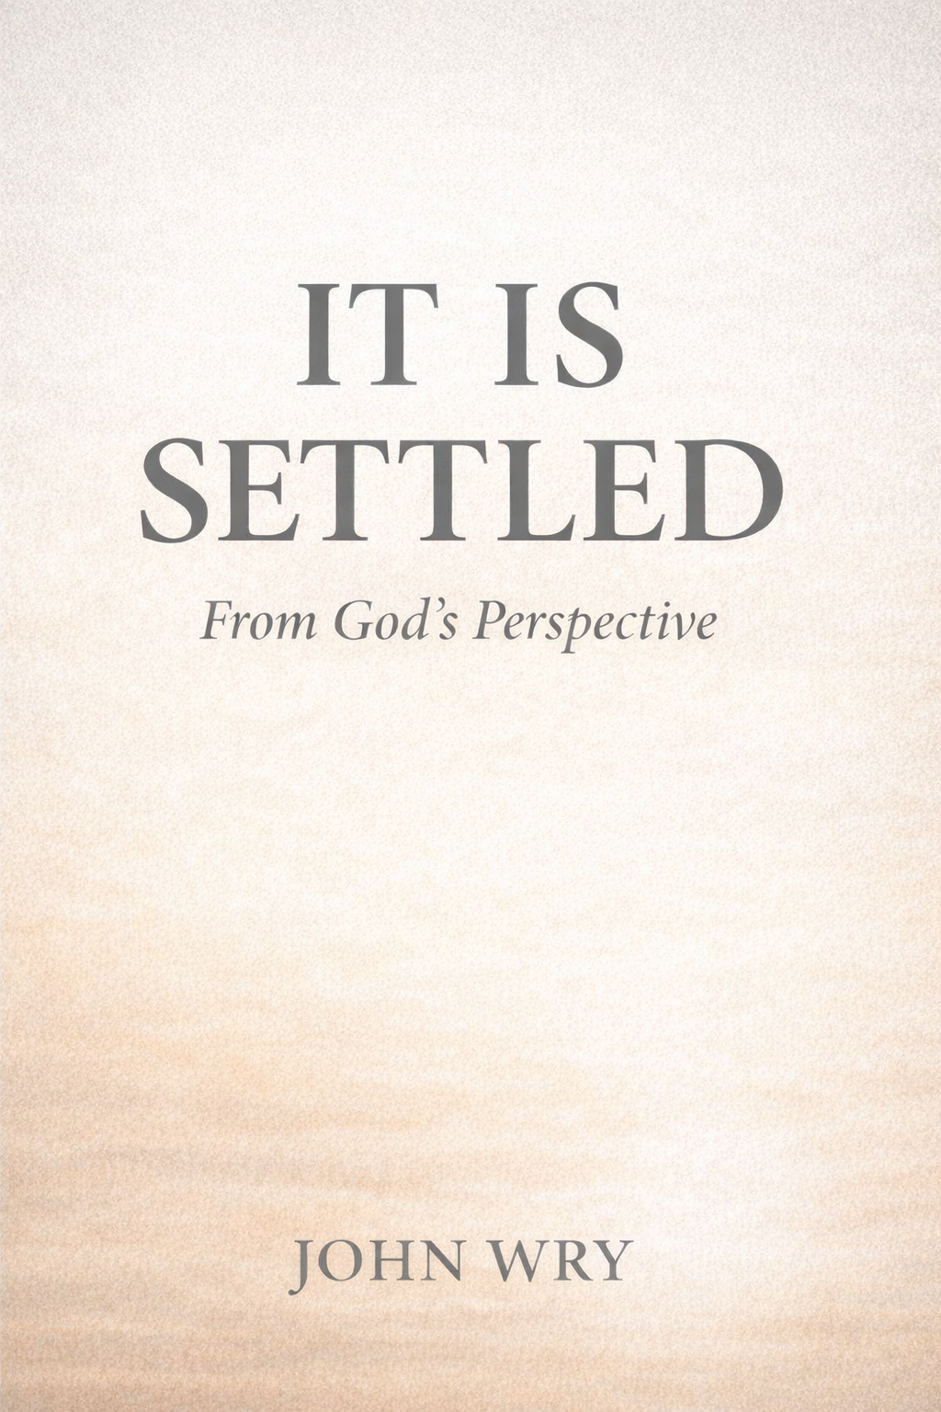

It Is Settled
From God’s Perspective
John Wry

Chapter 1

Reality Begins With God
Reality does not begin with human questions. It begins with God making Himself known. Scripture exists because God is not silent. He reveals who He is, how He relates to humanity, and what He has done. The story of the gospel is not the story of people discovering God, but of God disclosing reality before it was understood.
This matters because revelation establishes objectivity. Truth is not constructed from experience, refined through reflection, or reached through effort. It is revealed. God speaks before we respond. He acts before we interpret. Sin explains why revelation is necessary, but it does not initiate the story. God does.
When this order is reversed, confusion follows. When revelation is replaced with interpretation, everything loses its weight. Grace can sound like opinion. Truth can sound like perspective. Assurance can sound like confidence. Scripture can sound like advice.
None of those things are false—but none of them are stable.
Romans refuses to build on instability. It does not begin by asking how people should live. It begins by declaring what is true about God, about humanity, and about the situation between them. Only after reality is disclosed does life begin to make sense.
This is why Scripture consistently moves from revelation to response. God reveals Himself, then calls for understanding. God acts, then explains the meaning of that action. God speaks, then invites trust. The order is never reversed. Life is not the starting point; it is the outcome.
When God is not clearly recognized as the one who defines reality, people instinctively look elsewhere for grounding. Experience begins to interpret truth. Feelings begin to weigh more than declaration. Sincerity begins to substitute for certainty. The result is not rebellion, but instability.
This instability explains why many sincere people feel unsettled even while believing the right things. They may affirm grace, but experience still feels authoritative. They may agree with truth, but perspective still feels negotiable. They may believe Scripture, but hear it as guidance rather than disclosure.
The issue was never grace — it was authority.
More precisely, it was the question of who has the right to define what is true.
Scripture’s answer is unambiguous. God defines reality because God reveals Himself. The gospel does not begin with human need, human effort, or human failure. It begins with God acting, God speaking, and God making Himself known.
Only when this is settled can anything else be understood rightly.
This chapter does not explain the human problem yet. It establishes the reference point. Before Scripture diagnoses sin, it reveals God. Before it addresses collapse, it establishes truth. Before it speaks about how to live, it declares what is real.
Everything that follows depends on this.
**It is settled from God’s perspective.** Reality does not wait for our agreement to become true.

Reflection Questions
- What do I instinctively treat as the starting point for reality—God’s revelation or my experience?
- Have I been hearing Scripture more as advice than as disclosure?
- Where might truth have felt negotiable because God was no longer the reference point?
- What changes if reality is something revealed rather than something interpreted?
- What would it mean for life to proceed from what God has declared rather than toward it?

Chapter 2

God Is Displaced
When God reveals Himself, a response is unavoidable. Revelation does not force obedience, but it does remove neutrality. Once God is known, reality is no longer undefined. The question is no longer whether truth exists, but whether God will remain the reference point for it.
Romans describes what happens when He does not.
This is not the story of people rejecting rules or resisting authority in general. It is the story of exchange. God is not denied; He is displaced. Something else quietly takes His place as the starting point for meaning, judgment, and direction. Truth does not disappear—it is relocated.
When God is displaced, truth is no longer anchored in who He is. It becomes tethered to something closer, more manageable, and more comfortable. Human experience begins to interpret reality. Desire begins to shape value. Preference begins to guide judgment. What was once received is now rearranged.
This shift is subtle, but its effects are catastrophic.

The First Collapse: Human Conduct
Romans describes the initial consequence of this displacement in the most visible way—human conduct. Actions become disordered, not merely immoral. Behavior no longer flows from what is true about God, but from what now feels reasonable without Him as the reference point.
This is not ignorance. God has been made known. The issue is not lack of information, but loss of orientation. When truth is no longer anchored in God, behavior begins to drift. What once restrained no longer carries weight. What once warned now feels excessive.
This is the first collapse. But it is not the deepest.

The Second Collapse: Human Values
As conduct drifts, values begin to invert. What people approve, celebrate, excuse, or defend shifts accordingly. Romans describes this not as confusion, but as exchange—a trading of what is fitting for what is convenient.
At this stage, sin is no longer merely practiced; it is justified. What once felt wrong now feels normal. What once provoked discomfort now provokes defense. The problem is no longer simply what people do, but what they consider acceptable.
This is not moral weakness. It is moral reorientation.
What restrains behavior no longer restrains because values themselves have changed.

The Final Collapse: Human Thinking
The deepest collapse Romans describes is not behavioral or ethical—it is cognitive. Human thinking itself becomes unreliable as an authority. Reason no longer moves toward truth, but away from it. Logic is not lost; it is repurposed.
At this point, people are not merely doing what is wrong or approving what is wrong. They are thinking from the wrong starting point. Reality is reinterpreted to justify what has already been chosen. Truth is no longer discovered; it is defended selectively.
This is why Romans describes the mind itself as affected. When God is displaced, thinking does not remain neutral. It becomes captive to whatever has replaced Him.
This is the final collapse. And it explains everything that came before it.

Why the Situation Is Devastating
This progression matters because it removes every false hope of self-recovery. If conduct is disordered, values are inverted, and thinking is corrupted, then humanity cannot correct itself by trying harder, knowing more, or organizing better.
The situation is not improving. It is not manageable. It is devastating.
This is not because people are especially evil. It is because the reference point has been lost. When God no longer defines reality, nothing else can hold the weight.
This is why Scripture must speak. This is why revelation is necessary. This is why the gospel cannot begin with instruction or reform. There is nothing stable left to build on.
Romans does not describe this to shame humanity. It describes it to establish the legitimacy of what God will do next.

Reflection Questions
- Where do I see truth quietly being interpreted through experience rather than revealed by God?
- Have I assumed the problem was behavior when the issue was orientation?
- In what ways have values shifted to support what is already practiced?
- Do I trust my thinking as neutral, or do I recognize the need for revelation?
- Why would recovery require God to act rather than humanity to improve?

Chapter 3

God Acts
If Chapter 1 established the reference point and Chapter 2 established the collapse, Chapter 3 introduces the only possible response.
God acts.
This is not a reaction to human effort, improvement, or repentance. It is not triggered by moral recovery or spiritual insight. Romans presents God’s action as necessary precisely because humanity cannot act its way out of the situation it is in.
When God is displaced, truth is misplaced. When truth is misplaced, thinking collapses. When thinking collapses, recovery from within is impossible.
At that point, action must come from outside the system.

The Action Does Not Originate With Humanity
Romans is careful here. God’s action is not described as assistance, partnership, or reinforcement. It is not God helping humanity do what it was already trying to do. It is God doing what humanity could not do at all.
This is why the gospel is not introduced as advice or opportunity. It is introduced as intervention.
God does not wait for clarity. God does not wait for readiness. God does not wait for improvement.
He acts because reality requires it.

Righteousness Is Established, Not Requested
When God acts, He does not merely forgive. He establishes righteousness. This matters because forgiveness alone would leave the underlying question unresolved. Forgiveness without righteousness would still place reality on unstable ground.
Romans insists on something stronger.
God’s action is righteous because it is consistent with who He is. It does not overlook sin, minimize collapse, or pretend devastation was exaggerated. It addresses the problem at its deepest level.
The issue was not that humanity needed encouragement. The issue was that humanity stood exposed before truth.
God’s action answers that exposure definitively.

The Resolution Is Objective
This is where Romans quietly changes everything.
God’s action does not depend on human awareness, agreement, or experience. It establishes a reality that exists whether it is felt or not. Resolution is not measured by peace of mind but by divine declaration.
This is why Romans speaks in the language of verdict and standing. Something is said to be true before anything is felt to be different. Reality changes first. Experience follows later.
This does not dismiss experience. It explains it.
Lingering guilt does not undo the verdict. Ongoing struggle does not reopen the case. Delayed clarity does not negate what has been established.
God’s action stands independent of all of it.

Reflection Questions
- Do I instinctively think of God’s action as help, or as intervention?
- Have I treated forgiveness as sufficient without considering righteousness?
- What fears arise when resolution is declared before experience changes?
- Why would God’s action need to stand independent of how I feel about it?
- What becomes possible if reality has already changed?

Chapter 4

Standing Is Established
Once God acts, a new question emerges—not about effort, but about position.
Where does this leave us?
Romans does not rush past this question. It slows down to make something unmistakably clear: God’s action establishes standing before it addresses experience. Before life is described, position is secured. Before anything changes outwardly, something is settled inwardly—but not subjectively. Objectively.
Standing is not a feeling. It is a fact.

Standing Is Not Earned, Maintained, or Improved
Romans is careful to remove every familiar category. Standing before God is not achieved through effort, protected through consistency, or strengthened through time. It is not fragile. It is not provisional. It does not fluctuate with awareness or performance.
Standing is established because God has acted.
This matters because many people assume standing must be kept. Even after hearing about grace, they quietly believe acceptance is conditional, peace is delicate, and access can be interrupted. Life becomes about maintenance. Faith becomes vigilance.
Romans refuses that framework.
Standing is described as something already in place—not something we are trying to secure.

Peace Is Declared Before It Is Felt
One of the first ways Romans describes this standing is peace. Not peace as emotion, but peace as condition. Peace does not begin in the heart; it begins in the situation. The conflict that mattered most has been resolved.
This is why peace can be declared even when anxiety remains.
Peace is not the absence of struggle. It is the absence of hostility. It means the relationship itself is no longer in question. Whatever turmoil remains, it no longer defines the core reality.
This is difficult for many to accept, because we often treat peace as a sensation rather than a status. But Romans insists that peace is something that exists whether it is felt or not.
That distinction explains much confusion.

Access Is Granted, Not Achieved
Alongside peace, Romans speaks of access. This language is deliberate. Access implies permission. It assumes the question of approach has already been answered.
Access is not something we create by confidence or sustain through performance. It is granted because standing has been established. We do not move closer by behaving better. We come freely because we already belong there.
This is not casual language. It describes a new position—a place we now occupy because God has acted.
Standing determines access, not the other way around.

Reflection Questions
- Do I treat standing as something settled or something I must protect?
- Have I confused peace of situation with peace of feeling?
- Do I approach God as one with access or one seeking permission?
- Where have fear and suspicion reinterpreted what God has declared?
- What would change if life truly proceeded from established standing?

Chapter 5

Sin Repositioned
Once standing is established, a question immediately presses itself forward.
If the situation between God and humanity has been resolved, what place does sin now occupy? If condemnation no longer defines the relationship, does sin still matter? And if it does, how can it be addressed without undoing what has already been settled?
Romans does not avoid this tension. It anticipates it. The objection is not new, careless, or rebellious. It is logical. And it must be answered carefully.
Sin is not dismissed. But it is no longer allowed to sit where it once did.

Sin Is No Longer the Defining Issue
Before God acted, sin defined the situation. It exposed humanity, fractured relationship, and demanded judgment. But once God acts decisively, sin no longer occupies that role. It does not disappear, but it is displaced.
This distinction matters.
Sin is still present, still destructive, still capable of harm. But it is no longer the lens through which everything else is interpreted. It no longer defines standing. It no longer governs access. It no longer determines belonging.
Romans insists on this shift. If sin were allowed to remain the defining issue, standing would collapse back into uncertainty and life would revert to maintenance.
That is precisely what Romans refuses to allow.

Reflection Questions
- Do I instinctively treat sin as the defining issue after resolution?
- Have I organized my life around avoiding sin rather than understanding standing?
- Where has fear quietly replaced clarity as a motivator?
- How might sin lose power if it no longer interprets my relationship with God?
- What changes when sin is taken seriously but not given authority?

Chapter 6

Struggle Explained
Once sin is repositioned, a new tension emerges—one that many people quietly fear.
If standing is settled, if sin no longer defines the relationship, then why does struggle remain? Why does desire conflict with intention? Why does clarity not immediately produce consistency?
Romans does not treat this tension as failure. It treats it as expected.
Struggle does not mean the resolution was incomplete. It means life is now being lived in a new reality that is still being learned.

Reflection Questions
- Do I interpret struggle as evidence against what God has settled?
- Where have I allowed conflict to redefine my standing?
- Have I mistaken awareness for failure?
- What changes if struggle is understood as transition rather than threat?
- How might clarity reshape the way I respond to inner conflict?

Chapter 7

Life From a Settled Place
Only now does Romans begin to speak meaningfully about life.
Not because life was unimportant before, but because life cannot be understood until standing is settled, sin is repositioned, and struggle is explained. Any attempt to describe life earlier would have turned clarity into pressure and truth into demand.
Romans refuses to do that.
Life is not presented as a way to secure what God has given. It is presented as the expression of what has already been established.

Reflection Questions
- Have I been trying to produce outcomes without sharing the source?
- Where has effort been driven by fear rather than clarity?
- What changes if life is learned rather than forced?
- How does standing reshape motivation?
- What does alignment look like when acceptance is no longer at stake?

Chapter 8

Nothing Reopens the Case
Romans does not end by urging confidence. It ends by revealing why confidence is unavoidable.
Assurance is not introduced as a spiritual virtue or emotional posture. It is presented as the logical outcome of everything that has already been established.
Assurance is not confidence in our perspective of God. It is alignment with God’s perspective of us. The case is settled—not because we feel secure, but because God has spoken.

Reflection Questions
- Where have I treated assurance as risky rather than required?
- Have I confused humility with uncertainty?
- What fears depend on the verdict being reversible?
- How does suffering look different when separation is no longer possible?
- What does it mean to live under a reality that cannot be reopened?

Chapter 9

Israel: History as Proof
At this point in the argument, a serious question cannot be avoided.
If God’s verdict is settled, if nothing can separate from His love, if His purpose cannot be undone—what about Israel?
Israel’s story is not theoretical. It is historical, public, and unresolved in human terms. If God’s faithfulness can fail there, then everything said about assurance becomes fragile. Romans does not avoid this tension. It confronts it directly.
Paul turns to Israel not to revise his claims, but to prove them.
Israel is not an illustration—it is evidence.
Romans does not use Israel as a metaphor or object lesson. Israel is presented as a real people, with real promises, real failure, real judgment, and real continuity. Their history is not clean. It is marked by rebellion, exile, discipline, and apparent abandonment.
And yet, God does not erase them.
If God’s purposes were dependent on human consistency, Israel would be the clearest counterexample. If faithfulness could be nullified by disobedience, the story would have ended long ago. But Romans insists that it has not.
Israel stands as living proof that God does not reverse Himself.
Failure does not cancel calling.
Romans is explicit: Israel’s failure is real, but it is not final. Discipline occurs, but rejection does not. Hardening is described, but abandonment is denied. The calling remains intact even when response falters.
No replacement, no revision.
Romans is careful here. Israel is not replaced. The promises are not reassigned. God does not save face by redefining what He meant. The faithfulness on display is not abstract—it is specific, stubborn, and historically traceable.
History confirms the verdict.
By the time Romans finishes this section, the reader is meant to see something clearly: assurance is not a fragile doctrine built on ideal cases. It is grounded in God’s demonstrated faithfulness across time, failure, discipline, and delay.
Israel is the proof that assurance is justified.

Reflection Questions
- Why does Israel’s history strengthen assurance rather than weaken it?
- How does God’s faithfulness through failure protect confidence today?
- What does discipline look like when it does not mean abandonment?

Concluding Chapter

Living Under a Settled Reality
This book has not tried to tell you how to live. It has tried to clarify what is true.
Everything that follows in life depends on that order. When reality is unclear, life becomes anxious. When standing is uncertain, effort becomes exhausting. When truth feels negotiable, fear quietly takes control.
Reality begins with God. God makes Himself known.
That restoration does not begin with behavior. It begins with resolution.
The Christian life does not move toward acceptance. It moves from it.
The gospel does not ask you to complete what God has begun. It invites you to live in what God has already settled.
**It is settled—not because we have resolved it, but because God has.**

Final Reflection
- What changes when reality is something received rather than achieved?
- Where has life been driven by uncertainty instead of clarity?
- How does effort look different when it no longer carries the weight of standing?
- What fears lose their power if the verdict truly stands?
- What does it mean to live under a reality that cannot be reopened?

