UWB Location Simulation
UWB location use three bases and one tag for demonstration. We measure the distance from one tag to the three bases. Use that three distance to derive the exact location of the tag. Realistically, the measurement will have noise or error. Here we start to simulate the noise and will look into the error/bias of the distance measurement later. For the noise simulation, we will use gauss random noise.
The simulation starts from testing the random number generation:
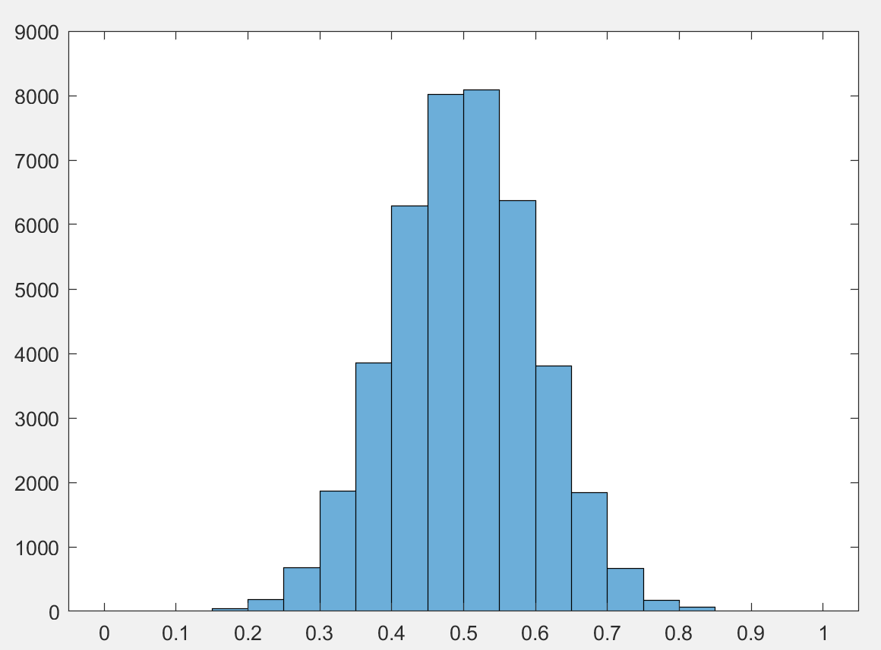
Use mu = 0.5 and sigma = 0.1 to simulate the random number generator

One simulation we use the base location of:
x1 = 0, y1 = 0
x2 = 50, y2 = 0
x3 = 50, y3 = 50
The tag exact location is:
xx = 23, yy = 20
so the exact three distance we get is:
d1 = 30.4795
d2 = 33.6006
d3 = 40.3609
we add noise on the exact distance:
d_m1 = d1 + δd1 δd1~(mu = 0, sigma = 0.3)
d_m2 = d2 + δd2 δd2~(mu = 0, sigma = 0.3)
d_m3 = d3 + δd3 δd3~(mu = 0, sigma = 0.3)
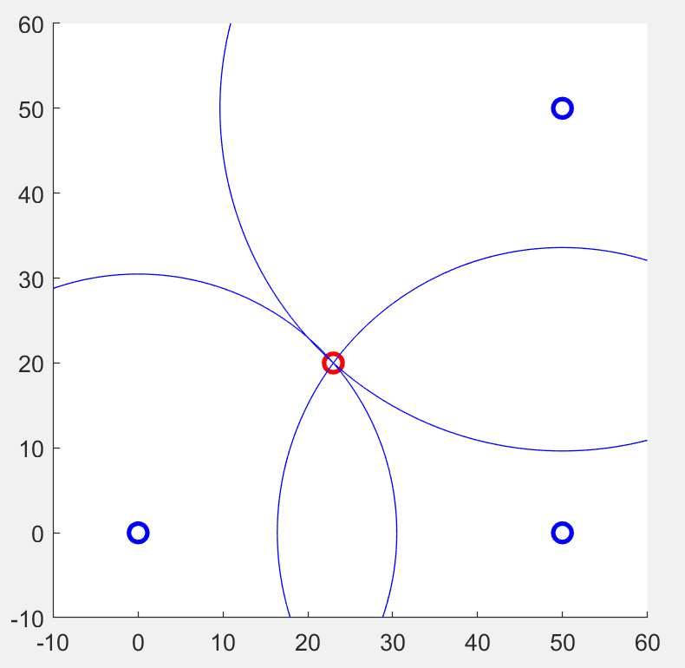
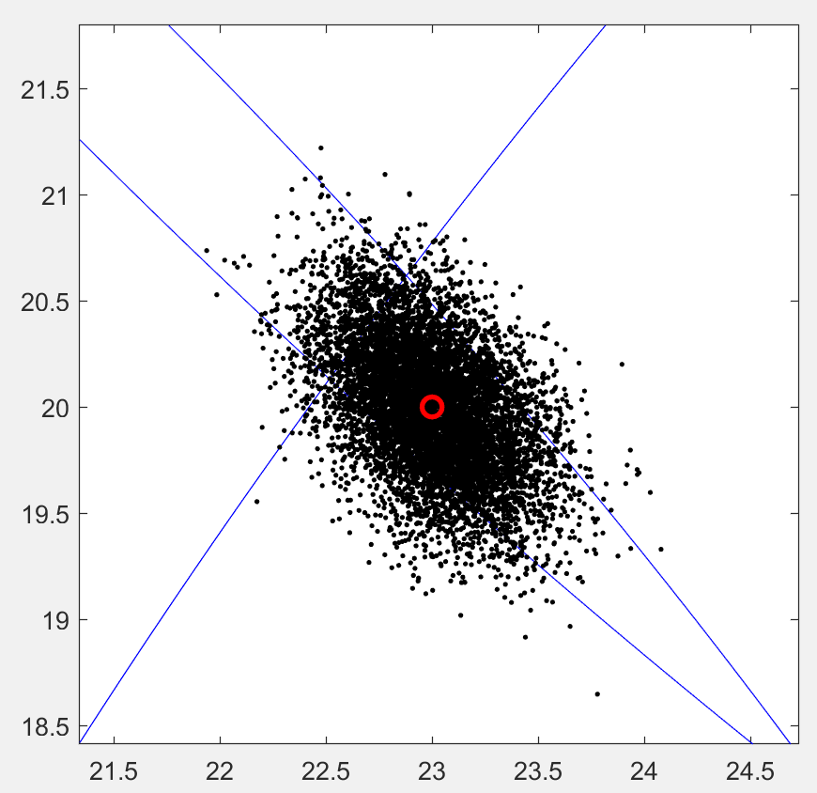
The location distribution is plot above.
The accuracy error between the measured position and the actual position is:
delta_d = sqrt((xm-xx)^2+(ym-yy)^2)
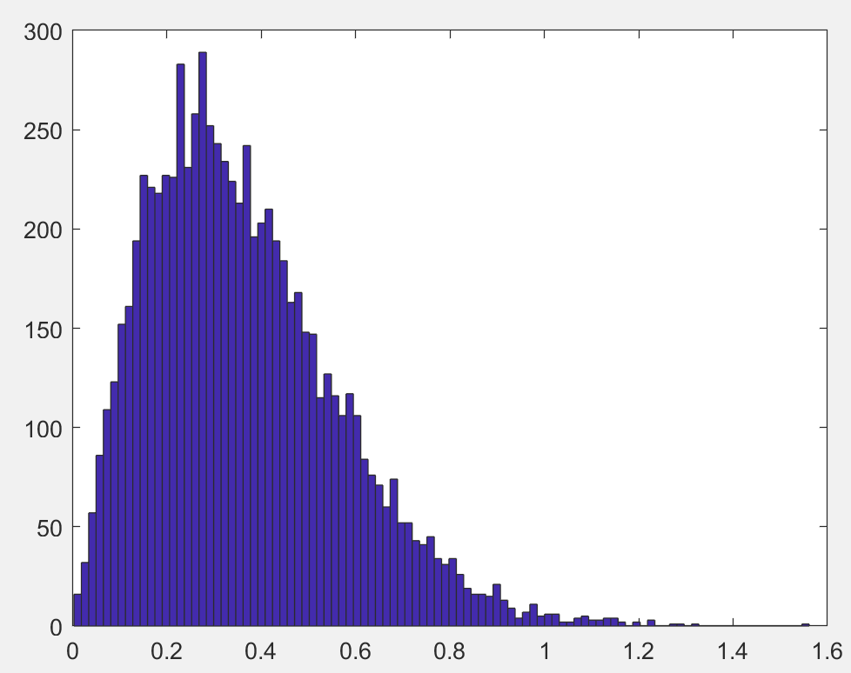
If we study delta_X and delta_Y seperately:
sigma of delta_X = 0.027
sigma of delta_Y = 0.031
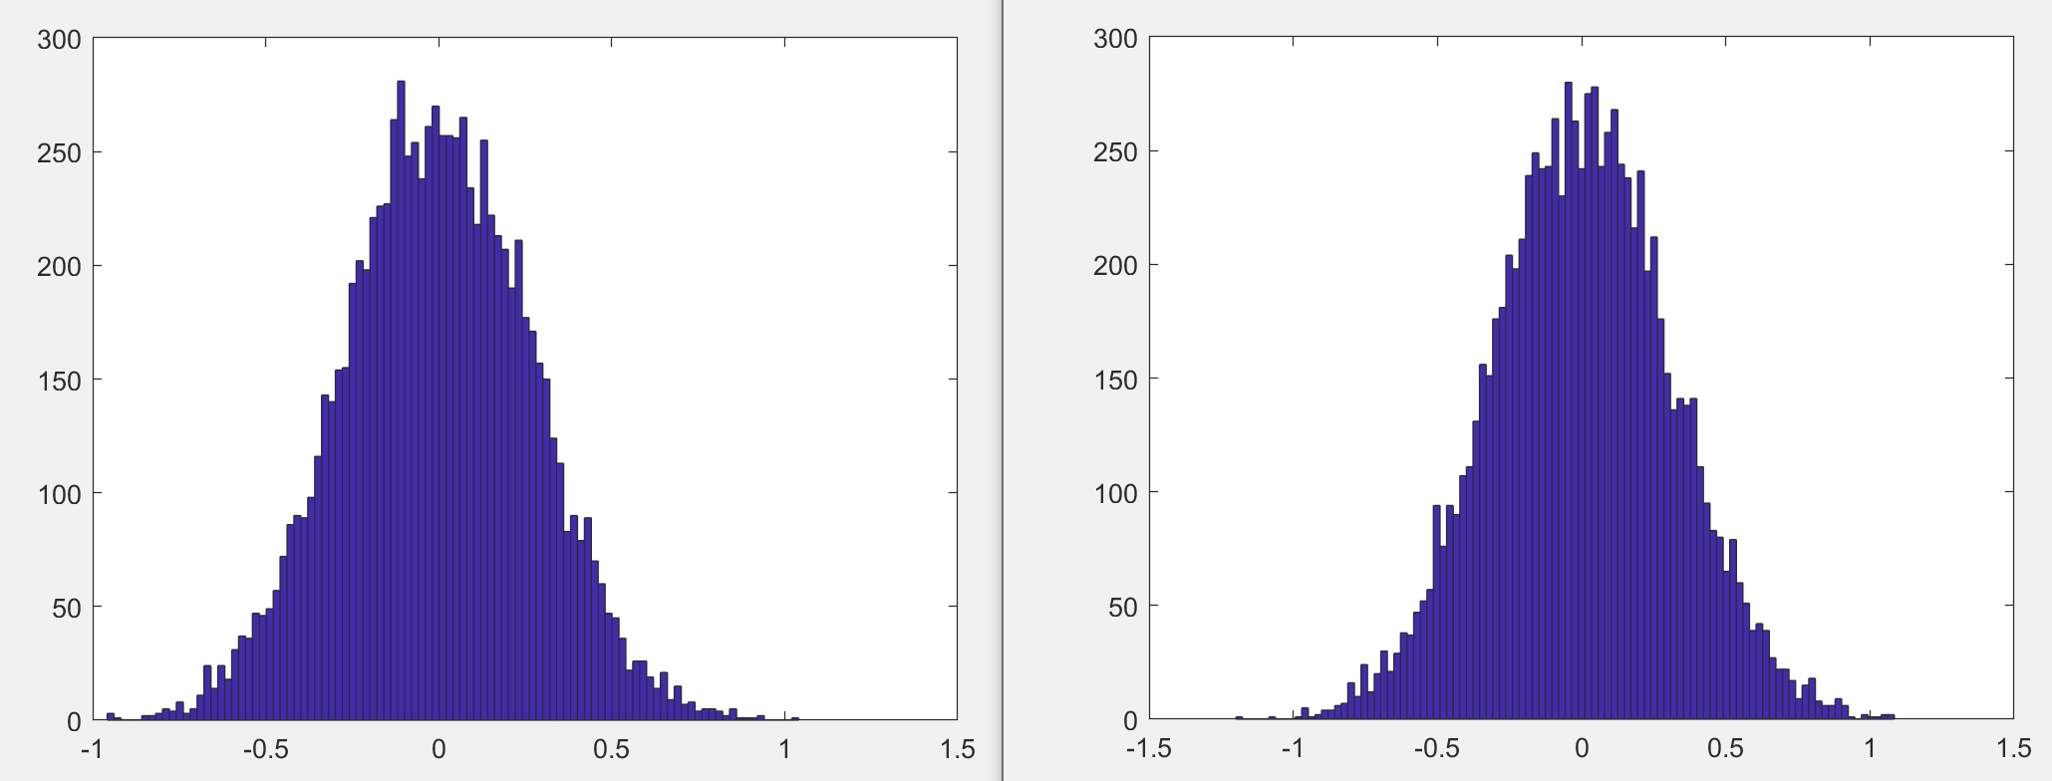
The above shows the delta x and delta y distribution:
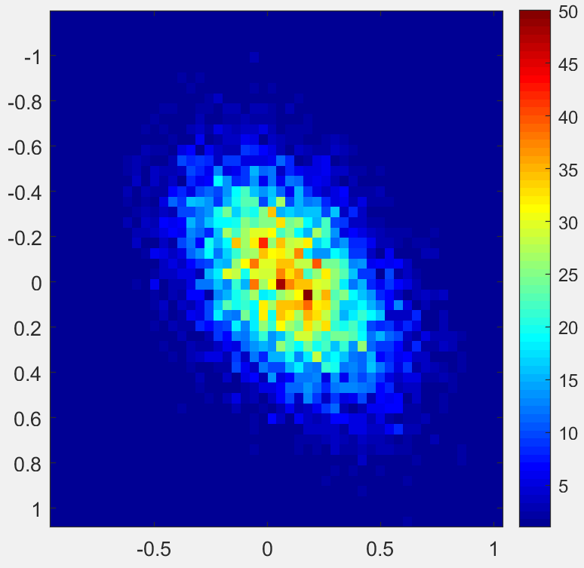
Above shows a 2D histogram plot.
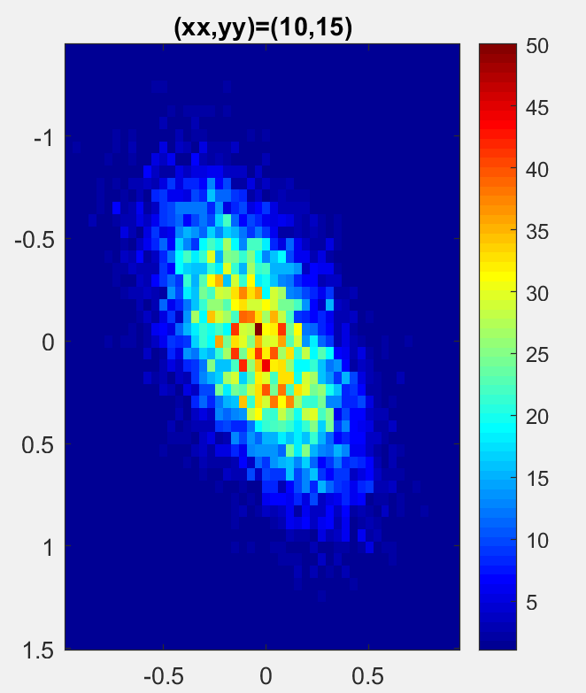
For a position of 10,15 the result is showed above.
And for position (0,15) the result is:
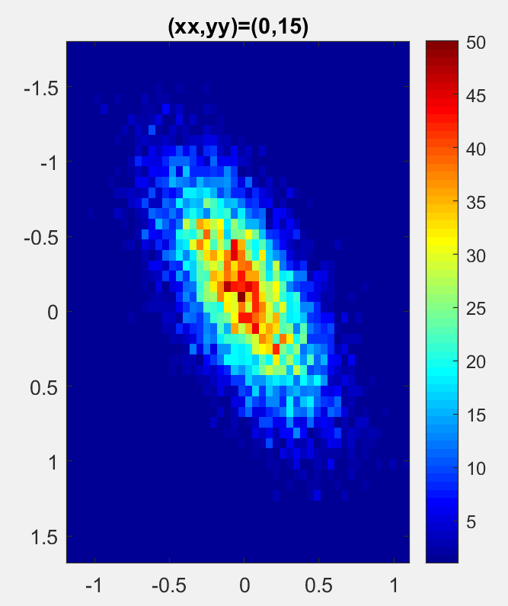
But the sigma is difference from distance:
sigma_min = ln(10)/10*sigma_sh/n*d
 | N | sigma_sh
Residual LOS | 1.79 | 2.22
Residual NLOS | 4.58 | 3.51
Indoor office LOS | 1.63 | 1.90
Indoor office NLOS | 3.07 | 3.90

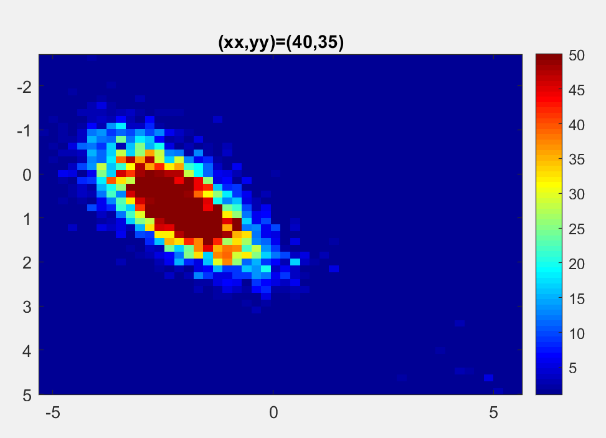
there is an offset:
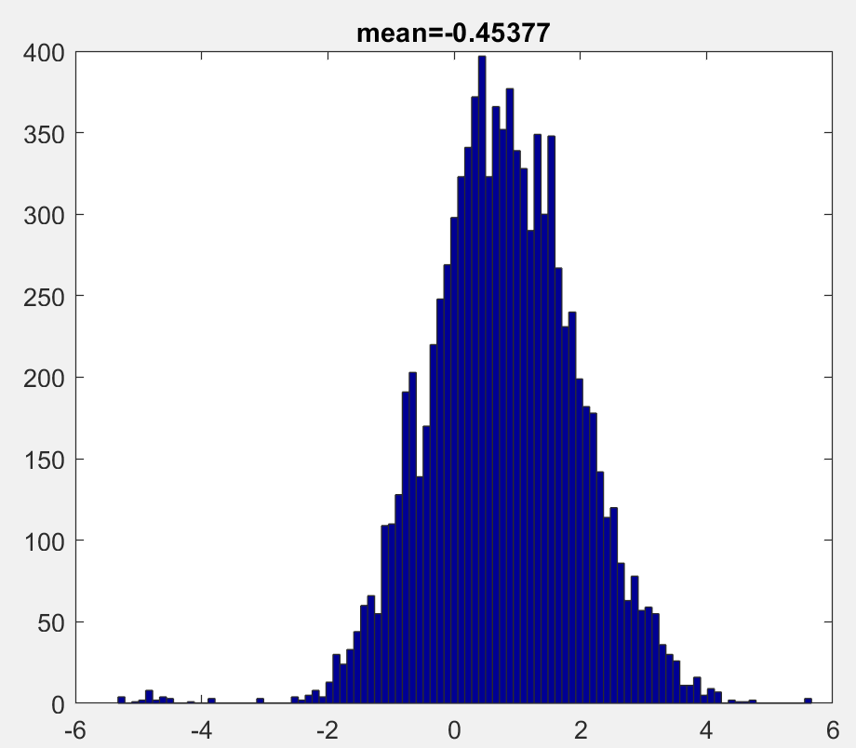
If we use:
normrnd(0,0.05*0.2856*d(i)
then we will get some result like:

