John Lor

Assignment06

Foundations of Databases

Nov 25, 2020

**SQL Views**

**Introduction**

As we continue to interface with databases, we may find that certain actions are repeated on a regular basis. In order to save precious time, we can assign names to regularly executed code to save the effort of typing things over and over again. In this paper we will examine the purpose of views, as well as their relation to functions and stored procedures.

**SQL Views**

As the name implies, a SQL view is a stored method of viewing a database. More specifically, it is a saved query that is given a name that can be referenced. One might create a view to save time when using a commonly used query. Further, views can be used for security as well. We may want users to see certain aspects of a table that contains sensitive information. Therefore, we can deny access to querying the table itself but allow queries to a view with predefined columns. See an example taken from the assignment below.

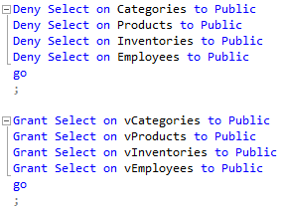

**Views, Functions, and Stored Procedures**

In essence, the purpose of views, functions, and stored procedures is to save keystrokes. Actions that are performed repeatedly can be saved negating the need to type a long query multiple times. However, the three are not exactly the same. See above for a proper definition of views. Unlike a view, a function can take a parameter to perform an action, such as returning a table. A stored procedure need not return data but can be used to execute a predefined block of code. Notably, we can also combine these things as well, such as having a function that calls on a view.

**Conclusion**

As can be seen views are both useful in saving time and applying some level of security to databases. Further, by creating views, functions, or stored procedures we can enhance the user experience by reducing the effort needed to produce a result.