**Get Current Weather User Guide**

**Author: J.Yang**

**06 03, 2016**

Overview

This document describes how to build and use the Get Current Weather web application.

1.) Steps to build the application

1. Download the package from <https://github.com/johnyang62/weather>, and extract to a directory, e.g. c:\ws\weather.  
   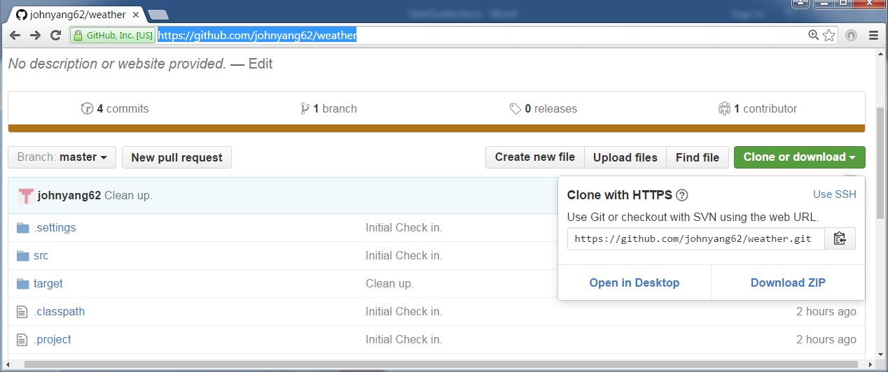
2. Run the following to install without running junit tests,  
   mvn -Dmaven.test.skip=true install
3. copy C:\ws\weather\target to C:\apache-tomcat-8.0.32\webapps  
   Start tomcat
4. Run the junit tests  
   mvn test

2.) Using the application

* Use case 1 – City selection page

Type <http://localhost:8180/weather/> to Browser address bar.

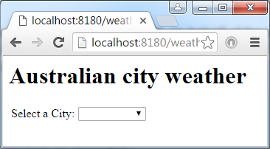

* Use case 2 – Select a city

