Pacemaker – HA KVM guest
- KVM Hyper-visor
- Redhat cluster Nodes – kvm-host1 & kvm-host2
- Shared storage – NFS
- KVM guest – guest_ha

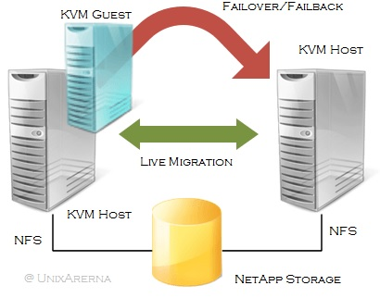

1. Login to one of the cluster node and halt the KVM guest.
[root@kvm-host1 ~]# virsh shutdown guest_ha
[root@kvm-host1 ~]# virsh list --all

2.Copy the Guest domain configuration file (XML) to NFS path.
[root@kvm-host1 qemu]# cp /etc/libvirt/qemu/guest_ha.xml /kvmpool/qemu_config

3. Un-define the KVM virtual guest. (To configure as cluster resource)
[root@kvm-host1 qemu]# virsh undefine guest_ha

4. Check the pacemaker cluster status.
[root@kvm-host1 ~]# pcs status

5. To manage the KVM guest, you need to use resource agent called “VirtualDomain”. Let’s create a new virtual domain using the guest_ha.xml file where we have stored in /kvmpool/qemu_config.
[root@kvm-host1 ~]# pcs resource create guest_ha_res VirtualDomain hypervisor="qemu:///system" config="/kvmpool/qemu_config/guest_ha.xml" migration_transport=ssh op start timeout="120s" op stop timeout="120s" op monitor timeout="30" interval="10" meta allow-migrate="true" priority="100" op migrate_from interval="0" timeout="120s" op migrate_to interval="0" timeout="120" --group guest_ha

6. Check the cluster status.
[root@kvm-host1 ~]# pcs status

7. KVM guest “guest_ha” must be created and started automatically. Check the running VM using following command.
[root@kvm-host1 ~]# virsh list
Id Name State
----------------------------------------------------
2 guest_ha running

8. Pacemaker also support the live KVM guest migration. To migrate the KVM guest to other KVM host on fly, use the following command.
[root@kvm-host1 ~]# pcs resource move guest_ha kvm-host2
In the above command,guest_ha refers the Resource group name & kvm-host2 refers the cluster node name

9. Check the cluster status.
[root@kvm-host1 ~]# pcs status

10. Check guest os moved from kvm-host1 to kvm-host2.
[root@kvm-host1 ~]# virsh list --all

