TrailGraph
Business Plan & Market Positioning
The graph-native, memory-powered trip planner for all U.S. public lands
Bootstrapped consumer freemium · NPS · State · USFS · BLM
Confidential Draft — June 2026

Contents

(In Word: right-click → Update Field to populate page numbers.)

1. Executive summary
TrailGraph is a graph-native, AI-powered trip planner for U.S. public lands. It unifies national parks, state parks, national forests (USFS), and BLM land into one explorable graph of parks, trails, campgrounds, activities, and conditions — fronted by an AI “ranger” that remembers each traveler’s preferences, constraints, and history across every conversation. Where competitors silo trails, camping, and routing into separate single-purpose apps with static search, TrailGraph plans the whole trip and gets smarter the more you use it.
The market is large, growing, and AI-receptive. The U.S. outdoor recreation economy reached $1.3 trillion in output (2.4% of GDP, 5.2M jobs) in 2024; national parks set a visitation record at 331.9 million recreation visits; 56 million Americans camped, spending $61 billion. Travelers have embraced AI planning — roughly 80% of U.S. travelers now use AI trip-planning tools — yet no incumbent combines integrated public-lands coverage with a memory-native agent.
The plan is deliberately bootstrapped and profitable. A consumer freemium model (free tier → Pro → Family/Overlander) priced in line with the market (~$39/yr Pro) targets a 4–6% free-to-paid conversion — squarely within the health-&-fitness app band — to reach roughly $4.9M revenue and ~84k paid subscribers by Year 5 with a lean team and no outside capital. A mobile app with an offline AI ranger — itinerary intelligence that works without cell service in the backcountry — is the premium differentiator no competitor offers.
The wedge is the moat. Start by owning integrated public-lands trip planning for the engaged hiker/camper/road-tripper, then expand outward. The graph + agent-memory architecture (already shipped for national parks) is hard to copy and compounds with every user and every data source added.

Highlights
- Category: integrated trip planning across all U.S. public lands (NPS + state + USFS + BLM).
- Model: bootstrapped B2C freemium subscriptions; affiliate/booking and data as secondary engines.
- Differentiator: graph-native memory + an AI ranger, plus a mobile offline AIworkflow for the backcountry.
- Base case: profitable around Year 3; ~$4.9M revenue / ~84k paid subscribers by Year 5.

2. The problem
Planning a public-lands trip is fragmented, competitive, and unforgiving — and current tools each solve only one slice:
- Fragmentation across tools and agencies. A single trip spans trails, campgrounds, drive routes, permits, and conditions — and crosses NPS, state-park, USFS, and BLM jurisdictions, each with its own site and data. Travelers stitch together AllTrails, The Dyrt, Recreation.gov, Google Maps, and a dozen browser tabs.
- The reservation scramble. Demand outstrips capacity: most reservable national-park campsites open on a 6-month rolling window, and summer and holiday dates “fill the first day they become available, usually within seconds.” Timed-entry permits (Arches, Rocky Mountain, Glacier, Yosemite) sell out in minutes. There is no good way to be told when a sold-out site frees up.
- Generic AI with no memory. New AI travel tools answer one prompt at a time and forget you between sessions — they don’t know your rig length, your accessibility needs, the parks you’ve considered, or the hikes you’ve done.
- The backcountry is offline. Cell coverage disappears exactly where planning help is needed most — at the trailhead and in the campground — yet most AI assistants are cloud-only and go dark when signal does.
- Record crowds, shrinking staff. 2024 set a visitation record while the Park Service faced staffing and budget cuts — pushing more planning burden onto visitors and onto software.
The opportunity: one tool that plans the whole trip across every public land, remembers the traveler, helps win the reservation race, and keeps working when the signal doesn’t.

3. Market opportunity

3.1 A vast, growing outdoor economy
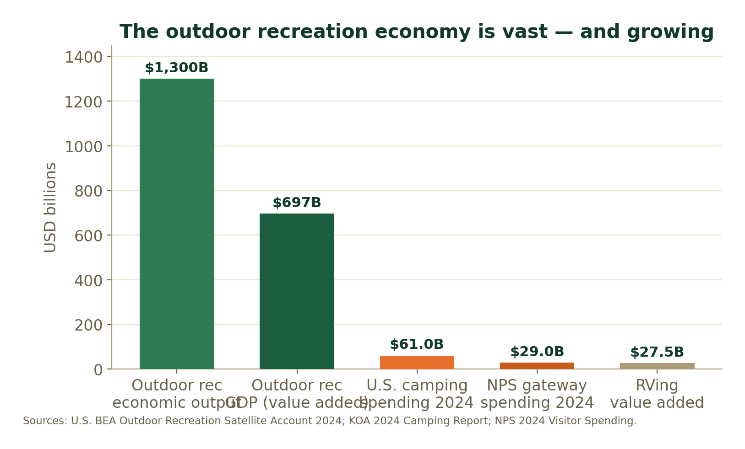
U.S. outdoor recreation, camping, and national-park spending (2024).
- $1.3T outdoor-recreation economic output; $696.7B value added (2.4% of GDP) and 5.2M jobs (BEA, 2024).
- 331.9M NPS recreation visits in 2024 (a record), generating $29B in gateway-town spending.
- 56M campers; $61B U.S. camping spend in 2024 ($200/household/day); 8.2M RV-owning households (+62% in 20 yrs).
- 41M first-time camping households since 2014 — a structurally larger, younger, digital-first base.

3.2 Digital trip planning is going AI-first
- $3.4B global travel-planner app market (2024), growing ~11% CAGR.
- $2.8B → $15.5B AI-powered travel app market (2024–2032), a 23.8% CAGR.
- ~80% of U.S. travelers now use AI tools to help plan trips — adoption is already mainstream.

3.3 Sizing the wedge (TAM / SAM / SOM)
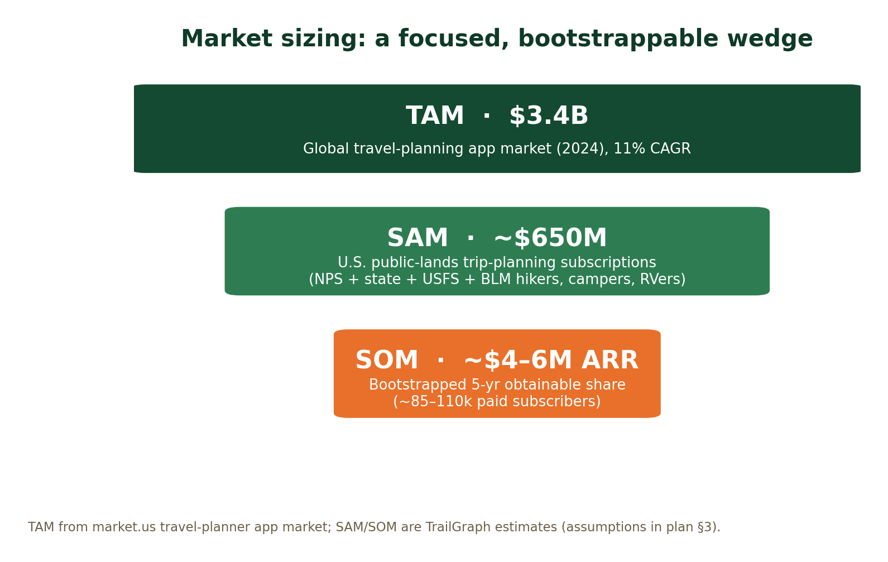
Assumptions. TAM = the global travel-planner app market ($3.4B). SAM = the U.S. subscription opportunity among public-lands trip planners — hikers, campers, and RVers who plan digitally — estimated at ~$650M (a low-single-digit-million paying-user base at ~$40 ARPU; AllTrails alone has 60M users and >$150M ARR in the adjacent trails niche). SOM = the bootstrapped, obtainable share over five years: ~85–110k paid subscribers / ~$4–6M ARR. These are deliberately conservative, defensible estimates, not top-down hype.

4. Competitive landscape
The market is healthy and proven — incumbents validate willingness to pay — but every leader is single-purpose, and none combines integrated public-lands coverage with a memory-native agent.
Player | Focus | Pricing/yr | What they do well — and the gap
AllTrails | Trails / hiking | ~$36 | 60M+ users, ~$150M ARR. Best trail catalog & reviews. Gap: trails only — no camping, routing, reservations, or cross-trip memory.
The Dyrt | Camping | ~$36–60 | 1M+ reviews, 50k+ campgrounds, offline maps, free-camping layers, Dyrt Alerts. Gap: camping-centric; no trails/itinerary depth or AI memory.
Wanderlog | Itinerary planner | ~$40 | Great collaborative itineraries + an AI assistant. Gap: general travel, thin on public-lands data, trails, and conditions; stateless AI.
Roadtrippers | Road trips / RV | ~$36–60 | Route discovery + RV routing. Gap: route-centric; limited trail/campsite depth, no memory or availability alerting.
Gaia GPS / onX | Offline maps/GPS | $30–100 | Best-in-class offline topo + navigation. Gap: maps, not planning; no agent, itineraries, or reservations.
NPS app / Recreation.gov | Official info / booking | Free | Authoritative content and the federal booking rails. Gap: utility, not a planner; federal-only, no personalization or AI.

4.1 Pricing context
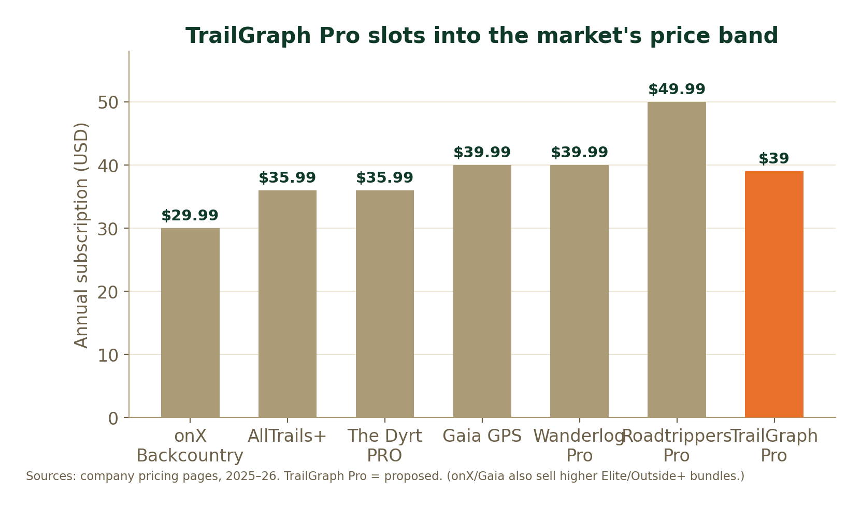
Annual subscription pricing across the category; TrailGraph Pro proposed at ~$39.
Willingness to pay $30–$60/yr for an outdoor app is well established. TrailGraph Pro at ~$39 sits mid-band — undercutting nothing on perceived value while differentiating on breadth and AI.

4.2 Positioning framework
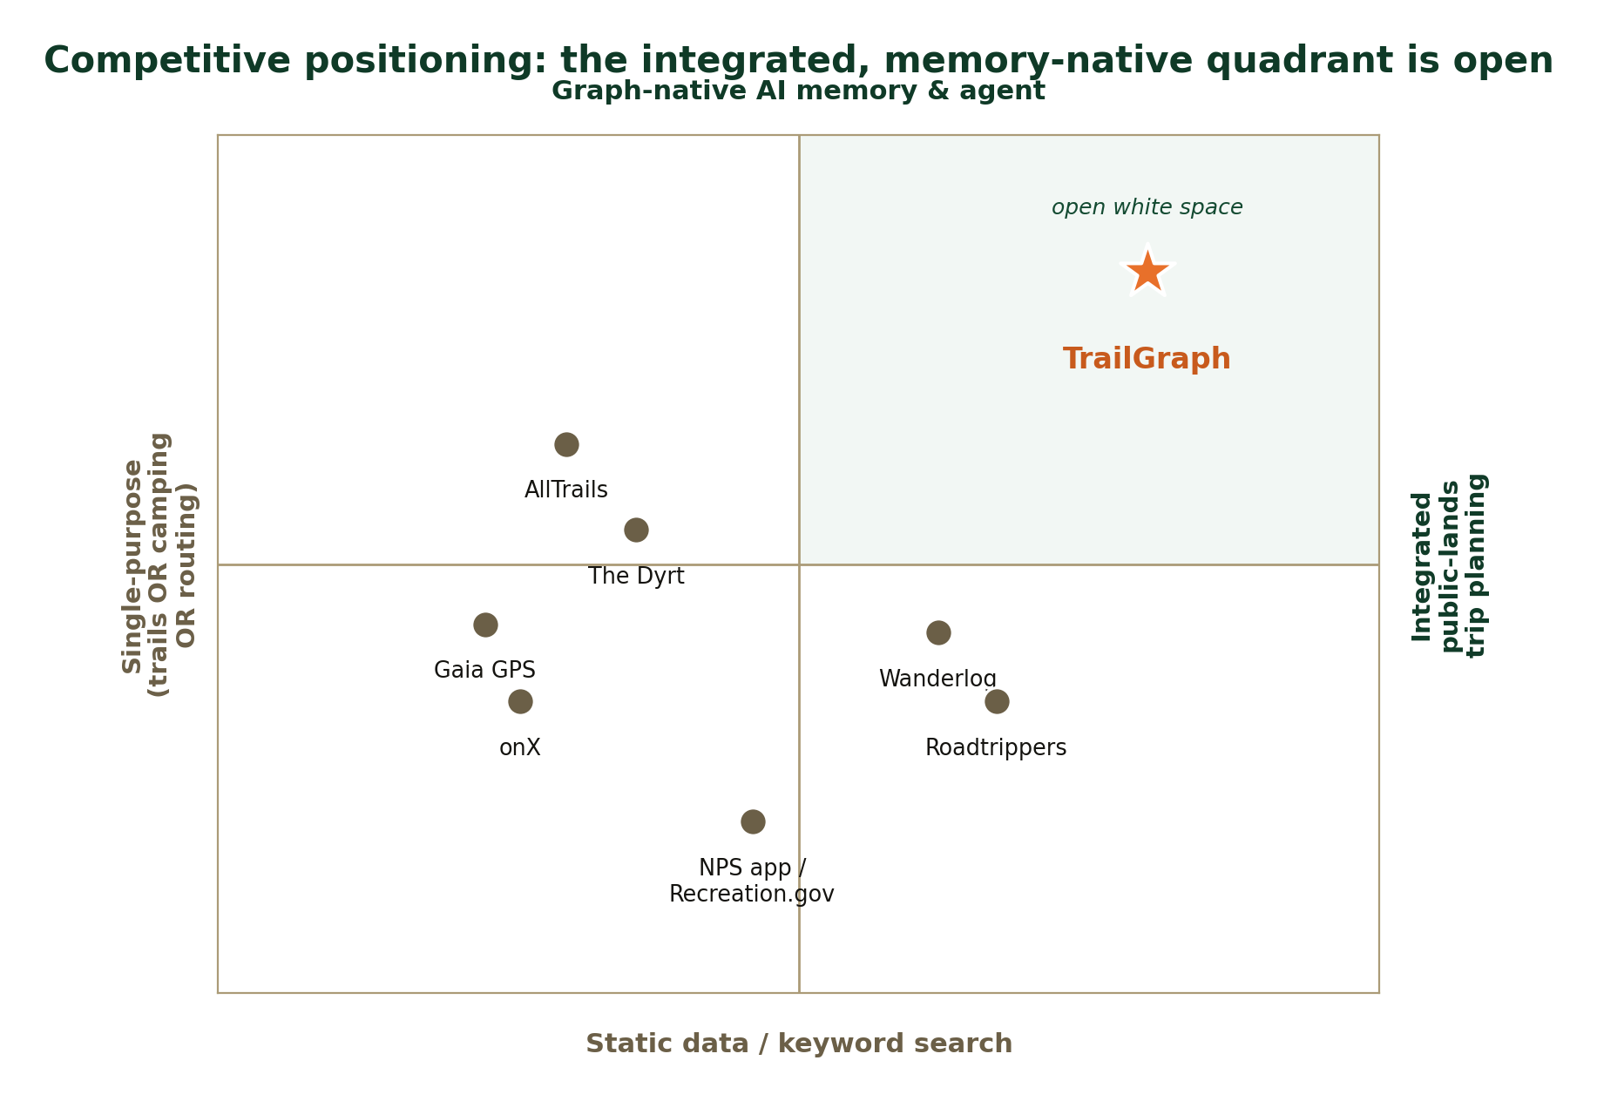
Two axes that matter: integration breadth (single-purpose → whole-trip) and intelligence (static search → graph-native memory + agent).
The open quadrant. Incumbents cluster as single-purpose tools with static (or stateless) intelligence. The upper-right — integrated public-lands planning powered by graph-native memory and an agent — is unoccupied. That is TrailGraph’s wedge, and it is defensible: the graph compounds as data sources and users grow, and cross-trip memory is something a single-purpose competitor can’t bolt on without re-architecting.

5. Product & the capabilities the business requires
Shipped today: the national-parks core — an explorable park graph, an AI ranger with graph-native memory (preferences, considered parks, constraints injected every turn), a trip planner with route drawing and GPX/calendar export, an interactive map, a graph explorer, and a Learn module. This is the proof the architecture works.
To support the business plan, the following capabilities need to be built, in priority order. Each is independently shippable and most are already designed (see the Trails and Campgrounds design docs).
Capability | What it is / why it matters | Supports
Multi-agency data pipeline | Ingest trails (NPS GIS + OSM), campgrounds/campsites (RIDB + USFS GIS + OSM), and conditions across NPS/state/USFS/BLM into the graph. The breadth that defines the category. | Differentiation, SEO
Real trails & activities | Actual hikeable trails with length/elevation/difficulty + activity-first browsing; integrated into map & trip days. | Free → Pro value
Availability + Camp Watch | Live campsite availability search and cancellation alerting (“tell me when a matching site opens”). The killer retention + Pro-conversion hook. | Pro, retention
Mobile app + offline AI ranger | Native app with downloaded maps, trips, and an on-device/edge AI assistant that works without signal. The premium differentiator nobody else has. | Pro+/Family
Accounts, billing, subscriptions | Auth (shipped), subscription billing (Stripe/App Store/Play), entitlement gating, trials, referrals. | Monetization
Affiliate / booking funnel | Deep-link to Recreation.gov / operators; affiliate partners (Hipcamp, gear). Revenue without processing payments. | Secondary revenue
Cost & abuse controls | LLM rate-limits, caching, and tiered usage so unit economics hold as usage scales (per the cost audit). | Margin

6. Pricing model & tiers
A freemium ladder: a genuinely useful free tier for discovery and SEO, a Pro tier that unlocks the planning + offline + alerting power, and a Family/Overlander tier for households and RVers (higher ARPU, the segment that spends the most).
 | Free | Pro — ~$39/yr | Family / Overlander — ~$69/yr
Who | Browsers, first-time planners | Active hikers & campers | Households, RVers, overlanders
Planning | AI ranger (limited turns), 1 saved trip | Unlimited ranger + trips, full graph memory | Everything in Pro + shared/collaborative trips
Data & maps | Browse parks, trails, campgrounds | Offline maps + trips; advanced filters | + RV/rig-aware routing & site fit
Offline AI | — | Offline AI ranger | Offline AI ranger (multi-device)
Availability | 1 Camp Watch alert | Unlimited Camp Watch + priority scan | Unlimited + faster scan cadence
Extras | Ads-free, community | Conditions alerts, GPX/field briefs | Up to 5 members, dispersed/free-camping layer

- Why this works: the free tier drives SEO and word-of-mouth; offline AI + Camp Watch are concrete, daily-value reasons to upgrade; Family/Overlander captures the highest-spending segment (RV households) at a premium.
- Trials: a 14–30-day Pro trial (longer trials convert ~3–4× better) timed to trip-planning season.
- Secondary revenue: affiliate/booking deep-links and, later, anonymized public-lands data/insights — never paid placement that compromises trust.

7. Go-to-market (capital-efficient)
Bootstrapped growth means CAC-light, compounding channels — exactly what the graph + content architecture is built for.
- Content & SEO engine. The graph already generates rich, interlinked park / trail / campground / “things to do” pages — a programmatic-SEO flywheel against high-intent queries (“dog-friendly campgrounds near Zion,” “easy hikes Glacier”). Free tier = the funnel.
- Reservation-race wedge. “Get alerted when a sold-out site opens” is a sharp, shareable hook with built-in urgency and word-of-mouth (the same wedge The Dyrt and Campnab grew on).
- Community & UGC. Reviews, trip reports, and saved trips deepen the graph and the moat while lowering content cost.
- Seasonal & partnerships. Time pushes to planning season (Jan–June) and the 6-month booking windows; partner with gateway towns, gear/RV brands, and creators for low-cost reach.
- App store + referral. The mobile app adds an organic discovery surface; in-product referral rewards Pro months.
Funnel & conversion.
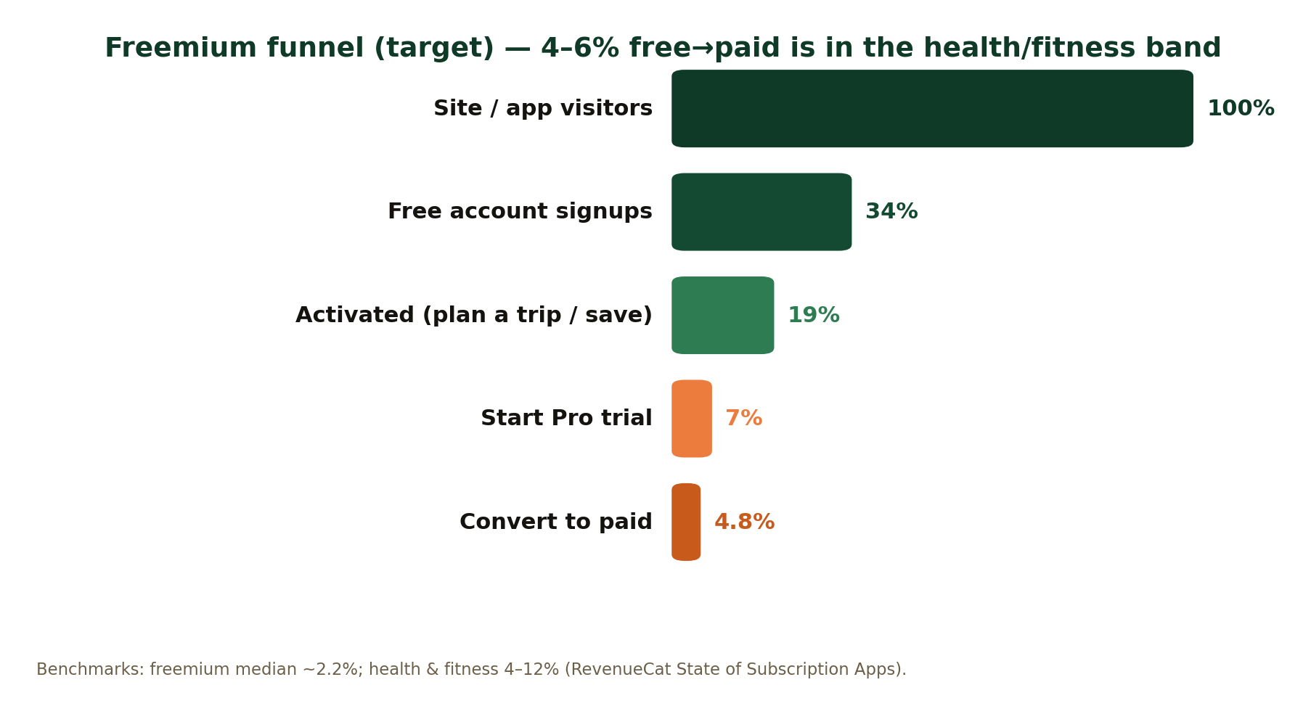
Target freemium funnel. A 4–6% free→paid rate is within the health-&-fitness band (RevenueCat); freemium median is ~2.2%.

8. Financial model (bootstrapped base case)
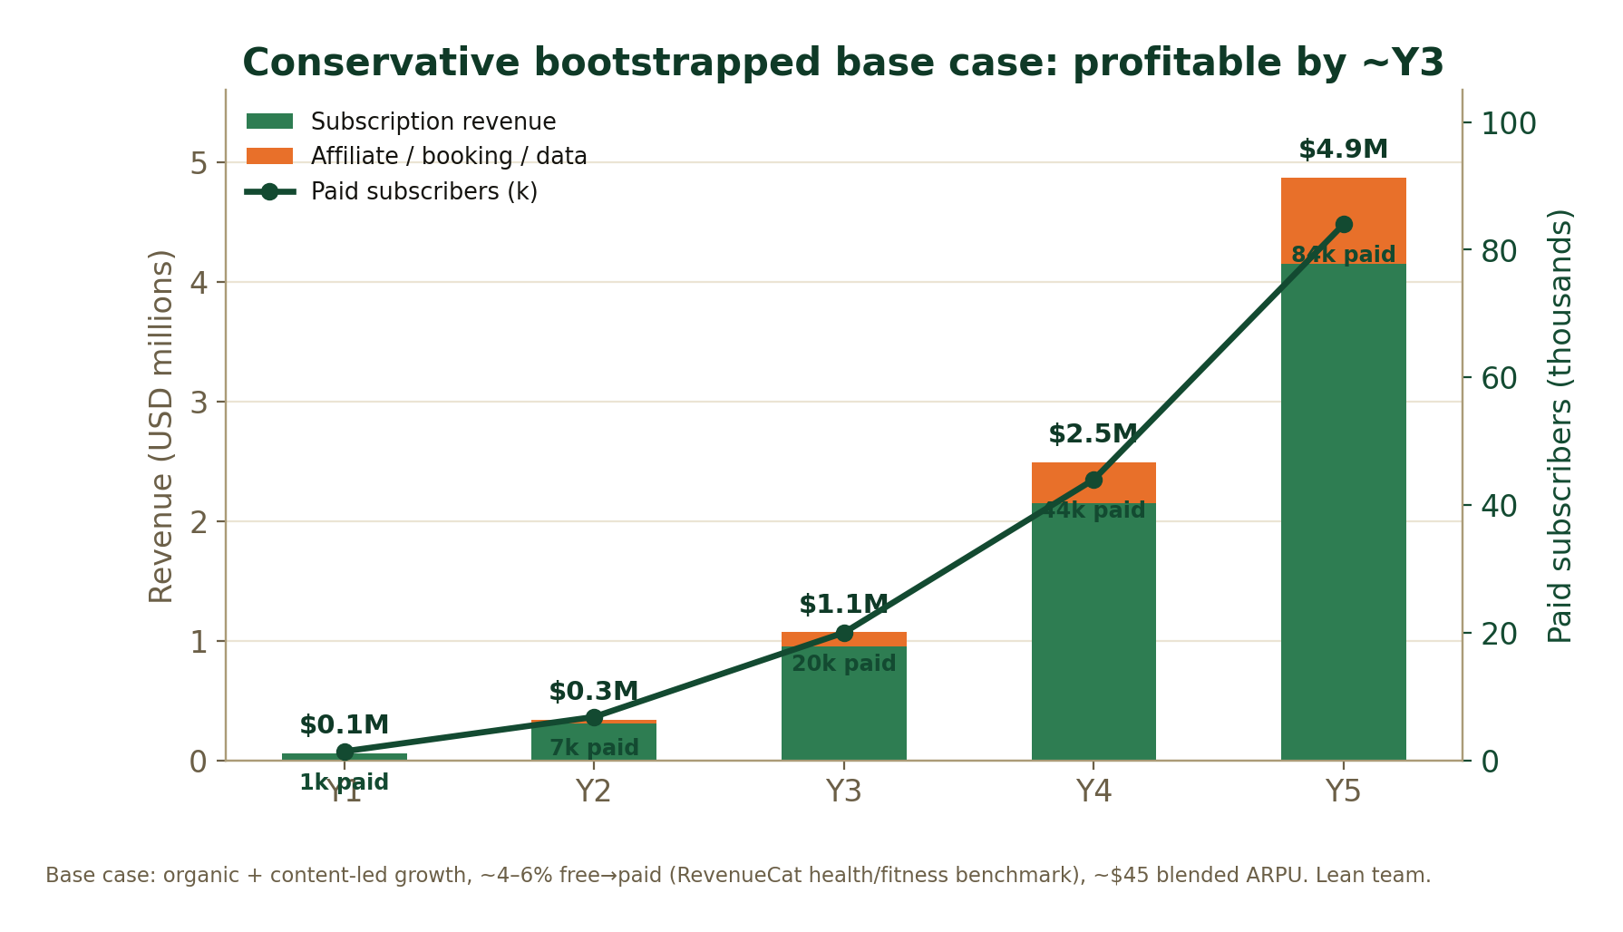
Five-year conservative base case. Subscription-led, with a small affiliate/booking layer; profitable around Year 3.
Metric | Y1 | Y2 | Y3 | Y4 | Y5
Registered free users | 40k | 150k | 400k | 800k | 1.4M
Free→paid conversion | 3.5% | 4.5% | 5.0% | 5.5% | 6.0%
Paid subscribers | 1.4k | 6.8k | 20k | 44k | 84k
Subscription revenue | $0.06M | $0.31M | $0.95M | $2.15M | $4.15M
Affiliate / booking / data | — | $0.03M | $0.12M | $0.34M | $0.72M
Total revenue | $0.06M | $0.34M | $1.07M | $2.49M | $4.87M

8.1 Assumptions & unit economics
- ARPU ~$45 blended (mix of $39 Pro and $69 Family/Overlander, net of app-store fees & churn).
- Conversion ramps 3.5%→6% as Camp Watch, offline AI, and trials mature — conservative vs. the 4–12% health-&-fitness range.
- Costs are dominated by (a) LLM inference — controlled via caching, deterministic graph reads, and per-tier rate limits; (b) infrastructure (single Neo4j, hosting, maps/Blob); (c) a lean team (2–3 in Y1–Y2 → 5–8 by Y5). No paid CAC assumed in the base case.
- Profitability around Year 3 as subscription revenue clears infra + team; all reinvested (bootstrapped).
- Upside levers (not in base case): paid acquisition once LTV:CAC is proven, B2B/B2G licensing, and international/global-parks expansion.

9. Roadmap
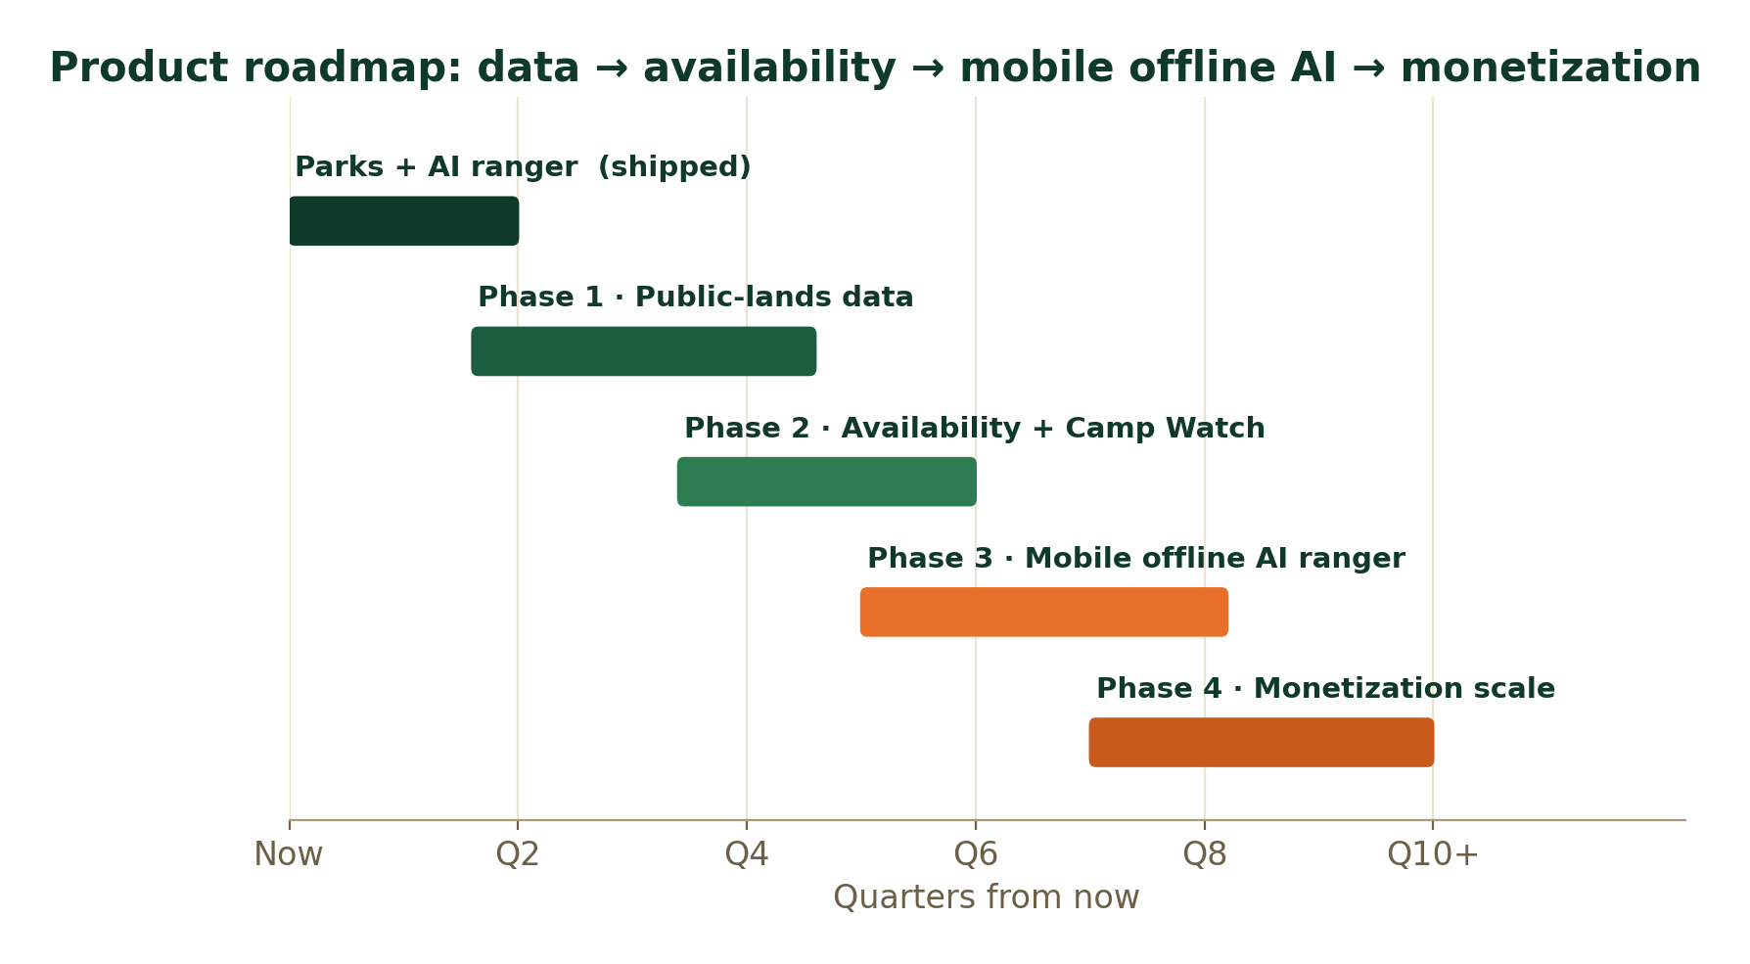
Sequencing: data breadth → availability/alerting → mobile offline AI → monetization scale.
- Phase 1 — Public-lands data. Trails + campgrounds/campsites across NPS/state/USFS/BLM; the breadth that defines the category and feeds SEO.
- Phase 2 — Availability + Camp Watch. Live availability search and cancellation alerting; the conversion + retention wedge.
- Phase 3 — Mobile + offline AI ranger. Native app with offline maps/trips and the on-device assistant — the premium differentiator and a new acquisition surface.
- Phase 4 — Monetization scale. Tier optimization, affiliate/booking, referrals, and (optional) data/insights.

10. Risks & mitigations
Risk | Mitigation
Incumbent scale (AllTrails, The Dyrt) | Don’t compete head-on; win the unoccupied integrated + memory-native quadrant. The graph + cross-trip memory is hard for single-purpose incumbents to retrofit.
Availability-data ToS / fragility | Treat the Recreation.gov availability endpoint as unofficial: cache aggressively, poll only watched/viewed campgrounds, back off, and degrade gracefully to deep-links. License state data via partners; never scrape proprietary sources.
LLM / infra cost outrunning revenue | Deterministic graph reads, response caching, and per-tier rate limits (per the cost audit); gate the heaviest AI behind Pro.
Seasonality of demand | Annual plans smooth revenue; off-season Learn/Journeys content and international parks (upside) fill the trough.
Entity resolution across data sources | Invest in a dedup/confidence step; surface source + confidence to users so trust is preserved.
Bootstrapped bandwidth | Ruthless sequencing (roadmap), automation, and AI-assisted development; ship one wedge at a time; keep the team lean and the burn low.

11. Why TrailGraph wins
The outdoor economy is enormous and AI planning is already mainstream, yet every leading tool solves one slice and forgets you between trips. TrailGraph occupies the open quadrant — integrated public-lands planning powered by a graph and a memory-native AI ranger — and adds the one thing the backcountry actually needs: an assistant that works offline. Built bootstrapped and profitable, priced in the market band, and grown through a compounding content + availability-alerting wedge, it can reach roughly $4.9M in revenue and ~84k paid subscribers within five years without outside capital — while building a data-and-memory moat that gets harder to catch every month.

Appendix: sources
- U.S. BEA — Outdoor Recreation Economic Statistics 2024 — https://www.bea.gov/news/2026/outdoor-recreation-economic-statistics-us-and-states-2024
- NPS — 2024 visitation record & visitor spending — https://www.nps.gov/nature/customcf/NPS_Data_Visualization/docs/NPS_2024_Visitor_Spending_Effects.pdf
- KOA — 2024/2025 North American Camping & Outdoor Hospitality Report — https://koa.com/north-american-camping-report/
- RVIA — outdoor recreation $1.3T economic driver — https://www.rvia.org/news-insights/new-data-reveals-outdoor-recreation-13-trillion-economic-driver
- market.us — Travel Planner App Market size & CAGR — https://market.us/report/travel-planner-app-market/
- AllTrails — Crunchbase profile (users, funding) — https://www.crunchbase.com/organization/alltrails-com
- The Dyrt PRO — features & pricing — https://thedyrt.com/pro
- Wanderlog / Roadtrippers / Gaia / onX — pricing pages — https://www.wanderlog.com/
- RevenueCat — State of Subscription Apps (conversion benchmarks) — https://www.revenuecat.com/state-of-subscription-apps/
- Campnab — how Recreation.gov availability alerts work — https://campnab.com/blog/how-to-get-campsite-availability-notifications-on-recreation-gov
- Recreation.gov / RIDB — data & docs — https://ridb.recreation.gov/docs

Market-size figures are from cited public sources; SAM/SOM, the financial model, and pricing are TrailGraph estimates with assumptions stated inline. For planning discussion, not investment advice.

