# CPU-DAI

**ASOC**

Platform

Machine

Codec

The main function of the Platform driver is to complete the management of audio data, and finally transmit the audio data to the Codec through the digital audio interface (DAI) of the CPU.

snd_soc_dai_driver.

snd_soc_platform_driver

Platform Driver

**ASOC**

ASoC divides the Platform driver into two parts: *snd_soc_platform_driver* and *snd_soc_dai_driver*. Among them, platform_driver is responsible for managing audio data and transferring audio data to cpu dai through dma or other operations. Dai_driver mainly completes the parameter configuration of dai on the cpu side. At the same time, it will also pass necessary dma and other parameters with snd_soc_platform_driver through certain channels to interact.

# Code flow

1. The CPU DAI is registered by calling *snd_soc_register_component*.

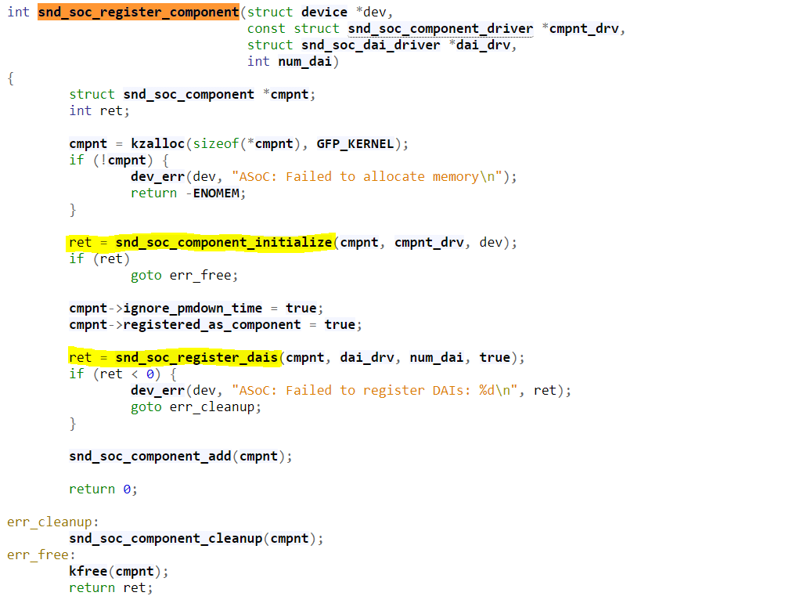

1. In *snd_soc_register_component* function, *snd_soc_component*  is created and memory is allocated. *snd_soc_component_driver*  and *snd_soc_dai_driver* are then registered.
2. Call *snd_soc_component_initiallize* to initialize the component, using *snd_soc_component_driver* to initialize the component. In CPU DAI, dapm mainly describes how *FE DAI* and *BE DAI* are linked.
3. assign the component driver to the driver member of the component, use the component driver dapm_widget and dapm_route to assign the corresponding members of the component, and initialize the dai_list of the component.

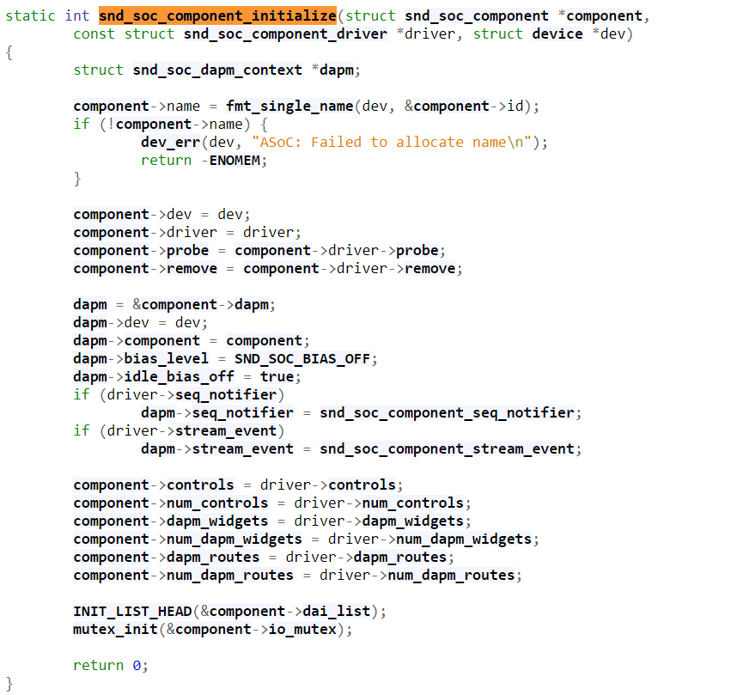

1. **Registration of cpu's snd_soc_dai driver**
   1. Define an instance of snd_soc_dai_driver structure;
   2. Register the snd_soc_dai instance through API: snd_soc_register_dai or snd_soc_register_dais in the probe callback in the corresponding platform_driver;
   3. Implement callbacks such as probe and suspend in the snd_soc_dai_driver structure;
   4. Implement the callback function in the snd_soc_dai_ops field in the snd_soc_dai_driver structure

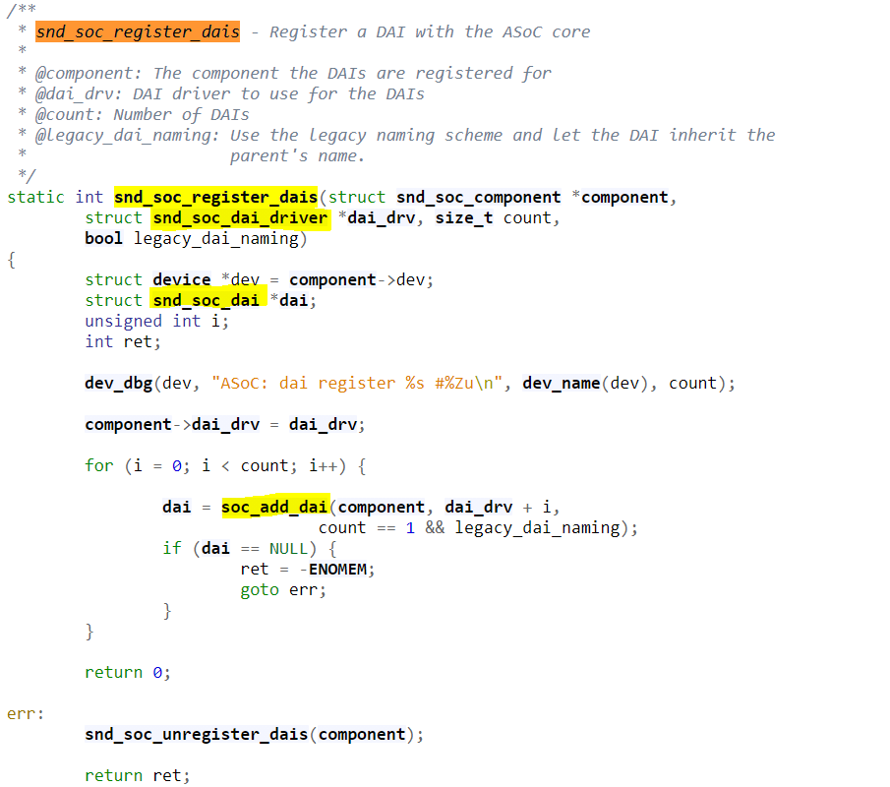

1. The structure of snd_soc_dai_driver needs to be defined according to different SOC chips. The key fields are introduced as follows:
   1. The probe and remove callback functions are called when the sound card is loaded and unloaded respectively;
   2. suspend, resume power management callback function;
   3. ops points to the snd_soc_dai_ops structure, which is used to configure and control the dai;
   4. The playback snd_soc_pcm_stream structure is used to indicate the number of channels, bit rate, data format and other capabilities supported by the dai;
   5. The capture snd_soc_pcm_stream structure is used to indicate the number of channels, bit rate, data format and other capabilities supported by the dai;
2. Traverse the snd_soc_dai_driver list in the snd_soc_register_dais function, and add each dai to the component dai_list through soc_add_dai.
3. **The ops field in snd_soc_dai_driver**
   1. all the configuration and control of dai are implemented through these callback functions.
   2. The working clock configuration function is usually called by the machine driver:
      1. set_sysclk sets the main clock of dai;
      2. set_pll set PLL parameters;
      3. set_clkdiv set frequency division coefficient;
      4. The format configuration function of dai is usually called by the machine driver:
      5. *set_fmt* sets the format of dai;
      6. *set_tdm_slot* If dai supports time division multiplexing, it is used to set the time division multiplexing slot;
      7. *set_channel_map* channel time division multiplexing mapping setting;
      8. *set_tristate* sets the state of the dai pin. This callback is required when the same pin is used in parallel with other dais;
4. The following apis are usually used by the machine driver. The machine driver uses these apis in the hw_params callback in the *snd_pcm_ops* field:
   1. *snd_soc_dai_set_fmt()* will actually call *snd_soc_dai_ops* or the *set_fmt* callback in the codec driver;
   2. *snd_soc_dai_set_pll()* will actually call *snd_soc_dai_ops* or the set_pll callback in the codec driver;
   3. *snd_soc_dai_set_sysclk()* will actually call *snd_soc_dai_ops* or the set_sysclk callback in the codec driver;
   4. *snd_soc_dai_set_clkdiv()* will actually call *snd_soc_dai_ops* or the set_clkdiv callback in the codec driver;
   5. The second parameter fmt of *snd_soc_dai_set_fmt(struct snd_soc_dai *dai, unsigned int fmt)* is specifically mentioned here. ASoC currently only uses its low 16 bits, and some macros are specifically defined for it to facilitate our use
5. Call *snd_soc_component*_add to add component to the global list component_list.
6. When the card is subsequently registered (*snd_soc_register_card*), the *soc_bind_dai_link* function will be called in *snd_soc_instantiate_card*. In this function, the cpu dai on a certain dai_link of the machine driver can be found by name, as follows:

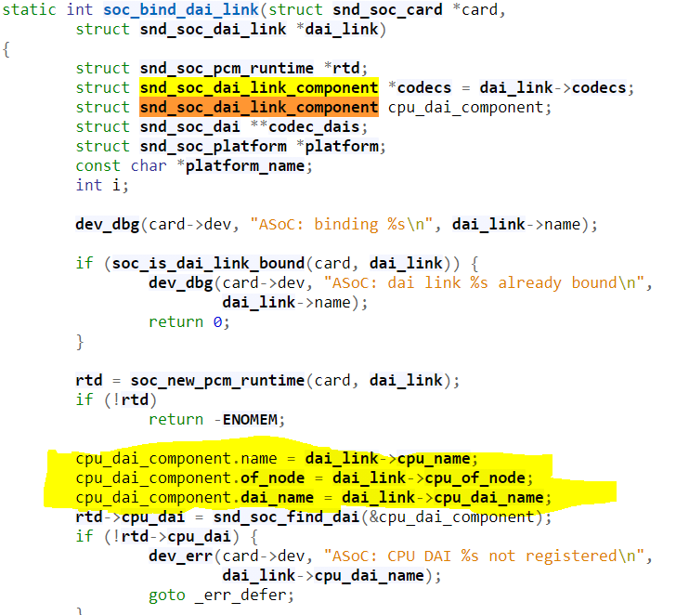

1. Find the corresponding cpu dai through the cpu_name and cpu_dai_name of dai_link. The specific search process is in the snd_soc_find_dai function. First find the component through cpu_name, then traverse component->dai_list, and use cpu_dai_name to match the name of dai.

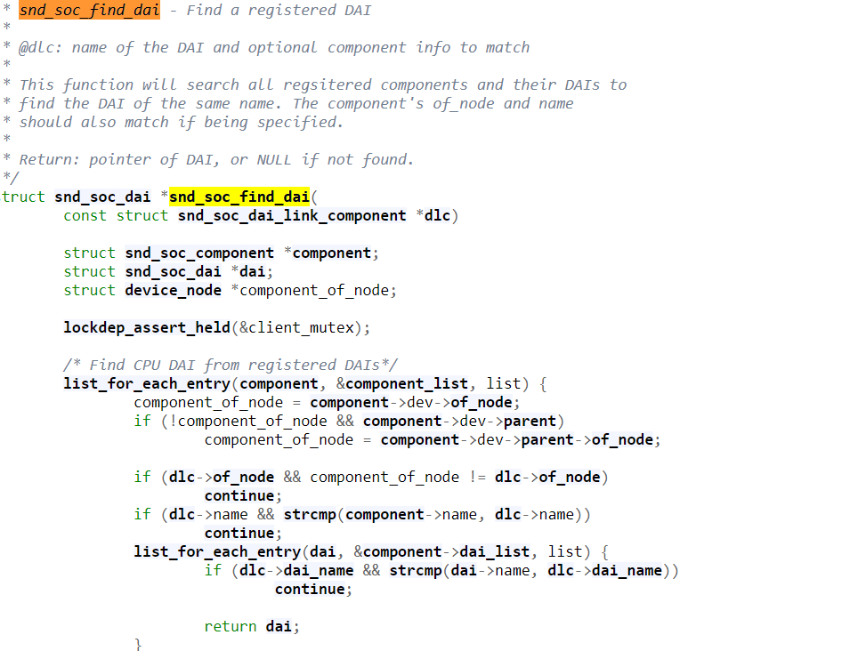

1. Probe the component of CPU DAI in soc_probe_link_components:

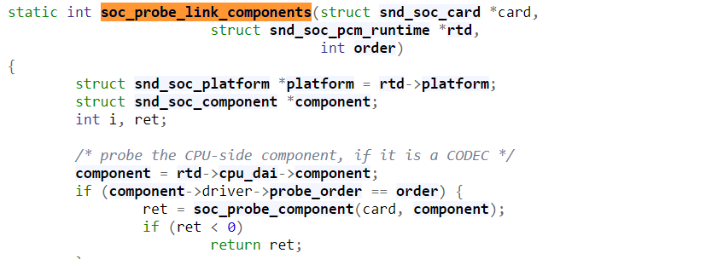

1. In the soc_probe_component function, probe the CPU DAI, mainly including
   1. Assign value to component and dapm context card.
   2. Call snd_soc_dapm_new_controls to create the dapm_widget of the component, and add the widget to the card->widgets list.
   3. Call snd_soc_dapm_new_dai_widgets for each dai widget in the component dai_list, the name of the widget is dai->driver->playback/capture.name. And the widget is added to the card->widgets list.
   4. Call the probe function of the component.
   5. Call snd_soc_dapm_add_routes to add dapm path to component's dapm_routes.
   6. Add the dapm context of the component to the dapm context list of the card.