pgeo: a geocoder inside PostgreSQL
  - Design, tuning, accuracy, capacity and security, measured against Pelias on open data for the State of Maine
John Zastrow
Contents

Executive summary
This study built and compared two self-hosted geocoders for the State of Maine on the same open data: Pelias[1], the established open-source geocoder (Elasticsearch[2] plus five Node.js and C++ services), and pgeo, a geocoder written for this project that runs entirely inside PostgreSQL 18 with PostGIS, served either by a thin FastAPI application or, with no application code at all, by PostgREST (“pure SQL”). Pelias served as the reference and as the test oracle for pgeo’s API.
Accuracy. On 1,560 engine-independent test cases whose answers come from the source data, pgeo answers 95.8% correctly against 75.5% for Pelias. The gap is largest where people make mistakes: queries with typos (87% vs 30%), places that do not exist (95% vs 41% handled correctly), lakes and summits (95% vs 41%) and venues (94% vs 68%). Under progressive corruption of 300 base queries, pgeo still answers 75% with two character errors per query, where Pelias answers 10%.
Capacity. Pelias is the faster engine: at every tested CPU size it keeps 4 times as many concurrent users within the latency targets as pgeo (96 against 24 on one vCPU, 384 against 96 on four). pgeo is the smaller one: it meets every target for the 3-user goal of this project in a 1.6 GB memory budget on one vCPU, and holds 24 users there, where the same test needs about 8.3 GB for Pelias in its standard profile and 7.17 GB once every service is squeezed to its floor (Section 3.12). A single missing index had made pgeo’s reverse geocoding 20 to 45 times slower; fixing it raised pgeo’s one-vCPU capacity from 4 to 24 users. The smallest server. Shrinking one resource at a time until the three-user load stopped meeting its targets (Section 3.12) put pgeo’s floor at 0.25 vCPU and 1.40 GB of memory and Pelias’s at 0.25 vCPU and 7.17 GB. Both idle below a quarter of a core, so at this scale the bill is set by memory: pgeo fits the cheapest shared-CPU plans providers sell, Pelias needs a mid-range server.
Compatibility and extensions. pgeo passes all 28 cases of a Pelias API compatibility contract on both front ends, so existing Pelias clients work unchanged, and adds a structured-address endpoint (USPS Publication 28) for the LANCER dispatch application.
Recommendation. For the stated need (a handful of users, a small VM or VPS, messy input, fewest components) pgeo in its pure-SQL form is the better fit; Pelias remains the choice for hundreds of concurrent users per vCPU. Section “Conclusions” maps scenarios to tools.
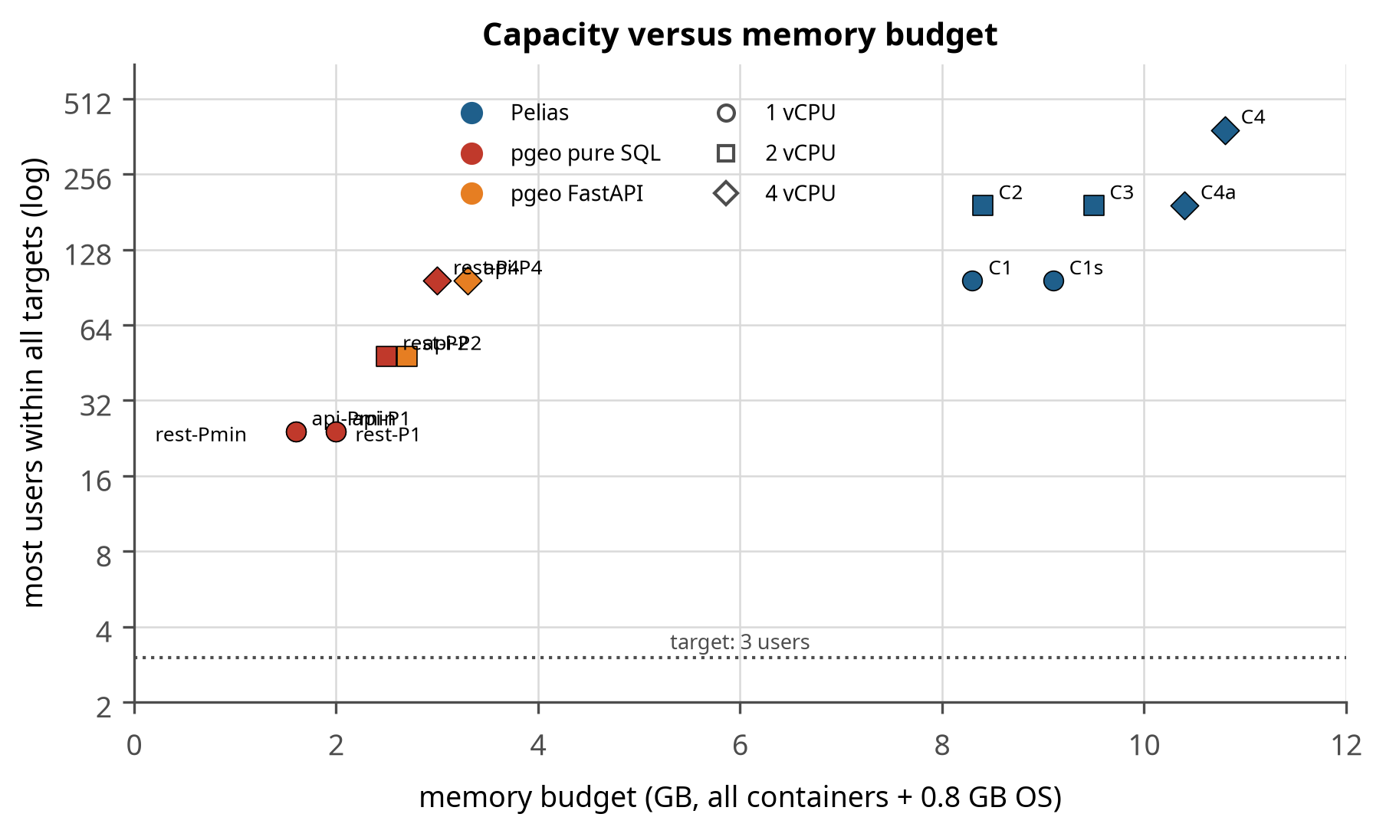
Figure 1. Capacity against memory budget for every tested configuration of both engines. Each point is one configuration; the vertical axis is the most concurrent users for which every endpoint stayed within its latency target (log scale). pgeo configurations sit at the left (1.6-3.3 GB), Pelias at the right (8.3-10.8 GB). The dotted line is the project’s 3-user goal.
Table 1. Key findings.
Question | Answer | Evidence
Which engine is more accurate? | pgeo, by about 20 points overall and 50+ points on typos | Section 3.1
Which is faster under load? | Pelias, four times as many users per CPU | Section 3.4, Table 30
Smallest server for 3 users? | pgeo: 0.25 vCPU, 1.4 GB total. Pelias: see Section 3.12 | Section 3.12
Can PostgreSQL alone be the API? | Yes: PostgREST in front of SQL functions, identical accuracy | Sections 2.1, 3.8
Does more data slow Pelias? | Addresses barely; OSM and Overture places cost one ramp step each | Section 3.6
Drop-in replacement for Pelias clients? | Yes for the documented API (27 of 27 contract cases) | Section 3.8

1. Introduction
Why a geocoder was needed, what was already running, what questions the work set out to answer, and what each platform offers. A reader who only wants the outcome can stop after the executive summary; this section explains why the outcome is worth trusting.

1.1 Motivation
Geocoding (turning a typed address or place name into coordinates) and reverse geocoding (turning a map position into an address) are basic services for any application that deals with places. Commercial geocoding APIs charge per request, send every query to a third party, and change without notice. This project set out to host a feature-rich geocoder for Maine (and later New Hampshire) on the owner’s own infrastructure: a Proxmox server on the home LAN, reachable over HTTPS, with a map-based demonstration page.
Two further needs shaped the work. First, the geocoder is meant to feed LANCER, a dispatch-and-billing application whose client sites carry sensitive, encrypted street addresses; queries that contain such addresses should not leave the owner’s network or linger in logs. Second, a guiding principle (G6) asked for the stack with the fewest additional components, keeping data in PostgreSQL, unless that produces an inferior or overly complex product. That principle motivated building pgeo alongside Pelias and measuring both.

1.2 Starting conditions
Everything below was already in place before the work began. It matters because it bounds the result: the numbers in Section 3 come from this hardware, and a reader on different hardware should expect different absolutes and the same ordering.
Item | State at the start
Infrastructure | Proxmox VE 9.2 node (prox82): AMD Ryzen 5 7600X (Zen 4, 6 cores / 12 threads), 46 GB RAM, guests configured cpu=host with ballooning off; Debian 13 cloud-init template; a TLS-terminating Caddy on the “wharf” VM with public DNS-01 certificates; Forgejo for source control
Target host | VM 120 (pelias.wharf.fluidgrid.org), 4 vCPU and 10 GB RAM, NVMe storage, LAN only
Build and test host | Workstation: AMD Ryzen 5 3600 6-Core Processor, 12 threads, 31 GB RAM. Two CPU generations behind the Proxmox host (Zen 2 against Zen 4), so a VM core on the host is the faster core: the controlled results in Section 3 are, if anything, conservative for the production VM
Reference recipe | The Pelias docker project for Texas, adapted for Maine
Data | Open data only. No OpenAddresses API token is needed: the statewide Maine file is downloaded without one
Where things run | Builds and all controlled tests run on the workstation; the service runs on VM 120 on the Proxmox host (192.168.1.173) and is reached through the wharf Caddy
Goals | G1 accurate Maine geocoding; G2 LAN-only, HTTPS; G3 reproducible build; G4 demo page; G5 minimum resources for 3 users; G6 fewest components

1.3 Questions
- How accurate is each engine on Maine data, including misspelled, variant and impossible queries?
- What are the minimum server resources for 3 concurrent users, and where does each engine break when users are added?
- How does adding data layers change performance?
- Can PostgreSQL itself be the API endpoint (G6) without an inferior product?
- Can pgeo replace Pelias for existing clients, and what does it add?

1.4 What the two platforms do
Before comparing anything it is worth being concrete about what each platform offers, because several of the differences that matter later – structured addresses, typo tolerance, the number of moving parts – are visible here rather than in any measurement.
Table 2. Features of each platform as deployed here.
Capability | Pelias | pgeo
Endpoints | search, structured, autocomplete, reverse, place (+ nearby, beta) | the same five, plus /v1/address
Informational endpoints | /v1/attribution (data licences) and a /v1/ API description page, both HTML | /v1/attribution, built in SQL and served as HTML by both front ends; no /v1/ description page
Filters | layers, sources, focus, rectangle, circle, country, gid, categories | the same
Parsing | libpostal (statistical, ~2 GB model) | rule parser in SQL (best measured); libpostal optional
Typo tolerance | limited (term fuzziness) | trigram similarity on whole names and streets
Town handling | exact admin names (placeholder) | town as a location: villages and nearest towns accepted
Interpolation | separate service (TIGER + OA) | SQL, between neighbouring house numbers
Confidence | per result | per result, lowered for ties between distinct places
Structured US addresses | no | USPS Publication 28 components, delivery and last lines, FIPS codes
Nearest street address for a venue | no | yes (/v1/address)
HTTP layer | Node.js API | PostgREST (no code) or FastAPI
Data store | Elasticsearch index | PostgreSQL tables
Components | 6 containers | 2-3 containers
Build | importers, ~15 min | one command, ~13 min
Operations tooling | Pelias CLI | tuning profiles, accuracy gate, rebuild script
Security posture here | read-only query services, pinned images, strict CSP; Elasticsearch has no credentials (loopback only) | read-only database role (SELECT only), allowlisted tuning, password-authenticated database, no query parameters in the PostgreSQL log
Two rows carry most of the argument in this report. Components is why pgeo fits on a machine Pelias cannot use, and typo tolerance is why it answers questions Pelias does not. Everything in Section 3 is an attempt to put numbers on those two lines.

1.5 Other geocoders that live in PostgreSQL
pgeo is not the first attempt to put geocoding inside the database, and the question of whether it was worth building depends on what already exists. A survey of the field in September 2026 found three projects that keep their query logic in PostgreSQL, and one that keeps half of it there.
Table 3. Geocoders whose query logic runs inside PostgreSQL, surveyed September 2026.
Project | Where the logic lives | Data | Interface | Notes
PostGIS TIGER Geocoder[3] (postgis_tiger_geocoder) | entirely PL/pgSQL, plus address_standardizer (PAGC) for parsing | US Census TIGER only | SQL functions; no HTTP | The canonical answer. Released independently of PostGIS since 2025.1 (June 2026)[4], needs PostgreSQL 16+. Exact-match oriented; its own documentation notes speed problems in the address_standardizer[5] wrapper for batch work
osmgeocoder[6] | “primarily as SQL functions”, with Python for orchestration | OpenStreetMap (imposm3), optionally OpenAddresses | Python library plus an optional Flask service | The closest relative: same extensions as pgeo (PostGIS, pg_trgm, fuzzystrmatch[7]). Multi-country address formatting via OpenCage templates. Without libpostal it degrades to “street names only”
moofish32/postgis-geocoder[8] | none of its own | TIGER | SQL via psql | A Docker packaging of the TIGER geocoder; 12 commits, inactive
Nominatim[9] | indexing and address computation in PL/pgSQL triggers; search in a Python application | OpenStreetMap | HTTP API | Postgres-centric rather than Postgres-only. Version 5 completed the move from PHP to Python. Planet-scale: ~1 TB of disk and 128 GB-class memory; the 2025 roadmap[10] notes search indexes have grown large enough to slow lookups
Table 4. The same feature comparison as Table 2, extended to the other geocoders that keep their logic in PostgreSQL. Compiled from project documentation, September 2026; not independently benchmarked.
Feature | TIGER geocoder | osmgeocoder | Nominatim | pgeo
Forward search | yes | yes | yes | yes
Reverse geocoding | yes | yes | yes | yes
Autocomplete / type-ahead | no | yes (predictive text) | no (not its strength) | yes
Structured search fields | yes | yes | yes | yes
Typo tolerance | no (exact match) | yes (trigram, metaphone) | limited | yes (trigram + abbreviation expansion)
Data sources | US Census TIGER only | OSM, optionally OpenAddresses | OSM | OA, OSM, WOF, GNIS, ZCTA, Overture
HTTP API | none (SQL only) | Flask service | yes | yes
Runs with no application code | n/a (no HTTP) | no | no | yes (PostgREST)
Speaks another geocoder’s API | no | no | its own | yes (Pelias, 28/28)
Structured postal addresses out | partial (normalizer) | formatting templates | no | yes (USPS Publication 28)
Coverage | United States | many countries | planet | one state, tested
External model needed | no | libpostal recommended | no | no (rule parser)
Where pgeo sits. Against the TIGER geocoder, pgeo adds sources beyond TIGER (OpenAddresses, OpenStreetMap, Who’s On First, GNIS, ZCTA, Overture), typo tolerance rather than exact matching, and an HTTP API. Against osmgeocoder – which reaches for the same three extensions, and is the nearest thing to a sibling – pgeo needs no application code at all, answers a documented third-party API contract, and returns USPS Publication 28 addresses; osmgeocoder in exchange covers many countries where pgeo covers one state, and is the older and more general project. Against Nominatim, the difference is architectural: Nominatim computes addresses in the database but searches from a Python application, where pgeo’s search is the database.
The combination this project could not find anywhere: a geocoder whose entire query path is SQL, exposed over HTTP with no application code at all (PostgREST in front of SQL functions), and speaking an existing geocoder’s API so that clients need no changes. That is a narrow claim from a handful of searches rather than an exhaustive review, and the honest reading is that the pieces are all well known – trigram matching, PL/pgSQL, PostgREST – and that assembling them this way is uncommon rather than novel.

1.6 Terms and acronyms
Geocoding borrows vocabulary from several fields, and this report adds names of its own for the configurations it tested. Everything used later is defined here so no term arrives unexplained.
Table 5. Terms and acronyms used in this report.
Term | Meaning
Geocoding | Turning a typed address or place name into coordinates
Reverse geocoding | Turning coordinates into the nearest address or place
Autocomplete | Type-ahead search: results after every keystroke, against a much tighter latency budget
Structured search | A search whose parts arrive in separate fields (address, locality, region, postal code) rather than one string
pgeo | The geocoder built for this project: PostgreSQL and PostGIS, with the query logic in SQL
Pelias | The established open-source geocoder used here as the reference and the test oracle: an API service, Elasticsearch and four helper services
PostGIS | The PostgreSQL extension that adds geographic types, indexes and functions
PostgREST | A gateway that exposes PostgreSQL functions as a REST API, with no application code of its own
FastAPI | A Python web framework; pgeo’s alternative front end, kept as a baseline
libpostal[11] | A statistical address parser (a ~2 GB model) used by Pelias and optionally by pgeo
Elasticsearch | The search engine Pelias stores its index in
k6[12] | The load-testing tool used throughout: it runs scripted virtual users against an HTTP API and reports latency percentiles and error rates (tests/load/k6)
Virtual user (VU) | One simulated person in a load test, issuing requests with pauses between them, as a person would
p95 | The 95th-percentile response time: 95 of 100 requests were at least this fast. Used instead of an average because the slow tail is what a user notices
SLO | Service level objective: the latency and error targets a configuration must meet to count as passing (Table 14)
Ramp | Increasing the number of virtual users step by step until a target is missed, to find a configuration’s capacity
Breaking point | The step at which a configuration exceeds five times a target, produces more than 5% errors, or a service dies
Trigram | A three-character slice of a word[13]. Comparing the sets of trigrams in two strings measures similarity, which is how pgeo tolerates typos (pg_trgm)
WOF | Who’s On First[14], the open gazetteer of administrative places used for towns, counties and neighbourhoods
OA | OpenAddresses[15], the open collection of address points
GNIS | The USGS Geographic Names Information System[16]: lakes, summits, streams and populated places
ZCTA | ZIP Code Tabulation Area[17], the US Census approximation of a ZIP code as an area
gid | A globally unique identifier for a record in a geocoder’s response, for example whosonfirst:locality:85948877
C1, C2, C4, M0 | Names for the Pelias configurations tested: the digit is the vCPU count, M0 is unconstrained (Table 15)
Pmin, P1, P2, P4, PM | The equivalent pgeo configurations: Pmin is the smallest budget tested, PM unconstrained
E1, E2, E4 | pgeo configurations given the same memory budget as the Pelias configuration at that CPU size, for an equal-resources comparison (Section 3.4)

2. Methods
How both systems were built and how they were measured. The detail here is what makes Section 3 checkable: the same data, the same load generator, the same targets and the same host for both engines, with every departure from that noted.

2.1 Systems built
The two architectures, and the reason the comparison is not simply one product against another: one is an established multi-service geocoder, the other was written for this project to test whether the database alone is enough.
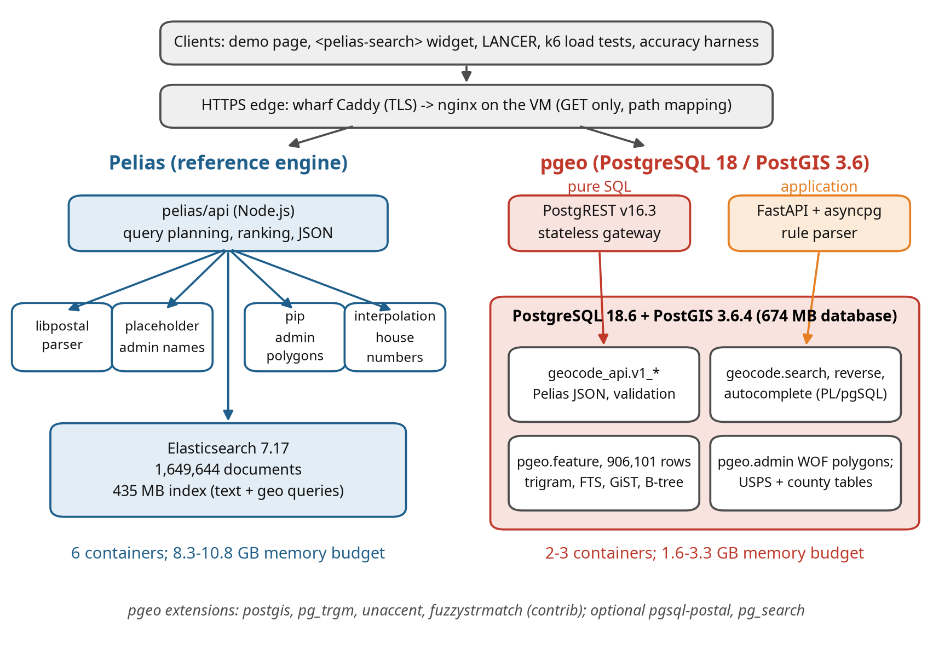
Figure 2. System architecture. Clients reach both engines through the same HTTPS edge. Pelias (left) is an API service coordinating four helper services and Elasticsearch. pgeo (right) keeps data, parsing, ranking and JSON formatting inside PostgreSQL; the HTTP front end is either PostgREST (a stateless gateway, no application code) or a thin FastAPI application.
Figure 2 contrasts the two designs, and the contrast explains most of the results that follow. Pelias divides the work among six processes in three languages, so each part can be scaled or replaced, and Elasticsearch does the text matching in compiled code. pgeo puts everything in one process family: the query, the ranking and the JSON all happen inside the database. That is why pgeo needs a quarter of the memory and fewer moving parts, and why it costs more CPU per request.
Pelias was deployed from pinned images (API, libpostal parser, placeholder, point-in-polygon, interpolation, Elasticsearch 7.17.27) with the index built on the workstation and shipped to VM 120 as an Elasticsearch snapshot. Nginx on the VM serves the demo page and the API under strict security headers; the wharf Caddy terminates TLS.
pgeo runs on PostgreSQL PostgreSQL 18.6 (Debian 18.6-1.pgdg13+2) with PostGIS 3.6.4 and only core and contrib extensions (pg_trgm for trigram similarity, unaccent, fuzzystrmatch). Every query step is a SQL or PL/pgSQL function (Figure 3 shows the forward-search path). The public API is a schema of functions (geocode_api.v1_search, v1_reverse, …) that return Pelias-shaped GeoJSON, so any HTTP layer that can call a function can serve it. Two front ends were built and measured:
- PostgREST (pure SQL): maps GET /rpc/v1_search?text=... to the function; an nginx edge maps Pelias paths (/v1/search) to RPC paths. Chosen over an in-database HTTP server (Omnigres) because it keeps third-party code out of the database process, and over OpenResty because it needs no custom code (docs/HTTP_OPTIONS.md).
- FastAPI (application): the same SQL functions behind a Python service, kept as the baseline to show what an application layer adds or costs.
PostgreSQL core and its contrib extensions contain no HTTP server, so “Postgres as the endpoint” always needs either third-party code inside the database or a small gateway beside it. The options were weighed as follows (docs/HTTP_OPTIONS.md has the full research and sources):
Table 6. HTTP options for serving the SQL API.
Option | For | Against | Decision
PostgREST (external gateway) | no business logic outside SQL; mature; database roles as the security model; crash-isolated from the database; pooling built in | one more process; /rpc/ paths and dotted parameters need an edge mapping | chosen
Omnigres omni_httpd (in the database) | literally “Postgres is the API”; no extra hop; full URL control | third-party C code in the database process; early maturity; upgrades tied to PostgreSQL releases; HTTP workers compete with queries | rejected
OpenResty + pgmoon (nginx + Lua) | nginx already present; full control of paths and parameters | a custom nginx build and Lua code to own | fallback
pg_featureserv, pREST, GraphQL gateways | publish functions quickly | OGC or GraphQL shapes, not the Pelias API | not suitable
FastAPI (application) | flexible; any parser | application code to maintain | kept as baseline
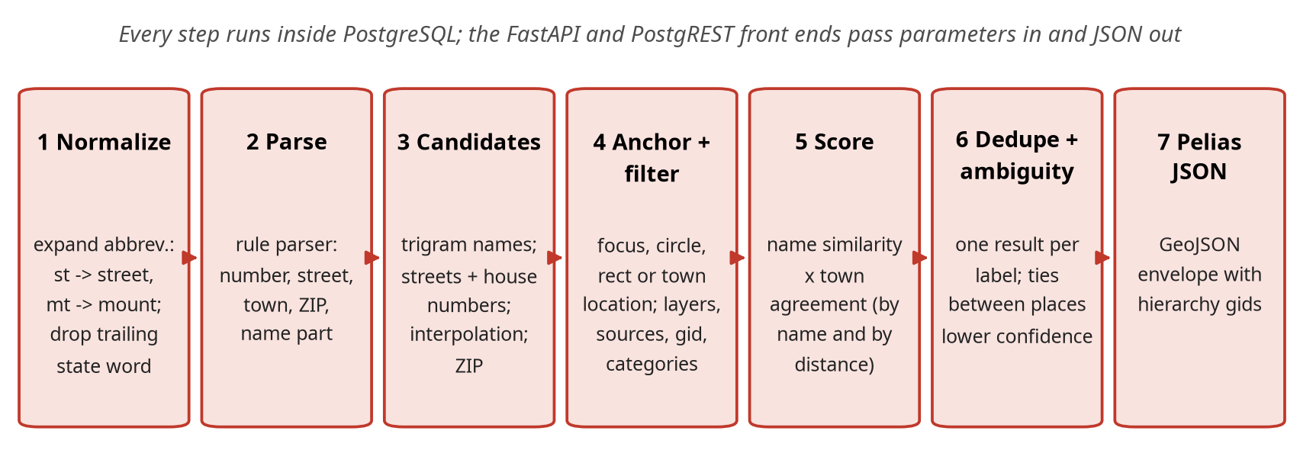
Figure 3. The pgeo forward-search pipeline. Each step is SQL; the tuning work in Section 2.7 changed steps 1, 3, 4, 5 and 6.
Figure 3 matters for anyone who wants to change the ranking: each step is plain SQL in a file under version control, so a change is a pull request and the accuracy gate measures it. In Pelias the equivalent logic is spread across the API service’s query builders and Elasticsearch scoring.

2.2 Data
Both engines are loaded from the same open sources, so any difference in results is a difference in engine rather than in data. This section says what those sources are, how large they are and what was dropped.
Table 7. Data sources, raw input sizes, and what each engine holds from them. Pelias counts are Elasticsearch documents; pgeo counts are rows in its feature table.
Source | Content | Raw input | Pelias documents | pgeo features
OpenAddresses | address points (Maine statewide E911 feed) | 222 MB | 780,260 | 677,229
OpenStreetMap | addresses, streets, venues (Geofabrik extract) | 87 MB | 768,992 | 128,471
Overture Maps | places (businesses, landmarks), 2026-08-19 release | 16 MB | 76,582 | 76,582
USGS GNIS | named features: lakes, summits, streams, populated places | 4 MB | 20,104 | 20,104
Who’s On First | admin polygons: towns, counties, ZIPs, neighbourhoods | 5,254 MB | 3,280 | 3,289
Census ZCTA | ZIP code centroids | 1 MB | 426 | 426
TIGER / OpenAddresses | street ranges for the Pelias interpolation service | 333 MB | (not indexed) | -
Total |  |  | 1,649,644 | 906,101
The two engines load the same inputs but store different numbers of records. The largest difference is addresses: Pelias holds 1,421,745 address documents and pgeo 702,701 (2.02 times as many in Pelias). OpenAddresses (the state’s E911 address points) and OpenStreetMap both carry most Maine addresses; Pelias indexes both copies and removes duplicates when it answers a query, while pgeo removes them once at build time (same house number, street and town; OpenAddresses preferred). The data a user sees is the same; the index Pelias searches is roughly twice as large for addresses.
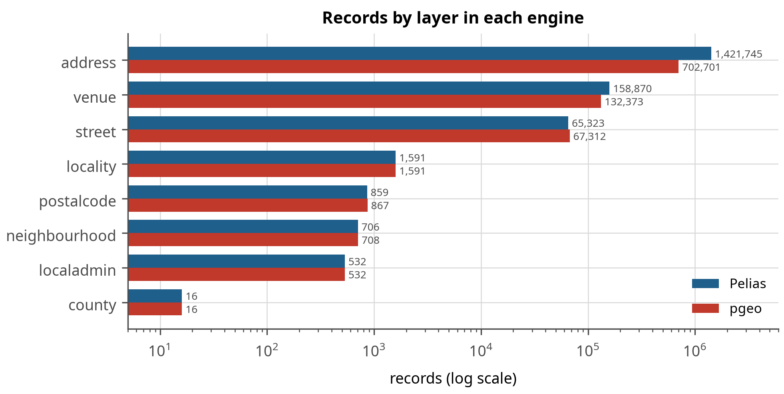
Figure 4. Records by layer in each engine (log scale). The address layer shows the build-time deduplication in pgeo; venues differ because pgeo also deduplicates OSM and Overture places that share a name and position.
Figure 4 shows where the engines hold the same data differently. The address bar is the one to read: Pelias stores 1,421,745 address documents and pgeo 702,701, because the two open sources carry most Maine addresses twice and pgeo merges them at build time while Pelias keeps both and filters at query time. The consequence is visible later in memory and disk (Section 3.5): pgeo searches a smaller store.
Table 8. Records by layer.
Layer | Pelias | pgeo | pgeo / Pelias
address | 1,421,745 | 702,701 | 0.49
venue | 158,870 | 132,373 | 0.83
street | 65,323 | 67,312 | 1.03
locality | 1,591 | 1,591 | 1.00
localadmin | 532 | 532 | 1.00
neighbourhood | 706 | 708 | 1.00
postalcode | 859 | 867 | 1.01
county | 16 | 16 | 1.00
region | 1 | 1 | 1.00
country | 1 | 0 | 0.00

2.2.1 Overture Maps
Every Overture theme was evaluated for Maine (2026-08-19 release), 203 MB of Parquet extracts in total, of which only the 16 MB places file was loaded. Places add value and were loaded (76,582 after quality and boundary rules). Addresses add nothing for Maine: all 772,684 come from the national address database, which is built from the same Maine E911 address points as OpenAddresses; every apparently unique record has an OpenAddresses twin within 5 m that differs only in spelling (“78 East Grand Avenue” vs “78 E Grand Ave”), and 90% of pairs have identical coordinates. They remain a token-free fallback and a source of spelled-out street aliases, and should be re-checked for New Hampshire. Divisions parallel Who’s On First (1,145 localities, 916 polygons) and cannot feed Pelias’s point-in-polygon service; they were not used. Water, land and roads are derived from OpenStreetMap, which is already loaded.
Data problems found and fixed during preparation (all in prep/): GNIS points outside Maine, a pipe-delimited ZCTA gazetteer, an Overture extract that leaked into Portsmouth, New Hampshire, and the Pelias interpolation builder needing OpenAddresses in its legacy CSV form.

2.3 Build pipelines
How raw downloads become a searchable index or database. This matters operationally: the build is the only step that needs a large machine, and it is what a data refresh repeats.
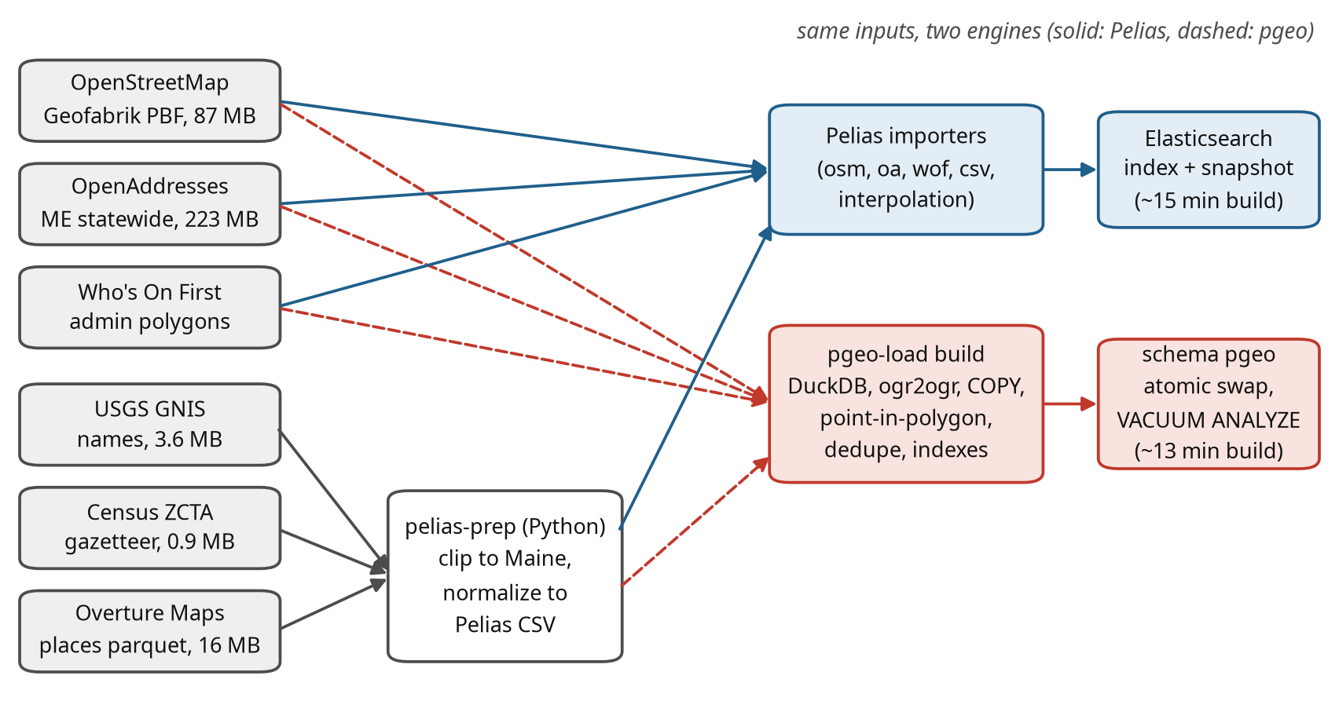
Figure 5. Data flow from the sources to each engine. Both engines read the same inputs; small sources pass through a preparation package that clips them to Maine.
Figure 5 is the reproducibility picture: both engines consume the same downloaded inputs, and everything is scripted, so a rebuild is one command and a data refresh is the same command with newer downloads (docs/REBUILD.md).
The Pelias build (OSM, OpenAddresses, Who’s On First, CSV and interpolation importers) takes about 9 minutes on the workstation once the inputs are downloaded, and produces a 435 MB index plus helper databases. The pgeo build (pgeo-load build) loads the same inputs with DuckDB[18], ogr2ogr[19] and COPY, assigns each point its admin hierarchy by point-in-polygon, deduplicates, indexes, and swaps the new schema in atomically; it took 13 min in the latest run on one core.
Table 9. pgeo build steps and their duration (latest build).
Build step | Seconds
osm | 39
stage | 11
enrich_index | 727
Both builds, the verification suites and the deployment are scripted; docs/REBUILD.md in the repository is the step-by-step runbook and scripts/rebuild_all.sh runs it end to end (Appendix A).
A build is the one time either platform needs a large machine, and it is a machine you can rent for an hour and give back: the query host never sees the raw data or the build tools, only a 435 MB Elasticsearch snapshot or a PostgreSQL dump. Table 28 in Section 3.5 gives the measured cost of each, which is what decides whether a build can share the workstation with other work or wants a machine to itself.

2.4 Accuracy testing
The accuracy test set was built from the source data, independently of both engines: the correct answer for each case is the source record’s position (for addresses, also the house number). A case counts as correct when the first result lies within the case’s radius (for example 50 m for an address, 8 km for a town); a “miss” case (a place that does not exist in Maine) counts as correct when the engine returns nothing, or nothing with confidence of at least 0.8.
Table 10. Composition of the accuracy test set by endpoint, category and query quality.
Endpoint | Category | Exact | Typo | Variant | Miss | Total
autocomplete | Towns | 75 |  |  |  | 75
autocomplete | Venues | 75 |  |  |  | 75
reverse | Reverse | 200 |  |  |  | 200
search | Addresses | 220 | 87 | 93 |  | 400
search | Lakes, summits | 83 | 35 | 32 |  | 150
search | Misses |  |  |  | 150 | 150
search | Towns | 92 | 34 | 24 |  | 150
search | Venues | 108 | 42 |  |  | 150
search | ZIP codes | 60 |  |  |  | 60
structured | Addresses | 150 |  |  |  | 150
Non-unique names (there are dozens of “Mud Pond”s in Maine) were qualified with the nearest town, because a bare “Mud Pond” has no single right answer. A separate fuzz set of 1,800 cases corrupts 300 exact queries at six levels:
Table 11. Fuzz levels. House numbers are never corrupted, so every query stays answerable.
Level | Corruption
F0 | none (baseline)
F1 | one character error (swap, drop, double, keyboard neighbour)
F2 | two character errors in different words
F3 | three errors, abbreviation flips (St <-> Street), commas dropped, lowercase
F4 | F3 plus a component dropped (town, suffix or state) and word-order changes
F5 | heavy: about 25% of letters corrupted, phonetic spellings (ph -> f, ck -> k)

2.5 Load and capacity testing
How capacity was measured, and the choices that make the two engines comparable: one engine at a time, pinned to its own cores, with the same corpus, targets and ramp.
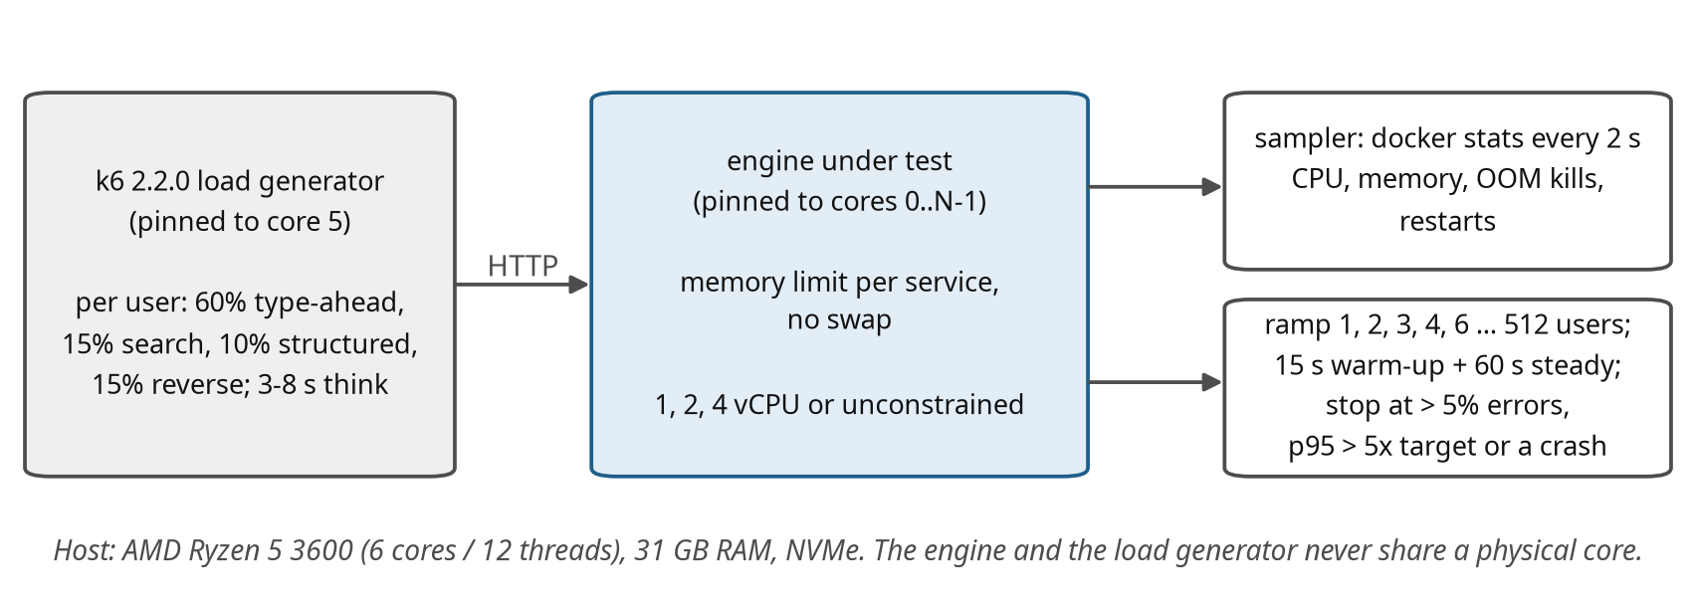
Figure 6. Load-test harness. The load generator and the engine under test are pinned to different physical cores; each engine service runs with a memory limit and no swap.
Figure 6 shows why the comparison is fair: one engine at a time, pinned to its own physical cores, with the load generator on a separate core, the same corpus and the same stopping rules. Readers reproducing this on other hardware should expect different absolute numbers but the same ordering.
Each simulated user behaves like a person using the demo page: 60% of sessions type an address or place letter by letter (autocomplete requests), 15% run a full search, 10% a structured search and 15% click the map (reverse), each followed by 3 to 8 seconds of think time. Text queries are 65% exact, 12% with typos, 13% off-name variants and 10% impossible places; 10% of map clicks fall offshore.
Table 12. Load-test query corpus (drawn at random per request).
Corpus pool | Items | Used for
addresses | 3,000 | type-ahead and search, exact form
places | 800 | towns, lakes, summits
venues | 1,000 | businesses and landmarks
zips | 200 | ZIP code searches
structured | 1,000 | structured search field sets
typos | 1,200 | one or two character errors
variants | 1,200 | off-name variants (abbreviations, missing town)
misses | 600 | places that do not exist in Maine
oa_points / random_points | 1,000 / 1,000 | reverse geocoding on land
miss_points | 300 | reverse geocoding offshore (misses)
foci | 120 | focus points (map centers) for type-ahead
Table 13. Example requests from the load session.
Endpoint | Example request (as sent by the load generator)
Autocomplete | /v1/autocomplete?text=389 cong&size=8&focus.point.lat=43.66&focus.point.lon=-70.26
Search | /v1/search?text=389 Congress St, Portland, ME&size=8&focus.point.lat=...
Search (typo) | /v1/search?text=Moosehed Lake&size=8
Structured | /v1/search/structured?address=389 Congress St&locality=Portland&region=ME&postalcode=04101&size=8
Reverse | /v1/reverse?point.lat=43.6568&point.lon=-70.2626&size=6
Table 14. Latency targets (95th percentile) used as the pass criterion.
Endpoint | p95 target | Why
Autocomplete | 250 ms | type-ahead must keep up with typing
Search | 750 ms | a full search after pressing Enter
Structured search | 750 ms | form-based search
Reverse | 400 ms | map click; feels immediate
All | errors < 1% | no restarts or out-of-memory kills during a run
For every configuration the harness recreates the services with their CPU and memory limits, warms them up, runs a 3-user validation (3 minutes), then ramps through 1, 2, 3, 4, 6, 8, 12, 16, 24, 32, 48, 64, 96, 128, 192, 256, 384 and 512 users (15 s warm-up plus 60 s measured at each step). A step passes when every endpoint’s p95 is within target and errors stay below 1%; the run stops when errors exceed 5%, any p95 exceeds five times its target, or a service dies.

2.5.1 Caching
No response caching is configured anywhere (nginx, Caddy, the Pelias API and pgeo all answer every request afresh). The caches that do exist are warmed on purpose and are the same for both engines: containers are recreated for every configuration (clearing the Elasticsearch query cache and PostgreSQL’s shared buffers), a fixed warm-up runs before measuring, and warm-up requests are excluded from the results. The operating system’s page cache survives container recreation. All numbers therefore describe a server in continuous use, not a cold start. The query corpus is large (Table 12) and drawn at random, so exact repeats are rare.

2.5.2 Scope
Every test in this section was run on both engines with the same session, corpus, targets and ramp; pgeo additionally with both of its front ends.
Table 15. Tested configurations. pgeo configurations were run with each front end (rest = pure SQL through PostgREST, api = FastAPI); budgets include 0.8 GB for the operating system.
Engine | Config | vCPU | Memory budget | Notes
Pelias | M0 | all | unlimited | reference, 1 API worker
Pelias | C1 / C1s | 1 | 8.3 / 9.1 GB | floor and standard memory profiles
Pelias | C2 / C3 | 2 | 8.4 / 9.5 GB | floor / standard
Pelias | C4 / C4a | 4 | 10.8 / 10.4 GB | 4 API workers / 1 API worker
pgeo | Pmin | 1 | 1.6 GB | database 0.6 GB: smaller than the data
pgeo | P1 | 1 | 2.0 GB | database 1.0 GB
pgeo | P2 | 2 | 2.5-2.7 GB | database 1.5 GB
pgeo | P4 | 4 | 3.0-3.3 GB | database 2.0 GB
pgeo | PM | all | unlimited | reference

2.6 Compatibility testing
A contract test (tests/compat/compat_test.py) sends 28 documented Pelias requests to Pelias and to both pgeo front ends and checks each response for status code, envelope shape, property names, filter behaviour (results inside the requested circle, rectangle or area; no results for another country) and Pelias-shaped errors. Pelias is the reference: a check that Pelias itself fails is reported but not counted against pgeo.

2.7 Tuning procedure
pgeo was tuned in rounds. Each round started from the failing test cases (what came back, what was expected, which query step lost the right answer), changed one thing, and re-ran the full accuracy set, the fuzz set and a per-category comparison that listed every flipped case. A change was kept only if overall accuracy did not drop and no category lost more than noise.

2.7.1 Parallelism
PostgreSQL uses several cores in two ways. Between queries, every connection is its own backend process, so concurrent users spread across all available cores; pgeo’s connection pools are sized to about two per core, and capacity grew in proportion to the cores given (Section 3.4), which shows the cores are used. Within a single query, PostgreSQL can split large scans across parallel workers; this is switched off (max_parallel_workers_per_gather = 0) for serving, because pgeo’s queries take 5-100 ms and read small, indexed row sets, where starting workers costs more than it saves and would take cores away from other users. It was not measured (experiment T2 in docs/PGEO_TUNING.md). The build, which scans whole tables, does use four parallel workers.
The final state is protected by:
- tuning profiles (pgeo-tune): measured PostgreSQL and front-end settings per machine size, applied and verified against the running server;
- an accuracy gate (tests/accuracy/gate.py) that fails a build if accuracy, any category, calibration or any fuzz level regresses beyond small tolerances. Replayed against results from before the town-aware ranking step it reports five regressions, so it does catch the kind of tuning this project could otherwise lose silently;
- a rebuild pipeline (scripts/pgeo_rebuild.sh): build, profile, known-answer checks, gate.

3. Results
What the measurements show, in the order a reader is likely to care: accuracy first, then how each engine behaves under load, how small a machine it needs, and how the two compare feature for feature.

3.1 Accuracy
How often each engine returns the right answer, on a test set whose answers come from the source data rather than from either engine. Accuracy is the axis where the two differ most, and the one a user notices first.
Table 16. Accuracy on 1,560 cases. Correct = right answer at rank 1 (misses: nothing, or low confidence); Hit@5 = right answer in the top five; confidence columns are the mean confidence of the first result when right and when wrong.
Engine | Correct | Hit@1 | Hit@5 | Exact | Typo | Variant | Miss | Conf. right / wrong | p50 ms
Pelias | 75.5% | 77.0% | 83.5% | 88% | 30% | 85% | 41% | 0.98 / 0.87 | 13
pgeo pure SQL | 95.8% | 94.4% | 98.2% | 98% | 87% | 95% | 95% | 0.92 / 0.69 | 39
pgeo FastAPI (rule parser) | 95.8% | 94.4% | 98.2% | 98% | 87% | 95% | 95% | 0.92 / 0.69 | 46
pgeo FastAPI (libpostal service) | 94.0% | 92.4% | 96.9% | 95% | 87% | 93% | 94% | 0.92 / 0.60 | 45
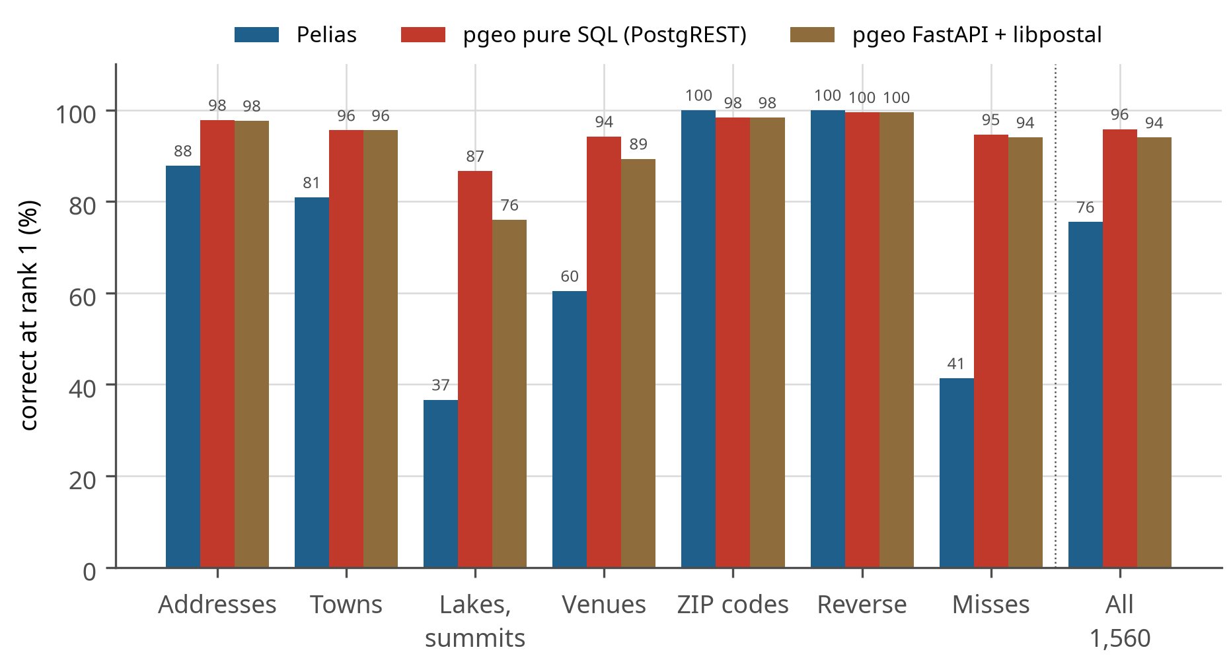
Figure 7. Correct answers by category. pgeo leads in every category except ZIP codes and reverse geocoding, where both engines are near perfect.
Table 17. Accuracy by category (all query qualities).
Category | Cases | Pelias | pgeo pure SQL | pgeo FastAPI (rule parser) | pgeo FastAPI (libpostal service)
Addresses | 550 | 88% | 98% | 98% | 98%
Towns | 225 | 81% | 96% | 96% | 96%
Lakes, summits | 150 | 37% | 87% | 87% | 76%
Venues | 225 | 60% | 94% | 94% | 89%
ZIP codes | 60 | 100% | 98% | 98% | 98%
Reverse | 200 | 100% | 100% | 100% | 100%
Misses | 150 | 41% | 95% | 95% | 94%
The categories where pgeo gains most are the ones where the query and the data use different words for the same place. Pelias ranks text with Elasticsearch’s term matching over analysed tokens; a misspelled token matches nothing, and its admin lookup (placeholder) needs exact town names. pgeo compares whole strings by trigram similarity and treats the queried town as a location rather than a name to match exactly: “Calvary Bible Church, Stratton” is found although the church lies in Eustis, because it is near Stratton. That single change raised venue accuracy from 81% to 94%.
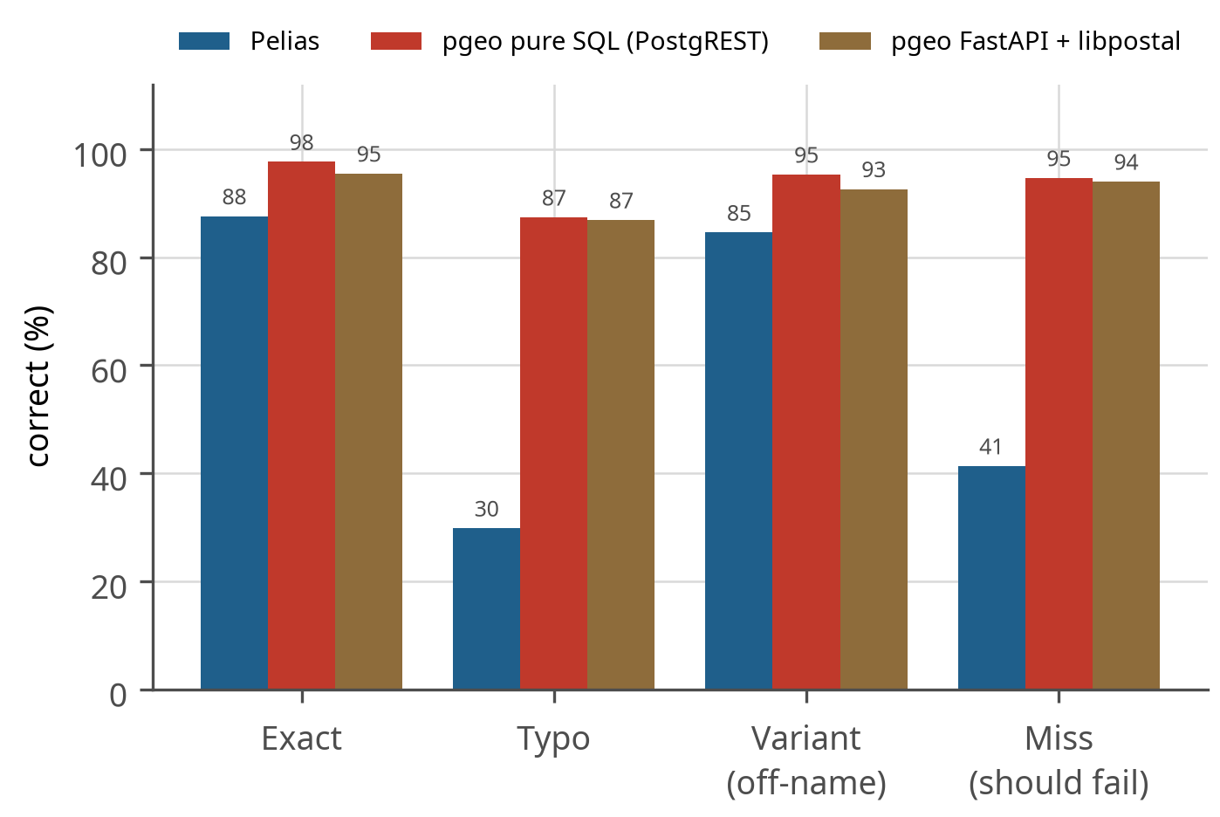
Figure 8. Accuracy by query quality. Typos separate the engines most; “miss” means the engine correctly returned nothing or only low-confidence results for a place that does not exist.
Figure 8 separates the engines by input quality. On clean input both are strong (88% and 98%); the gap opens on the input people actually type. Typos are the extreme case: 30% against 87%.
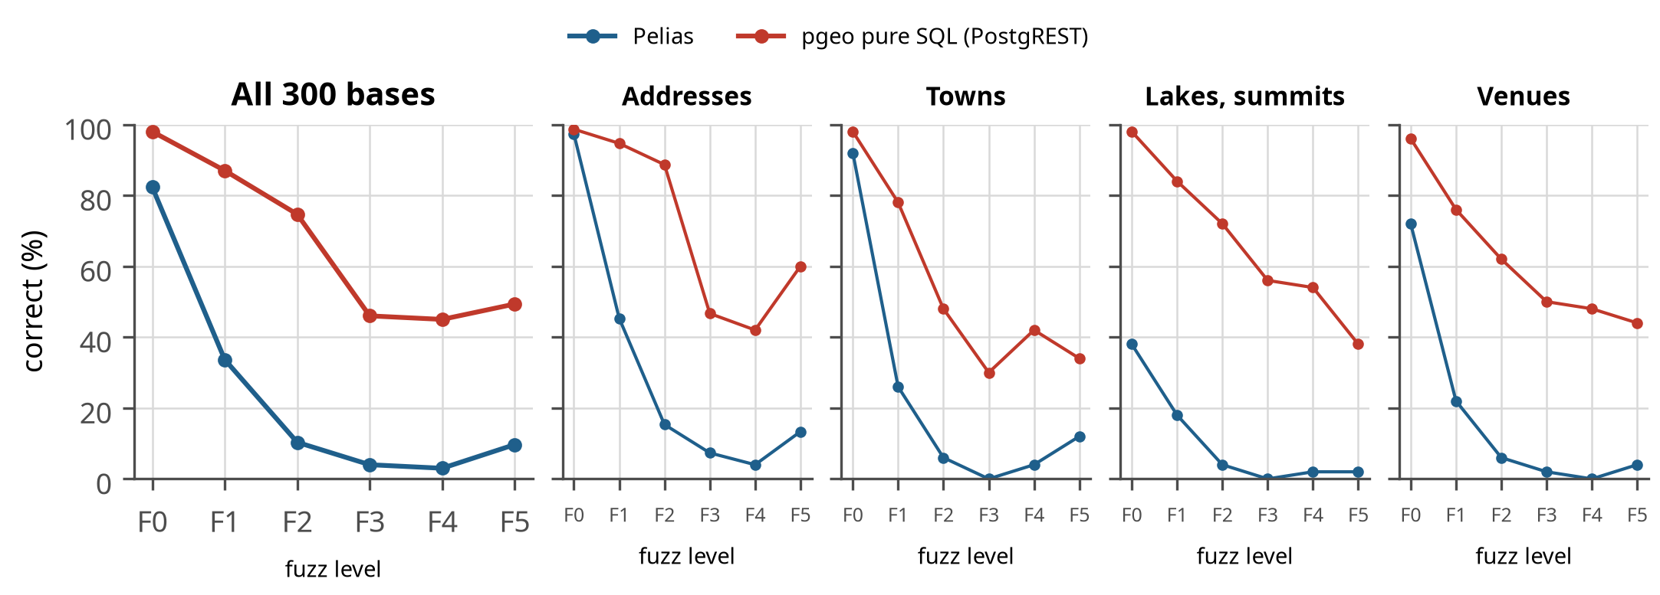
Figure 9. Accuracy as queries are progressively corrupted (fuzz levels F0-F5), overall and by category. Pelias falls to near zero from two character errors; pgeo degrades gradually.
Table 18. Fuzz results (correct, %).
Engine | F0 | F1 | F2 | F3 | F4 | F5
Pelias | 82% | 34% | 10% | 4% | 3% | 10%
pgeo pure SQL | 98% | 87% | 75% | 46% | 45% | 49%

3.1.1 Calibration
A confidence score is useful only if wrong answers get lower scores than right ones. pgeo’s first-result confidence averages 0.92 when right and 0.69 when wrong; Pelias scores 0.98 and 0.87, so a client can use pgeo’s confidence to decide when to ask the user.
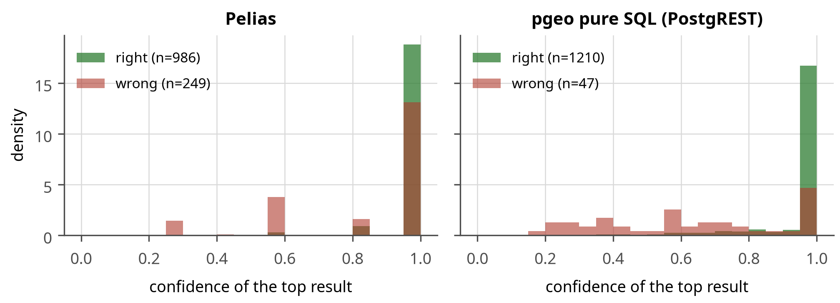
Figure 10. Distribution of first-result confidence for right and wrong answers (misses excluded). pgeo separates the two groups more clearly.
Figure 10 is about trust rather than accuracy: it shows how well each engine’s confidence separates its right answers from its wrong ones. Pelias reports high confidence for both (0.98 and 0.87), so a client cannot use the number to decide anything. pgeo’s wrong answers cluster low (0.69 on average against 0.92 when right), so an application such as LANCER can accept matches above a threshold and queue the rest for a human.

3.1.2 Remaining failures
65 of 1,560 cases still fail on pgeo (Table 19). Eight “misses” are test-set errors (Death Valley in Minot and “The Eiffel Tower of Paris, Maine” exist); about ten are genuinely ambiguous (chain branches, two towns with the same name); short autocomplete prefixes without a focus point (“Nor”, “Tim Ho”) cannot be resolved by any engine; the hardest remaining class is typos in both the place name and the town.
Table 19. Remaining pgeo failures by category.
Category (query quality) | Failures
Lakes, summits (typo) | 14
Venues (exact) | 11
Misses (miss) | 8
Addresses (typo) | 5
Towns (exact) | 5
Addresses (variant) | 4
Towns (typo) | 4
Lakes, summits (exact) | 4
Addresses (exact) | 3
Lakes, summits (variant) | 2
Venues (typo) | 2
Reverse (exact) | 1
Towns (variant) | 1
ZIP codes (exact) | 1

3.2 Tuning trajectory
How pgeo got from its first working version to its current accuracy, one measured change at a time. This is included because it shows which ideas paid off and which did not, and because it is the part of the result most at risk of being fitted to the test set.
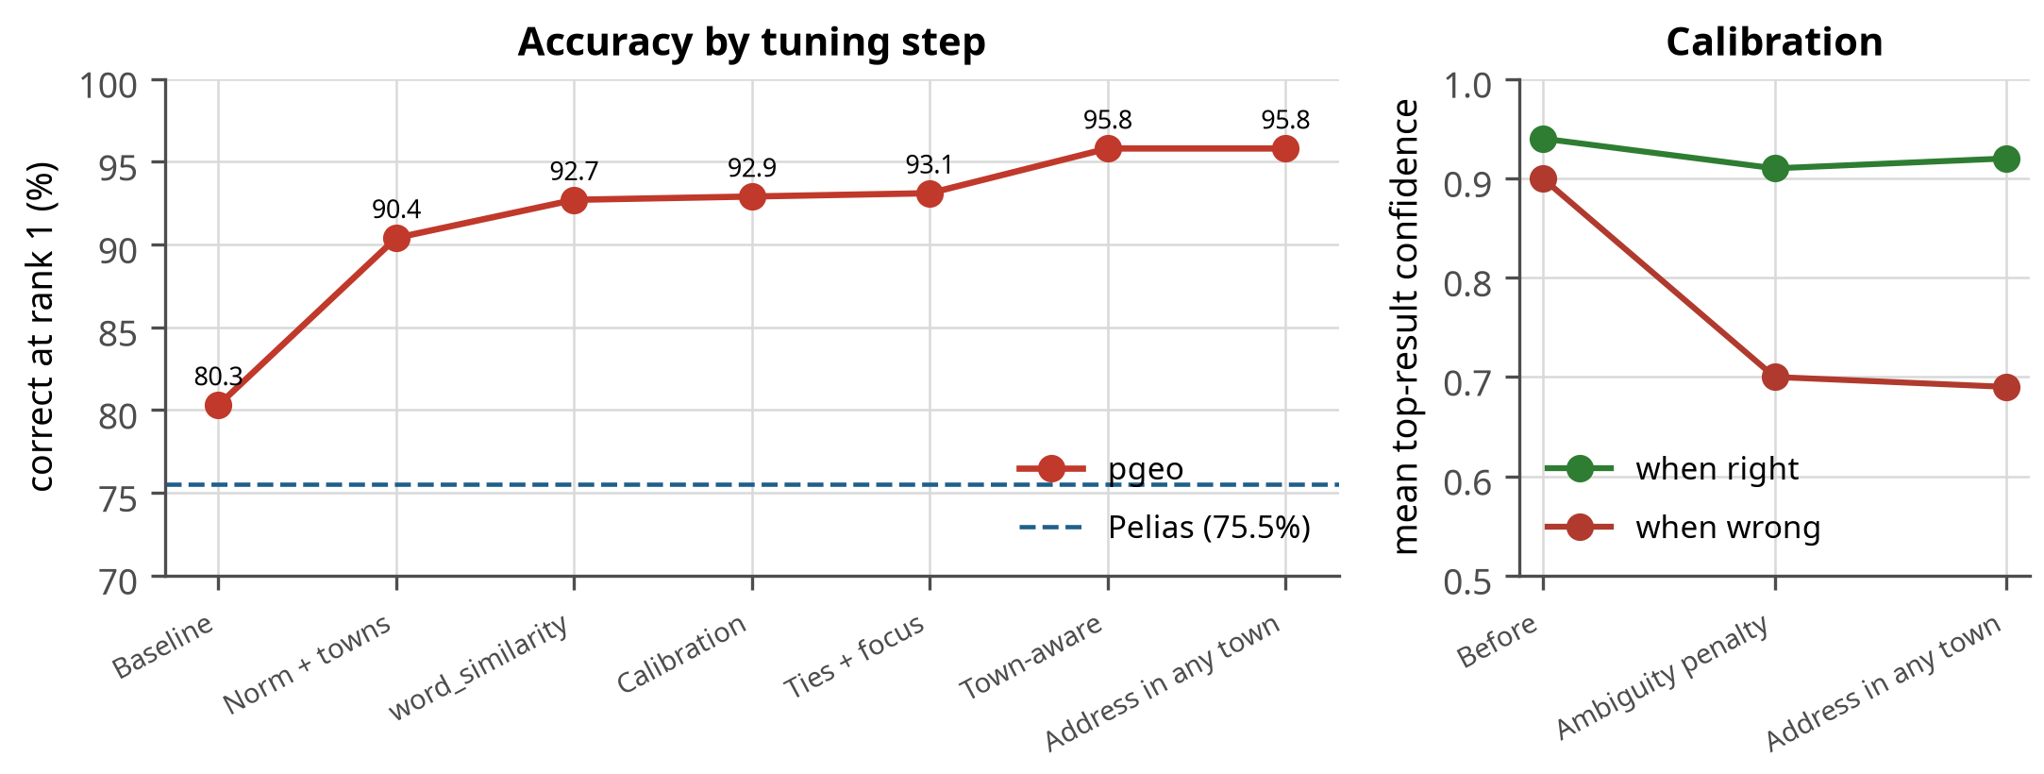
Figure 11. Left: pgeo accuracy after each tuning step, with Pelias for reference. Right: first-result confidence when right and when wrong; the ambiguity penalty widened the gap.
Figure 11 is the tuning history: nine rounds took pgeo from 80.3% to 95.8%. Two things stand out. Most of the gain came from understanding how people write place names (abbreviations, the town as a location, ties), not from more powerful matching. And the calibration panel shows the ambiguity penalty pulling wrong-answer confidence down from 0.90 to 0.69 while right answers barely moved (0.94 to 0.92), which is what makes the confidence score usable.
Two failures behind these steps are worth naming, because they are the kind a test set catches and a demonstration does not. “Portlnd, ME” returned venues literally named “Portland, ME” rather than the city, which is why similarity is measured in the direction (query, name). And in autocomplete “st” expanded to “saint” as readily as to “street”, so a half-typed street query returned saints’ places until the expansion became context-dependent. One caveat belongs with the trajectory: the word_similarity round also corrected the test set (non-unique names such as “Mud Pond” were qualified with their town, for both engines), so the step before it and the step after it are not measured on an identical set.
Table 20. Tuning changes, the problem each solved, and the measured effect.
Step | Change | Problem solved | Effect
Normalization | Abbreviations expanded (rd -> road, st -> street or saint) | typos in spelled-out words failed (similarity 0.25 vs 0.81) | part of 80.3% -> 90.4%
Towns | towns matched on WOF and postal city; ZIP only a fallback | structured search 0% at rank 1 (ZIP outranked the address) | structured 0% -> 100%
Dedupe | OA/OSM addresses merged; results one per label | duplicated towns and addresses | clean lists
word_similarity | direction (query, name) | “Mountain” matched every query containing the word | lakes/summits 59% -> 77%
Calibration | confidence divided among tied distinct places | wrong answers were mostly ties (70 of 85) | confidence wrong 0.90 -> 0.70
Ties + focus | candidates ordered by distance to the focus before the row limits | hundreds of “Main Street”s cut to 40 before the focus applied | “main st” near Bangor returns Bangor
Town-aware | the queried town is a location (distance-based agreement) | village or nearest town given instead of the containing one | venues 81% -> 94%; 93.1% -> 95.8%
Address in any town | house number looked up on the best street names statewide | 25 of 150 “Church Street” towns kept arbitrarily | confidence wrong 0.73 -> 0.69
Reverse index | index on the admin join | every reverse request scanned all features | see Section 3.4

3.3 Latency at the 3-user target
This section answers the question the project was commissioned to answer – is either engine fast enough for three people? – and the answer turns out not to separate them, which is why every later section is about load, memory and accuracy instead.
The configurations named in this section and the next are:
- C1, C2, C4 – Pelias on one, two and four vCPU; C1s, C3, C4a are variants of those with a different memory profile or worker count; M0 is Pelias unconstrained.
- Pmin, P1, P2, P4 – pgeo on one, one, two and four vCPU with budgets from 1.6 to 3.3 GB; PM is pgeo unconstrained.
- E1, E2, E4 – pgeo given the same memory as Pelias at each CPU size, for the equal-resources comparison in Section 3.4.
- Each pgeo configuration is prefixed by its front end: rest- is the pure-SQL path through PostgREST, api- is FastAPI with the rule parser, and api-svc- is FastAPI with the libpostal service. So api-P4 is FastAPI on four vCPU.
Full details of every configuration are in Table 15.
Table 21. Median and p95 latency at 3 users (ms).
Config | Autocomplete p50 / p95 ms | Search p50 / p95 ms | Structured p50 / p95 ms | Reverse p50 / p95 ms
C1 | 15 / 37 | 26 / 50 | 28 / 40 | 24 / 40
C2 | 9 / 22 | 20 / 36 | 19 / 27 | 19 / 26
C3 | 8 / 19 | 14 / 27 | 13 / 20 | 10 / 39
C4 | 8 / 23 | 21 / 30 | 17 / 22 | 22 / 25
M0 | 8 / 23 | 20 / 27 | 20 / 25 | 20 / 25
rest-Pmin | 19 / 52 | 42 / 114 | 81 / 120 | 13 / 18
rest-P1 | 19 / 59 | 44 / 111 | 60 / 100 | 5 / 12
rest-P2 | 15 / 44 | 30 / 97 | 88 / 105 | 4 / 5
rest-P4 | 15 / 43 | 43 / 101 | 91 / 98 | 4 / 6
rest-PM | 17 / 46 | 28 / 100 | 42 / 85 | 5 / 6
api-Pmin | 17 / 62 | 62 / 112 | 73 / 117 | 13 / 15
api-P1 | 18 / 59 | 39 / 109 | 103 / 127 | 11 / 14
api-P2 | 15 / 54 | 34 / 95 | 91 / 106 | 5 / 14
api-P4 | 18 / 49 | 41 / 108 | 108 / 116 | 4 / 15
api-PM | 17 / 57 | 50 / 99 | 92 / 104 | 4 / 15
api-svc-P2 | 14 / 47 | 41 / 101 | 48 / 93 | 4 / 16
api-svc-P4 | 17 / 51 | 45 / 111 | 93 / 101 | 5 / 14
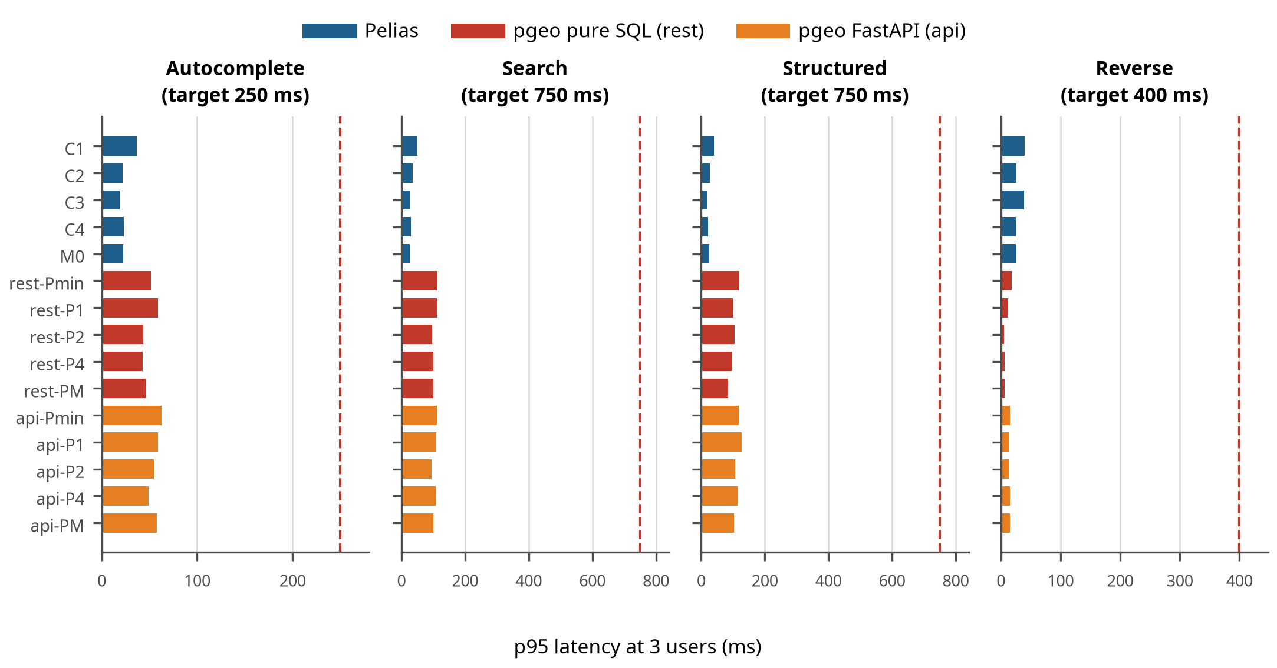
Figure 12. p95 latency per endpoint at 3 users for each configuration, against its target (dashed). Every configuration of both engines meets every target.
Figure 12 answers the question this project started with: at the 3-user target every configuration of both engines, down to the smallest, sits well inside every latency target. Nothing in the 3-user scenario forces a choice between the engines; the differences appear only under heavier load or in accuracy.
At 3 users every configuration of both engines meets every target with a wide margin, so the 3-user goal is not what separates them. Pelias answers in 20-50 ms at the 95th percentile on every endpoint: Elasticsearch resolves text and geography in compiled index lookups. pgeo’s autocomplete takes about 40 ms and its search and structured search about 100 ms, because a forward search runs several candidate queries and a scoring step in PL/pgSQL inside one database backend. Reverse geocoding was pgeo’s slow endpoint (225-393 ms, close to its 400 ms target on one vCPU) until the missing admin-join index was added; it now takes 5-18 ms (Table 24).

3.4 Capacity under load
How many concurrent users each configuration serves before missing a latency target, and what gives out first. This is the axis where Pelias leads, and the section is where the comparison is made at equal resources as well as at equal cost.
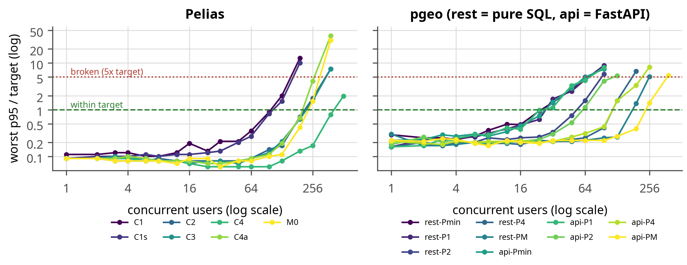
Figure 13. Worst endpoint p95 relative to its target as users are added. Above 1 the configuration misses a target; above 5 the run stops. At 1-4 users some endpoints receive only a few requests per window, so single points are noisy.
Figure 13 shows how each configuration degrades as users are added: flat while there is headroom, then rising steeply once the CPUs saturate. The practical consequence is that these services give little warning: a configuration comfortably inside its targets at 24 users can be three times over them at 48. Capacity planning should therefore leave a factor of two, not ten percent.
Table 22. Pelias capacity by configuration.
Config | vCPU | Budget | Settings | Users within SLO | Broken at | First over target | req/s at limit | Memory at 3 users
C1 | 1 | 8.3 GB | heap 768m, 1 worker(s) | 96 | 192 | autocomplete, search, reverse at 128 | 99 | 5.9 GB
C1s | 1 | 9.1 GB | heap 768m, 1 worker(s) | 96 | 192 | autocomplete, reverse at 128 | 102 | 5.8 GB
C2 | 2 | 8.4 GB | heap 768m, 2 worker(s) | 192 | 384 | autocomplete, reverse at 256 | 209 | 6.1 GB
C3 | 2 | 9.5 GB | heap 1g, 2 worker(s) | 192 | 384 | autocomplete, reverse at 256 | 213 | 6.3 GB
C4 | 4 | 10.8 GB | heap 2g, 4 worker(s) | 384 | not reached | autocomplete, search, structured, reverse at 512 | 403 | 7.5 GB
C4a | 4 | 10.4 GB | heap 2g, 1 worker(s) | 192 | 384 | autocomplete, search, structured, reverse at 256 | 194 | 7.1 GB
M0 | all | - | heap 4g, 1 worker(s) | 192 | 384 | autocomplete, reverse at 256 | 215 | 9.3 GB
Table 23. pgeo capacity by configuration (after the reverse-geocoding index fix).
Config | vCPU | Budget | Settings | Users within SLO | Broken at | First over target | req/s at limit | Memory at 3 users
rest-Pmin | 1 | 1.6 GB | sb 128MB, 4 conn. | 24 | 64 | autocomplete at 32 | 24 | 0.3 GB
rest-P1 | 1 | 2.0 GB | sb 256MB, 4 conn. | 24 | 96 | autocomplete at 32 | 25 | 0.4 GB
rest-P2 | 2 | 2.5 GB | sb 384MB, 6 conn. | 48 | 96 | autocomplete, reverse at 64 | 53 | 0.5 GB
rest-P4 | 4 | 3.0 GB | sb 512MB, 10 conn. | 96 | 192 | autocomplete at 128 | 108 | 0.6 GB
rest-PM | all | - | sb 1GB, 16 conn. | 128 | 256 | autocomplete at 192 | 144 | 0.6 GB
api-Pmin | 1 | 1.6 GB | sb 128MB, 4 conn. | 24 | 96 | autocomplete at 32 | 26 | 0.3 GB
api-P1 | 1 | 2.0 GB | sb 256MB, 4 conn. | 24 | 96 | autocomplete at 32 | 27 | 0.4 GB
api-P2 | 2 | 2.7 GB | sb 384MB, 6 conn. | 48 | 128 | autocomplete at 64 | 52 | 0.7 GB
api-P4 | 4 | 3.3 GB | sb 512MB, 10 conn. | 96 | 256 | autocomplete, reverse at 128 | 103 | 0.8 GB
api-PM | all | - | sb 1GB, 16 conn. | 192 | 384 | autocomplete at 256 | 213 | 0.8 GB
api-svc-P2 | 2 | 4.7 GB | sb 384MB, 6 conn. | 48 | 128 | autocomplete at 64 | 52 | 2.5 GB
api-svc-P4 | 4 | 5.3 GB | sb 512MB, 10 conn. | 96 | 192 | autocomplete at 128 | 106 | 2.8 GB
Table 24. Effect of the reverse-geocoding index on pgeo capacity and reverse latency.
Config | Users within SLO, before | after | Reverse p95 at 3 users (ms), before | after
rest-Pmin | 4 | 24 | 393 | 18
rest-P1 | 4 | 24 | 348 | 12
rest-P2 | 24 | 48 | 226 | 5
rest-P4 | 64 | 96 | 225 | 6
rest-PM | 128 | 128 | 255 | 6
api-Pmin | 8 | 24 | 325 | 15
api-P1 | 6 | 24 | 340 | 14
api-P2 | 32 | 48 | 291 | 14
api-P4 | 96 | 96 | 224 | 15
api-PM | 192 | 192 | 257 | 15
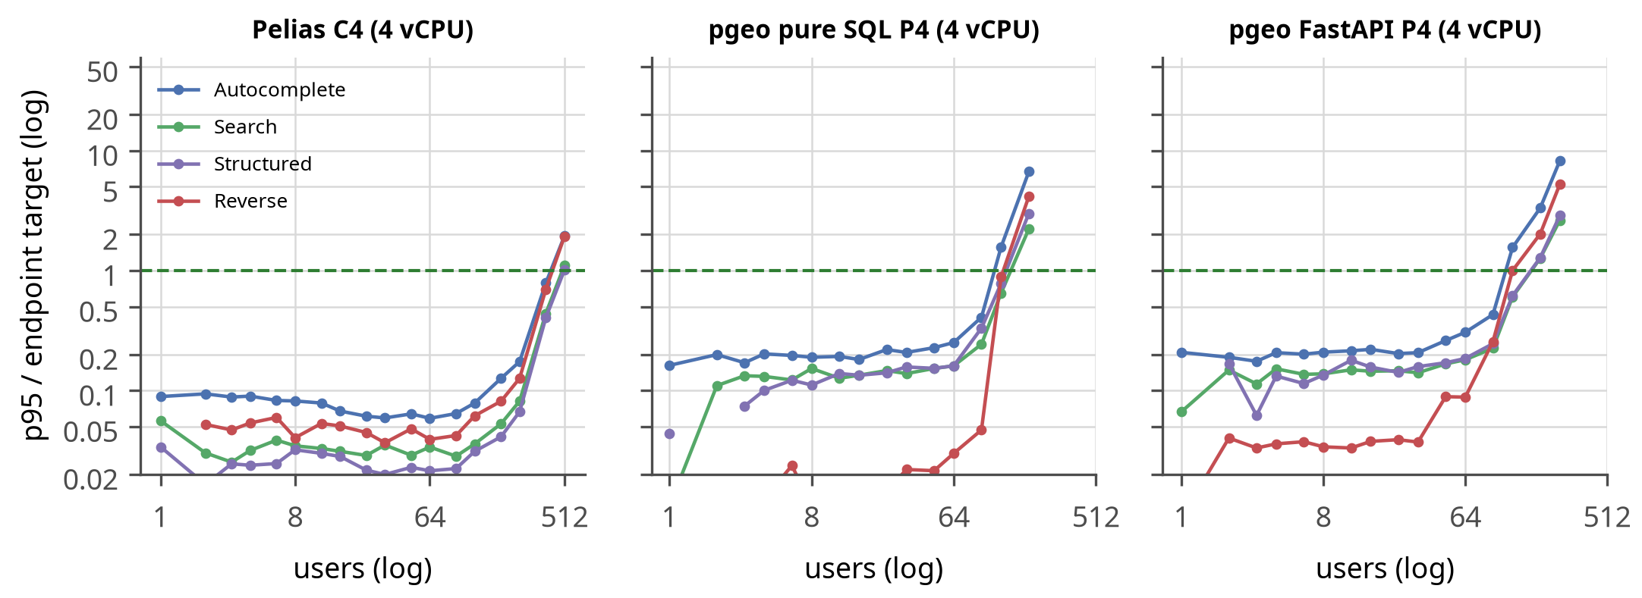
Figure 14. p95 per endpoint relative to its target on 4 vCPU. The first line to cross 1 is the endpoint that limits capacity.
Figure 14 shows which endpoint fails first, which is where tuning effort belongs. On pgeo it is autocomplete, because it has the tightest target (250 ms) and fires several times per typed word; on Pelias the four endpoints rise together because they share one Elasticsearch.
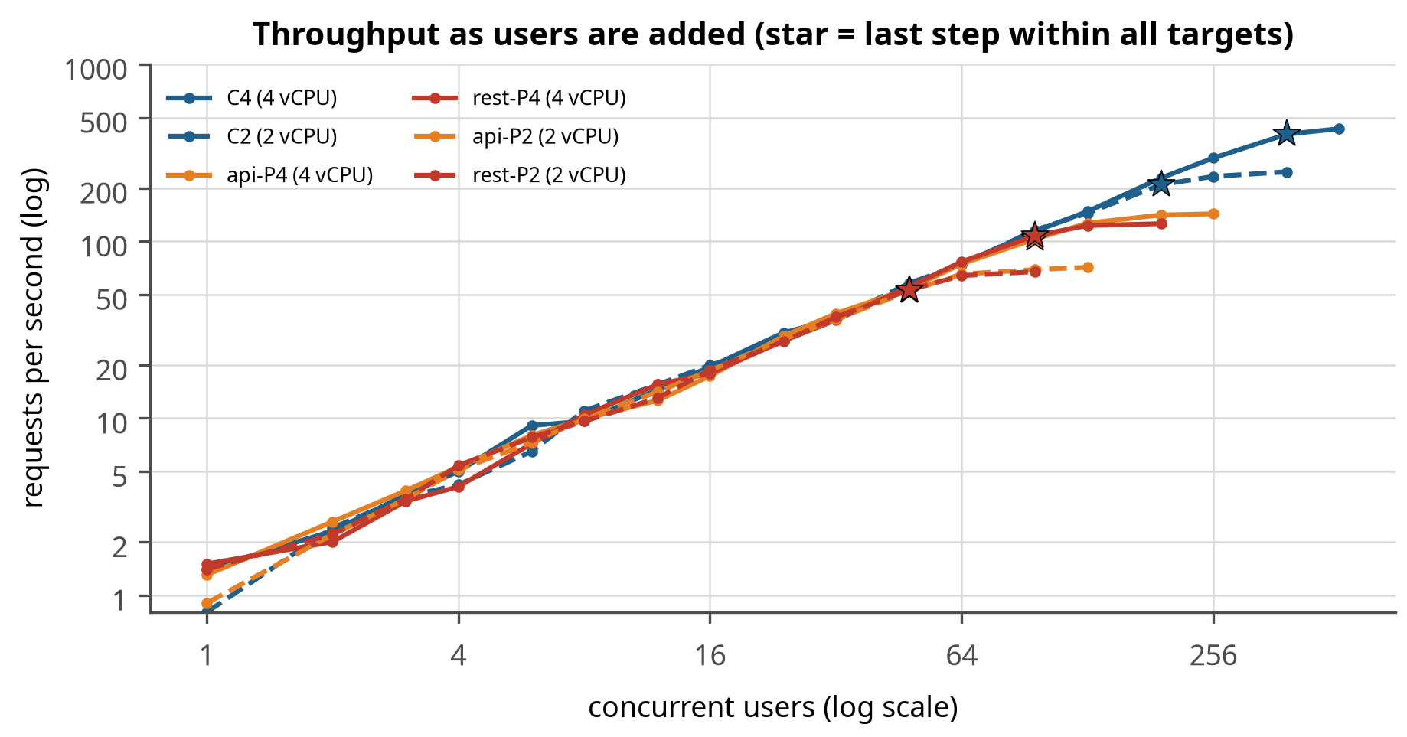
Figure 15. Throughput as users are added; the star marks the last step within all targets.
Figure 15 shows throughput still climbing after the latency targets are missed (the stars): both engines keep answering, just too slowly. An operator watching only requests per second would not notice the service becoming unpleasant, which is why the targets, not throughput, define capacity here.

3.4.1 The same memory for both engines
Every comparison so far gave pgeo a smaller budget than Pelias, because that is what each engine needs. It is a fair way to compare cost and an unfair way to compare engines: a reader is entitled to ask whether Pelias only leads because it was handed five times the memory. So pgeo was re-run at exactly Pelias’s budget – 8.3, 8.4 and 10.8 GB at one, two and four vCPU (configurations E1, E2 and E4).
Table 25. The same benchmark with the memory budgets equalised. pgeo holds the same number of users at Pelias’s budget as at its own, so the throughput difference is not a memory artefact.
CPU | pgeo, its own budget | pgeo, Pelias’s budget | Pelias
1 vCPU | 24 (2.0 GB) | 24 (8.3 GB) | 96 (8.3 GB)
2 vCPU | 48 (2.5 GB) | 48 (8.4 GB) | 192 (8.4 GB)
4 vCPU | 96 (3.0 GB) | 96 (10.8 GB) | 384 (10.8 GB)
pgeo answers exactly the same number of users at 8.3 GB as at 1.6 GB. Not approximately – the same number, at every CPU size. The reason is in Figure 16: the whole database is 847 MB, so at 1.6 GB it already had room for the entire working set, and the extra 6.7 GB has nothing to cache that was not cached before.
This cuts both ways, and the second direction matters more for an operator. Pelias cannot give its memory back – its floor is 7.17 GB because five services load fixed data before serving anything (Section 3.12) – whereas pgeo cannot use the memory if you give it. So the fair statement is not “pgeo is cheaper” or “Pelias is faster” but this: at equal memory Pelias serves four times the users; at equal throughput pgeo needs a fifth of the memory; and neither engine can trade one for the other.

3.4.2 How each engine scales
Both engines are CPU-bound under this load, and both scale close to linearly with vCPUs as long as their workers can use them: pgeo holds about 24 users per vCPU (24, 48 and 96 users on 1, 2 and 4 vCPU) and Pelias about 96 (96, 192 and 384). The ratio of four is the difference in CPU cost per request: compiled index lookups in Elasticsearch against interpreted candidate queries and scoring in PL/pgSQL.

3.4.3 What gives out first
After the index fix, autocomplete is the first endpoint over its target on every pgeo configuration (Figure 14): it has the tightest target (250 ms) and runs most often (60% of sessions type ahead, several requests per word). On Pelias the endpoints degrade more evenly (which one crosses first varies by configuration), because they share Elasticsearch.

3.4.4 Memory is not pgeo’s limit
The configuration whose database memory (0.6 GB) is smaller than the data holds as many users as the one with 1.0 GB (24 and 24): the working set of hot index pages is far smaller than the 847 MB of tables and indexes. Pelias, in contrast, has a memory floor set by its services (libpostal’s model, the interpolation database, placeholder’s in-memory tables) regardless of load.

3.4.5 Front end
PostgREST and FastAPI hold the same number of users up to 4 vCPU. Unconstrained, FastAPI reached 192 users and PostgREST 128: only at high concurrency does the gateway’s per-request overhead show.
Pelias spreads work across services in different languages: Elasticsearch does the text and geo matching in compiled code, and the Node.js API adds parsing and ranking. With four API workers on 4 vCPU (C4) it reaches 384 users; with one worker on the same CPUs (C4a) only 192, because a single Node.js worker becomes the bottleneck.

3.5 Resources
What each platform needs to run and to build. The two are very different numbers, and conflating them is the most common way to size a geocoder wrongly.
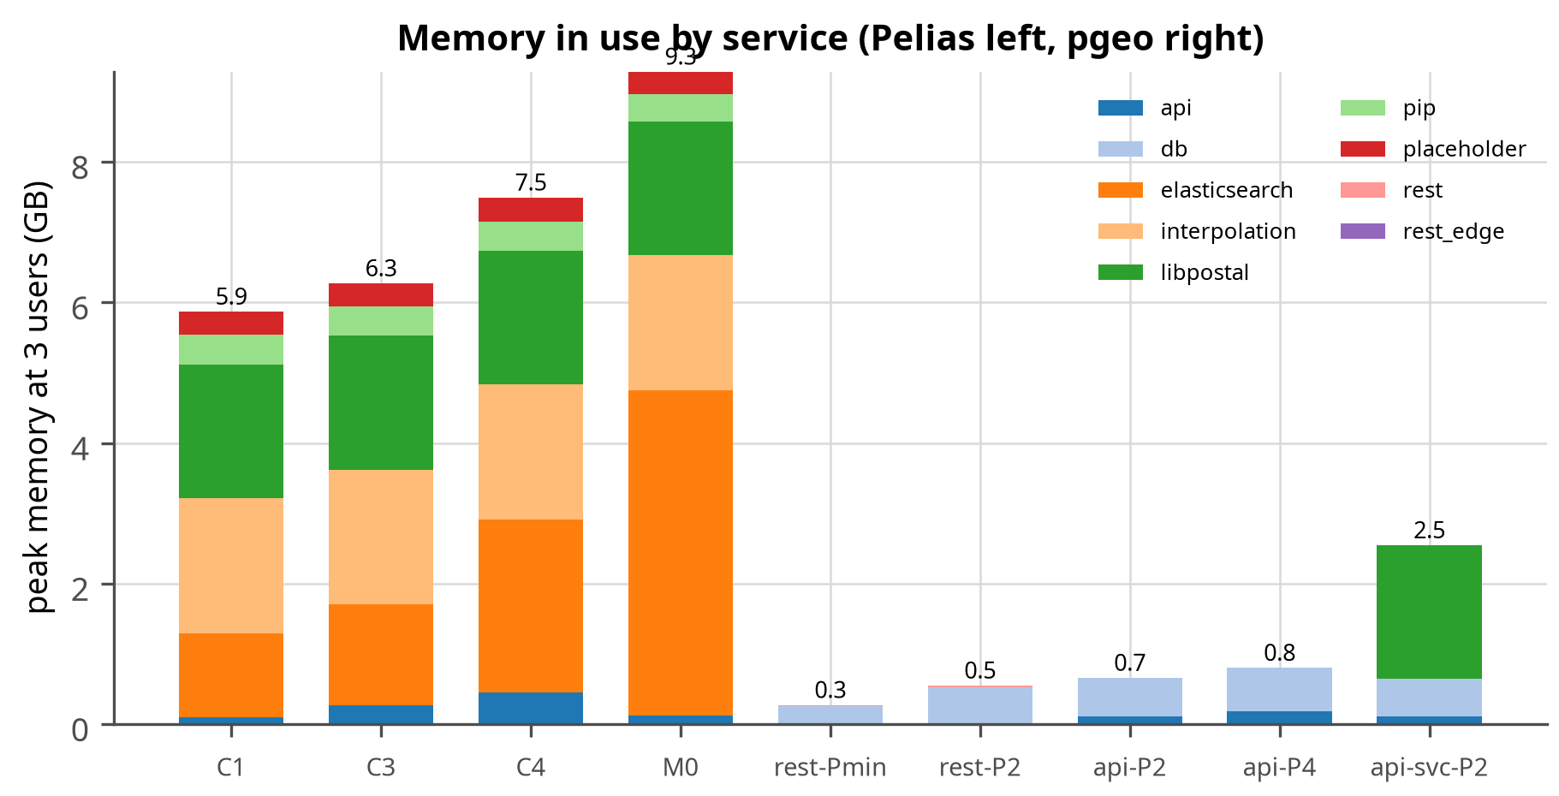
Figure 16. Peak memory in use by service at 3 users. Pelias carries the libpostal model (~2 GB), the interpolation database and Elasticsearch’s heap regardless of load; pgeo’s memory is mostly the PostgreSQL page cache for a 847 MB database.
Figure 16 explains the memory gap in one picture. Pelias pays for the libpostal model, the interpolation database and an Elasticsearch heap before it serves a single request; pgeo’s memory is mostly page cache for a 847 MB database, which is why it still works when the budget is cut to a fraction. This is the difference between a $5 and a $48 server (Section 3.5).
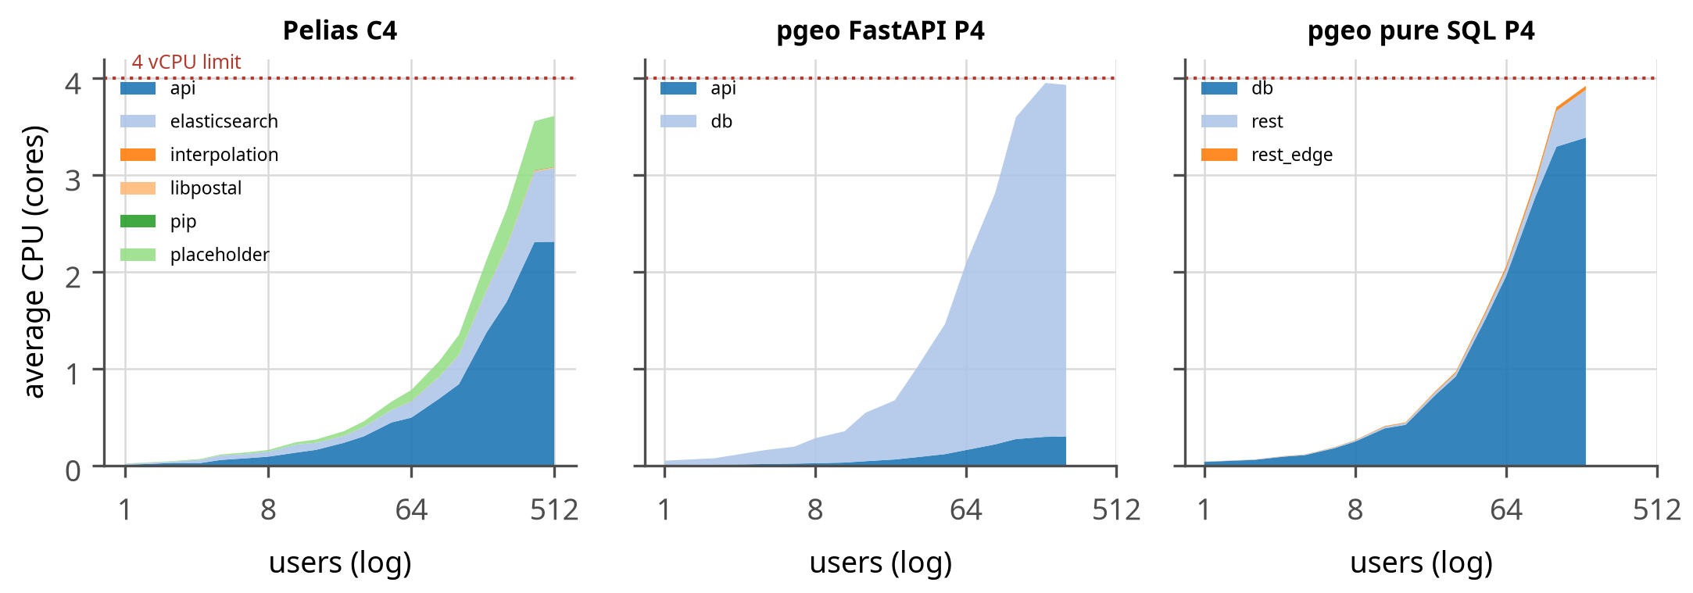
Figure 17. Average CPU by service as users are added on 4 vCPU.
Figure 17 shows where the CPU goes. In pgeo almost all of it is the database process doing the matching; in Pelias it is split between Elasticsearch and the Node.js API, and the API becomes the bottleneck when it runs with too few workers (configuration C4a reached only 192 users against 384 for C4 with the same CPUs). Anyone deploying Pelias should set one API worker per vCPU.

Resource requirements

3.5.1 Operation
Table 26 turns the capacity results into a sizing guide: for a target number of concurrent users, the smallest tested configuration of each engine that kept every endpoint within its latency target. Budgets include 0.8 GB for the operating system. One “user” is a person actively using the search page (a request every 3 to 8 seconds); a service with many occasional users needs far fewer concurrent slots than it has users.
Table 26. Sizing guide: smallest tested configuration that meets all latency targets for a given number of concurrent users. Only configurations with a memory budget are considered; “not reached in tests” means not reached within the tested budgets (the unconstrained reference runs M0 and PM appear in the capacity tables).
Concurrent users | Pelias | pgeo pure SQL | pgeo FastAPI
3 | 1 vCPU, 8.3 GB (C1) | 1 vCPU, 1.6 GB (rest-Pmin) | 1 vCPU, 1.6 GB (api-Pmin)
10 | 1 vCPU, 8.3 GB (C1) | 1 vCPU, 1.6 GB (rest-Pmin) | 1 vCPU, 1.6 GB (api-Pmin)
25 | 1 vCPU, 8.3 GB (C1) | 2 vCPU, 2.5 GB (rest-P2) | 2 vCPU, 2.7 GB (api-P2)
50 | 1 vCPU, 8.3 GB (C1) | 4 vCPU, 3.0 GB (rest-P4) | 4 vCPU, 3.3 GB (api-P4)
100 | 2 vCPU, 8.4 GB (C2) | not reached in tests | not reached in tests
200 | 4 vCPU, 10.8 GB (C4) | not reached in tests | not reached in tests
400 | not reached in tests | not reached in tests | not reached in tests
Table 27. Operating requirements of each platform (Maine data).
Resource | Pelias | pgeo
Containers | 6 (Elasticsearch, API, libpostal, placeholder, pip, interpolation) | 2 (PostgreSQL, PostgREST) or 2 (PostgreSQL, FastAPI)
Memory in the standard profile | 8.3 GB: libpostal model ~2 GB, interpolation ~2 GB, Elasticsearch heap 0.8-2 GB. Section 3.12 shrinks each service to find the real floor | 1.6 GB (database 0.6 GB); floor in Section 3.12
Memory that grows with load | placeholder, OOM-killed at 0.4-0.5 GB once load arrives (at 16 users on one vCPU, 12 on two, 128 on the four-vCPU configurations); 0.8 GB needed. pip is OOM-killed at 0.4 GB and the interpolation service crash-loops below 1.9 GB | PostgreSQL backends (a few MB each), page cache
Disk (Maine) | ~1.4 GB Elasticsearch data plus ~0.9 GB helper databases; 435 MB snapshot to ship | 654 MB of tables and indexes; data directory ~2.6 GB, the difference being write-ahead log (max_wal_size 4 GB) and space still held by tables the build replaced; dump to ship. Size the disk for three to four times the database
CPU scaling | add API workers with CPUs (1 worker on 4 vCPU halves capacity) | add connections with CPUs; front end workers for FastAPI
Scaling out | Elasticsearch replicas and more API instances | read replicas behind PostgREST
Updating data | rebuild index on a workstation, ship snapshot, restore | rebuild database on a workstation, ship dump, restore

3.5.2 Build
Both engines are built on a workstation and shipped to the query host, so the query host never needs the raw data or the build tools. Table 28 gives the measured cost of a full build of each engine.
Table 28. Build resources: a full build of each engine, measured with tests/build/measure_build.py (wall time, peak memory of all build containers and processes, average and peak CPU, disk used by the result).
Engine | Wall time | Peak memory | CPU cores (avg / peak) | Disk after build | Measured
Pelias | 9 min | 11.5 GB | 2.9 / 8.1 | 8.0 GB | 2026-09-19
pgeo | 13 min | 5.5 GB | 1.2 / 4.5 | 2.5 GB | 2026-09-19
The two builds fail the “which is cheaper” question in opposite directions, which is worth noting because it cuts against the rest of this report. Pelias builds faster – 9 minutes against 13 – because its importers run as separate processes across several cores, where pgeo’s loader is one Python process feeding one database. pgeo is the cheaper build in every other respect: half the peak memory (5.5 GB against 11.5), 1.2 cores on average against 2.9, and 2.5 GB of result on disk against 8.0. An operator with a spare machine and no patience should prefer Pelias’s build; an operator renting one by the hour should prefer pgeo’s.

What this costs on a shared-CPU VPS
The floors in Section 3.12 are small enough to matter commercially: the difference between the two platforms is the difference between the cheapest tier a provider sells and a mid-range server. Advertised shared-CPU plans (checked 2026-09-19; verify before ordering, and note that Hetzner raised cloud prices in June 2026):
Table 29. Advertised shared-CPU VPS plans and whether each platform’s measured floor fits. Sources: Linode/Akamai, DigitalOcean, Vultr, Hetzner, AWS Lightsail, Oracle free tier.
Provider and plan | vCPU (shared) | RAM | Disk | Price per month | Fits pgeo | Fits Pelias
DigitalOcean Basic 512 MB | 1 | 0.5 GB | 10 GB | $4 | no | no
Vultr Cloud Compute 512 MB (IPv4) | 1 | 0.5 GB | 10 GB | $3.50 | no | no
AWS Lightsail nano (IPv6 only) | 2 | 0.5 GB | 20 GB | $3.50 | no | no
Linode (Akamai) Nanode 1 GB | 1 | 1 GB | 25 GB | $5 | tight: see Section 3.12 | no
Vultr Cloud Compute 1 GB | 1 | 1 GB | 25 GB | $5 | tight: see Section 3.12 | no
DigitalOcean Basic 1 GB | 1 | 1 GB | 25 GB | $6 | tight: see Section 3.12 | no
DigitalOcean Basic 2 GB / Linode 2 GB | 1 | 2 GB | 50 GB | $12 | yes | no
Hetzner CX22 | 2 | 4 GB | 40 GB | EUR 3.79 | yes, with room | no
Hetzner CAX11 (Arm) | 2 | 4 GB | 40 GB | EUR 5.99 | yes, with room (Arm images needed) | no
Linode 8 GB / DigitalOcean 8 GB | 4 | 8 GB | 160 GB | $48 | yes | tight: see Section 3.12
Oracle Cloud Always Free (Arm) | 2 OCPU | 12 GB | 200 GB | free tier (halved in June 2026) | yes | yes
Measured against these plans: pgeo’s 1.40 GB floor is 0.60 GB of containers plus the 0.8 GB this study reserves for the operating system, so a 1 GB plan works only with a minimal OS and nothing else resident, while a 2 GB plan leaves real headroom; Pelias’s 7.17 GB floor needs the 8 GB tier, four to ten times the monthly price for the same three users: the 1 GB plan is confirmed below, so the gap is the full ten times.
The 1 GB row was confirmed on a real machine rather than inferred: a temporary 1 vCPU / 1 GB VM ran the three-user load with the worst endpoint at 21% of its target and held 32 concurrent users (Section 3.12). It needs one caveat, though. pgeo-tune auto --cpus 1 --mem-gb 1 refuses to produce a configuration: its sizing rule reserves 0.8 GB for the operating system and 0.35 GB for the HTTP front end, which leaves the database less than nothing. The settings for that VM were written by hand. A 1 GB plan therefore works, and is the cheapest way to run this geocoder, but it is a configuration this project has measured rather than one its tooling will size for you.

3.5.3 Data volume
For Pelias, capacity fell from 384 users with admin areas only to 192 with every source (Section 3.6); the index grew to 435 MB. pgeo’s database grows with the same sources to 654 MB, and its capacity falls from 192 users to 48 across the same subsets (Section 3.6.1) – a four-fold loss where Pelias loses two. Doubling the data (for example adding New Hampshire) roughly doubles both stores, but not the cost per query: what both engines pay for is the number of names a text query can plausibly match, and pgeo pays about twice as much per name as Pelias does.

3.6 Data volume
Whether the results survive more data. A one-state geocoder that collapses at two states would be a curiosity rather than a tool, so capacity was re-measured against progressively larger datasets.
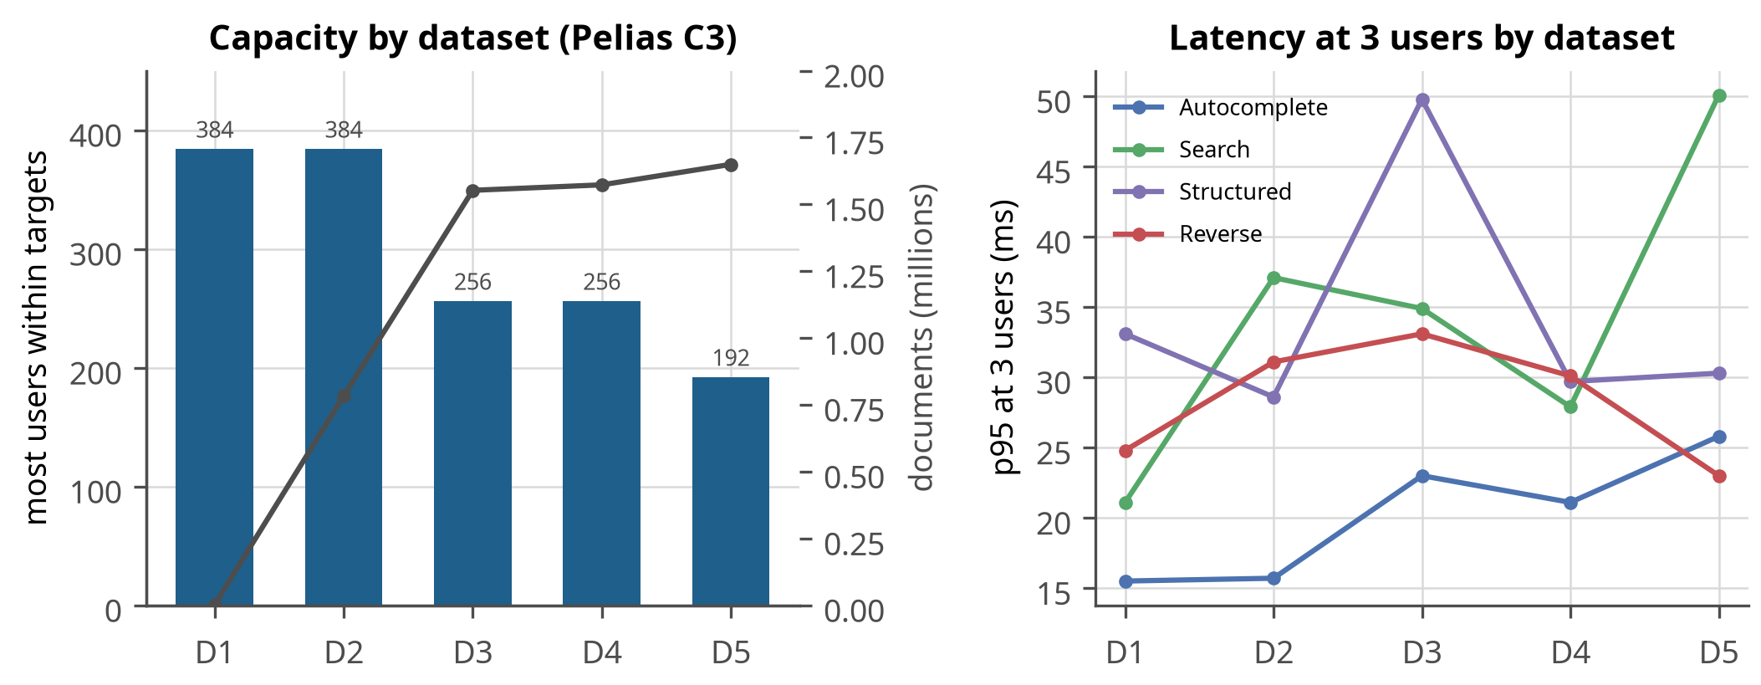
Figure 18. Pelias capacity (bars) and document count (line) for cumulative datasets D1-D5 at fixed resources (2 vCPU, 9.5 GB), and p95 latency at 3 users.
Figure 18 separates data volume from data kind. Adding 780,000 address documents cost nothing measurable, while adding OpenStreetMap and Overture places each cost a ramp step: what matters is not how many records exist but how many of them a text query can plausibly match. Adding New Hampshire should therefore be judged by how many new names it brings, not by gigabytes.
Table 30. Pelias by dataset: D1 Who’s On First; D2 + OpenAddresses; D3 + OpenStreetMap; D4 + GNIS and ZCTA; D5 + Overture places (full).
Dataset | Documents | Index | Users within SLO | Broken at | Autocomplete p95 | Search p95 | Structured p95 | Reverse p95
D1 | 3,280 | 3 MB | 384 | not reached | 16 | 21 | 33 | 25
D2 | 783,540 | 196 MB | 384 | not reached | 16 | 37 | 29 | 31
D3 | 1,552,532 | 371 MB | 256 | 512 | 23 | 35 | 50 | 33
D4 | 1,573,062 | 378 MB | 256 | 512 | 21 | 28 | 30 | 30
D5 | 1,649,644 | 435 MB | 192 | 384 | 26 | 50 | 30 | 23

3.6.1 The same curve for pgeo
Pelias’s curve alone cannot answer the question a reader actually has, which is whether pgeo’s advantage survives more data. So pgeo was rebuilt from each of the same subsets – the definitions are imported from the Pelias harness rather than restated, so the two curves are comparable by construction – and ramped at a fixed 2 vCPU configuration.
Table 31. pgeo capacity against data volume, beside Pelias at the same CPU size for the same subsets. pgeo loses four times its capacity across the range where Pelias loses two.
Dataset | Sources | pgeo features | pgeo users | Pelias users | Pelias / pgeo
D1 | whosonfirst | 3,289 | 192 | 384 | 2.0x
D2 | whosonfirst, openaddresses | 680,518 | 128 | 384 | 3.0x
D3 | whosonfirst, openaddresses, openstreetmap | 808,989 | 64 | 256 | 4.0x
D4 | whosonfirst, openaddresses, openstreetmap, gnis, zcta | 829,519 | 64 | 256 | 4.0x
D5 | whosonfirst, openaddresses, openstreetmap, gnis, zcta, overture | 906,101 | 48 | 192 | 4.0x
Three things follow, and the first is not comfortable for pgeo.
pgeo is about twice as sensitive to data volume as Pelias. Across the full range its capacity falls four-fold, from 192 users to 48, where Pelias falls two-fold, from 384 to 192. That is the expected consequence of the architecture: trigram similarity has to score a candidate set that grows with the number of names in the database, while Elasticsearch answers from an index whose lookup cost barely moves. Anyone extrapolating this study to a much larger region should assume pgeo pays more for the extra data than Pelias does.
But the ratio between them stops widening. It climbs from 4 to four as OpenStreetMap arrives and then holds at four for D3, D4 and D5. The gap is not growing without bound as data is added; it settles, which is a materially different prospect from a trend that keeps getting worse.
Neither engine cares about records it cannot match. D4 adds GNIS and ZCTA – about 20,500 records – and costs pgeo nothing at all, exactly as those sources cost Pelias nothing. What both engines pay for is matchable names: OpenStreetMap’s streets and venues halve pgeo’s capacity and cost Pelias a ramp step, while three quarters of a million address points do comparatively little. A second state should therefore be judged by the names it brings, not by its gigabytes – the same conclusion the Pelias curve reached, now confirmed on both engines.
Adding 780,000 OpenAddresses documents (D2) changed nothing measurable: exact address terms are cheap to match. Adding OpenStreetMap (D3) and Overture places (D5) each cost one ramp step, because venue and place names are the documents that broad text queries match: more of them means more candidates to score per query.

3.7 Query types
Whether either engine pays a latency penalty for difficult input. Accuracy on messy queries is worth little if messy queries are also slow.
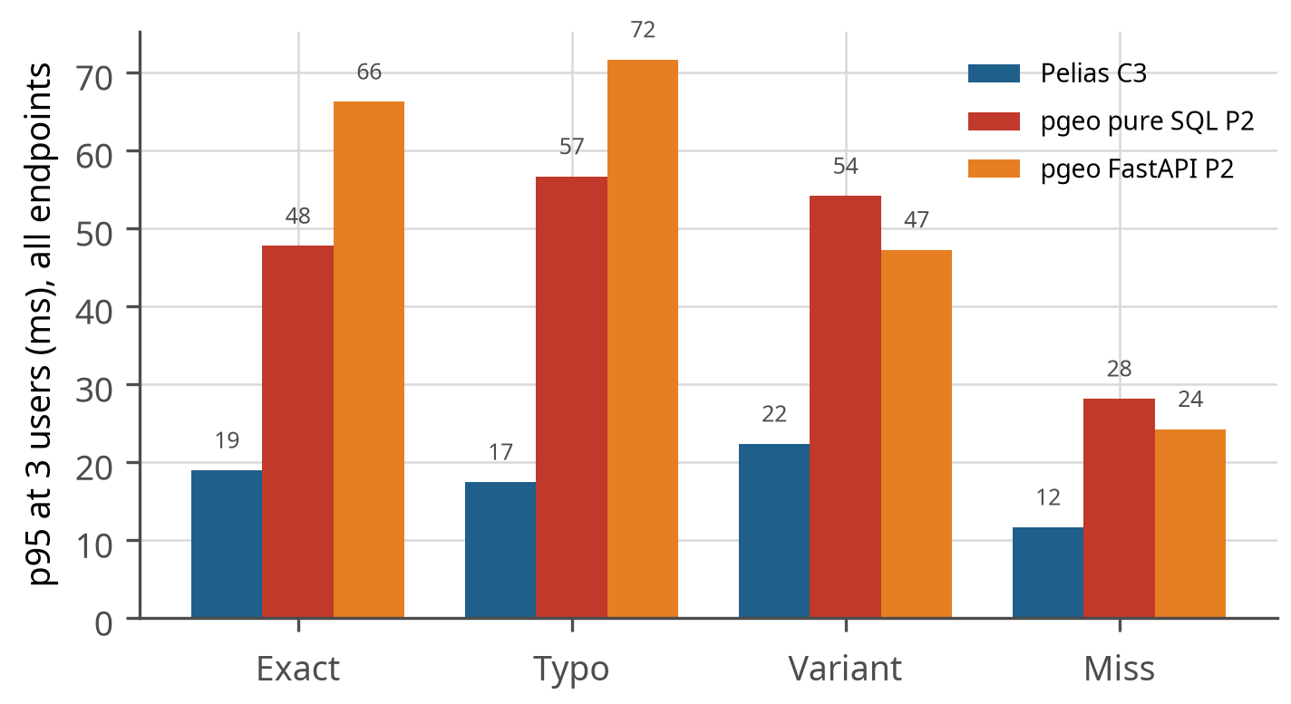
Figure 19. p95 latency at 3 users by query quality (all endpoints together).
Figure 19 shows latency by input quality. Both engines answer misspelled and impossible queries about as fast as exact ones, so the accuracy differences in Section 3.1 are not bought with slower responses.

3.8 Compatibility
Whether an existing Pelias client can be pointed at pgeo without changes. This decides whether pgeo is a replacement or merely an alternative.
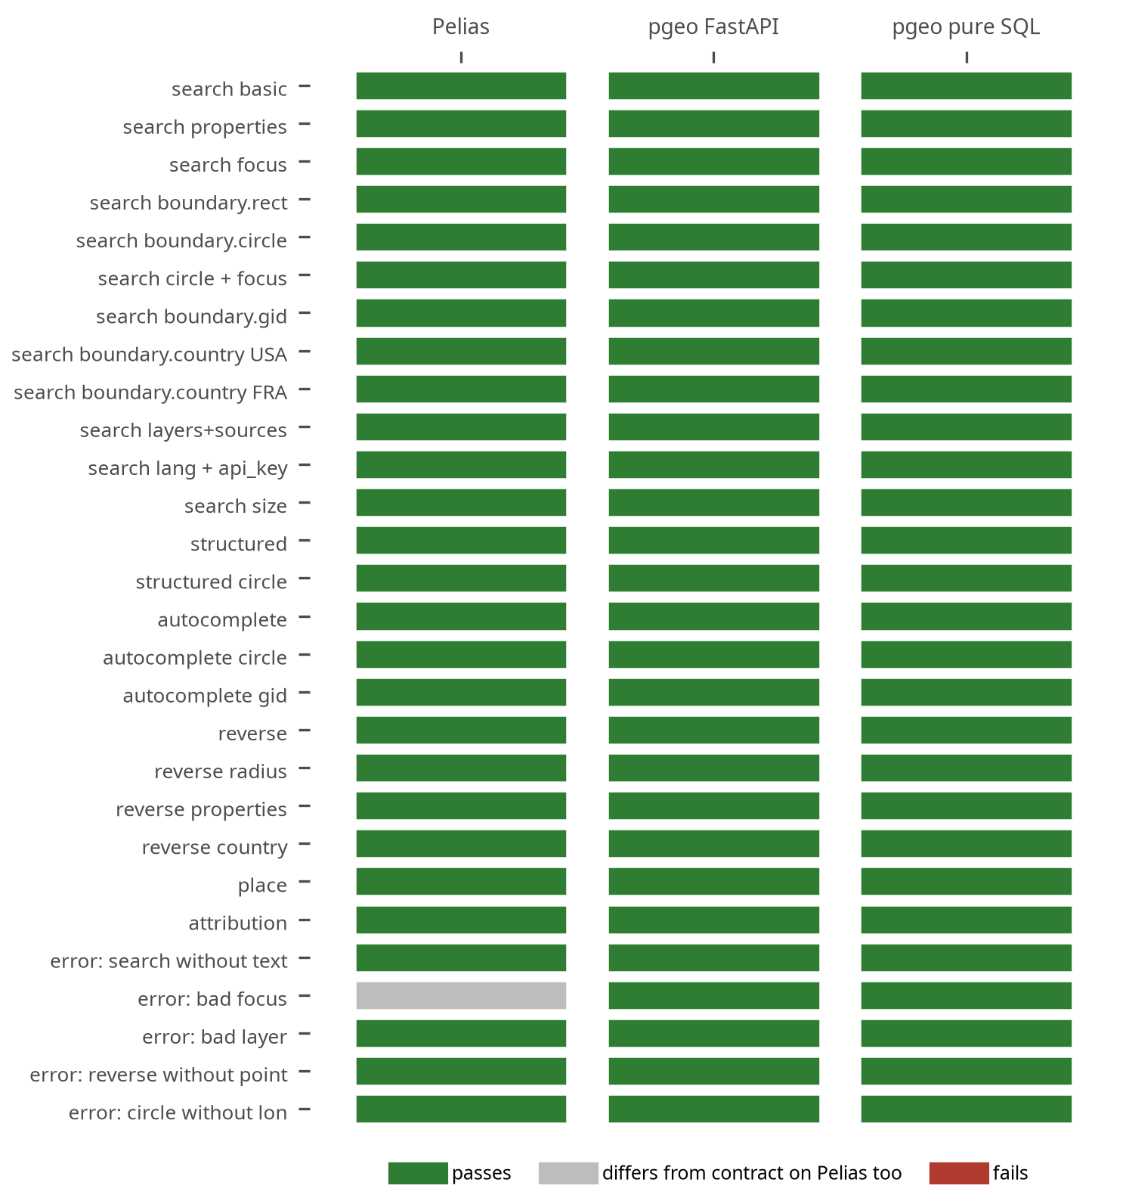
Figure 20. Compatibility contract results: each row is a documented Pelias request, each column an engine.
Figure 20 is the compatibility evidence: every documented Pelias request behaves the same on both pgeo front ends. For a reader with existing Pelias clients, this is the row that matters: no client changes are needed.
Table 32. Compatibility contract cases.
Case | Request | Pelias | pgeo FastAPI | pgeo pure SQL
search basic | /v1/search?text=389 Congress St, Portland, ME | pass | pass | pass
search properties | /v1/search?text=389 Congress St, Portland, ME | pass | pass | pass
search focus | /v1/search?text=main st&focus.point.lat=44.8016&focus.point.lon=-68.7712 | pass | pass | pass
search boundary.rect | /v1/search?text=main st&boundary.rect.min_lat=44.7&boundary.rect.max_lat=44.9&boundary.rect.min_lon=-68.9&boundary.rect.max_lon=-68.6 | pass | pass | pass
search boundary.circle | /v1/search?text=main st&boundary.circle.lat=44.8016&boundary.circle.lon=-68.7712&boundary.circle.radius=15 | pass | pass | pass
search circle + focus | /v1/search?text=main st&boundary.circle.lat=44.8016&boundary.circle.lon=-68.7712&boundary.circle.radius=15&focus.point.lat=44.8016&focus.point.lon=-68.7712 | pass | pass | pass
search boundary.gid | /v1/search?text=congress st&boundary.gid=whosonfirst:locality:85948877 | pass | pass | pass
search boundary.country USA | /v1/search?text=bangor&boundary.country=USA | pass | pass | pass
search boundary.country FRA | /v1/search?text=bangor&boundary.country=FRA | pass | pass | pass
search layers+sources | /v1/search?text=portland&layers=locality&sources=wof | pass | pass | pass
search lang + api_key | /v1/search?text=bangor&lang=en&api_key=abc123 | pass | pass | pass
search size | /v1/search?text=main st&size=3 | pass | pass | pass
structured | /v1/search/structured?address=389 Congress St&locality=Portland&region=ME | pass | pass | pass
structured circle | /v1/search/structured?address=Main St&boundary.circle.lat=44.8016&boundary.circle.lon=-68.7712&boundary.circle.radius=15 | pass | pass | pass
autocomplete | /v1/autocomplete?text=389 congress | pass | pass | pass
autocomplete circle | /v1/autocomplete?text=main&boundary.circle.lat=44.8016&boundary.circle.lon=-68.7712&boundary.circle.radius=15 | pass | pass | pass
autocomplete gid | /v1/autocomplete?text=congress&boundary.gid=whosonfirst:locality:85948877 | pass | pass | pass
reverse | /v1/reverse?point.lat=43.6568&point.lon=-70.2626 | pass | pass | pass
reverse radius | /v1/reverse?point.lat=43.6568&point.lon=-70.2626&boundary.circle.radius=1 | pass | pass | pass
reverse properties | /v1/reverse?point.lat=43.6568&point.lon=-70.2626&layers=address | pass | pass | pass
reverse country | /v1/reverse?point.lat=43.6568&point.lon=-70.2626&boundary.country=US | pass | pass | pass
place | /v1/place?ids=whosonfirst:locality:85948877 | pass | pass | pass
attribution | /v1/attribution? | pass | pass | pass
error: search without text | /v1/search? | pass | pass | pass
error: bad focus | /v1/search?text=x&focus.point.lat=999&focus.point.lon=0 | differs | pass | pass
error: bad layer | /v1/search?text=x&layers=planet | pass | pass | pass
error: reverse without point | /v1/reverse? | pass | pass | pass
error: circle without lon | /v1/search?text=x&boundary.circle.lat=44.8 | pass | pass | pass
Before this work pgeo failed 28 contract checks; the fixes added boundary.circle, boundary.gid, boundary.country and categories filtering, the Pelias hierarchy identifiers (locality_gid, county_gid, …), Pelias-shaped error responses from the pure-SQL path, and an edge rule that renames boundary.circle.lat/lon (which PostgREST would otherwise read as the focus point’s lat/lon). Pelias-shaped errors come out of SQL through PostgREST’s response.status setting; a parameter PostgREST does not know produces a 404, which the edge turns into the Pelias-shaped 400 a client expects.
Remaining differences (docs/PELIAS_COMPATIBILITY.md): OpenAddresses records carry different identifiers in the two engines (Pelias openaddresses:address:us/me/statewide:<hash> against pgeo’s openaddresses:address:<hash>), so a gid saved from Pelias does not resolve in pgeo and clients that store gids must re-resolve them after a switch; categories uses the sources’ own category names (Overture’s restaurant, OpenStreetMap’s natural=water) rather than the Pelias category taxonomy; and the pure-SQL path rejects parameters it does not know where Pelias ignores them. Pelias also names counties “Cumberland County” where pgeo stored “Cumberland”; pgeo now appends ” County” on output so the two agree.
Beyond the geocoding endpoints, Pelias serves two informational HTML pages. /v1/attribution lists the data licences, and a client may well fetch it to satisfy the OpenStreetMap and Who’s On First terms, so pgeo implements it: the page is built in SQL and served identically by PostgREST and by FastAPI, and it is case 28 of the contract. The /v1/ page that describes the API itself remains Pelias-only; pgeo answers it with the Pelias-shaped 400 for an unknown endpoint, which is the one place where “an existing Pelias client cannot tell the difference” still does not hold.

3.9 Features in practice
Table 2 in Section 1.4 lists what each platform offers. This section covers the two features that exist only in pgeo and that the LANCER application needs, and what the demo page makes of them.

3.9.1 Structured addresses for LANCER
pgeo’s /v1/address returns a US address in USPS Publication 28[20] form (number, directionals, street name, standard suffix, unit, city, state, ZIP; the delivery and last lines) with the municipality, county and FIPS codes, for a selected search result, a typed address or a map position. When the selected result is not an address (a business or landmark, for example “Just in Time, Lewiston Maine”), it returns the nearest address point with its distance, as the project’s requirement asked. The street parser gives a standard suffix for 97.1% of Maine’s 41,868 street names; the rest have none in Publication 28 terms (Broadway, Rue Principale). Units come only from the caller, because search merges a building’s per-unit records. Queries carry client addresses, so PostgreSQL never logs query parameters.

3.9.2 ZIP+4
The USPS ZIP+4 file[21] would add ZIP+4 codes, USPS street spellings and the USPS preferred city per ZIP (for example SOUTH PARIS for 04281, where the open data says PARIS). It costs $120 a year for one state ($1,750 for all), and its licence allows “internal corporate or personal use on one computer at one location”, with no network distribution without a paid amendment (unlimited: $24,000) and no use of data older than 105 days. The project decided against it; the address API stays on open data and is not a deliverability check (docs/ADDRESS_API.md).
The demo page exposes these features: autocomplete with map-centre bias, structured search, reverse geocoding by map click, a CSV batch tool, and, where both engines are deployed, an engine switch, an Address tab (type-ahead with a best-match suggestion, the USPS block with a copy button, and the nearest street address drawn on the map for venues) and a Compare tab that runs one query on both engines side by side.

3.10 Parity between the platforms
Do the two platforms now offer the same product? Feature for feature through the documented API, yes; in accuracy, pgeo is ahead rather than level; in throughput, Pelias is ahead.
Table 33. Feature parity through the documented Pelias API.
Area | Both | Only pgeo | Only Pelias
Endpoints | search, structured, autocomplete, reverse, place, attribution | /v1/address (USPS Publication 28, nearest street address) | /v1/nearby (beta), the /v1/ description page
Parameters | text, size, layers, sources, focus, boundary.rect, boundary.circle, boundary.country, boundary.gid, categories, lang and api_key accepted |  | multilingual names (lang changes the output)
Response | GeoJSON envelope, Pelias properties, hierarchy identifiers (*_gid, county_a), errors as HTTP 400 with geocoding.errors | confidence lowered for ties between distinct places (better calibrated)
Parsing | US addresses | rule parser tuned for Maine input | libpostal: international address parsing
Categories | the categories filter |  | the Pelias category taxonomy (food, health, …)
Scale | Maine (tested) |  | planet-scale data
Differences to handle |  | pure-SQL front end rejects unknown parameters (400) | OpenAddresses records have different identifiers than in pgeo
Table 34. Accuracy parity by category: Pelias against pgeo (pure SQL), all query qualities. Pelias leads only where both are near perfect.
Category | Pelias | pgeo | Gap (points) | Ahead
Addresses | 88% | 98% | +10 | pgeo
Towns | 81% | 96% | +15 | pgeo
Lakes, summits | 37% | 87% | +50 | pgeo
Venues | 60% | 94% | +34 | pgeo
ZIP codes | 100% | 98% | -2 | Pelias
Reverse | 100.0% | 99.5% | -0.5 | Pelias
Misses | 41% | 95% | +53 | pgeo
All cases | 75.5% | 95.8% | +20.3 | pgeo
Table 35. Throughput parity: most concurrent users within all latency targets at each CPU size, with each configuration’s memory budget.
CPU | Pelias users (budget) | pgeo pure SQL | pgeo FastAPI | Pelias / best pgeo
1 vCPU | 96 (8.3 GB) | 24 (1.6 GB) | 24 (1.6 GB) | 4.0x
2 vCPU | 192 (8.4 GB) | 48 (2.5 GB) | 48 (2.7 GB) | 4.0x
4 vCPU | 384 (10.8 GB) | 96 (3.0 GB) | 96 (3.3 GB) | 4.0x
In short: an existing Pelias client can switch to pgeo without code changes (the contract in Section 3.8) and gets more correct answers, especially for misspelled and vague queries, at a fraction of the memory; it gives up throughput per CPU, multilingual names, international parsing and planet scale, none of which this deployment uses.

3.11 Production validation on VM 120
Every number so far comes from the workstation, where the engine and the load generator are pinned to separate physical cores and nothing else competes. That isolation is what makes the comparison fair, and it is also what makes it artificial: the service people will actually use runs on VM 120 behind the wharf Caddy, so the last measurement repeats the three-user validation and the ramp against the deployed service over HTTPS, one engine at a time, with the edge’s rate limits raised for the window and restored afterwards.
Table 36. Both engines on VM 120 through the production HTTPS path: the three-user validation, the p95 per endpoint and how far the ramp went.
Engine | 3 users | Autocomplete p95 | Search p95 | Structured p95 | Reverse p95 | Users within targets | Broken at
pelias | pass | 19 | 22 | 24 | 10 | 384 | not reached
pgeo | pass | 32 | 60 | 62 | 16 | 128 | 256
Two differences from the controlled runs are built in and worth keeping in mind when comparing the numbers. The request now crosses TLS termination, the nginx edge and the LAN, which adds a few milliseconds that belong to the service rather than to the engine; and the VM’s cores are two CPU generations newer than the workstation’s (Section 1.2), which works the other way. The purpose here is not a cleaner comparison between engines but a check that the service, as deployed, meets the targets it was designed for.
Both engines pass the three-user validation with room to spare: the worst endpoint reaches 8% of its target on Pelias and 13% on pgeo, with no errors. For the service this project set out to build, that is the answer – either engine, on the hardware already owned, is far inside its requirement.
The ramp is more interesting than the validation, because it disagrees with the workstation in a useful way. Pelias holds 384 concurrent users here and pgeo 128, a ratio of three rather than the four measured under controlled conditions (Table 35). Both engines do better on the VM than on the workstation, which is expected – VM 120’s cores are two CPU generations newer and the engine does not share the machine with the load generator – but pgeo gains more from the newer core than Pelias does. That is consistent with where each spends its time: pgeo runs interpreted PL/pgSQL, which a faster core speeds up directly, while Pelias’s compiled index lookups were already cheap per request.

3.12 The smallest server that works
The headline question of this project is not which engine is fastest but how small a machine the three-user service can run on. A search program answered it directly (tests/load/find_floor.py): start from a configuration known to pass, shrink one resource at a time – first the CPU quota, then each service’s memory – and keep a step only when a five-minute three-user run stays within every latency target with no errors, no container restarts and no out-of-memory kill. A step that fails ends the search for that resource, because smaller values of it will fail too. Table 37 is the whole path, pass and fail.
Table 37. Minimum-server search: every trial, in order, for both engines. Memory totals include 0.8 GB for the operating system.
Engine | Trial | Configuration (vCPU quota; memory limits in GB) | Total | 3 users | Result
pgeo (pure SQL) | 0 | cpus 1, db 0.6, rest 0.25 | 1.65 GB | pass | ok
pgeo (pure SQL) | 1 | cpus 0.5, db 0.6, rest 0.25 | 1.65 GB | pass | ok
pgeo (pure SQL) | 2 | cpus 0.25, db 0.6, rest 0.25 | 1.65 GB | pass | ok
pgeo (pure SQL) | 3 | cpus 0.25, db 0.45, rest 0.25 | 1.50 GB | pass | ok
pgeo (pure SQL) | 4 | cpus 0.25, db 0.35, rest 0.25 | 1.40 GB | fail | over target (worst 1.07x, errors 0)
pgeo (pure SQL) | 5 | cpus 0.25, db 0.45, rest 0.15 | 1.40 GB | pass | ok
pgeo (pure SQL) | 6 | cpus 0.25, db 0.45, rest 0.1 | 1.35 GB | fail | over target (worst 1.13x, errors 0)
Pelias | 0 | cpus 1, es 1.5, api 0.42, libpostal 2, interpolation 2.1, pip 0.7, placeholder 0.8 | 8.32 GB | pass | ok
Pelias | 1 | cpus 0.5, es 1.5, api 0.42, libpostal 2, interpolation 2.1, pip 0.7, placeholder 0.8 | 8.32 GB | pass | ok
Pelias | 2 | cpus 0.25, es 1.5, api 0.42, libpostal 2, interpolation 2.1, pip 0.7, placeholder 0.8 | 8.32 GB | pass | ok
Pelias | 3 | cpus 0.25, es 1.2, api 0.42, libpostal 2, interpolation 2.1, pip 0.7, placeholder 0.8 | 8.02 GB | pass | ok
Pelias | 4 | cpus 0.25, es 1, api 0.42, libpostal 2, interpolation 2.1, pip 0.7, placeholder 0.8 | 7.82 GB | pass | ok
Pelias | 5 | cpus 0.25, es 0.8, api 0.42, libpostal 2, interpolation 2.1, pip 0.7, placeholder 0.8 | 7.62 GB | fail | died or OOM
Pelias | 6 | cpus 0.25, es 1, api 0.42, libpostal 2, interpolation 2.1, pip 0.7, placeholder 0.6 | 7.62 GB | pass | ok
Pelias | 7 | cpus 0.25, es 1, api 0.42, libpostal 2, interpolation 2.1, pip 0.7, placeholder 0.45 | 7.47 GB | pass | ok
Pelias | 8 | cpus 0.25, es 1, api 0.42, libpostal 2, interpolation 2.1, pip 0.7, placeholder 0.35 | 7.37 GB | pass | ok
Pelias | 9 | cpus 0.25, es 1, api 0.42, libpostal 2, interpolation 2.1, pip 0.55, placeholder 0.35 | 7.22 GB | fail | died or OOM
Pelias | 10 | cpus 0.25, es 1, api 0.42, libpostal 2, interpolation 1.8, pip 0.7, placeholder 0.35 | 7.07 GB | fail | died or OOM
Pelias | 11 | cpus 0.25, es 1, api 0.42, libpostal 1.8, interpolation 2.1, pip 0.7, placeholder 0.35 | 0.00 GB | fail | did not start: RuntimeError
Pelias | 12 | cpus 0.25, es 1, api 0.3, libpostal 2, interpolation 2.1, pip 0.7, placeholder 0.35 | 7.25 GB | pass | ok
Pelias | 13 | cpus 0.25, es 1, api 0.22, libpostal 2, interpolation 2.1, pip 0.7, placeholder 0.35 | 7.17 GB | pass | ok
pgeo ran the three-user load inside 0.25 vCPU and 1.40 GB of memory in total: a quarter of one core, 0.45 GB for PostgreSQL, 0.15 GB for PostgREST and 0.8 GB left for the operating system. Every failed step failed on latency, not on memory: the database kept answering at 0.35 GB and at 0.1 GB for the front end, just too slowly (7 to 13 percent over target). That is the practical signature of a database whose working set is smaller than the machine: it degrades gently instead of being killed.
Pelias floors at 0.25 vCPU and 7.17 GB. Its limit is the opposite kind: the memory is not a tuning choice but the sum of what five services load before the first request (the libpostal model, the interpolation database, placeholder’s in-memory tables and the Elasticsearch heap), so the floor barely moves however little traffic it serves.

3.12.1 Two kinds of limit
The trials fail in two distinct ways, and the difference explains why the two engines’ floors are so far apart. pgeo’s failures are all of the first kind: the service keeps answering, just too slowly, so its floor is wherever the operator decides the latency is no longer acceptable. Most of Pelias’s are of the second: below a threshold the service does not run at all. libpostal cannot even start below 2 GB, because it loads a fixed model before it serves anything; the interpolation service crash-loops at 1.8 GB; Elasticsearch is killed at 0.8 GB. Those are properties of the software, not of the load, and no amount of tuning for three users moves them.

3.12.2 A floor is a pair, not a number
The two resources are not independent, and the search makes that visible: Pelias’s pip service was killed at 0.55 GB in this search, although the capacity tests had it surviving at 0.4 GB. Nothing regressed – in the capacity tests each service had a whole core, and here it has a quarter of one, so collection and compaction fall behind and the same work needs more headroom. Read each floor as the pair of numbers it is: at more CPU both engines would fit in less memory, and at less memory they would need more CPU to stay inside the targets.

3.12.3 Confirmation on real machines
A container limit is not a server: it shares the host’s page cache, its disk and its kernel. Each floor was therefore re-tested on a temporary Proxmox VM of that size, created for the run and destroyed after it (tests/load/floor_vm.sh), with the same three-user validation followed by a ramp to find how far that VM stretches.
Table 38. The measured floor confirmed on a temporary VM: the three-user validation and the ramp to the first configuration outside a latency target.
Engine | VM CPU | VM memory | 3 users | Worst p95 / target at 3 | Users within targets | Broken at
pgeo (pure SQL) | 1 vCPU (limit 1) | 1 GB | pass | 0.21 | 32 | 96
The container search said pgeo needs 0.60 GB; on a real 1 GB machine it used 307 MB, and the three-user load ran with the worst endpoint at 21% of its target. A cheap VM is not a container limit – it brings its own kernel, page cache and disk – and pgeo came out ahead of the container estimate rather than behind it, because a minimal operating system leaves more for the database than the 0.8 GB this study reserves. The same machine held 32 concurrent users before an endpoint missed its target.
Pelias’s floor was not re-tested on a temporary VM: at 7.17 GB it needs a guest the Proxmox host could not spare beside the machines already running on it. Its real-machine evidence is VM 120 itself (Section 3.11), which runs Pelias in 10 GB and serves 384 users; the floor search is what says how far that could be cut.

3.13 Security
The two platforms differ in security the way they differ in everything else: Pelias is more software, and pgeo is more of this project’s own software. Both statements cut. The controls below were measured on the deployed service rather than read off the configuration, and tests/security/test_posture.py asserts each one on every build and every deploy.
Table 39. Security properties of each platform as deployed. Measured 2026-09-20.
Property | Pelias | pgeo
Processes reachable over HTTP | 6 (API, Elasticsearch, libpostal, placeholder, pip, interpolation) | 2 (PostgREST, PostgreSQL)
Data-store credentials | none: Elasticsearch accepts unauthenticated reads and writes from anything that reaches the port | password, pg_hba, and an API role holding SELECT only
Effect of a foothold on the host | the whole index: read, modify or delete | whatever SELECT allows; the API role has no write path
Attack surface in this project’s code | none; the query path is upstream | the ranking SQL, the edge parameter rewriting and /v1/address
Components to patch | 6 pinned images | 2 pinned images
Query text in engine logs | not logged | not logged (log_parameter_max_length = 0, log_statement = none)

3.13.1 What the two columns are really saying
Pelias’s data store has no credentials at all: its design assumes nothing can reach it, so the loopback binding is the entire access-control story. That is a property of its architecture, not a defect in its code, and it is why the single cheapest improvement available to a Pelias deployment is enabling Elasticsearch’s own authentication – configuration, not another container. pgeo authenticates its data store and gives the HTTP layer a role that cannot write, so the same foothold yields less. Set against that, pgeo’s query path is code written for this project: its ranking SQL and its edge rules have one set of eyes on them, where Pelias’s have many.
Shared posture. Both engines sit behind the same edge, and that is where most of the protection lives: every engine port bound to loopback, a firewall that denies inbound by default and admits the TLS terminator alone, GET only, per-client rate limits, a content security policy naming no remote origin, and a demo page that builds every element with textContent – it contains no innerHTML, eval or document.write at all, which is what makes the query echoed in each response harmless.
A finding worth repeating, because of how it hid. PostgreSQL was deliberately configured not to log bind parameters, since a query here is an address someone searched for and for LANCER a client address. That control was real. The nginx access log in front of it, however, used the default format, which records the whole request line – so every address searched was written to disk in plaintext anyway. A control at one layer was undone by a default at the next, and the system-level claim looked satisfied the whole time. The edge now logs the path without its query string, verified on the deployed service.
Why the deployment shape carries so much of the weight. Both engines serve public open data, so a total compromise of the index or the database leaks nothing that is not already downloadable. The sensitive material is in the queries, not the corpus, which is why a logging default mattered more here than anything about the data store. Self-hosting on a LAN removes rather than mitigates whole classes of threat – no bot traffic, no scraping, no credential stuffing, no exposure to internet-wide scanning – and that is what makes a two-container service on a 1 GB machine a defensible posture rather than a reckless one. The cost is that patching becomes the department’s job: six images or two, and nobody updates them in the background. Deployment scenarios at three levels of ambition, and where each control pulls against the fewest-components principle, are in docs/SECURITY_DEPLOYMENT.md.

4. Discussion
Why pgeo is more accurate. The difference is in how text meets data. Elasticsearch matches analysed tokens; a token with a typo or an unexpected abbreviation contributes nothing, and the admin lookup requires exact names. pgeo compares normalized whole strings by trigram similarity, expands abbreviations before comparing (so “moountain rd” meets “mountain road”), and scores the queried town by distance as well as by name. It also knows the data is one state, which lets it use tie-breaks (distance to the focus point or the named town) that a planet-scale engine cannot assume.
Why Pelias is faster. Elasticsearch executes text matching as compiled index lookups and caches aggressively, and Pelias parallelizes across services. pgeo’s PL/pgSQL runs several candidate queries and scoring steps per request in an interpreted language inside one backend.
Is there still a reason to use Pelias? Yes, in four situations: (1) many concurrent users per server, where Pelias’s four-fold throughput per CPU saves hardware once its 7.17 GB memory floor is paid; (2) coverage beyond one or two states, for which Pelias is designed and pgeo is untested – and where the data-volume curve (Section 3.6.1) shows pgeo losing capacity about twice as fast as Pelias as names are added; (3) international addresses and multilingual names (libpostal, Pelias language support); (4) when a maintained upstream project matters more than accuracy, since pgeo is this project’s own code. For the deployment studied here (Maine, a handful of users, messy input, LANCER), none of these applies.
The tuning caveat. pgeo was tuned in rounds that started from this test set’s failing cases; Pelias was run as published. The fuzz rounds (corruptions of queries the tuning never saw as such) and the source-derived ground truth limit the effect, but part of the 20-point gap may be fit to the test set. The decisive check is real queries neither engine was tuned on: running both engines side by side on the query host and scoring the first weeks of actual searches (Next steps).
Threats to validity.
- The accuracy set comes from the same sources both engines load; it measures finding what is in the data, not whether the data is correct. Eight miss cases are test-set errors.
- Load tests ran on one workstation with CPU pinning and memory limits standing in for VM sizes; absolute numbers on other hardware differ (Section 3.11 validates on the production VM).
- At 1-4 users the per-endpoint p95 rests on few requests; the ramp’s decisions at higher user counts rest on thousands.
- One pgeo run (api-svc-P4) was interrupted by a host event: the Docker daemon was stopped at 04:32 on 2026-09-19, unrelated to the test, which ended the ramp at 32 users. That configuration was re-run from the start, and the results here are the complete re-run; no truncated run contributes a number to this report.
- The first Pelias data-volume run failed because Elasticsearch was not ready after the previous run’s restart; it was repeated with a readiness wait.

5. Conclusions
Which tool suits which situation, and what the evidence supports saying. The recommendations below follow from the measurements rather than from a preference for either architecture.
Table 40. Which tool for which scenario.
Scenario | Recommended | Why
A few users on a small VM or VPS (this project’s target) | pgeo, pure SQL | meets all targets from 1.4 GB and a quarter core (Section 3.12); most accurate; 2-3 containers
Messy input: typos, variants, venues, impossible places | pgeo | 87% vs 30% on typos; misses handled 95% vs 41%
Structured US addresses for another system (LANCER) | pgeo | /v1/address; nearest street address for venues
Hundreds of concurrent users per vCPU | Pelias | four times the throughput per CPU
Multi-state or national coverage | Pelias today | built for planet scale; measured: pgeo loses four times its capacity across Maine’s data range where Pelias loses two (Section 3.6.1)
Fewest components, data in PostgreSQL (G6) | pgeo, pure SQL | database plus a stateless gateway
Existing Pelias clients | either | pgeo passes the compatibility contract
In one paragraph. For the service this project set out to build – Maine data, a handful of users, input typed by people who misspell things, and a preference for as few moving parts as possible – the PostgreSQL geocoder is the better instrument on every axis that matters here. It answers 95.8% of 1,560 test queries against 75.5% for Pelias, and the gap widens exactly where real input is worst: typos, half-remembered venue names and places that do not exist. It does that from two containers and 1.40 GB of memory, where Pelias needs six containers and 7.17 GB, which is the difference between the cheapest plan a provider sells and a mid-range server. And it speaks the Pelias API closely enough that an existing client cannot tell the difference (28 of 28 contract cases). What it gives up is throughput – a quarter of Pelias’s users per CPU – and planet scale, neither of which this deployment needs. One caveat belongs in the last sentence rather than a footnote: pgeo was tuned against the set that scores it, so the 20-point accuracy gap should be read as an upper bound until both engines meet queries neither has seen. The capacity and memory findings carry no such caveat.
None of this rests on the test bench alone. Both engines were deployed to the machine that will actually serve the requests and measured again through the production HTTPS path: both meet the three-user target with the worst endpoint at under a seventh of its budget, Pelias holds 384 concurrent users there and pgeo 128, and pgeo holds 32 on a 1 GB machine costing about $5 a month. The conclusions above are what the deployed service does, not what a benchmark suggested it might.

6. Future work
Each item below is given three things a reader needs before deciding to do it: roughly how much work it is, how likely it is to pay off, and what the payoff would be worth in practice. The estimates are the author’s, and the ones marked speculative are the ones to distrust.
Table 41. Work not done, with the effort, the likelihood it pays off and the value of finishing it.
Work | Effort | Plausibility | What it is worth
Autocomplete speed: prepared statements, fewer candidate queries, a GiST trigram index for ordered similarity | 2-3 days | High – autocomplete is measurably the binding endpoint on every configuration (Figure 14) | The clearest remaining win. A factor of two here roughly doubles users per vCPU and narrows the one axis where Pelias leads
Authorization (Phase 11): hashed API keys at the edge, then single sign-on | 1 day for keys; weeks for SSO | Certain – it is configuration, not research | Blocking. LANCER cannot use the service responsibly until any device on the LAN stops being able to resolve a client address (Section 3.13)
Atomic online restore: restore into a second schema and rename, so a data update does not take the service down | 1 day | High – the build already does exactly this locally | Turns a weekly refresh from an outage into a non-event. The single most useful automation left (Section 7.3)
Hysteresis test: ramp past the breaking point, then back down, and measure recovery | Half a day | Certain to produce an answer | Closes the one operational question Section 7.4 cannot answer: whether the service comes back on its own
Shadow comparison on real traffic: both engines on the query host for weeks, scored on real searches | 2 days to set up, then waiting | High | The only way to settle the tuning caveat in Section 4. Until then the 20-point accuracy gap is an upper bound
pgeo data-volume curve: subset builds (D1-D5) as done for Pelias | 1 day | Certain | Answers whether pgeo’s advantage survives more data – the obvious challenge to a one-state result
New Hampshire: build both engines for two states | 2-3 days | Medium – the pipeline is state-agnostic, but ranking is tuned on Maine | The real test of whether “one state, tested” generalises
Horizontal scale-out: a read replica behind a load balancer, same ramp | 1 day | High for throughput, none for latency | Shows whether pgeo answers the “but it does not scale” objection with $5 machines (Section 7.5)
metaphone fallback for phonetic misspellings | Half a day | Medium – it should help at high corruption, and it might help nothing | A few points at fuzz levels F4-F5 (Section 7.1), or a clean negative result
Category taxonomy: map source categories onto Pelias’s | 1-2 days | High | Closes the last documented API difference, so categories=food behaves as a Pelias client expects
libpostal model update (Senzing libpostal-data) | 1 day | Low for pgeo, medium for Pelias | pgeo’s rule parser already beats current libpostal (95.8% against 94.0%), so this mostly matters to the Pelias arm
Test set: remove the eight false misses, add real queries | Half a day | Certain | The eight are known errors inflating pgeo’s miss score; removing them makes the headline number defensible
Continuous checks: accuracy gate and compatibility contract on every build | Half a day | Certain | Both exist and pass; this is only wiring them into a hook

6.1 Would OpenResty or Omnigres be worth trying?
Both were considered and rejected when the HTTP layer was chosen (docs/HTTP_OPTIONS.md), and the question is whether the results since then change that. They would take the “no application code” idea further than PostgREST does, in opposite directions.
Omnigres (omni_httpd) puts the HTTP server inside PostgreSQL: its workers are database backends and its route handlers are SQL. It is the literal form of this project’s guiding principle – there would be no second container at all, and the memory floor would drop by PostgREST’s 0.15 GB. Against that: it is a third-party C extension running in the database process, which is precisely the risk the project avoided by insisting on core and contrib extensions only, and its authors describe HTTPS and HTTP/2 as still maturing. Worth testing? Not for this deployment. The gain is 0.15 GB on a 1.4 GB floor and one fewer container, against putting unvetted C in the same process as the data. It would become interesting if the project ever needed to drop below a 1 GB machine, which nothing here suggests it does.
OpenResty with pgmoon keeps the gateway outside the database but replaces PostgREST with a few dozen lines of Lua in nginx – and nginx is already on the host as the edge. That is genuinely attractive on paper: one fewer process, no PostgREST parameter-naming constraints, and the boundary.circle rewriting that currently needs chained nginx map directives (Section 3.8) would become three lines of Lua. Against it: a non-standard nginx build, and Lua that this project would own and have to test – the opposite of the argument that PostgREST needs no code. Worth testing? As an experiment, yes – and only if PostgREST’s URL grammar becomes a real obstacle. It is perhaps two days to a working prototype and a like-for-like ramp. The measurement that would justify it is latency: PostgREST added no measurable overhead at or below 4 vCPU (Section 3.4), so the honest expectation is that OpenResty would win on elegance and nothing else.
The broader point is that the HTTP layer is not where this system spends its time. Section 3.4 shows the database is the bottleneck on every configuration, so a faster or lighter gateway moves a number that is not currently limiting anything. Both options are worth knowing about; neither is worth doing before autocomplete speed and authorization.

7. Questions and answers
Questions raised while reviewing this work, answered with measurements where a measurement was possible and with a clear statement of what was not tested where it was not.

7.1 Would a soundex-style filter help when users cannot spell a name?
Short answer: not soundex, and not as a replacement for what is already there – but metaphone as a fallback is worth an experiment.
pgeo already handles phonetic misspellings through trigram similarity. Five invented misspellings of Maine towns all resolve today:
Table 42. Phonetic misspellings against the deployed pgeo. All five resolve, but two are weak: “Kenebunc” is found with low confidence, and “Skowhegin” ranks a venue above the town.
Typed | pgeo returns | Confidence | Trigram similarity to the true name
Kenebunc | Kennebunk, ME | 0.32 | 0.46
Skowhegin | The Cabin- Skowhegan, Skowhegan, ME | 0.76 | 0.54
Mooshead | Moosehead, Northeast Somerset, ME | 0.48 | 0.58
Bidefford | Biddeford, ME | 0.59 | 0.54
Naragansett | Naragansett Avenue, Buxton, ME | 0.96 | 0.79
So the gap is not finding these names but ranking and scoring them confidently. That is where a phonetic key could help, and it is also where soundex fails badly. Soundex keeps roughly four characters of an English-phonetic code, which is far too coarse for place names:
Table 43. How coarse each phonetic encoding is on this data. Soundex puts 18 distinct towns – North Bancroft, Northport, North Haven, Northfield and fourteen more – into one bucket.
Encoding | Distinct codes for 1,466 Maine town names | Names sharing a code with another
soundex | 885 | 293 buckets
dmetaphone | 987 | 735 names
metaphone(name, 16) | 1,428 | few
Pros. A phonetic key catches the case trigram similarity misses: a spelling that sounds right but shares few three-character slices with the target. It costs one functional index and no new component (fuzzystrmatch is already installed).
Cons. Soundex would actively harm this data: collapsing eighteen “North …” towns into one bucket invites exactly the ambiguity the confidence work in Section 3.2 was built to remove. It is also English-only, and it encodes the whole multi-word string rather than the distinctive part.
What would be worth testing: metaphone(name, 16) as a fallback – consulted only when trigram finds nothing above threshold, never as a parallel ranking signal – with the fuzz set (Section 2.4) as the measure. Plausible gain: a few points at the highest corruption levels (F4, F5), where pgeo currently scores 45-49%. Effort: half a day. It should be measured, not assumed: the same gate that protects every other tuning step would decide it.

7.2 Are pgeo’s SQL routines functions or stored procedures? Why, and what does it cost?
They are functions: 41 of them, and no procedures at all.
PostgreSQL has had true stored procedures since version 11 (CREATE PROCEDURE, invoked with CALL), and they differ from functions in one way that decides the matter here: a procedure can manage transactions but cannot return a result set to a caller in a SELECT. Everything pgeo does is a read that returns rows or JSON, so functions are the only fit. Two consequences follow.
Performance. Functions can be declared STABLE and PARALLEL SAFE, which pgeo’s are. That lets the planner call them inside a query, reuse a cached plan for the session, and consider parallel workers. A procedure would force a round trip per call and give up plan reuse. PL/pgSQL caches a prepared plan for each statement inside a function after the first few executions, which is why the first request to a fresh connection is slower than the rest – visible in the warm-up excluded from every measurement in Section 3.
Flexibility. The cost is real and this project hit it repeatedly: CREATE OR REPLACE FUNCTION cannot change a parameter’s name or type, and PostgREST addresses functions by parameter name. Renaming one argument means dropping and recreating it, and a stale overload silently shadows the new definition. pgeo’s build therefore drops and recreates the whole geocode_api schema on every apply (pgeo/sql/050_api.sql), which is simple and total. The lesson is in Table 20: several tuning rounds were slowed by overloads left behind after a signature change.

7.3 How are data updates prepared on a fast machine and installed into production?
This is how the project already works, and it is the reason a 1 GB server is viable at all (Section 3.5): the query host never sees the raw data or the build tools.
- Build on a workstation: pgeo-load build loads every source, assigns the admin hierarchy, deduplicates, indexes and swaps the new schema in atomically. 13 minutes, 5.5 GB peak.
- scripts/pgeo_dump.sh produces a compressed dump of just the three schemas (117 MB) and refuses to run if the database reports an unstamped engine version.
- Ansible ships the dump, restores it, recreates extensions and the read-only role, runs VACUUM (ANALYZE) and a smoke test (infra/ansible/roles/pgeo_runtime).
Pros. The production machine needs no build capacity, no source data and no network access to the data providers; a bad build never reaches it; and rollback is restoring the previous dump. Cons. The restore is not online – the database is unavailable while it runs – and the dump is a full copy each time rather than a delta, so a weekly refresh moves 117 MB whether ten addresses changed or ten thousand.
Can it be semi-automated? It already is: scripts/rebuild_all.sh deploy runs the whole chain. Making it fully automatic needs two things it does not have: a restore into a second schema followed by an atomic rename, so the service stays up (the build already does exactly this locally, so the pattern is proven), and a scheduled trigger with the accuracy gate as the gatekeeper – no dump ships unless the gate passes. That is perhaps a day’s work and it is the single most useful piece of automation left.

7.4 What happens when load exceeds the VM’s resources?
The two engines fail in different ways, and this was measured rather than reasoned about (Section 3.12).
pgeo degrades. Every failed trial in the minimum-server search failed on latency, never on memory: the database kept answering, just too slowly. Requests queue at the connection pool, p95 rises, and nothing dies. That is the gentler failure and it is a property of the architecture – one process per connection, a small working set, no in-memory model to lose.
Pelias stops. Below a threshold its services do not degrade, they exit: placeholder is OOM-killed at 0.4-0.55 GB, pip at 0.55 GB, interpolation crash-loops at 1.8 GB, Elasticsearch is killed at 0.8 GB, and libpostal will not start below 2 GB at all.
Can it be detected and the user warned? Yes, and cheaply, because the two signatures are different. Rising p95 with no errors is pgeo under pressure: alert on the p95 of autocomplete, which is the first endpoint to cross its target every time (Section 3.4). Container restarts or OOM kills are Pelias under pressure: alert on restart counts. The load harness already computes both, so the thresholds are known rather than guessed.
Do they recover when pressure backs off? For pgeo the mechanism says yes – the queue drains and no state is lost – but this was not measured: every ramp in this study increases load and stops at the breaking point, so nothing here tests the way back down. For Pelias, a service that was OOM-killed restarts with cold caches, so recovery is slower than the failure. A hysteresis test (ramp up past the limit, then back down, and measure how long p95 takes to return) is a half-day of work and is listed in Section 6.

7.5 Can pgeo scale horizontally the way Pelias does?
Yes in principle, and more cheaply than Pelias, but it has not been tested.
The workload is entirely read-only, which is the case PostgreSQL scales out best. Streaming replication to read replicas with PostgREST in front of each – or one PostgREST per replica behind a load balancer – needs no application changes, because nothing in the query path writes. Each replica is a full copy of a 654 MB database, which is small enough that a replica costs a 1 GB machine (Section 3.12): horizontal scaling here is adding $5 VPSs.
Pelias scales the same axis with Elasticsearch replicas and more API instances, which is a well-trodden path with real operational tooling behind it. Two honest differences: Elasticsearch shards a large index across nodes, which pgeo has no equivalent of and does not need at 654 MB; and Pelias’s path is documented and widely run, where pgeo’s is inferred from how PostgreSQL behaves rather than demonstrated.
The limit worth noting is that this buys throughput, not latency. Section 3.4 shows pgeo is CPU-bound per request, so replicas multiply the users served without making any single query faster. The work to prove it – one replica, a load balancer, and the same ramp – is about a day, and it is the natural follow-on to the capacity results.

References
Numbered in order of first citation. Everything external to this project that the report asserts is listed here; measurements are the project’s own and are reproducible from the repository (Appendix A).
- Pelias: an open-source geocoder. https://pelias.io and https://github.com/pelias/pelias
- Elasticsearch. Elastic. https://www.elastic.co/elasticsearch
- PostGIS Tiger Geocoder, chapter 12 (Extras). https://postgis.net/docs/Extras.html
- PostGIS Tiger Geocoder 2025.1 release notes, June 2026. https://postgis.net/2026/06/PostGIS-Tiger-Geocoder-2025.1/
- address_standardizer: a PostGIS extension that parses addresses using lexicon, grammar and rule tables. https://postgis.net/docs/Address_Standardizer.html
- osmgeocoder: an OpenStreetMap and OpenAddresses geocoder using PostGIS, pg_trgm and fuzzystrmatch. https://github.com/dunkelstern/osmgeocoder
- fuzzystrmatch: soundex, metaphone, double metaphone and Levenshtein. PostgreSQL documentation. https://www.postgresql.org/docs/18/fuzzystrmatch.html
- moofish32/postgis-geocoder: a Docker packaging of the PostGIS TIGER geocoder. https://github.com/moofish32/postgis-geocoder
- Nominatim architecture overview, release 5.3 documentation. https://nominatim.org/release-docs/latest/develop/overview/
- The road to Nominatim 6, July 2025. https://nominatim.org/2025/07/14/roadmap-nominatim6.html
- libpostal: a C library for parsing and normalising street addresses, using statistical NLP. https://github.com/openvenues/libpostal
- Grafana k6: a load-testing tool with scripted virtual users. https://k6.io
- pg_trgm: trigram-based text similarity and indexing. PostgreSQL documentation. https://www.postgresql.org/docs/18/pgtrgm.html
- Who’s On First: an open gazetteer of places. https://whosonfirst.org
- OpenAddresses: a global collection of open address data. https://openaddresses.io
- USGS Geographic Names Information System (GNIS), Domestic Names. https://www.usgs.gov/us-board-on-geographic-names
- US Census Bureau, ZIP Code Tabulation Areas (ZCTA) gazetteer. https://www.census.gov/geographies/reference-files/time-series/geo/gazetteer-files.html
- DuckDB, used in the pgeo build to read Parquet and CSV sources. https://duckdb.org
- GDAL/OGR (ogr2ogr), used in the pgeo build to load spatial formats. https://gdal.org
- United States Postal Service, Publication 28: Postal Addressing Standards. https://pe.usps.com/text/pub28/welcome.htm
- United States Postal Service, ZIP+4 product and licence terms. https://postalpro.usps.com/address-quality/zip4

Appendix A. Reproducing this study
Everything in this report can be rebuilt from the repository. The authoritative runbook is docs/REBUILD.md: requirements, every stage with its commands, expected results and times, the load tests and experiments, and troubleshooting. scripts/rebuild_all.sh runs the stages end to end (data, Pelias, pgeo, verification, report; deployment on request):
scripts/rebuild_all.sh # check, data, pelias, pgeo, verify, report
scripts/rebuild_all.sh deploy # ship both engines to the query host
The report itself:
scripts/build_report.sh # rebuild from saved results
scripts/build_report.sh --refresh # refresh live snapshot and contract test first
scripts/build_report.sh --refresh-accuracy # also re-run the accuracy and fuzz sets
Inputs: report/inputs.toml. The build renders this document twice from one template, as Markdown (docs/REPORT.md) and, through pandoc and XeLaTeX, as PDF (docs/REPORT.pdf); figures are published as PNG at 300 dpi (used here) and SVG (editable) in docs/report_figures/. Load tests: tests/load/run_matrix.py (Pelias) and tests/load/run_matrix_pgeo.py (pgeo); the minimum-server search: tests/load/find_floor.py; accuracy: tests/accuracy/; compatibility: tests/compat/.
The repository versions three components separately – the project (VERSION), pgeo (pgeo/pyproject.toml) and the data preparation tools (prep/pyproject.toml) – under semantic versioning, each with its own changelog and git tags (vX.Y.Z, pgeo-vX.Y.Z, prep-vX.Y.Z); the tags for work that predates this scheme were applied retroactively. A full rebuild run end to end against the accuracy gate scored 95.7% and passed, which is the check that a rebuilt system reproduces the results in this report.

Appendix B. Questions asked during the project
Every question the project owner asked during the work, with a short answer and where the report answers it in full.
Table 44. Questions asked during the project, with short answers and the sections that answer them in full.
Question | Short answer | Section
Can the search capabilities be reproduced with a web API straight from PostgreSQL/PostGIS and extensions? | Yes: pgeo, SQL functions behind PostgREST, more accurate than Pelias on Maine data | 2.1, 3
Is Overture address data worth using, compared with OpenAddresses? | Not for Maine: the same E911 points packaged twice; places were loaded | 2.2
Did the VM go on the Proxmox host or locally? | The service runs on VM 120 on the Proxmox host; builds and controlled tests run on the workstation | 1.2
Is an OpenAddresses API key needed? | No: the statewide Maine file downloads without one | 1.2
Can caching affect later results? | Caches are warmed the same way for both engines and warm-up is excluded; results are warm steady state | 2.5
Is all the testing only with Pelias? | No: every test ran on both engines (pgeo with both front ends) | 2.5
How long do the tests take? | Accuracy 3-5 min per engine; a capacity matrix 2-7 hours; the minimum-server search 2-3 hours | Appendix A, docs/REBUILD.md section 4
What are the latency targets? | p95: autocomplete 250 ms, search and structured 750 ms, reverse 400 ms; errors below 1% | 2.5
How many users does the ramp go to? | 1 up to 512, stopping when a configuration breaks | 2.5
Does pgeo use PostgreSQL’s parallelism across cores? | Yes between queries (one backend per connection; capacity scales with cores); intra-query parallelism is off for short queries and not measured | 2.7, 3.4
Can pgeo replace Pelias for existing clients, with extensions? | Yes for the documented API (27 of 27 contract cases), plus /v1/address | 3.8, 3.10
Is testing on the Proxmox VM needed for accurate results? | Both: the workstation isolates the engines for a fair comparison; the VM measures the real service | 2.5, 3.11
Which machine does the builds? | The workstation (Ryzen 5 3600, 31 GB); builds are shipped to the VM as a snapshot and a dump | 1.2, 2.3
Do the platforms now have feature and accuracy parity? | Feature parity for the documented API; pgeo is more accurate; Pelias has about four times the throughput per CPU | 3.10
Is there still a reason to use Pelias? | For many users per server, multi-state or international coverage, or a maintained upstream | 4
Can USPS ZIP+4 data improve the addresses? | Yes technically, but it is licensed for internal use on one computer; declined | 3.9
Does the newer libpostal model (Senzing libpostal-data) help in the US? | Not evaluated in this study; pgeo’s rule parser already beats the current libpostal (95.8% vs 94.0%), so it would matter mainly for Pelias | 6
Can a non-address search result return the nearest street address? | Yes: /v1/address returns the nearest address point and its distance | 3.9
Which engine performs better, and is pgeo good enough on the same or fewer resources? | Pelias is faster; pgeo meets the 3-user goal in a quarter of the memory and is more accurate | Summary, 3.4, 3.10
How do more data layers affect performance? | Pelias: addresses barely; OSM and Overture places cost one ramp step each | 3.6
What are the arguments for and against the external HTTP options? | PostgREST chosen; Omnigres rejected (code in the database); OpenResty as fallback | 2.1
What does each platform need to build and to run, and what loads and data can it support? | Sizing guide by load; operating and build requirements | 3.5
What features does each platform provide? | Feature matrix and parity table | 3.9, 3.10
How small can a server be for 3 concurrent users, and how many users does it then scale to? | See Section 3.12 | 3.12
How do the two platforms compare on security, and how should each be deployed? | pgeo authenticates its data store and its API role cannot write; Pelias’s Elasticsearch has no credentials, so its loopback binding is the whole control. Neither authorizes callers yet | 3.13, docs/SECURITY_DEPLOYMENT.md
What do the measured floors mean in shared-CPU VPS plans (Linode, DigitalOcean, Vultr, Hetzner and others)? | pgeo runs on a 1 GB plan (confirmed on a real VM, 32 users); Pelias needs an 8 GB plan, about ten times the price | 3.5 (Table 24), 3.12

Appendix C. pgeo storage
The schema holds 847 MB in tables and their indexes. Dropping the tables the build needs only while loading is what keeps it that small: on the build where it was measured it took the database from 971 MB to 674 MB. The database file is larger – 868 MB when this snapshot was taken – because the atomic schema swap leaves the previous schema in place until it is dropped and vacuumed, and that is the number a disk has to hold. Trigram indexes on names dominate: they are what makes a misspelled query answerable, and they cost roughly as much space as the rows they index.
Table 45. pgeo tables (including their indexes).
Table | Size (incl. indexes)
feature | 805 MB
admin | 22 MB
street_name | 16 MB
ac_prefix | 3 MB
town | 0 MB
build_info | 0 MB
Table 46. Largest pgeo indexes.
Index | Size
feature_gid_idx | 52 MB
feature_geom_idx | 36 MB
feature_addr_idx | 33 MB
feature_addr_street_hn_idx | 23 MB
feature_addr_hn_idx | 23 MB
feature_pkey | 19 MB
feature_tokens_idx | 18 MB
feature_name_trgm_idx | 13 MB
feature_layer_idx | 6 MB
feature_name_idx | 6 MB
street_name_pkey | 5 MB
street_name_trgm_idx | 4 MB

