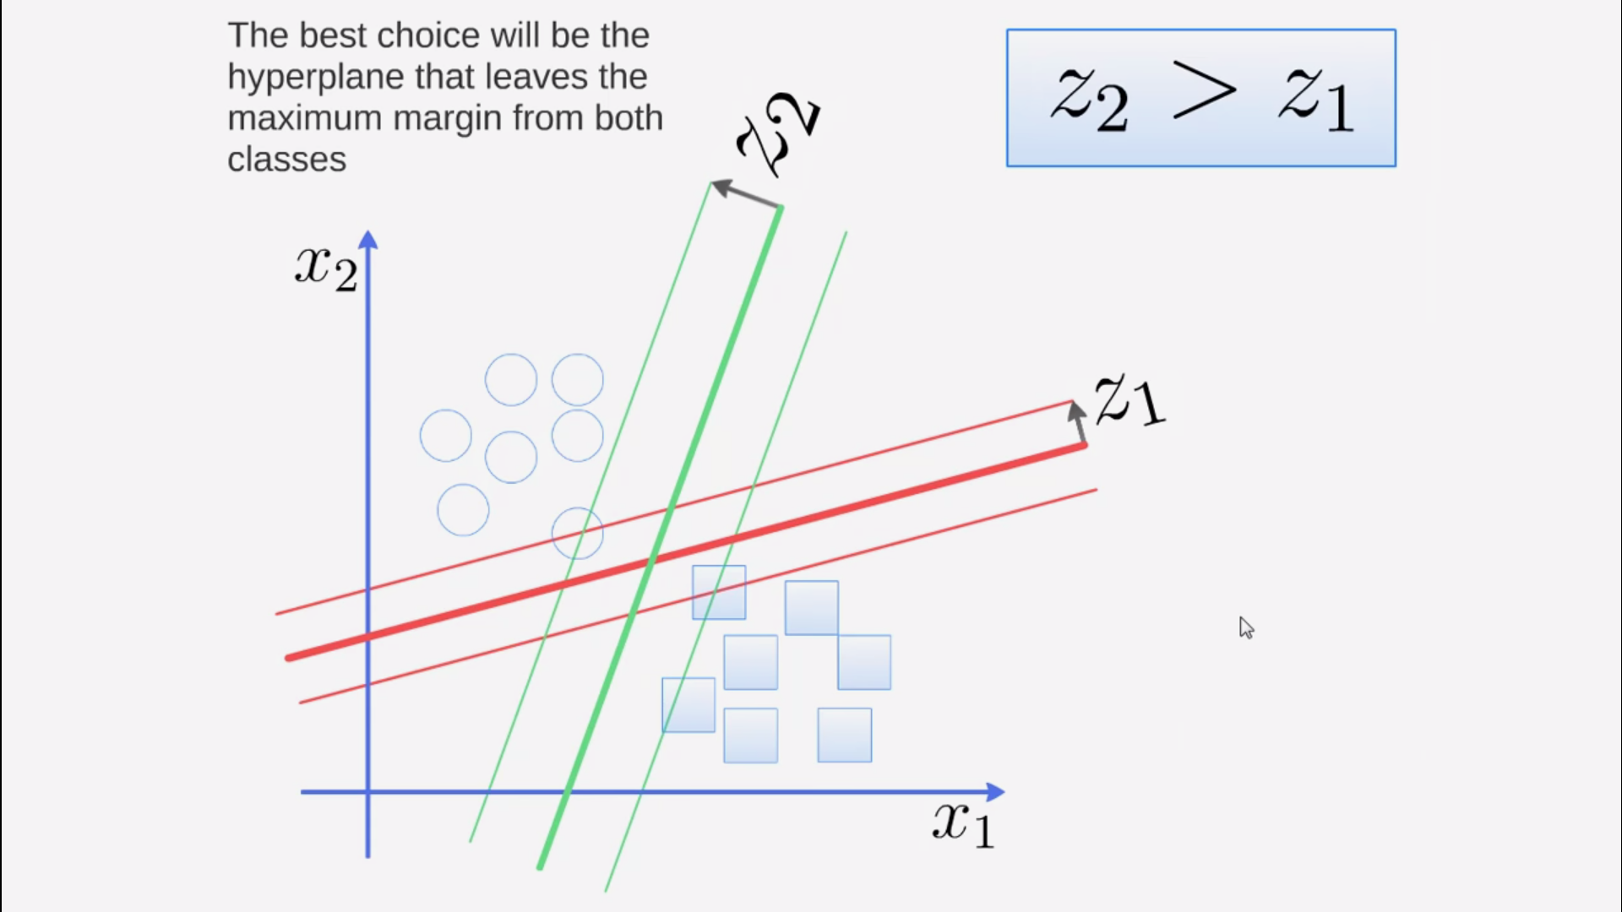

Green hyperplane is better than red one because margin of green z2 > z1

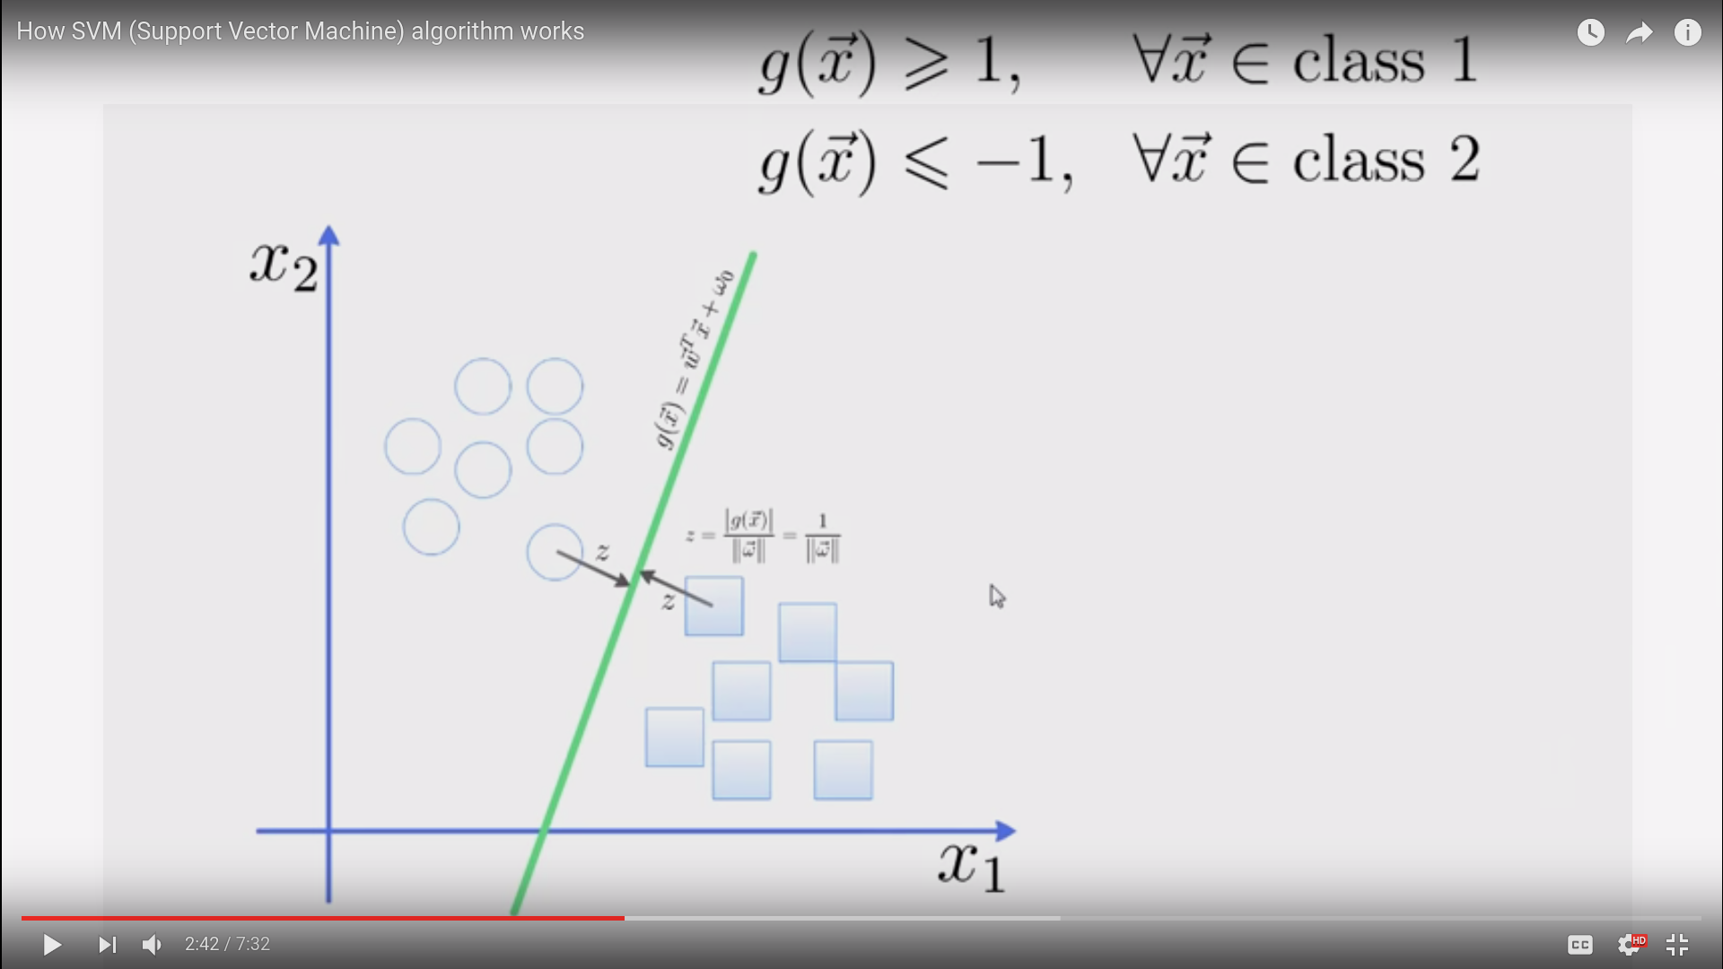

g(x)>= 1 x belongs to class1 (cycle) and g(x)<=-1 , x belongs to class2 (square)

