SpringSecurityOAuth2Example -- Authorization Server

Deploy to Eclipse Tomcat procedure

Step 1 mvn clean install

Step2 deploy folder , this project must be deployed using target war

project→properties→ Deploy Assembly→Add→Folder→target→ SpringSecurityOAuth2Example

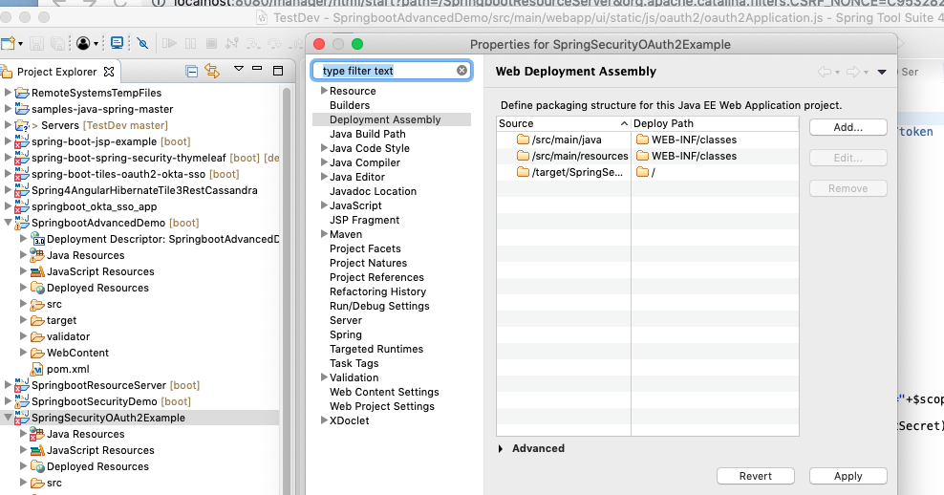

Right click server→ Add and Remove→ add SpringSecurityOAuth2Example

Add the client SpringbootAdvancedDemo – Client of Authorization Server

This project folder

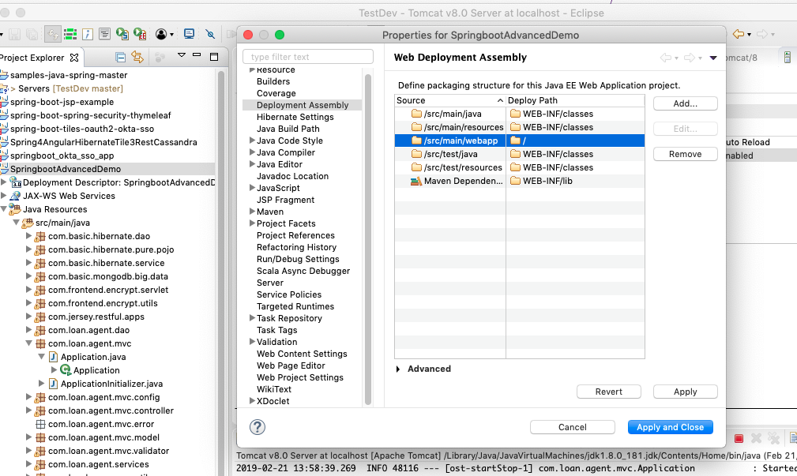

SpringbootResourceServer -- Resource Server

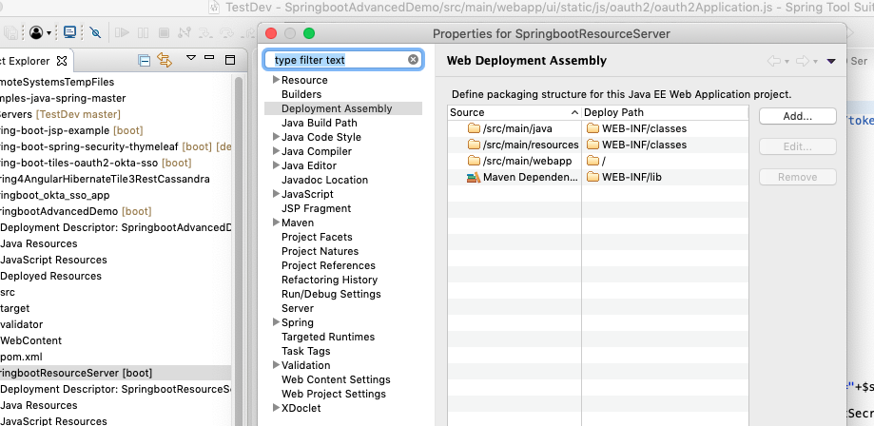

What is OAuth2
http://websystique.com/spring-security/secure-spring-rest-api-using-oauth2/
OAuth2 is an standardized authorization protocol/framework. As per Official OAuth2 Specification:
The OAuth 2.0 authorization framework enables a third-party application to obtain limited access to an HTTP service, either on behalf of a resource owner by orchestrating an approval interaction between the resource owner and the HTTP service, or by allowing the third-party application to obtain access on its own behalf.
Big players like Google, Facebook and others are already using their own OAuth2 implementations for quite some time. Enterprises too are moving fast towards OAuth2 adoption.
I found OAuth2 specification rather simple to follow. Yet if you want to start even quickly, an excellent article on OAuth2 fundamentals can be found here which gives a deep insight in OAUth2 theoretical concepts.
Spring Security OAuth project provides all the necessary API we might need in order to develop an OAuth2 compliant implementation using Spring. Official Spring security oauth project provides a comprehensive example for implementing OAuth2. The code samples of this post is inspired by that examples itself. The intention of this post is to just use bare-minimum functionality required in order to secure our REST API, nothing more.
At minimum, you should be aware of four key concepts in OAuth2:

1. OAuth2 Roles
OAuth2 defines four roles:
- resource owner:
Could be you. An entity capable of granting access to a protected resource. When the resource owner is a person, it is referred to as an end-user.
- resource server:
The server hosting the protected resources, capable of accepting and responding to protected resource requests using access tokens.
- client:
An application making protected resource requests on behalf of the resource owner and with its authorization. It could be a mobile app asking your permission to access your Facebook feeds, a REST client trying to access REST API, a web site [Stackoverflow e.g.] providing an alternative login option using Facebook account.
- authorization server:
The server issuing access tokens to the client after successfully authenticating the resource owner and obtaining authorization.
In our example, our REST API can only be accessed via Resource server which will require an access token to be present with request

2. OAuth2 Authorization Grant types
An authorization grant is a credential representing the resource owner’s authorization (to access its protected resources) used by the client to obtain an access token. The specification defines four grant types:
- authorization code
- implicit
- resource owner password credentials
- client credentials
We will be using resource owner password credentials grant type. The reason is simple, we are not implementing a view which redirects us to a login page. Only the usage where a client [Postman or RestTemplate based Java client e.g.] have the Resource owner’s credentials and they provide those credential [along with client credentials] to authorization server in order to eventually receive the access-token[and optionally refresh token], and then use that token to actually access the resources.
A common example is the GMail app [a client] on your smartphone which takes your credentials and use them to connect to GMail servers. It also shows that ‘Password Credentials Grant’ is best suited when both the client and the servers are from same company as the trust is there, you don’t want to provide your credentials to a third party.

3. OAuth2 Tokens
Tokens are implementation specific random strings, generated by the authorization server and are issued when the client requests them.
- Access Token : Sent with each request, usually valid for a very short life time [an hour e.g.]
- Refresh Token : Mainly used to get a new access token, not sent with each request, usually lives longer than access token.
A Word on HTTPS : For any sort of Security implementation, ranging from Basic authentication to a full fledged OAuth2 implementation, HTTPS is a must have. Without HTTPS, no matter what your implementation is, security is vulnerable to be compromised.

4. OAuth2 Access Token Scope
Client can ask for the resource with specific access rights using scope [want to access feeds & photos of this users facebook account], and authorization server in turn return scope showing what access rights were actually granted to the client [Resource owner only allowed feeds access, no photos e.g.].

. Endpoints and their purpose
- Attempt to access resources [REST API] without any authorization [will fail of-course].
GET http://localhost:8080/SpringSecurityOAuth2Example/user/
- Ask for tokens[access+refresh] using HTTP POST on /oauth/token, with grant_type=password,and resource owners credentials as req-params. Additionally, send client credentials in Authorization header.
POST http://localhost:8080/SpringSecurityOAuth2Example/oauth/token?grant_type=password&username=bill&password=abc123
- Ask for a new access token via valid refresh-token, using HTTP POST on /oauth/token, with grant_type=refresh_token,and sending actual refresh token. Additionally, send client credentials in Authorization header.
POST http://localhost:8080/SpringSecurityOAuth2Example/oauth/token?grant_type=refresh_token&refresh_token=094b7d23-973f-4cc1-83ad-8ffd43de1845
- Access the resource by providing an access token using access_token query param with request.
GET http://localhost:8080/SpringSecurityOAuth2Example/user/?access_token=3525d0e4-d881-49e7-9f91-bcfd18259109
- Not enter username and password
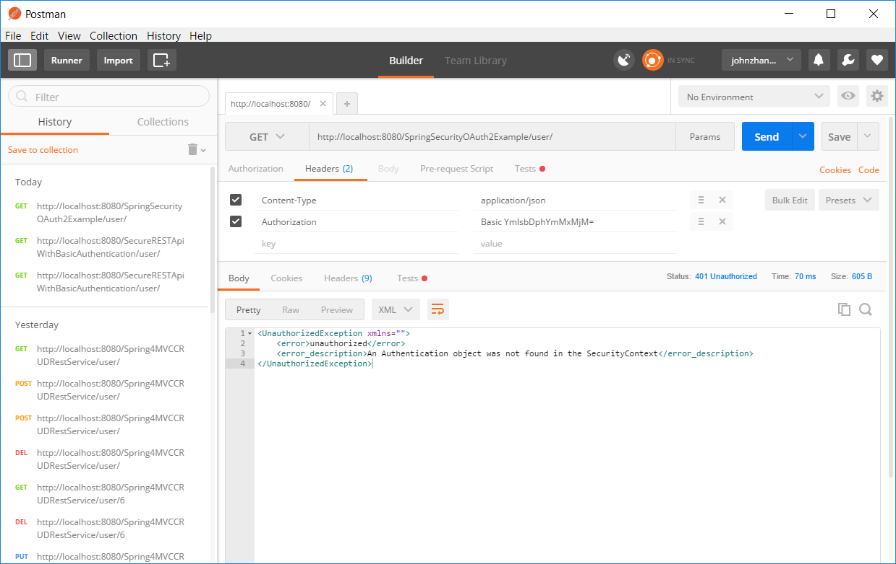Lj

let’s get the tokens. First add an authorization header with client credentials [my-trusted-client/secret].
- Ask for tokens[access+refresh] using HTTP POST on /oauth/token, with grant_type=password,and resource owners credentials as req-params. Additionally, send client credentials in Authorization header.
POST http://localhost:8080/SpringSecurityOAuth2Example/oauth/token?grant_type=password&username=bill&password=abc123
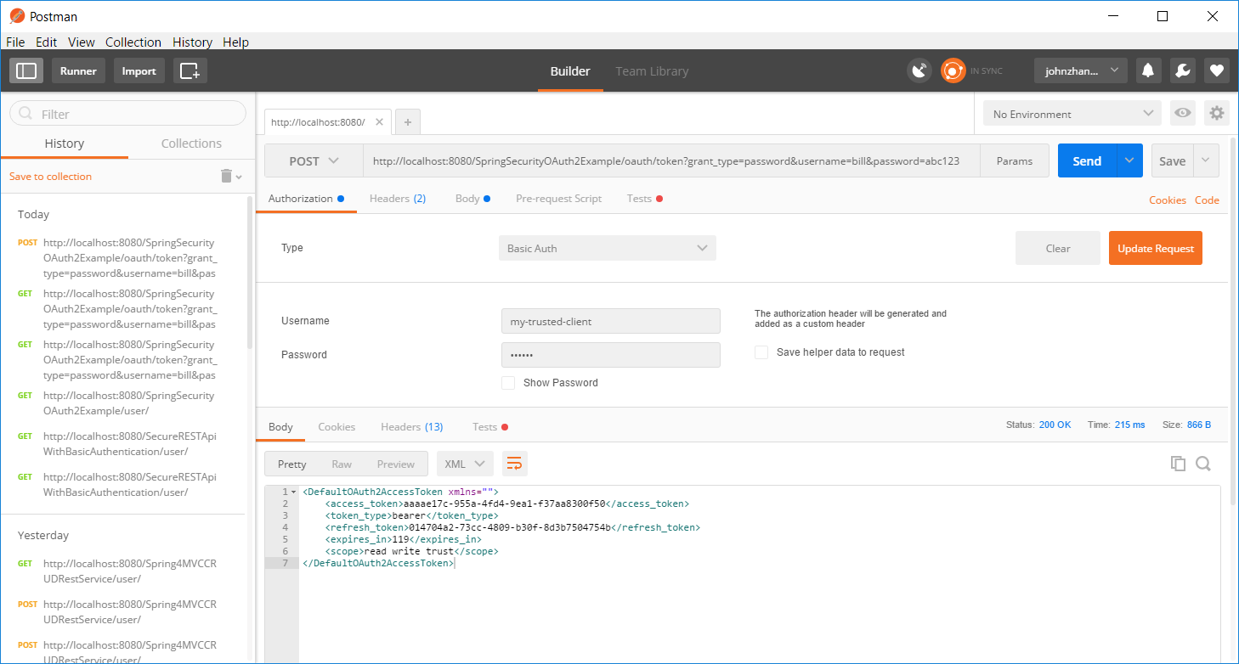
I get access token: aaaae17c-955a-4fd4-9ea1-f37aa8300f50
Refresh token: 014704a2-73cc-4809-b30f-8d3b7504754b
- Access the resource by providing an access token using access_token query param with request.
- GET http://localhost:8080/SpringSecurityOAuth2Example/user/?access_token= aaaae17c-955a-4fd4-9ea1-f37aa8300f50

Because I take long time, therefore expired 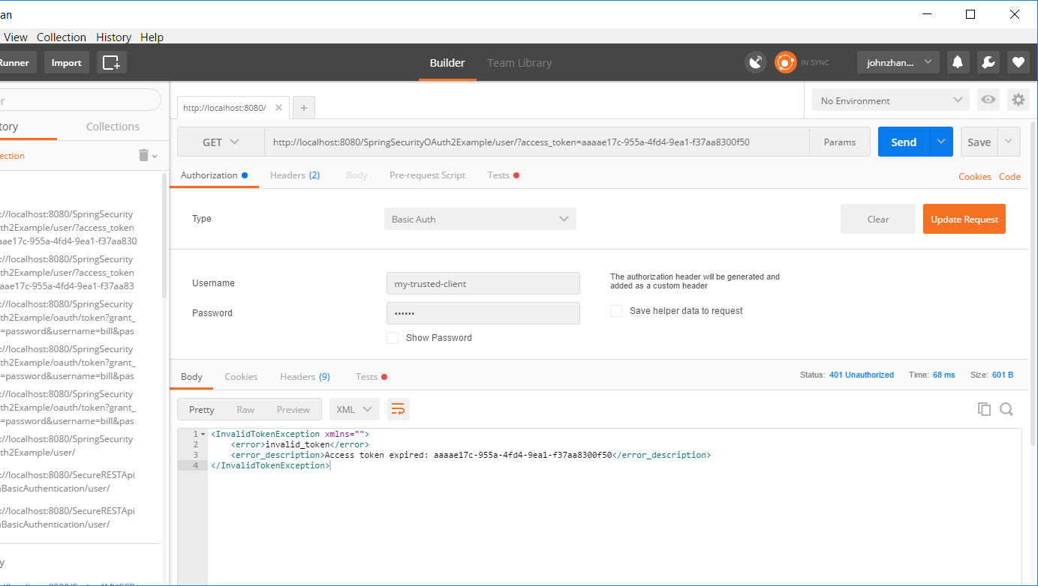
I asked again and using this token as quickly as possible, then I can get data using token
