I spent a lot of time to figure out Many to Many RelationShip generation , generate rules as following

Step 1. Create intersection table correctly
Create Composite Primary Key

create table agent_state (
user_id int(8) not null,
state varchar(4) not null,
primary key(user_id,state),
foreign key(user_id) references registration (user_id),
foreign key(state) references state (state)
) ENGINE=InnoDB AUTO_INCREMENT=1000 DEFAULT CHARSET=utf8;

Parent Tables:

create table registration (
user_id int(8) not null auto_increment,
username varchar(40) not null unique,
password varchar(40) not null,
confirm_password varchar(40) not null,
password_hint varchar(80) not null,
first_name varchar(40) not null,
last_name varchar(40) not null,
address1 varchar(60) not null,
address2 varchar(60) ,
city varchar(40) not null,
state varchar(40) not null,
zip_code varchar(10) not null,
country varchar(40) not null,
daily_phone varchar(30) not null,
email_address varchar(80) not null,
primary key(user_id)
) ENGINE=InnoDB AUTO_INCREMENT=1000 DEFAULT CHARSET=utf8;

create table state (
state varchar(4) not null,
state_name varchar(60),
primary key(state)
) ENGINE=InnoDB AUTO_INCREMENT=1000 DEFAULT CHARSET=utf8;

Step 2. Choose inter section table as reverse engineering and key generator must be foreign key because intersection table primary key rely on parents primary key

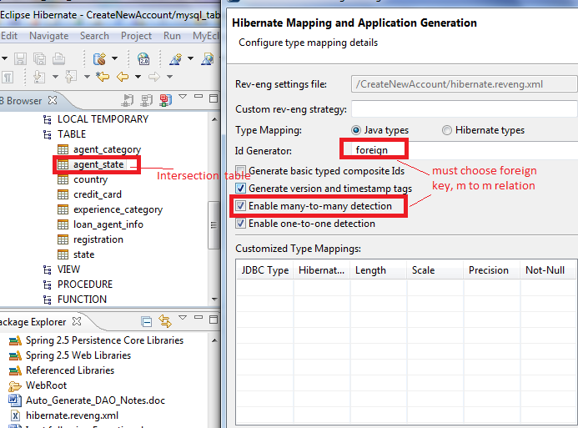

Step 3 must choose A->B relation

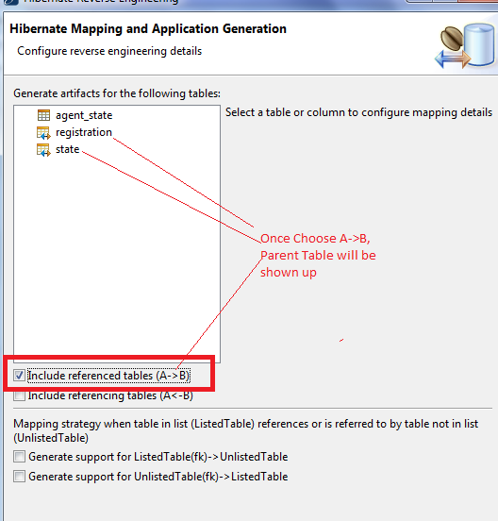

Leave Intersection Class Name and Id generator blank and
parent table must be filled , then finished

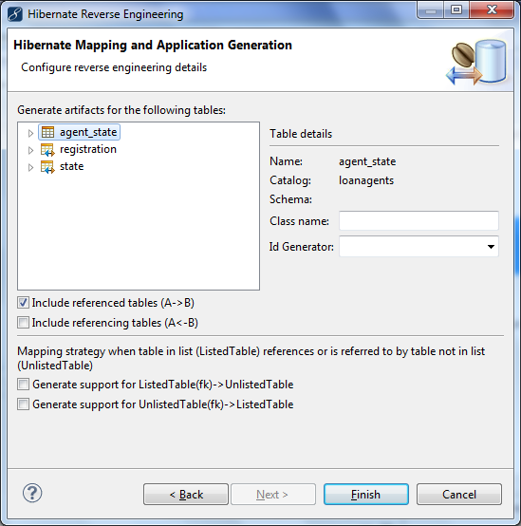

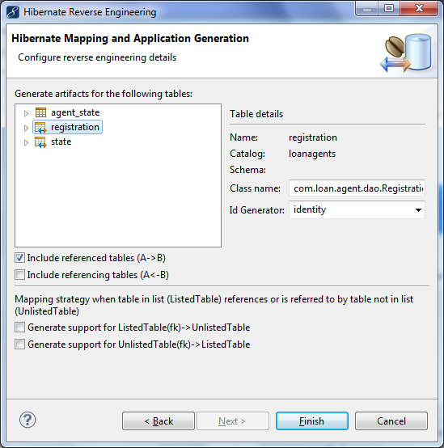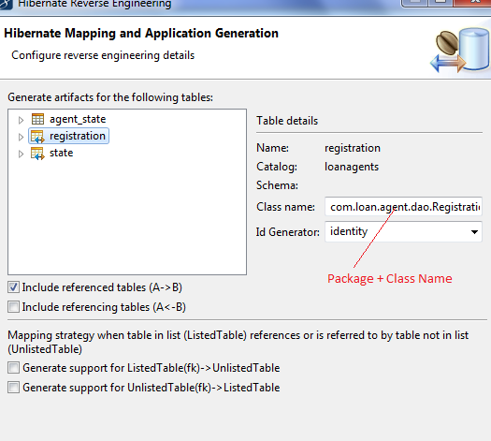

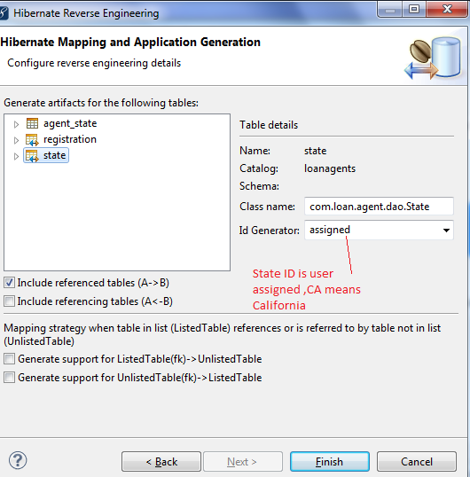

See the many to many relation from Registration and State, only there are parent tables , there is no intersection map and class

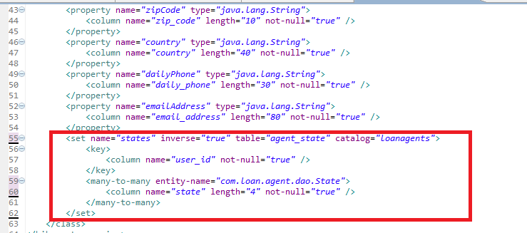

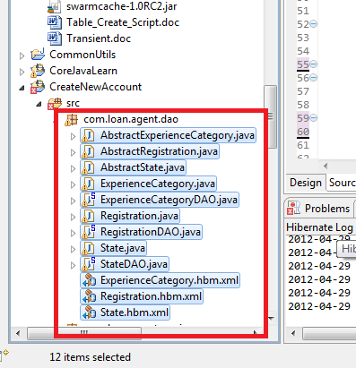

I finally user Registration (Top parent) to generate all objects
Step 1>

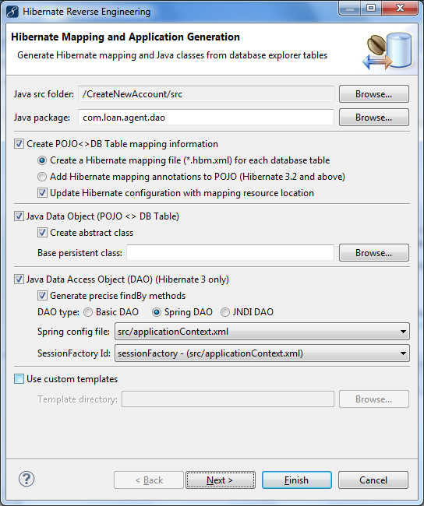

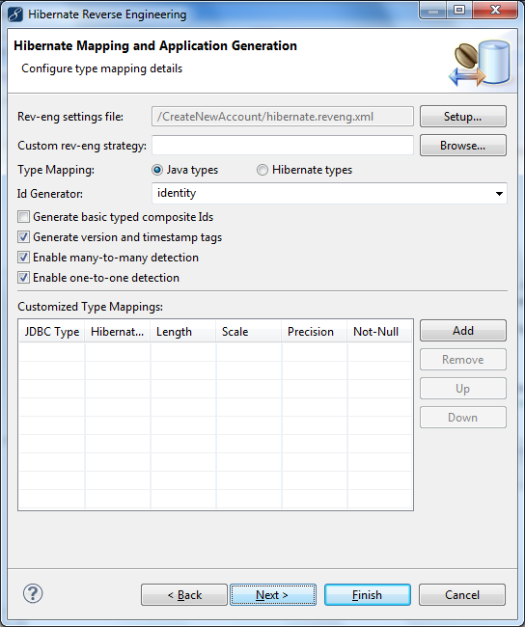

Step 3 Choose A<-B, fill all

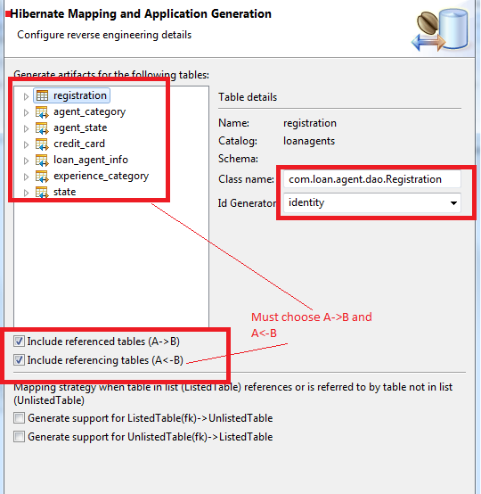

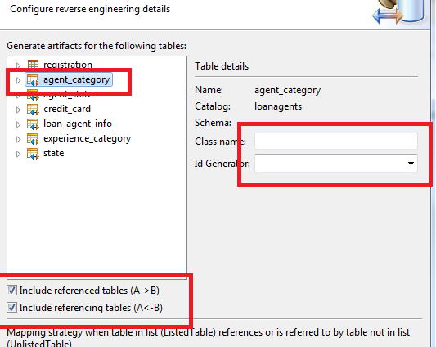

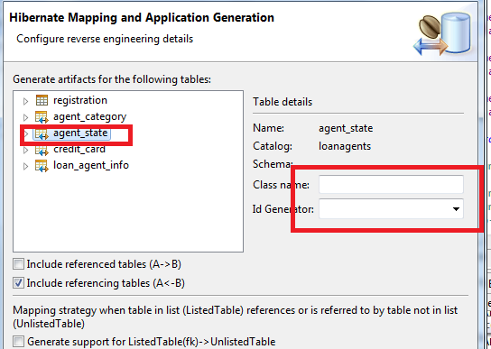

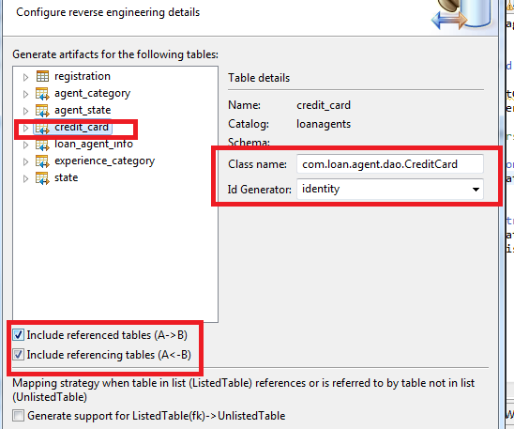
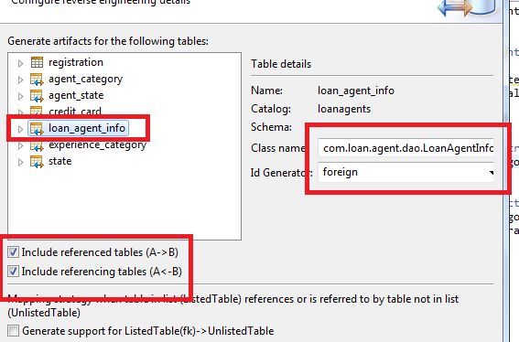

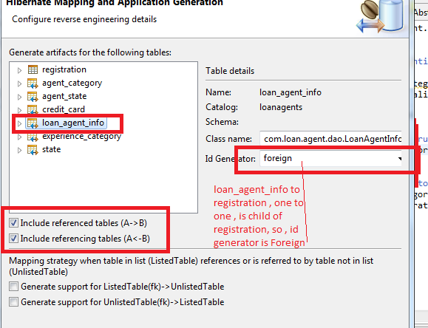

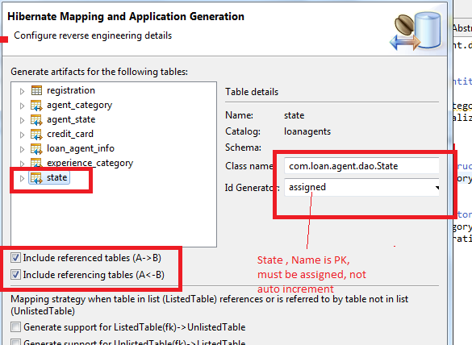

Press Finish
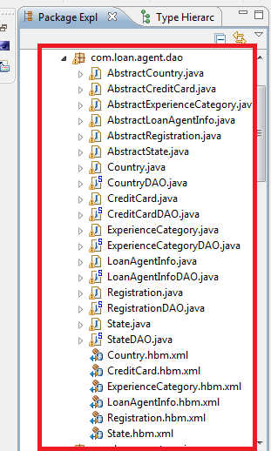

From above files view , we can see , no intersection table maps and DAO generation and MAP of registration.hbm.xml does have Many to Many relation, therefore , this is simplest and fastest generate way. There are only entity table, there is no any intersection table insides

Step 1.
Find top parents, reverse engineering

Step 2.

Generator to parent is identity

Step 3

in 'Configure reverse engineering' page, Check A->B and 'A<-B'
(1) specify class name with package name + class name and Id generator with identity for top parent (Registration)
(2) specify class name with package name + class name and Id generator with foreign key to One to One relation Child (Loan_Agent_Info)
(3) specify class name with package name + class name and Id generator with identity key to One to Many relation Child (Credit_Card)

(4) leave blank to class name Id generator to Many to Many relation Child

(5) individually generate Country which has no relation with any tables

Press Finish

