One to One Mapping

Key thing is map from child to parent otherwise mapping a lot of relations
Which table is child ? table who hold the foreign key

Choose StockDetail reverse engineering --> A->B (Child reference to parent)

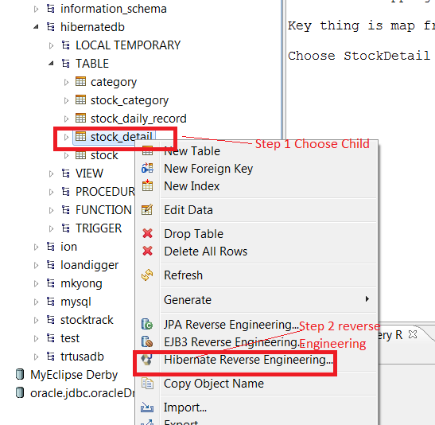

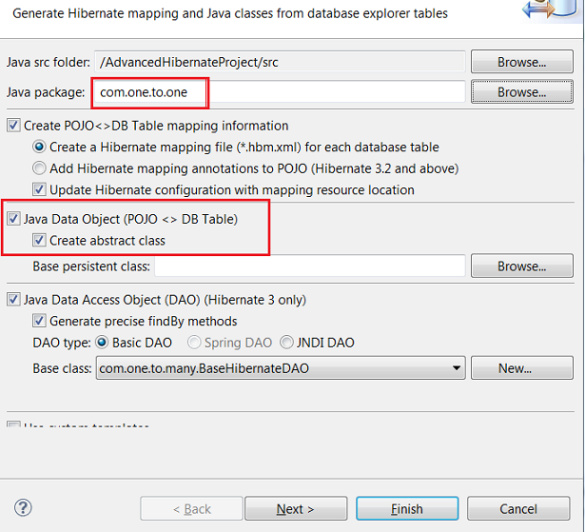

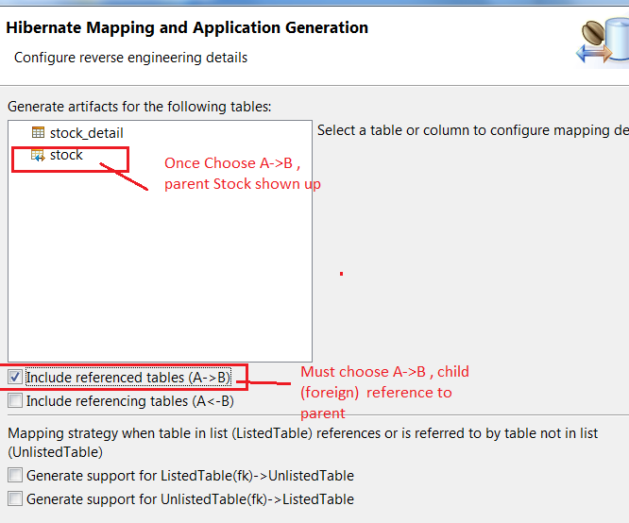

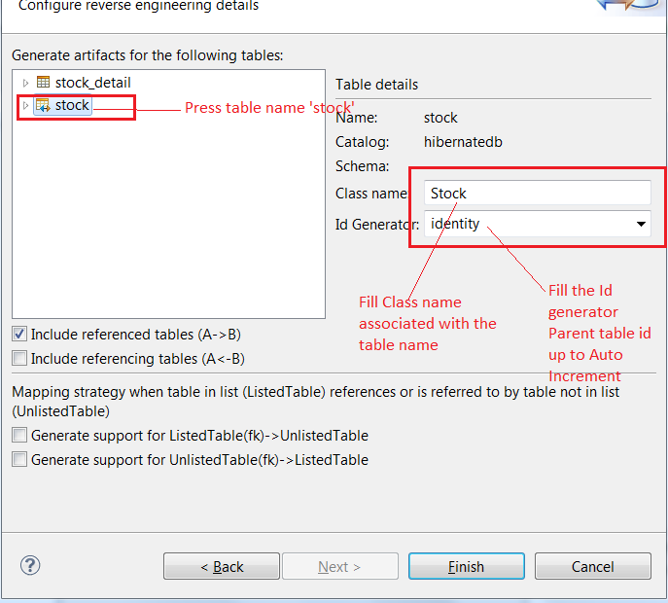

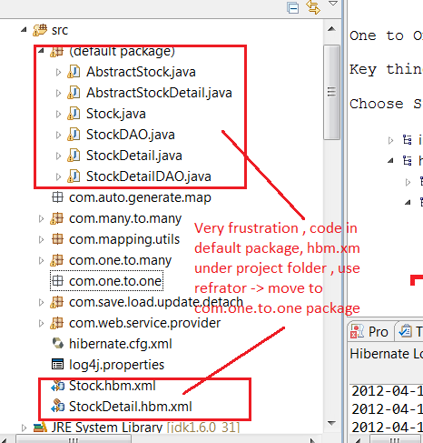

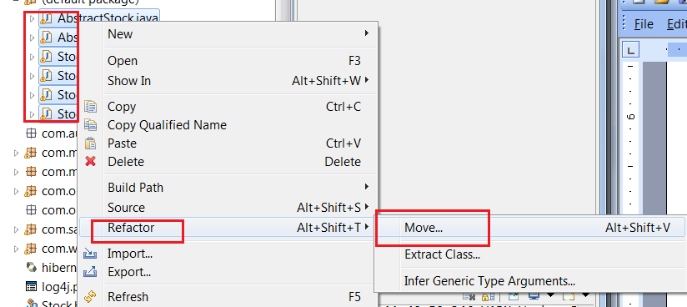

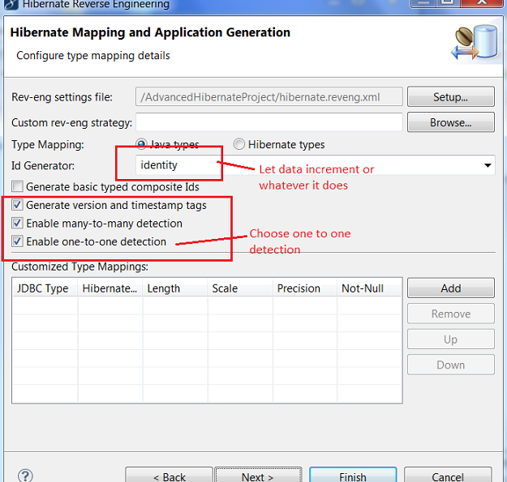

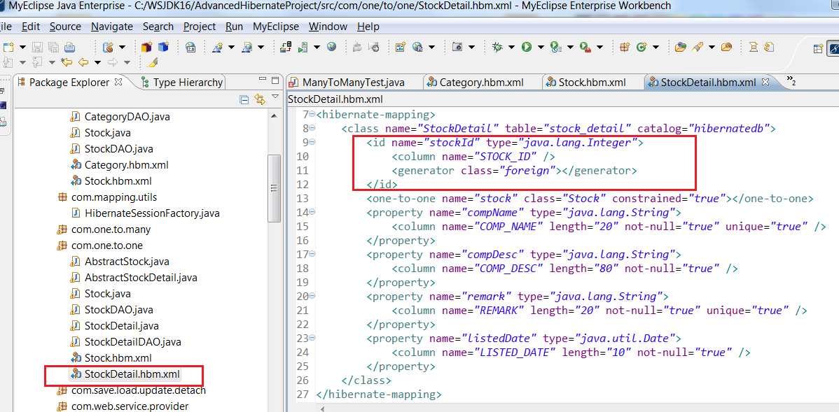

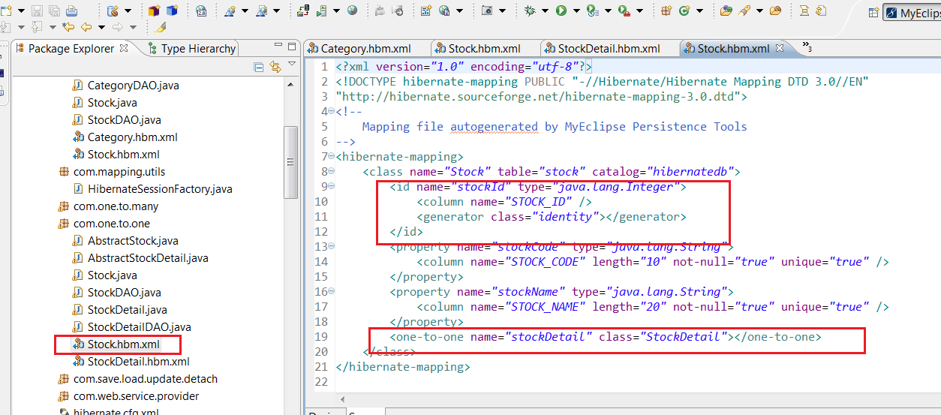

Many to Many Mapping

Key thing is map from child to parent otherwise mapping a lot of cascade relations to confuse and hard to hand for application to add and update

Which table is child ? table who hold the foreign key

Many to Many , the inter-section table is child , which is stock_category

Choose 'stock_category' reverse engineering --> A->B (Child reference to parent)
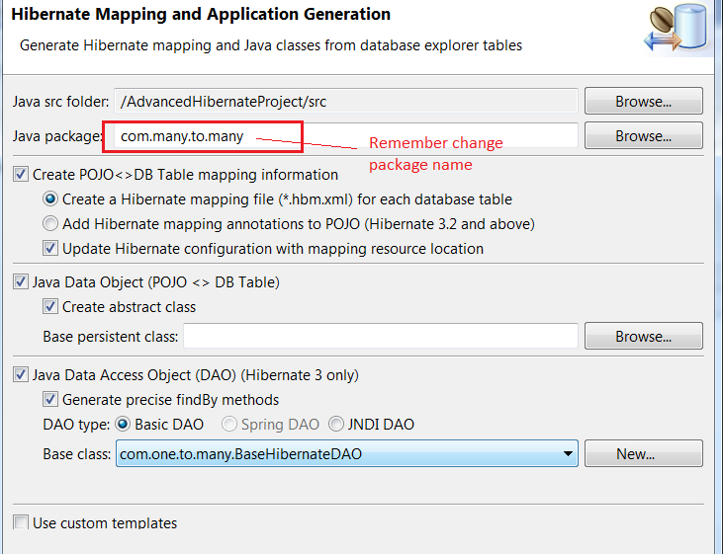

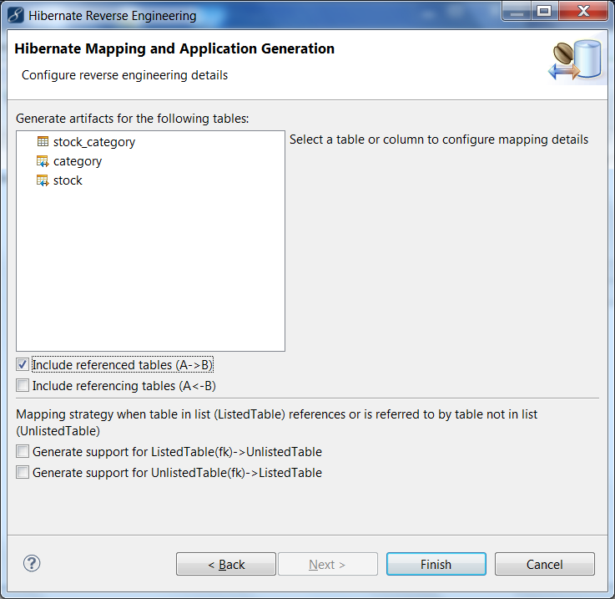

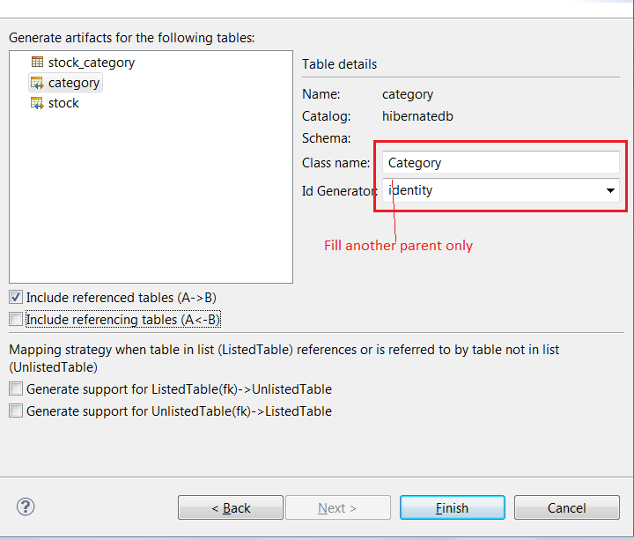

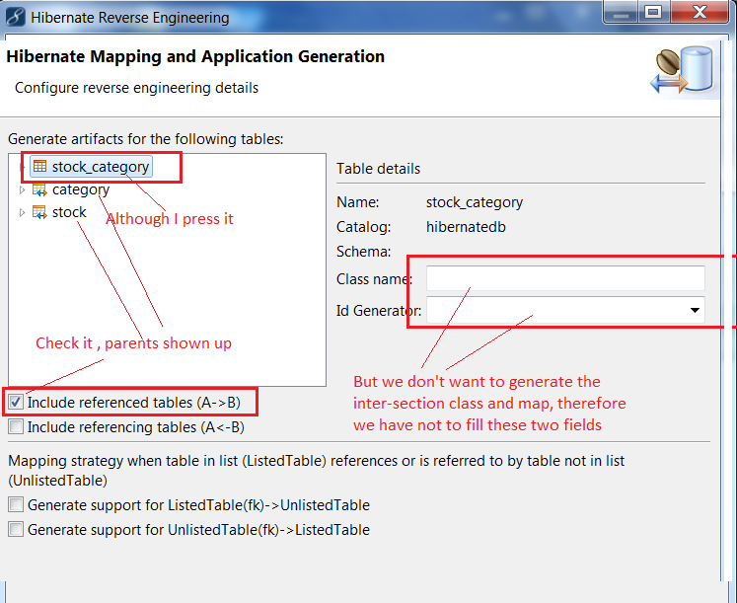

Press 'Finish' --> copy code from default package and under project to com.many.to.many package

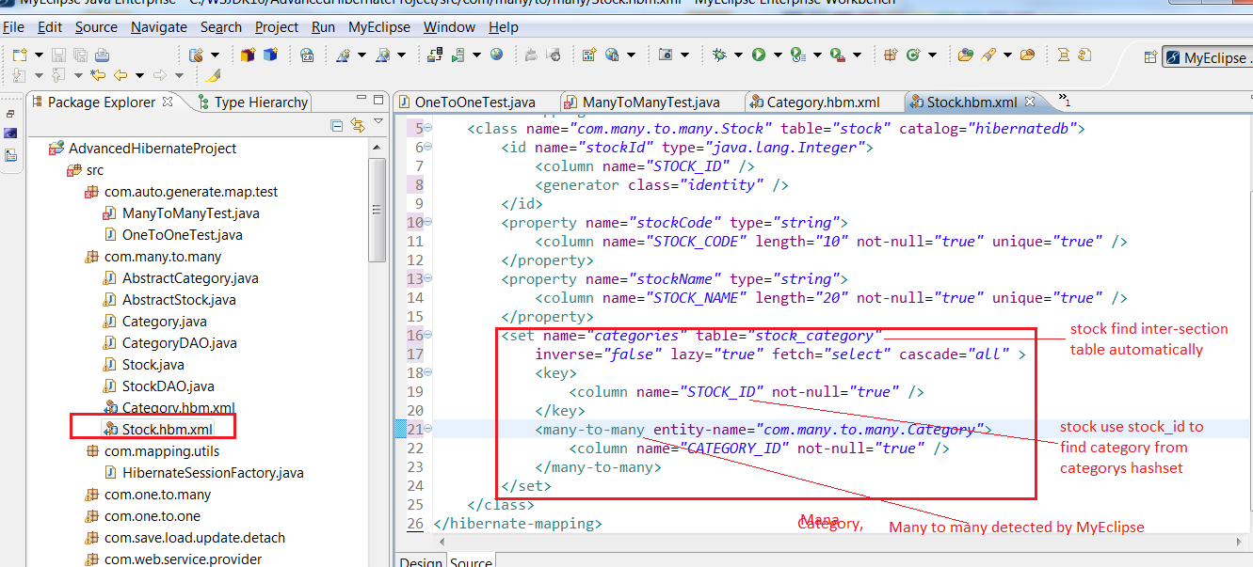

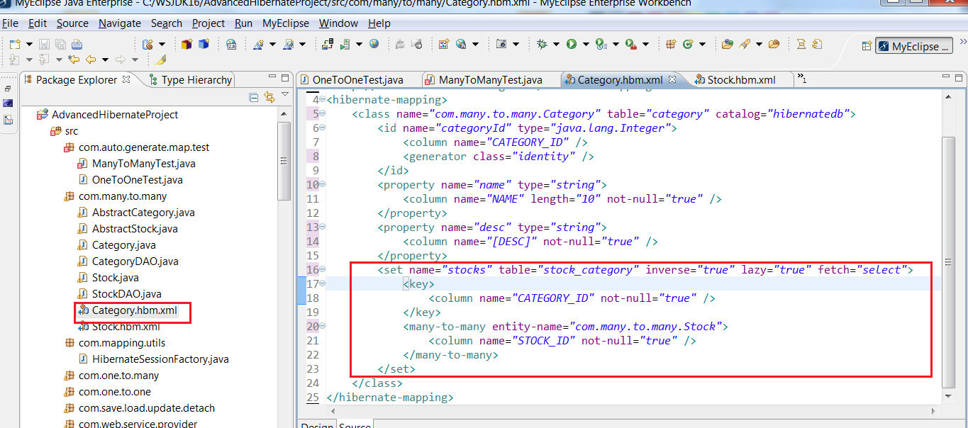

Merge Stock.bhm.xml
Edit Hibernate.hbm.xml

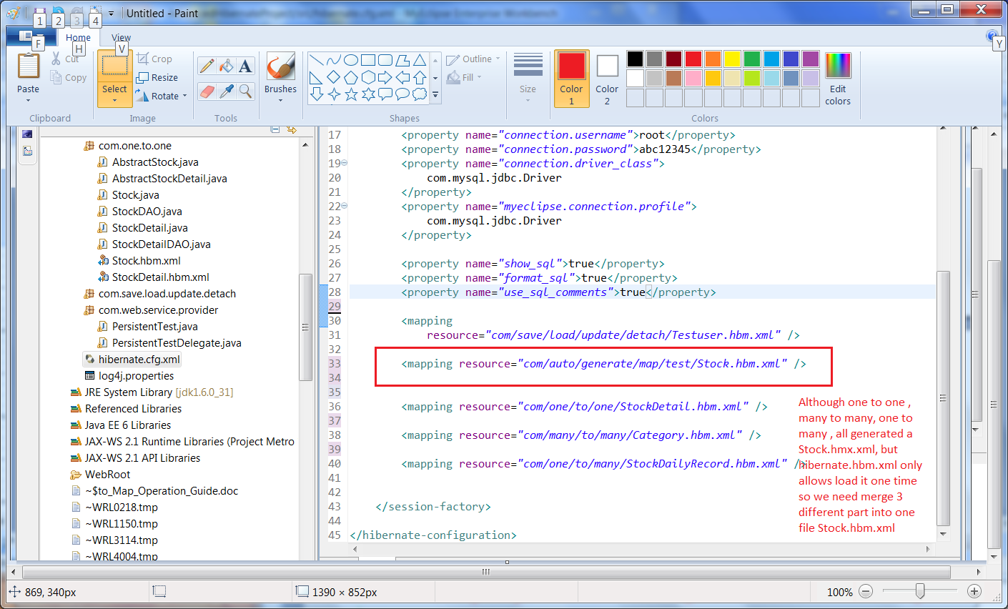

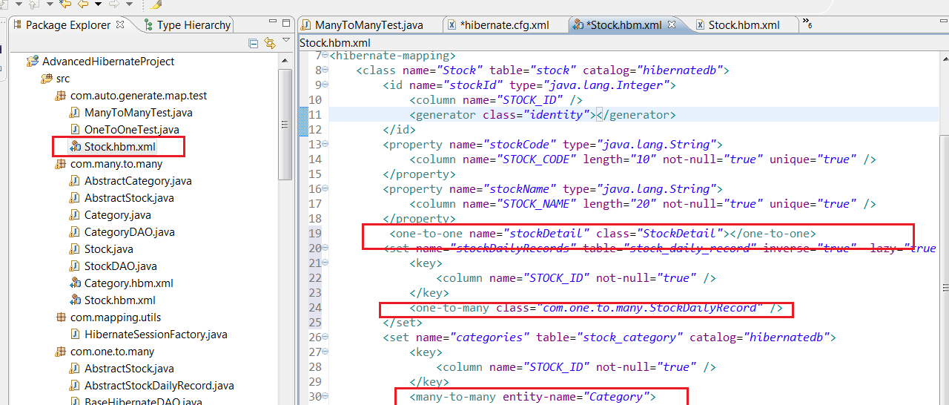

Above Step we need change each hbm.xml file

All in One is best and faster solutions

