Create Web Project --> Add Spring Capabilities first and Add Hibernate

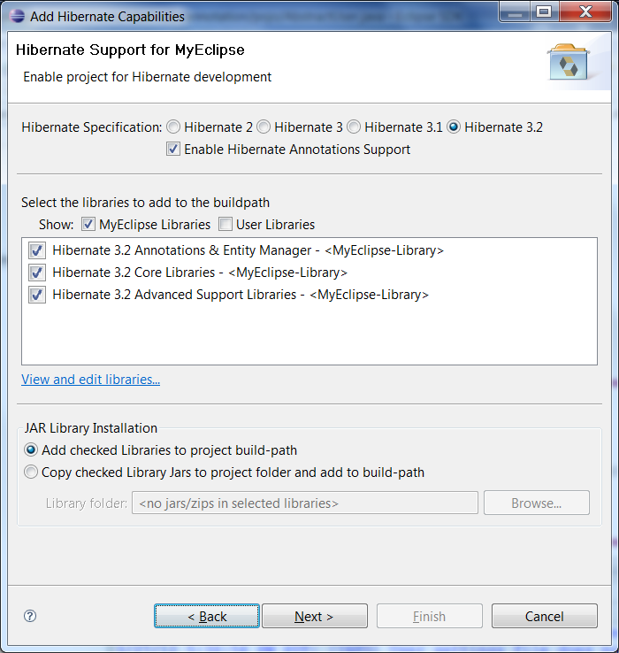

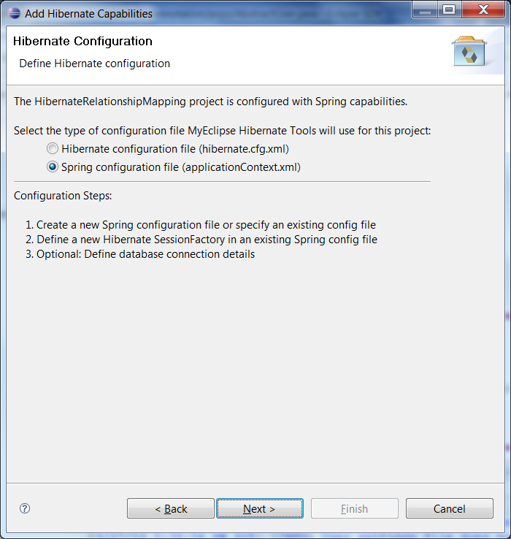

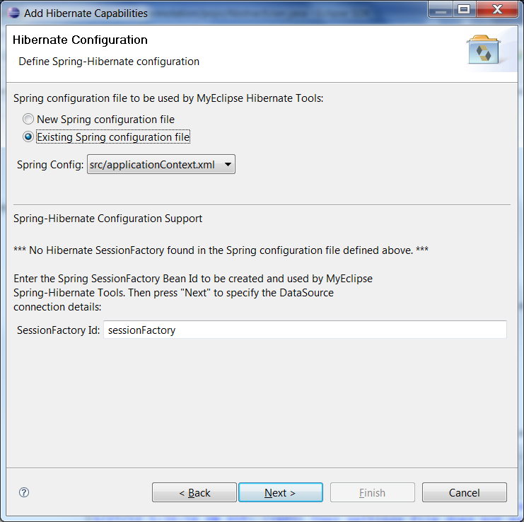

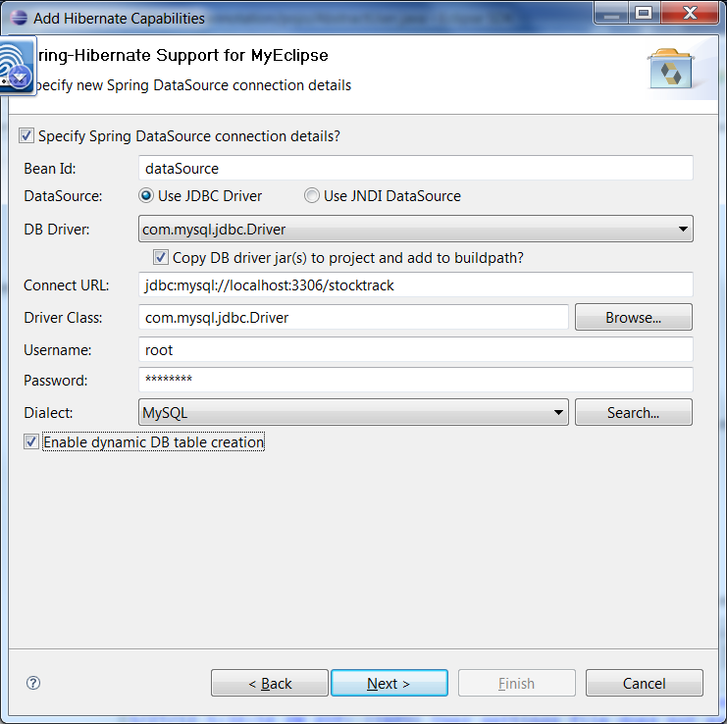

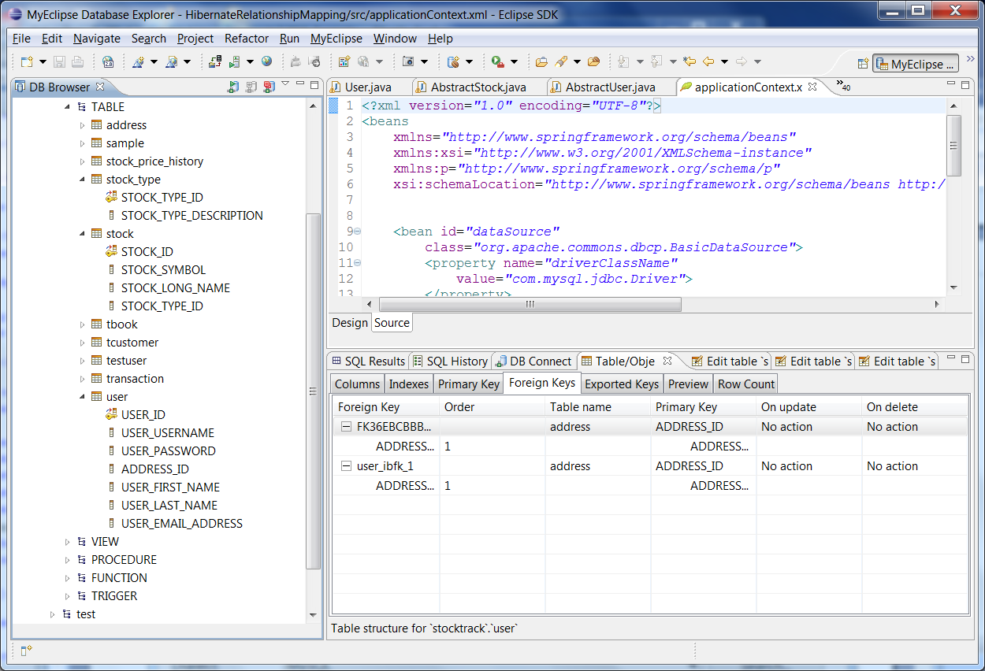

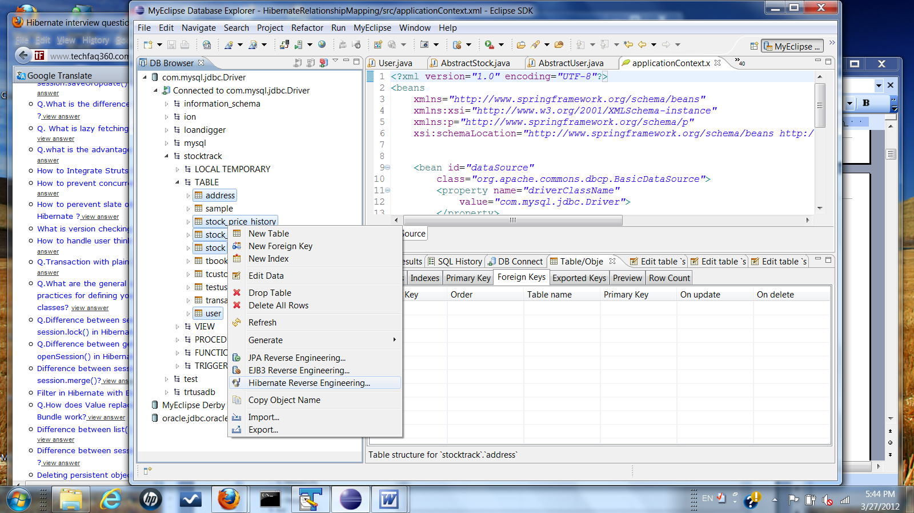

This time , we can choose sessionFactory Bean id from applicationContext.xml

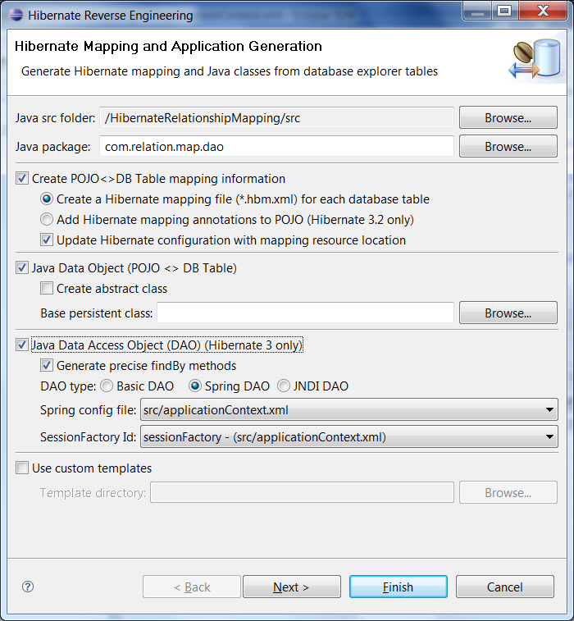

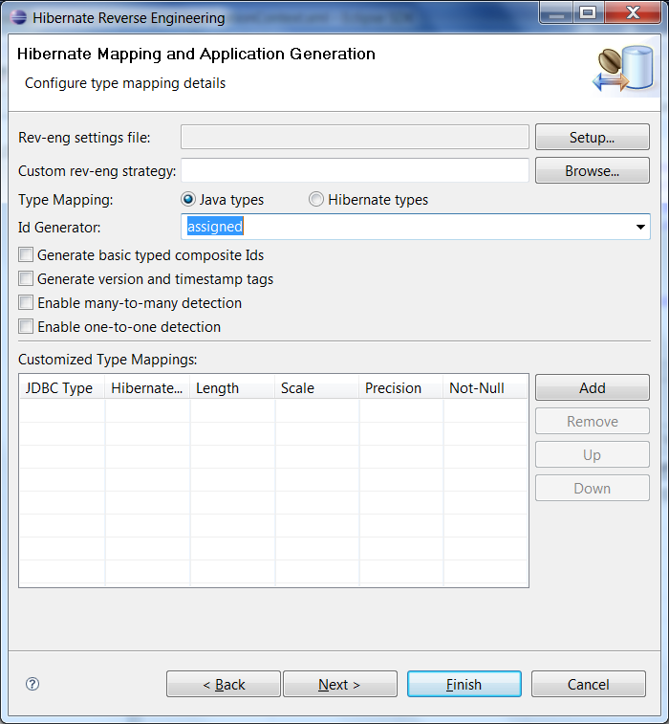

Include referencing and referenced tables

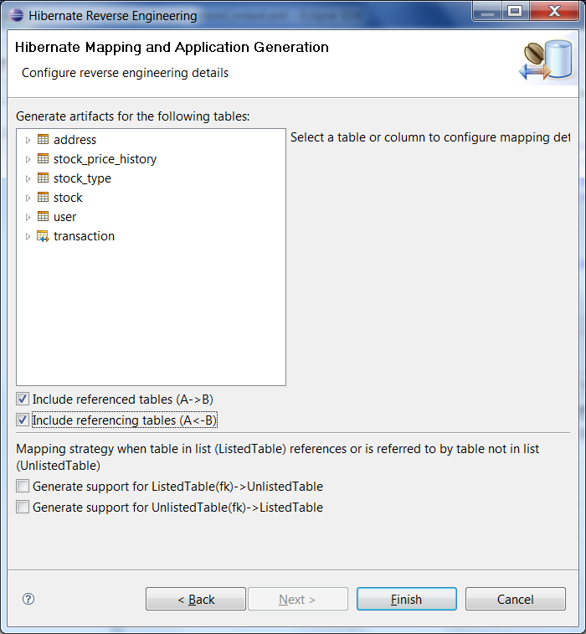

Here applicationContext.xml file

<?xml version="1.0" encoding="UTF-8"?>
<beans
xmlns="http://www.springframework.org/schema/beans"
xmlns:xsi="http://www.w3.org/2001/XMLSchema-instance"
xmlns:p="http://www.springframework.org/schema/p"
xsi:schemaLocation="http://www.springframework.org/schema/beans http://www.springframework.org/schema/beans/spring-beans-2.5.xsd">

<bean id="dataSource"
class="org.apache.commons.dbcp.BasicDataSource">
<property name="driverClassName"
value="com.mysql.jdbc.Driver">
</property>
<property name="url"
value="jdbc:mysql://localhost:3306/stocktrack">
</property>
<property name="username" value="root"></property>
<property name="password" value="abc12345"></property>
</bean>
<bean id="sessionFactory"
class="org.springframework.orm.hibernate3.annotation.AnnotationSessionFactoryBean">
<property name="dataSource">
<ref bean="dataSource" />
</property>
<property name="hibernateProperties">
<props>
<prop key="hibernate.dialect">
org.hibernate.dialect.MySQLDialect
</prop>
<prop key="hibernate.hbm2ddl.auto">update</prop>
</props>
</property>
<property name="mappingResources">
<list>
<value>com/relation/map/dao/Address.hbm.xml</value>
<value>com/relation/map/dao/User.hbm.xml</value>
<value>com/relation/map/dao/Transaction.hbm.xml</value>
<value>com/relation/map/dao/StockType.hbm.xml</value>
<value>com/relation/map/dao/Stock.hbm.xml</value>
<value>
com/relation/map/dao/StockPriceHistory.hbm.xml
</value></list>
</property></bean>
<bean id="AddressDAO" class="com.relation.map.dao.AddressDAO">
<property name="sessionFactory">
<ref bean="sessionFactory" />
</property>
</bean>
<bean id="UserDAO" class="com.relation.map.dao.UserDAO">
<property name="sessionFactory">
<ref bean="sessionFactory" />
</property>
</bean>
<bean id="TransactionDAO"
class="com.relation.map.dao.TransactionDAO">
<property name="sessionFactory">
<ref bean="sessionFactory" />
</property>
</bean>
<bean id="StockTypeDAO" class="com.relation.map.dao.StockTypeDAO">
<property name="sessionFactory">
<ref bean="sessionFactory" />
</property>
</bean>
<bean id="StockDAO" class="com.relation.map.dao.StockDAO">
<property name="sessionFactory">
<ref bean="sessionFactory" />
</property>
</bean>
<bean id="StockPriceHistoryDAO"
class="com.relation.map.dao.StockPriceHistoryDAO">
<property name="sessionFactory">
<ref bean="sessionFactory" />
</property>
</bean></beans>

