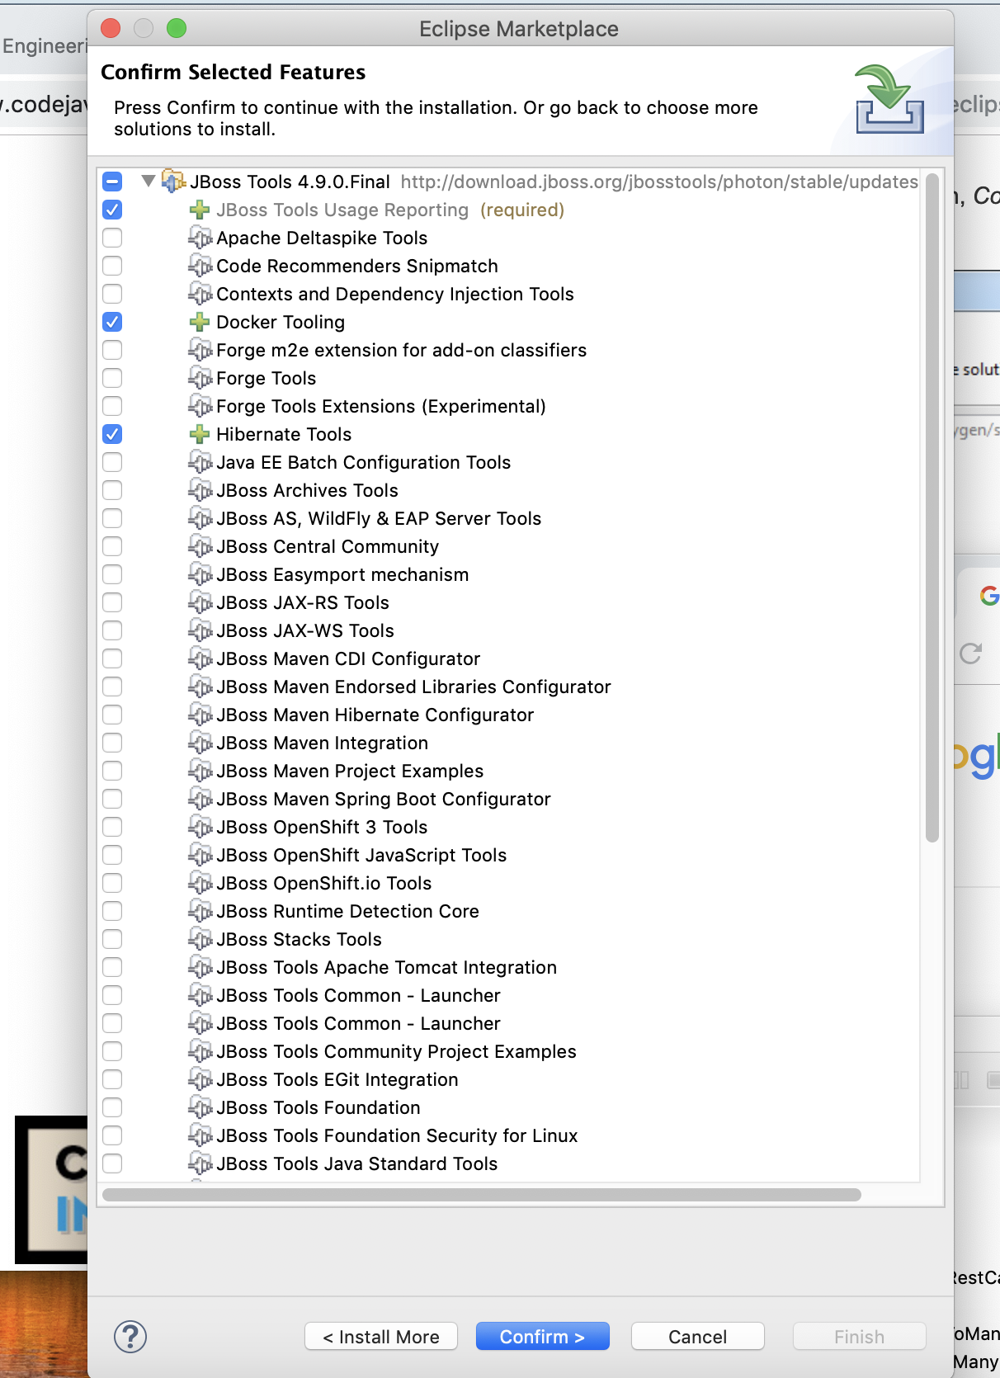

<https://www.codejava.net/frameworks/hibernate/java-hibernate-reverse-engineering-tutorial-with-eclipse-and-mysql>

] 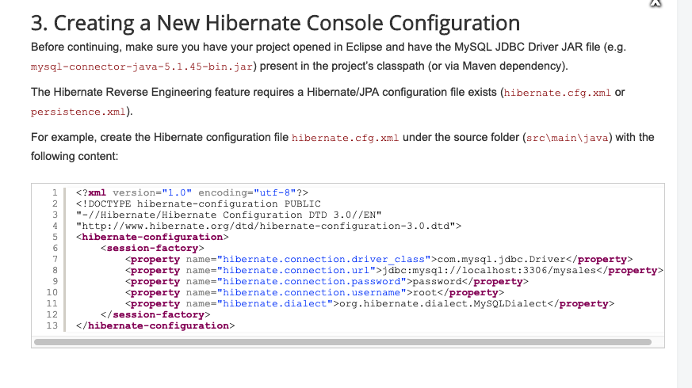

Now, in the *Hibernate Configurations* view, click the **Add Configuration…** button:

