Optimizing Cross-Border CCS Policy: An Integrated Energy–Carbon–Cost Framework for Source–Host Credit Allocation
John Z.Z.Ting¹, Jeng Shiun Lim^{1,2}, Sharifah Rafidah Wan Alwi^{1,2}, Zainuddin Abdul Manan^{1,2}, Bohong Wang³, Limei Gai³
¹Faculty of Chemical and Energy Engineering, Universiti Teknologi Malaysia (UTM), 81310 Johor Bahru, Malaysia
²Process Systems Engineering Centre (PROSPECT), Research Institute for Sustainable Environment, Universiti Teknologi Malaysia (UTM), 81310 Johor Bahru, Johor, Malaysia
³National & Local Joint Engineering Research Center of Harbor Oil & Gas Storage and Transportation Technology/Zhejiang Key Laboratory of Pollution Control for Port- Petrochemical Industry, School of Petrochemical Engineering & Environment, Zhejiang Ocean University, Zhoushan, Zhejiang 316022, China

Abstract
Cross-border carbon capture and storage (CCS) can support industrial decarbonisation where emissions and storage resources are unevenly distributed. Existing optimisation studies mainly minimise techno-economic cost and rarely integrate energy penalties, country-level emissions accounting, domestic-versus-export allocation, and source–host credit sharing. This study develops a process-systems-engineering-based mixed-integer linear programming framework linking CO₂ capture, shipping, offshore-pipeline transport, injection, energy use, physical emissions, carbon penalties, and country-specific credits. The framework is demonstrated using an anonymised Japan–Malaysia case with two Japanese sources, two Malaysian offshore sinks, domestic Japanese storage, route and pipeline choices, import limits, risk premiums, and α-based credit allocation. The model minimises annual system cost subject to mass-balance, capture, route, injection, and storage constraints. Under base assumptions, domestic Japanese storage costs USD0.420 billion/year, compared with USD0.462 billion/year for full export. The Combined Competitiveness case lowers the objective to USD0.442 billion/year and selects full export to MY-Sink 2 when the low host fee, country-specific credits, higher domestic cost, sink premiums, and reservation conditions are applied. The base export case sends 2.716 MtCO₂/year to MY-Sink 1 and stores 2.672 MtCO₂/year after transport losses. Source-country credit allocation gives the lowest α-case objective because Japan's credit value is higher, whereas host-country allocation transfers the accounting benefit to Malaysia. The framework provides a transparent method for assessing cross-border CCS competitiveness, operational emissions, sink selection, and hypothetical source–host benefit sharing.
Keywords: carbon capture and storage; process systems engineering; mixed-integer linear programming; cross-border CCS; Japan; Malaysia; carbon accounting

1. Introduction
Deep decarbonisation requires mitigation options for residual and process-related emissions from cement, steel, refining, chemicals, petrochemicals, and power generation. Carbon capture and storage (CCS) can address these hard-to-abate emissions through an integrated chain of capture, conditioning, transport, injection, monitoring, and geological storage. Deployment is increasing, but current and announced capacity remains below that required for net-zero pathways^{[1,2]}, strengthening the need for efficient full-chain planning.
CCS optimisation has traditionally focused on source–sink matching, transport-network design, pipeline sizing, storage allocation, and capacity expansion^{[3-5]}. Later studies improved the representation of shipping, ports, offshore pipelines, and storage logistics^{[6-9]}. These models establish a strong engineering basis for network design, but most emphasise techno-economic configuration. Energy-related emissions are often treated indirectly or assessed after optimisation, and the benefit of verified storage is rarely allocated explicitly between participating jurisdictions.
This limitation is important for cross-border CCS. Capture electricity, maritime transport, offshore pipeline transfer, and injection generate emissions in different countries, so stored CO₂ and net mitigation are not equivalent. The source country may seek recognition for avoided industrial emissions, whereas the host country provides storage capacity, infrastructure, monitoring, and long-term stewardship. Existing environmental studies support full-chain assessment^{[10-12]}, while continuing advances in capture materials demonstrate the broader development of efficient CO₂ separation technologies^{[13]}. However, optimisation models seldom connect energy use, national emissions balances, route and sink decisions, and source–host benefit allocation within one formulation.
Four related gaps motivate this study: incomplete representation of full-chain energy penalties; limited country-level physical-emissions accounting; absence of an explicit rule for allocating the verified storage benefit without double counting; and limited comparison of optimised export pathways with a domestic-storage alternative. Addressing these gaps requires an integrated energy–carbon–cost framework that links physical flows, infrastructure choices, operational emissions, policy values, and jurisdictional accounting.
Accordingly, this study develops a mixed-integer linear programming framework with four contributions. It integrates capture, shipping, offshore-pipeline, and injection energy with CO₂ flows; formulates physical, credited, and net-emissions balances for source and host countries; introduces α-source and α-host shares for hypothetical source-claim, host-claim, and shared-credit cases; and compares domestic storage with cross-border export within a common scenario structure. The framework is demonstrated using an anonymised Japan–Malaysia system with two Japanese sources and two Malaysian offshore sinks.

2. Methodology

2.1 Generalised Problem Statement and System Boundary
The optimisation problem is formulated as a general framework for cross-border CCS network design and operation. The proposed framework accommodates CCS systems involving multiple CO₂ emission sources, domestic and foreign storage alternatives, transport routes, infrastructure options, jurisdictions, and policy scenarios. The case-specific source locations, storage sites, transport distances, costs, capacities, and policy parameters are introduced later in the case study section.
Given a set of CO₂ emission sources $i∈I$, candidate storage sinks $j∈J$, transport routes $r∈R$, transport modes $m∈M$, countries or jurisdictions $k∈K$, operating periods $t∈T$, infrastructure options $d∈D$, and policy scenarios $s∈S$, the model determines the least-cost configuration and operation of the CCS chain. The storage set $J$may be divided into domestic storage alternatives $J^{D}$and foreign or cross-border storage sinks $J^{F}$. A general CCS superstructure is depicted in Figure 1.
Captured CO₂ can therefore be allocated either to domestic storage or to cross-border export routes. The cross-border pathway links source-country capture and export activities with host-country import, transport, injection, and geological storage activities. This structure allows the same optimisation framework to evaluate domestic-versus-export storage decisions, route and sink selection, infrastructure sizing, energy use, emissions accounting, and carbon-credit allocation.
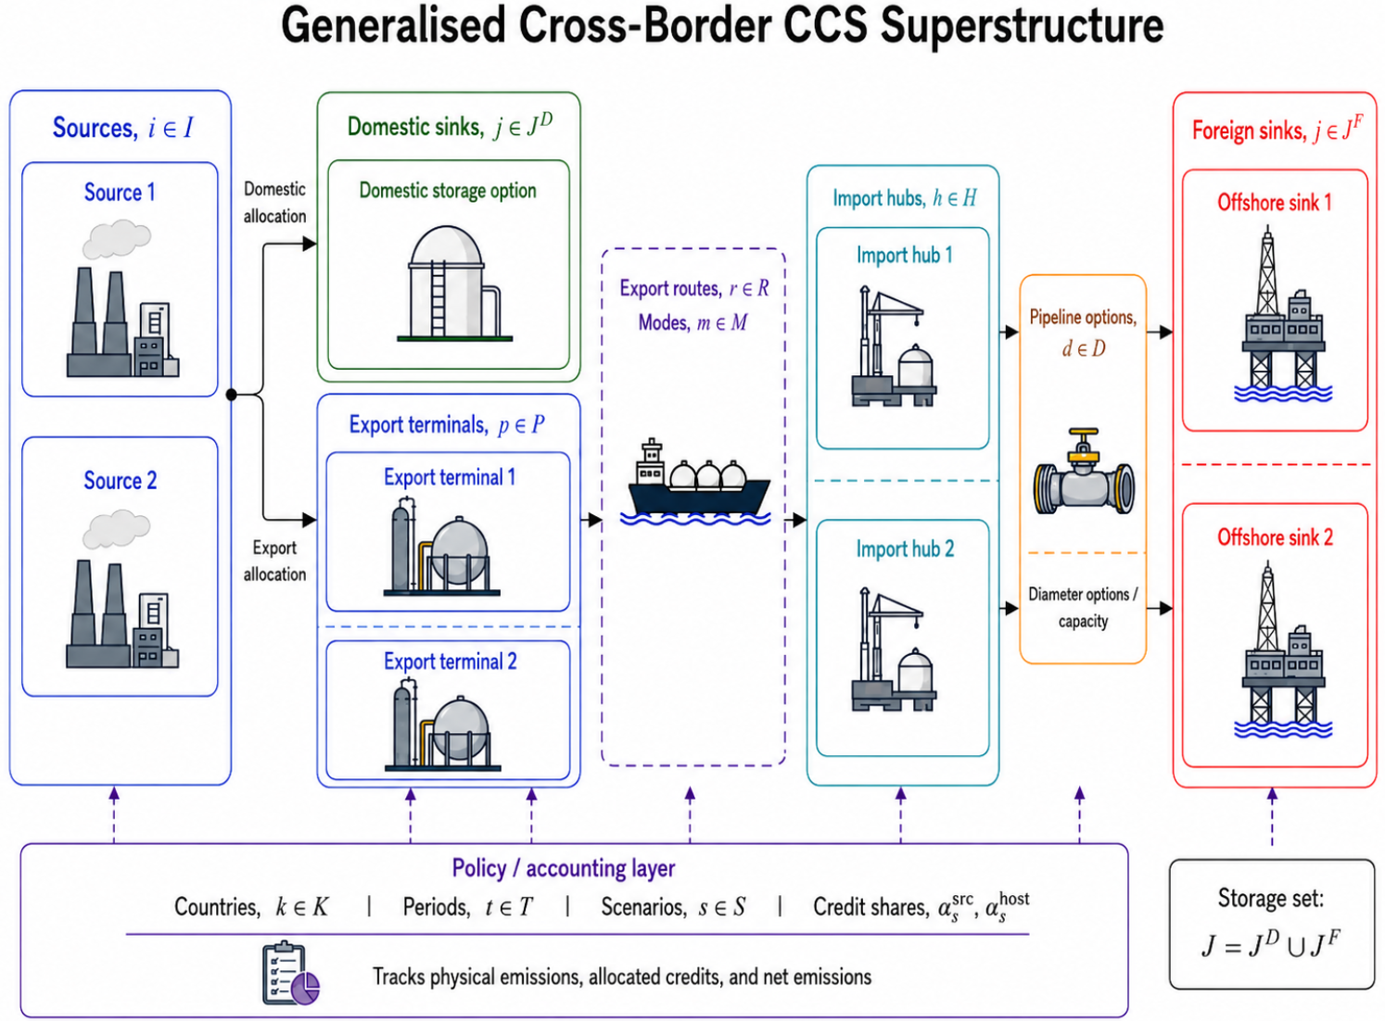
Figure 1: General CCS Superstructure from Source to Storage
The decision problem is to determine the amount of CO₂ captured, uncaptured, transported, lost, injected, and stored; the routes, modes, sinks, and infrastructure options selected; the energy consumed by capture, conditioning, transport, and injection; and the country-level physical emissions, allocated credits, and net emissions. The objective is to minimise total annual system cost, including capture, transport, storage, energy, infrastructure, risk or access premiums, carbon penalties, and carbon-credit benefits, while satisfying mass-balance, capacity, loss, storage, energy, accounting, and policy constraints. Table 1 summarises the general sets and system elements used in the optimisation framework.
Table 1: Generalised sets and system elements in the cross-border CCS optimisation framework
Set / element | Symbol | Description
CO₂ sources | $$i∈I$$ | Emission sources where CO₂ can be captured
Storage sinks | $$j∈J$$ | Candidate geological storage alternatives
Domestic storage sinks | $$j∈J^{D}$$ | Storage alternatives located in the source country
Foreign storage sinks | $$j∈J^{F}$$ | Storage alternatives located in the host country
Transport routes | $$r∈R$$ | Feasible source–hub–sink transport pathways
Transport modes | $$m∈M$$ | Available CO₂ transport modes
Export terminals | $$p∈P^{E}$$ | Loading or export-port systems
Import hubs | $$h∈H$$ | Receiving hubs before storage transport
Countries / jurisdictions | $$k∈K$$ | Source and host accounting jurisdictions
Time periods | $$t∈T$$ | Operating or representative time intervals
Infrastructure options | $$d∈D$$ | Discrete infrastructure choices
Scenarios | $$s∈S$$ | Policy, market, and operational cases

The generalised superstructure provides the basis for the MILP formulation. The model includes continuous variables for CO₂ capture, export flow, domestic storage, hub flow, stored CO₂, energy use, physical emissions, allocated credits, and net emissions. Binary variables are used for route and sink activation, while integer variables represent infrastructure-sizing decisions such as the number of offshore pipelines selected for each sink. The objective function and constraints are presented in the following subsections.

2.2 Objective Function
The objective function minimises the total annual system cost of the cross-border CCS chain. The objective includes capture cost, capture energy cost, shipping and port-related transport cost, offshore pipeline fixed cost, host-country storage and injection service cost, risk premium, domestic storage or non-capture cost, offshore pipeline and injection energy cost, carbon penalty cost, and country-specific carbon credit benefit. Representative-period operating costs are multiplied by the horizon scaling factor, while annualised infrastructure costs are added directly.
$$minZ=C^{cap}+C^{capE}+C^{shipPort}+C^{pipeFix}+C^{hostStor}+C^{risk}+C^{dom}+C^{pipeInjE}+C^{carbon}-C^{credit}$$
(1)
where $Z$is the total annual objective cost, $C^{cap}$is the capture cost, $C^{capE}$is the capture energy cost, $C^{shipPort}$ is the shipping and port-related transport cost, $C^{pipeFix}$is the annualised offshore pipeline fixed cost, $C^{hostStor}$is the host-country storage and injection service cost, $C^{risk}$is the risk-premium cost, $C^{dom}$is the domestic storage or non-capture cost, $C^{pipeInjE}$is the offshore pipeline and injection energy cost, $C^{carbon}$is the carbon penalty cost, and $C^{credit}$is the carbon credit benefit.
The carbon credit benefit is calculated using country-specific credit values. This allows the same physical amount of stored CO₂ to have different economic values depending on whether the credit is allocated to Japan or Malaysia.
$$\begin{aligned}C^{credit}=H\sum_{k∈K}{\sum_{t∈T}{P_{k}^{credit}}}CO_{2,k,t}^{cred}\end{aligned}$$
(2)
where $H$is the horizon-to-year scaling factor, $K$is the set of countries, $T$is the set of representative operating periods, $P_{k,s}^{credit}$is the country-specific carbon credit value for country $k$under scenario $s$, and $CO_{2,k,t}^{cred}$ is the allocated CO₂ credit for country $k$in period $t$. The expanded annual objective function is expressed as:

$$\begin{aligned}\begin{matrix}min Z= & H[\sum_{i∈I}{\sum_{t∈T}{c_{i}^{cap}}}x_{i,t}+\sum_{i∈I}{\sum_{t∈T}{c_{i}^{capE}}}E_{i,t}^{cap}+\sum_{r∈R}{\sum_{t∈T}{c_{r}^{shipPort}}}f_{r,t} \\ & +\sum_{j∈J}{\sum_{t∈T}{c_{j}^{Mystor}}}z_{j,t}+\sum_{j∈J}{\sum_{t∈T}{c_{j,s}^{risk}}}z_{j,t}+\sum_{i∈I}{\sum_{t∈T}{c_{i,s}^{dom}}}d_{i,t} \\ & +\sum_{j∈J}{\sum_{t∈T}{c_{j}^{pipeInjE}}}h_{j,t}+\sum_{k∈K}{\sum_{t∈T}{P_{k,s}^{carbon}}}CO_{2,k,t}^{phys}-\sum_{k∈K}{\sum_{t∈T}{P_{k,s}^{credit}}}CO_{2,k,t}^{cred}] \\ & +\sum_{j∈J}{\sum_{d∈D}{C_{j,d}^{pipeFix}}}n_{j,d}\end{matrix}\end{aligned}$$
(3)
where $I$is the set of source-country CO₂ sources, $J$is the set of candidate offshore storage sinks, $R$is the set of domestic and cross-border transport routes, $D$is the set of offshore pipeline diameter options, and $S$is the set of scenarios. The variable $x_{i,t}$denotes captured CO₂, $E_{i,t}^{cap}$denotes capture energy, $f_{r,t}$denotes export flow, $z_{j,t}$ denotes stored CO₂, $d_{i,t}$denotes domestic storage allocation, $h_{j,t}$denotes CO₂ arriving at the host-country import hub, and $n_{j,d}$denotes the integer number of pipelines of diameter option $d$selected for sink $j$. The parameters $c_{i}^{cap}$, $c_{i}^{capE}$, $c_{r}^{shipPort}$, $c_{j}^{hostStor}$, $c_{j,s}^{risk}$, $c_{i,s}^{dom}$, and $c_{j}^{pipeInjE}$are the corresponding unit cost coefficients. The parameters $P_{k,s}^{carbon}$and $P_{k,s}^{credit}$are the carbon penalty and country-specific credit value, respectively.

2.3 Mass Balance and Physical Constraints
The physical layer of the model ensures that CO₂ flows are conserved from source capture to domestic storage or cross-border export, while respecting route capacity, transport losses, sink injection limits, cumulative storage capacity, and host-country import-policy constraints. These constraints provide the engineering basis for the optimisation model and ensure that the economic and accounting results are physically feasible. The formulation is generalised so that captured CO₂ can either be assigned to domestic storage in the source country or exported to foreign storage sinks in a host country through source–sink routes.
The source emission balance partitions gross CO₂ emissions at each source-country emission source into captured and uncaptured emissions. This ensures that all source emissions are accounted for in each operating period.
$$x_{i,t}+u_{i,t}=E_{i} ∀i∈I, t∈T$$
(4)
where $x_{i,t }$is the amount of CO₂ captured at source $i$in period $t$, $u_{i,t}$is the uncaptured CO₂ emission at source $i$in period $t$, and $E_{i}$is the gross CO₂ emission rate of source $i$per period.
The capture fraction constraint limits the amount of CO₂ captured according to the maximum technically feasible capture share at each source. This prevents the model from capturing more CO₂ than the capture process can technically remove from the source emission stream.
$$x_{i,t}≤η_{i}E_{i} ∀i∈I, t∈T$$
(5)
where $η_{i}$is the maximum capture fraction at source $i$, and $E_{i}$is the gross CO₂ emission rate of source $i$per period.
The capture capacity constraint ensures that captured CO₂ does not exceed the installed capture capacity at each source. This separates the technical capture fraction from the physical or installed capacity of the capture facility.
$$x_{i,t}≤{\overset{ˉ}{C}}_{i} ∀i∈I, t∈T$$
(6)
where ${Cˉ}_{i}$is the maximum installed capture capacity of source $i$per period.
Captured CO₂ can either be allocated to cross-border export routes or assigned to domestic storage in the source country. This balance links source-level capture decisions with the export–domestic storage choice and allows the model to compare cross-border CCS against domestic storage alternatives.
$$x_{i,t}=\sum_{r∈R_{i}}{f_{r,t}}+d_{i,t} ∀i∈I, t∈T$$
(7)
where $R_{i }$is the set of export routes connected to source $i$, $f_{r,t }$is the CO₂ flow exported through route $r$in period $t$, and $d_{i,t}$is the amount of captured CO₂ from source $i$assigned to domestic storage in period $t$.
The route capacity constraint ensures that CO₂ can only flow through an activated export route and that the flow does not exceed the route capacity. This constraint links the continuous export-flow variable with the binary route-selection decision.
$$f_{r,t}≤{\overset{ˉ}{F}}_{r}y_{r} ∀r∈R, t∈T$$
(8)
where $f_{r,t}$is the CO₂ export flow on route $r$in period $t$, ${Fˉ}_{r}$is the maximum capacity of route $r$per period, and $y_{r}$is a binary variable equal to 1 if route $r$is selected and 0 otherwise.
The host-country import hub balance calculates the amount of CO₂ arriving at the host-country import hub after shipping losses. This constraint represents the loss of CO₂ during cross-border maritime transport before the CO₂ is transferred to the offshore pipeline system.
$$h_{j,t}=\sum_{r∈R_{j}}{\left(1-λ_{r}^{ship}\right)}f_{r,t} ∀j∈J, t∈T$$
(9)
where $h_{j,t}$is the CO₂ arriving at the host-country import hub serving sink $j$in period $t$, $R_{j}$is the set of export routes delivering CO₂ to sink $j$, $λ_{r}^{ship}$is the shipping loss factor on route $r$, and $f_{r,t}$is the exported CO₂ flow on route $r$in period $t$.
The storage balance defines the amount of CO₂ finally stored at each foreign offshore storage sink after offshore pipeline losses. This ensures that the stored CO₂ quantity reflects transport losses between the host-country import hub and the offshore geological storage site.
$$z_{j,t}=\left(λ_{j}^{pipe}\right)h_{j,t} ∀j∈J, t∈T$$
(10)
where $z_{j,t }$is the amount of CO₂ stored at sink $j$in period $t$, $λ_{j}^{pipe}$is the offshore pipeline loss factor for sink $j$, and $h_{j,t}$is the CO₂ arriving at the Malaysian hub for sink $j$in period $t$.
The sink injection constraint limits the amount of CO₂ delivered to each sink by the available injection capacity. It also prevents CO₂ from being injected into a sink unless the sink is activated.
$$h_{j,t}≤{\overset{ˉ}{Q}}_{j,s}^{avail}w_{j} ∀j∈J, t∈T$$
(11)
where ${Qˉ}_{j,s}^{avail}$is the scenario-dependent available injection capacity of sink $j$, and $w_{j}$is a binary variable equal to 1 if sink $j$is activated and 0 otherwise.
The cumulative storage constraint ensures that annualised CO₂ storage does not exceed the geological storage capacity of each sink as the model uses representative operating periods, the horizon scaling factor is used to convert period-level storage into an annualised storage quantity.
$$H\sum_{t∈T}{z_{j,t}}≤{\overset{ˉ}{S}}_{j} ∀j∈J$$
(12)
where $H$is the horizon-to-year scaling factor, $z_{j,t}$is the CO₂ stored at sink $j$in period $t$, and ${Sˉ}_{j}$is the cumulative or annual storage capacity of sink $j$.
The host country import-cap constraint limits the annualised amount of CO₂ exported to sink country under scenarios where host-country import capacity or policy access is restricted. This allows the model to evaluate constrained cross-border storage cases.
$$H\sum_{r∈R}{\sum_{t∈T}{f_{r,t}}}≤{\overset{ˉ}{M}}_{s}^{import} ∀s∈S$$
(13)
where ${Mˉ}_{s}^{import}$is the maximum annual CO₂ import allowance for host country under scenario $s$, $f_{r,t }$is the exported CO₂ flow on route $r$in period $t$, and $H$is the horizon-to-year scaling factor.
The minimum export constraint is used in forced hybrid scenarios where at least part of the captured CO₂ must be exported to host-country storage system. This enables the model to examine hybrid configurations that combine domestic source-country storage with a minimum level of cross-border storage utilisation.
$$H\sum_{r∈R}{\sum_{t∈T}{f_{r,t}}}≥M_{s}^{min} ∀s∈S$$
(14)
where $M_{s}^{min}$is the minimum annual CO₂ export requirement under scenario $s$, $f_{r,t}$is the exported CO₂ flow through route $r$in period $t$, and $H$is the horizon-to-year scaling factor.
The offshore pipeline capacity constraint ensures that the CO₂ flow arriving at each host-country import hub does not exceed the total offshore pipeline capacity installed for the corresponding sink. Pipeline capacity is determined by the number of selected pipelines and their diameter options.
$$h_{j,t}≤\sum_{d∈D}{{\overset{ˉ}{P}}_{d}}n_{j,d }∀j∈J, t∈T$$
(15)
where $h_{j,t}$is the CO₂ hub flow serving sink $j$in period $t$, ${Pˉ}_{d}$is the capacity of offshore pipeline diameter option $d$, and $n_{j,d}$is the integer number of pipelines of diameter option $d$selected for sink $j$.
The pipeline build-linking constraint ensures that offshore pipelines can only be selected for an activated sink. This prevents the model from installing pipeline capacity for a sink that is not used.
$$n_{j,d}≤{\overset{ˉ}{N}}_{d}w_{j} ∀j∈J, d∈D$$
(16)
where $n_{j,d }$is the integer number of pipelines of diameter option $d$ serving sink $j$, ${Nˉ}_{d }$is the maximum allowable number of parallel pipelines for diameter option $d$, and $w_{j}$is the binary sink-activation variable.

2.4 Energy Modelling
Energy use is modelled as an endogenous consequence of CCS operation. This is important because capture, transport, offshore pipeline transfer, and injection require energy, and this energy demand can generate additional emissions depending on the country in which the energy is consumed. The model therefore links energy consumption directly to physical CO₂ flows rather than treating energy penalty as an external adjustment.
The capture energy requirement is proportional to the amount of CO₂ captured at each source.
$$E_{i,t}^{cap}=a_{i}^{cap}x_{i,t} ∀i∈I, t∈T$$
(17)
where $E_{i,t}^{cap }$is the capture energy consumed at source $i$in period $t$, $a_{i}^{cap}$ is the capture energy coefficient for source $i$, and $x_{i,t}$is the captured CO₂ at source $i$in period $t$. The offshore pipeline energy requirement is proportional to the hub flow delivered to the offshore pipeline and the offshore pipeline distance to the storage sink.
$$E_{j,t}^{pipe}=a^{pipe}D_{j}h_{j,t} ∀j∈J, t∈T$$
(18)
where $E_{j,t}^{pipe}$is the offshore pipeline energy consumed for sink $j$in period $t$, $a^{pipe}$ is the offshore pipeline energy coefficient, $D_{j}$is the offshore pipeline distance from the host-country import hub to sink $j$, and $h_{j,t}$is the CO₂ flow arriving at the host-country import hub for sink $j$in period $t$. The injection energy requirement is proportional to the amount of CO₂ finally injected and stored at the foreign country offshore sink.
$$E_{j,t}^{inj}=a^{inj}z_{j,t} ∀j∈J, t∈T$$
(19)
where $E_{j,t}^{inj }$is the injection energy consumed at sink $j$in period $t$, $a^{inj}$is the injection energy coefficient, and $z_{j,t}$is the amount of CO₂ stored at sink $j$in period $t$. Shipping-related emissions are represented as proportional to export flow. In the current implementation, shipping emissions are allocated to the source country because the exported CO₂ originates from source country emission nodes and the export decision is associated with the source-country pathway.
$${SE}_{t}=\sum_{r∈R}{α_{r}^{ship}}f_{r,t} ∀t∈T$$

(20)
where $SE_{t }$is the shipping-related CO₂ emission in period $t$, $α_{r}^{ship}$is the shipping emission coefficient for route $r$, and $f_{r,t}$is the exported CO₂ flow on route $r$in period $t$.

2.5 Carbon Accounting Framework
The carbon-accounting layer separates physical emissions from credited mitigation outcomes. This distinction is essential in cross-border CCS because the country that generates the CO₂ and the country that stores the CO₂ are not necessarily the same. The model therefore reports physical emissions, allocated storage credits, and net emissions separately for host and source countries. Country-level physical emissions are defined as the sum of uncaptured emissions and energy-related emissions allocated to each country.
$$PE_{k,t}={UE}_{k,t}+{EE}_{k,t} ∀k∈K, t∈T$$
(21)
where$PE_{k,t }$is the physical CO₂ emission allocated to country $k$in period $t$, $UE_{k,t}$is the uncaptured source emission allocated to country $k$in period $t$, and ${EE}_{k,t }$ is the energy-related CO₂ emission allocated to country $k$in period $t$. For source country, physical emissions include uncaptured source emissions, capture energy emissions, and shipping-related emissions.
$$\begin{aligned}{PE}_{src,t}=\sum_{i∈I_{src}}{u_{i,t}}+γ_{src}\sum_{i∈I_{src}}{E_{i,t}^{cap}}+\sum_{r∈R}{e_{r}^{ship}}f_{r,t} ∀t∈T\end{aligned}$$

(22)
where $PE_{src,t }$is source-country physical CO₂ emission in period $t$, $I_{src}$is the set of source country nodes, $u_{i,t }$is uncaptured CO₂ at source $i$, $γ_{src}$is source-country grid emission factor, $E_{i,t}^{cap}$is capture energy consumption, $e_{r}^{ship}$ is the shipping emission coefficient, and $f_{r,t}$is the export flow on route $r$. For host country, physical emissions include offshore pipeline energy emissions and injection energy emissions.
$$\begin{aligned}{PE}_{host,t}=γ_{host}\left[\sum_{j∈J}{E_{j,t}^{pipe}} + \sum_{j∈J}{E_{j,t}^{inj}}\right] ∀t∈T\end{aligned}$$

(23)
where $PE_{host,t }$is host-country physical CO₂ emission in period $t$, $γ_{host}$is host-country grid emission factor, $E_{j,t}^{pipe}$is offshore pipeline energy consumption for sink $j$, and $E_{j,t}^{inj}$is injection energy consumption at sink $j$. Country-level net emissions are calculated by subtracting allocated storage credits from physical emissions. This allows the same physical CCS operation to produce different national accounting outcomes under different credit-sharing rules.
$${NE}_{k,t}={PE}_{k,t}- {Cr}_{k,t} ∀k∈K, t∈T$$
(24)
where $NE_{k,t }$is the net accounting emission of country $k$in period $t$, $PE_{k,t }$is the physical emission allocated to country $k$, and ${Cr}_{k,t }$is the CO₂ storage credit allocated to country $k$. Net emissions may be negative if the allocated credit exceeds the physical emissions from the CCS chain. In this study, negative net emissions are interpreted as accounting outcomes rather than physical negative emissions.

2.6 Credit-Sharing Mechanism
The credit-allocation formulation is defined using an explicit source–sink mapping to avoid ambiguity in the allocation of verified stored CO₂. Let $A_{i,j}$be a binary mapping parameter equal to 1 if captured CO₂ from source $i$can be allocated to storage sink $j$, and 0 otherwise. The variable $z_{i,j,t }$represents the amount of CO₂ from source $i$that is finally stored in sink $j$during period $t$, after transport and storage losses have been accounted for. This source–sink-specific storage variable ensures that the verified stored CO₂ is traced from its originating source to its final storage location.
The country-level credit allocated to country $k$in period $t$under scenario $s$is therefore expressed as:
$$Cr_{k,t,s}=\sum_{i∈I}{\sum_{j∈J}{A_{i,j}}}z_{i,j,t}\left[α_{s}^{src}δ_{i,k}^{src} + α_{s}^{host}δ_{j,k}^{host}\right] ∀k,t,s$$
(25)
where $Cr_{k,t,s}$is the CO₂ storage credit allocated to country $k$in period $t$under scenario $s$, $A_{i,j}$is the source–sink mapping parameter, $z_{i,j,t }$is the verified CO₂ stored at sink $j$from source $i$, $α_{s}^{src}$is the share of the storage credit allocated to the source country, and $α_{s}^{host}$ is the share allocated to the host storage country. The binary indicator $δ_{i,k}^{src}$equals 1 if source $i$is located in country $k$, and 0 otherwise. Similarly, $δ_{j,k}^{host}$equals 1 if storage sink $j$is located in country $k$, and 0 otherwise.
To prevent double counting, the source and host credit shares are constrained as:
$$α_{s}^{src}+α_{s}^{host}=1 ∀s∈S$$
(26)
this formulation ensures that each unit of verified stored CO₂ is allocated only once across the participating countries, subject to α_source + α_host = 1. A value of α_source = 1 assigns the full storage benefit to the source country, whereas α_host = 1 assigns it entirely to the host country. Intermediate values represent shared-benefit arrangements. The α parameters affect the allocation and monetary value of the verified storage benefit but do not change the physical CO₂ flows or stored quantities. These cases are hypothetical policy scenarios used to test model behaviour and are not interpreted as established international carbon-accounting practices. In practice, the allocation rule would depend on bilateral agreements, domestic regulations, contractual terms, MRV requirements, infrastructure contributions, liability allocation, and agreed responsibilities for CO₂ transport and long-term storage.

3. Japan–Malaysia CCS System Case Study

3.1. Case Study Description
The case study represents an anonymised Japan–Malaysia cross-border CCS system consisting of two Japanese CO₂ source nodes, JP-Source 1 and JP-Source 2, and two Malaysian offshore storage sink nodes, MY-Sink 1 and MY-Sink 2. The logic behind the use of Japan–Malaysia as source–storage relationship because Japan is geographically compact and may face a mismatch between future capture volumes and conveniently accessible domestic storage which create a need to consider cooperation with storage-rich jurisdictions. On the other hand, Malaysia has strong offshore geological storage potential and can represent a regional host country with greater storage availability. The pairing presents strong opportunity where uneven distributions of industrial emissions and offshore storage resources create a broader case for regional CO₂ transport and storage cooperation^{[1,2]}. JP-Source 1 represents a Japanese industrial CO₂ source node with access to marine export infrastructure. It is characterised by its annual CO₂ supply, capture-related parameters, export-terminal linkage, and route distance to Malaysian storage options. JP-Source 2 represents a second Japanese CO₂ source node with different source and route characteristics, allowing the model to examine whether multiple Japanese source nodes converge toward the same Malaysian storage sink or select different sink options under varying cost, capacity, and transport conditions. On the storage side, MY-Sink 1 represents a Malaysian offshore storage option with favourable storage availability, delivered-cost performance, and route feasibility under the base parameterisation. MY-Sink 2 represents an alternative Malaysian offshore storage option included to test sink competition and sensitivity to storage cost, storage capacity, route distance, transport losses, and risk-related assumptions. Based on the two source nodes and two sink nodes, the export network consists of four feasible cross-border route combinations: JP-Source 1–MY-Sink 1, JP-Source 1–MY-Sink 2, JP-Source 2–MY-Sink 1, and JP-Source 2–MY-Sink 2. The model also includes a domestic Japanese storage alternative, represented as JP-Domestic Sink, to assess the competitiveness of cross-border export against a non-export storage pathway. Figure 2 illustrates the anonymised cross-border CCS network structure between Japan and Malaysia, while Table 2 summarises the modelling role and parameter characteristics of each source and sink node used in the case study.
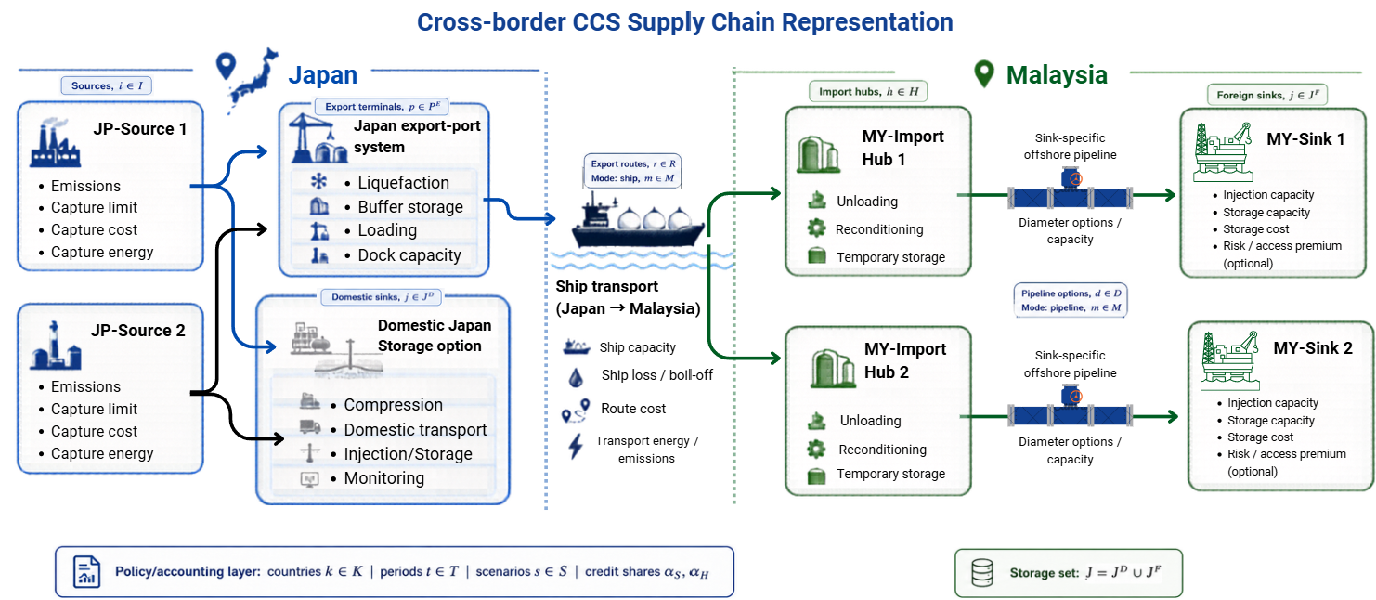
Figure 2: Cross-border CCS superstructure from Japan to Malaysia
Table 2: Node descriptions in the Japan–Malaysia case study
Node/route | Description
JP-Source 1 | Japanese CO₂ source node 1
JP-Source 2 | Japanese CO₂ source node 2
MY-Sink 1 | Malaysian offshore storage sink 1
MY-Sink 2 | Malaysian offshore storage sink 2
MY-Import Hub 1 | Malaysian import hub 1
MY-Import Hub 2 | Malaysian import hub 2
DJS | Domestic Japan storage sink
JP-Source 1–MY-Sink 1 | Export route from JP-Source 1 to MY-Sink 1
JP-Source 1–MY-Sink 2 | Export route from JP-Source 1 to MY-Sink 2
JP-Source 2–MY-Sink 1 | Export route from JP-Source 2 to MY-Sink 1
JP-Source 2–MY-Sink 2 | Export route from JP-Source 2 to MY-Sink 2

3.2. Input Data and Data Processing
The numerical inputs in the MILP model are grouped into source and country parameters, domestic Japanese benchmark values, Malaysian storage-sink data, transport and infrastructure parameters, and policy-scenario settings. Table 3 reports inputs supported by published studies, public data, or carbon-market information.
Table 3. Literature, public-data and country-credit inputs used in the MILP
Model input | Value used | Basis / derivation | Supporting source
Capture cost | USD90.00/tCO₂ | Literature-supported scenario value; equivalent to USD90.00/tCO₂ using the study's fixed exchange-rate basis. | IEAGHG^{[14]}; ERIA^{[15]}
Capture energy coefficient | 0.1745 MWh/tCO₂ | Literature-supported scenario value within the magnitude reported for post-combustion capture electricity requirements. | Beiron et al.^{[16]}
Japan electricity price | USD100.00/MWh | Representative Japan-specific scenario value; used as a rounded electricity-cost proxy. | Isogai et al.^{[17]}
Malaysia electricity price | USD47.17/MWh | Public-data-derived value; equivalent to 21.7 sen/kWh. | Sarawak Energy^{[18]}
Japan grid emission factor | 0.421 tCO₂/MWh | Official-data-based rounded proxy for the Japanese grid. | ANRE/METI^{[19]}
Malaysia grid emission factor | 0.199 tCO₂/MWh | Public-data value used as the common host-grid proxy in this case study. | Energy Commission Malaysia^{[20]}
Japan country-specific credit value | USD16.43/tCO₂ | Public-market-derived calculation using JPY3,022/tCO₂ × USD0.005437/JPY. | JPX/TSE^{[21]}; Bank Negara Malaysia^{[22]}
Malaysia country-specific credit value | USD10.87/tCO₂ | Public-market proxy based on the clearing price of the Malaysian Nature-Based Carbon Credits Plus auction. | Bursa Malaysia/BCX^{[23]}

The annual source emissions are case-study assumptions: JP-Source 1 is assigned 0.4 MtCO₂/year and JP-Source 2 is assigned 2.4 MtCO₂/year to compare a smaller and a larger Japanese source. The maximum capture share is set at 0.97 as a high-capture modelling assumption with precedent in Bennæs et al.^{[9]}. Shi et al. reported material-level adsorption performance for porous carbon^{[13]}; those results provide capture-material context but are not directly comparable with the assumed 0.97 process-scale capture fraction. Monthly source quantities and capture capacities are calculated by dividing the annual assumptions by 12. All monetary values are presented in USD using the study's fixed exchange-rate basis of USD1 = 4.60 Malaysian ringgit. The Japanese credit value is calculated from the JPX/TSE J-Credit proxy using this exchange rate. The Japanese carbon-penalty coefficient of USD23.70/tCO₂ is a rounded policy proxy aligned with the upper end of the FY2026 GX-ETS reference price. METI sets the FY2026 upper reference transaction price at JPY4,300/tCO₂^{[24]}, equivalent to approximately USD23.38/tCO₂ at USD0.005437/JPY. Malaysia has announced a carbon tax from 2026^{[25]}; USD3.26/tCO₂ is therefore used as a low carbon-price proxy for an emerging Malaysian carbon-pricing environment.
The domestic Japanese option is represented as an aggregate non-export benchmark because the case study does not resolve individual Japanese storage sites, transport routes, distances, or infrastructure. The model therefore optimises allocation to the domestic pathway but not its internal network. Table 4 lists literature-supported cost components. The base domestic non-capture component is USD44.57/tCO₂, while USD71.74/tCO₂ is applied only as a higher counterfactual sensitivity assumption in COMBINED_COMPETITIVE. Including capture and capture-energy costs gives a full base domestic pathway cost of USD152.02/tCO₂. Full data including source and sink input parameters, route and transport parameters, policy parameters as well as cost components is available in Zenodo^{[37]}.

Table 4. Literature-supported domestic Japan benchmark inputs
Domestic component | Value used (USD/tCO₂) | Supporting source
Compression infrastructure and fixed O&M | 5.43 | McCollum and Ogden^{[26]}
Domestic CO₂ transport | 14.13 | Isogai et al.^{[17]}; Smith et al.^{[27]}
Injection and geological storage | 21.74 | Hatta et al.^{[28]}; Isogai et al.^{[17]}
Monitoring | 3.26 | IEAGHG^{[29]}

Malaysian sink cost coefficients are supported by published storage-cost studies and summarised in Table 5. Physical sink capacities and injection limits are anonymised case-study assumptions. MY-Sink 1 is assigned 80 MtCO₂ total storage capacity and 3.7 MtCO₂/year gross injection capacity, with 1.0 MtCO₂/year reserved for domestic Malaysian CO₂. MY-Sink 2 is assigned 70 MtCO₂ total capacity and 5.0 MtCO₂/year injection capacity with no domestic reservation. These values create two distinct alternatives: MY-Sink 1 has tighter foreign-available throughput, whereas MY-Sink 2 provides greater annual injection capacity. After domestic reservation, 2.7 MtCO₂/year is available for imported CO₂ at MY-Sink 1 and 5.0 MtCO₂/year at MY-Sink 2.
Table 5. Malaysian sink cost inputs
Sink cost input | Value used | Supporting source
Geological storage cost | USD17.07/tCO₂ | Hatta et al.^{[28]}
Injection cost | USD6.83/tCO₂ | Hendriks et al.^{[30]}

Commercial and risk parameters are sensitivity assumptions. The base Malaysian storage-service fee is USD10.87/tCO₂, and the low-fee case reduces it to USD5.43/tCO₂, providing a 50% tariff sensitivity test. Access premiums of USD5.43/tCO₂ for MY-Sink 1 and USD2.17/tCO₂ for MY-Sink 2 test whether differences in access, reservation, or liability conditions can offset route-cost advantages.
Table 6 summarises transport and infrastructure inputs. Route-specific distances and derived coefficients are calculated before optimisation. The source, import-hub, and sink locations and route distances are hypothetical geographical inputs. Maritime distances range from 4,690.7 to 5,830.7 km, and offshore-pipeline distances are 190.6 km for MY-Sink 1 and 205.8 km for MY-Sink 2. The complete four-route matrix, including the individual shipping-loss factors, is reported in Supplementary Table 12.
Table 6. Model design transport and infrastructure inputs
Transport/infrastructure input | Value used | Supporting source
Ship service speed and boil-off | 14 knots; 0.001 of loaded CO₂ per 12-h period | Bennæs et al.^{[9]}
Shipping emissions coefficient | 0.013 tCO₂/tCO₂ transported | Bennæs et al.^{[9]}
Port conditioning costs | Liquefaction USD3.80/tCO₂; reconditioning USD1.38/tCO₂; loading/unloading USD0.18/tCO₂ | Roussanaly et al.^{[7]}; Bennæs et al.^{[9]}
Reference offshore-pipeline capacities | 0.20 m: 140,342.50 tCO₂/month; 0.30 m: 315,785.83 tCO₂/month | Bennæs et al.^{[9]}
Pipeline construction correlation | Cost base = 0.533 + 0.019Q million EUR/km; offshore factor = 2.0 | Serpa et al.^{[31]}
Route-specific shipping-loss factors | 0.0167 (JP-Source 1→MY-Sink 1); 0.0187 (JP-Source 1→MY-Sink 2); 0.0151 (JP-Source 2→MY-Sink 1); 0.0169 (JP-Source 2→MY-Sink 2) | Bennæs et al.^{[9]}

Pipeline transport-cost methods and their treatment of fixed and variable costs are reviewed by Knoope et al.^{[32]}. Decarre et al. reported complete ship-based CO₂ transport-chain costs of €24–32/tCO₂, equivalent to USD26.09–34.78/tCO₂ at USD1.087/EUR, and North Sea estimates of USD20–30/tCO₂ for volumes above 2 MtCO₂/year^{[33]}. The model's shipping coefficient of USD0.00391/(tCO₂·km) gives route-specific line-haul costs of USD18.35–22.82/tCO₂. Including USD5.36/tCO₂ for port conditioning gives USD23.72–28.18/tCO₂, within the literature benchmark of approximately USD20.00–34.78/tCO₂. McCoy and Rubin reported USD1.16/tCO₂ for a 100-km pipeline transporting 5 MtCO₂/year^{[34]}. The model coefficient of USD0.00435/(tCO₂·km) is lower because fixed offshore-pipeline construction cost is represented separately. Shipping loss is calculated from route distance, 14-knot service speed, 12-h periods, and 0.1% boil-off per period following Bennæs et al.^{[9]}, producing individual factors of 0.0151–0.0187. Pipeline construction costs of USD0.588–0.658 million/km are calculated from the Serpa correlation^{[31]} using the modelled capacities and USD1.087/EUR.
The offshore-pipeline loss factor of 0.001, pipeline energy coefficient of 0.00002 MWh/(tCO₂·km), and injection energy coefficient of 0.02 MWh/tCO₂ are engineering assumptions. Isogai et al.^{[17]} report a lower conditioning-electricity requirement for a narrower pre-injection boundary; the larger model coefficient is interpreted as a conservative allowance for conditioning, pressurisation, injection pumping, and associated site auxiliaries.
Finally, the policy and commercial inputs are scenario assumptions listed in Zenodo^{[37]}. The base Malaysian import cap of 8.7 MtCO₂/year is non-binding in the normal export case, while 2.0 MtCO₂/year represents a restrictive condition. A minimum export requirement of 1.0 MtCO₂/year applies only in the forced-hybrid case. The Malaysian storage-service fee decreases from USD10.87/tCO₂ to USD5.43/tCO₂ in the low-fee case. Sink-specific premiums represent possible access, liability, or storage-condition differences, while non-compliance and leakage penalties discourage undesirable outcomes. The allocation parameters α_source and α_host test alternative sharing of the verified storage benefit subject to α_source + α_host = 1; they are sensitivity assumptions rather than established accounting rules.
All operating flows, energy quantities, and variable costs are represented monthly. Annual source emissions and injection capacities are divided by 12 before entering monthly constraints. Monthly capture, transport, storage, energy, carbon-penalty, and credit terms are multiplied by the horizon factor of 12 for annual objectives and reporting. Annualised fixed infrastructure costs are added directly and are not multiplied by 12 again.

3.3. Scenario Design
The scenarios are organised into four categories. Reference pathways comprise base export and domestic Japan. Commercial and policy support comprises the low-fee, credit-support, combined-competitiveness, and risk-premium cases, which test changes in host charges, storage benefits, domestic cost, and sink premiums.
Physical access comprises the restrictive-import-cap and forced-hybrid cases, which test changes in export–domestic allocation. Credit ownership comprises source claim, shared 50:50, and host claim. These α cases change ownership and value of the verified storage benefit, not physical CO₂ flows. Table 7 reports all scenario categories, subcases, input settings and analytical purposes.
Table 7: Scenario categories, subcases, input settings, and analytical purpose
Category | Scenario case | Available pathway | Import cap  (MtCO₂/year) | Minimum export  (MtCO₂/year) | Malaysia service fee  (USD/tCO₂) | Japan domestic non-capture cost  (USD/tCO₂) | Policy, accounting, or risk setting | Analytical purpose
Reference pathways | Base export routing | Export only | 8.7 | 0 | 10.87 | NA | No added credit; cap non-binding. | Benchmark export pathway.
Reference pathways | Domestic Japan storage | Domestic only | 0 | 0 | NA | 44.57 | Aggregate domestic benchmark. | Benchmark non-export pathway.
Commercial and policy support | Low Malaysia storage fee | Export only | 8.7 | 0 | 5.43 | NA | Service fee reduced. | Tests lower access cost.
Commercial and policy support | Credit support | Export only | 8.7 | 0 | 10.87 | NA | Country credit values active. | Tests credit revenue.
Commercial and policy support | Combined competitiveness | Export + domestic | 8.7 | 0 | 5.43 | 71.74 | Credits; low fee; higher domestic cost; sink-specific premiums; MY-Sink 1 reservation. | Tests coordinated support; ±10% OAT reference.
Commercial and policy support | Risk premium | Export only | 8.7 | 0 | 10.87 | NA | Sink-specific premiums. | Tests sink switching.
Physical access | Restrictive import cap | Export + domestic | 2.0 | 0 | 10.87 | 44.57 | Import cap reduced. | Tests restricted access.
Physical access | Forced hybrid | Export + domestic | 8.7 | 1.0 | 10.87 | 44.57 | Minimum export enforced. | Forces hybrid allocation.
Credit ownership | Source claim | Export only | 8.7 | 0 | 10.87 | NA | αsource = 1; αhost = 0. | Benefit assigned to Japan.
Credit ownership | Shared 50:50 | Export only | 8.7 | 0 | 10.87 | NA | αsource = 0.5; αhost = 0.5. | Benefit shared equally.
Credit ownership | Host claim | Export only | 8.7 | 0 | 10.87 | NA | αsource = 0; αhost = 1. | Benefit assigned to Malaysia.

4. Results and Discussion

4.1. Overall Scenario Performance and Pathway Selection
Table 8 organises the results using the same four categories as the scenario design. The reference pathways first establish the economic and physical comparison: base export has an annual objective cost of USD0.462 billion, whereas the aggregate domestic-Japan pathway costs USD0.420 billion. Domestic storage is therefore cheaper by about USD42 million/year under the reference assumptions. Both cases capture 2.716 MtCO₂/year, but export stores 2.672 MtCO₂/year in Malaysia after transport losses, while the domestic case stores the full captured quantity in Japan.
Commercial and policy support reduces the export disadvantage. Lowering the Malaysian service fee reduces the objective to USD0.447 billion/year, while country-specific credit support reduces it to USD0.425 billion/year. Under the current Combined Competitiveness settings, which also retain sink-specific premiums and the MY-Sink 1 reservation, the objective is USD0.442 billion/year. This remains about USD22 million/year above the base domestic benchmark, but the MILP selects export over the higher-cost domestic alternative available within the combined case. The result therefore shows conditional pathway switching rather than an unconditional cost advantage over base domestic storage.
The low-fee, credit-support, and three alpha cases reported in Table 8 retain full export to MY-Sink 1, showing that their main effect is economic or accounting rather than physical. The Combined Competitiveness case instead selects MY-Sink 2 because the sink-specific premiums and MY-Sink 1 reservation offset its route-cost advantage. The forced-hybrid case changes the physical system: 1.000 MtCO₂/year is exported and 1.716 MtCO₂/year is stored domestically, with 0.984 MtCO₂/year stored in Malaysia after losses. This distinction separates pathway, sink, and accounting responses.
Credit ownership changes the reported economic benefit but not the optimized flow. The source-claim, shared, and host-claim cases produce credit benefits of USD43.90, USD36.47, and USD29.04 million/year, respectively, while all retain full export to MY-Sink 1. The corresponding objectives increase from USD0.418 to USD0.433 billion/year as a smaller share of the verified storage benefit is valued at Japan's higher country-specific credit value.
Table 8: Overall outcomes by scenario category and subcase
Panel A. Reference pathways, commercial and policy support, and physical access
Category | Scenario | Objective cost  (billion USD/year) | Export to MY  (MtCO₂/year) | Domestic storage  (MtCO₂/year) | Stored in MY  (MtCO₂/year) | Selected sink | Physical emissions  (MtCO₂/year)
Reference pathways | Base export | 0.462 | 2.716 | 0 | 2.672 | MY-Sink 1  (both sources) | 0.3315
Reference pathways | Domestic Japan | 0.420 | 0 | 2.716 | 0 | Not applicable | 0.2835
Commercial and policy support | Low MY storage fee | 0.447 | 2.716 | 0 | 2.672 | MY-Sink 1  (both sources) | 0.3315
Commercial and policy support | Credit case | 0.425 | 2.716 | 0 | 2.672 | MY-Sink 1  (both sources) | 0.3315
Commercial and policy support | Combined competitive | 0.442 | 2.716 | 0 | 2.667 | MY-Sink 2 / (both sources) | 0.3316
Physical access | Forced hybrid | 0.445 | 1.000 | 1.716 | 0.984 | MY-Sink 1 | 0.3015
Panel B. Credit ownership
Category | α scenario | α source | α host | Credit benefit  (million USD/year) | Objective cost  (billion USD/year) | Physical pathway | Flow changed?
Credit ownership | Source claim | 1.0 | 0.0 | 43.90 | 0.418 | Full export to MY-Sink 1 | No
Credit ownership | Shared 50:50 | 0.5 | 0.5 | 36.47 | 0.425 | Full export to MY-Sink 1 | No
Credit ownership | Host claim | 0.0 | 1.0 | 29.04 | 0.433 | Full export to MY-Sink 1 | No

4.2. Economic Competitiveness and Cost Drivers
Figure 3 compares annual objective costs across the principal pathway scenarios. The base-export objective is USD0.462 billion/year, compared with USD0.420 billion/year for the domestic benchmark, giving export a disadvantage of approximately USD42 million/year. The low-fee and credit-support cases reduce the objective to USD0.447 and USD0.425 billion/year, respectively. The Combined Competitiveness case gives USD0.442 billion/year, approximately USD22 million/year above base domestic storage, while selecting export over the higher domestic-cost alternative within that case. Cross-border CCS is therefore conditionally competitive and depends on the complete set of commercial, policy, and sink-specific assumptions.
The domestic option remains an aggregate non-export benchmark. Its allocation is endogenous, but its internal routes, sites, and infrastructure are not resolved at the same level as the Malaysian network. The cost differences should therefore be interpreted as scenario comparisons; equal-resolution optimisation of both pathways remains necessary for project-level ranking.
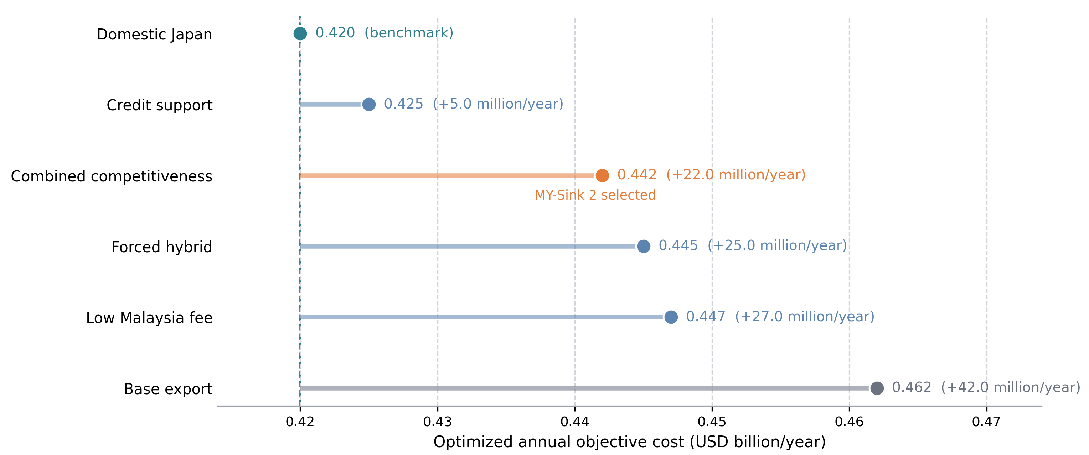
Figure 3: Annual objective cost across principal pathway scenarios
Figure 4 explains the economic mechanism. Capture and capture energy contribute approximately USD107.45/tCO₂ in every principal pathway and dominate positive cost. The base-export case is approximately USD170.00/tCO₂ captured. The base domestic pathway is approximately USD154.57/tCO₂. Under Combined Competitiveness, lower service fees and credit benefit are partly offset by MY-Sink 2 transport and pipeline requirements and the sink-risk term, giving a net objective of approximately USD162.88/tCO₂ captured. The combined package therefore narrows the export-cost gap without making it cheaper than the base domestic benchmark.
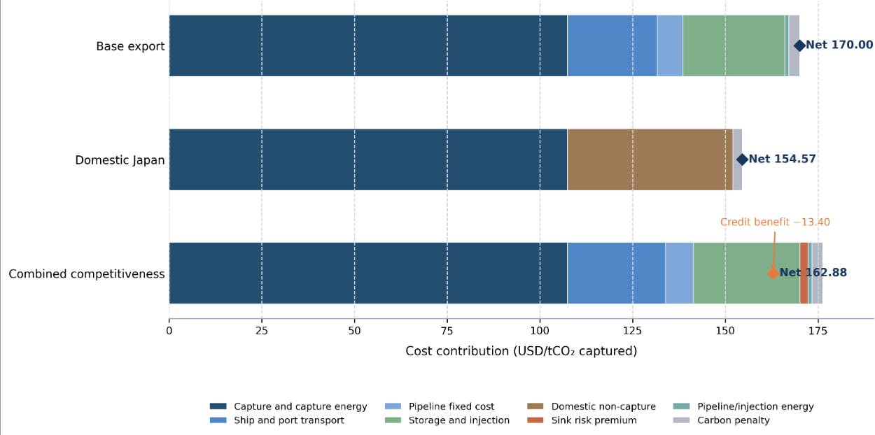
Figure 4: Cost-component decomposition of selected pathways on a common USD/tCO₂-captured basis
Recent benchmarks cover network source–sink performance^{[35]}, cluster and system abatement^{[36]}, shared transport infrastructure^{[37]}, integrated annual supply chains^{[38]}, national avoidance costs^{[39]}, full-chain deployment^{[40]}, and industrial abatement^{[41,42]}. Figure 5 groups these results by scope. Transport-only and transport-plus-storage estimates cannot be ranked directly against full-chain objectives because capture, energy, infrastructure, storage, financing, distance, and price-year boundaries differ.
The ranges nevertheless provide a scale check. Partial-chain estimates include approximately USD3.91-45.00/tCO₂, while cross-border and full-chain studies commonly fall between approximately USD51.96 and USD119.78/tCO₂. Industrial abatement can reach USD195.65-347.83/tCO₂. The present USD151.30-170.00/tCO₂ range is higher than several full-chain comparators because the objective includes capture energy, very long maritime routes, port handling, offshore-pipeline infrastructure, storage, penalties, sink premiums, and credits. Where component data are available, Figure 5(b) confirms that capture remains the dominant contribution.
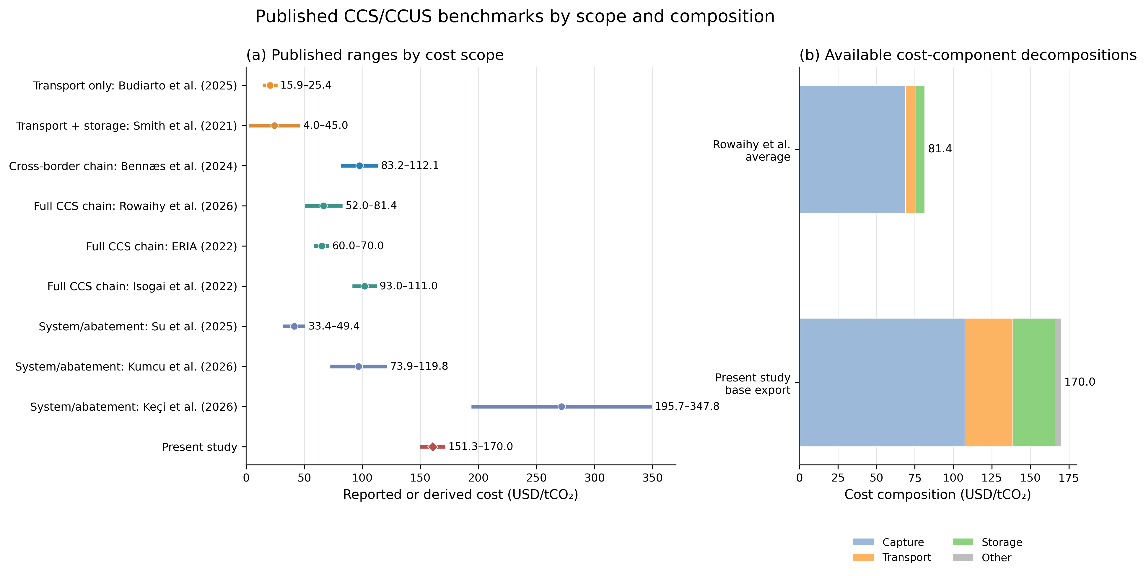
Figure 5: Published CCS/CCUS cost benchmarks by scope and available cost composition. (a) Published ranges by cost scope; (b) Available cost-component decompositions.

4.3. Network Configuration, Route and Sink Selection
In the base-export solution, JP-Source 1 and JP-Source 2 both use MY-Sink 1. The network exports 2.716 MtCO₂/year and stores 2.672 MtCO₂/year after losses. The 0.044 MtCO₂/year difference corresponds to a transport loss of approximately 1.63%, providing an internal mass-balance check.
Relative to the MY-Sink 2 route, MY-Sink 1 is 561.2 km shorter, USD2.20/tCO₂ cheaper in line-haul shipping, and 0.0020 lower in shipping-loss factor for JP-Source 1. For JP-Source 2, it is 638.3 km shorter, USD2.50/tCO₂ cheaper, and 0.0018 lower in shipping loss. The offshore pipeline to MY-Sink 1 is also 15.2 km shorter. These delivered-transport advantages outweigh MY-Sink 2's greater available injection capacity at the modelled flow.
MY-Sink 1 stores 2.672 MtCO₂/year against 2.7 MtCO₂/year of foreign-available injection capacity. The solution is therefore close to an annual throughput boundary, not geological exhaustion of the 80 MtCO₂ storage inventory. Higher source flow or reduced availability could make split routing or MY-Sink 2 relevant. Figure 6 contrasts this capacity advantage with the distance, cost, loss, and pipeline advantages of MY-Sink 1.
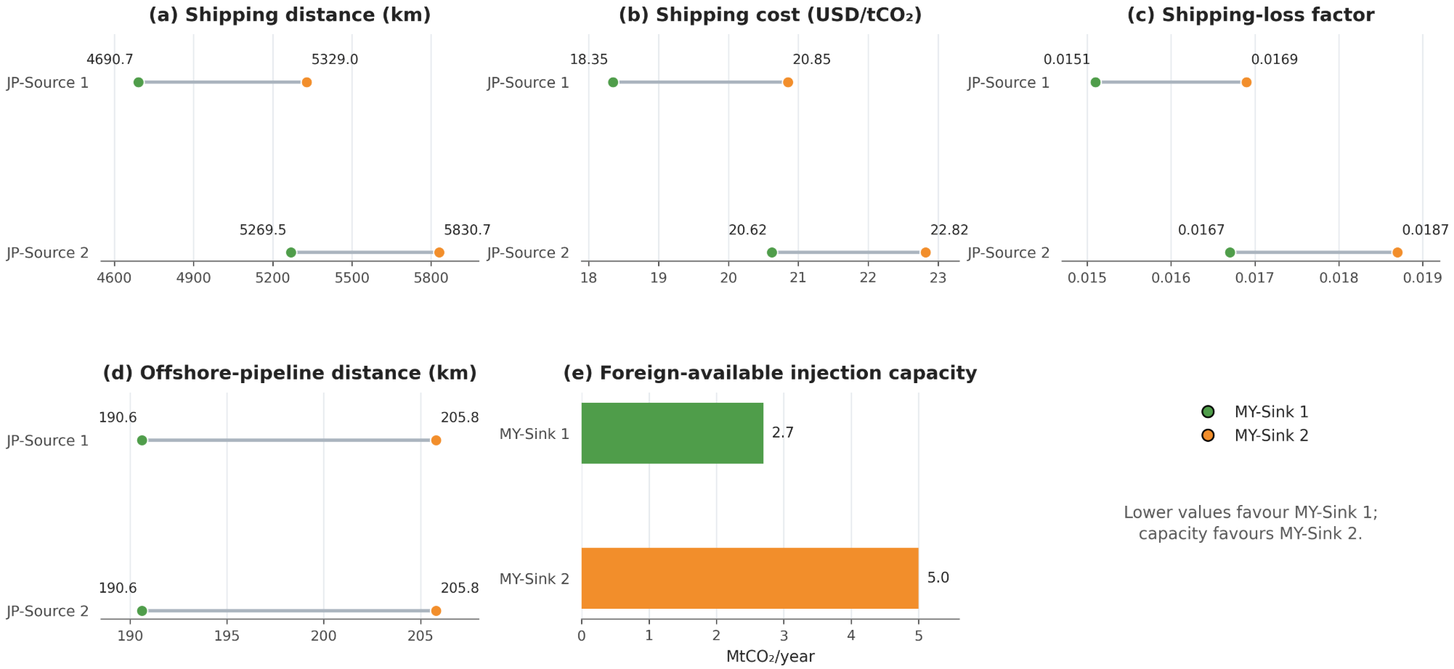
Figure 6: Route and sink performance comparison for the two Japanese sources and Malaysian storage sinks. (a) Shipping distance (km); (b) Shipping cost (USD/tCO2); (c) Shipping-loss factor; (d) Offshore-pipeline distance (km); (e) Foreign-available injection capacity

4.4. Source–Host Credit Allocation and Accounting Outcomes
Credit allocation changes economic value without changing verified storage or physical routing. Assigning the 2.672 MtCO₂/year stored entirely to Japan yields a benefit of USD43.90 million/year and an objective of USD0.418 billion/year. Equal sharing yields USD36.47 million/year and USD0.425 billion/year, whereas full allocation to Malaysia yields USD29.04 million/year and USD0.433 billion/year. The difference arises because Japan's modelled credit value, USD16.43/tCO₂, exceeds Malaysia's USD10.87/tCO₂ value.
Table 9 and Figure 7 distinguish physical emissions, allocated storage credit, and net accounting emissions. Under source claim, Japan's net balance is −2.353 MtCO₂/year and Malaysia's is +0.013 MtCO₂/year. Under 50:50 sharing, the balances are −1.017 and −1.323 MtCO₂/year; under host claim, they are +0.319 and −2.659 MtCO₂/year. The same physical system can therefore produce different national accounting outcomes when the verified storage benefit is reassigned.
These α cases are hypothetical benefit-sharing mechanisms, not established international accounting practice or legal transfer rules. Applied allocation would require bilateral terms covering MRV, liability, infrastructure contributions, ownership, and long-term storage responsibilities.
Table 9: Source–host credit-allocation results
Case | α_{source} | α_{host} | Credit benefit  (million USD/year) | Objective cost  (billion USD/year) | Japan net emissions  (MtCO₂/year) | Malaysia net emissions  (MtCO₂/year)
Source claim | 1.0 | 0.0 | 43.90 | 0.418 | −2.353 | +0.013
Shared 50:50 | 0.5 | 0.5 | 36.47 | 0.425 | −1.017 | −1.323
Host claim | 0.0 | 1.0 | 29.04 | 0.433 | +0.319 | −2.659

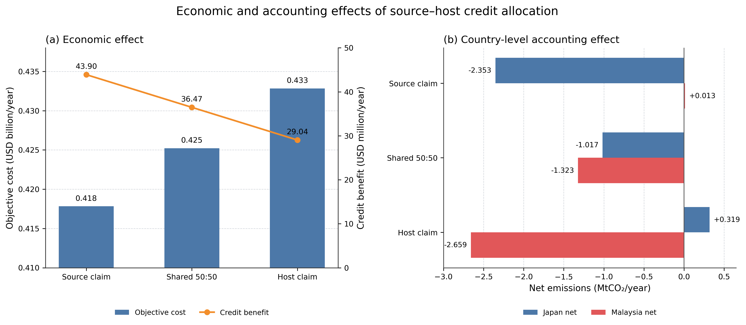
Figure 7: Economic and country-level accounting effects of source–host credit allocation (a) Economic effect; (b) Country-level accounting effect.

4.5. Physical Emissions and Net-Mitigation Performance
Only physically distinct pathways are compared. Domestic storage produces 0.2835 MtCO₂/year of operational emissions, full export 0.3315 MtCO₂/year, and the forced hybrid 0.3015 MtCO₂/year. The full-export increment is 0.0480 MtCO₂/year relative to domestic storage, while the hybrid increment is 0.0180 MtCO₂/year. Fee and credit changes are omitted because their physical flows and emissions are identical to full export.
The domestic pathway stores all 2.716 MtCO₂/year in Japan. Full export sends 2.716 MtCO₂/year to Malaysia and stores 2.672 MtCO₂/year after transport loss. The forced hybrid exports 1.000 MtCO₂/year, stores approximately 0.984 MtCO₂/year in Malaysia, and allocates 1.716 MtCO₂/year domestically. Consequently, captured CO₂, stored CO₂, physical net mitigation, and credited mitigation are distinct quantities. Figure 8 links the allocation and post-loss storage results to the associated operational emissions.
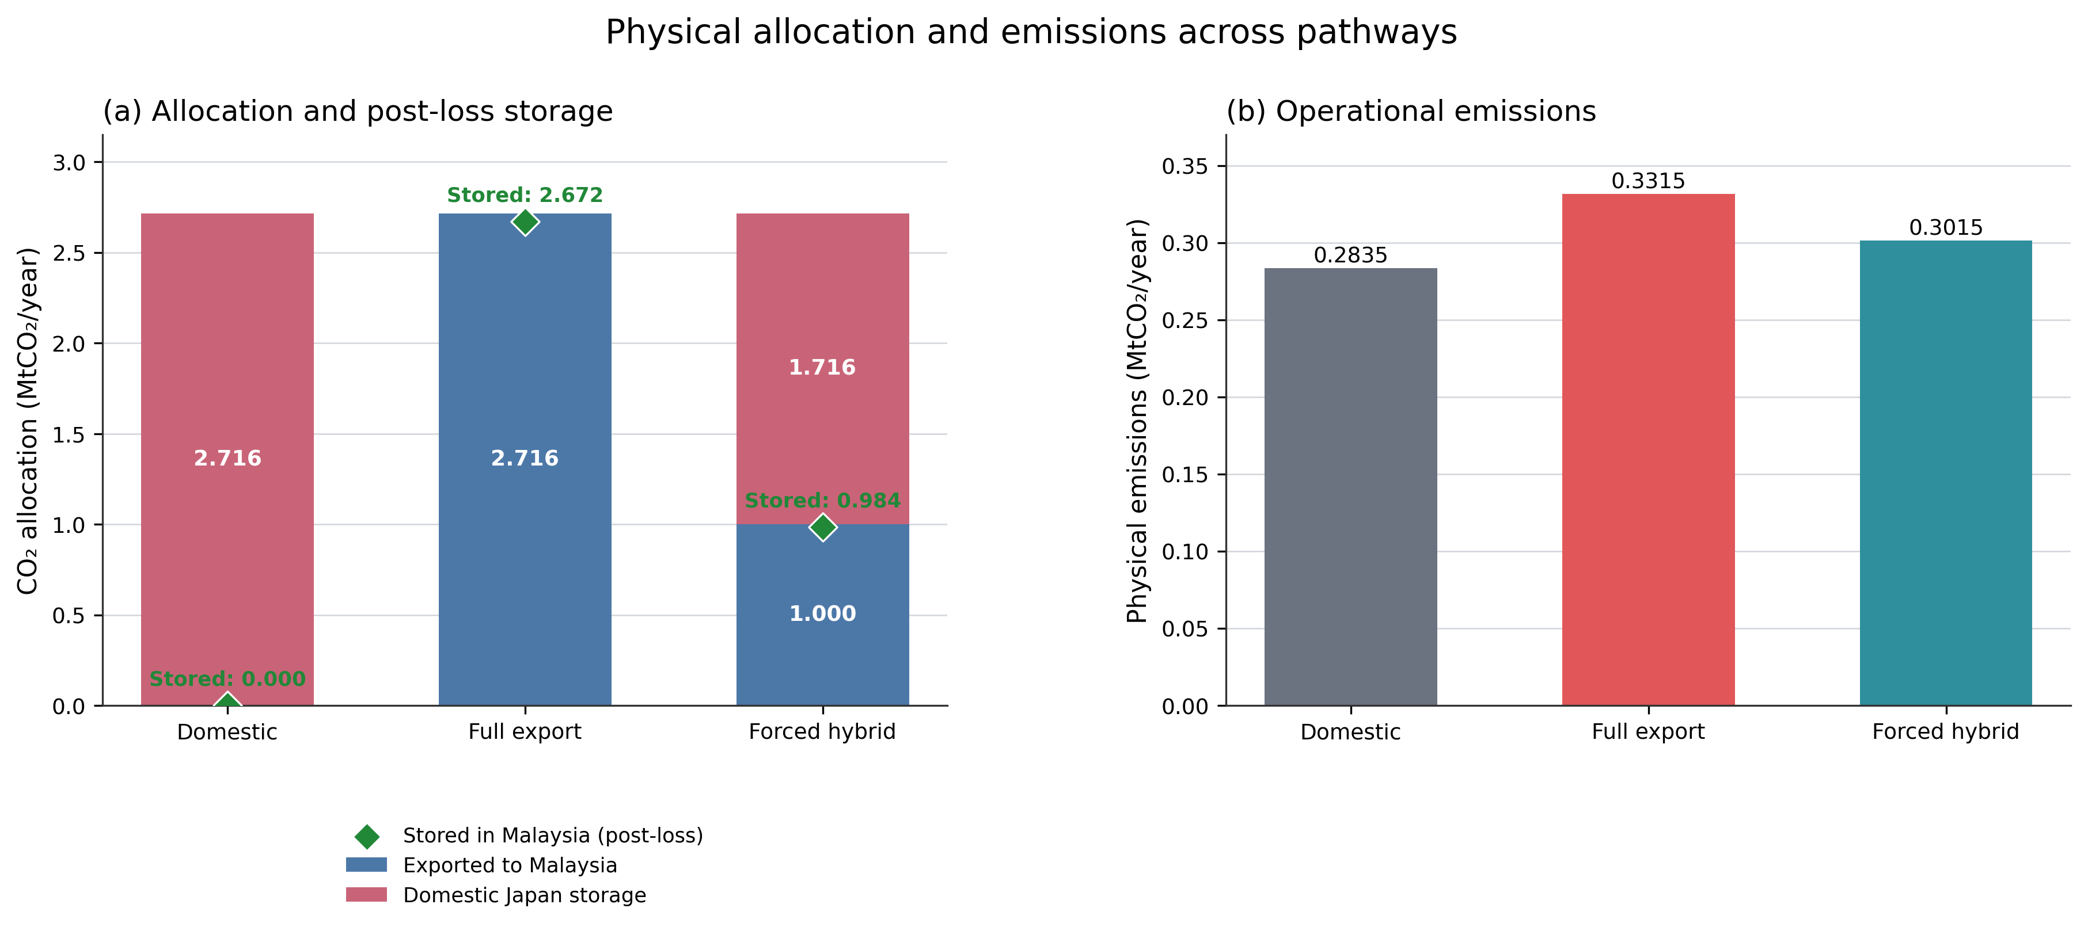
Figure 8: Physical CO₂ allocation, post-loss storage, and operational emissions across distinct pathways

4.6. Sensitivity Analysis
Sensitivity analysis uses the Combined Competitiveness case in Table 7 as the reference. This case allows domestic Japanese storage and export to both Malaysian sinks, activates the country-specific credit values, applies the low Malaysian service fee of USD5.43/tCO₂, uses the higher domestic non-capture cost of USD71.74/tCO₂, and retains the sink-specific premiums and MY-Sink 1 reservation. Five inputs are tested: shipping variable cost, Japanese domestic non-capture cost, country-specific carbon-credit values, Malaysian storage-service fee, and the MY-Sink 1 risk premium.
The Combined Competitiveness reference selects full export of 2.716 MtCO₂/year to MY-Sink 2 at an annual objective cost of USD442.368 million/year. Each input changes separately by -10% and +10%, while the other four tested inputs remain at their reference values. The Japanese and Malaysian credit values change together by the same percentage. Figure 9 illustrates Combined Competitiveness ±10% MILP sensitivity and decision response in which each endpoint represents a separate MILP optimization.
Shipping variable cost produces the widest endpoint range at USD11.339 million/year. This is followed by country-specific carbon-credit values at USD7.281 million/year, the Malaysian storage-service fee at USD2.899 million/year, and the MY-Sink 1 risk premium at USD0.267 million/year. The Japanese domestic non-capture cost has no local objective effect because the optimized solution remains full export at both endpoints. Higher credit values lower the objective because credit revenue is treated as an economic benefit.
The sink-risk response shows that objective-cost sensitivity and decision sensitivity are different. A 10% reduction in the MY-Sink 1 risk premium changes the selected sink from MY-Sink 2 to MY-Sink 1 and reduces the objective by USD0.267 million/year. A 10% increase retains MY-Sink 2. Thus, a parameter can have a small effect on total cost while still changing the selected infrastructure configuration.
This one-at-a-time analysis is a local assessment within the deterministic MILP. It identifies the inputs that most strongly affect optimized cost and shows whether moderate changes alter pathway or sink selection. It does not propagate probability distributions, represent correlations among uncertain inputs, or provide a probabilistic risk estimate.

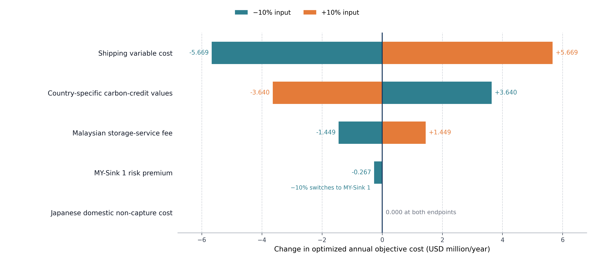
Figure 9: Combined Competitiveness ±10% MILP sensitivity and decision response

5. Conclusion
This study developed an integrated MILP framework linking route and sink selection, energy, emissions, cost, and source–host credit allocation. Domestic storage remains cheaper than base export, while coordinated fee, credit, and domestic-cost support narrows the export-cost gap. The Combined Competitiveness case selects MY-Sink 2 under the modelled sink premiums and reservation conditions, but a 10% reduction in the MY-Sink 1 risk premium switches the selection to MY-Sink 1. Shipping cost and carbon-credit value produce the largest local objective responses. Credit allocation changes economic and national accounting outcomes without changing physical flows. Future work should use project data, optimise domestic and export networks consistently, quantify joint uncertainty and switching thresholds, and develop monitoring-linked benefit-sharing rules.
Declarations
Acknowledgments
Not applicable.
Authors' contributions
Conceptualization, Investigation, Data curation, Formal analysis, Writing – original draft: Ting, J. Z. Z.; Lim, J. S.
Methodology, Validation, Supervision, Writing – review and editing: Ting, J. Z. Z.; Lim, J. S.
Writing – review and editing: Wan Alwi, S. R.; Abdul Manan, Z.; Wang, B.; Gai, L.
Availability of data and materials
The complete numerical inputs, route matrix, scenario settings, and parameter-provenance classification used in this study are to be found in Zenodo.
AI and AI-assisted tools statement
During the preparation of this manuscript, ChatGPT (GPT-5.6, OpenAI; released 2026-07-09) was used solely for language editing and Graphical Abstract, including its icon elements, based on prompts provided by the authors. The AI-generated visual output was reviewed by the authors and was used only for visual presentation. The tool did not influence the study design, data collection, analysis, interpretation, or the scientific content of the work. All authors take full responsibility for the accuracy, integrity, and final content of the manuscript.
Financial support and sponsorship
None
Conflicts of interest
All authors declared that there are no conflicts of interest.
Copyright
© The Author(s) 2026.
List of nomenclature

1. Mapping sets
R(i) — Routes connected to source i.
R(j) — Routes delivering CO₂ to storage sink j.
I(k) — Sources located in country k.
J(k) — Storage sinks located in country k.
A_{i,j} — Binary source–sink mapping equal to 1 if CO₂ from source i can be allocated or credited when stored in sink j, and 0 otherwise.
source(r) — Source associated with transport route r.
sink(r) — Storage sink associated with transport route r.
mode(r) — Transport mode associated with route r.
hub(r) — Import hub associated with route r, where applicable.
country(i) — Country where source i is located.
country(j) — Country where storage sink j is located.
δ_{i,k}^{src} — Binary indicator equal to 1 if source i is located in country k, and 0 otherwise.
δ_{j,k}^{host} — Binary indicator equal to 1 if sink j is located in host country k, and 0 otherwise.

2. Source parameters
E_{i,t} — Gross CO₂ emissions at source i in period t. Unit: tCO₂/period.
η_{i} — Maximum capture fraction at source i. Unit: fraction.
X̄_{i,t} — Maximum capture capacity at source i in period t. Unit: tCO₂/period.
c_{i}^{cap} — Capture cost at source i. Unit: RM/tCO₂.
a_{i}^{cap} — Capture-energy coefficient at source i. Unit: MWh/tCO₂.

3. Storage-sink parameters
Q̄_{j,s} — Maximum injection rate at sink j under scenario s. Unit: tCO₂/period.
Q̄_{j,s}^{avail} — Available injection capacity at sink j under scenario s. Unit: tCO₂/period.
S̄_{j} — Cumulative geological storage capacity of sink j. Unit: tCO₂.
c_{j}^{stor} — Storage cost at sink j. Unit: RM/tCO₂.
c_{j}^{inj} — Injection cost at sink j. Unit: RM/tCO₂.
λ_{j}^{pipe} — Offshore-pipeline or sink-delivery loss factor for sink j. Unit: fraction.
ρ_{j,s}^{risk} — Scenario-dependent risk, access, liability, or reservation premium for sink j. Unit: RM/tCO₂.
φ_{j,s}^{avail} — Scenario-dependent available share of sink or injection capacity. Unit: fraction.
Fee_{j,s}^{stor} — Scenario-specific storage-service fee for sink j. Unit: RM/tCO₂.

4. Route, transport, and infrastructure parameters
F̄_{r,t} — Maximum transport capacity of route r in period t. Unit: tCO₂/period.
D_{r}^{ship} — Shipping distance of route r. Unit: km.
D_{j}^{pipe} — Offshore-pipeline distance from the import hub to sink j. Unit: km.
c_{r}^{ship} — Variable shipping or route-transport cost. Unit: RM/tCO₂.
c_{j}^{pipe} — Variable offshore-pipeline transport cost for sink j. Unit: RM/tCO₂.
λ_{r}^{ship} — Shipping loss factor on route r. Unit: fraction.
a_{r}^{ship} — Shipping-emissions coefficient on route r. Unit: tCO₂ emitted/tCO₂ transported.
a_{j}^{pipe} — Offshore-pipeline energy coefficient for sink j. Unit: MWh/(tCO₂·km).
a_{j}^{inj} — Injection-energy coefficient for sink j. Unit: MWh/tCO₂.
P̄_{d} — Capacity of offshore-pipeline diameter option d. Unit: tCO₂/period.
N̄_{d} — Maximum allowable number of parallel pipelines for diameter option d. Unit: number of pipelines.

5. Country, policy, and accounting parameters
c_{k}^{elec} — Electricity cost in country k. Unit: RM/MWh.
γ_{k} — Grid-emission factor in country k. Unit: tCO₂/MWh.
P_{k,s}^{pen} — Carbon penalty or carbon tax in country k under scenario s. Unit: RM/tCO₂.
P_{k,s}^{cred} — Country-specific carbon-credit or avoided-compliance value. Unit: RM/tCO₂.
α_{s}^{src} — Share of verified storage credit allocated to the source country. Unit: fraction.
α_{s}^{host} — Share of verified storage credit allocated to the host country. Unit: fraction.
M̄_{s}^{import} — Host-country annual CO₂ import cap under scenario s. Unit: tCO₂/year or MtCO₂/year.
M_{s}^{min} — Minimum cross-border export requirement under scenario s. Unit: tCO₂/year or MtCO₂/year.
Ī_{k,s} — Maximum annual CO₂ import allowance for country k under scenario s. Unit: tCO₂/year or MtCO₂/year.
A_{s}^{dom} — Domestic-storage availability switch under scenario s. Unit: binary or fraction.
O_{s} — Minimum capture or storage share under scenario s. Unit: fraction.
H^{yr} — Horizon-to-year scaling factor. Unit: multiplier.

6. Continuous decision variables
x_{i,t} — CO₂ captured at source i in period t. Unit: tCO₂/period.
u_{i,t} — Uncaptured CO₂ at source i in period t. Unit: tCO₂/period.
f_{r,t} — CO₂ exported or transported through route r in period t. Unit: tCO₂/period.
d_{i,t}^{dom} — Captured CO₂ from source i assigned to domestic storage in period t. Unit: tCO₂/period.
h_{j,t} — CO₂ arriving at the host-country import hub serving sink j. Unit: tCO₂/period.
z_{j,t} — CO₂ injected and stored at sink j in period t. Unit: tCO₂/period.
z_{i,j,t} — Verified CO₂ originating from source i and stored at sink j. Unit: tCO₂/period.
E_{i,t}^{cap} — Capture-energy use at source i in period t. Unit: MWh/period.
E_{j,t}^{pipe} — Offshore-pipeline energy use for sink j in period t. Unit: MWh/period.
E_{j,t}^{inj} — Injection-energy use at sink j in period t. Unit: MWh/period.
SE_{t} — Shipping-related CO₂ emissions in period t. Unit: tCO₂/period.
PE_{k,t} — Physical emissions allocated to country k in period t. Unit: tCO₂/period.
UE_{k,t} — Uncaptured source emissions allocated to country k in period t. Unit: tCO₂/period.
EE_{k,t} — Energy-related emissions allocated to country k in period t. Unit: tCO₂/period.
Cr_{k,t,s} — CO₂ storage credit allocated to country k in period t under scenario s. Unit: tCO₂/period.
NE_{k,t} — Net accounting emissions of country k after credit allocation. Unit: tCO₂/period.
Z — Total annual objective cost. Unit: RM/year.

7. Binary and integer decision variables
y_{r} — Binary variable equal to 1 if route r is activated, and 0 otherwise. Unit: binary.
w_{j} — Binary variable equal to 1 if storage sink j is activated, and 0 otherwise. Unit: binary.
b_{j,d} — Binary variable equal to 1 if infrastructure option d is selected for sink j, and 0 otherwise. Unit: binary.
n_{j,d} — Integer number of pipelines of diameter option d installed for sink j. Unit: integer.

REFERENCES
1. International Energy Agency. Carbon capture, utilisation and storage. Paris: IEA; 2024.
2. Global CCS Institute. Global status of CCS 2024: collaborating for a net-zero future. Melbourne: Global CCS Institute; 2024.
3. Middleton RS, Bielicki JM. A scalable infrastructure model for carbon capture and storage: SimCCS. Energy Policy 2009;37:1052-60. DOI: https://doi.org/10.1016/j.enpol.2008.09.049.
4. d’Amore F, Bezzo F. Economic optimisation of European supply chains for CO₂ capture, transport and sequestration. Int J Greenh Gas Control 2017;65:99-116. DOI: https://doi.org/10.1016/j.ijggc.2017.08.015.
5. Zhang S, Liu L, Zhang L, Zhuang Y, Du J. An optimization model for carbon capture utilization and storage supply chain: a case study in Northeastern China. Appl Energy 2018;231:194-206. DOI: https://doi.org/10.1016/j.apenergy.2018.09.129.
6. Roussanaly S, Bureau-Cauchois G, Husebye J. Costs benchmark of CO₂ transport technologies for a group of various size industries. Int J Greenh Gas Control 2013;12:341-50. DOI: https://doi.org/10.1016/j.ijggc.2012.05.008.
7. Roussanaly S, Brunsvold AL, Hognes ES. Benchmarking of CO₂ transport technologies: Part II—offshore pipeline and shipping to an offshore site. Int J Greenh Gas Control 2014;28:283-99. DOI: https://doi.org/10.1016/j.ijggc.2014.06.019.
8. Kjärstad J, Skagestad R, Eldrup NH, Johnsson F. Ship transport—a low cost and low risk CO₂ transport option in the Nordic countries. Int J Greenh Gas Control 2016;54:168-84. DOI: https://doi.org/10.1016/j.ijggc.2016.08.024.
9. Bennæs A, Skogset M, Svorkdal T, Fagerholt K, Herlicka L, et al. Modeling a supply chain for carbon capture and offshore storage—a German–Norwegian case study. Int J Greenh Gas Control 2024;132:104028. DOI: https://doi.org/10.1016/j.ijggc.2023.104028.
10. Boot-Handford ME, Abanades JC, Anthony EJ, Blunt MJ, Brandani S, et al. Carbon capture and storage update. Energy Environ Sci 2014;7:130-89. DOI: https://doi.org/10.1039/C3EE42350F.
11. Bui M, Adjiman CS, Bardow A, Anthony EJ, Boston A, et al. Carbon capture and storage: the way forward. Energy Environ Sci 2018;11:1062-176. DOI: https://doi.org/10.1039/C7EE02342A.
12. Becattini V, Gabrielli P, Antonini C, Campos J, Acquilino A, et al. Carbon dioxide capture, transport and storage supply chains: optimal economic and environmental performance of infrastructure rollout. Int J Greenh Gas Control 2022;117:103635. DOI: https://doi.org/10.1016/j.ijggc.2022.103635.
13. Shi W, Guo Y, Lu Q, Li H, Liang Y, et al. Dynamic tailoring of the gradient porosity of biomass-derived porous carbons for highly effective CO₂ capture. Green Chem 2025;27:11416-28. DOI: https://doi.org/10.1039/D5GC03217B.
14. IEAGHG. Cost of CO₂ capture in the industrial sector: cement and iron and steel industries. Technical Report 2018-TR03. Cheltenham (UK): IEAGHG; 2018.
15. Economic Research Institute for ASEAN and East Asia. A model case study: CCUS cost estimation. In: Kimura S, Shinchi K, Coulmas U, Saimura A, editors. Study on the potential for promoting carbon dioxide capture, utilisation, and storage in ASEAN countries. Vol. II. Jakarta: ERIA; 2022. p. 7-22.
16. Beiron J, Normann F, Johnsson F. A techno-economic assessment of CO₂ capture in biomass and waste-fired combined heat and power plants: a Swedish case study. Int J Greenh Gas Control 2022;118:103684. DOI: https://doi.org/10.1016/j.ijggc.2022.103684.
17. Isogai H, Myers CA, Nakagaki T. Cost estimation of CCS integration into thermal power plants in Japan. Mech Eng J 2022;9:22-00028. DOI: https://doi.org/10.1299/mej.22-00028.
18. Sarawak Energy Berhad. Tariff information. Available from: https://www.sarawakenergy.com/assets/pdf/tariff-info.pdf [Last accessed on 10 Aug 2024].
19. Agency for Natural Resources and Energy, Ministry of Economy, Trade and Industry. Electricity emission factors applied to the Green Energy CO₂ Reduction Equivalent Certification System: FY2021 calculation results. Available from: https://www.enecho.meti.go.jp/category/saving_and_new/green_energy/newenergy/geco2_iinnkai/32doc2.pdf [Last accessed on 10 Aug 2024].
20. Energy Commission Malaysia. Grid emission factor in Malaysia, 2022-2024 (provisional). Available from: https://myenergystats.st.gov.my/documents/d/guest/grid-emission-factor-gef-in-malaysia-2022-2024-provisional- [Last accessed on 21 Aug 2026].
21. Japan Exchange Group. The carbon trading marketplace in Japan. Tokyo: Japan Exchange Group/Tokyo Stock Exchange; 2024.
22. Bank Negara Malaysia. Exchange rates. Available from: https://www.bnm.gov.my/latest-rates [Last accessed on 10 Aug 2024].
23. Bursa Malaysia. Bursa Carbon Exchange auctions first Malaysian nature-based carbon credits. Kuala Lumpur: Bursa Malaysia; 2024.
24. Ministry of Economy, Trade and Industry. Opinion on the FY2026 reference upper transaction price and adjustment benchmark transaction price. Available from: https://www.meti.go.jp/shingikai/sankoshin/sangyo_gijutsu/emissions_trading/pdf/20251219_2.pdf [Last accessed on 12 Aug 2026].
25. Ministry of Finance Malaysia. Expanded SST designed to be progressive, fairer—Amir Hamzah. Available from: https://www.mof.gov.my/portal/en/news/press-citations/expanded-sst-designed-to-be-progressive-fairer-amir-hamzah [Last accessed on 12 Aug 2026].
26. McCollum DL, Ogden JM. Techno-economic models for carbon dioxide compression, transport, and storage and correlations for estimating carbon dioxide density and viscosity. Research Report UCD-ITS-RR-06-14. Davis (CA): Institute of Transportation Studies, University of California, Davis; 2006.
27. Smith E, Morris J, Kheshgi H, Teletzke G, Herzog H, et al. The cost of CO₂ transport and storage in global integrated assessment modeling. Int J Greenh Gas Control 2021;109:103367. DOI: https://doi.org/10.1016/j.ijggc.2021.103367.
28. Hatta A, Consoli C, Seyyedi M. Cost of CO₂ storage. Melbourne: Global CCS Institute; 2025.
29. IEAGHG. Monitoring and modelling of CO₂ storage: the potential for improving the cost-benefit ratio of reducing risk. Technical Report 2020-01. Cheltenham (UK): IEAGHG; 2020.
30. Hendriks C, Graus W, van Bergen F. Global carbon dioxide storage potential and costs. Utrecht: Ecofys; 2004.
31. Correia Serpa dos Santos J, Morbee J, Tzimas E. Technical and economic characteristics of a CO₂ transmission pipeline infrastructure. EUR 24731 EN. Luxembourg: Publications Office of the European Union; 2011. DOI: https://doi.org/10.2790/30861.
32. Knoope MMJ, Ramírez A, Faaij APC. A state-of-the-art review of techno-economic models predicting the costs of CO₂ pipeline transport. Int J Greenh Gas Control 2013;16:241-70. DOI: https://doi.org/10.1016/j.ijggc.2013.01.005.
33. Decarre S, Berthiaud J, Butin N, Guillaume-Combecave JL. CO₂ maritime transportation. Int J Greenh Gas Control 2010;4:857-64. DOI: https://doi.org/10.1016/j.ijggc.2010.05.005.
34. McCoy ST, Rubin ES. An engineering-economic model of pipeline transport of CO₂ with application to carbon capture and storage. Int J Greenh Gas Control 2008;2:219-29. DOI: https://doi.org/10.1016/S1750-5836(07)00119-3.
35. Gu CS, Zhu CK, Gong X, Xu S, Zhang QQ, et al. A novel source–sink matching optimization model for carbon capture and storage. Geol J 2025;60:1840-51. DOI: https://doi.org/10.1002/gj.5178.
36. Su XN, Qiu JX, Luan LM, Mei YD. Source-sink matching and cluster layout of carbon capture, utilization and storage in China towards carbon neutrality. Clim Change Res 2025;21:373-86. DOI: https://doi.org/10.12006/j.issn.1673-1719.2024.153.
37. Ting JZZ, Lim JS, Wan Alwi SR, Abdul Manan Z, Wang B, Gai L. Optimizing cross-border CCS policy: an integrated energy–carbon–cost framework for source–host credit allocation. Zenodo; 2026. DOI: https://doi.org/10.5281/zenodo.21919319.
38. Budiarto O, Purwanto WW, Halimatussadiah A, Maharsi DA. Multi-period superstructure optimization for CCS source-sink matching in South Sumatra industrial clusters. Carbon Neutrality 2025;4:20. DOI: https://doi.org/10.1007/s43979-025-00135-w.
39. Leonzio G, Foscolo PU, Zondervan E. Sustainable utilization and storage of carbon dioxide: analysis and design of an innovative supply chain. Comput Chem Eng 2019;131:106569. DOI: https://doi.org/10.1016/j.compchemeng.2019.106569.
40. Kumcu S, Özyörük B, Bezzo F, d’Amore F. Optimization of carbon capture, utilization, and storage supply chains for the hard-to-abate industry in Türkiye. Int J Greenh Gas Control 2026;150:104568. DOI: https://doi.org/10.1016/j.ijggc.2026.104568.
41. Rowaihy F, Hamieh A, Odeh N, Hejazi M, Al-Juaied M, et al. Decarbonizing Saudi Arabia’s energy and industrial sectors: an integrated techno-economic assessment of CCS. Energy Convers Manag X 2026;29:101536. DOI: https://doi.org/10.1016/j.ecmx.2026.101536.
42. Keçi H, Alcani M, Dorri A. Assessing the potential of carbon capture, utilization, and storage for industrial decarbonization. Int J Innov Technol Interdiscip Sci 2026;9:1371-88. DOI: https://doi.org/10.15157/IJITIS.2026.9.2.1371-1388.

