Marriott.com Hotel Web Sites

Fairfield Inn & Suites Gen 4 Photography

1. PART 1. Complete Hotel Information and indicate if any photos currently on the photo tour need to be removed.
2. PART 2. Select the Fairfield Inn & Suites photos you would like to appear on your Marriott.com Hotel Website photo tour. The brand-approved captions shown are the captions that will be displayed.
3. E-mail completed form to Design.HWS@marriott.com
4. These photos will remain on your photo tour for 90 days and will not meet the LQA guidelines.

PART 1: Hotel Information

Property/Hotel Name:
MARSHA code:
Hotel Contact (employee name):
Phone:
E-mail address:

List any existing images you would like REMOVED from the site (as listed in photo tour):

1. Image Name |  | 4. Image Name |  | 7. Image Name
2. Image Name |  | 5. Image Name |  | 8. Image Name
3. Image Name |  | 6. Image Name |  | 9. Image Name

PART 2: Image Submission Information

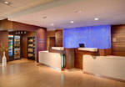

A warm and welcoming front desk area features a Corner Market, where snacks and refreshments are available 24/7.This photo is a representation of the hotel’s facilities and amenities.
ffi_genIV_phototour01

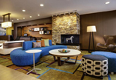

The lobby’s modern living zone is bright and lively, and offers guests plenty of space to gather, work and relax. It also features a Connect & Print area. This photo is a representation of the hotel’s facilities and amenities.
ffi_genIV_phototour02

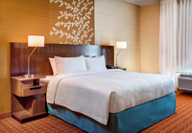

Our spacious, modern “smart” rooms feature comfortable bedding and creative storage solutions such as a signature closet and a built-in luggage rack for those who prefer to live out of their suitcases. This photo is a representation of the hotel’s facilities and amenities.
ffi_genIV_phototour03

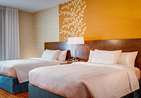

Our spacious, modern “smart” rooms feature comfortable bedding and creative storage solutions such as a signature closet and a built-in luggage rack for those who prefer to live out of their suitcases. This photo is a representation of the hotel’s facilities and amenities.
ffi_genIV_phototour11

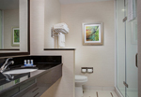

Our bathrooms feature thoughtful amenities, including a modern bath design with stand-in shower in king guest rooms and suites. This photo is a representation of the hotel’s facilities and amenities.
ffi_genIV_phototour10

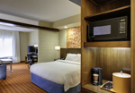

Our suites let you stretch out, work and sleep in separate spaces with creative storage solutions such as a signature closet, a built-in luggage rack for those who prefer to live out of their suitcases, as well as a mobile desk on wheels so you can work your way. This photo is a representation of the hotel’s facilities and amenities.
ffi_genIV_phototour09

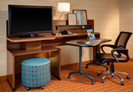

Our spacious accommodations feature a movable desk to create a flexible work environment, outlets in all the right places and creative storage solutions. This photo is a representation of the hotel’s facilities and amenities.
ffi_genIV_phototour08

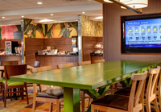

The breakfast area features a communal “farm table” as well as plenty of space to spread out and enjoy the complimentary breakfast. This photo is a representation of the hotel’s facilities and amenities.
ffi_genIV_phototour04

