# Marriott.com Hotel Web Sites

# Fairfield Inn & Suites® Breakfast Food Photos

**1.** Complete Hotel Information and indicate if any photos currently on the photo tour need to be removed on PART 1.

**2.** Select **up to four** Fairfield Inn & Suites Breakfast photos on PART 2 (there is a limit of four). The brand-approved captions shown are the captions that will be displayed.

**3.** E-mail completed form to [Design.HWS@marriott.com](mailto:Design.HWS@marriott.com)

PART 1: Hotel Information

Property/Hotel Name:

MARSHA code:

Hotel Contact (employee name):

Phone:

E-mail address:

      List any existing images you would like ***REMOVED*** from the site (as listed in photo tour):

|  |  |  |  |  |  |
| --- | --- | --- | --- | --- | --- |
| 1. Image Name |  | 4. Image Name |  | 7. Image Name |  |
| 2. Image Name |  | 5. Image Name |  | 8. Image Name |  |
| 3. Image Name |  | 6. Image Name |  | 9. Image Name |  |

PART 2: Image Submission Information

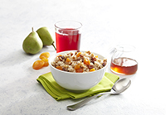

**Quaker® Oatmeal**

Made fresh all morning long, our oatmeal is always hot and ready to be topped off with a variety of tasty options like sliced almonds, agave syrup, dried fruit and cinnamon.

ffi_food01

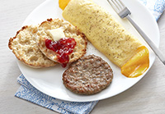

**Hi Protein**

Choose a Colby cheese omelet or scrambled eggs and then top off with shredded cheese and salsa. Or grab a couple of hard-boiled eggs for a healthy protein boost to kick-start your day.

ffi_food02

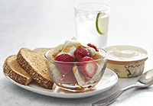

**A Healthy Start with Chobani® Yogurt (U.S. properties only)**

Enjoy Chobani flavored Greek yogurt or Dannon® Light & Fit. Mix things up with our delicious toppings like walnut pieces, granola and fresh fruit.

ffi_food03

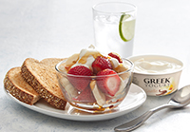

**A Healthy Start with Greek Yogurt (Canadian properties only)**

Enjoy Greek or traditional yogurt, then mix things up with our delicious toppings like walnut pieces, granola and fresh fruit.

ffi_food08

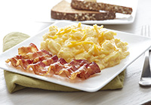

**Warm Up to our Hot Breakfast**

To help you fuel up for the day, we offer a healthy mix of delicious, fresh and free breakfast options.

ffi_food04

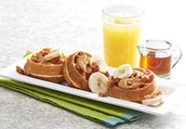

**Mini Waffles, Big Taste**

Create your own morning masterpiece with a variety of toppings like syrup, peanut butter, sliced bananas and bacon. It’s everything you need for a delicious start to your day.

ffi_food05

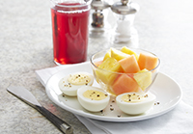

**Fresh Fruit, Daily Rotation**

Options like whole strawberries, cantaloupe, grapes, bananas and seasonal fruit will freshen up your morning.

ffi_food06