|  |  |
| --- | --- |
|  | Medication Manager  Encarnacion, John Philip A.  Laab, Charles Daniel L.  Quintos, Juan Santiago S.  Rodriguez, Robert Charles R. |

1. Table of Contents

A Objectives 1

B Scope and Features 2

B.1 Log-in 2

B.2 Sign-up 2

B.3 Home Page 2

B.4 Profile Page 2

B.5 Manage Medication Page 2

B.6 Alarm 2

B.7 Med Count Check 2

B.8 Contact Us Page 2

B.9 Update Password 2

B.10 Forget Password 2

B.11 Rating and Recommendations 2

B.12 Intake Log 2

C Limitations 3

C.1 Log-in 3

C.2 Sign-Up 3

C.3 Home Page 3

C.4 Profile Page 3

C.5 Manage Medication Page 3

C.6 Alarm 3

C.7 Med Count Check 3

C.8 Contact Us Page 3

C.9 Update Password 3

C.10 Forgot Password 3

C.11 Rating and Recommendations 3

C.12 Intake Log 3

D Development System Requirements 4

D.1 Development Hardware Requirements 4

D.1.1 Processor 4

D.1.2 Memory 4

D.1.3 Storage 4

D.2 Development Software Requirements 4

D.2.1 Operating System 4

D.2.2 Software Requirements 4

E Mobile System Requirements 5

E.1 Mobile Hardware Requirements 5

E.1.1 Processor 5

E.1.2 Memory 5

E.1.3 Storage 5

E.2 Mobile Software Requirements 5

E.2.1 Operating System 5

F Database Diagram 6

F.1 Medication Manager Database Diagram 6

G Class Diagram 7

G.1 Medication Manager Class Diagram 7

H Class Definition 8

H.1 Account Class Definition 8

H.2 Medtake Class Definition 8

H.3 Ratings_Recommendation Class Definition 8

H.4 IService Class Definition 9

H.5 Service Class Definition 9

H.6 MedType Class Definition 12

H.7 MedTake Class Definition 12

H.8 MedTakeSchedule Class Definition 13

H.9 MedTakeToday Class Definition 13

H.10 AccountLog Class Definition 14

H.11 IntakeLog Class Definition 14

I User Manual 15

I.1 Log-in Interface 15

I.2 Home Page 17

I.3 User Manual Image # 3 18

J References 19

J.1 Reference # 1 19

J.2 Reference # 2 19

J.3 Reference # 3 19

J.4 Reference # 4 19

J.5 Reference # 5 19

J.6 Reference # 6 19

List of Figures

Figure F.1.a: Medication Manager Database Diagram 6

Figure I.1.a: Account Registration 15

Figure I.2.a: Home Page 20

# Objectives

For some people, taking a medicine can be the difference between life and death. People have a lot on their minds these days and because of this, most of us forget to take our prescribed medicine.

Medication Manager is a mobile app and its sole purpose is to manage our medications. With this, patients can take the right medication, with the right dosage, and right time that will help them avoid the possible dangers of wrong medication administration. This app does not suggest or prescribe medicine for its us. It only reminds us to take our medication

We believe that this is a helpful tool for everyone especially the senior citizen. Proper medication administration helps people to meet their healthcare goals. It also lessens the stress for the users because they will be comfortable that our app will remind them about their medication.

# Scope and Features

## Log-in

Login page for users using their registered email address and password.

## Sign-up

Users can create an account to access the app.

## Home Page

This is the page where the user could find the information of the medications that is currently managed by our app. This is where they can see the names of the medications, the time it should be taken, and the dosage.

## Profile Page

The users could edit their information like their age, weight, height and other information here.

## Manage Medication Page

This is the page where the user could find the information of the medications that is currently managed by our app. This is where they can see the names of the medications, the time it should be taken, and the dosage.

## Alarm

There will be an alert message when the time that was set by the user is reached. It will be a short message that will say “It’s time to take your (Medicine Name)”. There will be a Dismiss button below it to stop the alarm.

## Med Count Check

Notifies the users if the medication reaches the critical number that is also set by the user.

## Contact Us Page

Shows contact details of our website.

## Update Password

Users may use this feature to change the password of their account.

## Forget Password

Users could reset the password of their account using their e-mail.

## Rating and Recommendations

This feature allows the users to send recommendations, and feedback to the developers to further improve the app.

## Intake Log

This feature will allow the users to view the days that they have missed to take their medicine.

# Limitations

## Log-in

Only registered users can log in and use the app.

## Sign-Up

Collects basic information from the users such as their full name, email address, age, and gender. Other personal information like home address is not needed due to privacy purposes

## Home Page

This page will only show the medication that is being managed by the app. It will not prescript or suggest medications for the user.

## Profile Page

Shows only the basic information like full name, email address, age, and gender.

## Manage Medication Page

The app cannot verify if the medication that you have entered is really for your illness.

## Alarm

The alarm would just remind the users to take the medication, therefore we have no guarantee if the user will take the medicine or not.

## Med Count Check

The number of tablets/pills will be set by the user, so this feature will be dependent on the input of the user. This feature is not applicable to medications that are in liquid form.

## Contact Us Page

The users could only reach us thru the contact information that we will provide in this page

## Update Password

The user should know his current password to update the new password..

## Forgot Password

The user cannot retrieve their password if they have also forgotten their e-mail address.

## Rating and Recommendations

Each user can only rate the app’s services and submit a feedback once.

## Intake Log

The intake log can only handle one medication at a time.

# Development System Requirements

## Development Hardware Requirements

### Processor

Processor Core Count : 4

### Memory

Memory Capacity : 4 GB

### Storage

Disk Size : 50 GB

## Development Software Requirements

### Operating System

Operating System Name : Windows 7 and above

Architecture Type : 64 bit

Edition : Premium Edition

### Software Requirements

Software Application # 1 : Visual Studio 2019 Community Edition

Software Application # 2 : Microsoft SQL Server 2019 Express Edition

Software Application # 3 : SQL Server Management Studio v18.7

# Mobile System Requirements

## Mobile Hardware Requirements

### Processor

Processor Core Count : 4

### Memory

Memory Capacity : 1 GB

### Storage

Disk Size : 200 MB

## Mobile Software Requirements

### Operating System

Operating System Name : Android

Architecture Type : Lollipop

Edition : 5.0

# Database Diagram

## Medication Manager Database Diagram



Figure F.1.a: Medication Manager Database Diagram

# Class Diagram

## Medication Manager Class Diagram

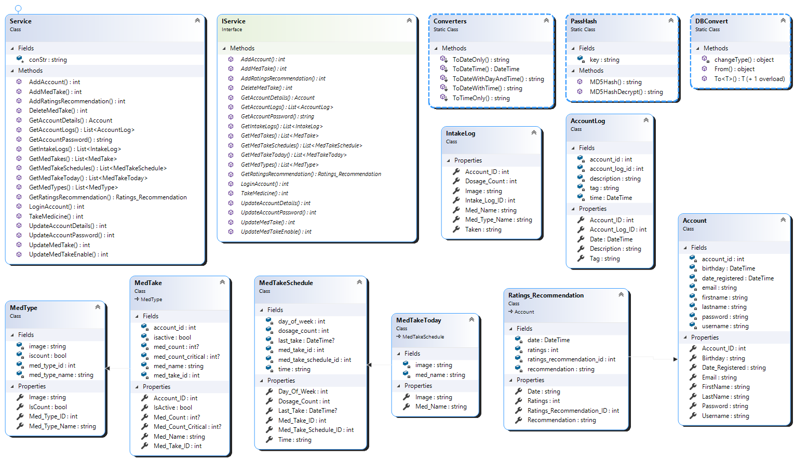

Figure G.1.a: Medication Manager Class Diagram

# Class Definition

## Account Class Definition

|  |  |
| --- | --- |
| **Name:** | Account |
| **Type:** | Class |
| **Description:** | Used to store and get account information. |
| **Fields:** | account_id : int |
| birthday : DateTime |
| date_registered : DateTime |
| email : string |
| firstname : string |
| lastname : string |
| password : string |
| username : string |
| **Properties:** | AccountID { get; set; } : int |
| Birthday {get; set;} : string |
| Date_Registered {get; set;} : string |
| Email {get; set;} : string |
| FirstName {get; set;} : string |
| LastName {get; set;} : string |
| Password {get; set;} : string |
| Username{get; set;} : string |

## Medtake Class Definition

|  |  |
| --- | --- |
| **Name:** | MedTake |
| **Type:** | Class |
| **Description:** | Used to store and get medication information. |
| **Fields:** | med_take_id : int |
| med_name : string |
| med_count : int |
| med_take_time : DateTime |
| **Properties:** | Med_Take_ID { get; set; } : int |
| Med_Name {get; set;} : string |
| Med_Count {get; set;} : int |
| Med_Take_Time {get; set;} : string |

## Ratings_Recommendation Class Definition

|  |  |
| --- | --- |
| **Name:** | Ratings_Recommendation |
| **Type:** | Class |
| **Description:** | Used to store and get ratings and recommendations information. |
| **Fields:** | ratings_recommendation_id : int |
| ratings : int |
| recommendations: string |
| date : DateTime |
| **Properties:** | Ratings_Recommendation_ID { get; set; } : int |
| Ratings {get; set;} : int |
| Recommendations {get; set;} : string |
| Date {get; set;} : string |

## IService Class Definition

|  |  |
| --- | --- |
| **Name:** | IService |
| **Type:** | Interface |
| **Description:** | Contains a collection of methods used in performing CRUD operation in WCF Web Service. |
| **Methods:** | GetAccountDetails(string id); |
| LoginAccount(string username, string password); |
| AddAccount(Account account); |
| UpdateAccountDetails(Account account); |
| UpdateAccountPassword(int account_id, string old_password, string new_password); |
| AddRatingsRecommendation(Ratings_Recommendation ratingsRecommendation); |
| GetRatingsRecommendation(int account_id); |
| AddMedTake(MedTake medtake); |
| GetMedTakes(int account_id); |
| UpdateMedTake(MedTake medtake); |
| DeleteMedTake(MedTake medtake); |

## Service Class Definition

|  |  |
| --- | --- |
| **Name:** | Service |
| **Type:** | Class |
| **Description:** | Contains a collection of methods with their definitions that are used in performing CRUD operation in WCF Web Service. |
| **Methods:** | GetAccountDetails(string id) : Account |
| LoginAccount(string username, string password) : int |
| AddAccount(Account account) : int |
| UpdateAccountDetails(Account account) : int |
| UpdateAccountPassword(int account_id, string old_password, string new_password) : int |
| AddRatingsRecommendation(Ratings_Recommendation ratingsRecommendation) : int |
| GetRatingsRecommendation(int account_id) : Ratings_Recommendation |
| AddMedTake(MedTake medtake) : int |
| GetMedTakes(int account_id) : List<MedTake> |
| UpdateMedTake(MedTake medtake) : int |
| DeleteMedTake(MedTake medtake) : int |

|  |  |
| --- | --- |
| **Name:** | Service |
| **Member Name:** | GetAccountDetails |
| **Type:** | Method |
| **Description:** | Used to retrieve user’s account and personal information. |
| **Parameters:** | string id |
| **Return Value:** | Account |
| **Return Type:** | Account |

|  |  |
| --- | --- |
| **Name:** | Service |
| **Member Name:** | LoginAccount |
| **Type:** | Method |
| **Description:** | Used to check if the supplied username and password are valid. |
| **Parameters:** | string username |
| string password |
| **Return Value:** | Account_ID |
| **Return Type:** | int |

|  |  |
| --- | --- |
| **Name:** | Service |
| **Member Name:** | AddAccount |
| **Type:** | Method |
| **Description:** | Used to create a new account after user’s successful registration. |
| **Parameters:** | Account account |
| **Return Value:** | result |
| **Return Type:** | int |

|  |  |
| --- | --- |
| **Name:** | Service |
| **Member Name:** | UpdateAccountDetails |
| **Type:** | Method |
| **Description:** | Used to update the user’s account and personal information. |
| **Parameters:** | Account account |
| **Return Value:** | result |
| **Return Type:** | int |

|  |  |
| --- | --- |
| **Name:** | Service |
| **Member Name:** | UpdateAccountPassword |
| **Type:** | Method |
| **Description:** | Used to update the user’s account password. |
| **Parameters:** | int account_id, |
| string old_password |
| string new_password |
| **Return Value:** | result |
| **Return Type:** | int |

|  |  |
| --- | --- |
| **Name:** | Service |
| **Member Name:** | AddRatingsRecommendation |
| **Type:** | Method |
| **Description:** | Used to add new ratings and recommendations of a user. |
| **Parameters:** | Ratings_Recommendation ratingsRecommendation |
| **Return Value:** | result |
| **Return Type:** | int |

|  |  |
| --- | --- |
| **Name:** | Service |
| **Member Name:** | GetRatingsRecommendation |
| **Type:** | Method |
| **Description:** | Used to retrieve ratings and recommendations of a user. |
| **Parameters:** | int account_id |
| **Return Value:** | ratingsRecommendation |
| **Return Type:** | Ratings_Recommendation |

|  |  |
| --- | --- |
| **Name:** | Service |
| **Member Name:** | AddMedTake |
| **Type:** | Method |
| **Description:** | Used to add a medication intake schedule of a user. |
| **Parameters:** | MedTake medtake |
| **Return Value:** | result |
| **Return Type:** | int |

|  |  |
| --- | --- |
| **Name:** | Service |
| **Member Name:** | GetMedTakes |
| **Type:** | Method |
| **Description:** | Used to retrieve all medication intake schedules of a user. |
| **Parameters:** | int account_id |
| **Return Value:** | medtakes |
| **Return Type:** | List<MedTake> |

|  |  |
| --- | --- |
| **Name:** | Service |
| **Member Name:** | UpdateMedTake |
| **Type:** | Method |
| **Description:** | Used to update a medication intake schedule of a user. |
| **Parameters:** | MedTake medtake |
| **Return Value:** | result |
| **Return Type:** | int |

|  |  |
| --- | --- |
| **Name:** | Service |
| **Member Name:** | DeleteMedTake |
| **Type:** | Method |
| **Description:** | Used to delete a medication intake schedule of a user. |
| **Parameters:** | MedTake medtake |
| **Return Value:** | result |
| **Return Type:** | int |

## MedType Class Definition

|  |  |
| --- | --- |
| **Name:** | MedType |
| **Type:** | Class |
| **Description:** | Used to store and identify the type of medication |
| **Fields:** | med_type_id : int |
| med_type_name: string |
| iscount: bool |
| image: string |
| **Properties:** | Med_Type_ID {get; set;} : int |
| Med_Type_name {get; set;} : string |
| IsCount {get; set;} : bool |
| Image {get; set;} : string |

## MedTake Class Definition

|  |  |
| --- | --- |
| **Name:** | MedTake |
| **Type:** | Class |
| **Description:** | Used to store and get medications |
| **Fields:** | med_take_id : int |
| med_name: string |
| med_count: int |
| med_count_critical: int |
| account_id :int |
| isactive: bool |
| **Properties:** | Med_Take_ID {get; set;} : int |
| Med_Name {get; set;} : string |
| Med_Count {get; set;} : int |
| Med_Count_Critical {get; set;} : int |
| Account_ID {get; set;} : int |
| IsActive {get; set;} : bool |

## MedTakeSchedule Class Definition

|  |  |
| --- | --- |
| **Name:** | MedTakeSchedule |
| **Type:** | Class |
| **Description:** | Used to store and get medication schedules set by the user |
| **Fields:** | med_take_schedule_id : int |
| day_of_week : int |
| dosage_count: int |
| med_take_id: int |
| time : string |
| last_take: DateTime |
| **Properties:** | Med_Take_Schedule_ID {get; set;} : int |
| Day_Of_Week {get; set;} : int |
| Dosage_Count {get; set;} : int |
| Med_Count_Critical {get; set;} : int |
| Med_Take_ID {get; set;} : int |
| Time {get; set;} : string |
| Last_Take {get; set;} : DateTime |

## MedTakeToday Class Definition

|  |  |
| --- | --- |
| **Name:** | MedTakeToday |
| **Type:** | Class |
| **Description:** | Used to store and get scheduled medications for the day |
| **Fields:** | med_name : string |
| image : string |
| **Properties:** | Med_Name {get; set;} : string |
| Image {get; set;} : string |

## AccountLog Class Definition

|  |  |
| --- | --- |
| **Name:** | AccountLog |
| **Type:** | Class |
| **Description:** | Used to record information about the user’s account activity |
| **Fields:** | account_log_id : int |
| account_id : int |
| time: DateTime |
| tag: string |
| description : string |
| **Properties:** | Account_Log_ID {get; set;} : int |
| Account_ID {get; set;} : int |
| Time {get; set;} : DateTime |
| Tag{get; set;} : string |
| Description {get; set;} : string |

## IntakeLog Class Definition

|  |  |
| --- | --- |
| **Name:** | IntakeLog |
| **Type:** | Class |
| **Description:** | Used to record information about the user’s medication intake |
| **Properties:** | Intake_Log_ID {get; set;} : int |
| Account_ID {get; set;} : int |
| Med_Name {get; set;} : string |
| Dosage_Count{get; set;} : int |
| Med_Type_Name {get; set;} : string |
| Image {get; set;} : string |
| Taken {get; set;} : string |

# User Manual

## Account Registration, Log-in, Change Password and Forget Password

The user should register for an account in order to use the application.

Upon registering, the user should fill up all the required information.

Figure I.1.a: Account Registration

In order to log-in, the user should provide the registered username and password.

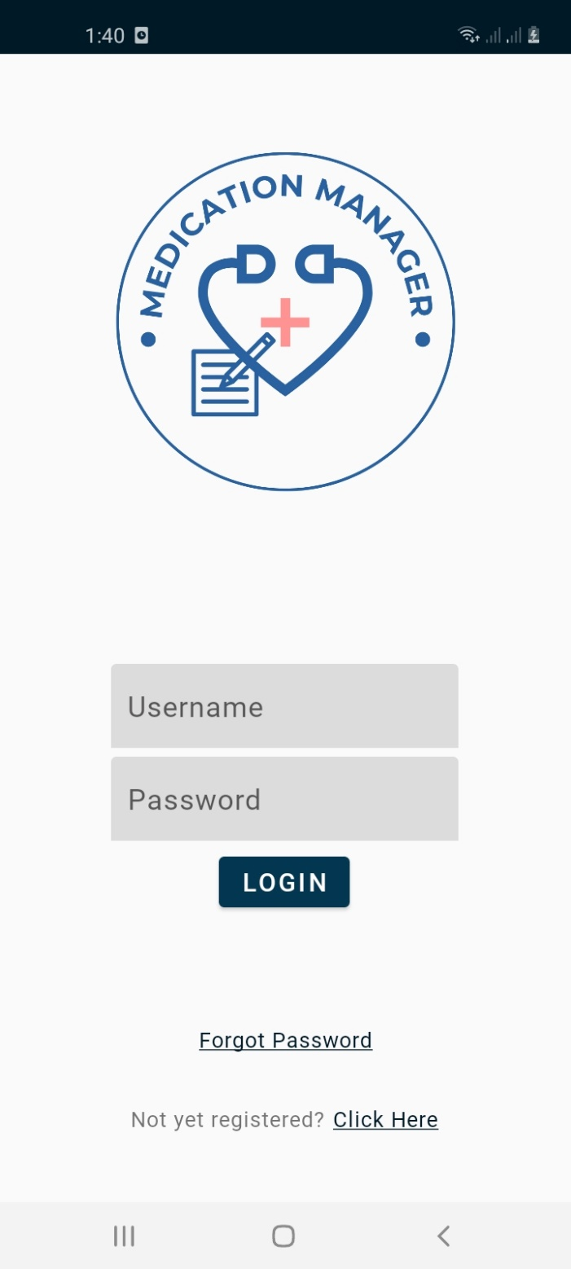

Figure I.1.b: User Log-in

If the user intends to edit the details that they have entered the may do so by clicking the Profile Tab.

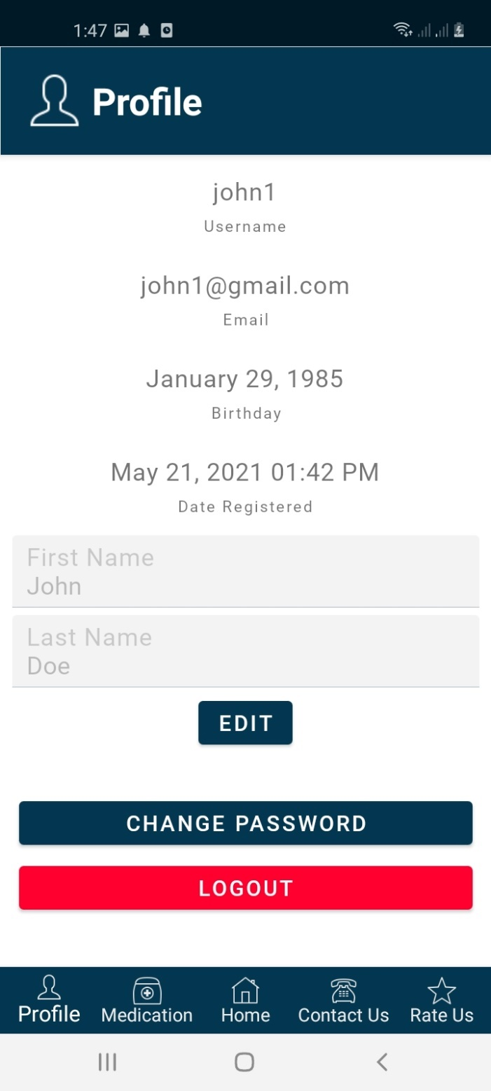

Figure I.1.c: Profile Tab

If the user wants to change the password, they may do so by clicking the Change Password button on the Profile Tab. The user would be asked to input the current password and the new password.

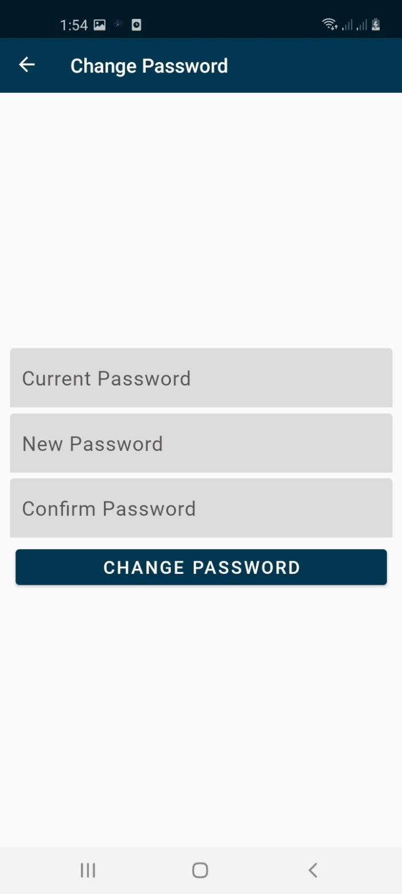

Figure I.1.d: Change Password Page

If the user wants to change the password, they may do so by clicking the Change Password button on the Profile Tab. The user would be asked to input the current password and the new password.

Figure I.1.e: Forgot Password Page

## Home Page

Upon logging in, the user would be directed to the Home page. This is where they can manage and view the medications being managed by the app as well as the user activity logs.

A  check mark will be shown beside the medication name if it is already taken within the day. Otherwise, an  exclamation mark will appear.

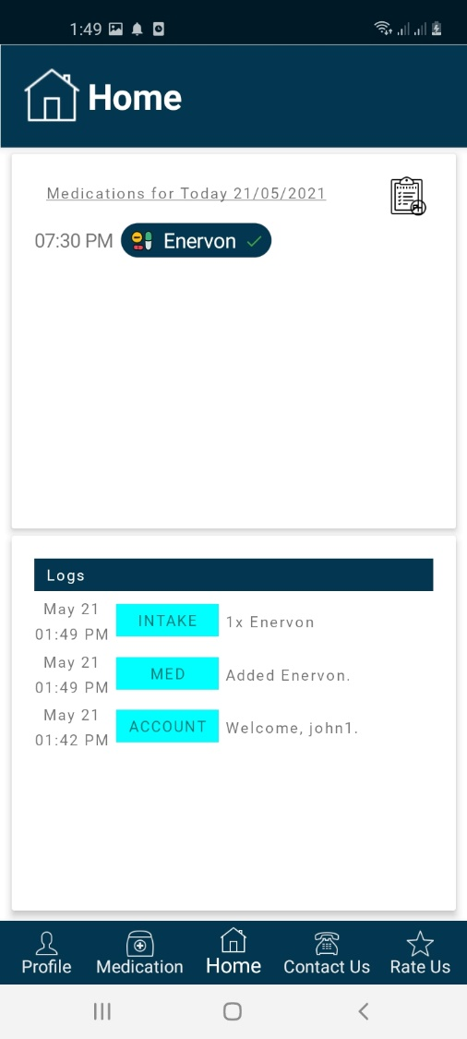 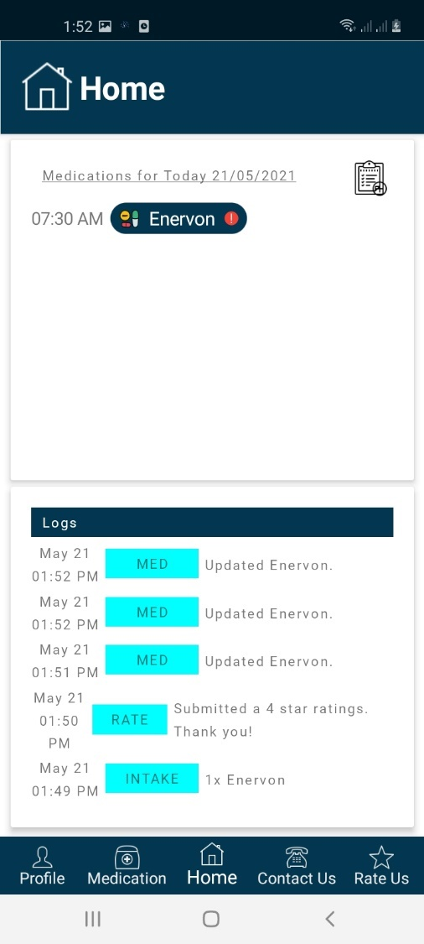

Figure I.2.a: Home Page

## Managing Medication

All medications will be listed in the Medication tab. The user can activate/deactivate specific medications by clicking the toggle button.

If a medication has reached its critical count, an  exclamation mark will be shown beside the count text of the medication.

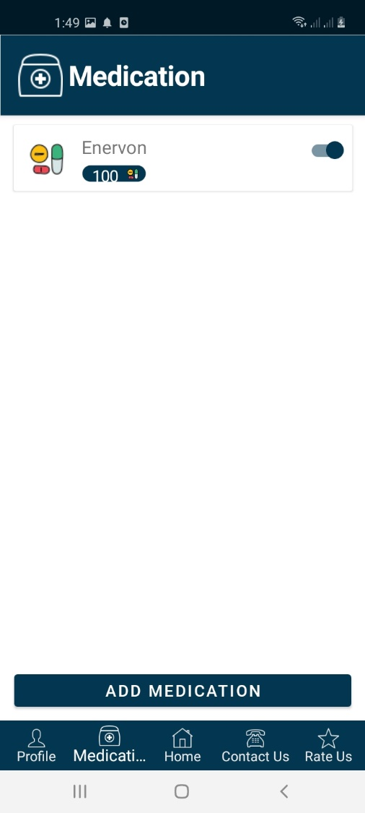 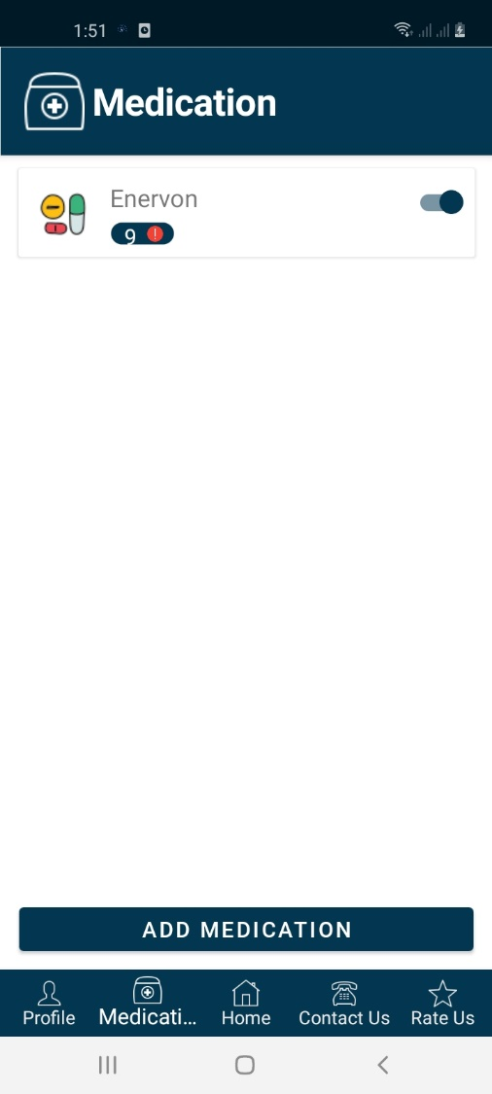

Figure I.3.a: Medication Tab

If the user intends to add or edit a medication, they will be required to fill up the fields and click the  check mark to save.

To delete an existing medication, click the ‘Delete Medication’.

Figure I.3.b: Adding Medication

# References

## Reference # 1

Reference Title : Basics of WCF Security

Reference Author : Ramesh Kartik

Reference Page Source : [link](https://www.c-sharpcorner.com/UploadFile/rkartikcsharp/basics-on-wcf-security/)

## Reference # 2

Reference Title : XAML Controls - Xamarin

Reference Author : Microsoft

Reference Page Source : [link](https://docs.microsoft.com/en-us/xamarin/xamarin-forms/xaml/xaml-controls)

## Reference # 3

Reference Title : XF.Material Library

Reference Author : Baseflow

Reference Page Source : [link](https://github.com/Baseflow/XF-Material-Library)

## Reference # 4

Reference Title : Publishing ASP.NET Web API REST Service Using File System Method

Reference Author : Vithal Wadje

Reference Page Source : [link](https://www.c-sharpcorner.com/article/publishing-asp-net-web-api-rest-service-using-file-system-method/)

## Reference # 5

Reference Title : WCF RESTful Service

Reference Author : Ramakrishna Basagalla

Reference Page Source : [link](https://www.c-sharpcorner.com/article/wcf-restful-service/)

## Reference # 6

Reference Title : Consume a REST service with HttpClient

Reference Author : Microsoft

Reference Page Source : [link](https://docs.microsoft.com/en-us/learn/modules/consume-rest-services/3-consume-rest-service-with-httpclient)

