**Internal Assessment Resource**

**Resource title**

**FAVOURITE FOODS WEBSITE**

**(Basic Image Manipulation & Web Design)**

**Due Date: 7 June 2018**

**91880: Develop a Digital Media Outcome**

**Version 1, Credits 4, Level 1**

|  |  |  |
| --- | --- | --- |
| **Achievement** | **Achievement with Merit** | **Achievement with Excellence** |
| Develop a digital media outcome | Develop an informed digital media outcome | Develop a refined digital media outcome |

Task

Plan and create a multi-page website that meets the specifications outlined in the ‘specifications’ area below.

As you go about the task, keep a record of the results of all testing (ie: complete the evidence template).

When you have finished, upload your website and evidence template to a subfolder at wgpinfotech.ddns.net.

* Your website (including any necessary subfolders and images)
* Your completed evidence template

Context

You have been asked to create a multi-page website based on the phrase ‘Food Glorious Food’. Your website could…

* Showcase three of your favourite foods with an explanation of what you love about each dish
* Promote a diet/lifestyle with a focus on three specific dishes (eg: Best Vegan Meals)
* Feature three ‘family favourites’ (complete with recipes if desired)

**Specifications** for your ‘food-related website’:

The website has:

* A home page explaining what the site is about (eg: This site showcases my favourite foods. The dishes have been chosen because…)*.*
* Three ‘food’ pages. Each page should describe one dish/meal/food item
* A ‘contact’ page so users can get in touch if they want to find out more information.
* Suitable images (eg: A banner image and photographs of the various food items featured on your site)
* Easy to use Navigation (ie: Users should be able to easily access all the pages of the website without having to resort to using the ‘back’ button
* Suitable colours which work well together (ie: Page must be easy to read and aesthetically pleasing)
* Clear titles and subheadings that are easily identifiable
* Headings balanced with images
* The text is easy to read/digest. Lists / other features have been used where appropriate
* An ability to be displayed in different browsers.

91880 – Web Design Evidence Template

# **Wire Frame**

Create a simple wireframe for your site showing the placement of the major elements of your page. Either hand in a hard copy or put a screenshot of your layout in the space below

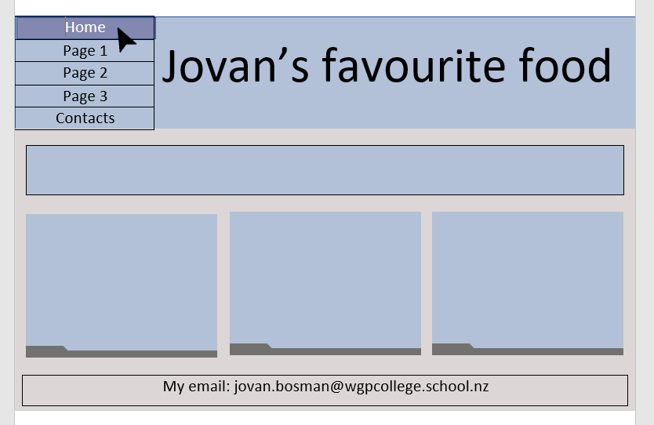Home Page:

Page 1,2 and three layouts:

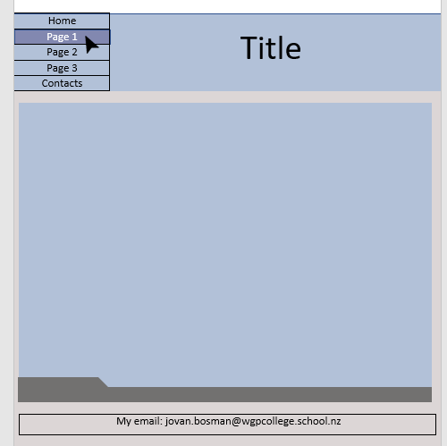

Contact Page:

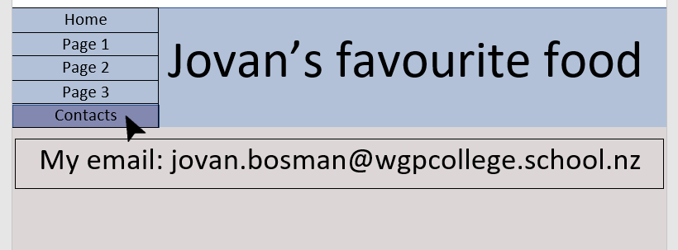

# **Image Skills**

Screenshot your ‘layers’ toolbox in GIMP / Photoshop and annotate it to show how your banner image was created. Replace the example below with your work.

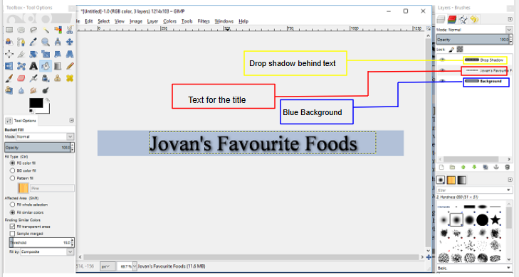

# **Testing**

Test your site! Does it work in two unrelated browsers IE/Chrome/Firefox/Safari?

Firefox: It works perfectly because I did most of my testing on that browser while making my website.

Chrome: In chrome, there is one slight problem with my navigation bar at the top because it is too tall but as for everything else it worked fine.

Internet Explorer: In Internet Explorer, there is one slight problem with my navigation bar at the top because it is too tall but as for everything else it worked fine.

Microsoft Edge: The same height problem for the Navigation bar happens again but it is not as severe as chrome and Internet Explorer

Safari: I could not test it on safari because apple does not support safari for windows anymore.

Produce evidence showing that your website has passed CSS and HTML validation.

My CSS Validation:



All my HTML validations(for all the images that show my validations, which shows a part of my code in it will be uploaded with all my other files):

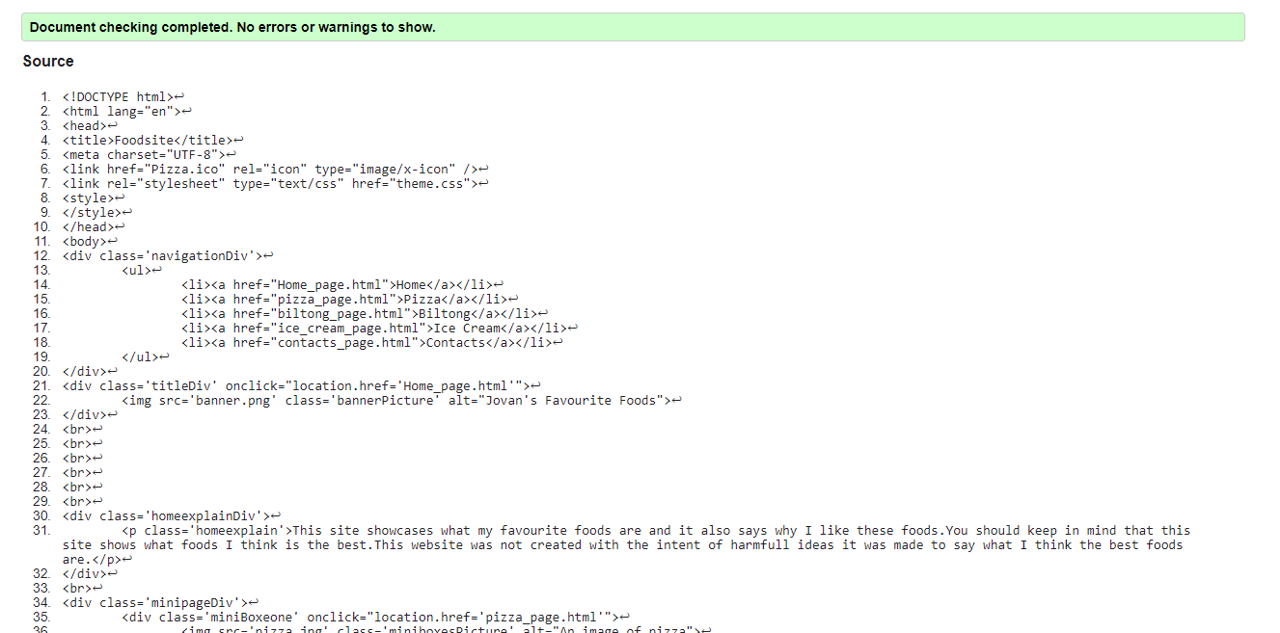

Outline how testing identified any issues and how you resolved them. How did testing improve the quality and/or functionality of the outcome?

|  |
| --- |
| When testing my CSS and HTML all the errors I got was for not setting my HTML language to English and for not having alt tags for my images.  Fixing these errors will be very helpful people who are blind because the alt tags would describe what is in the image, which would help them understand what is being presented to them on my website. Also setting my HTML language to English would help people which don’t speak English because their browser would recognise that the site would be in English then it would translate the text on the website to their preferred language. |

# **Implications**

Some the following implications may be need to be considered while completing the website.

* social
* cultural
* legal
* ethical
* intellectual property
* privacy
* accessibility
* usability
* functionality
* aesthetics
* sustainability and future proofing
* end-user considerations
* health and safety.

Describe why some of these implications will be important to consider during the creation of the website and how you addressed the relevant implications.

|  |
| --- |
| Legal : I would not want to break any laws that would affect any of the people that would use the site or make anyone that uses my site would also be breaking the law of my site because I am concerned of my own well-being and for the people who visit my site, so none of us would land in prison because I either made my site for Illegal intentions or anyone using it to break the law.  Aesthetics: I want people to be interested in my site and not be discouraged away from just how it looks. If I also were to put my website on a free domain or my own public domain I would want people to go to my website either of the contents of it or how it looks because there would be ads on it, which will in return for them receiving my content that I have made will give me money through ad revenue.  Functionality: I would really want it to be easy for anyone to use my site because it could very frustrating for my user to struggle to use it and that since I’m doing this assessment it is required for me to make it in such otherwise I would not be able to pass and get my credits to go to NCEA level 2.  Privacy: I believe this is the most important implication anyone should think about because if an end user would find out that you were tracking and/or stealing their data it could end up in legal issues and/or your reputation would be ruined and people wouldn’t visit your site anymore because they wouldn’t trust you anymore, which are two negative impacts that could affect the creator of the site. The risk should not be taken and it shouldn’t be an option because it can affect the creator of the site negatively and it the user of the site. |

# **Design Elements**

Outline the advanced design elements used on the website and how they enhanced the final outcome.

|  |
| --- |
| On my homepage, I decided to have three small boxes that would give the user enough information to know what the page it's representing about, so the user can decide if they want to know more about what the page is about.  I also decided to place my email address on the bottom of all my pages so my user would be able to easily know how to contact me if they either need or want to.  I decided to make my cursor change to a pointer when the user’s mouse is hovering over something that would take them to another site if they were to click because most people would tend to know if something were to take them to other pages/sites if the cursor would show as a pointer.  On my all my boxes where content is stored in it, except for my banner and navigation bar, there is a grey image that indicates that this is the bottom of the box although people can see that just from the change in colour but and the image displays it more easily that you have reached the bottom of the box |

**Basic Web design - Assessment Schedule Name:Jovan Bosman**

Digital Technologies 91880 (1.4): Implement basic procedures to produce a specified digital media outcome

|  |  |  |
| --- | --- | --- |
| **Achieved** | **Merit** | **Excellence** |
| Develop a digital media outcome | Develop an informed digital media outcome | Develop a refined digital media outcome |

|  |  |  |  |  |  |
| --- | --- | --- | --- | --- | --- |
| |  | | --- | | **91880:**  **Develop a digital media outcome** | | | | | **Comments** |
| using appropriate tools, techniques and design elements for the purpose and end users | A |  |  |  |
| applying appropriate data integrity and testing procedures in the development of the outcome | A |  |  |  |
| using information from testing procedures to improve the quality and functionality of the outcome |  | M |  |  |
| describing relevant implications. | A |  |  |  |
| addressing relevant implications. |  | M |  |  |
| iterative improvement throughout the design, development and testing process |  |  | E |  |
| applying design elements effectively. |  |  | E |  |

First Attempt: Not Submitted Resub Required Achieved Merit Excellence

Final Attempt: Not Achieved Achieved Merit Excellence

Date_____________________ Teacher____________________