The dose-response of urban noise to human mobility measured with a city-scale IoT sensor network in Seoul
Hyun In Jo*
Department of Architectural Engineering, Hanyang University, Seoul 04763, Korea

Corresponding author:
Hyun In Jo (best2012@hanyang.ac.kr)
Architectural Acoustics Lab (Room 605-1)
Department of Architectural Engineering
Hanyang University
222 Wangsimni-ro, Seongdong-gu
Seoul 04763, Korea
Phone: +82 2 2220 1795
Fax: +82 2 2220 4794

Highlights
• Graded distancing, measured mobility and 1,123 IoT sensors give a dose-response
• A 30% fall in neighbourhood mobility is tied to only ~0.23 dB less daytime noise
• Only daytime noise shows a detectable association, consistent in sign across seasons
• The 2.3 dB multi-year S-DoT decline is consistent with drift, not quieter streets
• Within-sensor, same-day designs are essential for low-cost noise networks

ABSTRACT
How strongly the urban acoustic environment responds to human mobility is a first-order question for mobility, land-use and noise policy, yet mobility rarely varies exogenously. We exploit Korea's graded COVID-19 social distancing, which repeatedly tightened and relaxed activity over 2020-2023, together with a city-scale low-cost IoT noise network, as a graded natural-experiment setting. We assembled 1,248,794 sensor-days from 1,123 Smart Seoul Data of Things (S-DoT) sensors across 421 neighbourhoods (dong) and matched each sensor-day to neighbourhood daytime de-facto population. Because low-cost sensors carry calibration offsets and multi-year drift, we estimate the dose-response only from within-sensor variation and from cross-neighbourhood variation within each date (two-way fixed effects), and read it as a within-date conditional association. Daytime noise rises and falls with daytime mobility (β = +0.65 dB per log-unit; a 30% mobility reduction corresponds to about 0.23 dB), is robust to a dong-level permutation check (p = 0.003), and is positive across seasons; only daytime noise is individually significant, and the high-low neighbourhood gap tracks regime tightening and closes after full lifting. No robust gradient survives in the long-run spatial cross-section, and a calibrated network shows that S-DoT reads about 12 dB below nearby calibrated L_{Aeq} stations, its multi-year decline consistent with sensor drift. The response is statistically robust but modest: at the neighbourhood scale, mobility-demand management alone is unlikely to deliver large noise reductions and should be paired with source- and propagation-stage measures. The design offers a transferable, drift-aware template for smart-city noise monitoring.
Keywords: urban noise; environmental acoustics; human mobility; dose-response; IoT sensor network; smart-city monitoring; de-facto population; Seoul; natural experiment

1. Introduction

1.1. Environmental noise and urban sustainability
How much quieter does a city become when its people move less? Much of sustainable urban policy, from remote work to travel-demand management and land-use reform, acts on mobility, yet the slope of this simple relationship has rarely been quantified. Environmental noise is regarded as the second-largest environmental burden on human health in cities after air pollution. The World Health Organization identifies it as a leading cause of disease burden in European cities and estimates that more than one million healthy life-years are lost to traffic noise every year in western Europe alone [1,2]. The health effects go beyond annoyance. Night-time noise fragments sleep [3], chronic exposure raises the risk of hypertension and ischaemic heart disease through autonomic and endocrine stress pathways [4,5], and daytime exposure causes annoyance and impairs cognitive performance [6,7]. These effects translate into substantial social and economic costs [8].
Noise is therefore a central physical stressor for urban sustainability and liveability, and because its burden falls disproportionately on socioeconomically disadvantaged groups it is also a matter of environmental justice, although the scope of this study is limited to changes in physical sound levels. The soundscape approach, which treats sound as human experience in context rather than as decibels alone [9,10,11,12,13,14], has broadened this perspective to cover the acoustic comfort of public spaces [15] and the spatiotemporal variation of urban sound environments across land use and urban form [16]. Managing noise, however, requires an answer to a basic question. The lever that sustainability policy actually holds is not the vehicle fleet itself but the volume and placement of travel and activity. How sensitively, then, does urban noise respond to that lever, to human activity and mobility? This responsiveness is the starting point for judging any mobility- or land-use-based noise policy, and it has rarely been quantified.

1.2. Mobility as a driver of urban noise
There are clear physical grounds for expecting such responsiveness. Road traffic is the dominant source of urban noise, and sound levels rise with traffic volume [17]. But policy acts on more than traffic counts; it acts on the whole of human activity and movement, and the relationship between citywide activity and noise has almost never been estimated as a causal slope. The obstacle is identification. In a normally functioning city, mobility does not vary exogenously. It is bound up with land use, time of day, day of week and weather, the same factors that drive noise. Simple correlations between observed mobility and noise are therefore confounded, and they say little about how much noise would change if mobility itself changed.
Established traffic-noise models, such as the CNOSSOS-EU standard and land-use regression [17,18,29], predict noise from traffic volume, road geometry and land use, but they are essentially cross-sectional and static. They reproduce the spatial pattern that busy places are loud, yet they cannot answer the dynamic dose-response question of how much quieter a place becomes when mobility falls. Filling this gap requires exogenous, graded variation in mobility together with dense noise observation, a combination that ordinary urban conditions almost never supply.

1.3. COVID-19 as a natural experiment
The COVID-19 pandemic supplied exactly this combination as a natural experiment. Lockdowns and distancing cut human mobility exogenously, and a series of studies documented reductions of several decibels in measured urban noise (4-6 dB in Madrid [19], with further reports from Dublin [20], London [21], Stockholm [22], Montreal [23], Granada [24] and Kanpur [28]). Perception surveys in Argentina [25], Lima [26] and Italy [27] likewise reported changes in the sound environment during lockdowns. Air quality shifted at the same time, with sharp drops in nitrogen dioxide and carbon dioxide [30,31,32], evidence of how broadly confinement reshaped the urban environment.
This rapidly accumulated literature, however, shares four structural limitations that motivate the present study. First, most studies compare a binary lockdown period against a reference period, which cannot recover a graded dose-response curve across levels of restriction; whether noise responds proportionally to mobility, and with what slope, remains unknown. Second, most studies attribute the observed reductions to reduced traffic in narrative terms, without measuring mobility and linking it to noise quantitatively; the exposure is assumed rather than observed. A few studies did pair noise with measured vehicle traffic (four noise sensors with nearby inductive-loop counts in Porto [52], a floating-car traffic and emission simulation in Rome [53], and 23 recording sites with a single traffic-count station in Bochum [54]), but their coverage stays at a handful of locations or at vehicle flows alone, and to our knowledge none links citywide human activity to noise at the neighbourhood level. Third, measurement points are few (typically 4-70) and concentrated in western cities, so the fine-grained spatial heterogeneity of dense East Asian cities goes unobserved. Fourth, almost all studies compare absolute sensor readings directly, leaving room for network calibration bias and multi-year drift to contaminate the results. Compared along these four axes, graded exposure, measured mobility, high-density observation and drift-aware identification, no representative study satisfies more than two of them at once (Table 1), and none brings all four together in a dense East Asian city. This study addresses that gap.

Table 1. Design features of representative COVID-19 urban-noise studies and the present study.
Study | City (measurement points) | Exposure contrast | Mobility measured? | Sensor-bias handling
Asensio et al. [19] | Madrid (municipal noise network) | Binary: lockdown vs. pre-lockdown | No | Absolute levels
Basu et al. [20] | Dublin (12 fixed stations) | Binary: lockdown phases vs. baseline | No | Absolute levels
Aletta et al. [21] | London (short-term site measurements) | Binary: lockdown vs. pre-lockdown | No | Absolute levels
Rumpler et al. [22] | Stockholm (central station) | Binary: recommendation period vs. before | No | Absolute levels
Manzano et al. [24] | Granada (urban measurement points) | Binary: lockdown vs. reference | No | Absolute levels
Mishra et al. [28] | Kanpur (campaign sites) | Binary: lockdown vs. before | No | Absolute levels
Traffic-count studies [52,53,54] | Porto (4 sensors + loop detectors); Rome (FCD simulation); Bochum (23 sound monitors, 1 traffic-count station) | Lockdown era, vehicle traffic only | Partly: vehicle counts, no de-facto population | Absolute levels / emission model
This study | Seoul (1,123 IoT sensors, 421 neighbourhoods) | Graded: repeated tightening and relaxation, 2020-2023 | Yes: daily neighbourhood de-facto population | Within-sensor change; within-date two-way FE; calibrated-network cross-comparison
Note: measurement-point descriptions are indicative; see the cited papers for details.

1.4. Measured mobility and IoT noise sensing
Two recent developments in urban data make the first three requirements attainable. The first is de-facto population estimated from mobile-network signals, which records where people actually are at a given moment, at fine spatial and temporal resolution, rather than where they reside [35,36,37,38,39]. The second is the low-cost acoustic sensor network. SONYC [40], low-cost monitoring devices [41], wireless acoustic sensor networks [42,43], the participatory NoiseCapture platform [44] and smart-city sensing programmes [45,46] now sustain continuous observation of urban sound at hundreds to thousands of points. Korea's graded distancing, the citywide S-DoT noise network in Seoul (about 1,100 sensors) and dong-level de-facto population provide these ingredients together in a single city, a rare combination.
Low-cost noise networks, however, carry a structural problem that the COVID noise literature has largely ignored: each sensor has its own calibration offset, and readings drift slowly with age and environmental exposure. The same problem is well documented for low-cost air-quality networks [47]. These devices are simply not calibrated to measure absolute sound pressure levels. Ignoring this and comparing absolute levels over time or across space produces spurious patterns or spurious conclusions, and this study demonstrates a concrete case. What remains is the fourth requirement: removing this contamination at the design stage of identification rather than at the stage of interpretation.

1.5. The present study
This study combines Korea's graded social distancing as a natural-experiment setting, Seoul's S-DoT noise sensors as the outcome, and dong-level de-facto population as the measured mobility dose, and estimates the mobility dose-response of urban noise. Specifically, we adopt a two-way fixed-effects strategy [48,49] within a natural-experiment framework [50] that identifies the slope only from within-sensor changes and from variation across dong within the same date, never from absolute levels, and we check the drift and resolution limits of the low-cost network against official monitoring stations. In doing so we extend the descriptive work on the spatiotemporal variation of Seoul's sound environment [16] towards quantitative, quasi-experimental estimation; the position of this study relative to prior work is summarised in the last row of Table 1. We ask three questions, and answering them doubles as an answer to a methodological one: under what design can low-cost IoT noise networks be trusted at all?
- RQ1. How much does urban noise fall when measured mobility falls, and with what dose-response slope?
- RQ2. How does the response differ by land use, day and night, day type and season?
- RQ3. How does noise rebound as restrictions are relaxed and lifted, and does the relationship also appear in long-run neighbourhood averages (the spatial cross-section)?
The study makes four contributions. First, to our knowledge it provides the first quantitative estimate of a graded dose-response of urban noise to activity that is measured, dong by dong, across an entire city rather than assumed. Second, it combines a high-density IoT network of about 1,100 sensors with administrative-neighbourhood de-facto population to identify the response at fine urban resolution. Third, it extends a literature concentrated on western cities to Seoul, a high-density East Asian megacity. Fourth, it quantifies the calibration and drift limits of low-cost noise sensing and derives a design principle: rely on within-sensor change and same-day comparisons across neighbourhoods, not on absolute levels.

2. Materials and methods

2.1. Study area, period and study design
The study area is the whole of Seoul, covering all 25 autonomous districts. With about 9.6 million residents on 605 km², Seoul is among the densest megacities in the world, and its fine grid of 421 administrative neighbourhoods (dong) over intensely mixed land use makes it well suited to capturing within-city contrasts (Fig. 1). The analysis runs from 2020-04-01, the first day of S-DoT noise provision, to 2023-12-31, extending well past the full lifting of distancing on 2022-04-18 so that the return of noise to its usual level, the rebound, is observed in full. The design rests on three elements. Korean distancing tightened and relaxed restrictions repeatedly, moving mobility gradually and for reasons external to the noise environment, and we treat this variation as a natural-experiment setting. Because each low-cost sensor reads with its own constant bias, as explained below, absolute levels are never used; the outcome is always the change of each sensor relative to its own norm. And the response is identified from how much mobility differed across neighbourhoods within the same day.
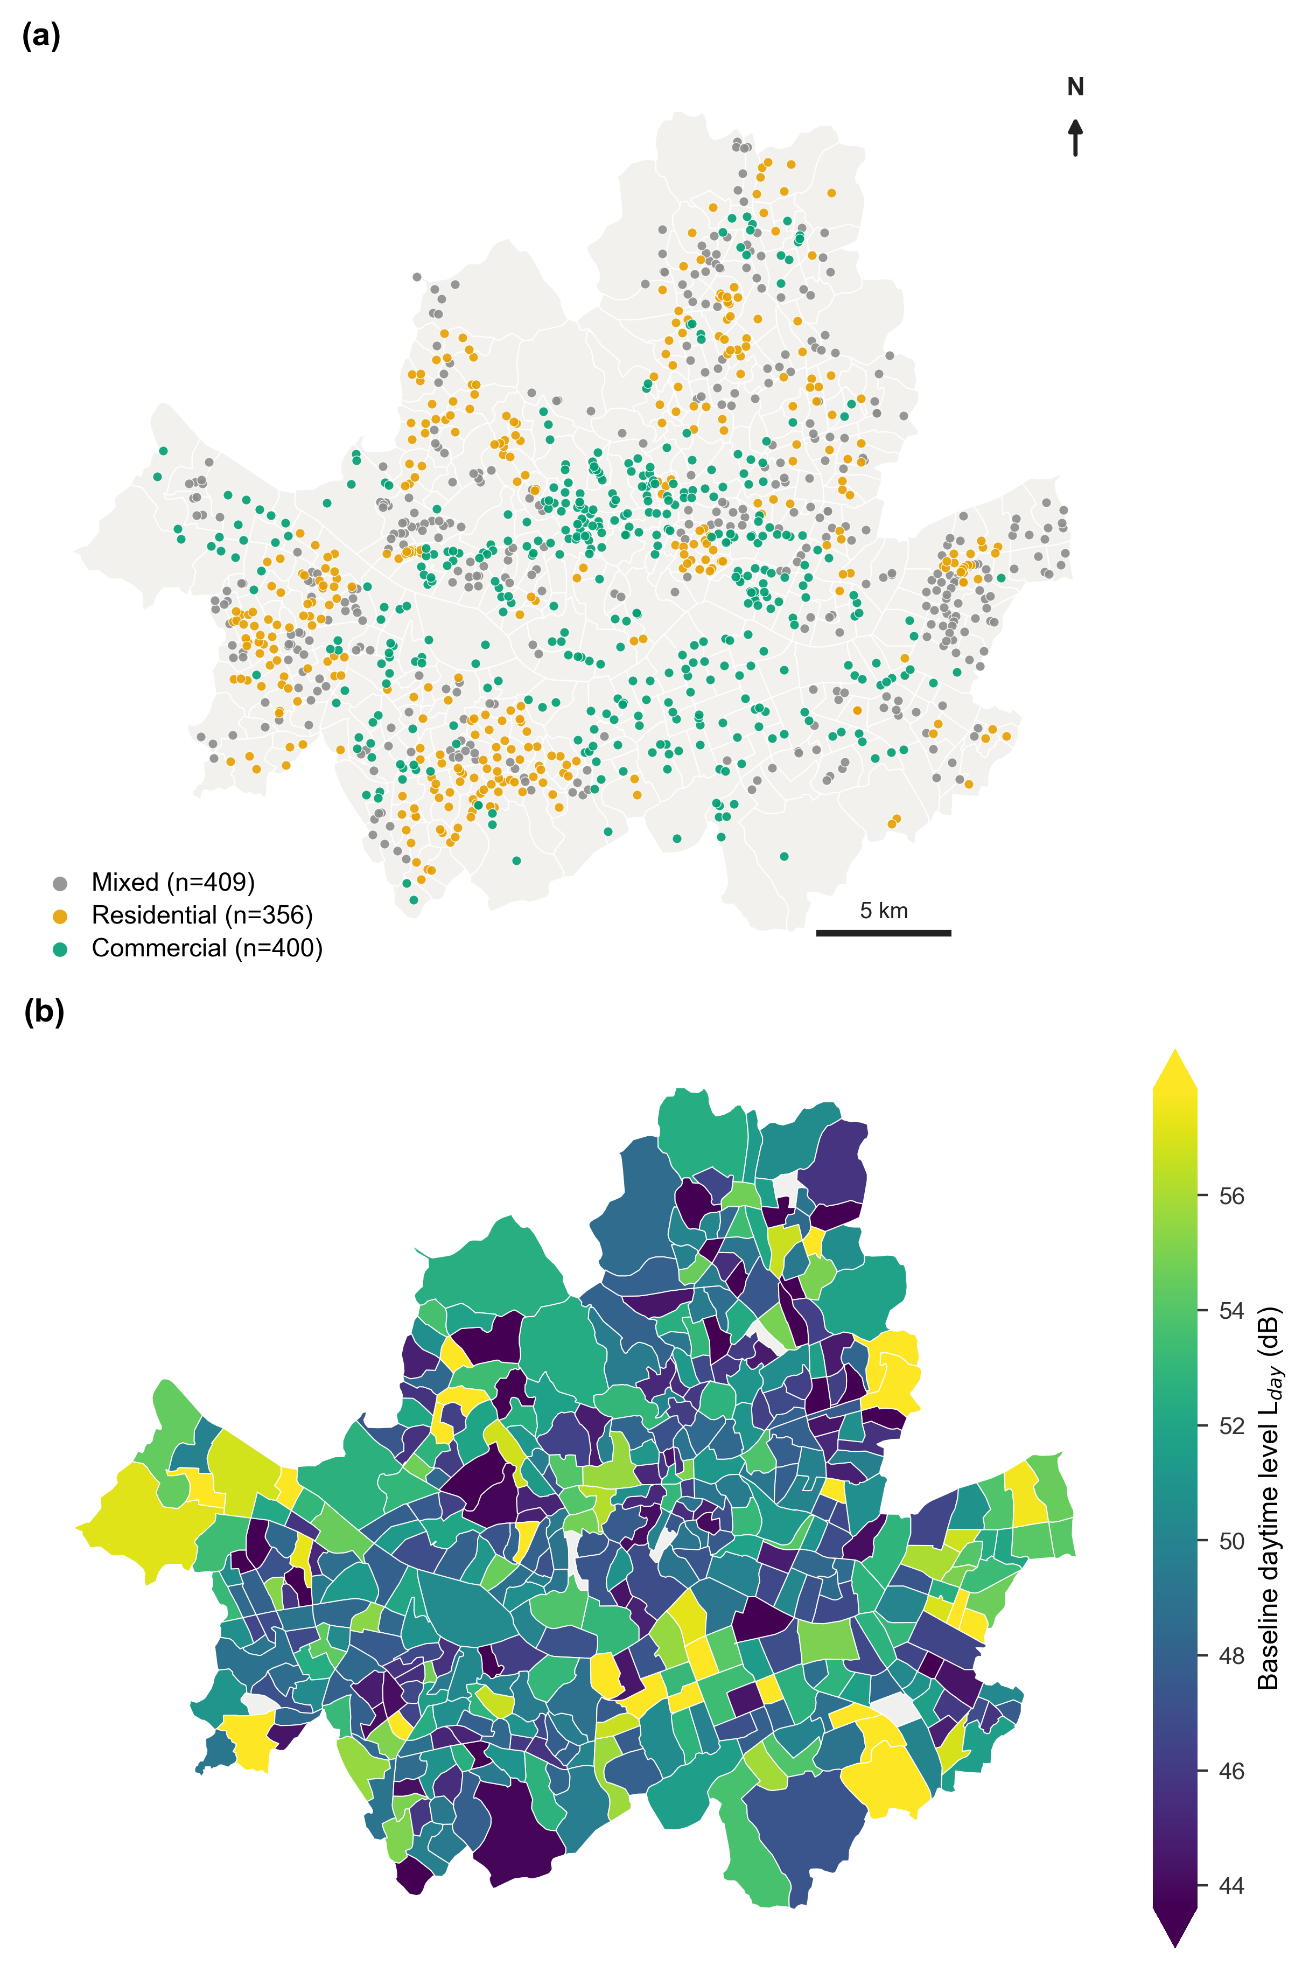
Fig. 1. Study area and the S-DoT sensing network. (a) 1,165 geolocated S-DoT noise sensors (1,123 enter the analysis panel after quality control) across the 421 administrative neighbourhoods (dong) of Seoul, coloured by neighbourhood activity type (terciles of the daytime/night-time de-facto population ratio: commercial, mixed, residential; Supplementary Fig. S3). (b) Baseline daytime noise level (post-lifting mean L_{day}, July 2022 to December 2023) by neighbourhood.

2.2. Outcome: urban noise from the S-DoT network
The outcome variable is noise from the Smart Seoul Data of Things (S-DoT), the city's permanently operated IoT sensing network. About 1,100 stations record hourly broadband sound pressure levels in dB, and all data are openly downloadable without authentication (Table 2). We aggregate the hourly values into daily energy-equivalent levels, computing the full-day L_{eq,24h}, the daytime L_{day} (06-21 h) and the night-time L_{night} (22-05 h) as 10·log10 of the mean of 10^(L/10), and retain only sensor-days with at least 12 observed hours and values in a physically plausible range (20-95 dB). In 2023 the data schema changed and noise was split into maximum, mean and minimum fields; we use the mean. One caveat matters throughout. S-DoT is a general-purpose urban sensing node rather than an environmental-noise monitor: it reports uncalibrated broadband decibels (the values carry no A-weighted L_{Aeq} label, and the microphone specification, the frequency and time weighting, and the rule aggregating 2-minute raw records into hourly values are not documented in the public specification), so absolute readings cannot be compared across sensors. Day and night windows follow the calendar date; L_{night} combines the 00-05 h and 22-23 h records of the same calendar day. We therefore use only within-sensor changes over time, and we check their reliability against the official calibrated L_{Aeq} networks (Fig. 8, Supplementary Fig. S2).

Table 2. Data sources and processing.
Component | Dataset (provider) | Resolution / processing | Period | Use in analysis
Outcome:  urban noise | S-DoT city-wide IoT sensing network (Seoul Open Data Plaza, OA-15969) | ~1,100 fixed sensors; hourly broadband SPL (dB) aggregated to daily L_{eq,24h}, L_{day} (06-21 h), L_{night} (22-05 h); QC: ≥12 valid h/day, 20-95 dB; 2023 schema change reconciled ('mean' field) | 2020-04 to 2023-12 | Outcome; within-sensor change only (absolute levels never compared across sensors)
Exposure:  mobility | De-facto ('living') population per administrative dong (Seoul Open Data Plaza, OA-14991) | Hourly counts per 424 dong, averaged to daily daytime (06-21 h) and night-time (22-05 h) values; 619,464 dong-days, no missing | 2020-01 to 2023-12 | Dose lp = log(daily / dong's post-lifting baseline mean); within-dong relative change
Policy  covariate | Social-distancing implementation history (KDCA) | Daily regime re-coded to continuous stringency 0-7 from business curfew hour and gathering cap | 2020-01 to 2022-04 | Auxiliary descriptor (Table 3); absorbed by date FE in M2
Weather  covariate | Open-Meteo ERA5 reanalysis at Seoul city centre (37.57° N, 126.97° E) | Daily mean/max/min temperature, precipitation, maximum wind speed | 2020-2023 | M1 covariates; absorbed by date FE in M2
Calendar | Day of week, weekend, Korean public holidays (incl. substitutes), season | Daily indicators | 2020-2023 | Weekend/holiday indicators as M1 covariates; absorbed by date FE in M2
Comparison  networks | Calibrated official stations: national environmental-noise network (noiseinfo.or.kr; automatic daily road stations, manual quarterly general/road stations) and four roadside L_{Aeq} stations (OA-15473) | Station-level standard L_{Aeq} | 2020-2024 | Drift diagnosis and absolute-offset comparison (Fig. 8, Supplementary Fig. S2)

2.3. Exposure: human mobility from de-facto population
Mobility exposure is measured with Seoul's de-facto ('living') population: the number of people actually present in each dong at a given time, estimated from mobile-network signals rather than from residence records (Table 2). Aggregating the hourly stock to daily means (daytime 06-21 h and night-time 22-05 h averages) yields 424 dong × 1,461 days = 619,464 dong-days with no missing values, of which the 421 dong hosting S-DoT sensors enter the analysis. One feature of these data shapes the dose definition. The citywide total of de-facto population is almost conserved, because people who stay home are still counted where they are; distancing shows up not in the total but in spatial redistribution. Under the strongest restrictions the daytime population of commercial and business dong fell by up to about 35%, depending on the dong, while residential dong gained up to 37% (averaged over the whole distancing era, neighbourhood reductions mostly lie in the 0-13% range; Fig. 7a). We therefore define the dose as each dong's change relative to its own norm, lp = log(daily de-facto population / the dong's post-lifting baseline mean), so that it captures how far a dong departs from its own normal and is unaffected by level differences across dong or sensors. Two clarifications are in order. First, de-facto population is a stock of presence, not a flow of movement, so 'mobility' in this paper is an operational term for changes in activity presence. Second, the baseline period is 2022-07 to 2023-12, chosen to exclude the transitional weeks immediately after full lifting (2022-04 to 06). Within a given date, the standard deviation of the dose across dong averages 0.115 log-units, ample variation for identification under date fixed effects.

2.4. Linking sensors to neighbourhoods
Sensor metadata contain street addresses but no administrative-neighbourhood name, so each sensor was assigned to a dong by point-in-polygon matching of its coordinates against public boundary data (the vuski/admdongkor GeoJSON, 2022-01 vintage). The de-facto population data and the boundary file use slightly different dong-code systems in a few reorganised areas of Gangbuk and Gangdong; these were reconciled by name matching. In the result, 1,165 of 1,170 sensors (99.6%) were assigned to a dong, and the assigned dong agreed with the district recorded in the street address in 99.6% of cases. After the noise quality filters (at least 12 h per day, 20-95 dB) and the merge with daily mobility, the final panel comprises 1,123 sensors in 421 dong (1,248,794 sensor-days); the main two-way fixed-effects model uses the 1,122 sensors and 420 dong with non-missing daytime mobility (1,247,546 sensor-days).

2.5. Covariates: social distancing, weather and calendar
Distancing 'tiers' (Levels 1, 2, 2.5 and 4, among others) are unsuitable as an exposure variable: the tier system was redefined twice (2020-11 and 2021-07), the spacing between tiers is not uniform, and the same tier corresponded to different mobility at different times. We instead re-coded the daily regime into a continuous stringency index from 0 (no restriction) to 7 (strongest), built from two concrete enforceable components, the business closing hour and the private-gathering cap (Table 3). This index remains auxiliary; the primary exposure throughout is measured mobility (de-facto population). Weather comes from the Open-Meteo ERA5 daily reanalysis (temperature, precipitation, wind). The calendar controls entering M1 are weekend and Korean public-holiday indicators; day-of-week and season are available in the data, but under M2 the date fixed effects absorb all calendar effects, so separate terms are unnecessary.

Table 3. Seoul capital-area social-distancing timeline and its quasi-continuous re-coding (selected regime changes).
Effective from | Regime | Business curfew (h) | Gathering cap | Stringency (0-7)
2020-01 | Pre-COVID (normal) | 24 | none | 0
2020-03-22 | 1st intensive distancing | 21 | ≤10 | 4
2020-05-06 | Daily-life distancing | 24 | none | 0
2020-08-30 | Capital Level 2.5 (first 21 h cap) | 21 | ≤50 | 5
2020-12-23 | Level 2.5 + 5-person ban | 21 | ≤4 | 6
2021-02-15 | Level 2 + 5-person ban | 22 | ≤4 | 5
2021-07-12 | Capital Level 4 | 22 | ≤4 | 5
2021-11-01 | With-COVID recovery | 24 | ≤10 | 1
2021-12-18 | Special measures | 21 | ≤4 | 6
2022-03 | Gradual easing | 23 | ≤8 | 3
2022-04-18 | Full lifting | 24 | none | 0
Note: the stringency index re-codes the two enforceable components (business curfew hour and private-gathering cap) onto a 0-7 scale. The official tier system itself was redefined in 2020-11 and 2021-07, so tier labels are not comparable over time and are never used as the dose; the measured mobility of each dong is the exposure throughout.

2.6. Statistical analysis and identification
A low-cost S-DoT sensor is not precision-calibrated: presented with the same sound, each unit records a level that is systematically high or low by its own constant amount. Because this offset differs across sensors and is unknown, comparing absolute decibels between two sensors is meaningless. If we look only at how a sensor changes over time, however, for instance how today compares with that sensor's own average, the constant offset cancels in the subtraction. Every analysis in this paper therefore rests on within-sensor relative change rather than on absolute levels. Statistically this takes the form of a fixed-effects model: subtracting each sensor's mean removes its idiosyncratic offset (we use the mathematically equivalent within-transformation rather than 1.25 million dummy variables). Standard errors are made robust to within-cluster correlation and are clustered by dong, the level at which the mobility dose is assigned, in both the sensor fixed-effects and the two-way models [48]. Fig. 2 summarises the identification logic.
The main analysis proceeds in two steps. (M1) The sensor fixed-effects model removes each sensor's mean and explains its noise variation with dong mobility, weather (temperature, temperature squared, precipitation, wind, a rain indicator) and weekend and holiday indicators. This controls the visible temporal confounders while leaving temporal variation available for estimation. (M2), the core model of the paper, adds date fixed effects. A date fixed effect absorbs everything the whole city experienced in common on a given day: that day's weather, the day-of-week and holiday pattern, secular trends in city noise, network-wide sensor drift and nationwide distancing itself. What remains is a single source of information: how much mobility differed across dong within the same day. M2 therefore answers one question. On a given day, did sensors in neighbourhoods that emptied more than their norm become quieter than sensors in neighbourhoods that emptied less? One consequence of the design is that any variable taking a single value per day citywide (total subway ridership, the stringency index) is absorbed by the date effects and cannot be estimated; only mobility measured per dong remains a valid exposure. Formally, M2 is Y_sdt = α_s + λ_t + β·x_dt + ε_sdt, and the identifying assumption is that residual noise shocks within a date are unrelated to dong mobility. Shocks at the dong-by-date level that move mobility and noise together, such as construction or local events, can violate this assumption, so we read β conservatively as a within-date conditional association rather than a causal effect, and we keep that reading throughout. The two sets of fixed effects are removed by iterating the alternating subtraction of sensor and date means to convergence.
Several auxiliary analyses sit on top of these two models. (M3) Segmented estimation: M2 is re-estimated by outcome (daytime, night-time, day-night gap), by activity type (commercial, mixed and residential terciles of each dong's daytime-to-night-time population ratio; Supplementary Fig. S3; the classification uses only post-lifting level information rather than the daily exposure variation, which limits circularity, and although it is in substance an activity-profile grouping we call it 'land use' for brevity), by weekday versus weekend, and by season, to locate where the response arises. (M4) High-loss versus low-loss trajectories: dong that emptied strongly (mostly commercial) are compared week by week with dong that barely emptied (mostly residential). Common factors such as weather, season and sensor drift largely cancel in the difference. Because the groups are defined from realised mobility during the restriction era and both series are normalised to the post-lifting window, convergence to zero after lifting is partly built in, and we therefore interpret this as a descriptive comparison rather than a formal event study. (M5) Official-network comparison: the reliability of S-DoT absolute levels and multi-year trends is checked against the calibrated national environmental-noise networks (automatic and manual stations) and four permanent roadside L_{Aeq} stations, using level offsets at nearby station pairs and 2020-2023 trends to diagnose sensor drift and the 2023 schema change. (M6) Robustness and sensitivity: a permutation check that reshuffles the dong-level dose across dong within each date (300 shuffles, applied identically to all sensors of a dong because the dose is assigned at the dong-day level); an equal-weight re-estimation on the dong-day panel, to confirm that sensor-rich dong do not dominate; a quadratic term, to probe nonlinearity; and Benjamini-Hochberg FDR adjustment over the segmented tests of M3. Finally, all dong-level spatial analyses use outlier-robust statistics (Theil-Sen regression, Spearman rank correlation) and are restricted to dong with at least two sensors, so that no small set of extreme neighbourhoods drives the results. All computations use Python 3.13 (pandas, NumPy, SciPy, statsmodels); the two-way fixed effects are absorbed by iterated demeaning, and the robust estimators come from SciPy.
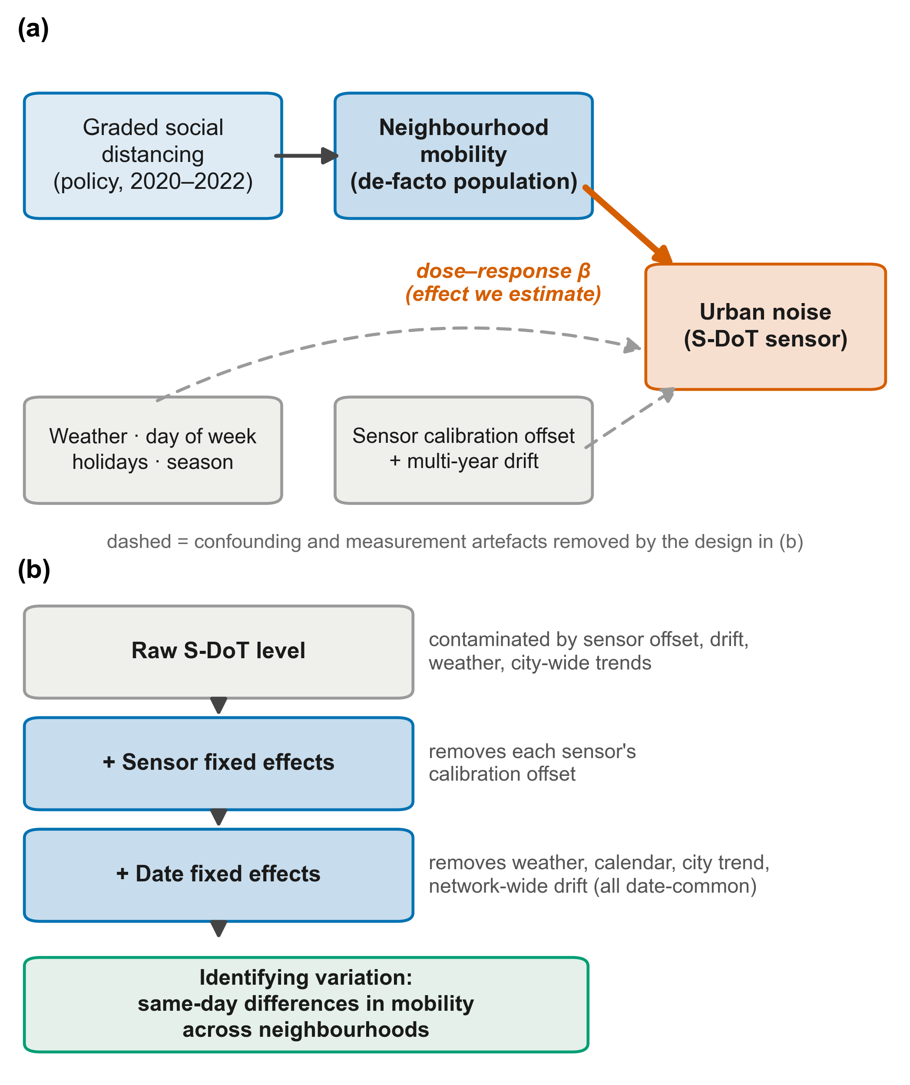
Fig. 2. Identification strategy. (a) Conceptual structure: graded social distancing shifts neighbourhood mobility, whose effect on urban noise (solid arrow) must be separated from weather and calendar confounding and from sensor-side artefacts (calibration offset and multi-year drift; dashed arrows). (b) Fixed-effects ladder: sensor fixed effects remove each sensor's calibration offset; date fixed effects remove all date-common factors (weather, calendar, city-wide trend, network-wide drift); the remaining identifying variation is the same-day difference in mobility across neighbourhoods.

3. Results

3.1. A robust but modest daytime dose-response
Table 4 reports descriptive statistics. In the sensor fixed-effects model (M1, Table 5), a dong's daytime mobility and the daytime noise of its sensors move together (β=+1.130 dB per log-unit, SE 0.292, p<0.001; standard errors are clustered at the dong level, where the dose is assigned). The control variables behave physically: temperature is U-shaped (louder when cold or hot), precipitation adds +0.045 dB/mm and rainy days +0.10 dB, weekends run 0.83 dB quieter and holidays 1.18 dB quieter (all p<0.001). Adding date fixed effects, which strip out everything the city shared on a given day (weather, trends, drift), shrinks the response: in the core model (M2, Table 5) the daytime slope is β=+0.648 dB per log-unit (95% CI 0.17-1.13, p=0.008) and the full-day slope is β=+0.628 (p=0.038). In concrete terms, when a dong's daytime mobility falls 30% below its norm, its daytime noise falls by about 0.23 dB; a 50% drop corresponds to about 0.45 dB. The dose-response estimated purely from same-day differences across neighbourhoods is statistically solid but small (RQ1).
Table 4. Descriptive statistics of the analysis panel (1,248,794 sensor-days; 1,123 sensors; 421 dongs; 2020-2023).
Variable | Mean | SD | P5 | P95 | N
L_{day} (dB) | 50.52 | 7.20 | 40.87 | 65.54 | 1,248,793
L_{night} (dB) | 47.58 | 6.81 | 38.46 | 61.80 | 1,248,623
L_{eq,24h} (dB) | 49.93 | 7.07 | 40.51 | 64.76 | 1,248,794
Daytime mobility (log relative) | 0.01 | 0.13 | -0.20 | 0.17 | 1,247,547
Mean temperature (°C) | 12.53 | 10.45 | -5.80 | 26.50 | 1,248,794
Precipitation (mm) | 4.40 | 12.18 | 0.00 | 27.80 | 1,248,794
Max wind (m/s) | 4.61 | 1.68 | 2.50 | 7.81 | 1,248,794
Note: mobility is the within-dong log change relative to the dong's post-lifting baseline; N = sensor-days.

Table 5. Mobility dose-response of urban noise: sensor fixed-effects (M1) and two-way fixed-effects (M2) estimates. Coefficient (SE), dong-clustered. *p<0.05, **p<0.01, ***p<0.001.
Term | M1: sensor FE |  |  | M2: sensor + date FE
 | L_{day} | L_{night} | L_{eq,24h} | L_{day} | L_{night} | L_{eq,24h}
Mobility (log rel., own period) | +1.130***  (0.292) | +2.283**  (0.748) | +1.258***  (0.352) | +0.648**  (0.245) | +0.504  (0.631) | +0.628*  (0.303)
Mean temperature | -0.113***  (0.004) | -0.098***  (0.003) | -0.113***  (0.004) | - | - | -
Temperature² | +0.007***  (0.000) | +0.004***  (0.000) | +0.006***  (0.000) | - | - | -
Precipitation (mm) | +0.045***  (0.001) | +0.048***  (0.001) | +0.047***  (0.001) | - | - | -
Max wind (m/s) | +0.052***  (0.005) | +0.055***  (0.005) | +0.052***  (0.005) | - | - | -
Rain day (0/1) | +0.098***  (0.010) | +0.155***  (0.009) | +0.116***  (0.010) | - | - | -
Weekend (0/1) | -0.833***  (0.029) | -0.022  (0.019) | -0.686***  (0.027) | - | - | -
Holiday (0/1) | -1.176***  (0.032) | -0.186***  (0.040) | -0.999***  (0.033) | - | - | -
Date fixed effects | No | No | No | Yes | Yes | Yes
Weather + calendar | Yes | Yes | Yes | absorbed | absorbed | absorbed
Within-R² | 0.117 | 0.060 | 0.112 | - | - | -
Clusters (dong) | 420 | 420 | 420 | 420 | 420 | 420
N (sensor-days) | 1,247,546 | 1,247,376 | 1,247,547 | 1,247,546 | 1,247,376 | 1,247,547
Note: all columns use own-period doses (daytime dose for L_{day}, night-time dose for L_{night}, whole-day dose for L_{eq,24h}). M1 controls for weather and weekend/holiday with sensor fixed effects; M2 adds date fixed effects, which absorb all date-common terms. SEs are clustered by dong, the level at which the dose is assigned.

Splitting the estimate by segment (Fig. 3, Table 6, RQ2) shows the individually significant responses concentrating in the daytime. Across outcomes, only daytime noise is significant; night-time noise and the day-night gap are not (their interpretation follows in the next section). Across activity types, commercial (+0.34), mixed (+0.86) and residential (+0.85) dong all show positive slopes, but the split samples lose power, none is individually significant, and an interaction test finds no significant difference across types; the response appears broadly uniform. Weekdays (+0.49) and weekends (+0.64) are similar. All four seasons carry the same positive sign (DJF +0.66, MAM +0.69, JJA +0.53, SON +0.76), with winter, spring and autumn nominally significant; after FDR adjustment, spring and autumn remain so. The response is consistent in direction through the year rather than an artefact of one season.
Table 6. Function-segmented dose-response (M2, two-way fixed effects): β (dB per log-unit mobility), 95% CI, nominal and BH-FDR-adjusted p-values. *p<0.05, **p<0.01 (nominal).
Segment | Group | β | 95% CI | p | FDR p | N
By outcome | Daytime L_{day} | +0.648** | [+0.17, +1.13] | 0.008 | 0.033 | 1,247,546
 | Nighttime L_{night} | +0.504 | [-0.73, +1.74] | 0.42 | 0.46 | 1,247,376
 | Day-night gap | +0.019 | [-0.35, +0.39] | 0.92 | 0.92 | 1,247,375
By land use (daytime) | Commercial | +0.335 | [-0.41, +1.08] | 0.38 | 0.45 | 430,160
 | Mixed | +0.858 | [-0.09, +1.81] | 0.076 | 0.15 | 425,584
 | Residential | +0.847 | [-0.42, +2.12] | 0.19 | 0.25 | 391,802
By day type (daytime) | Weekday | +0.486 | [-0.16, +1.13] | 0.14 | 0.21 | 899,272
 | Weekend/holiday | +0.641 | [-0.17, +1.45] | 0.12 | 0.21 | 348,274
By season (daytime) | Winter (DJF) | +0.658* | [+0.09, +1.22] | 0.022 | 0.066 | 276,254
 | Spring (MAM) | +0.695** | [+0.26, +1.12] | 0.002 | 0.018 | 277,158
 | Summer (JJA) | +0.527 | [-0.02, +1.08] | 0.060 | 0.14 | 344,417
 | Autumn (SON) | +0.758** | [+0.20, +1.31] | 0.007 | 0.033 | 349,717
Note: all segments use the two-way (sensor + date) fixed-effects specification with dong-clustered SEs; FDR p = Benjamini-Hochberg adjusted over the pre-specified exploratory family of 12 tests.

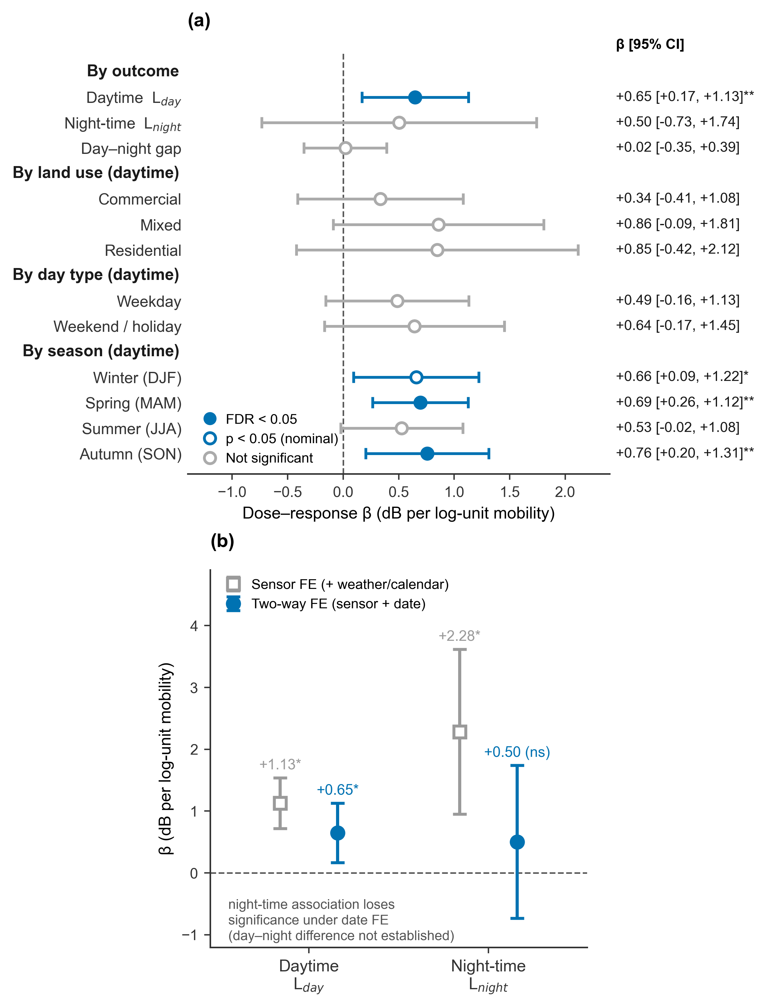
Fig. 3. Mobility dose-response of urban noise (two-way sensor + date fixed effects). (a) Segment-specific estimates (markers = β, bars = 95% CI, dong-clustered SEs) by outcome, land use, day type and season; filled markers survive Benjamini-Hochberg FDR correction (FDR < 0.05), open blue markers are nominally significant (p < 0.05), grey markers are not significant; the right-hand column lists β [95% CI]. (b) Sensor-FE versus two-way FE estimates: the night-time association under sensor FE alone (+2.28) loses significance once date fixed effects absorb common time-varying confounds (+0.50, ns), whereas the daytime estimate survives (+0.65); note that the wide night-time CI overlaps the daytime estimate, so a day-night difference in the coefficients is not itself established.

3.2. Daytime versus night-time responses
Separating day and night shows that the significant response is confined to the daytime outcome (Fig. 3b). Night-time noise appeared to respond strongly to night-time mobility under sensor fixed effects alone (β=+2.28, p=0.002), but the association loses significance once date fixed effects are added (β=+0.50, 95% CI -0.73 to +1.74, p=0.42), which indicates that much of the apparent night-time response reflected time-varying confounding shared across the city (drift, season, secular trends). The daytime association survives the same test. The wide night-time interval does, however, contain the daytime coefficient (+0.65), so a difference between the day and night responses cannot be claimed. Consistent with this, the day-night gap, regressed on the same daytime dose, has a coefficient of essentially zero (β=+0.02, p=0.92), which also fits daytime and night-time noise moving together in similar measure with daytime activity. Individually detectable signals are thus confined to the daytime outcome, while the day-night difference itself remains statistically unresolved.

3.3. Spatiotemporal mobility and functional differentiation
How the exposure moved through time and space is central to the design (Fig. 4). The citywide total of de-facto population barely changes (staying home still counts as presence), but where that population sits is reallocated sharply with each phase of distancing. In the strongest phases, commercial and business dong lost up to about 35% of their daytime population, depending on the dong (phase-window averages; the distribution of distancing-era average reductions appears in Fig. 7a), while residential dong gained. Central commercial dong emptied most under the strictest regimes (the 5-person ban of December 2020, capital-area Level 4 of July 2021) and recovered through the with-COVID relaxation (November 2021) and full lifting (April 2022).
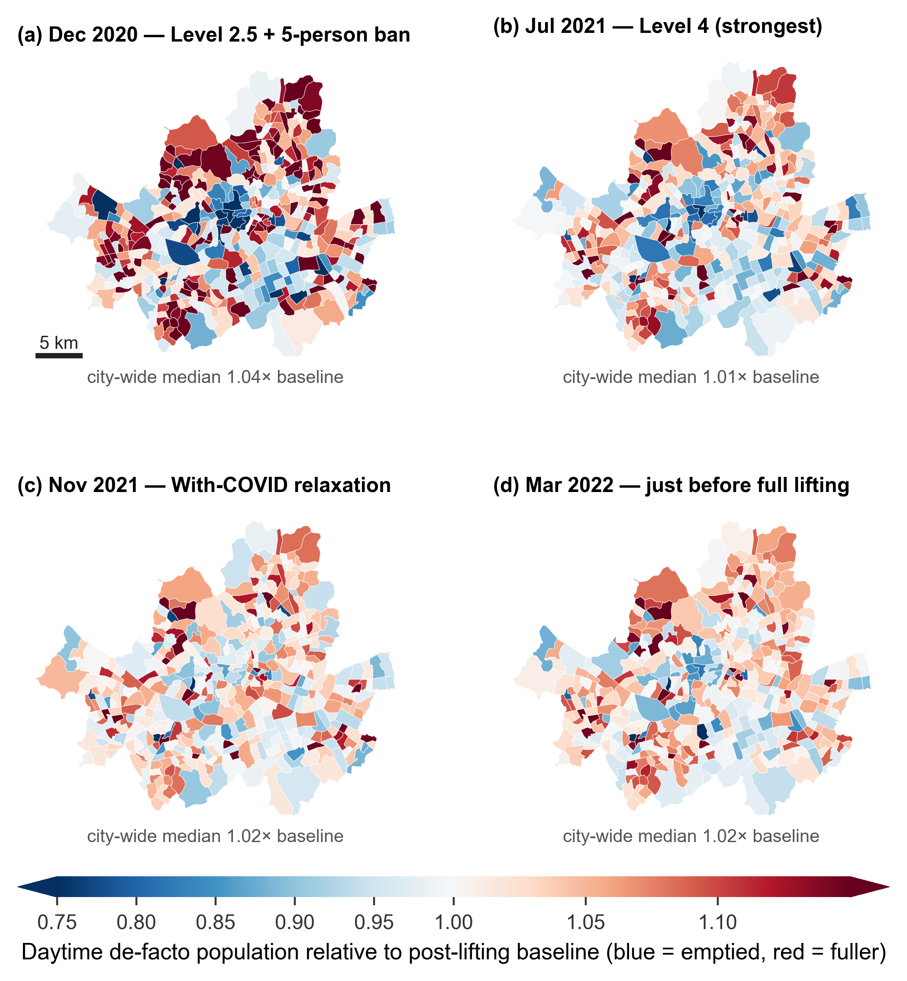
Fig. 4. Spatiotemporal evolution of the mobility dose across four graded distancing phases (phase-window averages of neighbourhood daytime de-facto population relative to the post-lifting baseline): (a) December 2020, Level 2.5 with the 5-person gathering ban; (b) July 2021, capital-area Level 4 (strongest); (c) November 2021, with-COVID relaxation; (d) March 2022, the weeks before full lifting. The city-wide median stays near 1.0 in every phase, but central commercial/business neighbourhoods empty by up to about 35% under the strongest restrictions (blue) while residential neighbourhoods fill (red), and the contrast fades through (c) and (d).

The same functional contrast is visible over time (Fig. 5, RQ3). Weekly daytime mobility in commercial dong stayed below baseline throughout the restriction era while residential dong stayed above, and the two converged after the 2022 lifting (Level 4 period medians: commercial 0.98 versus residential 1.05). Drift-robust relative noise (group mean minus city mean) likewise shows commercial dong running quieter than the city average during restrictions. The dynamics of regime switches are read from the weekly gap between high-loss and low-loss dong (a descriptive comparison, Fig. 6; the groups are defined ex post from realised mobility and both series are normalised to the post-lifting window, so this is not a formal event study). The weekly noise gap tilts negative during restrictions and converges to zero in the normal period (shown with dong-clustered 95% confidence bands), and the weekly correlation between the mobility gap and the noise gap is Pearson +0.44 and Spearman +0.46.
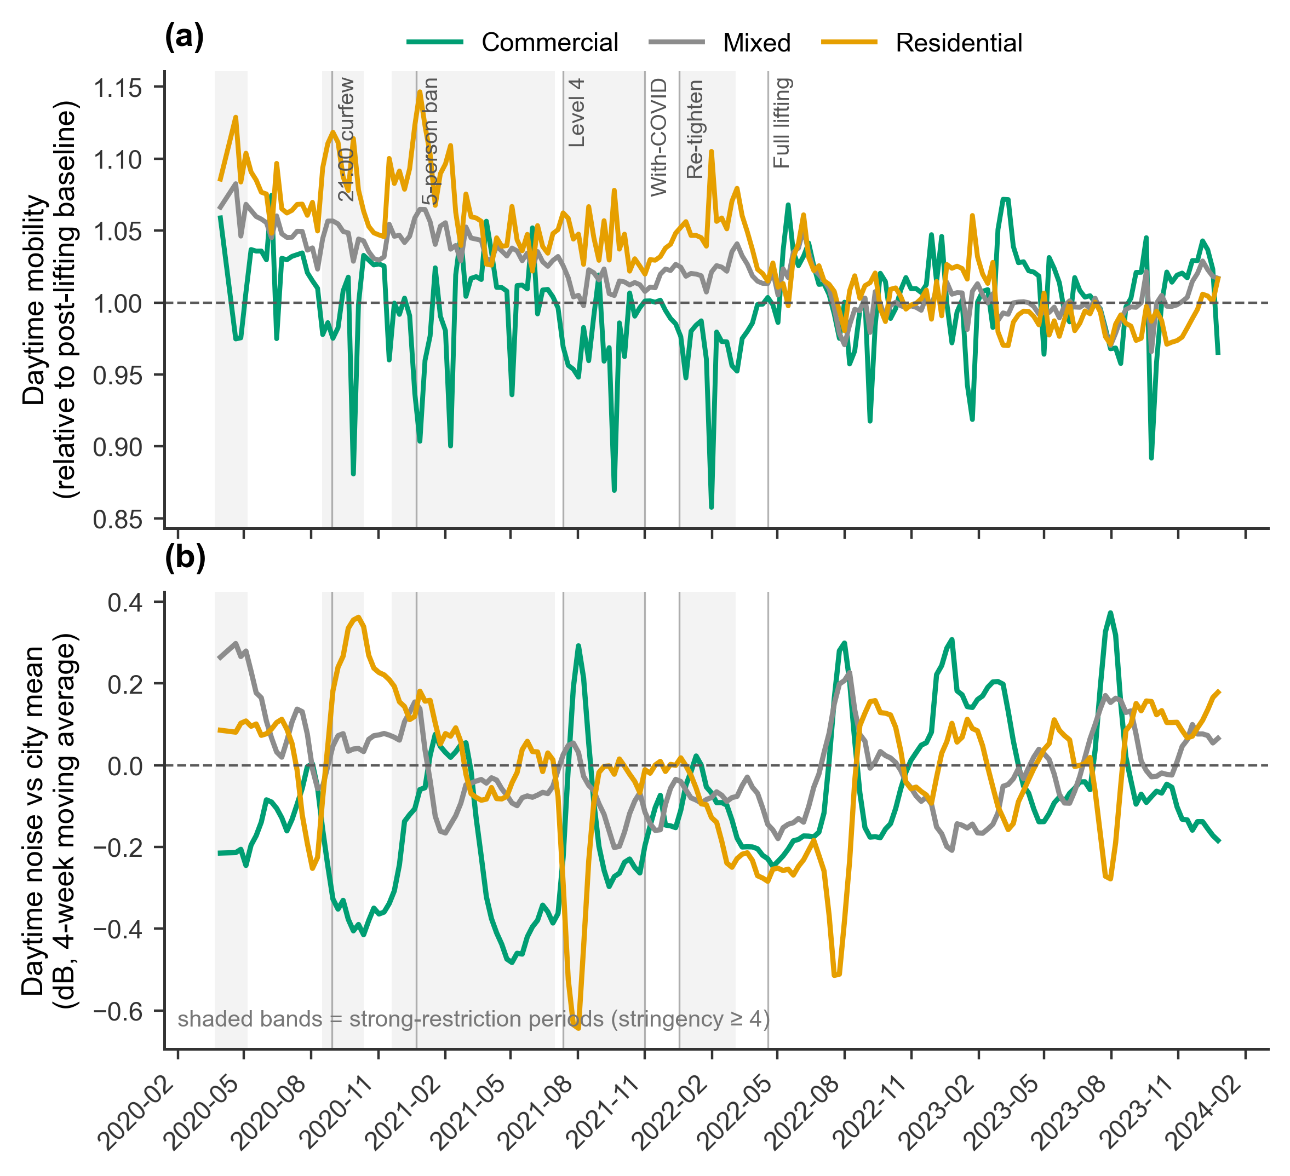
Fig. 5. Functional differentiation of mobility and noise over time. (a) Weekly daytime mobility by neighbourhood activity type: commercial neighbourhoods fall below and residential neighbourhoods rise above the post-lifting baseline during restrictions (shaded bands, stringency >= 4), converging after the April 2022 lifting. (b) Daytime noise relative to the city-wide mean (drift-robust, 4-week moving average) by activity type.
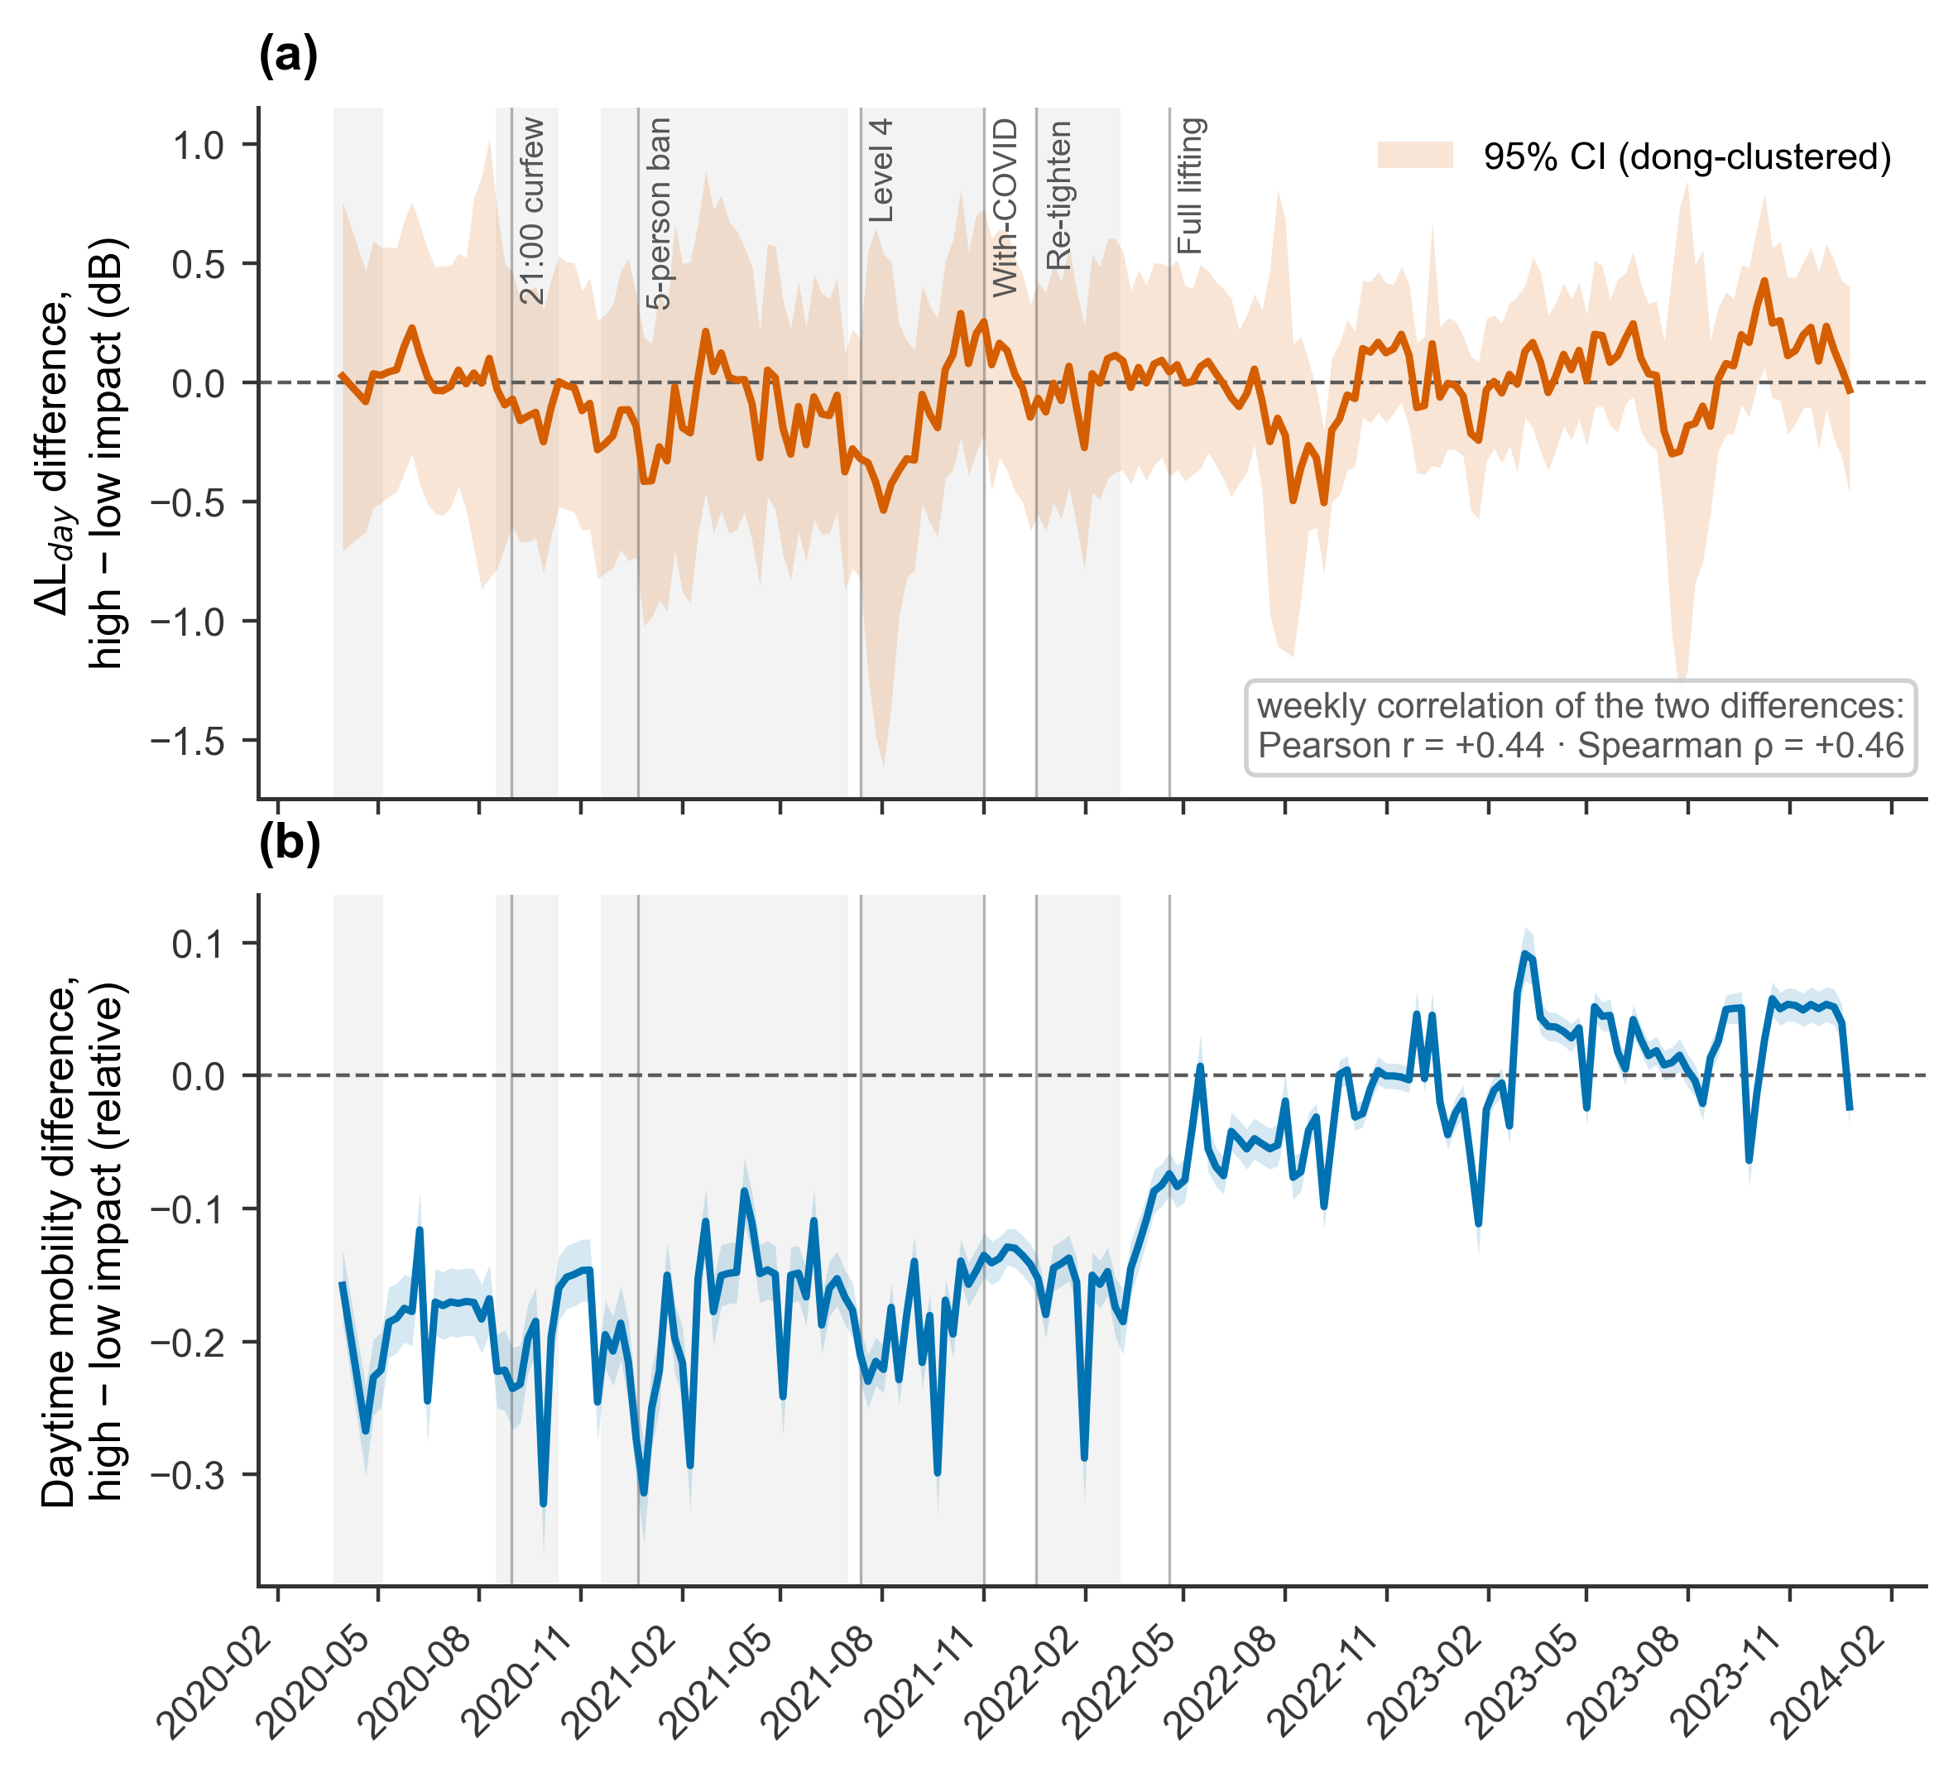
Fig. 6. High- versus low-mobility-loss neighbourhood trajectories (descriptive). Weekly difference between the two groups in (a) within-sensor ΔL_{day} and (b) daytime mobility; shading shows pointwise 95% confidence bands from dong-clustered standard errors (groups treated as independent), and grey bands mark strong-restriction periods. Date-common drift, season and city-wide trends cancel in the difference. Because groups are defined from realised mobility during the Level-4 period and both series are normalised to the post-lifting window, near-zero differences after lifting are partly built in; the panel is read as a descriptive trajectory rather than a formal event study. The noise gap turns negative during strong restrictions, tracking the mobility gap (weekly correlation r = +0.44, ρ = +0.46).

3.4. No robust long-run spatial gradient
By contrast, the long-run spatial cross-section, which treats each dong as a single point and compares distancing-era averages, shows no robust association between mobility loss and noise change (Fig. 7). Across all analysable dong (those with at least two sensors), the rank correlation between mobility reduction and noise change relative to the city mean is essentially zero (Spearman ρ ≈ -0.05). Among commercial dong the ordinary correlation looks positive (Pearson r=+0.38), but that value is driven by a few extreme neighbourhoods; robust statistics on the same dong leave almost nothing (Spearman ρ=+0.08, Theil-Sen slope near zero; Fig. 7c, detail in Supplementary Fig. S1). The mobility-noise signal, in other words, lives in same-day differences across neighbourhoods (M2, M4) and does not survive being painted onto a map of long-run averages.
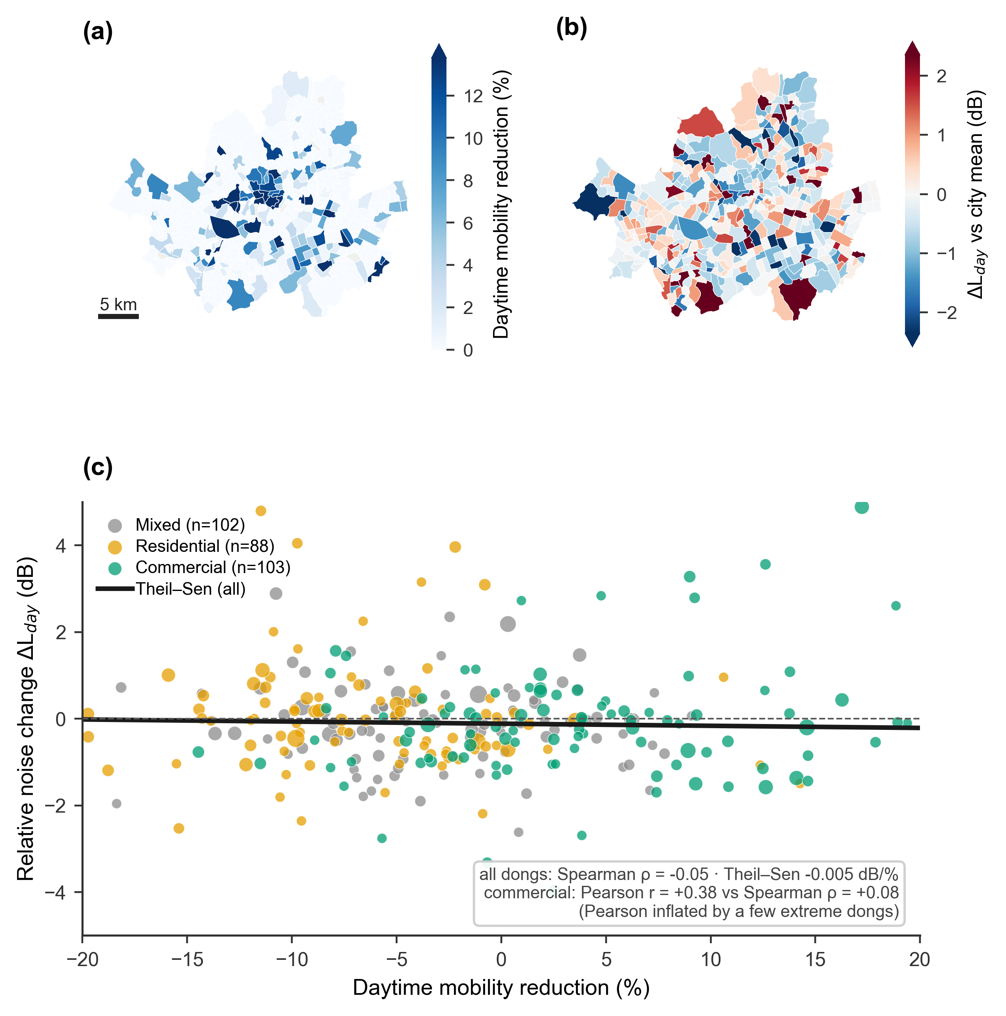
Fig. 7. No robust long-run spatial gradient. (a) Neighbourhood daytime mobility reduction (distancing-era average; peak-phase reductions are larger, cf. Fig. 4). (b) Drift-removed relative noise change over the same period. (c) Neighbourhood-level association (dongs with >= 2 sensors; point size proportional to sensor count; Theil-Sen fit): the robust correlation is near zero overall, and the apparently positive Pearson correlation among commercial dongs is driven by a few extreme neighbourhoods (Supplementary Fig. S1).

3.5. Sensor drift and official-station comparison
Plotting each sensor's change from its own post-lifting norm (ΔL_{day}) produces an apparent paradox: daytime noise during the strictest restrictions comes out higher than in the normal period (+0.85 in the strictest phases versus -0.04 after lifting). The diagnosis is not a COVID effect but multi-year movement of absolute levels (Fig. 8a). Among the 842 sensors operating through all four years, the annual mean L_{eq,24h} declined steadily from 49.4 dB (2020) to 47.6, 47.2 and 47.1 dB (2023), with 85% of sensors trending downward; that decline is what makes 2020-21 look relatively loud. (There is no level jump at the 2023 schema change: +0.02 dB.)
We checked this decline against the calibrated official environmental-noise network (the national noise information system). Absolute levels disagree substantially: near official stations, S-DoT reads on average 11.7 dB below the standard daytime L_{Aeq}, and about 16 dB below at roadside sites (pairs matched within 500 m across non-simultaneous years, 2022 versus 2024; Fig. 8b, Supplementary Fig. S2), which quantifies why S-DoT absolute values cannot be read as standard noise indicators. The calibrated networks' own multi-year trends, meanwhile, are flat or rising (Fig. 8a): the automatic daily roadside network (9 stations) moved +0.04 dB from 2020 to 2023, while the quarterly manual networks rose +1.93 dB at 91 general sites and +1.91 dB at 60 roadside sites (the separate four-station roadside L_{Aeq} series moves the same way). Constant offsets cancel in trend differences, so a 2.3 dB decline unique to S-DoT while calibrated networks hold or rise is a pattern consistent with downward sensor drift rather than a real environmental change (residual confounding, such as differing seasonal composition across years, cannot be excluded entirely). That the S-DoT decline concentrates in quiet non-roadside areas, where the calibrated residential network actually rose, strongly suggests that the decline was not real. The calibrated rise deserves note for another reason: calibrated noise was lowest in 2020, when mobility was most depressed, and climbed through 2023 as activity recovered, matching the direction of our dose-response. The networks that can be trusted in multi-year absolute terms thus support the sign of our estimate; the series that moves the other way is the drift-contaminated S-DoT trend. Above all, our dose-response is identified from same-day differences across dong, with date fixed effects absorbing all multi-year and seasonal variation, and makes no use of the S-DoT multi-year trend. This is precisely why the analysis relies on within-sensor change and same-day comparison (M2) instead of absolute or time-series contrasts.
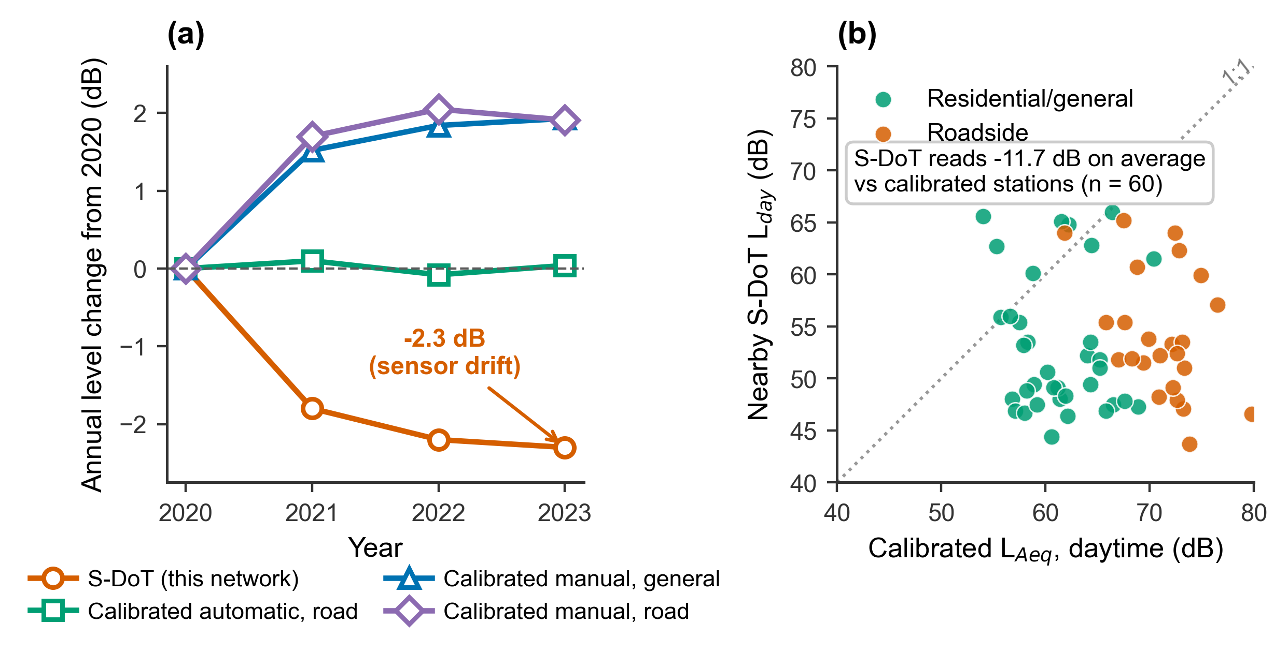
Fig. 8. Sensor drift and calibrated-network comparison. (a) Annual network-mean level change from 2020: the S-DoT network declines by 2.3 dB over 2020-2023 while calibrated environmental-noise stations (automatic daily road stations; manual quarterly general and road stations) stay flat or rise, a pattern consistent with a sensor-drift artefact rather than a real citywide quieting. (b) Nearby S-DoT sensors read on average 11.7 dB below calibrated daytime L_{Aeq} (n = 60 station pairs within 500 m; non-simultaneous years, 2022 S-DoT vs 2024 survey; larger at roadside), so absolute S-DoT levels cannot be interpreted as standard noise indicators (Supplementary Fig. S2).

3.6. Robustness and sensitivity
Five sensitivity checks establish that the headline estimate is not a mechanical artefact (Fig. 9, Table 7). First, reshuffling the dong-level dose across dong within each date (300 shuffles, applied identically to all sensors of a dong) yields placebo coefficients tightly distributed around zero (mean -0.001, SD 0.023); the actual estimate of +0.65 lies entirely outside that distribution (two-sided p=(B+1)/(N+1)=0.003). Because the date-by-date shuffle does not preserve the temporal persistence of each dong's dose, we read this p-value as a diagnostic check rather than formal inference. Second, re-estimating on the dong-day panel with equal dong weights gives β=+0.83 (SE 0.42, p=0.047), preserving sign and magnitude (the main estimate is a sensor-location-weighted slope). Third, a quadratic mobility term is not significant (β²=-0.59, p=0.44), supporting the linear approximation (Fig. 9b). Fourth, Benjamini-Hochberg FDR adjustment across the 12 segmented tests of Table 6 leaves the daytime, spring and autumn responses significant (FDR<0.05). Finally, excluding sensor-days with more than 24 recorded hours (5.9% of rows, a possible duplicate-transmission artefact) leaves the estimate essentially unchanged at β=+0.651 (SE 0.248). The same-day cross-neighbourhood signal is therefore robust to implementation, weighting, functional form and aggregation rules.
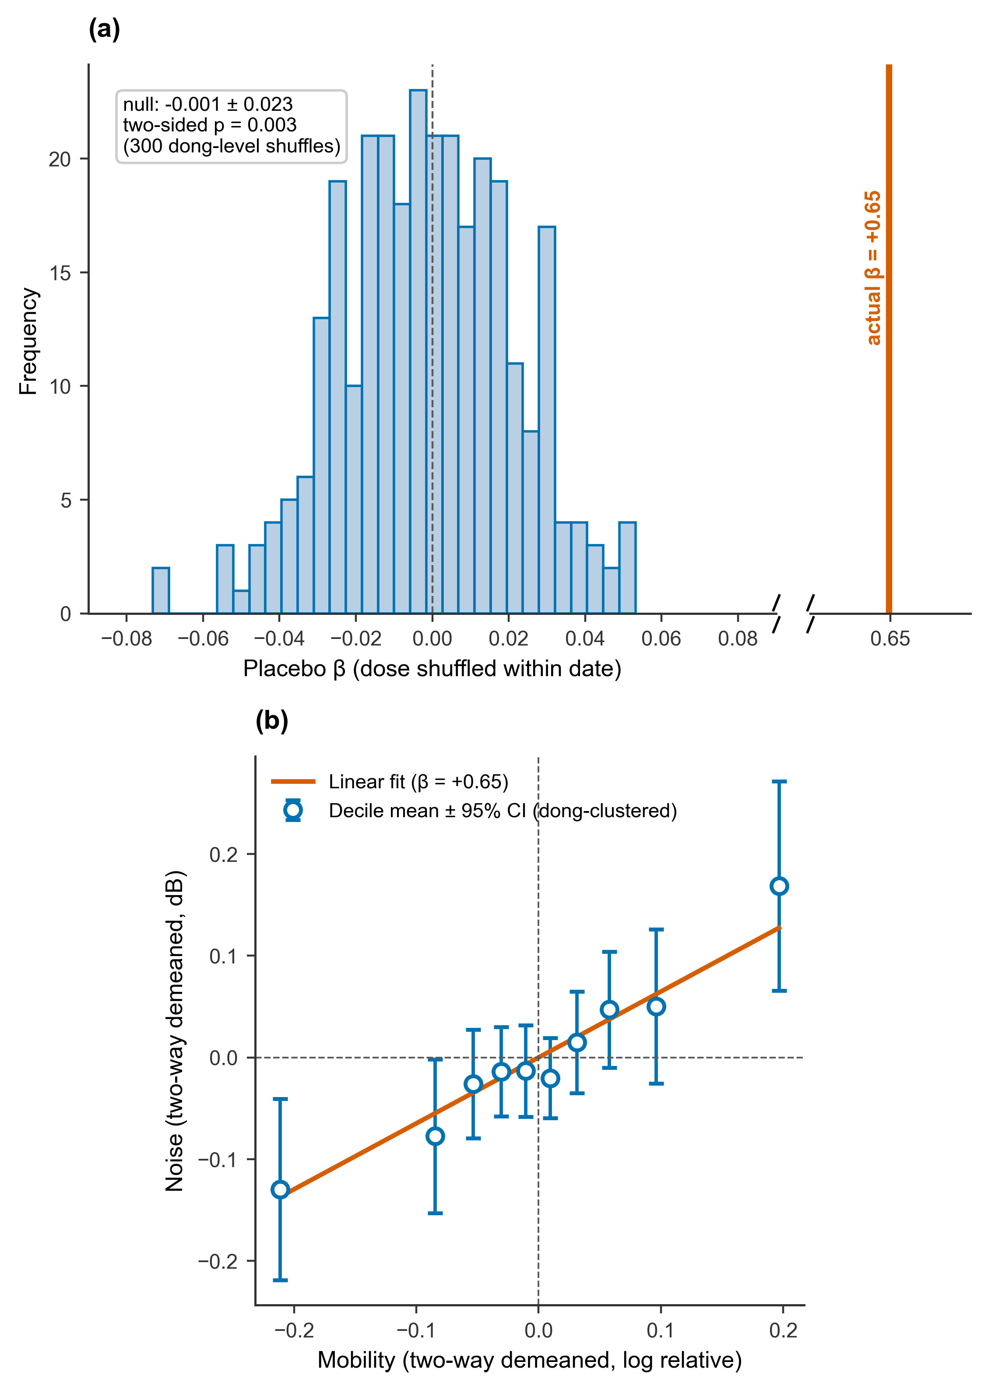
Fig. 9. Robustness and sensitivity. (a) Permutation sensitivity check: distribution of the dose-response coefficient when the dong-level mobility dose is reshuffled across neighbourhoods within each date and broadcast to all sensors in the dong (300 shuffles); the actual estimate (+0.65, vertical line on the broken axis) lies far outside the null (two-sided p = (B+1)/(N+1) = 0.003). (b) Binned dose-response after two-way demeaning: decile means (error bars = 95% CI, dong-clustered) lie close to the linear fit, supporting the linear approximation.

Table 7. Robustness and sensitivity checks for the headline two-way fixed-effects dose-response.
Check | Specification | Result | Conclusion
Permutation sensitivity | Dong-level dose reshuffled across dongs within each date, broadcast to all sensors in the dong (300 shuffles) | Null β = −0.001 ± 0.023; actual β = +0.648; two-sided p = (B+1)/(N+1) = 0.003 | Signal is not mechanical
Weighting sensitivity | Dong-day panel re-estimated with equal dong weights (main estimate is sensor-location weighted) | β = +0.826 (SE 0.416, p = 0.047) | Sign and magnitude preserved
Nonlinearity | Quadratic mobility term added to M2 | β₂ = −0.59 (p = 0.44) | Linear approximation adequate
Multiple comparisons | BH-FDR over the 12 segment tests of Table 6 | Daytime, spring (MAM) and autumn (SON) remain significant (FDR < 0.05) | Daytime effect robust
Hour-count filter | Sensor-days with more than 24 recorded hours excluded (5.9% of rows) | β = +0.651 (SE 0.248) | Estimate unchanged after exclusion

4. Discussion

4.1. Summary of findings
This study provides, to our knowledge, the first quantitative estimate of a graded dose-response of urban noise to measured mobility. Four findings summarise the results. First, a statistically solid positive conditional association links a dong's daytime mobility to its daytime noise, but it is small: a 30% fall in mobility corresponds to roughly 0.2-0.3 dB, and the association carries through to the full-day L_{eq,24h} (β=+0.628). Second, individually significant responses appear only for the daytime outcome (the day-night difference itself remains unresolved), with the same positive sign in all four seasons and significance surviving FDR adjustment in spring and autumn; the apparent night-time association dissolves under strict identification as a time confound. Third, the signal appears only in same-day cross-neighbourhood contrasts and in the high-loss versus low-loss trajectories; it vanishes in the long-run spatial cross-section. Fourth, the multi-year absolute levels of the low-cost network are contaminated by sensor drift and uneven recovery, so neither time-series nor absolute comparisons can be trusted; only designs built on within-sensor change and cross-neighbourhood comparison remain valid. The upward multi-year trend of the calibrated networks, which tracks recovering activity, independently supports the direction of the estimated response.

4.2. The magnitude in context
Our estimate stands in contrast to the several-decibel reductions reported for lockdowns [19,20,21,22,23,24]. Those studies mostly compare absolute noise at particular busy locations before and during confinement, an approach that readily generalises the extreme changes of the loudest, most-emptied spots to the whole city. Here the marginal association (the average noise change per unit change in mobility) is estimated across roughly 1,100 locations, from within-sensor changes, along the whole range of mobility, over the full period; a citywide average response is bound to come out smaller. One qualification is essential. The core model identifies the slope only from same-day differences across dong, so the effect of the common citywide component of reduced mobility, everyone moving less at once, is not identified in this design. We offer neither an upper nor a lower bound for that component, and the estimate should be read strictly as the response to relative, neighbourhood-level changes. The small magnitude also fits two physical facts: much urban noise comes from background sources such as through-traffic and arterials, which empty little, and the 1 dB resolution of S-DoT adds measurement noise that widens standard errors. The popular impression that lockdowns made cities several decibels quieter is therefore likely an overstatement when read as a mobility dose-response; the graded response that survives strict identification is real but small.
The two kinds of estimate answer different questions, so rather than comparing them head-on it is more useful to push our slope through the exposure of the earlier studies. Taking as the dose the largest daytime emptying observed for commercial dong in the strictest phases (about 35%, Fig. 4), the predicted reduction at β=+0.648 is about 0.28 dB. The drop in the daytime coefficient from +1.13 to +0.65 when date fixed effects are added reflects the removal of date-common confounding (citywide trends, network-wide drift, weather); it does not by itself measure any common mobility effect. The gap between such figures and Madrid's 4-6 dB [19] then decomposes into three parts: (1) the effect of the citywide common decline in mobility, which date fixed effects absorb and this design does not identify; (2) site selection, since monitoring points concentrated in the busiest streets carry doses and responsiveness far above the city average; and (3) background trends and sensor changes folded into absolute before-and-after comparisons. Of the several decibels reported, the share explained by relative cross-neighbourhood mobility differences is around 0.3 dB; the remainder belongs to components this design deliberately does not identify, and to site selection. In perceptual terms a 0.65 dB shift lies below what an individual listener would notice, though as a movement of a long-run exposure indicator for an entire urban population it retains meaning.

4.3. Mechanisms behind the patterns
The pattern of the response is consistent with its likely mechanism. A significant response appears in the daytime outcome and keeps its direction through the year, which fits daytime noise being tied directly to human activity (commerce, commuting, visits), whereas night-time noise carries a larger share of fixed installations and arterial through-traffic and may respond weakly to changes in occupancy (with the caveat, again, that the day-night difference is not statistically settled). The disappearance of the apparent night-time association under stricter identification is a warning against reading simple time trends as causal. The rough uniformity of the response across activity types suggests that the mobility-noise link is not confined to one kind of place but spread thinly across the city. The absence of a clean long-run spatial gradient deserves emphasis. It does not indicate an absent effect; it indicates that long-run neighbourhood averages are dominated by idiosyncratic factors, construction, road changes and sensor-specific drift. The signal lives in fast same-day variation between neighbourhoods and is invisible to simple spatial mapping. Indeed the briefly positive correlation among commercial dong turned out to be an artefact of a few extreme neighbourhoods under Pearson correlation, and it disappears under robust statistics: a compact demonstration of how easily spatial analysis of dense IoT data can mislead.
Reading the night-time null as 'night noise is insensitive to activity' would nevertheless be premature; three alternative explanations run in parallel. One is statistical power. The night-time standard error (0.63) is about 2.6 times the daytime one (0.245), and at that precision an estimated coefficient would need to reach about 1.2 dB to attain two-sided 5% significance, so a night-time response equal in size to the daytime one would go undetected in these data. A second is exposure variation. Because the practical instruments of distancing were closing hours and gathering caps, the relative variation of night-time presence across dong may be narrower than in the daytime, and a smaller dose variance estimates the same true slope less precisely. A third is measurement error. The daily quality filter imposes no minimum on within-window hours, so some L_{night} values rest on few observations. If the resulting outcome error is conditionally mean-zero, it inflates the residual variance and widens standard errors rather than attenuating the coefficient; non-random hour coverage could, however, bias it. A similar precision problem extends to the long-run spatial cross-section: sensor-specific drift adds a large random component to the outcome, while error in the estimated mobility change can attenuate the exposure coefficient. The spatial null is therefore inconclusive rather than evidence of an absent effect; it is what a cross-section with error in both exposure and outcome would be expected to produce.

4.4. Methodological implications
The methodological lessons matter as much as the estimates. Attempts to measure urban environmental effects with dense low-cost noise networks run into three pitfalls: (1) each sensor's idiosyncratic bias must be cancelled by designs that use only within-sensor change; (2) multi-year drift, staggered installation and uneven recovery make absolute levels incomparable over time and space, which forces same-day cross-neighbourhood comparison; and (3) exposure variables that take one value per day citywide are fragile to time confounding, so exposures must be measured below the city level. The stable spatial null of the long-run cross-section is itself instructive: painting uncalibrated absolute levels onto maps can produce spurious patterns, or spurious blankness. These lessons apply to the spreading families of low-cost noise monitoring, SONYC [40], wireless acoustic sensor networks [42], NoiseCapture [44] and low-cost devices generally [41], and to policy uses of smart-city sensor data at large [45,46]. The procedures shown here (fixed effects, outlier-robust statistics, cross-checks against official networks) are offered as a template for future IoT-based urban environmental research.

4.5. Policy implications and limitations
For planning and policy, the direct noise co-benefit of managing mobility and travel demand is probably smaller than commonly assumed: even lockdown-scale collapses in mobility produced differences of only about 0.3 dB at the level of relative neighbourhood change (the citywide common component lies outside this design). The estimate applies to relative dong-level changes; it does not transfer directly to policies that cut total citywide travel, or to street-scale interventions that close a single road. Fifteen-minute-city policies in particular redistribute activity rather than reduce it, so their noise effect differs in kind from the component identified here. What survives these caveats is the conclusion that the mobility channel alone cannot be counted on for reductions of several decibels. Mobility policies remain justified on their own grounds, but noise targets call for source- and propagation-stage measures in parallel: quieter pavements, quieter vehicles, barriers [17,51]. The rough uniformity of the response across activity types suggests scope for broad approaches rather than regulation differentiated by land use. Whether these results generalise to Tokyo, Hong Kong, Singapore and other dense East Asian cities remains a hypothesis to be tested.
Several limitations qualify these conclusions. (1) S-DoT is uncalibrated, coarse (1 dB steps) and subject to ageing drift, so absolute levels and multi-year series cannot be taken at face value; our workaround is within-sensor change plus same-day comparison. (2) De-facto population records presence, not the activities that generate noise (traffic above all), and dong-by-date shocks such as construction or events, which move both presence and noise, survive date fixed effects; this is why we read the estimate as a conditional association. Linking stop-level transit boardings to dong [35,37] would sharpen interpretation. (3) The exact effective dates in the stringency coding warrant further checking against KDCA source records. (4) Weather comes from reanalysis (ERA5) and could be replaced with official station observations. (5) The effect of the citywide common mobility component is absorbed by date fixed effects and is not identified here, with no bound on its size or direction; recovering absolute levels by fusion with calibrated reference networks is a task for follow-up work. (6) The activity classification approximates land use by the day-night population ratio (with circularity limited by using only post-lifting levels); official zoning data would refine it. (7) The daily quality filter (12 h or more) sets no within-window minimum, so some L_{night} values rest on few hours; window-specific thresholds remain to be examined. (8) The analysis window opens with S-DoT provision (2020-04) and misses the strongest mobility shock, the first wave and the first intensive distancing of March 2020; with the extremes of the dose distribution truncated, power to detect saturation or thresholds is limited, and the linear approximation is claimed only within the observed range. (9) De-facto population does not separate indoor from outdoor presence. In phases when people stayed indoors, equal presence produced less street-level source activity, overstating exposure and attenuating the coefficient; noise-source changes that ran against the fall in mobility, such as the pandemic-era growth in delivery motorcycles, may likewise be folded into the observed slope. (10) Installation context (setback from roads, mounting height, facades) is unobserved, so heterogeneous responsiveness across sites is averaged into β. (11) The analysis covers a single city, and extensions to the fine spectral and temporal structure of noise and to human soundscape perception [11,16,33,34] remain open.

5. Conclusions
Using Korea's graded distancing as a natural-experiment setting, we estimated, to our knowledge for the first time, a graded dose-response of urban noise to measured mobility on a city-scale IoT network. The association is statistically solid but small: a 30% fall in mobility corresponds to about 0.23 dB of daytime noise, and a 50% fall to about 0.45 dB. Detectable responses appear only for the daytime outcome (the day-night difference itself is unresolved), keep the same sign through all four seasons (spring and autumn surviving multiplicity adjustment), and are estimated under the conservative same-day cross-neighbourhood comparison; in that strict sense they are conditional associations. The signal vanishes in long-run spatial cross-sections, and the multi-year absolute levels of the low-cost network are corrupted by drift. For policy, at least at the level of relative neighbourhood change, mobility-reducing urban policies (car-free streets, fifteen-minute cities) are unlikely on their own to lower urban noise by much, and noise targets will require source- and propagation-stage interventions alongside them. The results also temper the popular reading of the lockdown literature: citywide quieting of several decibels, generalised from a few hotspots, may overstate what a graded mobility dose-response supports, and correcting for this helps recalibrate expectations about the costs and benefits of noise policy.
Methodologically, the study sets out a procedure for using uncalibrated high-density IoT noise networks with confidence: within-sensor relative change, two-way fixed effects, outlier-robust statistics and cross-checks against official networks, with the signal confirmed by dong-level permutation and weighting sensitivity checks. Because absolute levels mislead under multi-year drift, smart-city noise monitoring should adopt within-sensor change designs from the outset. Future work should link more direct traffic exposures, such as stop-level boardings, to sharpen the estimate, fuse the network with calibrated reference stations to restore absolute levels, and repeat the design on other low-cost networks (SONYC, wireless acoustic sensor networks, NoiseCapture) and in other dense East Asian cities (Tokyo, Hong Kong, Singapore) to test its generality.

CRediT authorship contribution statement
Hyun In Jo: Conceptualization, Methodology, Software, Formal analysis, Data curation, Writing, original draft, Writing, review & editing, Visualization.

Declaration of competing interest
The author declares no competing financial interests or personal relationships that could have appeared to influence the work reported in this paper.

Funding
This research received no specific grant from any funding agency in the public, commercial, or not-for-profit sectors.

Ethics
This study analysed only publicly available, aggregated and de-identified data and did not involve human participants directly; institutional review board approval was therefore not required.

Data Availability Statement
All raw data are public: S-DoT noise (Seoul Open Data Plaza OA-15969), de-facto population (OA-14991), subway ridership (OA-12921), the distancing implementation history (data.go.kr 15106451), weather (Open-Meteo ERA5), administrative boundaries (vuski/admdongkor), the four roadside L_{Aeq} stations (OA-15473) and the calibrated environmental-noise networks (noiseinfo.or.kr). The subway data are distributed under KOGL Type 3 (attribution, no modification). Analysis code will be made available at [repository TBD].

References
[1] World Health Organization. Environmental Noise Guidelines for the European Region. Copenhagen: WHO Regional Office for Europe; 2018.
[2] World Health Organization. Burden of disease from environmental noise: quantification of healthy life years lost in Europe. Copenhagen: WHO Regional Office for Europe; 2011.
[3] Basner M, McGuire S. WHO Environmental Noise Guidelines for the European Region: A Systematic Review on Environmental Noise and Effects on Sleep. International Journal of Environmental Research and Public Health. 2018;15:519. doi:10.3390/ijerph15030519
[4] Basner M, Babisch W, Davis A, Brink M, Clark C, Janssen S, et al. Auditory and non-auditory effects of noise on health. The Lancet. 2014;383:1325-1332. doi:10.1016/s0140-6736(13)61613-x
[5] Münzel T, Gori T, Babisch W, Basner M. Cardiovascular effects of environmental noise exposure. European Heart Journal. 2014;35:829-836. doi:10.1093/eurheartj/ehu030
[6] Guski R, Schreckenberg D, Schuemer R. WHO Environmental Noise Guidelines for the European Region: A Systematic Review on Environmental Noise and Annoyance. International Journal of Environmental Research and Public Health. 2017;14:1539. doi:10.3390/ijerph14121539
[7] Miedema H, Oudshoorn C. Annoyance from Transportation Noise: Relationships with Exposure Metrics DNL and DENL and Their Confidence Intervals. Environmental Health Perspectives. 2001;109:409. doi:10.2307/3454901
[8] Hammer M, Swinburn T, Neitzel R. Environmental Noise Pollution in the United States: Developing an Effective Public Health Response. Environmental Health Perspectives. 2014;122:115-119. doi:10.1289/ehp.1307272
[9] Schafer RM. The Soundscape: Our Sonic Environment and the Tuning of the World. Rochester (VT): Destiny Books; 1994.
[10] International Organization for Standardization. ISO 12913-1:2014 Acoustics - Soundscape - Part 1: Definition and conceptual framework. Geneva: ISO; 2014.
[11] Aletta F, Kang J, Axelsson Ö. Soundscape descriptors and a conceptual framework for developing predictive soundscape models. Landscape and Urban Planning. 2016;149:65-74. doi:10.1016/j.landurbplan.2016.02.001
[12] Axelsson Ö, Nilsson M, Berglund B. A principal components model of soundscape perception. The Journal of the Acoustical Society of America. 2010;128:2836-2846. doi:10.1121/1.3493436
[13] Kang J, Aletta F, Gjestland T, Brown L, Botteldooren D, Schulte-Fortkamp B, et al. Ten questions on the soundscapes of the built environment. Building and Environment. 2016;108:284-294. doi:10.1016/j.buildenv.2016.08.011
[14] Kang J. Noise Management: Soundscape Approach. Encyclopedia of Environmental Health. 2019:683-694. doi:10.1016/b978-0-12-409548-9.10933-9
[15] Yang W, Kang J. Acoustic comfort evaluation in urban open public spaces. Applied Acoustics. 2005;66:211-229. doi:10.1016/j.apacoust.2004.07.011
[16] Hong J, Jeon J. Relationship between spatiotemporal variability of soundscape and urban morphology in a multifunctional urban area: A case study in Seoul, Korea. Building and Environment. 2017;126:382-395. doi:10.1016/j.buildenv.2017.10.021
[17] Adulaimi A, Pradhan B, Chakraborty S, Alamri A. Traffic Noise Modelling Using Land Use Regression Model Based on Machine Learning, Statistical Regression and GIS. Energies. 2021;14:5095. doi:10.3390/en14165095
[18] Gharehchahi E, Hashemi H, Yunesian M, Samaei M, Azhdarpoor A, Oliaei M, et al. Geospatial analysis for environmental noise mapping: A land use regression approach in a metropolitan city. Environmental Research. 2024;257:119375. doi:10.1016/j.envres.2024.119375
[19] Asensio C, Pavón I, de Arcas G. Changes in noise levels in the city of Madrid during COVID-19 lockdown in 2020. The Journal of the Acoustical Society of America. 2020;148:1748-1755. doi:10.1121/10.0002008
[20] Basu B, Murphy E, Molter A, Sarkar Basu A, Sannigrahi S, Belmonte M, et al. Investigating changes in noise pollution due to the COVID-19 lockdown: The case of Dublin, Ireland. Sustainable Cities and Society. 2021;65:102597. doi:10.1016/j.scs.2020.102597
[21] Aletta F, Oberman T, Mitchell A, Tong H, Kang J. Assessing the changing urban sound environment during the COVID-19 lockdown period using short-term acoustic measurements. Noise Mapping. 2020;7:123-134. doi:10.1515/noise-2020-0011
[22] Rumpler R, Venkataraman S, Göransson P. An observation of the impact of CoViD-19 recommendation measures monitored through urban noise levels in central Stockholm, Sweden. Sustainable Cities and Society. 2020;63:102469. doi:10.1016/j.scs.2020.102469
[23] Steele D, Guastavino C. Quieted City Sounds during the COVID-19 Pandemic in Montreal. International Journal of Environmental Research and Public Health. 2021;18:5877. doi:10.3390/ijerph18115877
[24] Manzano J, Pastor J, Quesada R, Aletta F, Oberman T, Mitchell A, et al. The 'sound of silence' in Granada during the COVID-19 lockdown. Noise Mapping. 2021;8:16-31. doi:10.1515/noise-2021-0002
[25] Maggi A, Muratore J, Gaetán S, Zalazar-Jaime M, Evin D, Pérez Villalobo J, et al. Perception of the acoustic environment during COVID-19 lockdown in Argentina. The Journal of the Acoustical Society of America. 2021;149:3902-3909. doi:10.1121/10.0005131
[26] Montano W, Gushiken E. COVID-19 and soundscape changes due to the lockdown. The case of Lima, Peru. Akustika. 2021;39. doi:10.36336/akustika20213946
[27] Bartalucci C, Bellomini R, Luzzi S, Pulella P, Torelli G. A survey on the soundscape perception before and during the COVID-19 pandemic in Italy. Noise Mapping. 2021;8:65-88. doi:10.1515/noise-2021-0005
[28] Mishra A, Das S, Singh D, Maurya AK. Effect of COVID-19 lockdown on noise pollution levels in an Indian city: a case study of Kanpur. Environmental Science and Pollution Research. 2021. doi:10.1007/s11356-021-13872-z
[29] Sonaviya D, Tandel B. Integrated road traffic noise mapping in urban Indian context. Noise Mapping. 2020;7:99-113. doi:10.1515/noise-2020-0009
[30] Le Quéré C, Jackson R, Jones M, Smith A, Abernethy S, Andrew R, et al. Temporary reduction in daily global CO2 emissions during the COVID-19 forced confinement. Nature Climate Change. 2020;10:647-653. doi:10.1038/s41558-020-0797-x
[31] Brancher M. Increased ozone pollution alongside reduced nitrogen dioxide concentrations during Vienna’s first COVID-19 lockdown: Significance for air quality management. Environmental Pollution. 2021;284:117153. doi:10.1016/j.envpol.2021.117153
[32] Mahato S, Pal S. Revisiting air quality during lockdown persuaded by second surge of COVID-19 of megacity Delhi, India. Urban Climate. 2022;41:101082. doi:10.1016/j.uclim.2021.101082
[33] Erfanian M, Mitchell A, Aletta F, Kang J. Psychological well-being and demographic factors can mediate soundscape pleasantness and eventfulness: A large sample study. Preprint, bioRxiv; 2020. doi:10.1101/2020.10.16.341834
[34] Torresin S, Albatici R, Aletta F, Babich F, Oberman T, Siboni S, et al. Indoor soundscape assessment: A principal components model of acoustic perception in residential buildings. Building and Environment. 2020;182:107152. doi:10.1016/j.buildenv.2020.107152
[35] Deville P, Linard C, Martin S, Gilbert M, Stevens F, Gaughan A, et al. Dynamic population mapping using mobile phone data. Proceedings of the National Academy of Sciences. 2014;111:15888-15893. doi:10.1073/pnas.1408439111
[36] Paez A. Using Google Community Mobility Reports to investigate the incidence of COVID-19 in the United States. Findings. 2020. doi:10.32866/001c.12976
[37] Kalleitner F, Schiestl DW, Heiler G. Varieties of mobility measures: Comparing survey and mobile phone data during the COVID-19 pandemic. Preprint, SocArXiv; 2021. doi:10.31235/osf.io/r78fk
[38] Romanillos Arroyo G. Urban population dynamics during the COVID-19 pandemic based on mobile phone data. Datasets. 2021. doi:10.36443/10259/6864
[39] Yim B, Lee J, Park M. A Two-Timescale Typology of Neighborhood-Scale Commercial Districts in Seoul: Evidence from Mobile Phone De Facto Population Data. Sustainability. 2026;18:4326. doi:10.3390/su18094326
[40] Bello J, Silva C, Nov O, Dubois R, Arora A, Salamon J, et al. SONYC. Communications of the ACM. 2019;62:68-77. doi:10.1145/3224204
[41] Mydlarz C, Salamon J, Bello J. The implementation of low-cost urban acoustic monitoring devices. Applied Acoustics. 2017;117:207-218. doi:10.1016/j.apacoust.2016.06.010
[42] Alías F, Alsina-Pagès R. Review of Wireless Acoustic Sensor Networks for Environmental Noise Monitoring in Smart Cities. Journal of Sensors. 2019;2019:1-13. doi:10.1155/2019/7634860
[43] Sevillano X, Socoró J, Alías F, Bellucci P, Peruzzi L, Radaelli S, et al. DYNAMAP - Development of low cost sensors networks for real time noise mapping. Noise Mapping. 2016;3. doi:10.1515/noise-2016-0013
[44] Picaut J, Bocher E, Aumond P, Petit G, Fortin N. Exploiting data from the NoiseCapture application for environmental noise measurements with a smartphone. INTER-NOISE and NOISE-CON Congress and Conference Proceedings. 2021;263:3149-3159. doi:10.3397/in-2021-2316
[45] Boumchich A, Picaut J, Bocher E. Using a Clustering Method to Detect Spatial Events in a Smartphone-Based Crowd-Sourced Database for Environmental Noise Assessment. Sensors. 2022;22:8832. doi:10.3390/s22228832
[46] Peng B, Wang K, Abdulla W. An Integrated Hierarchical Wireless Acoustic Sensor Network and Optimized Deep Learning Model for Scalable Urban Sound and Environmental Monitoring. Applied Sciences. 2025;15:2196. doi:10.3390/app15042196
[47] Cui H, Zhang L, Li W, Yuan Z, Wu M, Wang C, et al. A new calibration system for low-cost Sensor Network in air pollution monitoring. Atmospheric Pollution Research. 2021;12:101049. doi:10.1016/j.apr.2021.03.012
[48] Abadie A, Athey S, Imbens GW, Wooldridge JM. When should you adjust standard errors for clustering? The Quarterly Journal of Economics. 2023;138:1-35. doi:10.1093/qje/qjac038
[49] Guo J, Qu X. Fixed effects spatial panel data models with time-varying spatial dependence. Economics Letters. 2020;196:109531. doi:10.1016/j.econlet.2020.109531
[50] Craig P, Campbell M, Deidda M, Dundas R, Green J, Katikireddi S, et al. Using natural experiments to evaluate population health interventions: a framework for producers and users of evidence. Public Health Research. 2025:1-59. doi:10.3310/jtyw6582
[51] Vogiatzis K, Remy N. Soundscape design guidelines through noise mapping methodologies: An application to medium urban agglomerations. Noise Mapping. 2017;4:1-19. doi:10.1515/noise-2017-0001
[52] Pascale A, Mancini S, d'Orey PM, Guarnaccia C, Coelho MC. Correlating the effect of Covid-19 lockdown with mobility impacts: A time series study using noise sensors data. Transportation Research Procedia. 2022;62:115-122. doi:10.1016/j.trpro.2022.02.015
[53] Aletta F, Brinchi S, Carrese S, Gemma A, Guattari C, Mannini L, et al. Analysing urban traffic volumes and mapping noise emissions in Rome (Italy) in the context of containment measures for the COVID-19 disease. Noise Mapping. 2020;7:114-122. doi:10.1515/noise-2020-0010
[54] Hemker F, Haselhoff T, Brunner S, Lawrence BT, Ickstadt K, Moebus S. The role of traffic volume on sound pressure level reduction before and during COVID-19 lockdown measures - a case study in Bochum, Germany. International Journal of Environmental Research and Public Health. 2023;20:5060. doi:10.3390/ijerph20065060

