Supplementary material
The dose-response of urban noise to human mobility measured with a city-scale IoT sensor network in Seoul
Hyun In Jo, Kyung-Tae Lee

Supplementary Methods S1. Sensor-to-neighbourhood matching
Sensor metadata contain street addresses but no administrative-neighbourhood name. Each sensor was therefore assigned to a dong by point-in-polygon matching of its coordinates against public boundary data (the vuski/admdongkor GeoJSON, 2022-01 vintage). The de-facto population data and the boundary file use slightly different dong-code systems in a few reorganised areas of Gangbuk and Gangdong; these were reconciled by name matching. In the result, 1,165 of 1,170 sensors (99.6%) were assigned to a dong, and the assigned dong agreed with the district recorded in the street address in 99.6% of cases. Sensor-days then passed the noise quality filters (at least 12 observed hours per day, values within 20-95 dB) before the merge with daily mobility.
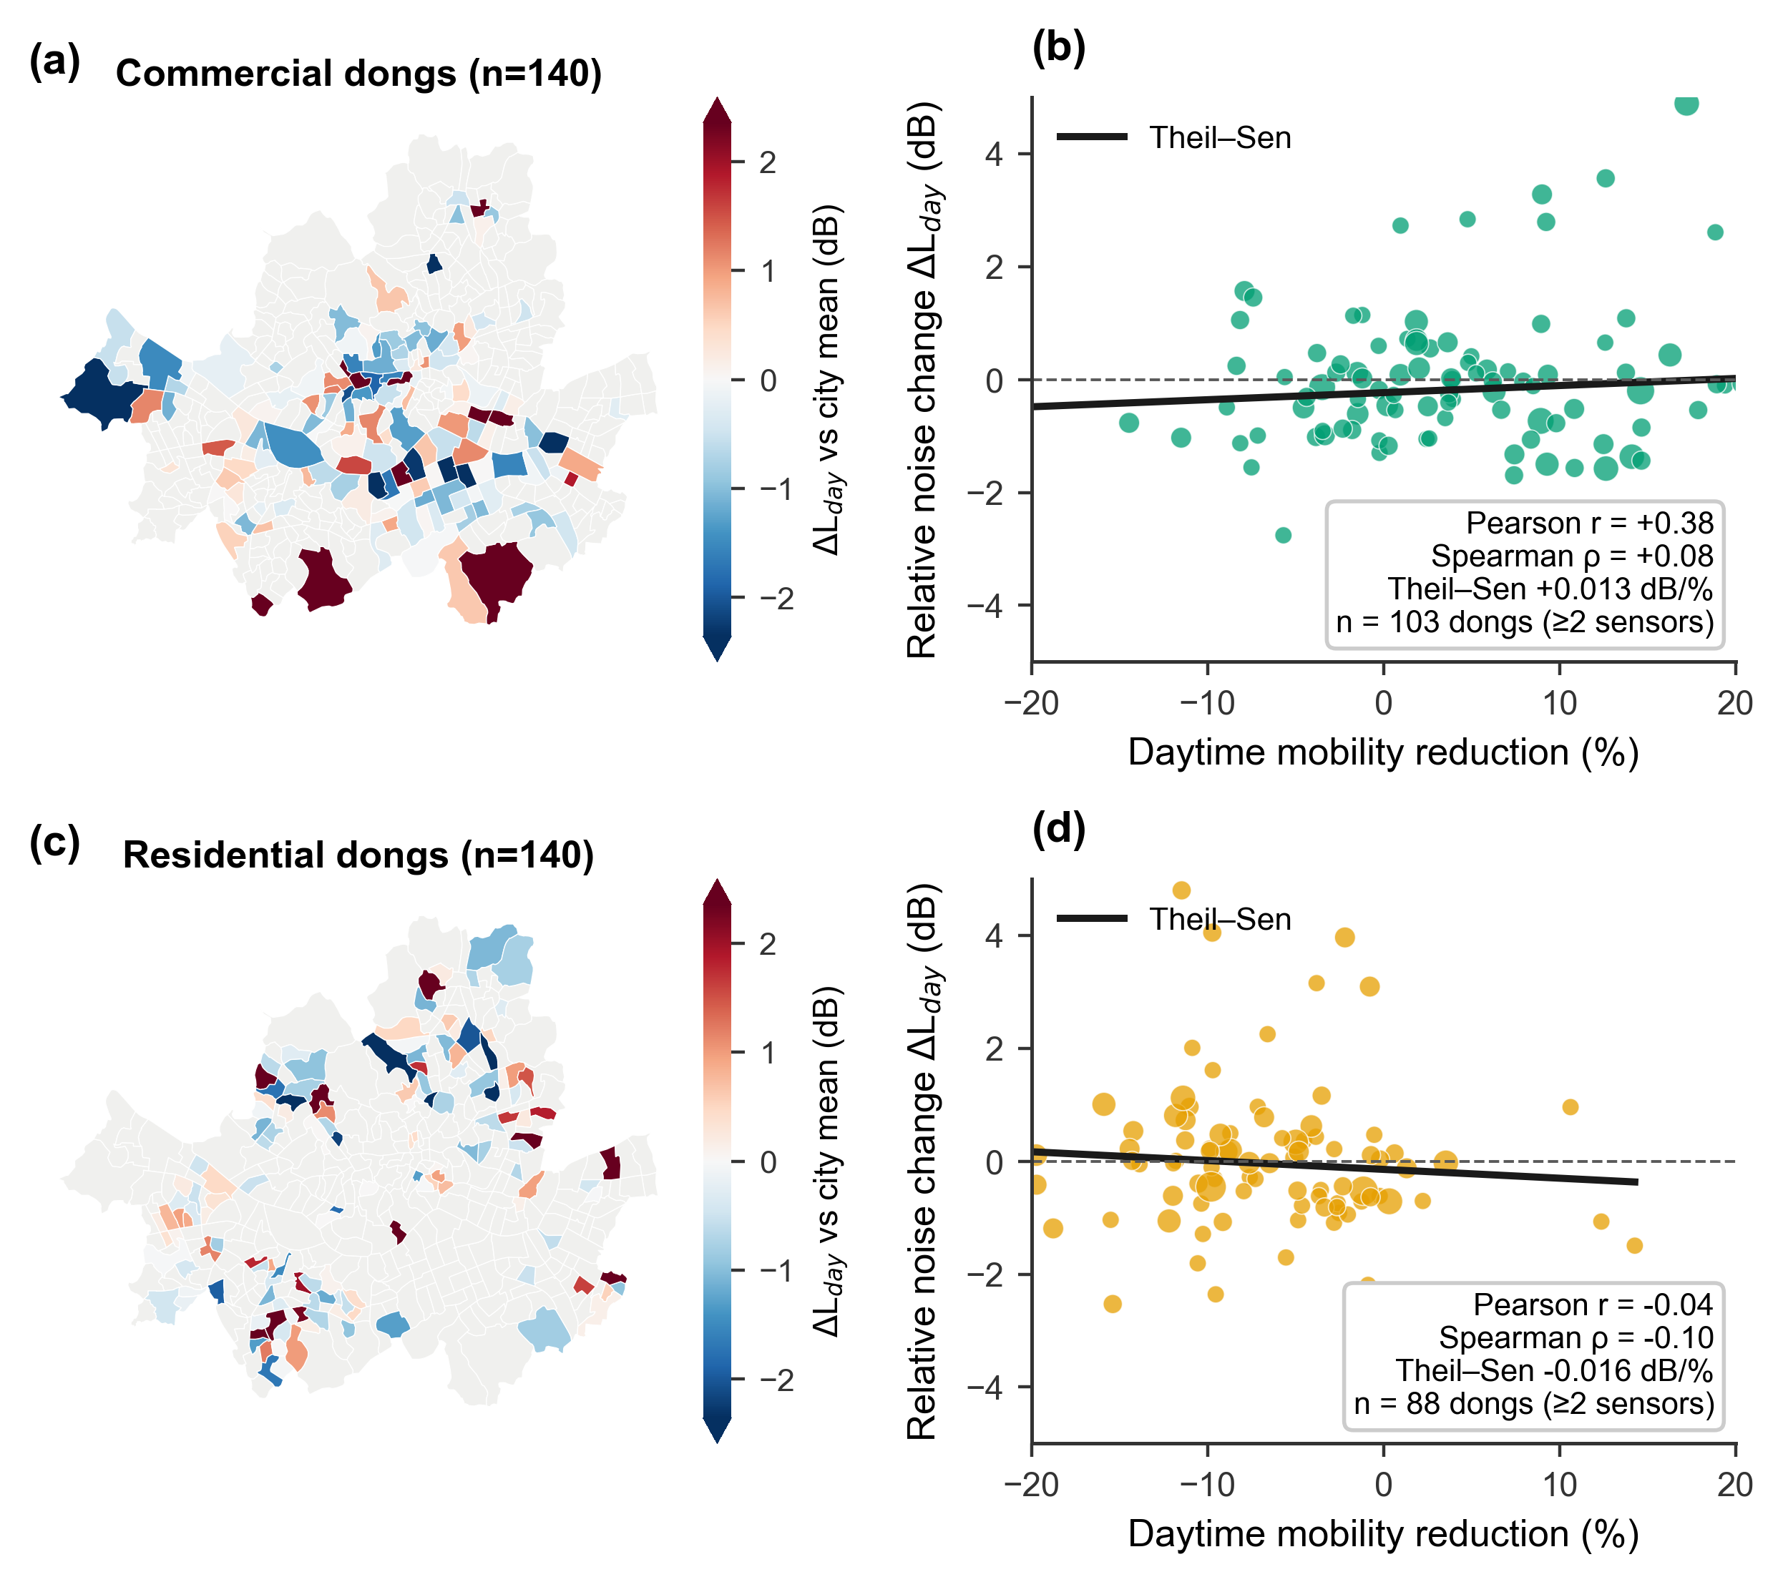
Supplementary Fig. S1. Commercial versus residential detail of the long-run spatial cross-section. (a, c) Drift-removed relative noise change for commercial and residential dongs (all classified dongs mapped). (b, d) Neighbourhood-level association between distancing-era mobility reduction and relative noise change (dongs with >= 2 sensors): the commercial Pearson correlation (+0.38) collapses to rho = +0.08 under rank-based statistics, and residential dongs show no association either.
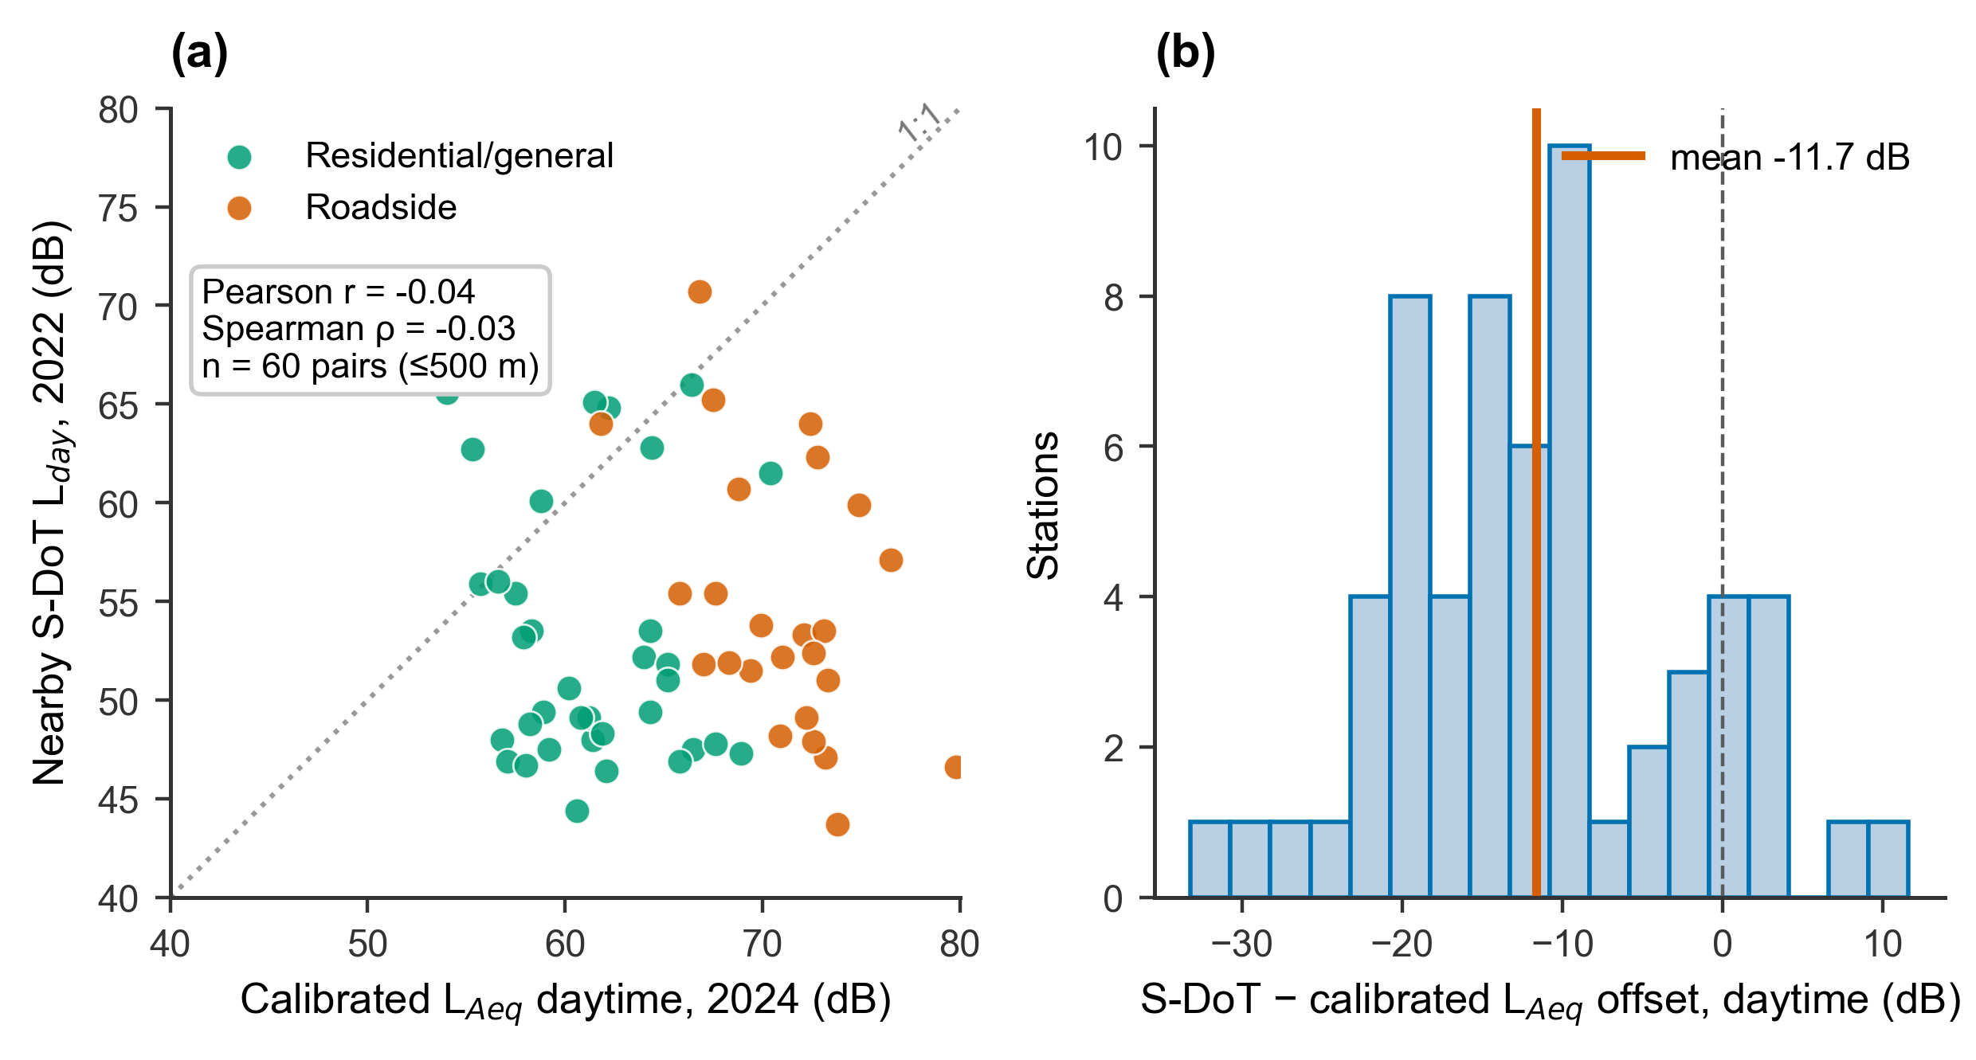
Supplementary Fig. S2. Absolute-level validation detail. (a) Calibrated L_{Aeq} (2024 survey) versus nearby S-DoT L_{day} (2022): no cross-sectional correlation (r = -0.04), reflecting sensor-specific calibration offsets. (b) Distribution of the S-DoT minus calibrated L_{Aeq} offset (mean -11.7 dB; n = 60 pairs within 500 m).
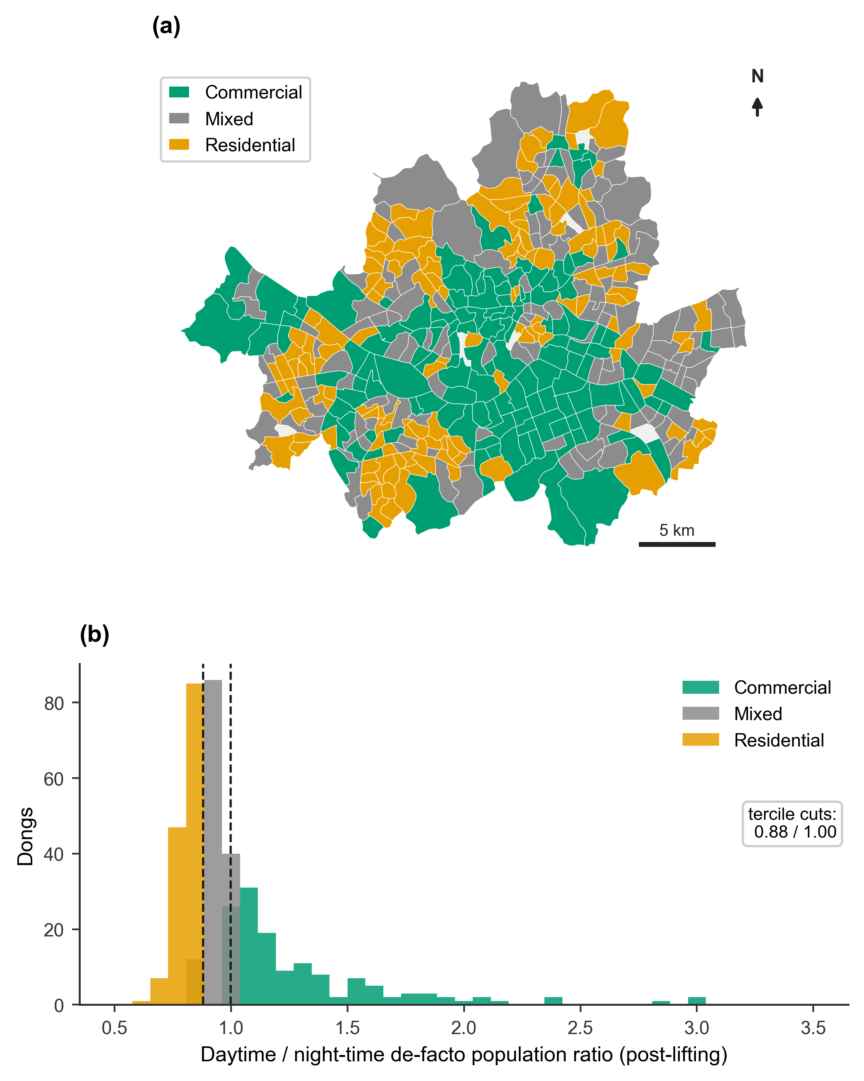
Supplementary Fig. S3. Neighbourhood activity-type classification. (a) Commercial / mixed / residential terciles of the post-lifting daytime/night-time de-facto population ratio. (b) Distribution of the ratio with tercile cuts (0.88 / 1.00).

